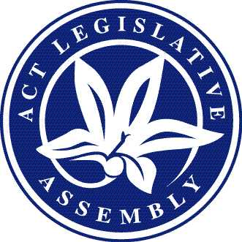

LEGISLATIVE ASSEMBLY FOR THE AUSTRALIAN CAPITAL TERRITORY
Request to broadcast, or record for broadcast, the public proceedings of the Legislative Assembly and its committees
approval statement for
Approved form AF2020-1
made under the
Legislative Assembly (Broadcasting) Act 2001—Section 10—Approved forms

1 Name of instrument
This instrument is the Request to broadcast, or record for broadcast, the public proceedings of the Legislative Assembly and its committees.
2 Commencement
This instrument commences on the day after its notification.
3 Approval
The attached form, Request to broadcast, or record for broadcast, the public proceedings of the Legislative Assembly and its committees, is approved and revokes the existing form AF2010-187.

Tom Duncan
Clerk of the Legislative Assembly

21 January 2020

