Australian Capital Territory
Road Transport (Dimensions and Mass) Higher Mass Limits (HML) Exemption Notice 2006
Disallowable Instrument DI2006—132
made under the
Road Transport (Dimensions and Mass Act 1990), Section 31A (Exemptions)

1. Name of Instrument
This Instrument is the Road Transport (Dimensions and Mass) Higher Mass Limits (HML) Exemption
Notice 2006.

2. Commencement
This instrument commences on 1 July 2006.

- Vehicle exemption
Under paragraph 31A(1) of the Road Transport (Dimensions and Mass) Act 1990 (the Act), I exempt vehicles fitted with road friendly suspensions that are described in clause 1.3 of the Schedule to this notice, from the requirements of sections 24 and 25 of the Act and Table 1 of clause 3.6 – Mass Limits relating to Axle Spacing for B-Doubles in DI2006-118, which determines:

- the gross mass (in tonnes) of a vehicle, or of a motor vehicle and a trailer or semi-trailer coupled to it in relation to the class of vehicles or class of combination; and

- the mass carried by the wheel of a vehicle, the axle load of an axle, or the axle group load of an axle group of a vehicle in relation to the relevant class of wheels, axles or axle groups.

- Conditions and Requirements

Eligible vehicles exempted under this notice are subject to the conditions and requirements set out in the Schedule to this notice.

In this exemption notice, a diagram that is called an essential diagram is part of the exemption notice. Any other diagram or any note is illustrative only. All other relevant legislation related to the operation of vehicles to which this notice is applicable must be adhered to.

- Effect
This instrument remains in force until it is amended or repealed.

JOHN HARGREAVES
Minister for the Territory and Municipal Services
26 June 2006

SCHEDULE

Part 1 – Preliminary

  - Interpretation

Unless stated otherwise, words and expressions used in this Notice have the same meaning as those set out in the Dictionary forming part of the Road Transport (Dimensions and Mass) Act 1990.

  - Application

Only vehicles or combinations listed in clause 1.3, that are fitted with a road friendly suspension specified in clause 2.2, may operate at the higher axle mass limits specified in Table 1.

Notes:

- Refer to clause 2.1 – Mass Management Accreditation, for vehicles and combinations that are fitted with tri-axle groups.

- Refer to clauses 1.6 or 1.7, to determine the maximum gross mass limit for your vehicle or combination.

  - Eligible vehicles

An eligible vehicle means any of the following:

- a rigid truck fitted with a tandem drive axle group that is not towing another vehicle;
- a rigid truck fitted with a tandem drive axle group towing a trailer that is fitted with a single, tandem or tri-axle group towards the rear of the trailer, where both the truck and trailer are designed to carry vehicles on 2 or more partly or completely overlapping decks;
- a combination where the prime mover is fitted with a single axle or tandem axle or tri-axle group;
- a bus fitted with a single drive or tandem axle group;
- a truck or bus with a six-tyred tandem axle group at the rear;
- a B-Double where the prime mover is fitted with a tandem drive axle group and the trailer is, or the trailers are, fitted with either a tandem or tri-axle group.

  - Mass limits

The axle loads specified in Table 1 apply in respect of an eligible vehicle and must also comply with
Part 2 of this Schedule.

Table 1 – Mass Limits for Single axle or axle groups

Axle or Axle Group | Mass Limit (tonnes)
Single axle with dual tyres (buses only) | 10.0
Tandem axle group fitted with single tyres on one axle and dual tyres on the other axle | 14.0
Tandem axle group fitted with dual tyres | 17.0
Tri-axle group fitted with dual tyres | 22.5

  - Maximum gross mass limits for a vehicle or combination

The maximum gross mass limit for a combination must not exceed the lowest of the following:

- The sum of:
  - The single axle and single axle group, the twinsteer axle group and the quad-axle group mass limits in the Table to Schedule 2 of DI2006-119, and
  - The axle and axle group mass limits in Table 1;

- In the case of a bus or rigid truck – the vehicles Gross Vehicle Mass (GVM);

- The Gross Combination Mass (GCM) of the prime mover;

- The sum of the vehicle’s GVM for the prime mover and the semi-trailer;

- In the case of a rigid truck fitted with a tandem drive axle group that is not towing another vehicle: - 28 tonnes;

- In the case of a combination: - 45.5 tonnes;

- In the case of a rigid truck fitted with a tandem drive axle group towing a trailer that is fitted with a single, tandem or tri-axle group towards the rear of the trailer, where both the truck and trailer are designed to carry vehicles on 2 or more partly or completely overlapping decks: - 50.5 tonnes;

- In the case of a B-Double: - 68.0 tonnes;

  - Wide single tyres (super singles)

This Notice does not apply to those vehicles fitted with wide single tyres, which are used in substitution for dual tyres.

Part 2 – Operating requirements and other conditions

  - Mass Accreditation Scheme

If the axle group on the vehicle is a tri-axle group:

- The operator of the vehicle must be an accredited operator, and the vehicle be accredited under a Mass Management Accreditation Scheme, and

- A label or some other device (approved by the Authority) that indicates that the vehicle is operating under a Mass Management Accreditation Scheme must be prominently displayed in the position required by the Scheme.

Note:

Operators must be accredited under the National Heavy Vehicle Accreditation Scheme (NHVAS). The ACT does not offer NHVAS accreditation, however, ACT operators may apply for accreditation in other jurisdictions. Refer to Contacts at the end of this notice, for further information regarding application to the NHVAS.

  - Performance standards for Road Friendly Suspensions (RFS)

Vehicles operating under this Notice must have RFS certified in accordance with Vehicle Standards Bulletin No. 11 issued by the Department of Transport and Regional Services of the Commonwealth.

Note:
Also refer to the definition of Road Friendly Suspension in Part 4 to this Notice.

Note:

Any air suspension system manufactured prior to 1 July 2000 that does not meet the performance standards for RFS after 31 June 2002 may be ineligible for the increased mass limits described in this Notice.

2.3 Routes

A heavy vehicle, vehicle combination or bus operating under this Notice is only permitted to travel along the routes specified in Part 3 to this Notice.

2.4 Route compliance

a) Vehicles operating under this Notice must meet any route compliance requirements determined by the Road Transport Authority.
- Vehicles may be required to meet the requirements of an intelligent transport system approved by the Authority.
- Vehicles may be permitted to carry higher mass only on the proviso that, once policy and administrative systems are resolved for an intelligent transport system, they comply with the fitting of this technology.
Note:

The monitoring of vehicles under an approved intelligent transport system ie. The Intelligent Access Program (IAP) is not yet in force as the IAP is not yet operational.

2.5 Notice to be carried

A copy of this Notice, or an information sheet issued by the Road Transport Authority setting out the obligations imposed under this Notice, must be carried in the driving compartment of the vehicle and must be produced to a police officer or an authorised person when requested.
2.6 Additional Notices to be carried

Any vehicle or combination that is operating at a higher mass limit under this Notice that is also required to comply with the provisions of any other Notice that is pertinent to that vehicle or combination, must also carry a copy of such Notice.

Example:

Operators must also comply with:
- the Road Transport (Dimension and Mass) Act 1990, 62.5 Tonne B-Double, 4.6 Metre High Vehicles and 14.5 Metre Long Bus Exemption Notice (DI2006 - 118).

Part 3 – Approved routes
Type of Route | Road | Starting Point | Finishing Point
Higher Mass Limits | Barton Highway | ACT/NSW Border | Mitchell Industrial Estate or Federal Highway, Downer, ACT
Higher Mass Limits | Approaches To Mitchell Industrial Estate | - Barton Hwy/Gunghalin Drive  - Barton Hwy/Federal Hwy/Flemington Road  - Gunghalin Drive/Sandford Street | - Hoskins Street  - Lysaght Street  3. Flemington Road
Higher Mass Limits | Mitchell Industrial Estate Area | All roads in the area bounded by Gunghalin Drive, Sandford Street, Wells Station Drive, Hoskins Street, Vicars Street, Flemington Rd & Lysaght Streets

ACT Higher Mass Limit Routes (as at 1 July 2006)
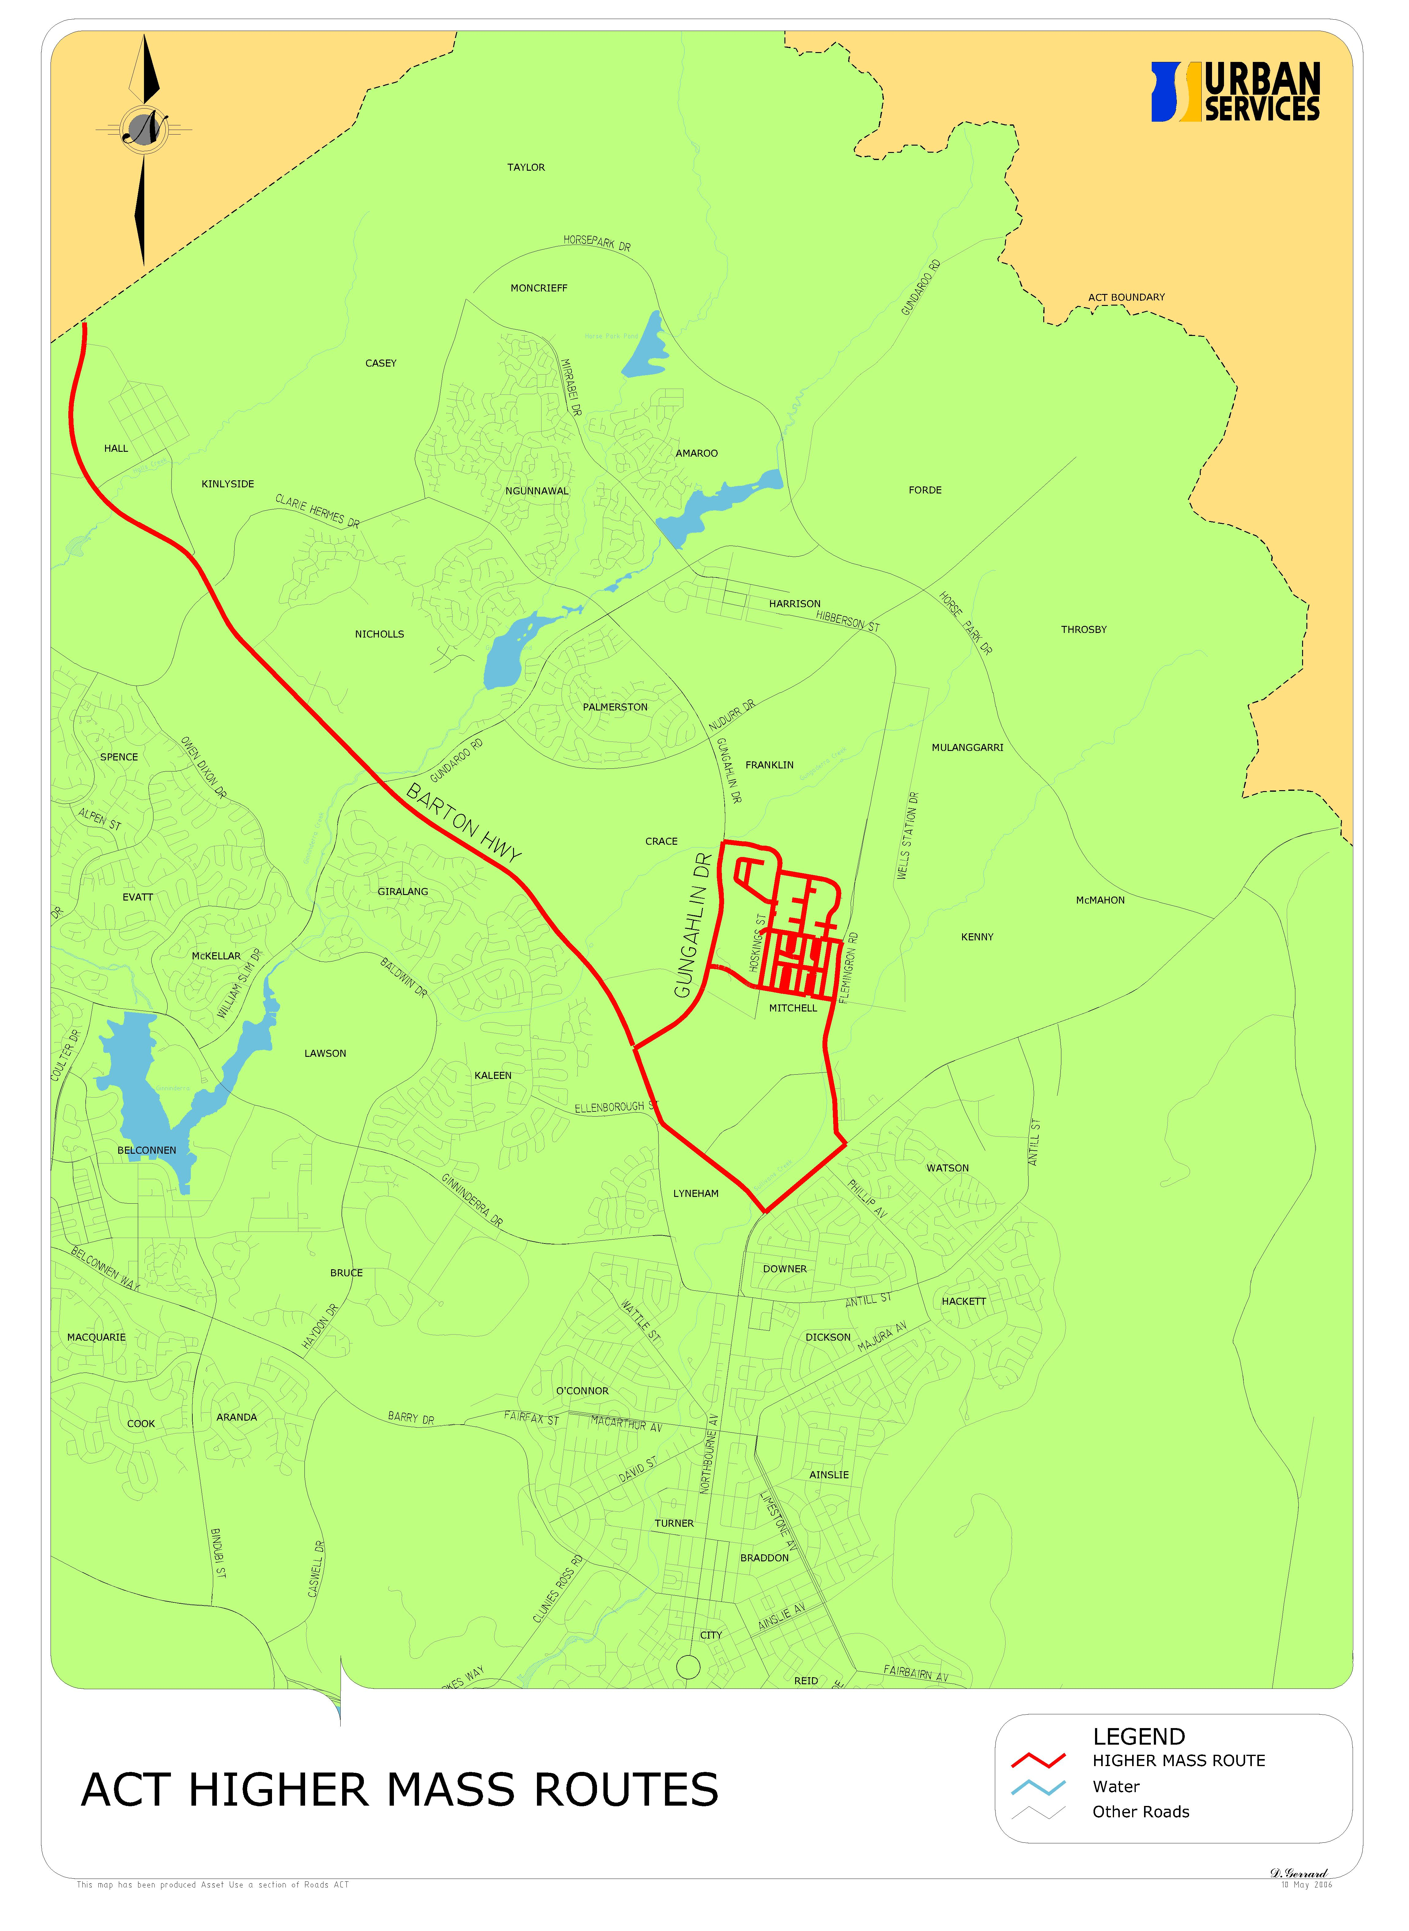
Part 4 – Definitions

For the purpose of this Notice:

“air suspension” means a suspension system where at least 75% of the spring effect is caused by the air spring.

“authorised person” means:

- a person is appointed as an authorised person under the Road Transport (General) Act 1999; or
- a person who, under the regulations made under the Road Transport (Dimensions and Mass) Act 1990, or the Road Transport (General) Act 1999, is an authorised person for the provision.

“Mass Management Accreditation Scheme” means:

(a) a scheme under the Mass Management Module of the National Heavy Vehicle Accreditation Scheme that is approved by the Authority, or
(b) any other scheme (that is not a national scheme) in relation to mass management developed by a body or organisation other than the National Transport Commission that is approved by the Authority.

“road friendly suspension” means a suspension system that complies with subclauses (1) or (2) below.

(1) A motor vehicle with a date of manufacture, as shown on its compliance plate, before 1 January 2000 or a motor vehicle not required by the Road Transport (Vehicle Registration) Regulations 2000 to be fitted with a compliance plate:

- must have at least 1 axle group that has:

- an air suspension system; and
- dual tyres supporting each axle other than a steer axle or a 6-wheeled tandem axle group in which 1 of the 2 axles is fitted with dual tyres; and
- functioning dampers incorporated on each axle; and
- if it is a multi-axle group – a static load on each axle that is within 5% of its nominal share of the total load on the multi-axle group; and

- if it has a new suspension system fitted on or after 1 January 2000 – must have a suspension type that is certified as complying with the performance criteria detailed in the Federal Office of Road Safety Vehicle Standards Bulletin 11 – Certification of Road Friendly Suspension Systems, April 1999.

(2) For a motor vehicle with a date of manufacture, as shown on its compliance plate, on or after 1 January 2000, at least 1 axle group:

- must have a suspension type that is certified as complying with the performance criteria detailed in the Federal Office of Road Safety Vehicle Standards Bulletin 11 – Certification of Road Friendly Suspension Systems, April 1999; and
- must have dual tyres supporting each axle other than:

- a steer axle: or
- a 6-wheeled tandem axle group in which 1 of the 2 axles is fitted with dual tyres.

Contacts – General and Emergency
Technical Inquiries | For details concerning approved Mass Management Accreditation Schemes
ACT Road User Services  Vehicle Inspection * Technical Unit  Telephone: (02) 6207 7236  Fax: (02) 6207 6561 | NSW Roads & Traffic Authority  Telephone: (02) 9843 3851  Fax: (02) 9843 3824
Roads ACT Heavy Vehicle Permit Officer:
Telephone: (02) 6207 6565 (BH)

Fax: (02) 6207 6872
Australian Federal Police:

000 – Life Threatening Emergency
11444 – Police Attendance
(02) 6256 7777 – General Enquiries

