Australian Capital Territory
Domestic Animals (Cat Containment) Declaration 2019 (No 1)
Disallowable Instrument DI2019-33
made under the
Domestic Animals Act 2000, s 81 (Declaration of cat containment)

1 Name of instrument
This instrument is the Domestic Animals (Cat Containment) Declaration 2019 (No 1).

2 Commencement
This instrument commences on the day after the last day when it could have been disallowed by the Legislative Assembly.

3 Revocation
This instrument revokes the Domestic Animals (Cat Containment) Declaration 2018 (No 1) (DI2018-220).

4 Declaration
(1) I declare the following areas of land as cat containment areas:
- the division of Bonner;
- the division of Coombs;
- the division of Crace;
- the division of Denman Prospect;
- the division of Forde;
- the division of Jacka;
- the division of Lawson;
- the division of Macnamara
- the division of Molonglo;
- the division of Moncrieff;
- the division of Strathnairn
- the division of Taylor;
- the division of Throsby;
- the division of Whitlam;
- the division of Wright;
- that part of the division of Watson outlined by a bold dotted line on the map at schedule 1 (‘The Fair’ development); and
- that part of the division of Gungahlin outlined by a bold dotted line on the map at schedule 2 (the Gungahlin Town Centre (east)).
(2) A cat located within a cat containment area declared in clause 4 (1) must be confined to its keeper’s or carer’s premises at all times.

Chris Steel MLA
Minister for City Services

5 April 2019

Schedule 1
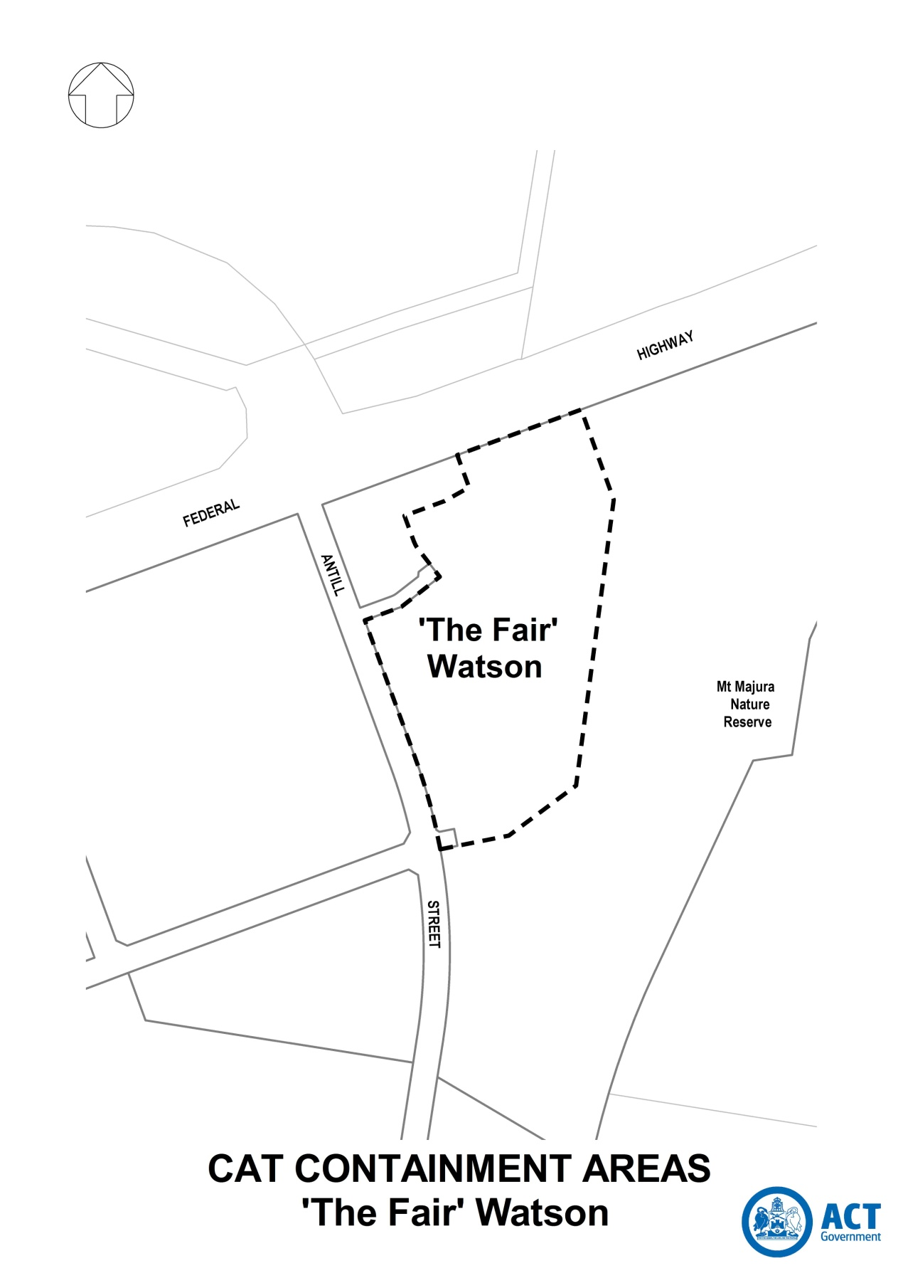

Schedule 2

