Australian Capital Territory

Planning and Development (Technical Amendment—Rezoning - boundary changes) Plan Variation 2010 (No 1)

Notifiable instrument NI2010—258
Technical Amendment No 2010-15
made under the
Planning and Development Act 2007, section 89 (Making technical amendments) (s96A Rezoning – boundary changes)

This plan variation commences on the day after it is notified.

Variation No 2010-15 to the Territory Plan has been approved by the Planning and Land Authority

The variation specifies miscellaneous changes to zone boundaries to be consistent with the amendment or creation of block boundaries and does not affect existing leasehold. Areas that are affected by this change are identified on the following maps:

Annexure A – Division of Macquarie section 50 blocks 43 and 44
Annexure B – District of Gungahlin block 354
Annexure C – Division of Mitchell section 47 block 19
Annexure D – Division of Mitchell Section 40 Block 17
Annexure E – Division of Greenway Section 46 Block 15
Annexure F – Division of Phillip Sections 81,156, 158, 176 and 177

Kelvin Walsh
Delegate of Planning and Land Authority
Date: 24 May 2010
THIS IS PAGE ONE OF ANNEXURE A
TO NOTIFIABLE INSTRUMENT NI2010 –258
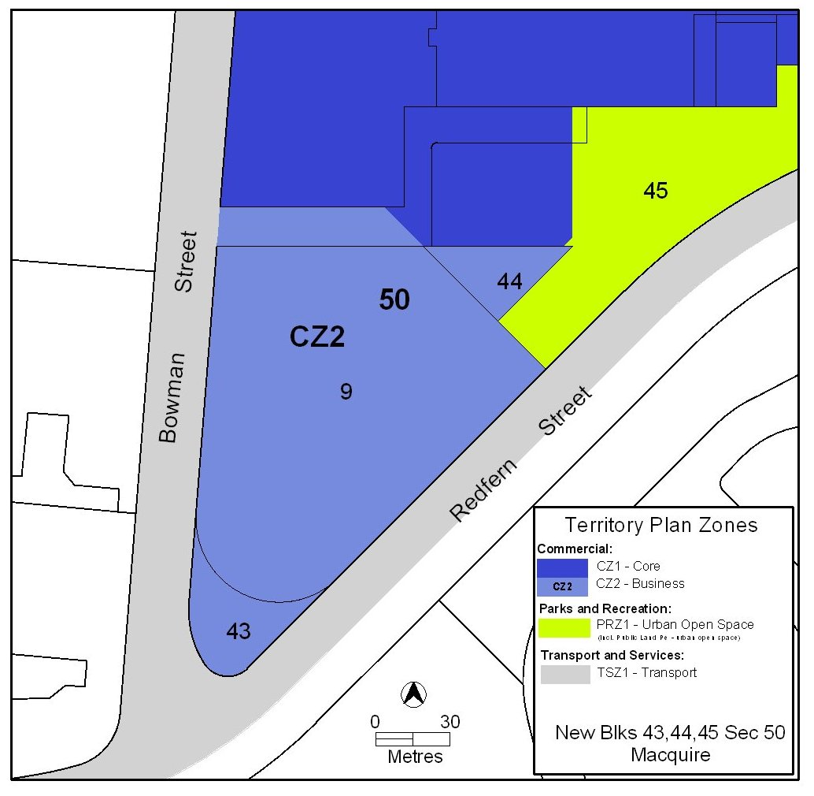

Kelvin Walsh
Delegate of Planning and Land Authority
Date: 24 May 2010
THIS IS PAGE ONE OF ANNEXURE B
TO NOTIFIABLE INSTRUMENT NI2010 –258

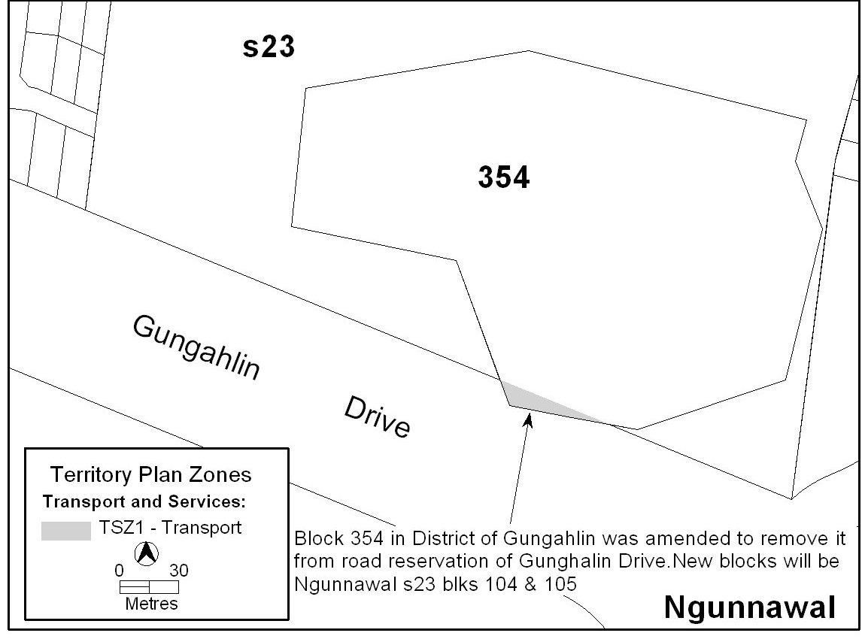

Kelvin Walsh
Delegate of Planning and Land Authority
Date: 24 May 2010
THIS IS PAGE ONE OF ANNEXURE C
TO NOTIFIABLE INSTRUMENT NI2010 –258

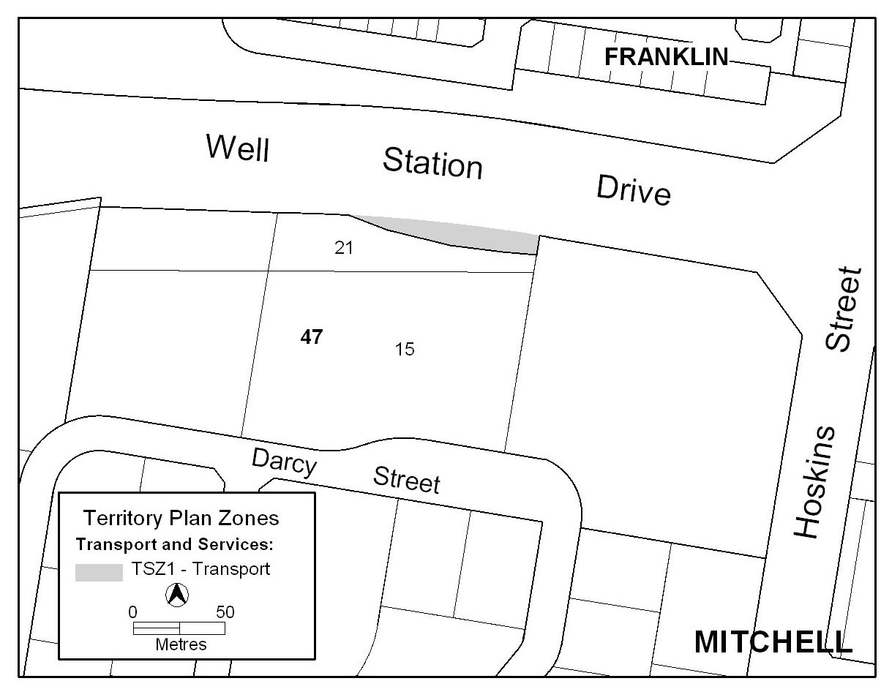

Kelvin Walsh
Delegate of Planning and Land Authority
Date: 24 May 2010
THIS IS PAGE ONE OF ANNEXURE D
TO NOTIFIABLE INSTRUMENT NI2010 –258

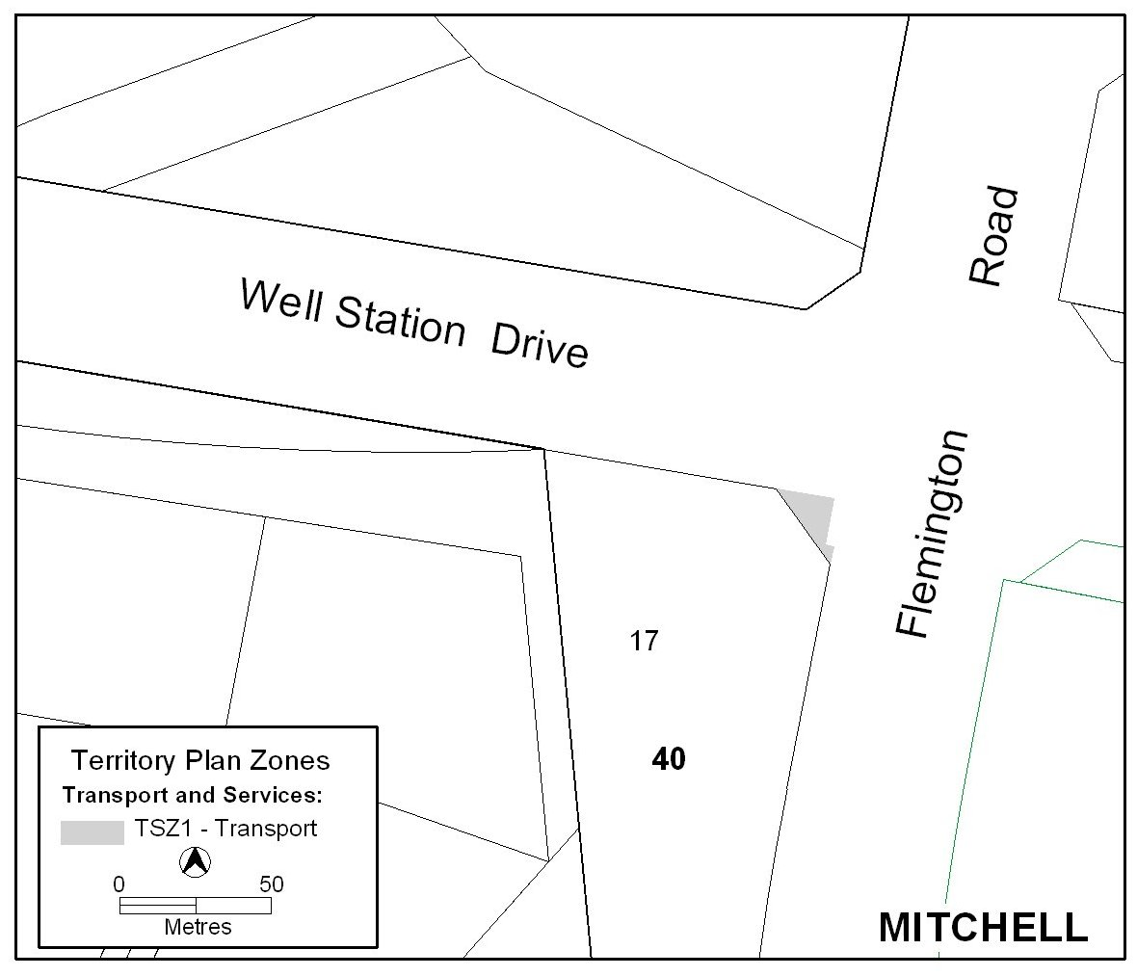

Kelvin Walsh
Delegate of Planning and Land Authority
Date: 24 May 2010
THIS IS PAGE ONE OF ANNEXURE E
TO NOTIFIABLE INSTRUMENT NI2010 –258

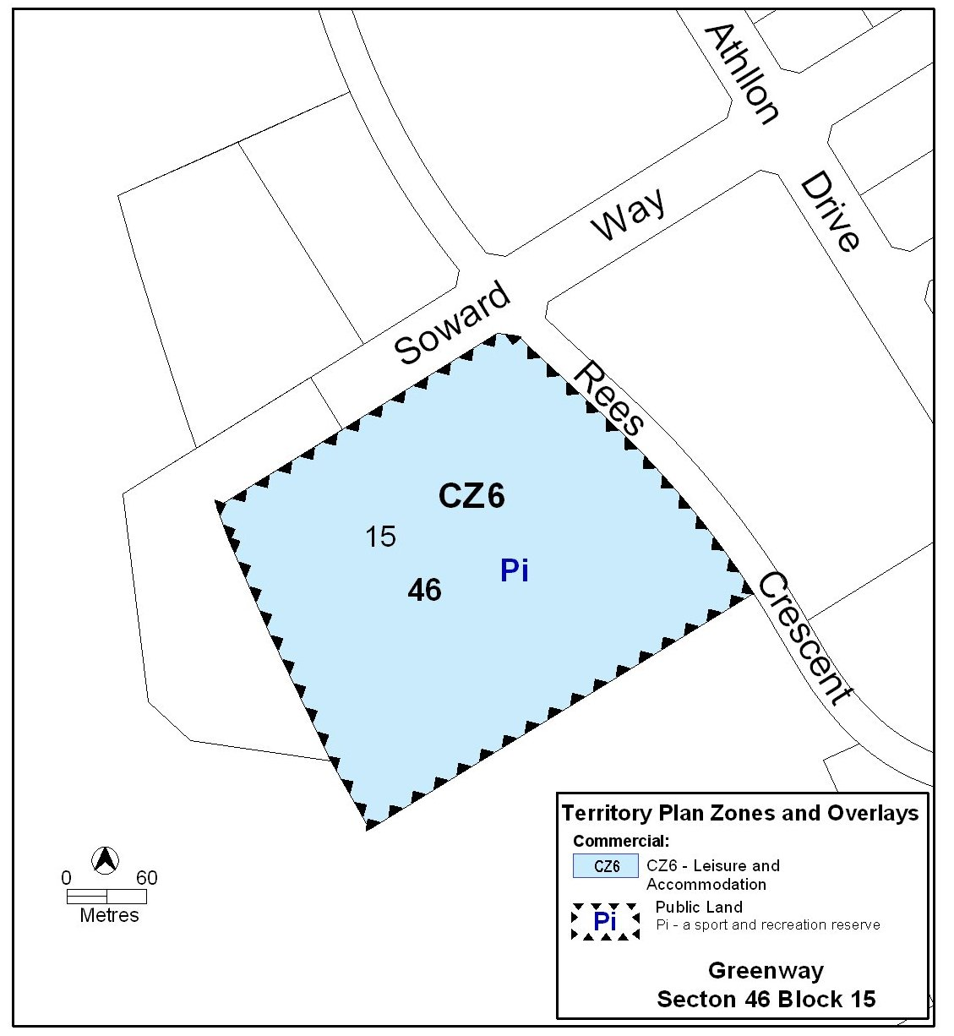

Kelvin Walsh
Delegate of Planning and Land Authority
Date: 24 May 2010
THIS IS PAGE ONE OF ANNEXURE F
TO NOTIFIABLE INSTRUMENT NI2010 –258

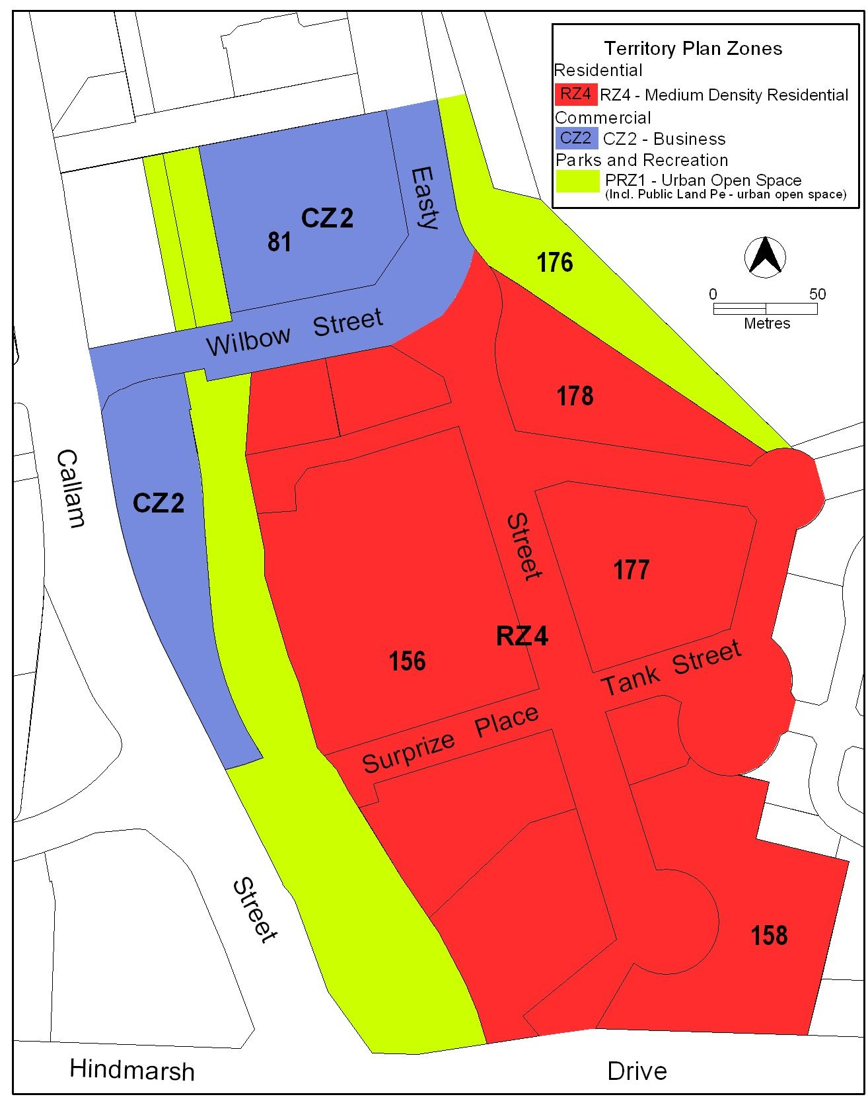

Kelvin Walsh
Delegate of Planning and Land Authority
Date: 24 May 2010

