Australian Capital Territory

Planning and Development (Technical Amendment—Casey) Plan Variation 2010 (No 2)

Notifiable instrument NI2010—382
Technical Amendment No 2010-20
made under the
Planning and Development Act 2007, section 89 (Making technical amendments) (s96 land ceases to be in future urban area)

This plan variation commences on the day after it is notified.

Variation No 2010-20 to the Territory Plan has been approved by the Planning and Land Authority

The variation specifies that the land identified on the map at Annexure A being land within the Division of Casey, may be used for the purposes indicated in the Annexure.

The variation also introduces a Casey Precinct Code at Section 10.4 of the Territory Plan as identified at Annexure B.

Kelvin Walsh
Delegate of Planning and Land Authority
Date: 12 July 2010

THIS IS PAGE ONE OF ANNEXURE A
TO NOTIFIABLE INSTRUMENT NI2010 –382

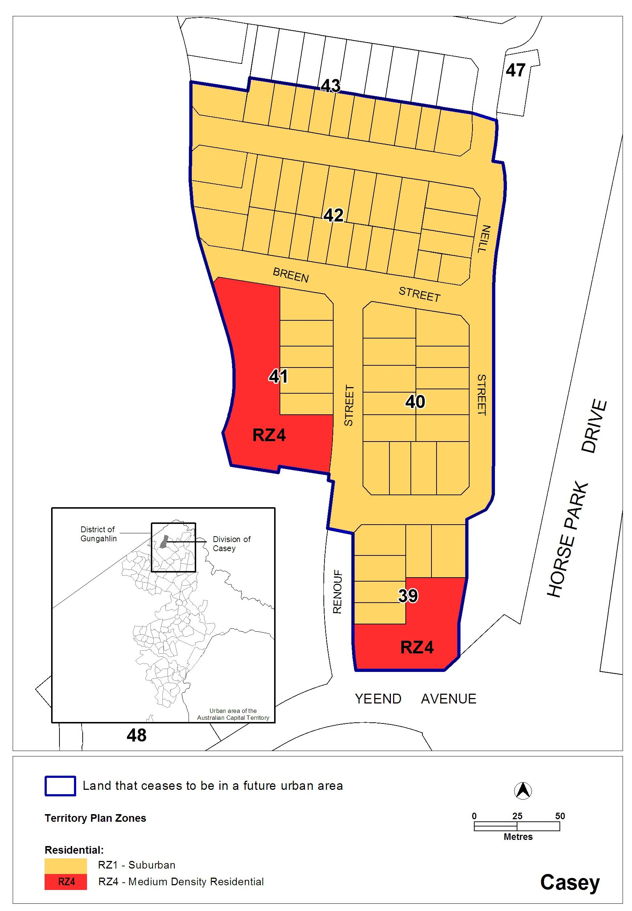

Kelvin Walsh
Delegate of Planning and Land Authority
Date: 12 July 2010

THIS IS PAGE ONE OF ANNEXURE B
TO NOTIFIABLE INSTRUMENT NI2010 –382

Casey Precinct Code
Covering the Division of Casey

Contents
Introduction 2
Part A Suburb of Casey – ongoing block specific provisions 3

Introduction

Name
The name of this code is the Casey Precinct Code.

Application
This Precinct Code applies to the division of Casey. The provisions applying to individual blocks are identified in the legend and are located in the Single Dwelling Housing Development Code.

Purpose of codes
Codes provide additional planning, design and environmental controls to support the zone objectives and assessable uses in the Development Tables.
The Codes are used by the Authority to assess development applications. The Codes therefore also provide guidance to intending applicants in designing their developments and preparing their development applications.

Structure
The Casey Precinct Code has one Part:
Part A provides any ongoing block specific provisions for individual blocks identified in the Precinct Code within the suburb of Casey

Where more than one type of Code applies to a development, the order of precedence when there is inconsistency of provisions between Codes, as defined by the Act, is Precinct Code, then Development Code, and then General Code.

Further information
Please refer also to the Casey Concept Plan for other relevant or applicable planning provisions.

Part A Suburb of Casey – ongoing block specific provisions

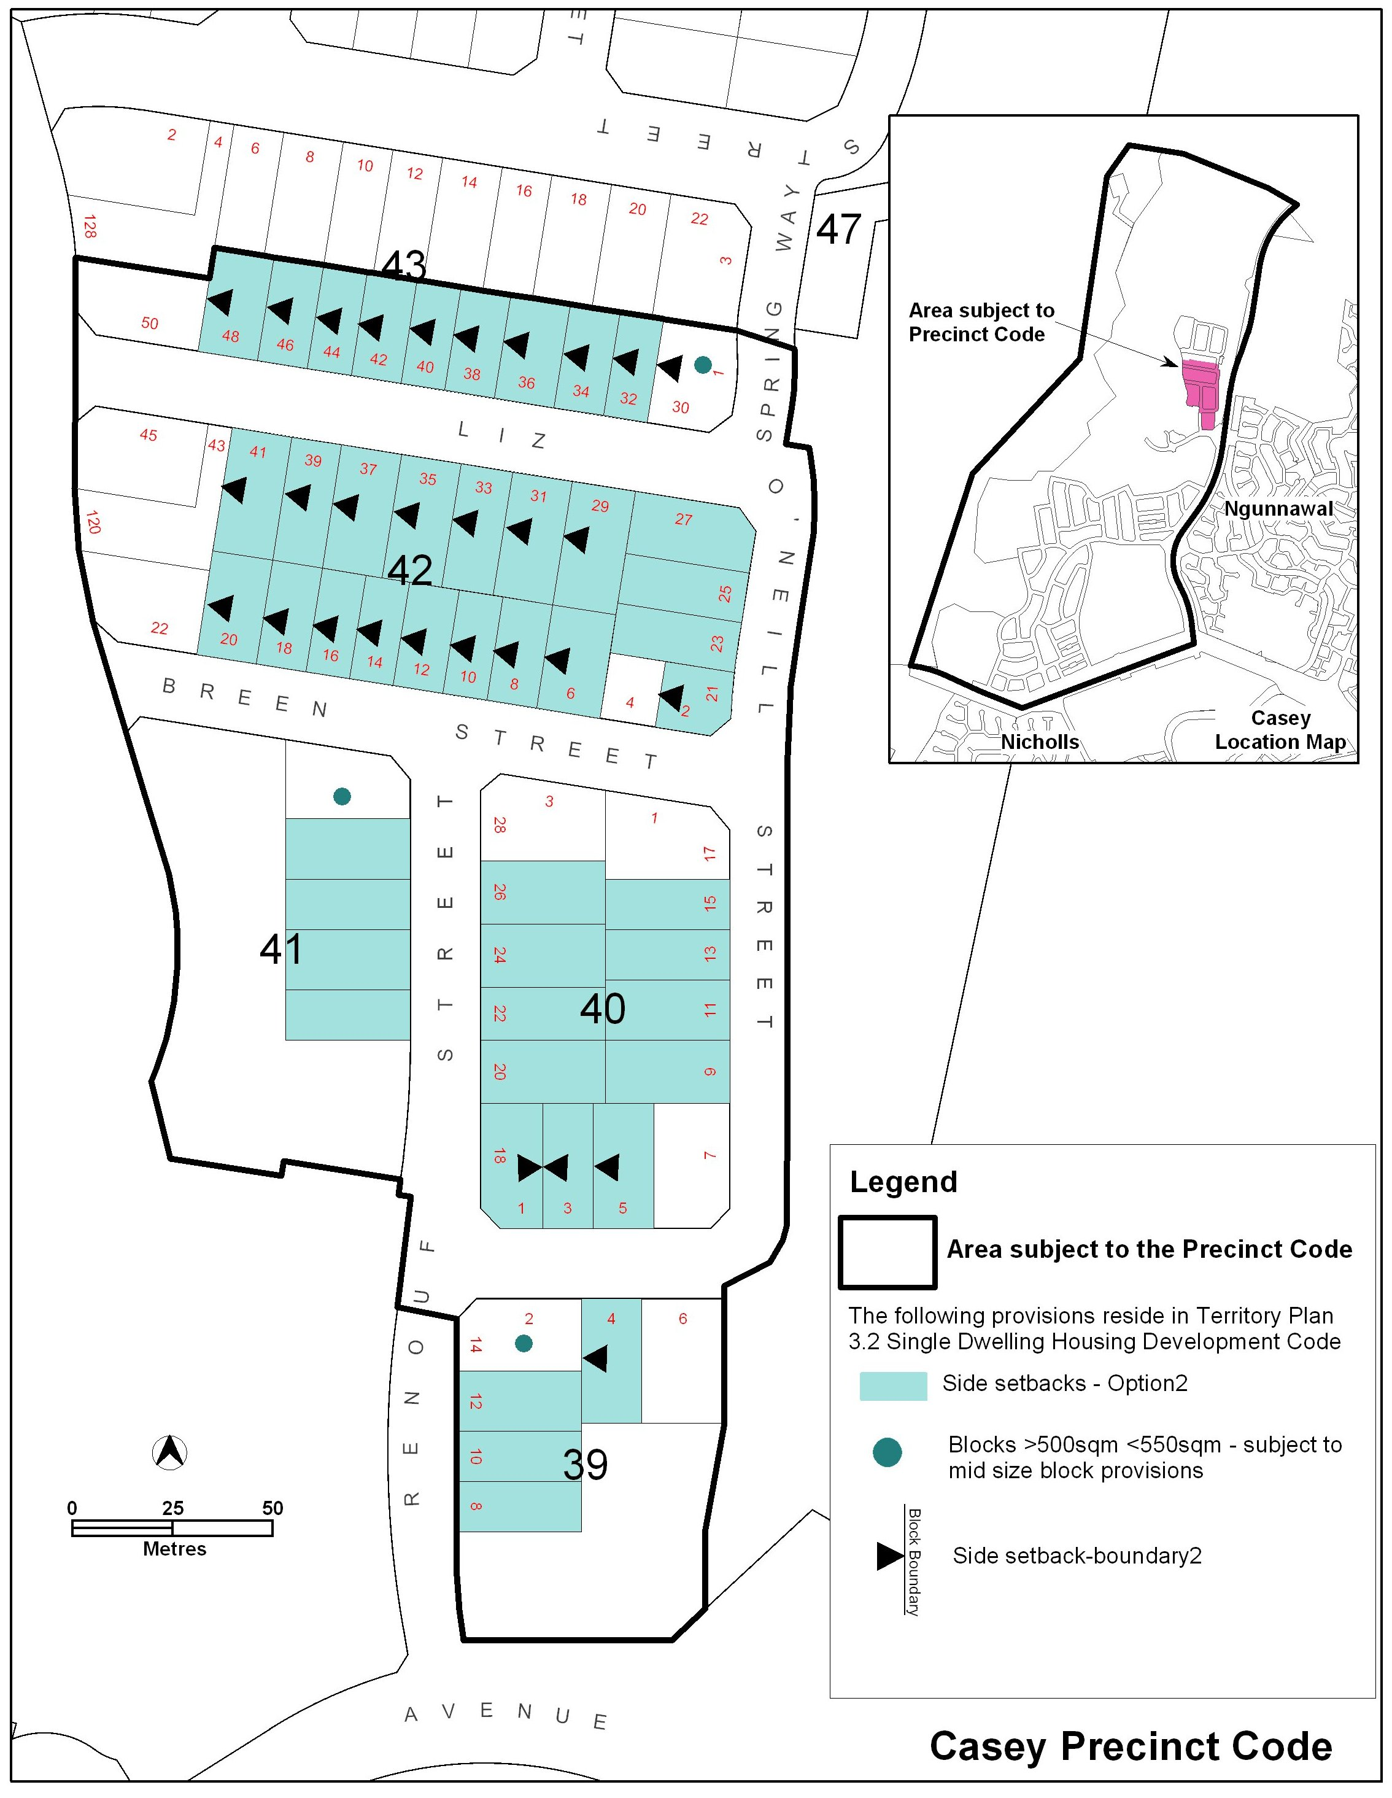

Kelvin Walsh
Delegate of Planning and Land Authority
Date: 12 July 2010

