Australian Capital Territory

Planning and Development (Technical Amendment — Miscellaneous Amendments and Corrections) Plan Variation 2010 (No 2)*
Notifiable instrument NI2010—602
Technical Amendment No 2010-22
made under the
Planning and Development Act 2007, section 89 (Making technical amendments)

This technical amendment commences on 29 October 2010.

Technical amendment number 2010-22 to the Territory Plan has been approved by the Planning and Land Authority.

Kelvin Walsh
Delegate of Planning and Land Authority

22 October 2010

Planning & Development Act 2007

Technical Amendment
to the Territory Plan
Variation 2010-22

Miscellaneous amendments and corrections

October 2010
Table of Contents

1 INTRODUCTION 2
Outline of the process 2
2 EXPLANATORY STATEMENT 2
Proposed Changes and Reasons 2
3. TECHNICAL AMENDMENT 5

1 INTRODUCTION

Outline of the process

The Commonwealth’s Australian Capital Territory (Planning and Land Management) Act 1988 allows for the Legislative Assembly to make laws to establish a Territory Planning Authority and for that Authority to prepare and administer a Territory Plan. The Planning and Development Act 2007 (the Act) establishes the ACT Planning and Land Authority as the Authority which prepares and administers the Territory Plan, including continually reviewing and proposing amendments as necessary. Part 5.4 section 87 of the Act allows for technical amendments to be made to the Territory Plan in a number of circumstances.

This technical amendment is subject to approval of the ACT Planning and Land Authority (the Authority) under sections 87(a) and 87(e) of the Act.

A variation under section 87(a) is a technical amendment that:
(i) would not adversely affect anyone’s rights if approved; and
(ii) has as its only object the correction of a formal error in the plan.

2 EXPLANATORY STATEMENT

Proposed Changes and Reasons

- Correction to defect in form of structure of precinct codes in contents page of Territory Plan (item 1)

There is currently a limitation in the structure of the Territory Plan which does not make provision for the introduction of suburb specific precinct codes. These suburb specific precinct codes are being prepared which contain the ongoing provisions resulting from approved estate development plans. It is proposed to amend the current structure of section 10 Precinct Codes in the Territory Plan by reordering and renumbering into two sub-sections – one for precinct codes by suburbs and one for all other precinct codes. This outcome will also allow for additional categories of precinct codes to be added to the structure at a later date, if required.

- Correction to spelling in part 2.1 Statement of Strategic Directions (item 2)

The word ‘net’ is spelt incorrectly in paragraph 1.8 of the section on Principles for Sustainable Development.

- Correction to alphabetical order in commercial CZ4 local centres zone development table (item 7b)

The uses of ‘restaurant’ and ‘recyclable materials collection’ are in the incorrect alphabetical order and will be changed so that recyclable materials collection is placed above restaurant in the merit assessment development table.

- Amendments to inconsistent use of ‘NON RETAIL COMMERCIAL USE’ in commercial development tables and codes
(items 4-6, 7a, 8, 9)

The commercial zone development tables refer to ‘NON RETAIL COMMERCIAL’ whereas the correct terminology is ‘NON RETAIL COMMERCIAL USE’. These references in the development tables will be changed to ‘NON RETAIL COMMERCIAL USE’ in line with the correct terminology. A correction is also made in the town centres development code to refer to the correct terminology.

- Standardisation of terminology ‘Exempt Development’ and ‘Prohibited Development’ in development tables for various zones (items 3, 11-21)

There is inconsistent use of the terms ‘Exempt’ and ‘Exempt Development’ and ‘Prohibited’ and ‘Prohibited Development’ in some of the development tables in various zones. This amendment aims to standardise the terminology in these development tables where the correct terms are to be changed to “Exempt Development’ and ‘Prohibited Development’.

- Correction of commercial zone boundaries for Erindale group centre in group centres development code (item 10)

There is an inconsistency between the commercial group centre zone boundaries depicted on the Territory Plan map and in the group centres development code for the Erindale group centre in the suburb of Wanniassa. The Territory Plan map shows the correct zone boundaries consistent with the previous Territory Plan prior to 31 March 2008, whereas the boundaries shown in Figure A12 of the group centres development code are incorrect. Figure A12 will be revised to show the correct boundaries as part of this technical amendment.

- Correction to commercial CZ2 and CZ3 city centre zone and CZ2 Northbourne Avenue precinct parking rates for Office in the parking and vehicular access general code (items 22-23)

Under the previous Territory Plan the city centre areas were divided into precincts. The ACT Parking and Vehicular Access Guidelines (transcribed into the parking and vehicular access general code) prescribed parking rates for various commercial uses (including Office) depending on the location of the precinct. When the Territory Plan was restructured in 2008, the precincts were translated into zones. Precincts b2, b3 and b4 in the city centre were incorporated into the commercial CZ2 zone and precinct c was included in the CZ3 zone. The parking rates for precincts b2, b4 and c were assigned a rate of 2 spaces per 100m² gross floor area (GFA) and precinct b3 a rate of 2.5 spaces/100m² GFA. In July 2008, Technical Amendment 2008-05 changed the rate for the CZ2 zone from 2.0 spaces/100m² GFA to 2.5 spaces/100m² GFA. However, the more appropriate rate for this zone is 2 spaces per 100m² GFA as per the previous Guidelines. The rate for the CZ3 zone (precinct c in the previous Territory Plan) will also be changed to 2 spaces per 100m² GFA in accordance with the previous Guidelines. This is the appropriate rate for this zone due to its proximity to Northbourne Avenue which is a major public transport route to and from the city.

Part of the CZ2 zone in city centre adjacent Northbourne Avenue between Moore Street, Barry Drive and Masson Street in Turner and between Mort Street, Cooyong Street and Girrahween Street in Braddon is within the Northbourne Avenue precinct area. The parking and vehicular access general code has a specific column in the schedule of parking provision rates for commercial zones for CZ2 zones outside centres and Northbourne Avenue precinct. The parking rates for office in this column specifies 2.5 spaces/100m² GFA however to be consistent with the previous Guidelines and in recognition of the close proximity of the CZ2 zone (within the Northbourne Avenue precinct area) to Northbourne Avenue as a major public transport route the rate will be changed to 2 spaces per 100m² GFA. This rate will only apply to development within the Northbourne Avenue CZ2 precinct.

- Correction to surge protection line in the Coombs and Wright concept plan (item 24)

Revised flood level maps have been provided to ACTPLA showing a reduction in the extreme flood levels estimates compared to previous modelling which was previously revised in the concept plan via technical amendment 2010-06.

The consequence of this change is that the area of Coombs, North Weston and small areas of Molonglo 2 impacted by the surge protection line constraints has been reduced.

An amended diagram is provided to replace the existing Figure 4 in the concept plan.

3. TECHNICAL AMENDMENT

Variation to website layout
- Territory Plan page on ACT legislation register section 10 Precinct Codes

Substitute with

10.1 Precinct Code by Suburb
- Casey Precinct Code (pdf) (143KB)

  - Other Precinct Codes
- Northbourne Avenue Precinct Code (pdf) (602KB)
- Rural Village Precinct Code (pdf) (215KB)
- Inner North Precinct Code (pdf) (1.191MB)

Variation to 2.1 Statement of Strategic Directions

- Principles for Sustainable Development, Environmental Sustainability, 1.8

Substitute ‘nett’ with

net

Variation to CZ1 - Core Zone

- CZ1 – Core Zone Development Table

Substitute ‘PROHIBITED’ with

PROHIBITED DEVELOPMENT

Variation to CZ1 - Core Zone Development Table

- Minimum assessment track merit

Substitute ‘NON RETAIL COMMERCIAL’ with

NON RETAIL COMMERCIAL USE

Variation to CZ2 - Business Zone Development Table

- Minimum assessment track merit

Substitute ‘NON RETAIL COMMERCIAL’ with

NON RETAIL COMMERCIAL USE

Variation to CZ3 - Services Zone Development Table

- Minimum assessment track merit

Substitute ‘NON RETAIL COMMERCIAL’ with

NON RETAIL COMMERCIAL USE

Variation to CZ4 - Local Centre Zone Development Table

- Minimum assessment track merit

- Substitute ’NON RETAIL COMMERCIAL’ with

NON RETAIL COMMERCIAL USE

- Reorder ‘restaurant’ and ‘recyclable materials collection’ in alphabetical order.

Variation to CZ5 - Mixed Use Zone Development Table

- Minimum assessment track merit

Substitute ‘NON RETAIL COMMERCIAL’ with

NON RETAIL COMMERCIAL USE

Variation to the town centres development code

- Part A(2) – CZ2 Business Zone, Element 1 Restrictions on Use, Item 1.5 Woden – Phillip Section 23, C23

Substitute with

NON RETAIL COMMERCIAL USE is only permitted on land contiguous with the Phillip Oval where of a type compatible with the operation of a day and night sporting oval.

Variation to the group centres development code

- Part A - Group Centres - Overview, Group Centres Tuggeranong, Figure A12 Erindale Group Centre Zones (Wanniassa)

Substitute

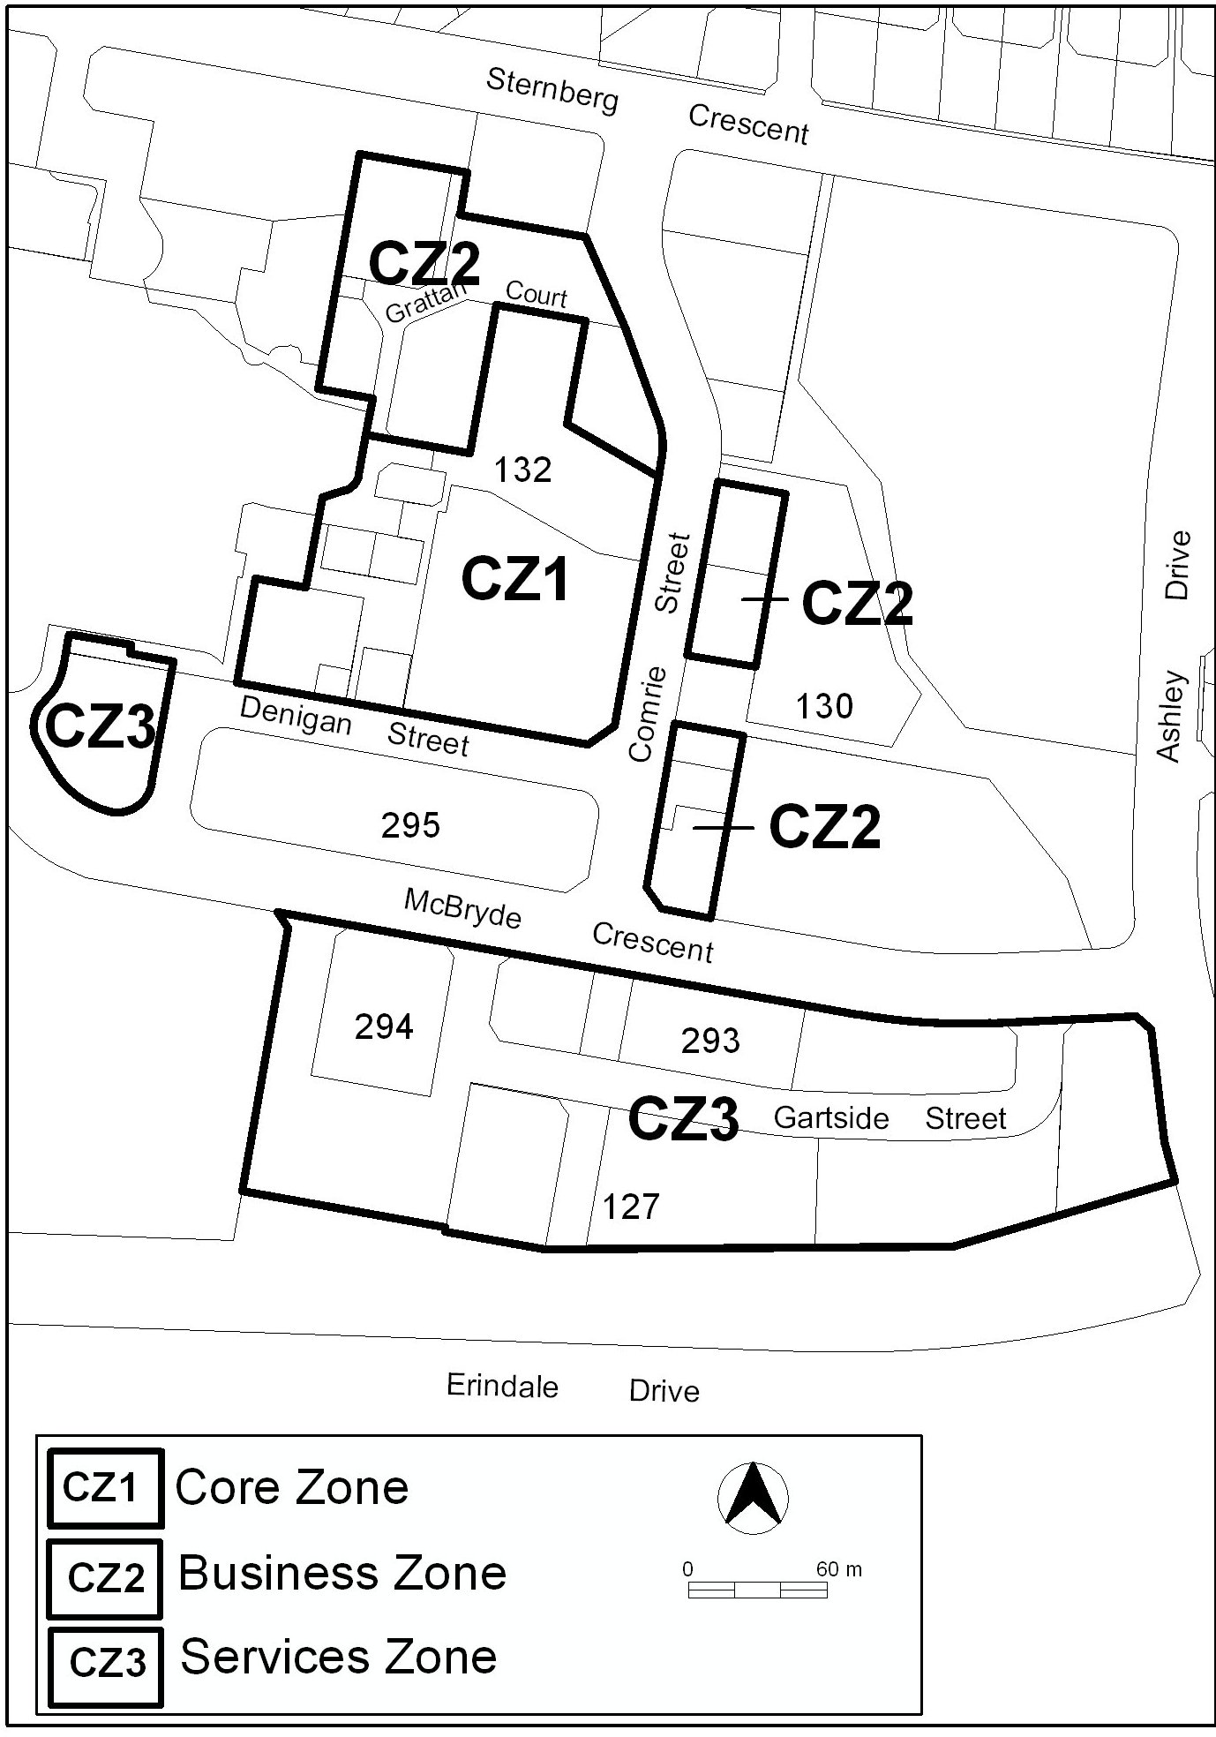

Figure A12 Erindale Group Centre Zones (Wanniassa)

Variation to IZ2 – Industrial Mixed Use Zone

- IZ2 – Industrial Mixed Use Zone Development Table

a) Substitute ‘EXEMPT’ with

EXEMPT DEVELOPMENT

b) Substitute ‘PROHIBITED’ with

PROHIBITED DEVELOPMENT

Variation to CFZ – Community Facility Zone

- CFZ – Community Facility Zone Development Table

a) Substitute ‘EXEMPT’ with

EXEMPT DEVELOPMENT

b) Substitute ‘PROHIBITED’ with

PROHIBITED DEVELOPMENT

Variation to PRZ1 – Urban Open Space Zone

- PRZ1 – Urban Open Space Zone Development Table

a) Substitute ‘EXEMPT’ with

EXEMPT DEVELOPMENT

b) Substitute ‘PROHIBITED’ with

PROHIBITED DEVELOPMENT

Variation to PRZ2 – Restricted Access Recreation Zone

- PRZ2 – Restricted Access Recreation Zone Development Table

a) Substitute ‘EXEMPT’ with

EXEMPT DEVELOPMENT

b) Substitute ‘PROHIBITED’ with

PROHIBITED DEVELOPMENT

Variation to TSZ1 – Transport Zone

- TSZ1 – Transport Zone Development Table

a) Substitute ‘EXEMPT’ with

EXEMPT DEVELOPMENT

b) Substitute ‘PROHIBITED’ with

PROHIBITED DEVELOPMENT

Variation to TSZ2 – Services Zone

- TSZ2 – Services Zone Development Table

a) Substitute ‘EXEMPT’ with

EXEMPT DEVELOPMENT

b) Substitute ‘PROHIBITED’ with

PROHIBITED DEVELOPMENT

Variation to NUZ1 – Broadacre Zone

- NUZ1 – Broadacre Zone Development Table

a) Substitute ‘EXEMPT’ with

EXEMPT DEVELOPMENT

b) Substitute ‘PROHIBITED’ with

PROHIBITED DEVELOPMENT

Variation to NUZ2 – Rural Zone

- NUZ2 – Rural Zone Development Table

a) Substitute ‘EXEMPT’ with

EXEMPT DEVELOPMENT

b) Substitute ‘PROHIBITED’ with

PROHIBITED DEVELOPMENT

Variation to NUZ3– Hills Ridges and Buffer Zone

- NUZ3 – Hills Ridges and Buffer Zone Development Table

a) Substitute ‘EXEMPT’ with

EXEMPT DEVELOPMENT

b) Substitute ‘PROHIBITED’ with

PROHIBITED DEVELOPMENT

Variation to NUZ4 – River Corridor Zone

- NUZ4 – River Corridor Zone Development Table

a) Substitute ‘EXEMPT’ with

EXEMPT DEVELOPMENT

b) Substitute ‘PROHIBITED’ with

PROHIBITED DEVELOPMENT

Variation to NUZ5 – Mountains and Bushland Zone

- NUZ5 – Mountains and Bushland Zone Development Table

a) Substitute ‘EXEMPT’ with

EXEMPT DEVELOPMENT

b) Substitute ‘PROHIBITED’ with

PROHIBITED DEVELOPMENT

Variation to parking and vehicular access general code

- 3.2.5 Schedules of parking provision rates for commercial zones, Schedule 2 Parking provision rates for commercial zones

In the City Centre column for Office:

- In the ‘CZ2 Zone’ substitute

2.0 spaces/100m² GFA

- In the ‘CZ3 Zone’ substitute

2.0 spaces/100m² GFA

- 3.2.5 Schedules of parking provision rates for commercial zones, Schedule 2 Parking provision rates for commercial zones

In the Group centres, Local centres and CZ2 zones outside centres and Northbourne Avenue precinct column associated with Office substitute:

2.5 spaces/100m² GFA except for Northbourne Avenue precinct where the rate is 2.0 spaces/100m² GFA

Variation to concept plans – Precinct codes for section 93 of the Planning and Development Act 2007 Coombs and Wright

- Part C – Buildings and structures Figure 4

Substitute with Figure 4 Concept Plan at Appendix A.

Interpretation service

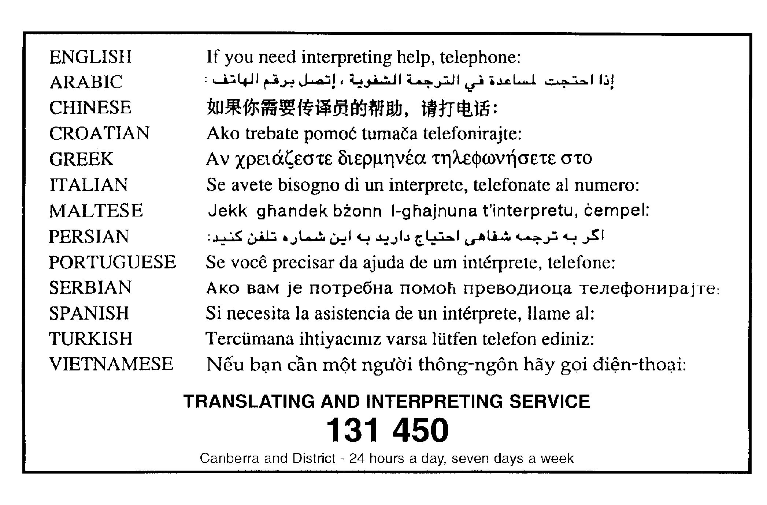

APPENDIX A

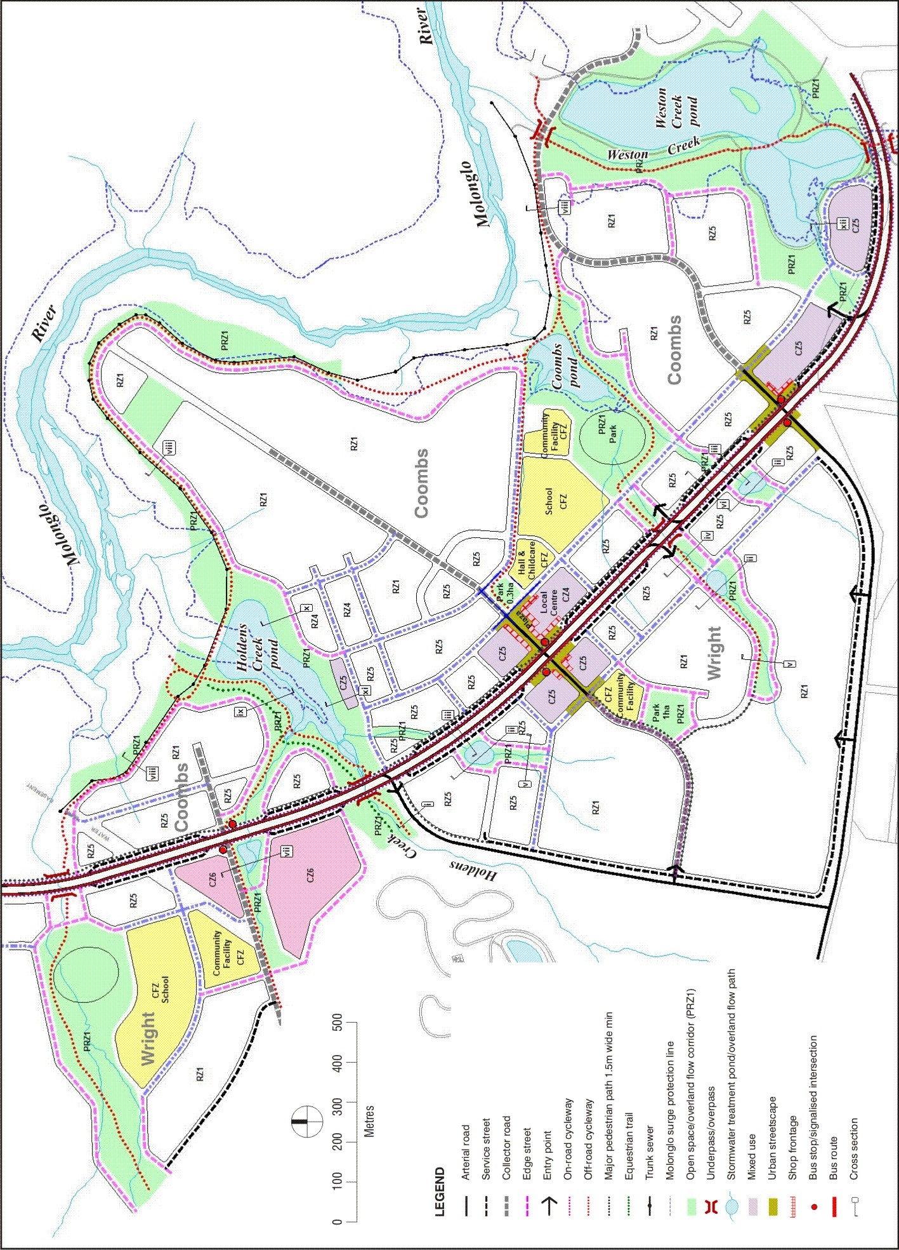

Figure 4 Concept Plan

