Australian Capital Territory

Planning and Development (Technical Amendment—Code and clarification changes to various development codes, general codes, definitions and concept plans) Plan Variation 2011
Notifiable instrument NI2011– 355
Technical Amendment No. 2011–11
made under the
Planning and Development Act 2007, section 89 (Making technical amendments)

This technical amendment commences on 8 July 2011.

Technical amendment number 2011-11 to the Territory Plan has been approved by the Planning and Land Authority.

Ben Ponton
Delegate of Planning and Land Authority

30 June 2011
Planning & Development Act 2007

Technical Amendment
to the Territory Plan

Variation 2011-11

Code and clarification changes to various development codes, general codes, definitions and concept plans

July 2011

Table of Contents

1. INTRODUCTION 2
Outline of the process 2
2. EXPLANATORY STATEMENT 3
Changes, reasons, and compliance with the Planning and Development Act 2007 3
2.1.1 Code variations 3
2.1.2 Clarification variations 8
2. TECHNICAL AMENDMENT 10

INTRODUCTION

Outline of the process
The Commonwealth’s Australian Capital Territory (Planning and Land Management) Act 1988 allows for the Legislative Assembly to make laws to establish a Territory Planning Authority and for that Authority to prepare and administer a territory plan.
The Planning and Development Act 2007 (the Act) establishes the ACT Planning and Land Authority as the Authority which prepares and administers the territory plan, including continually reviewing and proposing amendments as necessary.
Technical amendments to the territory plan are prepared in accordance with the Act. This technical amendment has been prepared in accordance with the following two sections of the Act:
A code variation (section 87(b) of the Act) is a technical amendment that
- would only change a code; and
- is consistent with the policy purpose and policy framework of the code; and
- is not an error variation.

A variation under section 87(g) of the Act is a technical amendment that clarifies the language in the territory plan, provided it does not change the substance of the plan.

Following the release of the variation under section 90 of the Act, submissions from the public were invited. At the conclusion of the limited consultation period, representations (if any) were considered by the ACT Planning and Land Authority (the Authority). The Authority then determines a day when the code variation commences by way of a commencement notice. The date of commencement is provided on the attached notifiable instrument (commencement notice).

2. EXPLANATORY STATEMENT

Changes, reasons, and compliance with the Planning and Development Act 2007

    - Code variations

- Multi unit housing development code – changes to the habitable suite requirements to allow people other than the person requiring care to reside in the suite (item 3)

This technical amendment changes the wording of rule R250 to clarify the intent of the resident requirements for a habitable suite. The wording is changed to ensure that people who are receiving or providing care and who live with others are not discriminated against, by clarifying that others including the person requiring care may also reside in the habitable suite.

Section of Act | Statement of compliance with Act
s87(b) a variation (a code variation) that -
(i) would only change a code; and | Would only change a rule in the multi unit housing development code regarding habitable suites.
(ii) is consistent with the policy purpose and policy framework of the code; and | The purpose of the code is to provide additional planning, design and environmental controls to support the zone objectives and assessable uses in the Development Tables. The amendment is considered to be consistent with the purpose of the multi unit housing development code.
(iii) is not an error variation | Is not a formal error

- Parking and vehicular access general code – change to the requirements for visitor parking spaces for persons with disabilities (item 4)

A change is made to the wording of provisions in the parking and vehicular access general code to clarify the intent of the requirements. The change to the wording aims to ensure that the car parking requirements for people with disabilities apply to visitor parking provided within residential developments.

This will ensure that parking spaces for visitors with a disability are included in the visitor parking calculations for larger residential developments where visitor parking spaces required on-site exceed 29 spaces.

Section of Act | Statement of compliance with Act
s87(b) a variation (a code variation) that -
(i) would only change a code; and | Only changes the intent in the parking and vehicular access general code in section 2.2.4 relating to parking spaces for persons with disabilities.
(ii) is consistent with the policy purpose and policy framework of the code; and | The purpose of the code is to ensure that development achieves the relevant objectives of the Territory Plan and will be used by the Authority in the assessment of development applications involving development, redevelopment and lease variations. The code specifies vehicular access and parking requirements for development.  The change seeks to tighten existing controls to ensure better design and development outcomes in terms of parking provision requirements for people with disabilities.
(iii) is not an error variation | Is not a formal error

- Crime prevention through environmental design guidelines general code – changes to include subdivision as a development requiring consideration (item 5)

Table 1 of the crime prevention through environmental design guidelines provides a list of development types which are required to meet the guidelines.

Subdivision is currently absent from this list, despite it generally being the precursor to other forms of development which are required to be considered against the guidelines.

For this reason subdivision is added to the list of developments so that the measures in the guidelines are considered as early as possible in the development process.

Section of Act | Statement of compliance with Act
s87(b) a variation (a code variation) that -
(i) would only change a code; and | Only makes a minor change to the crime prevention through environmental design guidelines general code.
(ii) is consistent with the policy purpose and policy framework of the code; and | The purpose of the code is to ensure that development achieves the relevant objectives of the Territory Plan and will be used to assess development applications involving development, redevelopment and lease variations. The code specifies environmental design requirements for development, designed to prevent crime.  The addition of subdivision as a new category of development required to meet the guidelines is considered to be consistent with the policy purpose and framework. Subdivision is often the precursor to other forms of development, so it is appropriate to add it to this list to ensure consideration of the guidelines at the subdivision stage.
(iii) is not an error variation | Is not a formal error

- Crace concept plan - inclusion of ongoing fencing provisions for specific blocks (item 7)

This technical amendment allows the fencing controls that were established in stage 1 of the development (subject to lease and development conditions) to be consistently applied in stages 2 and 3 of the subdivision of Crace. The controls relate specifically to fencing on corner blocks, north facing blocks and blocks adjoining open space and are intended to promote more useable private open space to the front of these blocks.

Section of Act | Statement of compliance with Act
s87(b) a variation (a code variation) that -
(i) would only change a code; and | Only changes the Crace concept plan, which is a precinct code for the purposes of Section 93 of the Planning and Development Act 2007.
(ii) is consistent with the policy purpose and policy framework of the code; and | Section 93 of the Planning and Development Act 2007 states that a concept plan guides:  (i) preparation and assessment of development in future  urban areas to which the concept plan relates; and  (ii) assessment of development when the land ceases to be in a  future urban area.  The changes seek to add ongoing block specific provisions to the concept plan to ensure specific fencing requirements are provided on certain blocks to promote active use of private open space when the areas cease to be future urban areas.  The changes are consistent with the policy framework of the code.
(iii) is not an error variation | Is not a formal error

- Coombs and Wright concept plan – changes to the road network and to the residential density requirements (items 8 and 9)

This technical amendment changes the wording of rule R46 and criterion C46 to allow flexibility for road network and traffic arrangements at the detail design and construction stage. The current rule includes a note which could be interpreted to allow for flexibility to the design and layout; but because it is located under the rule rather than as a criterion there is some confusion. The wording has been rearranged and the mandatory requirements separated from the criterion appropriately.

Changes are made to the wording of rule R49 to better explain the intended outcomes for residential density requirements. It is currently ambiguous and can be interpreted to be quite restrictive. On this basis the rule will refer to the minimum average residential density in each precinct, rather than the minimum residential density on each block, resulting in the same overall dwelling number outcome whilst enabling greater dwelling diversity.

Section of Act | Statement of compliance with Act
s87(b) a variation (a code variation) that -
(i) would only change a code; and | Only changes a criterion in the Coombs and Wright concept plan, which is a precinct code for the purposes of Section 93 of the Planning and Development Act 2007.
(ii) is consistent with the policy purpose and policy framework of the code; and | Section 93 of the Planning and Development Act 2007 states that a concept plan guides:  (i) preparation and assessment of development in future  urban areas to which the concept plan relates; and  (ii) assessment of development when the land ceases to be in a  future urban area.  The changes to rule R46 and criterion C46 seek to allow flexibility for road network and traffic arrangements at the detailed design and construction stage without changing the overall layout of the road network policy.  The changes to rule R49 broaden existing controls to ensure better design and development outcomes enabling greater housing diversity whilst maintaining overall residential density.
(iii) is not an error variation | Is not a formal error

    - Clarification variations

- Single dwelling housing development code (SDHDC) and multi unit housing development code (MUHDC) – clarification of the wording of bushfire rules to regulate design in addition to construction (items 1 and 2)

This technical amendment changes the wording of rules R20A (SDHDC) and R34A (MUHDC) pertaining to development in bushfire-risk areas to clarify that the rule regulates both building design and construction. Currently the rule only refers to the construction of the development, and does not mention the design which forms an integral part of the assessment.

Section of Act | Statement of compliance with Act
s87(g) a variation to clarify the language in the territory plan if it does not change the substance of the plan | The changes to bushfire rule (R20A/ R34A) only clarifies the language used and does not change the substance of the plan. The addition of the word ‘design’ into the provision will help clarify that the design component of the development is being considered.

- Definitions – clarification of difference between veterinary hospital and veterinary surgeon (item 6 a) and i))

This technical amendment clarifies the reference to ‘veterinary surgeon’ on the list of common terminology under the definition of health facility. It is noted that there is already a separate definition pertaining to a veterinary hospital, and it is unclear as to what the distinction is between these two terms. The reference to veterinary surgeon was intended to involve only day procedures, which is why it can be considered under the definition of health facility. However a veterinary hospital includes the keeping of animals overnight on the premises which may have impacts of the amenity of the surrounding area; it is for this reason that a veterinary hospital is prohibited within the community facility zone for example whereas a veterinary surgeon, listed under the common terminology of health facility, is not. In order to enhance the distinction between the two terms, the common terminology has been changed to refer to ‘veterinary day clinic’.

For the same reason as listed above, the definition for ‘veterinary hospital’ has also been changed to clarify that animals may be kept on the premises overnight for the purposes of treatment.

Section of Act | Statement of compliance with Act
s87(g) a variation to clarify the language in the territory plan if it does not change the substance of the plan | The change to the list of common terminology under the health facility definition seeks to clarify the distinction between a veterinary surgeon and a veterinary hospital which is a separate definition not clustered under the same umbrella category of community use. The wording change to ‘veterinary day clinic’ is intended to clarify the meaning behind the previous term of veterinary surgeon in order to avoid confusion.  The wording change to the definition of veterinary hospital is to clarify that a veterinary hospital allows for animals to be kept on the premises overnight.

- Definitions – clarification of the meaning of minor use (item 6 b)

The amendment clarifies the language within the definition of minor use, to improve its workability and to confirm that it is intended to include minor service reticulation.

Section of Act | Statement of compliance with Act
s87(g) a variation to clarify the language in the territory plan if it does not change the substance of the plan | The change to the definition of minor use is intended to clarify the original intent of the provision through clearer wording of the definition and providing greater clarity as to what constitutes a minor use.

- Definitions – clarification of the meanings of various definitions and maintain consistency (item 6 c) to h))

Changes are made to clarify and rearrange the wording of the following definitions to ensure consistency in readability and formatting across all definitions in the Territory Plan:

  - freight transport facility
  - office
  - outdoor education establishment
  - overnight camping area
  - parkland
  - playing field

Section of Act | Statement of compliance with Act
s87(g) a variation to clarify the language in the territory plan if it does not change the substance of the plan | The changes to the definitions of office, freight transport facility, and outdoor education establishment are to bring the wording into line with the same formatting as other definitions.  The changes to overnight camping area, parkland and playing field are intended to clarify the original intent of the provision through clearer wording and formatting of the definitions.

TECHNICAL AMENDMENT

Variation to single dwelling housing development code
- Part B – General Development Controls, Element 2: Building and Site Controls, Section 2.7 Bushfire, rule R20A

Substitute with

2.7 Bushfire
R20A  Where identified in a precinct code or lease and development conditions, buildings are to be designed and constructed in accordance with the specified bushfire construction level of Australian Standard AS 3959. | This is a mandatory requirement. There is no applicable criterion.

Variation to multi unit housing development code
- Part B – General Development Controls, Element 2: Building and Site Controls, Section 2.7 Bushfire, rule R34A

Substitute with

2.7 Bushfire
R34A  Where identified in a precinct code or lease and development conditions, buildings are to be designed and constructed in accordance with the specified bushfire construction level of Australian Standard AS 3959. | This is a mandatory requirement. There is no applicable criterion.

- Part D – Development Type Controls – Other Forms of Residential Development and Non-residential Development, Element 1: Restrictions on Use, Section 1.3 Habitable Suite, rule R250

Substitute with

1.3 Habitable Suite
R250  The applicant submits a statutory declaration stating that, while the habitable suite is occupied as a separate domicile, at least one of the persons resident in the habitable suite is providing care to or receiving care from an occupant of the main dwelling for reasons of infirmity (due to age) or disability. | C250  This is a mandatory requirement. There is no applicable criterion.

Variation to parking and vehicular access general code

- Section 2. General Design and Vehicular Access Requirements, 2.2.4 Percentages of parking spaces for people with disabilities – minimum parking provision rate (excluding residential zones)

Substitute wording in section 2.2.4 second paragraph as underlined below

This requirement does not apply to the parking provided for residents in residential developments in any zone (as these are subject to adaptable housing requirements) but it does apply to visitor parking provided for such residential developments.

Variation to the crime prevention through environmental design guidelines general code
- Part A – General Requirements, Table 1: Development required to meet the Crime Prevention Through Environmental Design General Code

Insert ‘subdivision’ as an additional category into Table 1

Variation to Definitions
- Part A – Definitions of Development

  - In the column labelled ‘Some Common Terminology’ associated with the development definition for ‘Health facility’, substitute ‘Veterinary surgeon’ with ‘Veterinary day clinic’

  - Substitute wording underlined below into the definition of ‘minor use’ in the development column

Minor use means the use of land for a purpose that is incidental to the use and development of land in the zone and includes but is not limited to open space; public car parking; community path systems; minor service reticulation; other utility services that do not exclude other uses from the land; public roads (other than major roads); street furniture and the like.

  - Substitute wording underlined below into the definition of ‘freight transport facility’ in the development column

Freight transport facility means the use of land for the principal purpose of bulk handling and storage of goods or materials whether or not facilities are included for the parking, servicing and repair of vehicles used to transport the goods or materials on site, but does not include any retail sales or wholesaling from the site.

  - Substitute wording underlined below into the definition of ‘office’ in the development column

Office means the use of land for the purpose of administration, clerical, technical, professional or like business activities, including a government office, which does not include dealing with members of the public on a direct and regular basis except where this is ancillary to the main purpose of the office.

  - Substitute wording underlined below into the definition of ‘outdoor education establishment’ in the development column

Outdoor education establishment means the use of land for an education centre for children or adults where the primary focus is on the natural and/or cultural resources of the area. It may include a residence where this is necessary for the protection or management of the primary facility.

  - Substitute the definition of ‘overnight camping area’ with

Overnight camping area means the use of land for holiday and recreational purposes which involves primarily the setting up and use of tents for overnight accommodation which is open to public use.

  - Substitute the definition of ‘parkland’ with

Parkland means the use of land for recreation, conservation or amenity purposes and includes facilities for the enjoyment and convenience of the public, such as kiosks, car parks, shelters, pavilions, public toilets and the like. The term also includes the use of the land for the management of stormwater drainage, for community paths and landscape buffers, and for other minor utility purposes where such uses can be integrated into the open space system. It has unrestricted public access.

  - Substitute the definition of ‘playing field’ with

Playing field means the use of land for the conduct of sports, athletics and games and includes facilities with such land for the enjoyment or convenience of the public such as kiosks, car parks, changing facilities, pavilions and the like. It has unrestricted public access.

  - Substitute wording underlined below into the definition of ‘veterinary hospital’ in the development column

Veterinary hospital means the use of land for diagnosis, surgical or medical treatment of animals, and where the animals may be kept on the premises overnight for the purposes of treatment.

Variation to Crace Concept Plan
- Crace Concept Plan

Insert new Section 7 including Figures 9 and 10, and update contents page accordingly:

7 Ongoing block-specific provisions

The following rules are intended to apply to areas covered within Figures 9 and 10. These requirements will be transferred into the relevant precinct code at the time of the Future Urban Area Overlay uplift.

Rules | Criteria
Interface
R1  This rule applies to all ‘boundary fencing corner blocks’ identified on the Crace ongoing block specific provisions map.  For a minimum of 9m from the corner of the primary and secondary frontages, any fencing forward of the building must comply with all of the following:  - is between 600mm and 900mm high  - is located on the boundary.  Beyond 9m of the corner of the primary and secondary frontages, any fencing forward of the building line must comply with all of the following:  - is located on or adjacent to the block’s secondary frontage (except for north fronting blocks)  - not less than 50% of the fencing is set back at least 600mm from the front boundary  - is not more than 1.5m high. | This is a mandatory rule. There is no applicable criterion.
R2  This rule applies to all ‘boundary fencing blocks adjacent to open space’ identified on the Crace ongoing block specific provisions map.  For a minimum of 9m from the corner of the primary and secondary frontages, any fencing forward of the building must comply with all of the following:  - is a maximum of 1m high  - is located on the boundary.  Beyond 9m of the corner of the primary and secondary frontages, any fencing forward of the building line must comply with all of the following:  - is located on or adjacent to the block’s secondary frontage  - not less than 50% of the fencing is set back at least 600mm from the front boundary  - is not more than 1.5m high. | This is a mandatory rule. There is no applicable criterion.
R3  This rule applies to all ‘boundary fencing north facing blocks’ identified on the Crace ongoing block specific provisions map.  Any fencing forward of the building line must comply with all of the following:  - not less than 50% of the fencing is set back at least 600mm from the front boundary  - is adjacent to the block’s principal private open space  - is not more than 1.5m high. | This is a mandatory rule. There is no applicable criterion.
R4  This rule applies to all ‘boundary fencing blocks’ identified on the Crace ongoing block specific provisions map.  Any fencing forward of the building line complies with all of the following:  - is constructed of masonry or stone work and includes infill panels of timber slats (excluding raw treated pine or palings) or metal slats (excluding metal cladding or swimming pool fencing) and contains planting to minimum 50% of the solid masonry walls. | C4  This criterion applies to all ‘boundary fencing blocks’ shown on the Crace ongoing block specific provisions map.  Boundary fencing forward of the building line is partially transparent and is constructed of quality materials that complement those used in the dwelling.

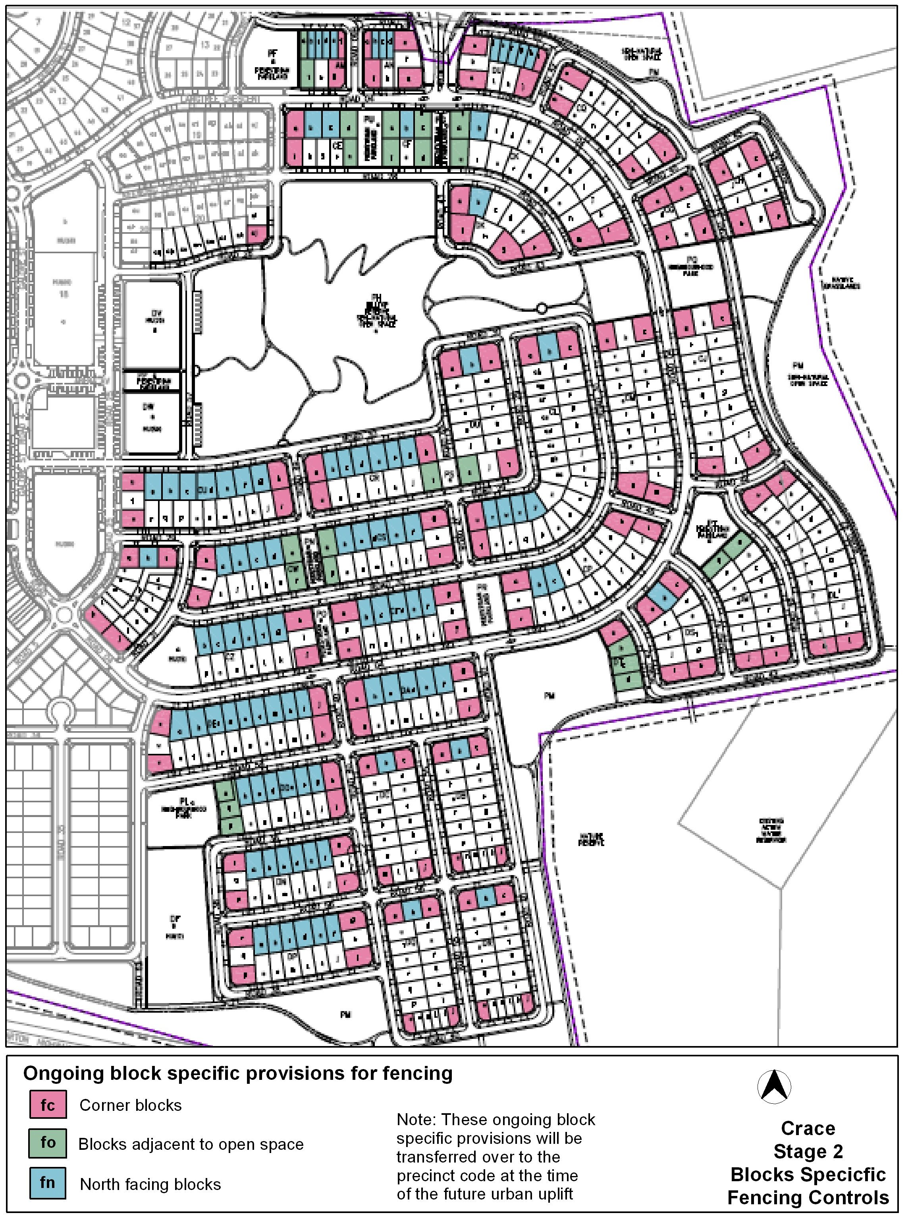

Figure 9

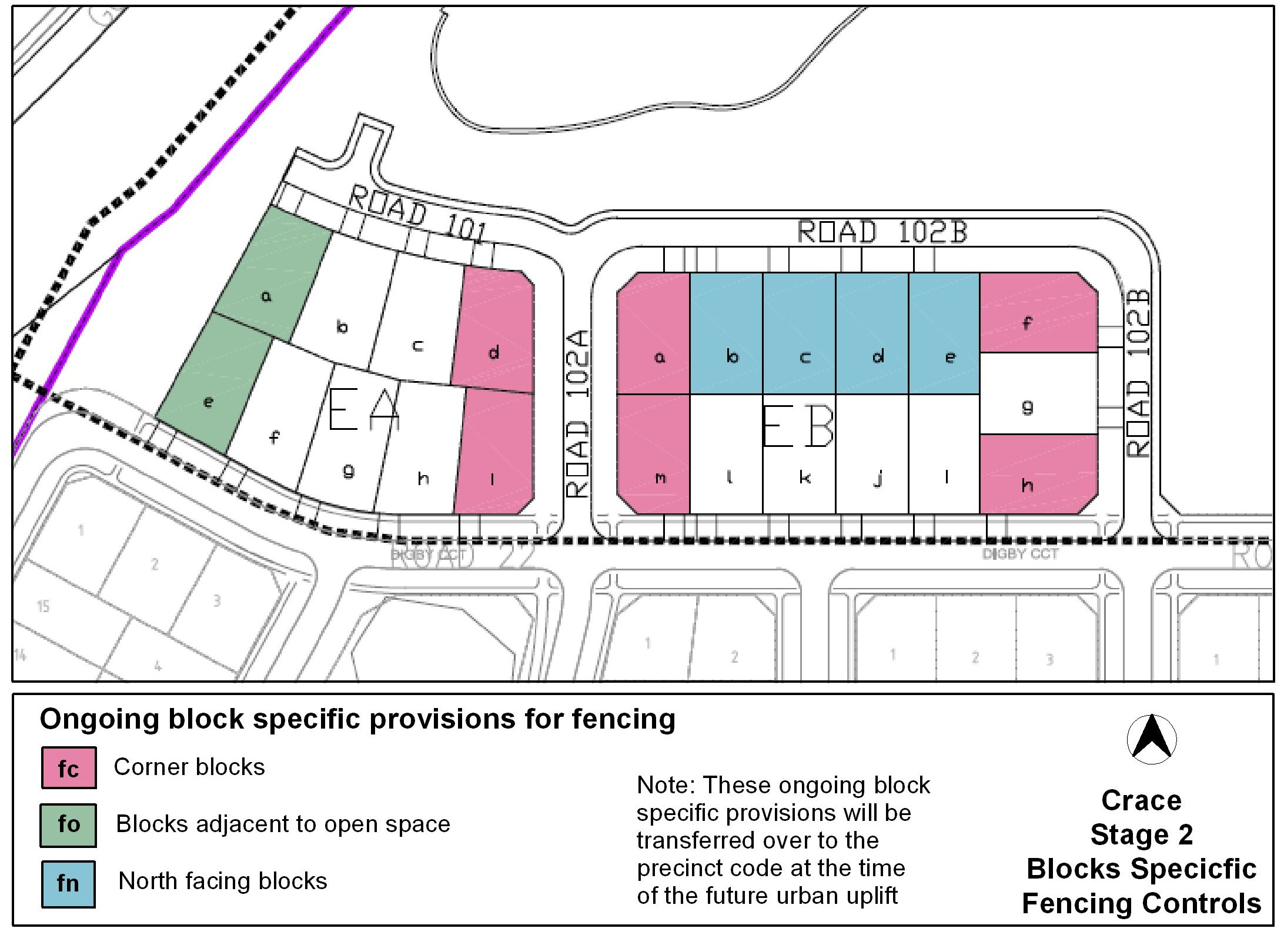

Figure 10

Variation to Coombs and Wright Concept Plan

- Part B – Subdivision, Element 8: Road network, rule R46 and criterion C46

Substitute with

5. Road network
Note: Desired planning outcomes relevant to this element are: b, c, d, e, f, g, i, l, n, o and q.
R46  Junctions with the north south arterial are limited to the following:  - locations shown in Figure 3  - an uncontrolled T-intersection adjacent to the Stromlo Forestry Depot (temporary only)  - a left-in/left out arrangement near the Holdens Creek bridge accessing to the east  - protected right turn arrangements at the following locations –  - adjacent to the Stromlo Forest Depot [in place of temporary arrangements referred to in item b)]  - approximately 100m to the west of the junction referred to in item d)i)  - approximately mid way between intersections 1 and 2 shown on Figure 3 accessing both sides  - at Holdens Creek accessing Uriarra Road  - a left-in/left out arrangement at the location referred to in item d) ii). | C46  Intersections on the north-south arterial road will be located and configured to achieve all of the following:  - convenient and safe vehicular access  - pedestrian and cyclist safety  - minimal impact on through traffic flow.
R46A  Vehicular access to Wright complies with both of the following:  - not fewer than 1 access from Uriarra Road  - not fewer than 1 access from Cotter Road. | C46A  This is a mandatory requirement. There is no applicable criterion.

R46B  Vehicular access from the north south arterial to adjoining blocks is permitted only from service streets.  This rule does not apply to the Stromlo Forestry Depot. | C46B  This is a mandatory requirement. There is no applicable criterion.

- Part C – Buildings and structures, Element 10: Residential density, rule R49

Substitute with

R49  In RZ4 and RZ5 zones in precincts B, E, G, I, M, N, P, Q and T, the minimum average residential density for these zones in each precinct is one dwelling for each 200m² of site area (rounded to the nearest whole number). | This is a mandatory rule. There is no applicable criterion.

Interpretation service
