Australian Capital Territory

Planning and Development (Plan Variation No 310) Notice 2011*

Notifiable Instrument NI2011—688

made under the

Planning and Development Act 2007, section 76(3)

**1 Name of instrument**

This instrument is the *Planning and Development (Plan Variation No 310) Notice* *2011*.

**2 Plan Variation Number 310**

On 4November 2011 the Minister for Environment and Sustainable Development approved the attached plan variation under s76(3).

Ben Ponton

Delegate of the Planning and Land Authority

9 November 2011

**ACT Planning and Land Authority**

Variation to the   
Territory Plan 310

Removal of specified restrictions on use at

Turner section 47 and part 63

and

North of Macarthur and Wakefield Avenues

(RZ4 Medium Density Residential Zone)

Table of Contents

1. EXPLANATORY STATEMENT 1

1.1 Background 1

1.2 Summary of the proposal 2

1.3 National Capital Plan 2

1.4 Revisions to the Exhibited Draft Variation 2

1.5 Current Territory Plan provisions 3

1.5.1 Residential Zones—Multi Unit Housing Development Code 3

1.5.2 Inner North Precinct Code 4

1.6 Changes to the Territory Plan 6

1.6.1 Changes to the Residential Zones—Multi Unit Housing Development Code (item 1) 6

1.6.2 Changes to the Inner North Precinct Code (item 2, 3 and 4) 6

1.7 Consultation on the draft variation 6

2. VARIATION 7

1. EXPLANATORY STATEMENT
   1. Background

The inquiry into RZ3 and RZ4 Residential Redevelopment Policies – Inner North Canberra was referred to the Legislative Assembly’s Standing Committee on Planning, Public Works and Territory and Municipal Services by the ACT Legislative Assembly on 25 June 2009 for inquiry and report. It was proposed by the Minister for Planning, Mr Andrew Barr MLA, in order to consider whether current planning policies, including those contained within the Inner North Precinct Code, remain appropriate in light of issues such as climate change and population growth.

On 17 February 2011, the Standing Committee released report No. 9 on its inquiry into RZ3 and RZ4 Residential Redevelopment Policies – Inner North Canberra. The ACT Government response to DV310 was tabled in the Legislative Assembly on 21 June 2011. It provided a comprehensive response to all 15 recommendations of the Standing Committee report. The policy changes proposed by variation 310 were identified in the Government response as addressing the first three recommendations of the Standing Committee report which are:

**Recommendation 1**

The Committee recommends that Rule 21, restricting development in RZ4 zones north of Macarthur Avenue and Wakefield Avenue, be removed from the Residential Zones—Multi Unit Housing Development Code.

**Recommendation 2**

The Committee recommends that Rule 44, restricting use on Blocks 12-21, Section 63 Turner should be removed from the Inner North Precinct Code.

**Recommendation 3**

The Committee recommends that Rule 44, restricting use on Section 47 Turner should be removed from the Inner North Precinct Code.

Under recommendation 1, development in the RZ4 medium density residential zone in the area specified would be subject to the same rules that apply to development elsewhere in this zone, ie. a building height of 3 rather than 2 storeys, and a plot ratio of 80% rather than 65% (including other provisions of the Inner North Precinct Code).

Under recommendations 2 and 3, redevelopment beyond minor additions and alterations to existing buildings would be possible on the land specified, subject to the prevailing RZ3 urban residential zone, and relevant codes (including other provisions of the Inner North Precinct Code).

* 1. Summary of the proposal

The purpose of this variation is to implement the Government’s response to three recommendations of the Legislative Assembly’s Standing Committee on Planning, Public Works and Territory and Municipal Services Report No. 9, released on 17 February 2011.

V310 removes the specified building height and plot ratio limitations applying to the RZ4 medium density residential zones north of Macarthur Avenue and Wakefield Avenue, North Canberra, under the Residential Zones—Multi Unit Housing Development Code (rule R21). The variation also removes the prohibition on redevelopment of Turner Section 47 and Turner Section 63 Blocks 12-21, under the Inner North precinct code.

* 1. National Capital Plan

The Australian Capital Territory (Planning and Land Management) Act 1988 established the National Capital Authority (NCA) with two of its functions being to prepare and administer a National Capital Plan (NCP) and to keep the NCP under constant review and to propose amendments to it when necessary.

The NCP, which was published in the Commonwealth Gazette on 21 January 1990, is required to ensure that Canberra and the Territory are planned and developed in accordance with their national significance. The Planning and Land Management Act 1988 also required that the Territory Plan is not inconsistent with the NCP.

* 1. Revisions to the Exhibited Draft Variation

After analysis of the comments received during the draft variation consultation period, changes to the Turner South and O’Connor/Turner North control plans were made to the exhibited draft variation. These changes inserted the 7m rear setback (deep root zone) to blocks in Turner section 47 and section 63, blocks 12-21.

* 1. Current Territory Plan provisions
     1. Residential Zones—Multi Unit Housing Development Code

The current provisions affecting RZ4 medium density residential land north of Macarthur Avenue and Wakefield Avenue are found in *Residential Zones— Multi Unit Housing Development Code*, part A(4) section 2.1 – Restrictions on Use – Staging of Development – Inner North Canberra, which includes rule R21, see **Figure 1 and Map 1** below.

**Figure 1** – Extract from *Residential Zones—Multi Unit Housing Development Code*

| Rules | Criteria |
| --- | --- |
| 2.1 Restrictions on Use – Staging of Development – Inner North Canberra | |
| R21  )  Development of land in the RZ4 zones of O’Connor, Dickson and Lyneham, north of Macarthur Avenue and Wakefield Avenue, is restricted in height to 2 storeys and a maximum plot ratio of 65%, until 23.5 hectares of residential blocks in the RZ4 zones of O’Connor, Turner and Braddon north of Cooyong Street and Donaldson Streets has been developed for multi-unit housing. | C21  )  This is a mandatory requirement. There is no applicable criterion. |

**Map 1 –** RZ4 zones north of Macarthur Avenue and Wakefield Avenue

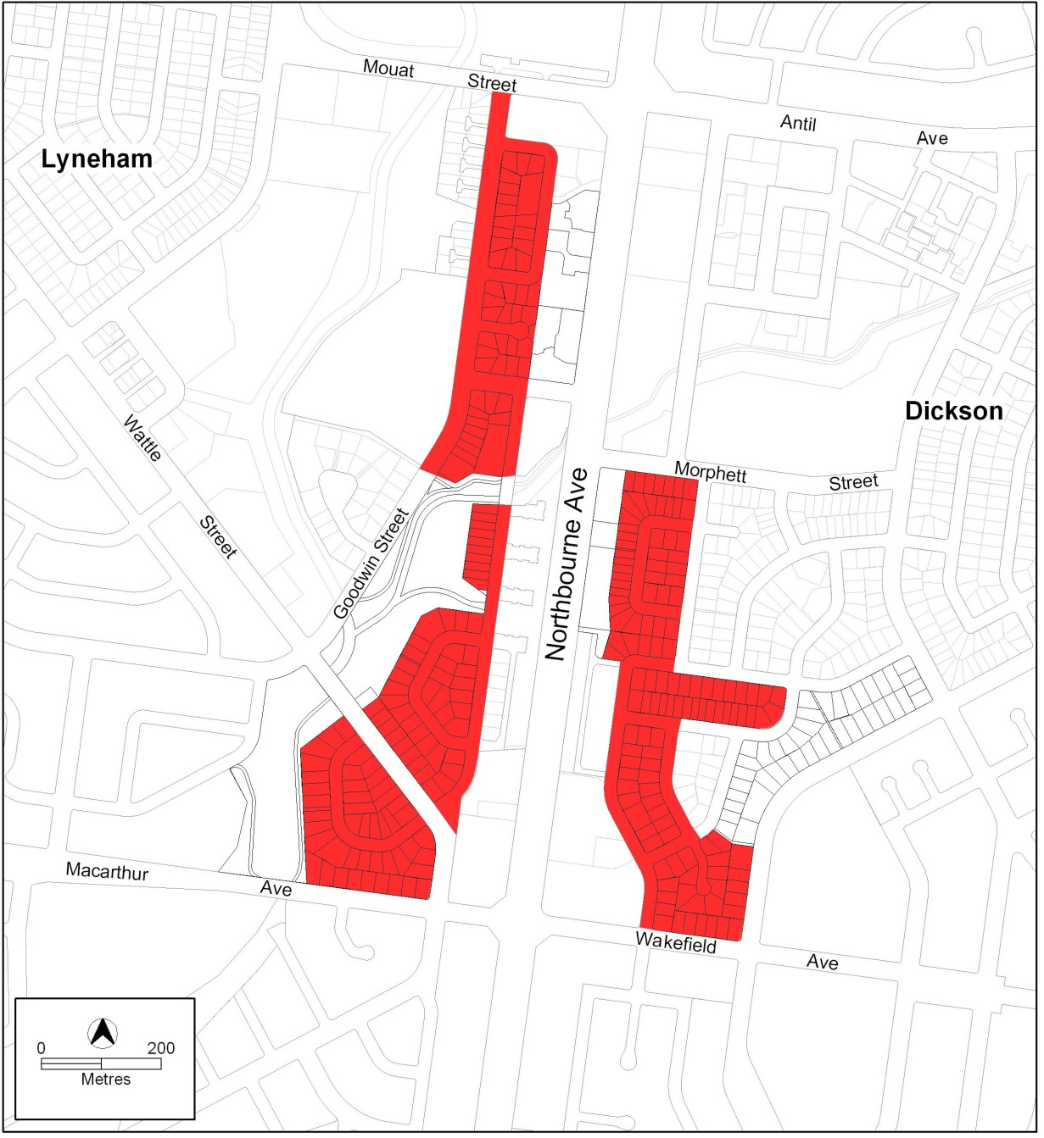

* + 1. Inner North Precinct Code

The current provisions affecting certain land in Turner are found in Inner North Precinct Code part C(5), element 1 (which includes rule 44), see **Figure 2** and **Map 2**.

**Figure 2** – Extract from *Inner North Precinct Code*

|  |
| --- |
| Part C(4) – Turner |

Element 1: Restrictions on Use

Intent:

)

a) To protect the existing residential amenity of neighbouring lessees

| Rules | Criteria |
| --- | --- |
| 1.1 Residential | |
| R44  )  Redevelopment is not permitted on Turner Section 47 and Section 63 Blocks 12-21. | C44  )  Minor additions or alterations, which do not result in a significant change to the scale and/or character of the dwelling may be permitted. |

**Map 2** – Turner Section 47 and Section 63 Blocks 12-21

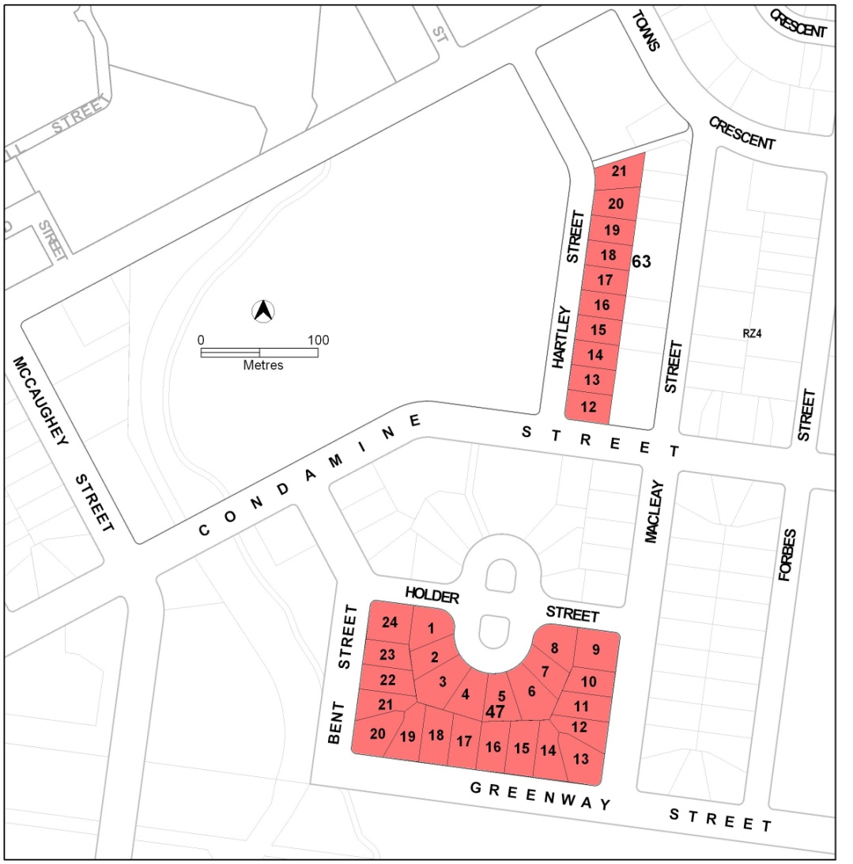

* 1. Changes to the Territory Plan
     1. Changes to the Residential Zones—Multi Unit Housing Development Code (item 1)

It is proposed to delete part A(4) section 2.1 – Restrictions on Use – Staging of Development – Inner North Canberra, which includes rule R21.

* + 1. Changes to the Inner North Precinct Code (item 2, 3 and 4)

It is proposed to delete from the Inner North Precinct Code part C(5) element 1, which includes rule 44. The Turner South and O’Connor/Turner North control plans are also proposed to be amended.

* 1. Consultation on the draft variation

Draft variation 310 (DV310) was released for public comment from 6 May 2011 to 21 June 2011. A consultation notice under section 63 of the *Planning and Development Act 2007* was published in the ACT Legislation Register on 6 June 2011.

There were 29 submissions received during the formal public notification period. One additional late submission was also accepted and has been considered along with other submissions. The majority of submissions were made by individual members of the public.

Eleven submissions supported all or part of DV310 and included the following topics:

* enables sustainable development
* responds to issues such population growth, climate change and the like
* decreases dependence on the car
* increases access to the city, services and facilities and public transport
* will improve vibrancy of the city and Dickson
* provides certainty for residents

Key concerns raised in the public submissions related to the following issues:

* traffic and safety
* housing diversity
* streetscape character
* solar access and privacy
* level of development
* development provisions
* infrastructure
* community issues
* standing committee recommendations
* vegetation
* quality of building design
* other general issues.

The issues raised in the written submissions have been addressed in a report on consultation. This report was prepared by the Environment and Sustainable Development Directorate, which now incorporates the statutory responsibilities of the ACT Planning and Land Authority. The report on consultation is required under s 69 (2) of the *Planning and Development Act 2007*.

The public consultation process resulted in a minor amendment to DV310 which is outlined below.

1. VARIATION

The Territory Plan is varied as follows.

Variation to residential zones—multi unit housing development code

1. Part A – Zone Specific Controls, Part A(4) – RZ4 – Medium Density Residential Zone, Element 2: Building and Site Controls

*Omit*

2.1 Restrictions on Use – Staging of Development – Inner North Canberra including Rule R21

Variation to Inner North precinct code

2. Part B – Control Plan – O’Connor and Turner North

*Substitute control plan – O’Connor and Turner North with control plan below:*



3. Part B – Control Plan – Turner South

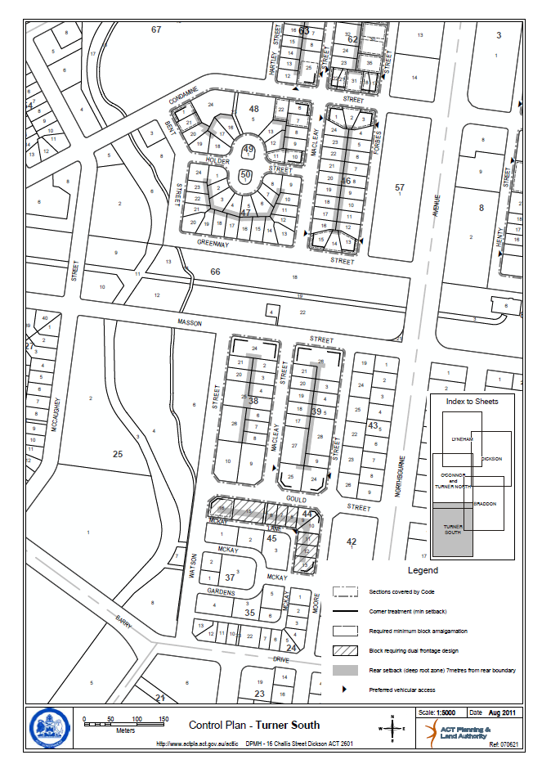*Substitute control plan –Turner South with control plan below:*

4. Part C(5) – Turner

*Omit*

Element 1: Restrictions on Use including Intent, 1.1 Residential and Rule R44 and Criterion C44

Interpretation service

