Australian Capital Territory

Planning and Development (Plan Variation No 307) Notice 2012*
Notifiable Instrument NI2012-201
made under the
Planning and Development Act 2007, section 76(3)

1 Name of instrument
This instrument is the Planning and Development (Plan Variation No 307) Notice 2012.

2 Plan Variation 307
On 19 April 2012, the Minister for the Environment and Sustainable Development approved a draft of the attached plan variation under s 76 (3).

Ben Ponton
Delegate of the Planning and Land Authority
23 April 2012

ACT Planning and Land Authority

Variation
to the
Territory Plan 307

Griffith, Section 42 Block 15
– Change of zoning from commercial CZ6 leisure and accommodation zone to RZ4 medium density residential zone
- Amendment of the Griffith precinct code

Table of Contents
1. EXPLANATORY STATEMENT 1
1.1 Background 1
1.2 Summary of the proposal 1
1.3 National Capital Plan 2
1.4 Site Description 2
1.5 Current Territory Plan provisions 3
1.6 Changes to the Territory Plan 5
1.6.1 Changes to the Territory Plan map 5
1.6.2 Changes to Territory Plan Griffith precinct code 5
1.7 Consultation on the draft variation 5
1.8 Revisions to the Exhibited Draft Variation 6
2. VARIATION 7
2.1 Variation to the Territory Plan 7
2.2 Variation to the Griffith precinct code 8

- EXPLANATORY STATEMENT
- Background
This variation rezones land at Austin Street Griffith (section 42, block 15) from the commercial CZ6 leisure and accommodation zone to the RZ4 medium density residential zone. It also amends the Griffith precinct code by including provisions relating to the site.

The commercial CZ6 leisure and accommodation zoning of the land reflects the previous use of the site as the Canberra South Bowling and Recreation Club. The bowling club utilised the site until 1998, when by mutual arrangement it provided the Brumbies Rugby with training and administrative facilities on the site. This continued until 2007 when the bowling club went into voluntary administration and in 2008 the site was sold to Brumbies Rugby. At that time, bowling activities were relocated to Canberra West and Forrest Bowling Clubs.

The Brumbies Rugby has been the sole occupier of the site since then and it is currently used as the Brumbies Rugby headquarters and part of its training centre.

- Summary of the proposal
Variation 307 changes the zone of Griffith section 42 block 15 from commercial CZ6 leisure and accommodation to RZ4 medium density residential zone to allow for medium density housing up to 3 storeys in height. The Griffith precinct code is also amended to include provisions relating to future redevelopment of the site for medium density housing.

The proposal is consistent with the Canberra Spatial Plan, the Draft ACT Planning Strategy and the Statement of Strategic Directions of the Territory Plan because of the following considerations:
- The site is well proportioned and of sufficient size to accommodate medium density residential redevelopment
- The site is separated from surrounding low density residential areas by Austin Street to the south and open space area to the north, east and west
- The current zoning of the site primarily reflects a former use that has not operated on the site for more than three years.
- Many of the uses permitted in the commercial CZ6 leisure and accommodation zone are permitted in other commercial zones and are more appropriately undertaken in commercial centres rather than in an established residential neighbourhood
- The site is well located close to commercial and employment centres at Manuka, Kingston and Civic and close to public transport along Captain Cook Crescent
- The rezoning will increase housing choice in the Griffith/ Forrest area without directly affecting existing single dwelling housing.
- The rezoning will further assist in offsetting the population decline that occurred in South Canberra after its peak in 1961.

- National Capital Plan
The Australian Capital Territory (Planning and Land Management) Act 1988 established the National Capital Authority (NCA) with two of its functions being to prepare and administer a National Capital Plan (NCP) and to keep the NCP under constant review and to propose amendments to it when necessary.

The NCP, which was published in the Commonwealth Gazette on 21 January 1990 is required to ensure that Canberra and the Territory are planned and developed in accordance with their national significance. The Australian Capital Territory (Planning and Land Management) Act 1988 also requires that the Territory Plan is not inconsistent with the NCP.

- Site Description
The site (Figure 1) is located at Austin Street, Griffith section 42, block 15. The site is surrounded on three sides by open space with Captain Cook Crescent to the east, La Perouse Street to the west and an open space corridor to the north. To the south across Austin Street are Wells Gardens and residential dwellings.

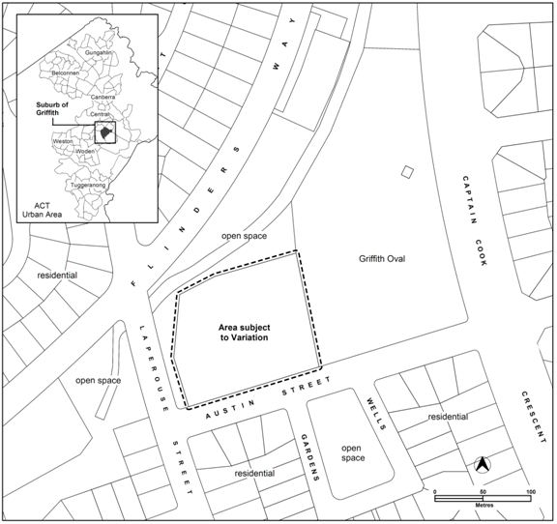
Figure 1: Location of the site and surrounding uses.

- Current Territory Plan provisions
The Territory Plan Map zone for the area subject to this variation is shown in Figure 2. The site is surrounded on three sides by the parks and recreation PRZ1 urban open space zone. To the south across Austin Street the land is partly PRZ1 urban open space zone and partly residential RZ1 suburban zone.

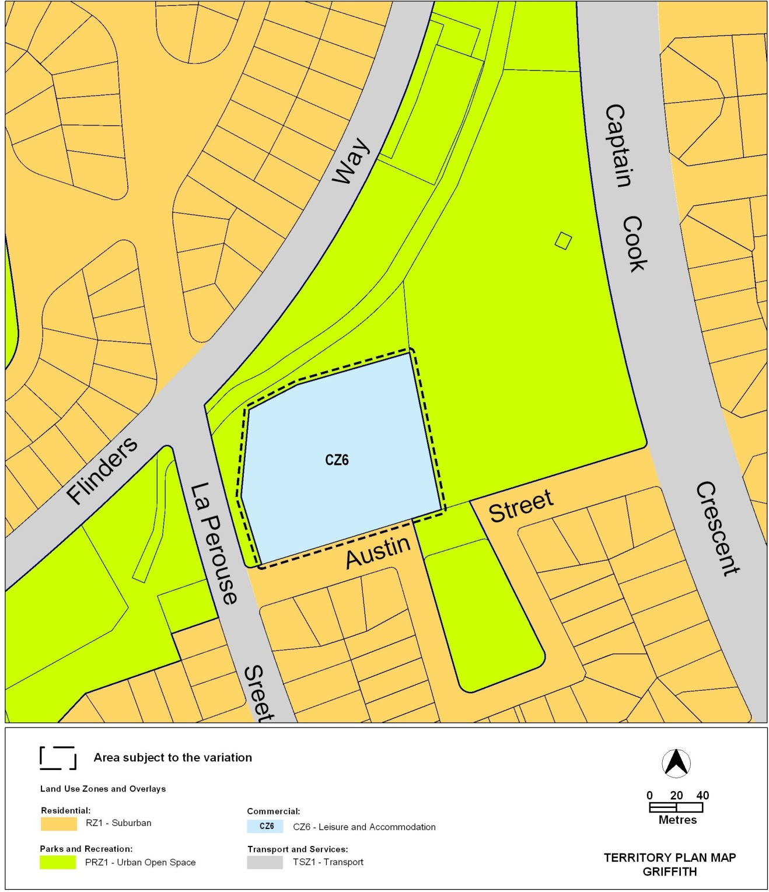
Figure 2: Territory Plan Zones Map

- Changes to the Territory Plan

Changes to the Territory Plan map
The changes to the Territory Plan map are indicated in Figure 3 at Part 2 of this document and consist of removing Griffith section 42, block 15 from the commercial CZ6 leisure and accommodation zone and including it in the RZ4 medium density residential zone.

Changes to Territory Plan Griffith precinct code
Changes to the Griffith precinct code are detailed in Part 2 of this document and include the introduction of a number of provisions to guide future redevelopment of the site. These provisions include: limitations on basement parking; inclusion of setbacks from Griffith, section 42, block 7; requirements for adaptable housing; protection of trees on the perimeter of the site; formalisation of the informal shared paths on part of Block 15 and on the adjoining block 16; and the erection of flood signage on section 42.

- Consultation on the draft variation
Draft variation 307 was released for public comment between 25 January 2011 and 15 March 2011. A consultation notice under section 63 of the Planning and Development Act 2007 was placed in the ACT Legislation Register on 25 January 2011.

A total of 116 written submissions were received, two (2) of which were late submissions accepted after 15 March 2011. The majority of submissions were made by individual members of the public. Submissions were also received from the following organisations:
- The Inner South Canberra Community Council
- The Griffith/Narrabundah Community Association Inc.
- The National Trust

Key concerns raised include:
- motives for the rezoning
- concessional lease status of the site
- alternative uses for the site, including community, open space or recreation uses
- compliance with the relevant strategic and statutory documents including the Canberra Spatial Plan, Territory Plan - Statement of Strategic Directions, the National Capital Plan and the Griffith Neighbourhood Plan
- justification for the proposal in terms of population and housing choice
- a range of potential impacts including flooding, traffic, amenity, character, heritage, garden city values and loss of trees.

- Revisions to the Exhibited Draft Variation
The following changes were made to the draft variation 307 following consideration of the Legislative Assembly’s Standing Committee on Planning, Public Works and Territory and Municipal Services report 12 of February 2012:
- The Griffith precinct code has been amended to include provisions which respond to the recommendations of the standing committee as follows:
  - Recommendation 1(a) – stipulation of a 35m setback of development on block 15 from block 7 and a public access easement
  - Recommendations 1 (b) and (c) – a requirement to formalise the existing paths on block 16 adjoining block 15
  - Recommendation 1 (d) – a requirement to erect flood signage on section 42
  - Recommendation 1(e) – limitations on encroachments under the stands of trees on the perimeter of block 15
  - Recommendation 1(f) – stipulation that basement parking is limited to one level only
  - Recommendation 1(g) – a requirement that 100% of dwellings on the site are built to adaptable housing standards.
- As the Griffith precinct code currently consists of just a map, it is necessary for the code to be restructured in order to accommodate an amendment to the precinct code map and to insert the additional provisions detailed above. For this reason variation 307 entirely replaces the existing Griffith precinct code, rather than updating it to insert the provisions. This restructure is administrative in nature and does not alter the policy context of the existing code.

- VARIATION
- Variation to the Territory Plan
- Territory Plan Map

The Territory Plan map is varied as indicated in Figure 3 for the area shown as subject to the variation.
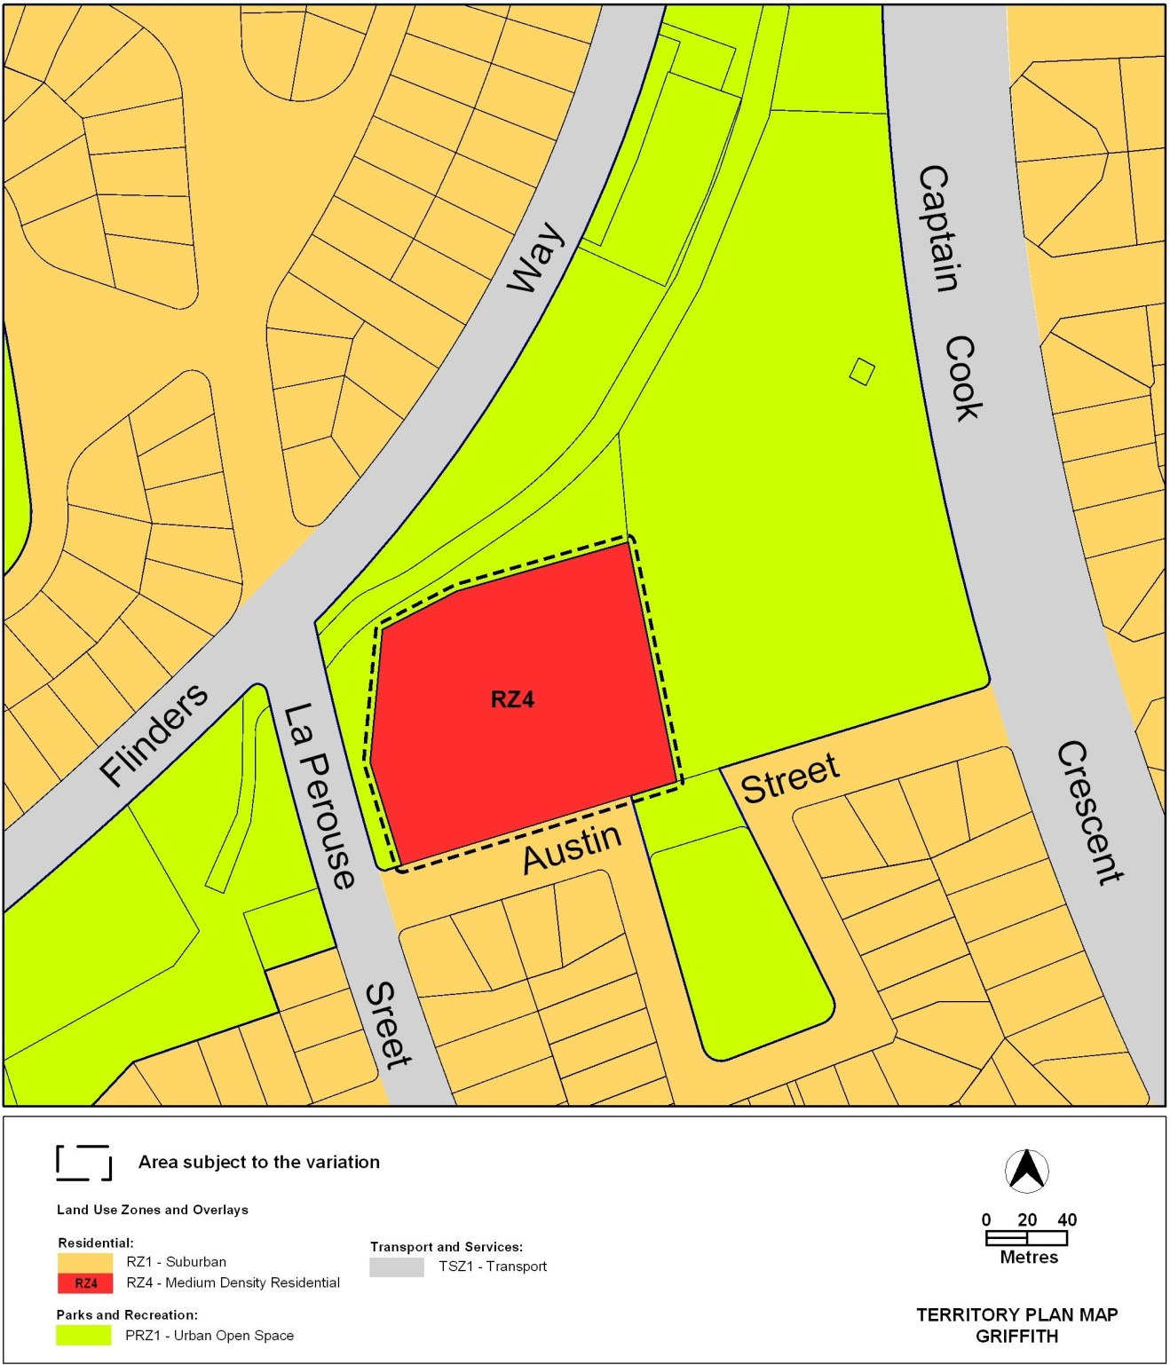
Figure 3: Proposed Territory Plan Zones Map

- Variation to the Griffith precinct code

2. Suburb precinct codes Griffith precinct code

Substitute with Appendix A

Interpretation service
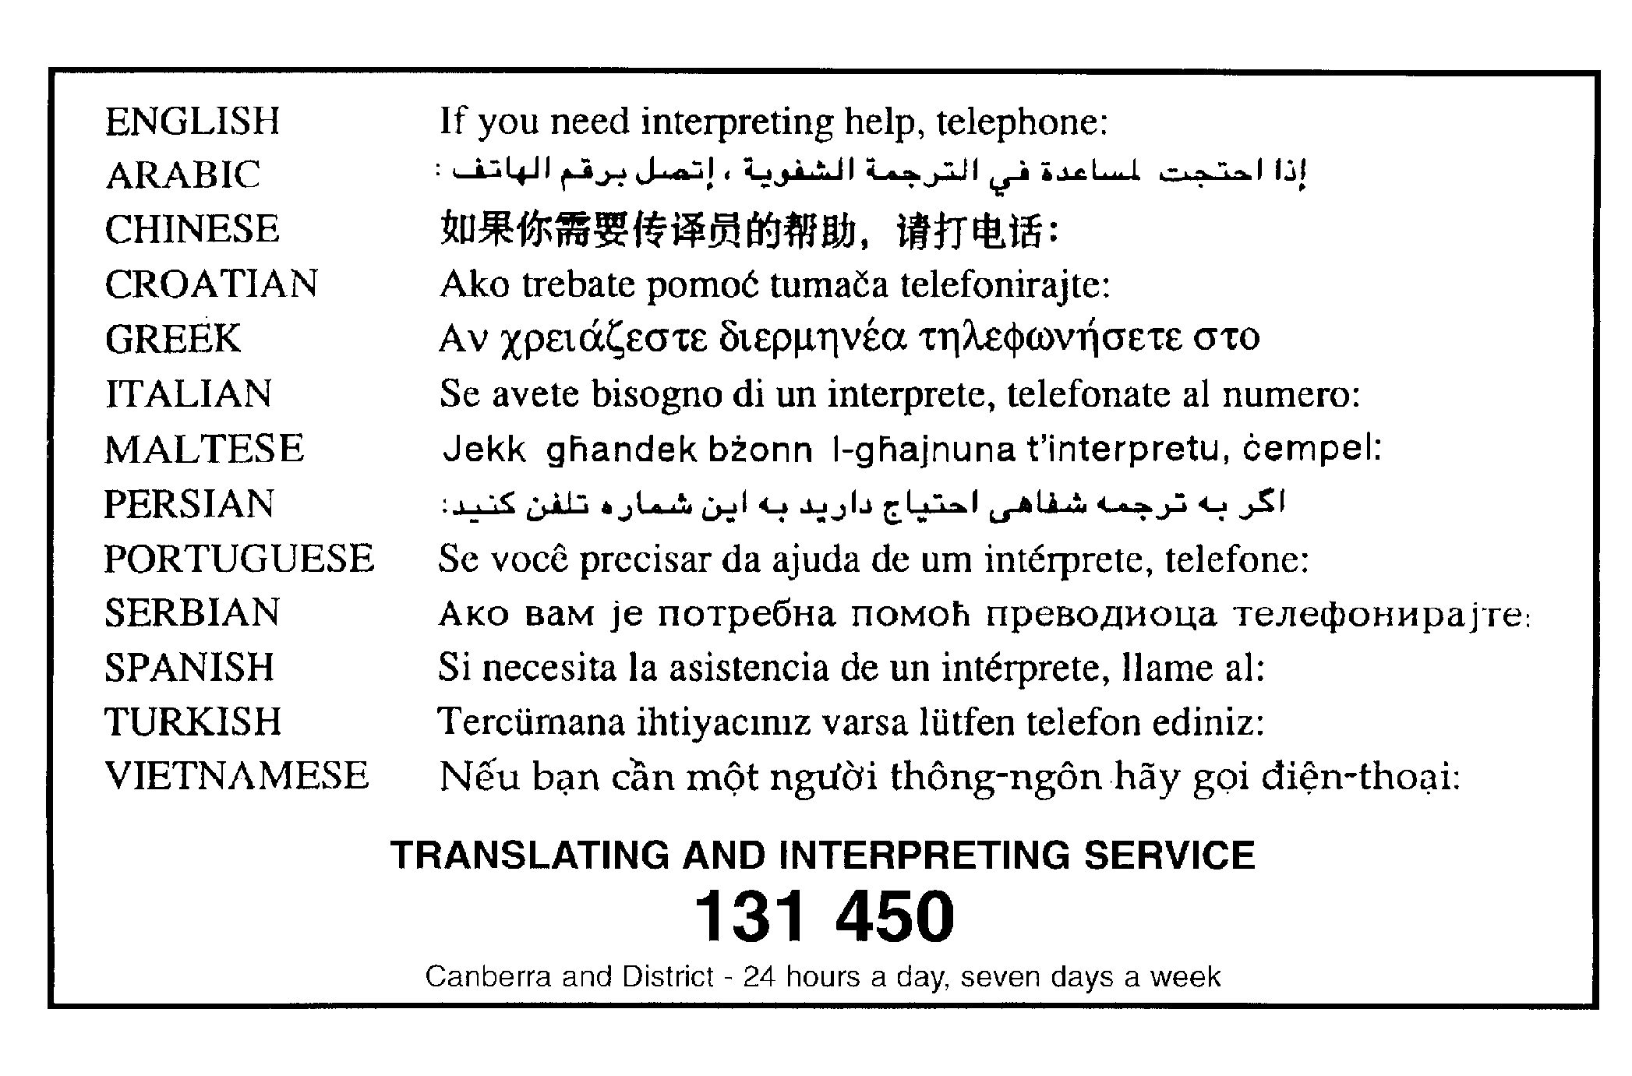

Appendix A

Griffith Precinct Code

This page is intentionally blank

Contents
Introduction 1
Part A – Additional rules and criteria 4
Element 1: Restrictions on use 4
1.1 Basement Parking 4
Element 2: Building and site controls 4
2.1 Setback 4
Element 3: Built Form 4
3.1 Accessibility (mobility) 4
Element 6: Environment 4
6.1 Trees 4
Element 7 Services 5
7.1 Off site works 5

This page is intentionally blank

Introduction
Name
The name of this code is Griffith Precinct Code.
Application
The code applies to the Division of Griffith.
Purpose
This code provides additional planning, design and environmental controls for specific areas or blocks and may also contain references to provisions in other codes.
In conjunction with other relevant codes it will be used by the Authority to assess development applications and offer guidance to intending applicants in designing development proposals and preparing development applications.
Structure
This code contains the following:
Precinct map
This map may identify blocks or parcels:
- that are referred to in development codes (eg. blocks that may have an elevated bush fire risk and require a dwelling house to be built to a certain standard)
- affected by part A or part B of this code.
Part A – Additional rules and criteria
This part may contain:
- sub-parts
- additional rules and/or criteria for, to be read in conjunction with the relevant development code
for particular blocks or parcels identified on the precinct map.
Each part has a number of elements. Each element has one or more rules and, unless the respective rule is mandatory, each rule has an associated criterion. Rules provide quantitative, or definitive, controls. By contrast, criteria are chiefly qualitative in nature.
In some instances rules are mandatory. Such rules are accompanied by the words “This is a mandatory requirement. There is no applicable criterion.” Non-compliance with a mandatory rule will result in the refusal of the development application. Conversely, the words “There is no applicable rule” is found where a criterion only is applicable.
Code hierarchy
Under the Act, where more than one type of code applies to a development, the order of precedence if there is inconsistency of provisions between codes is: precinct code, development code and general code.
If more than one precinct code applies to the site, the most recent precinct code takes precedence to the extent of any inconsistency.

Definitions
Defined terms, references to legislation and other documents are italicised.
Definitions of terms used in this code are listed in part 13 of the Territory Plan or, for terms applicable only to this code, associated with the respective rule.
Abbreviations
Authority Planning and Land Authority within the ACT Environment and Sustainable Development Directorate
The Act Planning and Development Act 2007

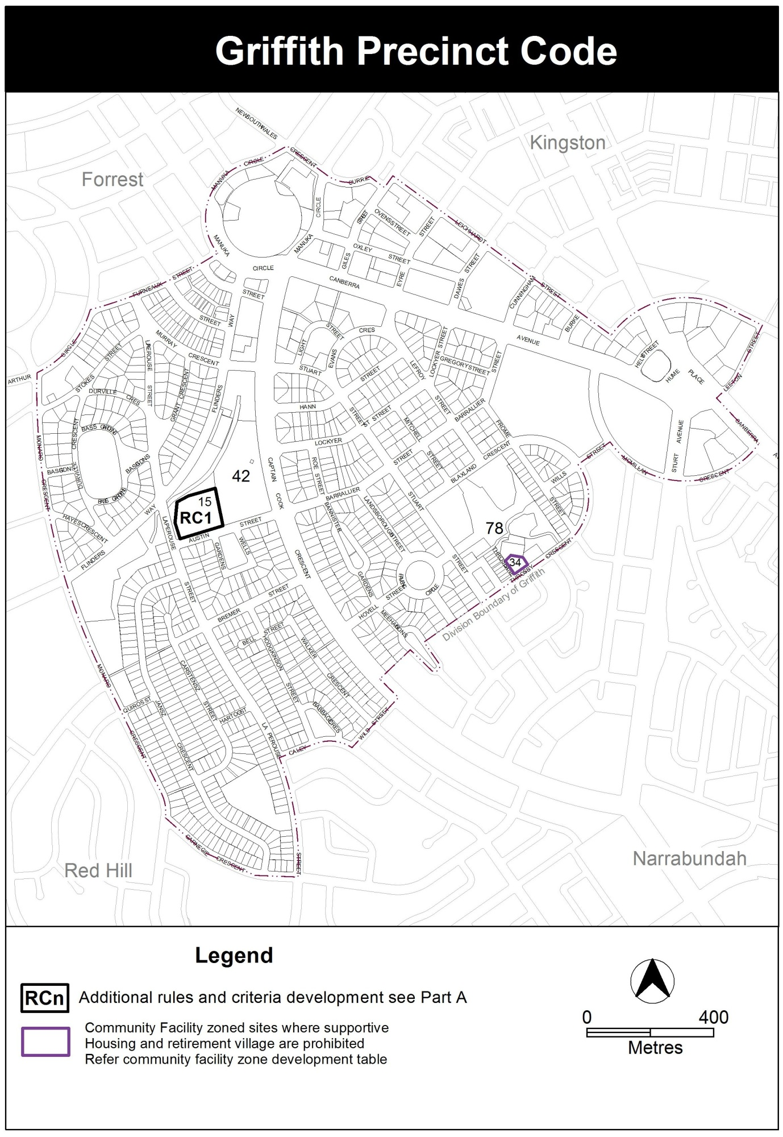
Part A – Additional rules and criteria
- This part applies to blocks and parcels identified in the Griffith Precinct Map (RCn). It should be read in conjunction with the relevant zone development code and related codes.
Part A1 Specific provisions for RC1 in the Griffith Precinct Map
Element 1: Restrictions on use
- Rules | - Criteria
  - Basement Parking
R1  Basement Parking is limited to one (1) level. | This is a mandatory requirement. There is no applicable criterion.

Element 2: Building and site controls
- Rules | - Criteria
  - Setback
R2  Buildings and other development are setback a minimum of 35 metres from the boundary of Griffith, section 42, block 7. Any part of block 15 within this setback is included in a public access easement. | This is a mandatory requirement. There is no applicable criterion.

Element 3: Built Form
- Rules | - Criteria
  - Accessibility (mobility)
R3  100% of the dwellings of any multi unit housing development are designed to meet the relevant Australian Standard for Adaptable Housing and any relevant considerations in the Access and Mobility General Code. | This is a mandatory requirement. There is no applicable criterion.

Element 6: Environment
- Rules | - Criteria
  - Trees
R4  Building and construction works do not encroach on land within the drip zone plus 2.0m of the existing stands of trees on the perimeter of Block 15 as identified on Figure 1. | C4  The health of existing trees on the perimeter of block 15 is maintained. Compliance with this criterion is supported by an assessment by a suitably qualified arborist and to the satisfaction of the Conservator of Flora and Fauna.
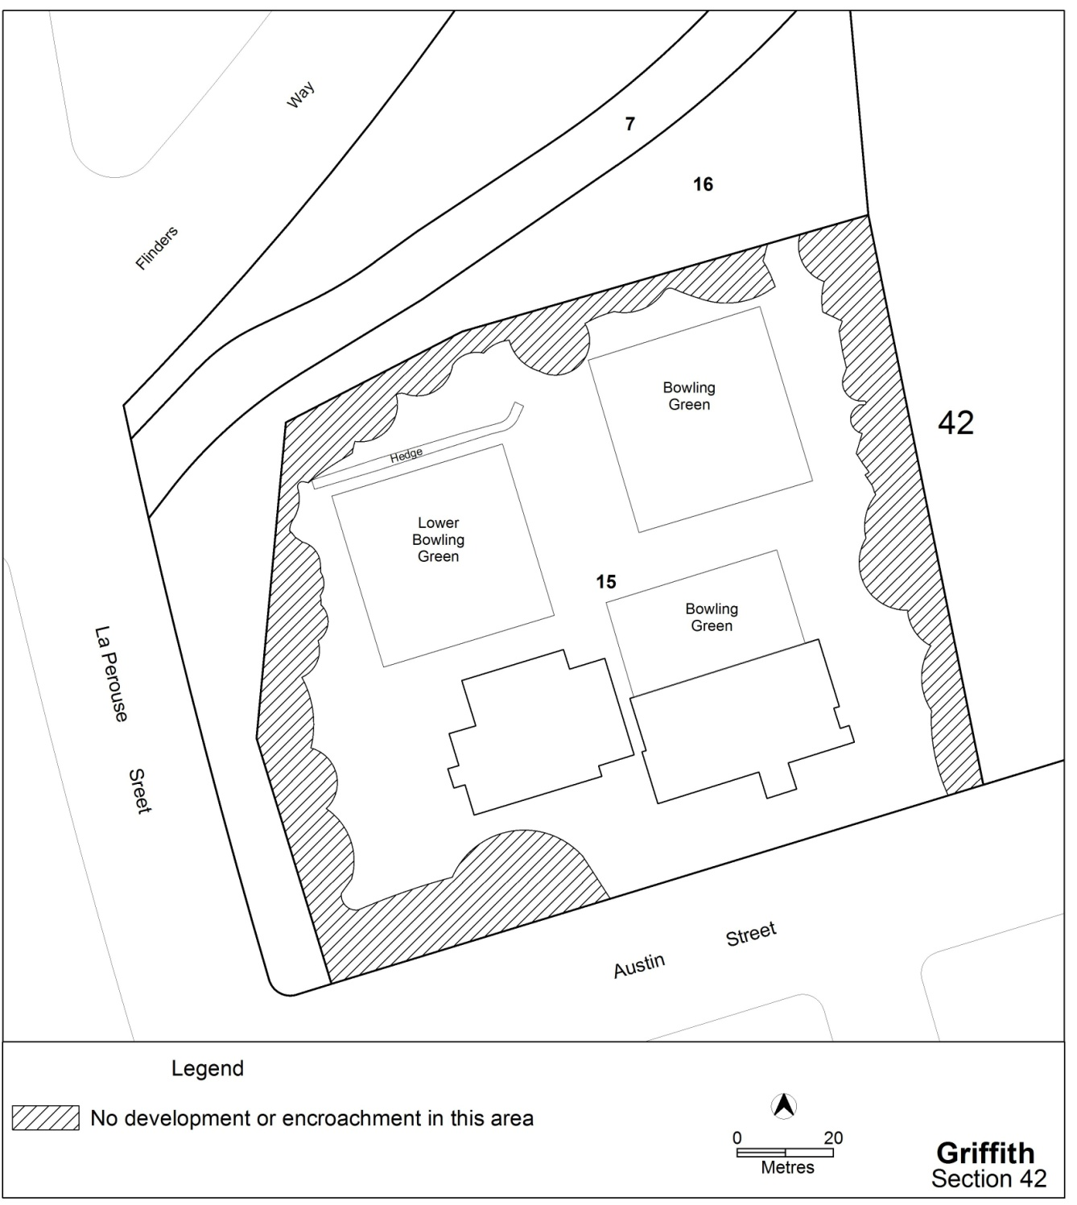

Figure 1 Areas with no development or encroachments

Element 7 Services
- Rules | - Criteria
  - Off site works
R5  Shared paths are constructed within block 16 and the part of block 15 subject to the public access easement in Rule R2, along the northern and eastern boundaries of block 15 as identified on Figure 2 and are endorsed by the Territory agency responsible for asset acceptance. | This is a mandatory requirement. There is no applicable criterion.
R6  Flood signage is erected along pathways and access points to Section 42 Griffith and is endorsed by the Territory agency responsible for asset acceptance. | This is a mandatory requirement. There is no applicable criterion.

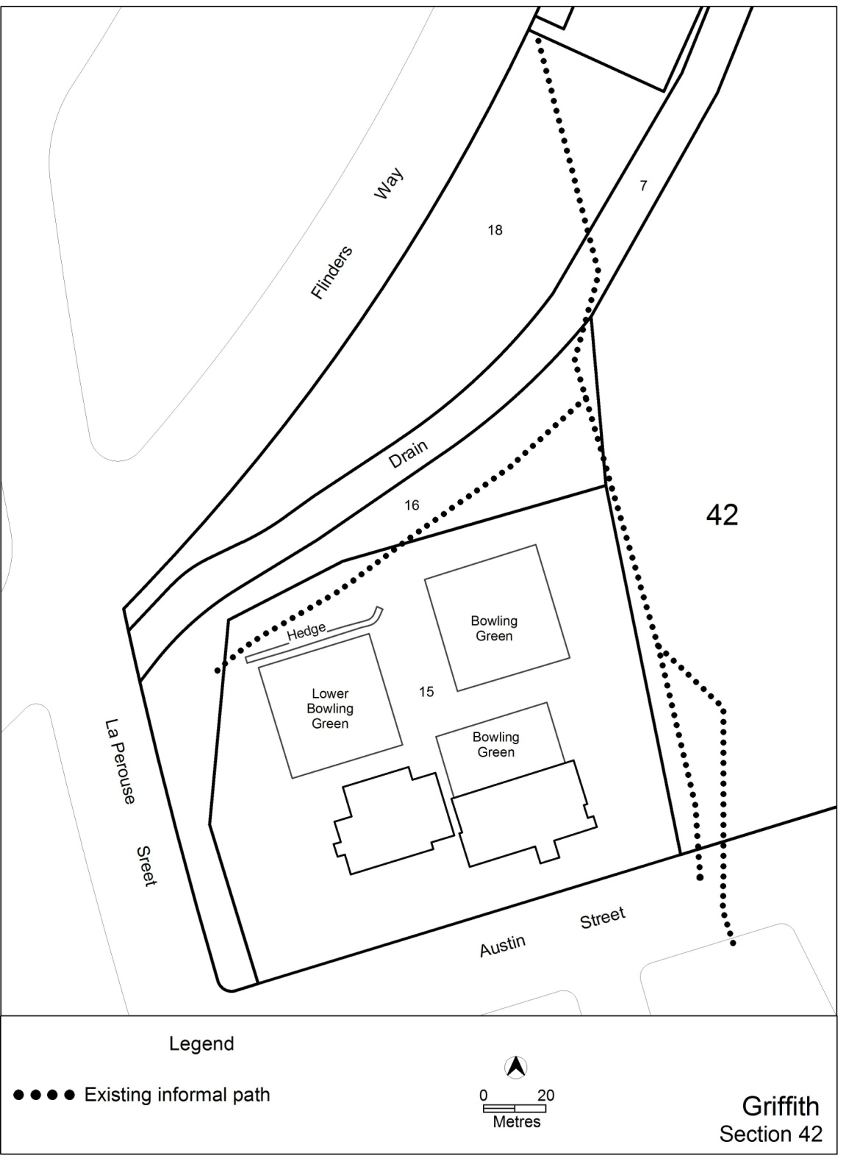

Figure 2 location of existing informal paths to be formalised

