Australian Capital Territory
Planning and Development (Plan Variation No 305) Notice 2013
Notifiable Instrument NI2013-530
made under the
Planning and Development Act 2007, section 76(3)

- Name of instrument
This instrument is the Planning and Development (Plan Variation No 305) Notice 2013.*

- Plan Variation No 305
On 21 November 2013, the Minister for Planning approved a draft of the attached plan variation to the Territory Plan (Annexure A) under s76 (3).

Jim Corrigan
Delegate of the Planning and Land Authority
21 November 2013

ANNEXURE A

Planning and Development Act 2007

Variation to the
Territory Plan
No 305

Mugga Lane Resource Management Centre –
Jerrabomberra Block 2247

Amendment to the Territory Plan to accommodate the expansion of the existing Mugga Lane Resource Management Centre onto Jerrabomberra Block 2247

Final variation prepared under s76 of the
Planning and Development Act 2007
This page is intentionally left blank.

Contents

1. INTRODUCTION 1
1.1 Background 1
1.2 Summary of the Proposal 1
1.3 National Capital Plan 1
1.4 Site Description 2
1.5 Current Territory Plan Provisions 3
1.6 Changes to the Territory Plan 4
1.7 Consultation on the Draft Variation 4
1.8 Revisions to the Draft Variation Recommended to the Minister 4
2. VARIATION 5
2.1 Variation to the Territory Plan 5
Appendix A 7
Appendix B 8
Appendix C 9

This page is intentionally left blank.

- INTRODUCTION
  - Background
ACT NOWaste has investigated options for long term waste disposal in the ACT. This has included implementation of recycling facilities and strategies for waste management. However, there remains a longer term need for a landfill facility. The existing facility at Mugga Lane is anticipated to reach capacity in 2015/2016. Alternative landfill sites have been investigated and the preferred option is to expand the existing facility onto Jerrabomberra Block 2247. This will meet the ACT’s landfill requirements for up to 30 years.
  - Summary of the Proposal
The Variation to the Territory Plan No 305, Mugga Lane Resource Management Centre – Jerrabomberra Block 2247, proposes to amend the Territory Plan to accommodate the expansion of the existing Mugga Lane Resource Management Centre onto Jerrabomberra Block 2247 which adjoins the existing landfill.
The land is currently included in the NUZ1 Broadacre zone in which landfill is a prohibited use. The existing landfill in the resource management centre on Block 2114 is currently permitted in the Broadacre zone through a site specific provision in the Jerrabomberra District Precinct Map and Code. The Variation No 305 proposes to extend the site specific provision onto Block 2247 by changing the MT2 boundary in the Jerrabomberra District Map to include Block 2247. A clearance zone has also been redrawn to restrict development of community use and residential use within 500m around the expanded MT2 boundary. There are also consequential amendments to the Tuggeranong District Precinct Map and Hume Precinct Map.
  - National Capital Plan
The Australian Capital Territory (Planning and Land Management) Act 1988 established the National Capital Authority (NCA) with two of its functions being to prepare and administer a National Capital Plan (NCP) and to keep the NCP under constant review and to propose amendments to it when necessary.
The NCP, which was published in the Commonwealth Gazette on 21 January 1990 is required to ensure that Canberra and the Territory are planned and developed in accordance with their national significance. The Planning and Land Management Act 1988 also required that the Territory Plan is not inconsistent with the NCP.
In accordance with section 10 of the Australian Capital Territory (Planning and Land Management) Act 1988, the National Capital Plan defines the planning principles and policies for Canberra and the Territory, for giving effect to the object of the NCP and sets out the general policies to be implemented throughout the Territory, including the range and nature of permitted land uses.
It also sets out the detailed conditions of planning, design and development for areas that have special significance to the National Capital known as designated areas and identifies special requirements for the development of some other areas.
  - Site Description
The site for the expansion of the landfill is Jerrabomberra Block 2247 and is adjacent to the existing landfill as identified on Figure 1 below.
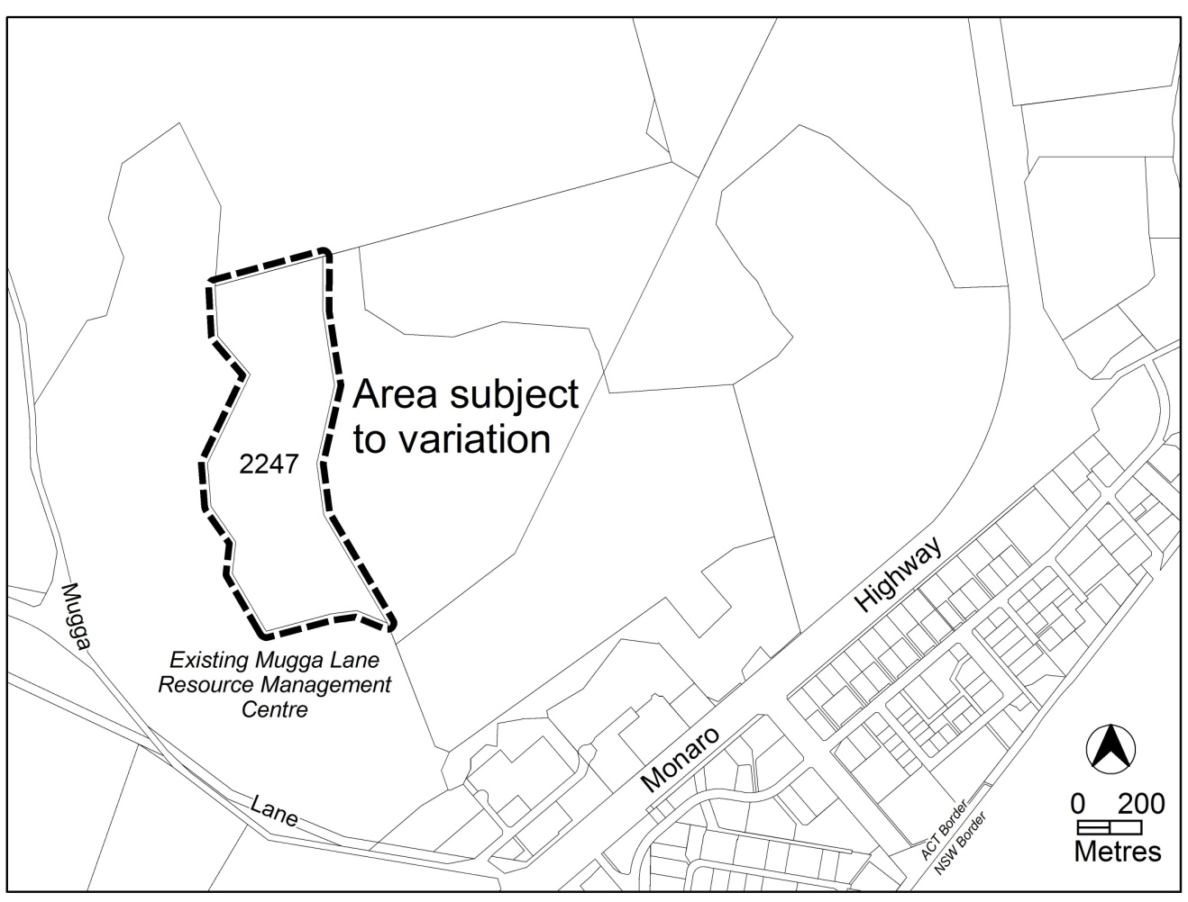
Figure 1 Site Plan
  - Current Territory Plan Provisions
The Jerrabomberra District Precinct Map for the area subject to this variation is shown in Figure 2 below. There is also a need for consequential amendments of the Tuggeranong District Precinct Map and the Hume Precinct Map.
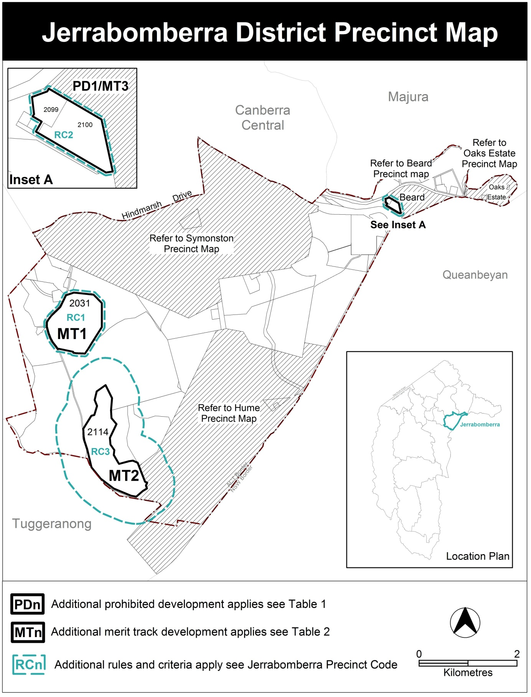
Figure 2 Jerrabomberra District Precinct Map
  - Changes to the Territory Plan
Detailed changes to the Territory Plan are noted in section 2 of this document.
  - Consultation on the Draft Variation
The Draft Variation No 305 was released for public comment between 15 February 2013 and 5 April 2013. A consultation notice under section 63 of the Planning and Development Act 2007 was published on the ACT Legislation Register on 15 February 2013 and in The Canberra Times on 16 February 2013.
A total of three (3) written submissions were received, which included submissions from Canberra Airport, the Conservation Council ACT Region and an individual. The main issues raised by submitters included:
- The need to consider an alternative location for a landfill facility
- Potential visual impacts
- Traffic and transport impacts from construction and operation of the proposed facility
- The need for waste reduction and management in the ACT
- Potential environmental impacts including:
- Changes to bird and wildlife activities which may impact on aircraft operations
- Potential impacts on groundwater, local runoff and drainage
- Impacts on Yellow Box Red Gum Grassy Woodland
- The proposed offset strategy for the Yellow Box Red Gum Grassy Woodland
- Rehabilitation of the landfill site and future long term land use
These issues have been considered and are detailed in a Report on Consultation.
  - Revisions to the Draft Variation Recommended to the Minister
No changes were made to the draft variation recommended to the Minister.

- VARIATION
  - Variation to the Territory Plan
The Territory Plan is varied in all of the following ways:
Variation to the Jerrabomberra District Precinct Map and Code
- Jerrabomberra District Precinct Map

Substitute with Appendix A

Variation to the Tuggeranong District Precinct Map and Code
- Tuggeranong District Precinct Map

Substitute with Appendix B

Variation to the Hume Precinct Map and Code
- Hume Precinct Map

Substitute with Appendix C

Interpretation service
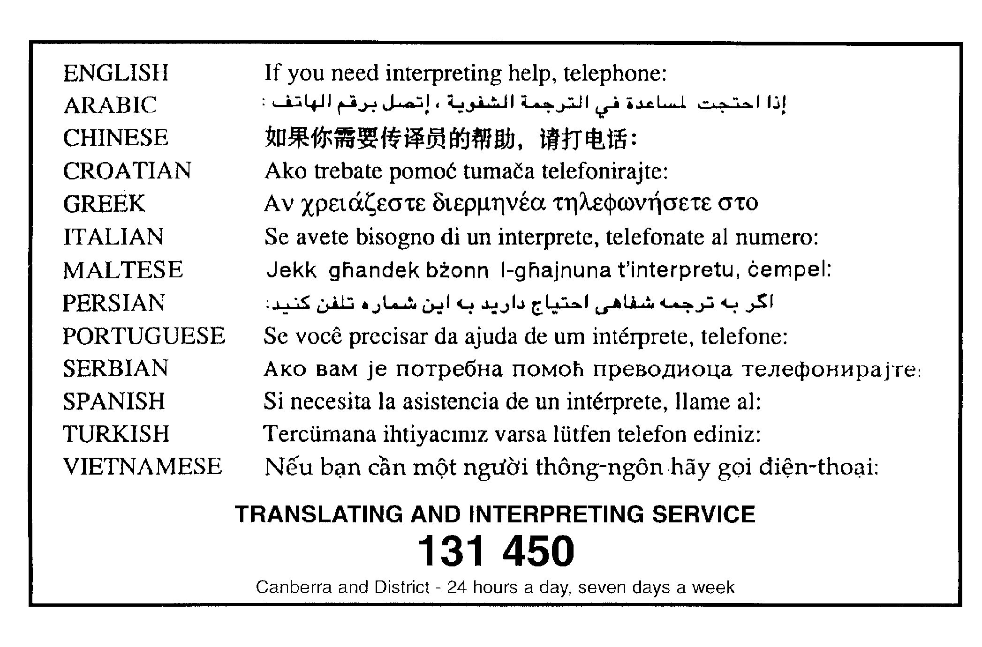

Appendix A
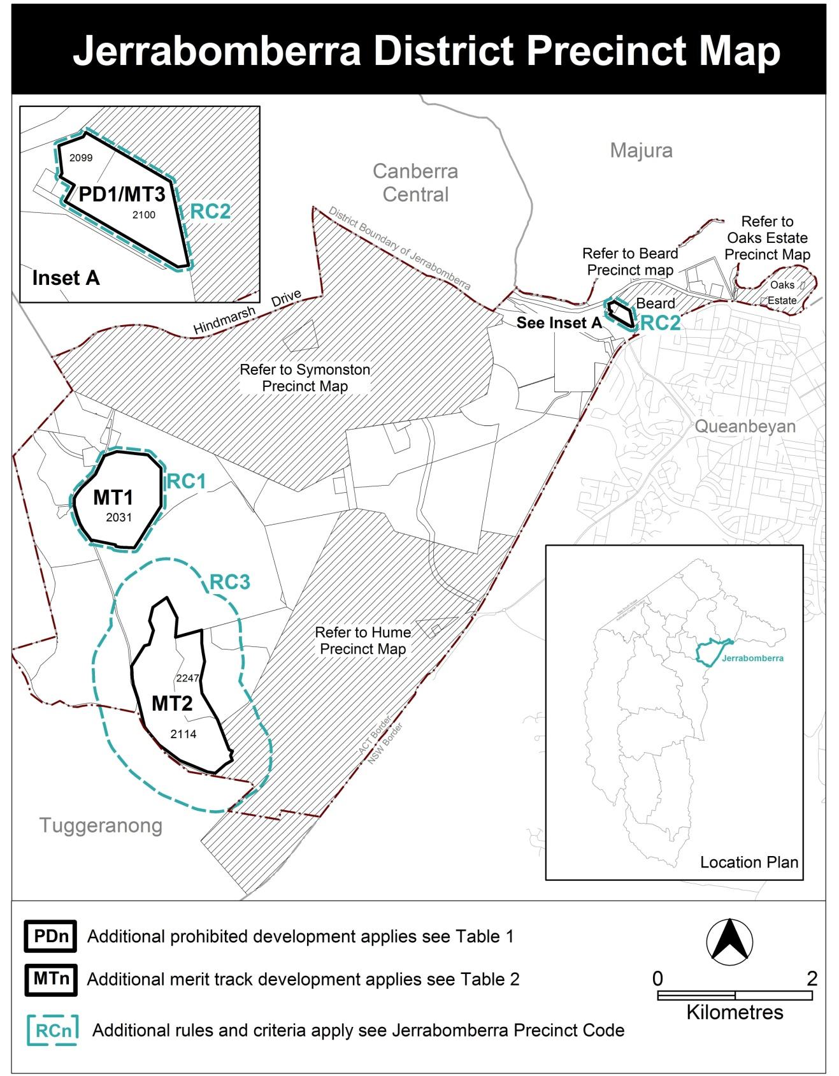

Appendix B
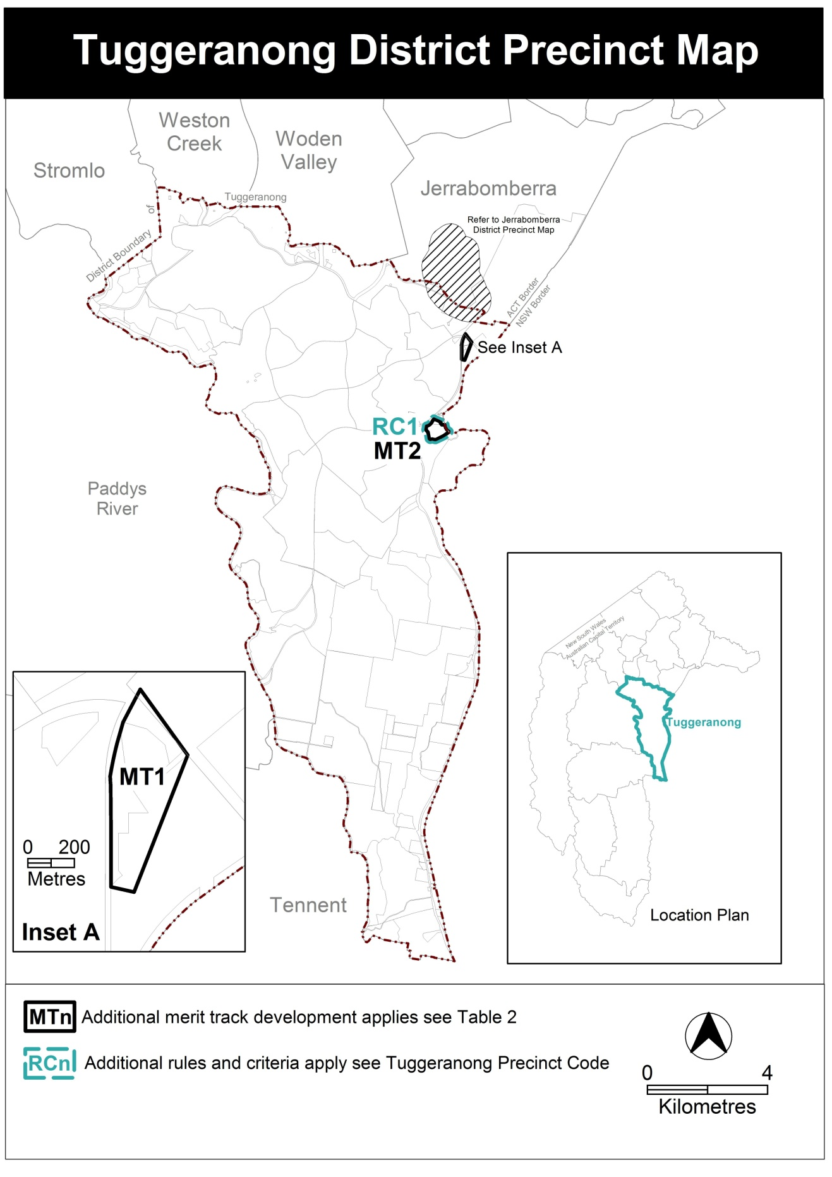

Appendix C
