Australian Capital Territory

Planning and Development (Technical Amendment—Barton and Campbell) Plan Variation 2014 (No 1)*

Notifiable Instrument NI2014—649

Technical Amendment No 2014—23
made under the
Planning and Development Act 2007, section 89 (Making technical amendments)

This technical amendment commences on 12 December 2014.

Variation No 2014—23 to the Territory Plan has been approved by the planning and land authority.

Jim Corrigan
Delegate of the planning and land authority
10 December 2014

Planning & Development Act 2007

Technical Amendment
to the Territory Plan
Variation 2014-23

Removal of Pe (urban open space) Public Land Reserve overlay from block 15 Section 33 Barton and block 12 Section 118 Campbell
and
Replacement of Pc (nature reserve) Public Land Reserve overlay over part block 13 section 18 Campbell with Pe (urban open space) overlay

December 2014

This page is left intentionally blank
Table of Contents

1. INTRODUCTION 1
1.1 Purpose 1
1.2 National Capital Authority 1
1.3 Process 1
1.4 Types of technical amendments under the Act 1
2. EXPLANATION 3
2.1 Removal of Pe (urban open space) Public Land Reserve overlay from block 15 section 33 Barton and Block 12 Section 118 Campbell 3
2.2 Replacement of Pc (nature reserve) Public Land Reserve overlay boundary over part Block 13 Section 118 Campbell 4
3. TECHNICAL AMENDMENT 8
3.1 Territory Plan Map 8

This page is left intentionally blank

- INTRODUCTION
  - Purpose

This technical amendment makes the following changes to the Territory Plan:

Territory Plan Map

- Remove Pe (urban open space) Public Land Reserve overlay from Block 15 Section 33 Barton and Block 12 Section 118 Campbell (Clair Holland House hospice)
- Adjust Public Land Reserve overlay boundary over part Block 13 Section 118 Campbell from Pc nature reserve to Pe urban open space in line with Jerrabomberra Wetlands Plan of Management and the Inner Canberra's and Tuggeranong's Urban Parks and Sportsgrounds Plan of Management

  - National Capital Authority
The National Capital Authority has been advised of this technical amendment.

  - Process
This technical amendment has been prepared in accordance with section 87 of the Planning and Development Act 2007 (the Act).
Under section 88 of the Act this type of technical amendment is not subject to public consultation.
The planning and land authority must notify the public of the commencement of this technical amendment.

  - Types of technical amendments under the Act
The following categories of technical amendments are provided under section 87 of the Act:
(a) a variation (an error variation) that –
- would not adversely affect anyone’s rights if approved; and
- has as its only object the correction of a formal error in the plan
(b) a variation (a code variation) that –
- would only change a code; and
- is consistent with the policy purpose and policy framework of the code; and
- is not an error variation
(c) a variation in relation to a future urban area under section 95 (Technical amendments – future urban areas);
(d) a variation in relation to an estate development plan under section 96 (Effect of approval of estate development plan);
(e) a variation to change the boundary of a zone or overlay under section 96A (Rezoning – boundary changes);
(f) a variation required to bring the territory plan into line with the national capital plan;
(g) a variation to omit something that is obsolete or redundant in the territory plan;
(h) a variation to clarify the language in the territory plan if it does not change the substance of the plan;
(i) a variation to relocate a provision within the territory plan if the substance of the provision is not changed.
Following each item in Part 2 Explanation of this technical amendment is a statement of compliance against the specific criteria for the relevant category of technical amendment.
TA2014-23 has been prepared in accordance with sections 87(e) and (f) of the Act.

- EXPLANATION
This part of the technical amendment document explains the changes to be made to the Territory Plan, the reasons for the change, and a statement of compliance against the relevant section of the Act.

  - Removal of Pe (urban open space) Public Land Reserve overlay from block 15 section 33 Barton and Block 12 Section 118 Campbell

Claire Holland House hospice is located on Block 15 Section 33 Barton and Block 12 Section 118 Campbell, on the eastern edge of Lake Burley Griffin on Menindee Drive. Both these blocks are in a Designated Area under the National Capital Plan (having special characteristics of the National Capital) in that the site is located on the foreshore of the lake. As such, the land is subject to the National Capital Authority’s planning regulations and works approval. However, the blocks are also subject to a Pe Public Land Reserve overlay under the Territory Plan making them public land, urban open space.

The ACT Government’s Health Directorate intends to issue a licence under delegation from the planning and land authority over the hospice site but in accordance with section 303 of the Planning and Development Act 2007 (the Act) a licence cannot be granted over public land unless the Conservator of Flora and Fauna agrees in writing. The Conservator can only provide this agreement if the proposed use is in accordance with the management objectives for the area as provided in Schedule 3 of the Act. The management objectives for urban open space are to provide for public and community use of the area, and to develop the area for public and community use. The use of the land as a hospice does not meet these objectives.

The siting of the hospice at this location was approved by the National Capital Authority as this is an allowable use under the National Capital Plan. Having the urban open space public land overlay that does not permit this use makes the Territory Plan inconsistent with the National Capital Plan. This technical amendment proposes to bring the Territory Plan in line with the National Capital Plan under section 87(f) of the Act. Once the overlay has been removed, the National Capital Plan will be the only planning instrument that is applicable and the Territory’s Plan of Management will no longer apply over the site.

Statement of compliance with the Planning and Development Act 2007

Section | Statement
s87(f)  a variation required to bring the territory plan into line with the national capital plan | Compliant.  The change brings the Territory Plan in line with the National Capital Plan by removing the Pe Public Land Reserve overlay over the Canberra Hospice site.

  - Replacement of Pc (nature reserve) Public Land Reserve overlay boundary over part Block 13 Section 118 Campbell

The enactment of the new Nature Conservation Act will mean there will be a requirement for each nature reserve and special purpose reserve to have an Activities Declaration which will state what people can do in a reserve. The project for developing these declarations has identified some anomalies in the boundaries of the nature reserve adjacent to the hospice as shown on the Territory Plan.

Currently, part Block 13 Section 118 Campbell, which is located between Morshead Drive and the Molonglo River, is subject to a Pc nature reserve Public Land Reserve overlay. However, this area is mown and managed as parkland rather than nature reserve and shown in the Inner Canberra's and Tuggeranong's Urban Parks and Sportsgrounds Plan of Management as a District Park (part of Molonglo Reach).

To correct this anomaly, the boundary of the nature reserve overlay needs to be adjusted to align with the boundaries as shown in the Jerrabomberra Wetlands Plan of Management, which is the normal high water mark on the northern bank of the Molonglo River. The Pc overlay over Part Block 13 Section 118 Campbell will be substituted for a Pe urban open space Public Land Reserve overlay, in line with its use as a District Park.

Statement of compliance with the Planning and Development Act 2007

Section | Statement
s87(e) / S96A  Rezoning – boundary changes  - The planning and land authority may vary the territory plan under section 89 (Making technical amendments) to change the boundary of a zone or overlay if the change is consistent with--  - the apparent intent of the original boundary line; and  - the objective for the zone | Compliant.  The change brings the Territory Plan in line with the requirements of the Jerrabomberra Wetlands Plan of Management and by removing the Pc nature reserve Public Land Reserve overlay and replacing with the correct Pe urban open space Public Land Reserve overlay for the use of the land.

Location

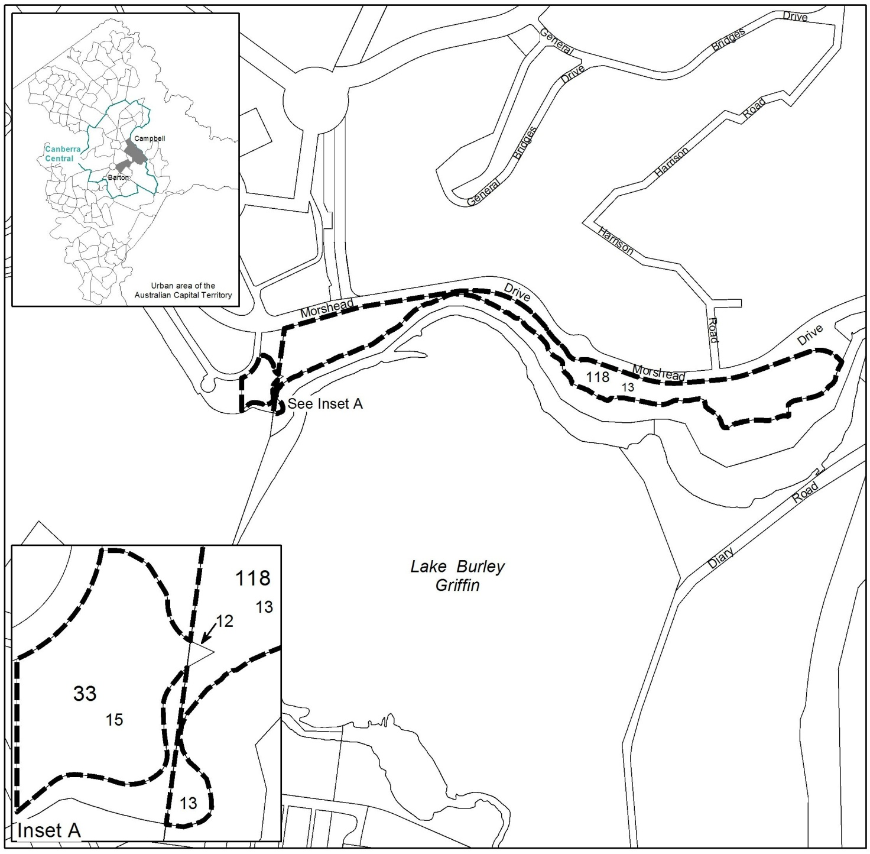

Existing Public Land Reserve overlay boundaries

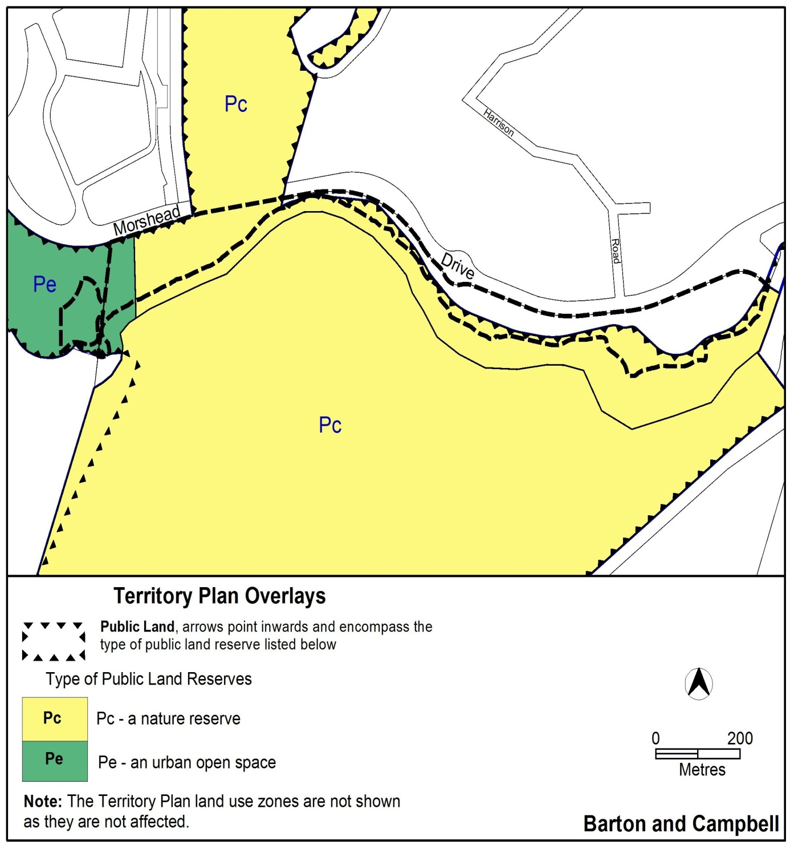

Proposed Public Land Reserve overlay boundaries

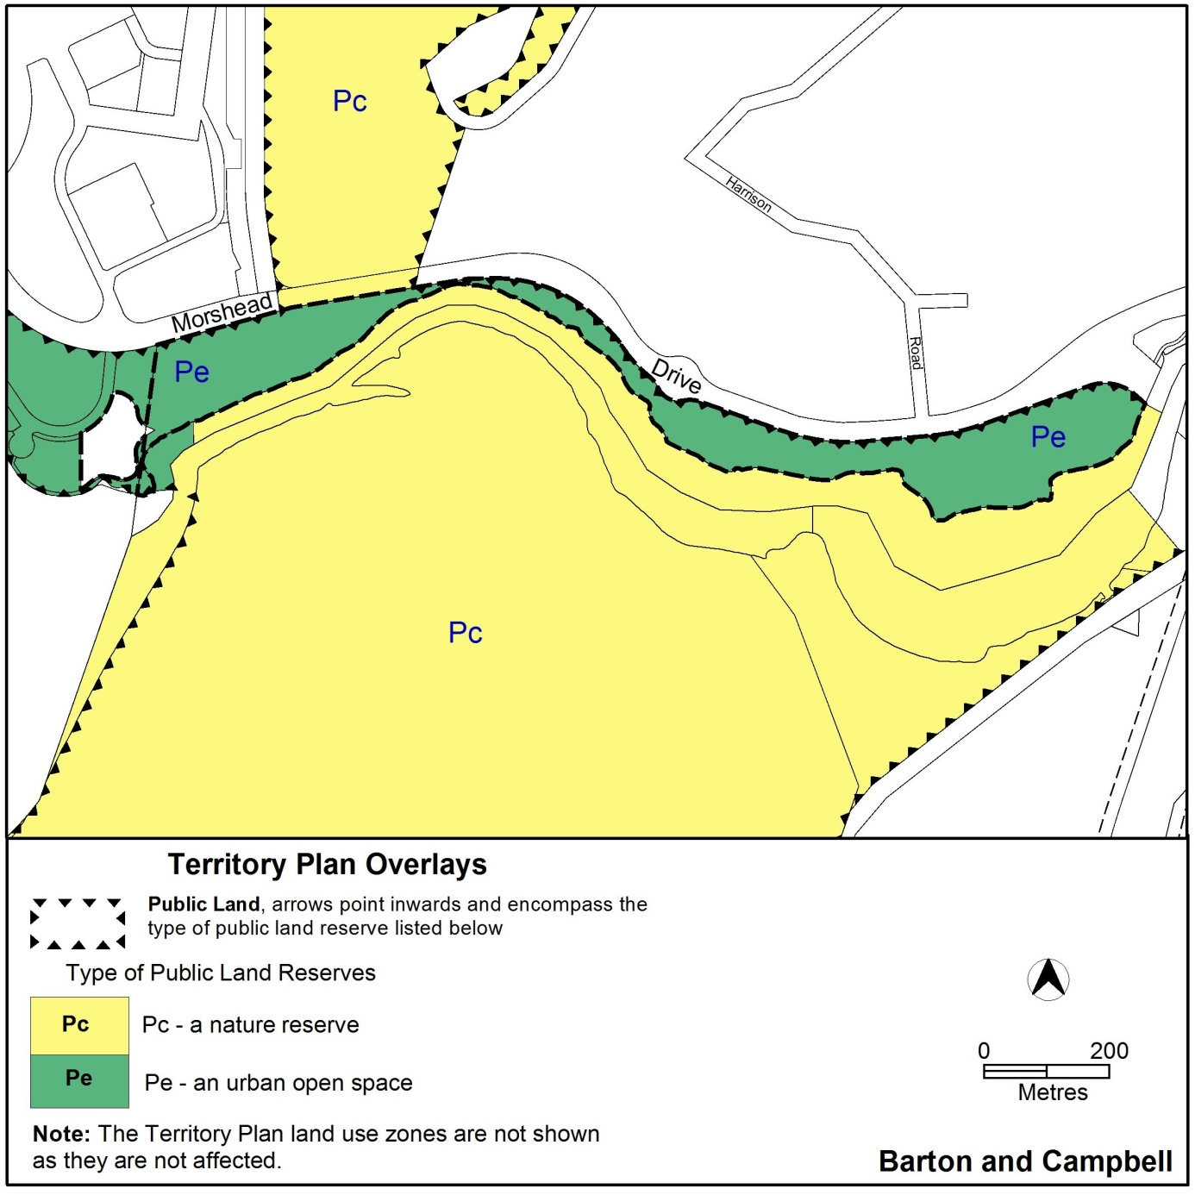

- TECHNICAL AMENDMENT
This section of the technical amendment document provides the actual instructions for implementing the changes to the Territory Plan.

  - Territory Plan Map

Substitute the ‘Subject Area’ on the Territory Plan map:

Interpretation service
