Australian Capital Territory

Planning and Development (Technical Amendment—Kingston) Plan Variation 2015 (No 1)

Notifiable Instrument NI2015—115
Technical Amendment No 2015—04
made under the
Planning and Development Act 2007, section 89 (Making technical amendments) s96 (land ceases to be in future urban area)

This plan variation commences on the day after it is notified.

Variation No 2015—04 to the Territory Plan has been approved by the Planning and Land Authority.

Variation to the Territory Plan
The Territory Plan map is varied as indicated in Annexure A to identify the zone that apply to the land ceasing to be in a future urban area.

Variation to the Precinct Map and Code
Replace RC4 – Kingston Foreshore and RC5 – Canberra Avenue Corridor Site, from Element 7 to Element 11 of the Kingston Precinct Map and Code at Annexure B to incorporate ongoing block specific provisions for the area.

Jim Corrigan
Delegate of the Planning and Land Authority
13/03/2015

THIS IS PAGE ONE OF ANNEXURE A
TO NOTIFIABLE INSTRUMENT NI2015 – 115

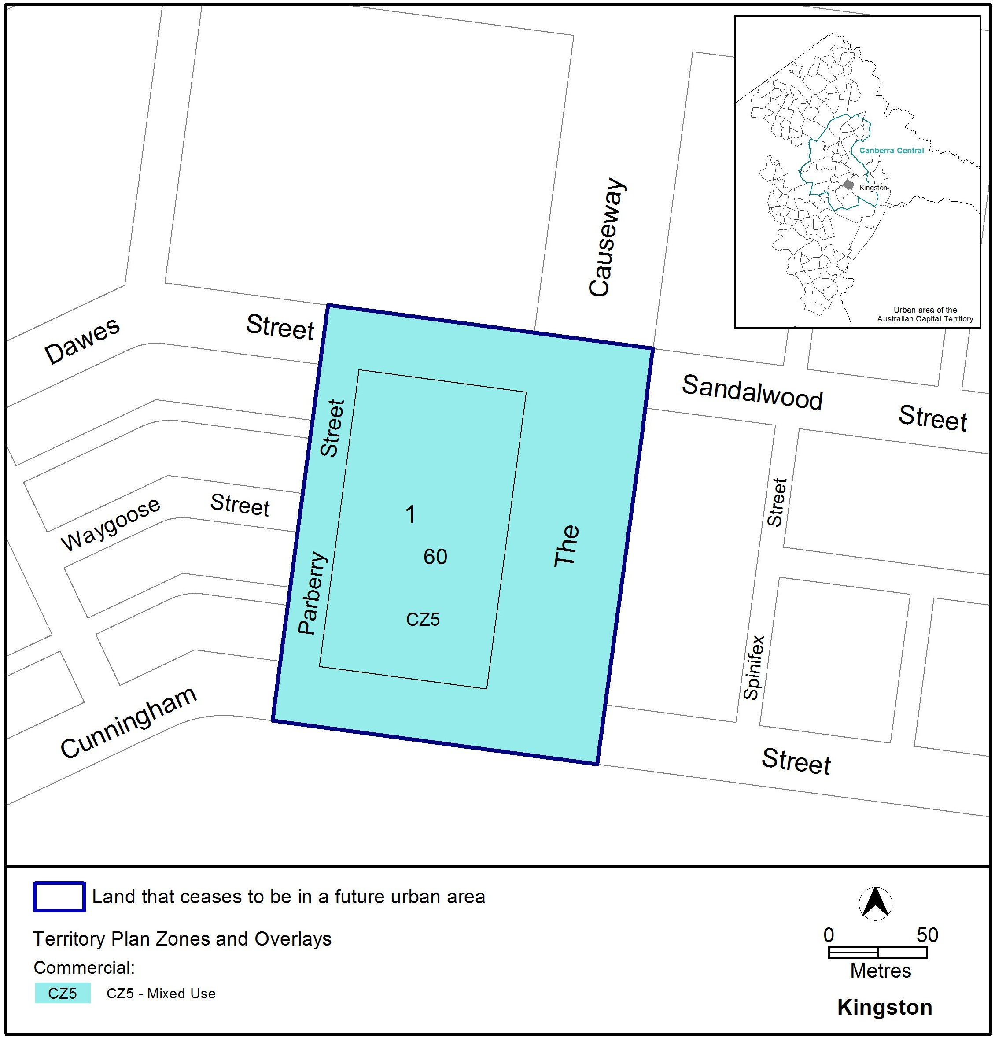

Jim Corrigan
Delegate of the Planning and Land Authority
13/03/15
THIS IS PAGE ONE OF ANNEXURE B
TO NOTIFIABLE INSTRUMENT NI2015 –115

Jim Corrigan
Delegate of the Planning and Land Authority
13/03/15
Replace RC4 – Kingston Foreshore and RC5 – Canberra Avenue Corridor Site, from Element 7 to Element 11 of the Kingston Precinct Map and Code

Element 7: Use

Rules | Criteria
7.1 Shop
There is no applicable rule. | C33  SHOP development achieves one or more of the following:  - a convenience service limited to the local workforce and residents  - related to the sale of entertainment and leisure goods such as specialty items or arts, crafts and souvenirs
R34  The maximum gross floor area of SHOP selling food is 250m2. | This is a mandatory requirement. There is no applicable criterion.
7.2 Major utility installation
R35  Only a MAJOR UTILITY INSTALLATION that is  essential to the operation of the electricity supply network, the augmentation of the local water and sewerage system or the management of the stormwater system may be approved.  An application for a MAJOR UTILITY INSTALLATION is accompanied by written endorsement of a relevant service provider. | This is a mandatory requirement. There is no applicable criterion.

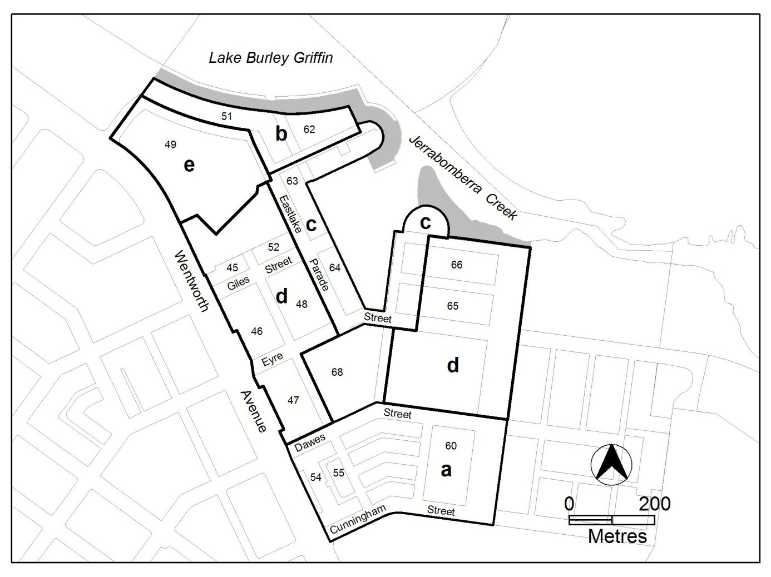
Figure 4 Kingston Foreshore

Rules | Criteria
7.3 Residential use and office
There is no applicable rule. | C36  This rule applies to the area c shown in figure 4.  Buildings at the ground floor level achieve all of the following:  - avoid office and RESIDENTIAL USE in areas fronting main pedestrian areas and routes  - adaptable for commercial use
7.4 Office
R37  This rule applies to the areas b, c and e shown in figure 4.  The maximum gross floor area of office  complies with all of the following  - 500m2 per tenancy  - 2000m2 per lease | This is a mandatory requirement. There is no applicable criterion.

Rules | Criteria
R38  This rule applies to the area d shown in figure 4.  The maximum gross floor area of office per lease is 2000m² | This is a mandatory requirement. There is no applicable criterion.
7.5 Parberry Street/ The Causeway
There is no applicable rule. | C39  This criterion applies to figure 5:  The ground floor level of all buildings fronting The Causeway are designed to be adaptable for commercial use.

Element 8: Buildings

Rules | Criteria
8.1 Number of storeys
R40  The maximum number of storeys is 4 with a parapet level at the third storey level. | C40  The number of storeys achieve all of the following:  - a limited number of buildings may exceed 4 storeys provided they comply with all of the following:  - they achieve urban design objectives such as adding visual interest to the built form, appropriately framing major public spaces, marking important corners or transition points, or screening unsightly elements from the public domain  - they do not significantly impact on the landscape of the area  - their ground floor level is not greater than RL 560m  - they do not detract or compromise views and vistas to the Power House  - the footprint of the higher building elements is no greater than a 15m x 20m rectangle  - to retain significant visual links between the Power House building and East Basin, the roofline of development in area b is punctuated to frame and emphasise the views of the Power House building  - the overall maximum height of building does not exceed the lesser of RL578m or 20m

Rules | Criteria
R41  This rule applies to area A shown in figure 5.  A maximum of 2 storeys is permitted to Parberry Street.  The two storey height limit applies for the first 3m of all built form along the frontage with Parberry Street. | This is a mandatory requirement. There is no applicable criterion.
R42  This rule applies to area B shown in figure 5.  The maximum number of storeys is 4. | This is a mandatory requirement. There is no applicable criterion.
8.2 Built Form
R43  This rule applies to figure 5.  Built form fronting The Causeway is broken into a minimum of 3 buildings.  The separation between buildings is a minimum of 10m.  Separation may need to be increased to allow for solar access to all north facing dwellings at all levels in order to meet the requirements of the Multi Unit Housing Development Code. | This is a mandatory requirement. There is no applicable criterion.
8.3 Roof forms, materials and finishes
There is no applicable rule. | C44  Building roof forms, materials and finishes achieve all of the following  - colour scheme is light in tone although some highlighting with darker colours may be acceptable where these do not present the dominant colour scheme when viewed from or across Lake Burley Griffin  - high quality, durable and low maintenance materials are used on buildings and structures near the edge of Lake Burley Griffin  - avoid the use of highly reflective materials on buildings fronting the edge of Lake Burley Griffin

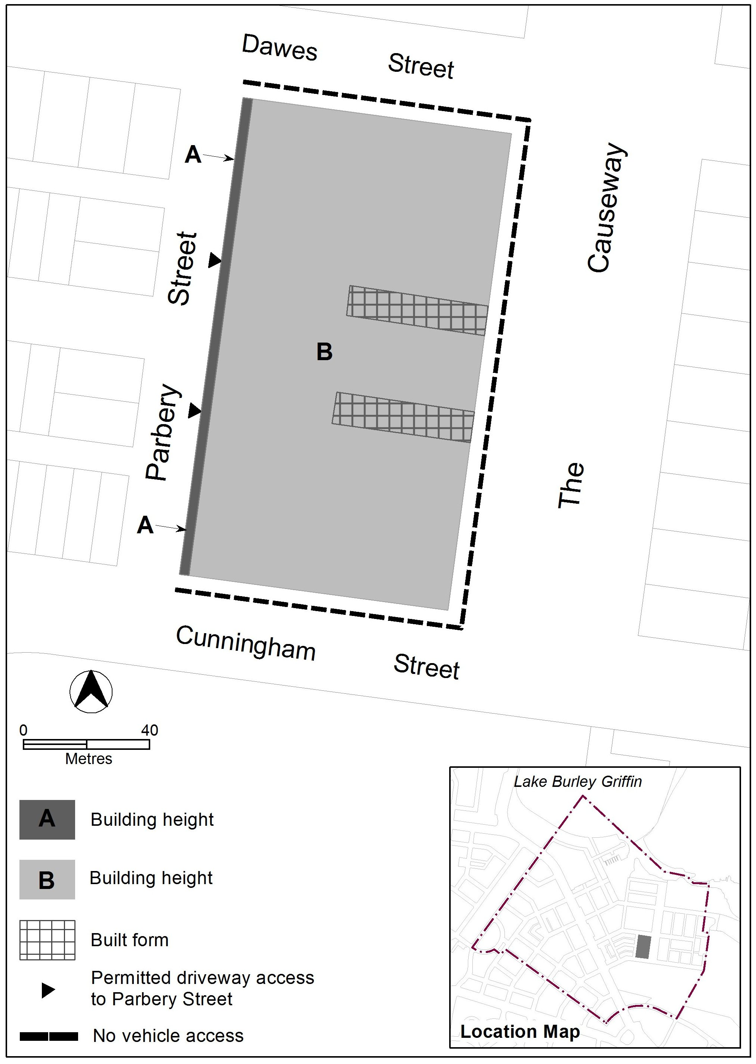

Figure 5 Parberry Street/ The Causeway

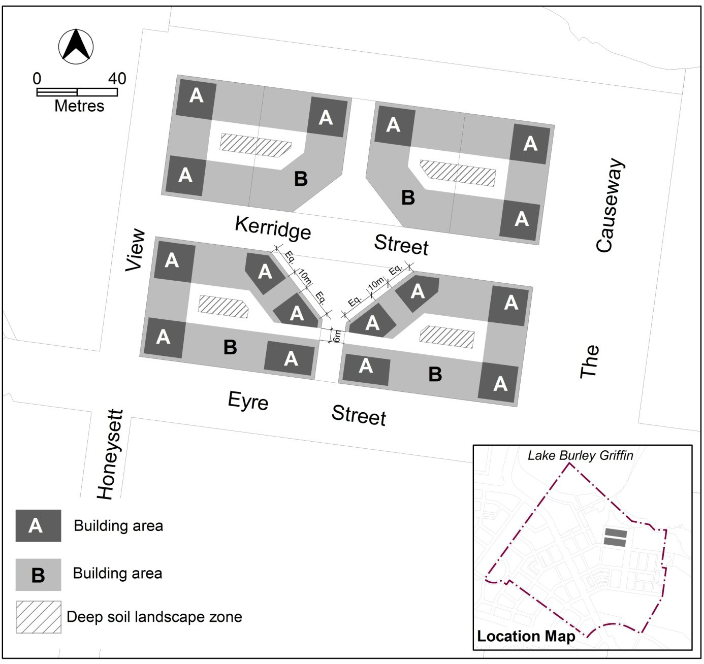

Figure 6 Kerridge Street

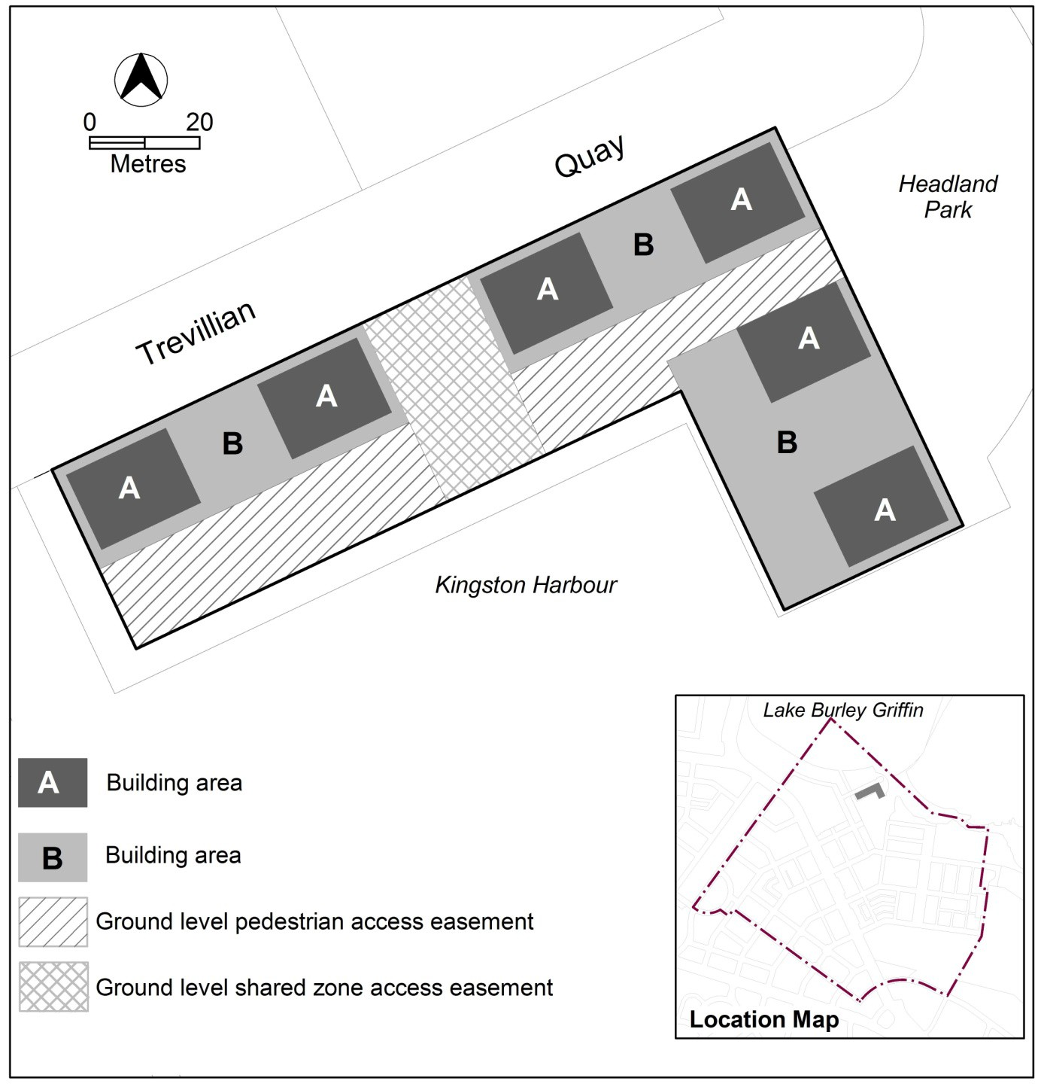

Figure 7 Trevillian Quay - South

Rules | Criteria
8.4 Kerridge Street
R45  This rule applies to each area A shown in figure 6.  The maximum number of storeys is 6.  The maximum height of building is the lesser of RL578 and 20m.  The maximum floor area for storey 5 is 300m². The maximum floor area for storey 6 is 300m².  The maximum external horizontal dimension for any part of the building over 4 storeys is 20m.  The minimum front boundary setback for that part of the building with more than 4 storeys is 2m.  Rule 18 does not apply. | This is a mandatory requirement. There is no criterion.
R46  This rule applies to each area B shown in figure 6.  The maximum number of storeys is 4.  The maximum external horizontal depth is 18m (including enclosed building area and articulation elements but excluding awnings over footpaths and basements). | C46  4 storey building elements achieve all of the following:  - alignment to the block perimeter  - high levels of natural daylight, ventilation and solar access to dwellings  - central courtyards sized to meet the reasonable needs of residents.
8.5 Trevillian Quay
R47  This rule applies to each area A shown in figure 7.  The maximum dimensions for each area A are 20m x 15m.  The maximum number of storeys is 6.  The maximum height of building is the lesser of RL578 and 20m  The minimum setback from Trevillian Quay and Headland Park for that part of the building with more than 4 storeys is 2m.  Rule 18 does not apply. | This is a mandatory requirement. There is no criterion.
R48  This rule applies to each area B shown in figure 7.  The maximum number of storeys is 4. | This is a mandatory requirement. There is no criterion.

Element 9: Site

Rules | Criteria
9.1 Outdoor lighting
There is no applicable rule. | C49  Outdoor lighting in the area should generally use full-cut off light fittings and up-lighting of buildings and structures should be carefully designed to keep night time overspill lighting to a minimum.
There is no applicable rule. | C50  The overall lighting impact should not compete in prominence with the lighting of the National Triangle. The area should be lit predominantly with high pressure sodium light sources for streets and mercury vapour for pedestrian routes. Lake frontages external lighting should use metal halide sources. There should be no flashing or laser beam lighting on or around buildings fronting Lake Burley Griffin.
9.2 Kerridge Street - deep soil landscape zones
R51  This rule applies to the hatched areas identified as deep soil landscape zones in figure 6.  The location of deep soil landscape zones are indicatively shown in figure 6.  Deep soil landscape zones represent a minimum of 10% of the total site area. | C51  Provision is made for sufficient soil to allow planting and growth of healthy canopy trees in the central courtyards.
9.3 Trevillian Quay - shared zone
R52  Ground level shared zone access easements are provided in accordance with figure 7. | C52  Shared zones achieve all of the following:  - safe and convenient public pedestrian access to buildings on the site and the foreshore  - reasonable vehicular access to the foreshore.

Rules | Criteria
9.4 Trevillian Quay - pedestrian areas
R53  Ground level pedestrian access easements are provided in accordance with figure 7. | C53  Pedestrian access easements achieve all of the following:  - safe and convenient public pedestrian access to buildings on the site and the foreshore  - provision for small scale ancillary buildings and structures associated with harbour operations.
9.5 Vehicular access
R54  This rule applies to figure 5.  No vehicle access is permitted in areas shown in figure 5. | This is a mandatory requirement. There is no applicable criterion.
R55  This rule applies to figure 5.  Driveways are permitted to Parberry Street in locations shown in figure 5. | This is a mandatory requirement. There is no applicable criterion.

RC5 – Canberra Avenue Corridor Site
This part applies to blocks and parcels within area RC5 shown on the Kingston precinct map.
RC5 includes the Canberra Avenue corridor site.

Element 10: Use

Rules | Criteria
10.1 Restaurant and shop
R56  One or more of the following uses are permitted where it is ancillary to other uses:  - restaurant  - SHOP | This is a mandatory requirement. There is no applicable criterion.

Element 11: Buildings

Rules | Criteria
11.1 Number of storeys
R57  The maximum number of storey is 4. | C57  The number of storeys comply with all of the following:  - are compatible with existing, or future desired character of, adjacent development  - are appropriate to the scale and function of the use  - minimise detrimental impacts, including overshadowing and excessive scale  - are no higher than the established tree canopy along main avenues with primarily landscaped frontage
11.2 Materials and finishes
R58  Building colours are off-white to light buff/grey. | C58  Building colours achieve all of the following:  - Relate to clearly defined elements of the building  - are predominantly earthy toned  - minor elements in the building facade may be accented  - subsidiary to the main off-white to light buff/grey materials

