Australian Capital Territory
Planning and Development (Draft Variation No 351) Consultation Notice 2015
Notifiable Instrument NI2015—220
made under the
Planning and Development Act 2007, section 63 (Public consultation—notification) and section 64 (Public consultation—notice of interim effect etc)

Under the Planning and Development Act 2007 (the Act), section 63(1), the planning and land authority has prepared Draft Variation No 351 to the Territory Plan – West Belconnen Urban Development (see Annexure A).
Draft Variation No 351 to the Territory Plan proposes to
- rezone part of the site to a range of urban zones
- introduce a nature reserve overlay to the river corridor
- rezone the Transgrid Canberra Substation to a Transport and Services zoning
- rezone the Strathnairn Arts Precinct and Belconnen Farm Heritage Precinct to community facility zone
- apply a future urban area (FUA) overlay to part of the site
- introduce a site-specific structure plan and concept plan into the Territory Plan

The draft variation and background documents are available online at www.act.gov.au/draftvariations until the closing date for written comments.

Printed copies of the draft variation and background documents are available for inspection and purchase at the Environment and Planning Directorate Customer Service Centre, 16 Challis Street, Dickson, Monday to Friday (except public holidays) between 8:30am and 4:30pm. Please call 6207 1923 to arrange a copy for purchase.

Written comments from the public are invited from the public by COB Monday 6 July 2015.

Comments should include reference to the draft variation, your name and contact details, and be addressed to the Territory Plan Unit.

Comments can be:
- emailed to terrplan@act.gov.au
- mailed to Territory Plan Comments, GPO Box 158, Canberra, ACT 2601
- delivered to EPD’s Customer Service Centre at 16 Challis Street, Dickson

Copies of written comments will be made publicly available 10 working days after the closing date for no less than 15 working days at EPD’s Customer Service Centre in Dickson and may be published on EPD’s website.

Comments made available will include personal contact details unless excluded under section 411 or 412 of the Act. A request for exclusion under these sections must be in writing, clearly identifying what you are seeking to exclude and how the request satisfies the exclusion criteria.

Effect of the draft variation

Section 65 of the Act does not apply in relation to the draft variation so it does not have interim effect. The current Territory Plan will continue to apply while the variation remains in draft form.

Jim Corrigan
Delegate of the ACT Planning and Land Authority
19 May 2015

Annexure A

Planning and Development Act 2007

Draft
Variation to the
Territory Plan
No 351

West Belconnen Urban Development
Belconnen District

May 2015

Draft variation for public consultation prepared
under s60 of the Planning and Development Act 2007

This page is intentionally blank.

Contents

1. INTRODUCTION 1
1.1 Summary of the Proposal 1
1.2 Outline of the process 1
1.3 This document 3
1.4 Public Consultation 3
2. EXPLANATORY STATEMENT 4
2.1 Background 4
2.2 Site Description 4
2.3 Current Territory Plan Provisions 7
2.4 Proposed Changes 8
2.4.1 Proposed Changes to the Territory Plan Map 8
2.4.2 Proposed Changes to Territory Plan 8
2.5 Reasons for the Proposed Draft Variation 10
2.6 Planning Context 10
2.6.1 National Capital Plan 10
2.6.2 Territory Plan 11
2.7 Interim Effect 12
2.8 Consultation with Government Agencies 12
3. DRAFT VARIATION 20
3.1 Variation to the Territory Plan 20

This page is intentionally blank.

- INTRODUCTION
  - Summary of the Proposal
The draft variation proposes to rezone an area immediately west of the suburbs of Holt and Macgregor for future urban development. The main changes indicating potential future urban development patterns and guiding future development and assessment of the area include:
- rezoning part of the site to a range of urban zones
- introducing a nature reserve overlay to the river corridor zone
- rezoning the Transgrid Canberra Substation to a Transport and Services zoning
- rezoning the Strathnairn Arts Precinct and Belconnen Farm Heritage Precinct to community facility zone
- apply a future urban area (FUA) overlay to part of the site
- introduce a site-specific structure plan and concept plan into the Territory Plan

  - Outline of the process
The Commonwealth’s Australian Capital Territory (Planning and Land Management) Act 1988 allows for the Legislative Assembly to make laws to establish a Territory Planning Authority and for that Authority to prepare and administer a Territory Plan. The Planning and Development Act 2007 (the Act) establishes the planning and land authority as the Authority which prepares and administers the Territory Plan, including continually reviewing and proposing amendments as necessary. The functions of the planning and land authority are administered by the Environment and Planning Directorate (EPD).
The Territory Plan is comprised of a written statement and a map. The written statement contains a number of parts, namely governance; strategic directions; zones (including objectives and development tables and zone or centre development codes); precinct codes; general codes; overlays; definitions; structure plans, concept plans and development codes for future urban areas.
The Territory Plan Map graphically represents the applicable land use zones (under the categories of residential, commercial, industrial, community facility, urban parks and recreation, transport and services and non urban), precincts and overlays. The zone, precinct and overlay requirements are detailed in the volumes of the Territory Plan.
Draft variations to the Territory Plan are prepared in accordance with the Act. Following the release of the draft variation under section 63 of the Act, submissions from the public are invited. At the conclusion of the consultation period the EPD submits a report on consultation and a recommended final variation to the Minister responsible for planning for approval. The Minister has the discretion to determine if referral to the Legislative Assembly standing committee responsible for planning is warranted prior to approval, depending on the nature and significance of the proposal. If the draft variation is referred to the committee by the Minister or otherwise, the Minister must consider the findings of the committee before deciding whether to approve the draft variation. If the Minister approves the variation, the variation and associated documents will be tabled in the Legislative Assembly. Unless disallowed by the Legislative Assembly within five sitting days, the variation commences on a day nominated by the Minister.

  - This document
This document contains the background information in relation to the proposed variation. It comprises the following parts
Part 1 This Introduction
Part 2 An Explanatory Statement, which gives reasons for the proposed variation and describes its effect
Part 3 The Draft Variation, which details the precise changes to the Territory Plan that are proposed
  - Public Consultation
Written comments about the draft variation are invited from the public by Monday 6 July 2015.
Comments should include reference to the draft variation, your name and contact details, and be addressed to the Territory Plan Section.
Comments can be:
- emailed to terrplan@act.gov.au
- mailed to Territory Plan Section, GPO Box 158, Canberra, ACT 2601
- delivered to EPD’s Customer Service Centre at 16 Challis Street, Dickson
Copies of written comments will be made available (unless excluded) for public inspection for no less than 15 working days starting 10 working days after the closing date for comment. The comments will be available at EPD’s customer service centre in Dickson and may be published on EPD’s website.
Comments made available will include personal contact details unless excluded under section 411 or 412 of the Planning and Development Act 2007. A request for exclusion under these sections must be in writing, clearly identifying what you are seeking to exclude and how the request satisfies the exclusion criteria.
Further Information
The draft variation and background documents are available online at www.act.gov.au/draftvariations until the closing date for written comments.
Printed copies of the draft variation (this document) and background documents are available for inspection and purchase at the Environment and Planning Customer Service Centre, 16 Challis Street, Dickson, Monday to Friday (except public holidays) between 8:30am and 4:30pm. Please call 6207 1923 to arrange a copy for purchase.

- EXPLANATORY STATEMENT
  - Background
The development potential of West Belconnen was previously recognized in the Canberra Spatial Plan. In 2012, the Canberra Spatial Plan was replaced by the ACT Planning Strategy. The Planning Strategy is the current long-term planning policy that ‘provides long-term planning policy and goals to promote orderly and sustainable development, consistent with the social, environmental and economic aspirations of the people’ in the ACT. In the planning strategy, the site is marked as a ‘future urban investigation area’ for future possible settlement. This draft variation is to put the intent of the planning strategy into effect.
The proposed development is expected to accommodate approximately 6500 dwellings and associated retail and community infrastructure. It proposes a 360ha conservation corridor along the Murrumbidgee River. The proposed development also extends into NSW, where there will be potential to accommodate a further 5000 dwellings and to add a further 220ha to the conservation corridor.
As such, the proposal is subject to a rezoning of the Yass Valley Local Environment Plan, a variation to the Territory Plan, an amendment to the National Capital Plan and environmental approvals from the Commonwealth and ACT Government. This document is the explanatory document for a draft variation to the Territory Plan, which only applies to land in the ACT.

  - Site Description
The area subject to the proposed variation is at West Belconnen, immediately beyond the existing suburbs of Holt and Macgregor. The Murrumbidgee River provides the south western and western boundary and Ginninderra Creek is the northern boundary for the NSW land. Woodstock nature reserve is located along the southern bank of the Murrumbidgee River immediately opposite the site in the ACT.
The area includes the following rural blocks in the district of Belconnen blocks 853; 856; 857; 858; 859; 860; 993; 1329; 1332; 1333; 1420; 1440; 1442; 1540; 1559; 1560;1586; 1605; 1606; 1607; 1613; 1621; 1622; and parts of block 1620 Belconnen, block 7 section 149 Macgregor and block 2 section 186 Dunlop.
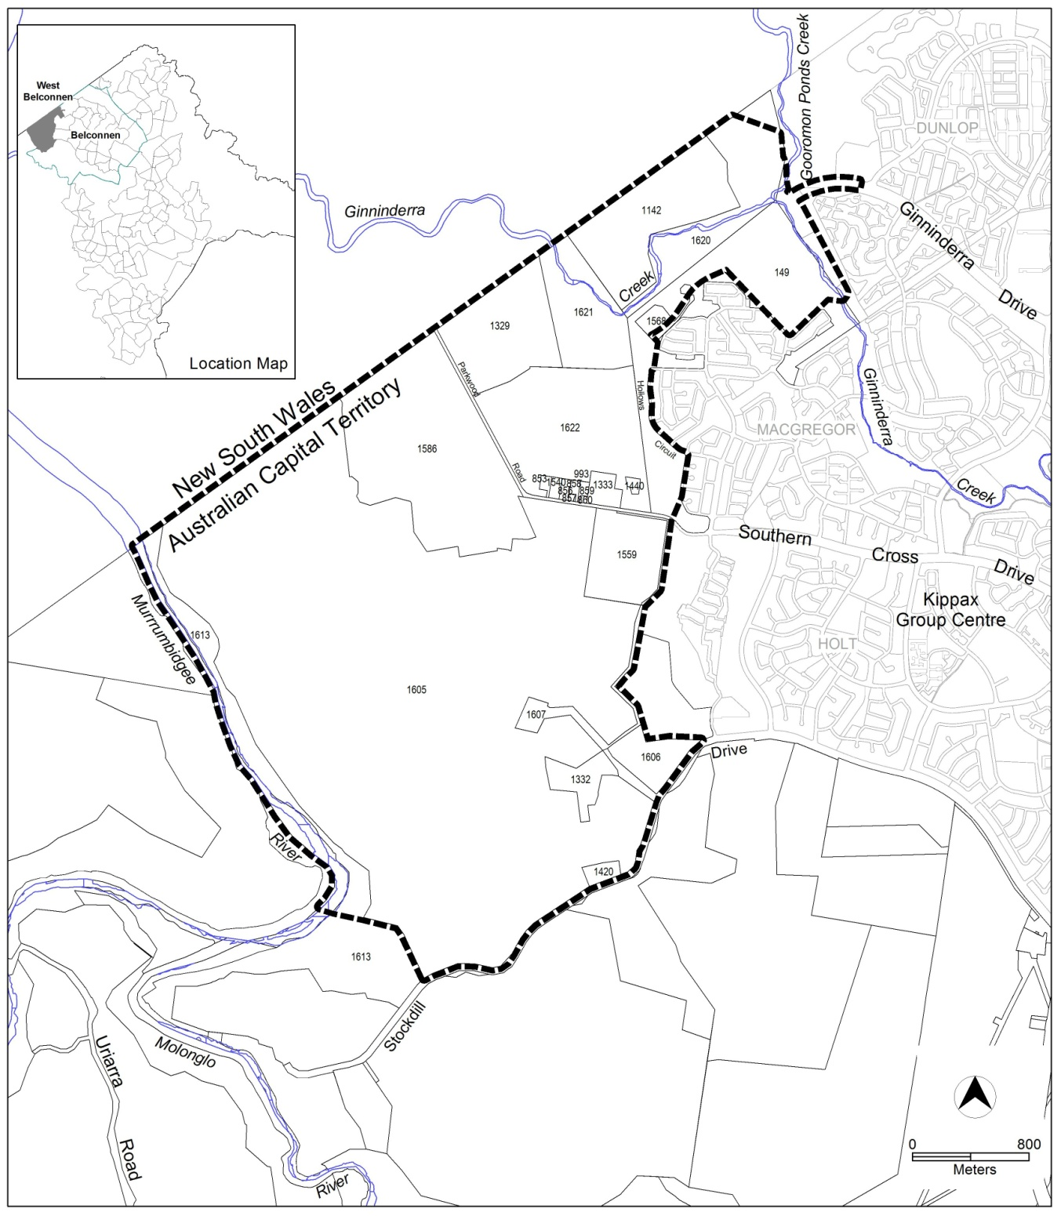
Figure 1 Site Plan
This draft variation also includes the potential extension of Ginninderra Drive to the development area. The road’s alignment is likely to impact on the existing Jarramlee and West Macgregor environmental offset areas. As a consequence, the road’s extension will be subject to a separate approval under the Commonwealth’s Environment Protection Biodiversity and Conservation Act 1999 (EPBC Act). For the purposes of this draft variation, the preferred alignment for the road is indicative. It should be noted that the final variation will reflect the actual road alignment, if approved by the Commonwealth.
There are various existing uses/activities within the site. It includes TransGrid Canberra Substation, Strathnairn Arts Precinct, Billabong Aboriginal Development Corp facility, Belconnen Farm, Belconnen landfill site, horse paddocks, Green Waste and Parkwood Egg Farm.
Due to the nature of the uses, Belconnen landfill site, Green Waste and Parkwood Egg Farm are considered incompatible with residential development. As such, clearance zones around these uses are retained until such time as they cease operation. Clearance zones may be adjusted subject to an appropriate audit process and approval of the Environment Protection Authority.
An exclusion area has been established around the nest tree of a breeding pair of Little Eagles in the Lower Molonglo area, awaiting the findings of a research project currently underway to determine where the pair of Little Eagles is mainly foraging. As such, urban development is not permitted until such time as the research on the Little Eagle has been completed and confirms the site’s suitability for development.
A new ActewAGL zone substation is required to service the development. A site for the ActewAGL zone substation has been identified to the south of the existing TransGrid Canberra Substation.
  - Current Territory Plan Provisions
The Territory Plan map zones for the area subject to this variation are shown in Figure 2.
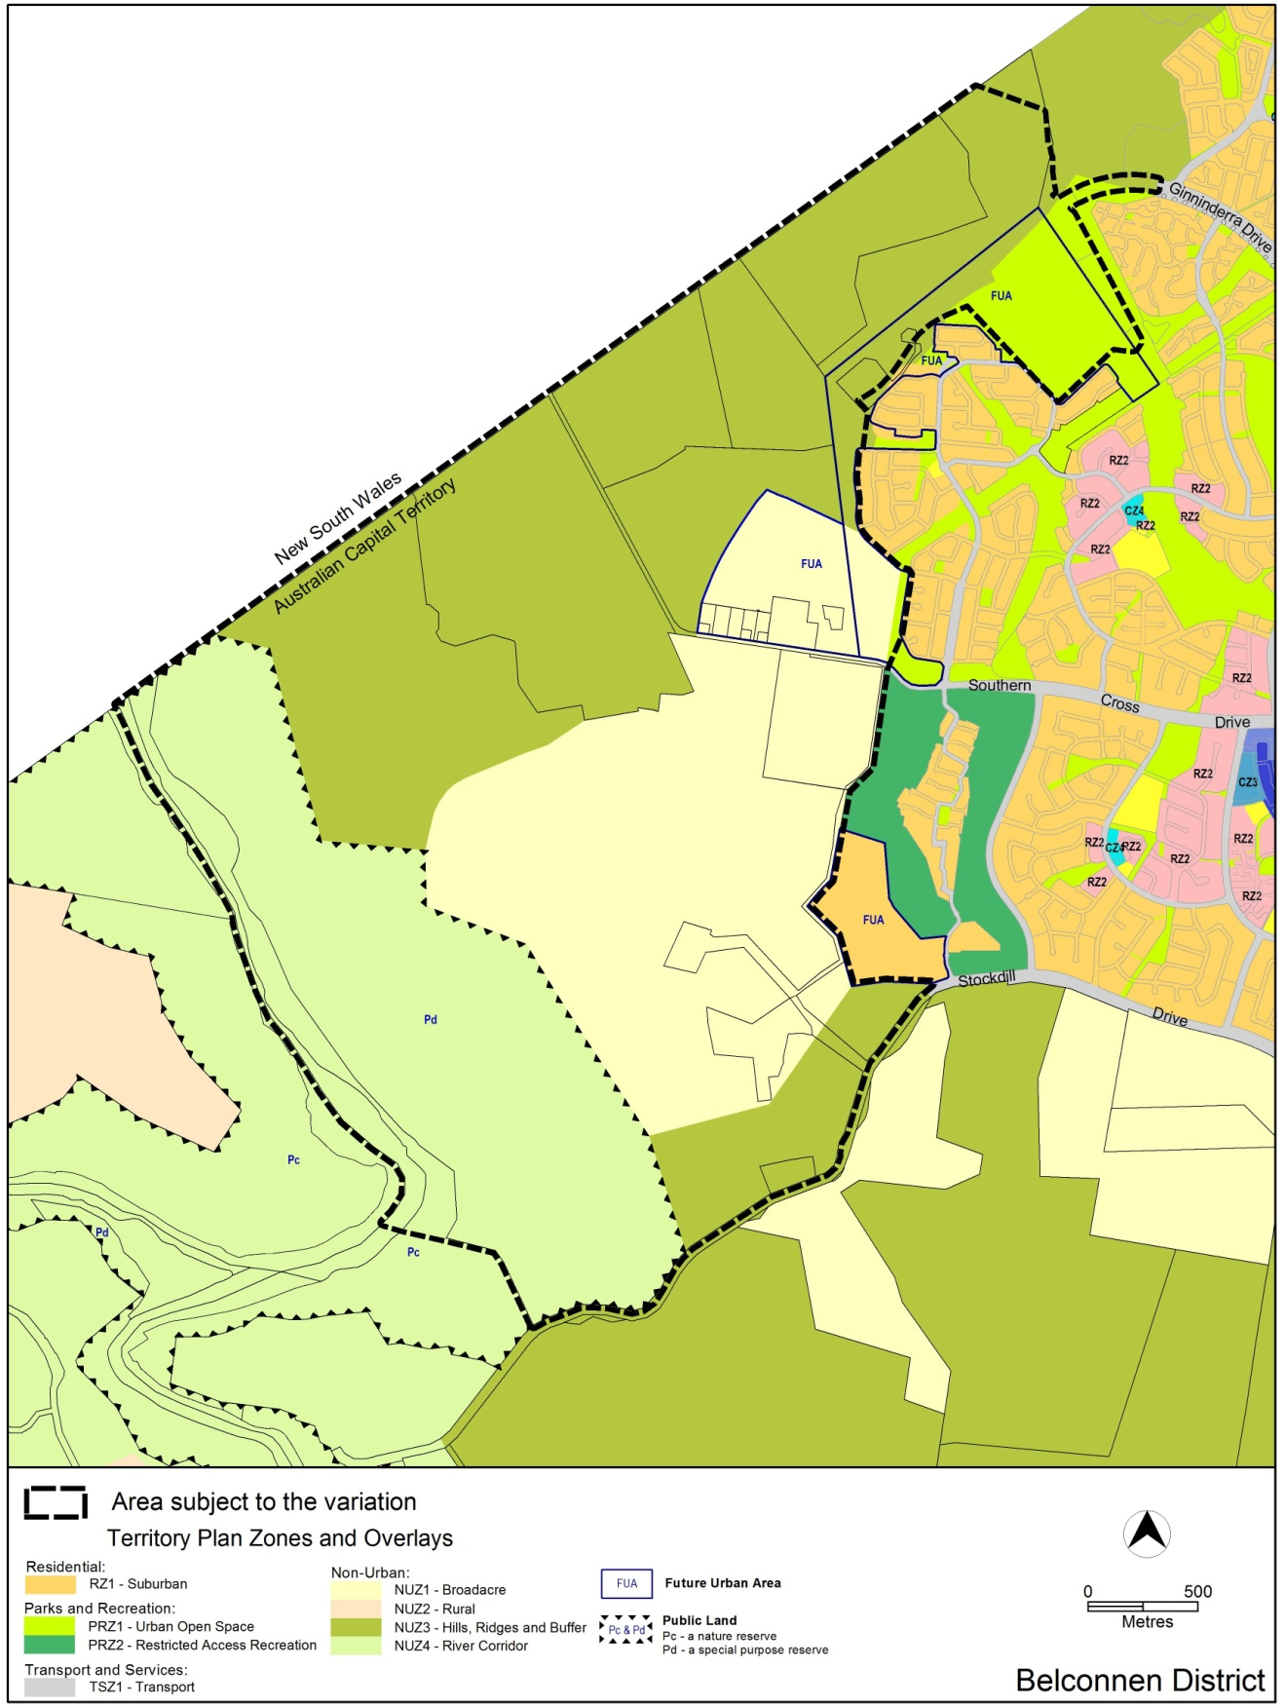
Figure 2 Territory Plan Zones Map

  - Proposed Changes
    - Proposed Changes to the Territory Plan Map
The proposed changes to the Territory Plan map are indicated in Figure 3 at Part 3 of this document and are detailed as follows:
- Remove current land use zones of Broadacre; Hills, Ridges and Buffer from part of the site
- Insert various urban zones including TSZ2 services to part of the site
- Rezone the Strathnairn Arts Precinct and Belconnen Farm Heritage Precinct to community facility zone
- Apply a future urban area overlay to part of the site
- Adjust the river corridor boundary
- Apply a Pc nature reserve overlay to part of the site
- Apply an indicative location for the Ginninderra Drive extension
The draft variation map indicates the proposed zone boundaries as accurately as possible but may be subject to adjustments following detailed surveys.
Ginninderra Drive extension
It should be noted that the road alignment of Ginninderra Drive extension nominated in this draft variation is indicative and subject to a separate approval under the EPBC Act because the road may impact on the existing Jarramlee and West Macgregor environmental offset areas. If the road is approved under the EPBC Act, it will be reflected in the final variation.

    - Proposed Changes to Territory Plan
It is proposed to amend the Territory Plan in the following manner:
1. At Belconnen District Precinct Map and Code of 10.2 District Precinct Maps and Codes, substitute
Belconnen District Precinct Map
(see Appendix A)
2. At Part 14 Structure Plans, substitute
West Belconnen Structure Plan
(see Appendix B)

3. At Part 15 Concept Plans – Precinct Codes for Section 93 of the Planning and Development Act 2007, insert
West Belconnen Concept Plan
(see Appendix C)
4. Proposed changes to Strathnairn Arts Precinct
The rezoning of the Strathnairn Arts Precinct on Block 1332 Belconnen from Broadacre zone to Community Facility zone is proposed to more accurately reflect the use of the land as an artist facility by the Strathnairn Arts Association under licence from the ACT Government (Arts ACT). The facility provides working spaces and facilities for a range of artists, crafts people and community groups.
To support the development of West Belconnen and to provide flexibility for the facility into the future, it is proposed to add the following use to the Community Facility zoning, as an area specific policy:
- Craft workshop
- Place of assembly
- Produce market
- Restaurant (limited to a maximum of 250m² for the entire block)
- Shop (limited to a maximum of 100m² for the entire block but excluding uses that are ancillary to the main use of the land for arts and craft)
- Business agency (limited to a maximum 500m² for the entire block)
The Future Urban Area provision applies to the land that accommodates the Strathnairn Arts Precinct only to permit some minor rationalising of the block’s boundaries with the adjacent area.
5. Proposed changes to Belconnen Farm Heritage Precinct
The rezoning of the Belconnen Farm Heritage Precinct on part Block 1605 Belconnen from Hills, Ridges and Buffer to Community Facility zone is proposed to more accurately reflect the use as a heritage precinct.
To support the development of West Belconnen and subject to being consistent with the heritage registration, it is proposed to add the following use to the Community Facility zoning, as an area specific policy:
- Craft workshop
- Place of assembly
- Produce market
- Restaurant (limited to a maximum of 250m² for the entire block)
- Shop (limited to a maximum of 100m² for the entire block but excluding uses that are ancillary to the main use of the land for arts and craft)
- Business agency (limited to a maximum 500m² for the entire block)
The Future Urban Area provision applies to the land that accommodates the Heritage Precinct only to permit the future creation of a block for the Heritage Precinct.

  - Reasons for the Proposed Draft Variation
The reason for the draft variation is as follows:
- West Belconnen is recognised as being suitable for future possible settlement in the ACT Planning Strategy, which states that West Belconnen is an ‘area(s) for future possible settlement within the ACT …will be considered in a regional context and in terms of their interrelationships with immediately adjoining areas of NSW’. This draft variation is to put this intent into effect.
- As such, West Belconnen is identified in the ACT Government’s Indicative Land Release Program 2014/15 to 2017/18 (published June 2014) for land release commencing in the 2015/16 financial year.

  - Planning Context
    - National Capital Plan
The Australian Capital Territory (Planning and Land Management) Act 1988 established the National Capital Authority (NCA) with two of its functions being to prepare and administer a National Capital Plan (NCP) and to keep the NCP under constant review and to propose amendments to it when necessary.
The NCP, which was published in the Commonwealth Gazette on 21 January 1990 is required to ensure that Canberra and the Territory are planned and developed in accordance with their national significance. The Planning and Land Management Act 1988 also required that the Territory Plan is not inconsistent with the NCP.

    - Territory Plan
Statement of Strategic Directions
The proposal is consistent with the Territory Plan’s statement of strategic directions in terms of environmental, economic and social sustainability and spatial planning and urban design principles.

1. Principles for Sustainable Development
General Principles
1.2 Matters of broader National Capital, metropolitan and regional significance will be carefully considered when formulating Territory Plan policies and when making decisions about development proposals and sequencing.

Social Sustainability
1.20 Planning policies for community facilities and open space will encourage multiple use and flexible design to allow for changing needs.

1.24 New suburban areas will be planned with a legible and permeable hierarchy of roads; conveniently located commercial and community facilities; a network of open spaces; an off-road system for pedestrians and cyclists; and provision for accessible public transport.

2. Spatial Planning and Urban Design Principles
Non-urban Areas

2.11 Planning policies will protect the landscape and environmental qualities of the hills and ridges surrounding urban areas, the Murrumbidgee and other river corridors, the mountains and forests west of the Murrumbidgee River, and productive rural landscapes.

2.13 Clearance zones will be established where necessary around major facilities to protect the operational efficiency of those facilities and to minimise adverse environmental impacts.

To ensure the landscape and environmental qualities of the hills and ridges and protect the water quality of the river surrounding the development area, the proposed development will have land of 360ha added to the river corridor. It looks at providing commercial and community facilities at a convenient location within its development area with provisions allocated for accessible public transport, urban open space, pedestrian and cycle ways. It also promotes energy efficiency, housing affordability through its staged development.

  - Interim Effect
Section 65 of the Planning and Development Act 2007 does not apply in relation to the draft variation so it does not have interim effect. The current Territory Plan will continue to apply while the variation remains in draft form.

  - Consultation with Government Agencies
The EPD is required to, in preparing a draft variation under section 61(b) consult with each of the following in relation to the proposed draft variation:
- the national capital authority
- the conservator of flora and fauna
- the environment protection authority
- the heritage council
- if the draft variation would, if made, be likely to affect unleased land or leased public land – each custodian for the land likely to be affected

National Capital Authority
The National Capital Authority provided the following comments on Friday 10 April 2015:
I refer to your letter of 25 March 2015 concerning Draft Variation to the Territory Plan 351 – West Belconnen (DV351).

As you are aware, the National Capital Authority (NCA) has commenced preparation of a Draft Amendment to the National Capital Plan (the Plan) to run concurrently with DV351. It is noted that the DV351 documentation only briefly refers to the Draft Amendment process. It is suggested that the NCA and EPD liaise to determine the level of information available in both DV351 and the NCA’s Draft Amendment to ensure that readers are adequately informed of the respective processes.

It is noted that the Belconnen landfill site is proposed to be zoned as Hills, Ridges and Buffers in DV351. The Planning Study Report outlines retention of the existing recycling estate followed by evolution to other non-residential uses currently under investigation. While the recycling estate is within existing use rights, a number of potential uses may be incompatible with those permitted for Hills, Ridges and Buffers in the Plan.

It is the NCA’s preference to zone the landfill site as Urban Land Use in the General Policy Plan – Metropolitan Canberra of the Plan (GPP). The proposed land use of Hills, Ridges and Buffers in the Territory Plan is considered not inconsistent with the proposed urban land use of the GPP. With this approach an additional amendment to the Plan will not be required should the master planning propose land uses inconsistent with Hills, Ridges and Buffers.

Response
Comments are noted and agree to the NCA’s preferred zoning for the landfill site in the GPP.

Conservator of Flora and Fauna
The Conservator of Flora and Fauna made the following comments on Friday 10 April 2015:
In accordance with Section 61(b) of the Planning and Development Act 2007, I advise that I have examined Draft Variation to the Territory Plan No 351, West Belconnen. The variation proposes to change the land use zoning immediately adjacent to the suburbs of Holt and Macgregor to facilitate future urban development of the area.

The proposed changes to the River Corridor – public land (nature reserve) boundaries are as previously agreed and can be supported.

The Variation also proposes changes to include a new Transport (TSZ1) zoning for a future extension to Ginninderra Drive. The construction of a road in this location will impact on an area set aside as an environmental offset for impacts on Golden Sun Moth from previous developments. This cannot be supported at this time as the road extension has not been approved; a route alignment has not been agreed upon; and the road would require offsetting of established offsets. The planning study report states that the Ginninderra drive completion “... is not an essential pre-requisite for the rezoning of the project area”. Until the issues regarding impacts of this road on the offset area have been addressed, and a final alignment has been agreed, the land use zoning should remain the current mixture of Hills Ridges and Buffer and Urban Open Space.

A minor matter of correction is how current research and the agreed approach to uncertainty regarding the use of the area surrounding the Little Eagle nest is described. The position is correctly described in the table on P151 of the Planning Study as:

“A research project is currently underway to determine where the pair of little eagles is mainly foraging, while an exclusion area has been established around the nest tree, and southern development area awaiting the findings of this research. “

This wording should be consistently used throughout the planning documents.

Changes need to be made to the documentation:

- Page 6 of the Draft Variation, where the position is not fully stated and gives the impression that an exclusion zone is permanently in place “A clearance zone is also applied to an area near Strathnairn Arts Centre and within the Lower Molonglo area so to protect a breeding pair of Little Eagles nesting in the area”. This should be changed to reflect the wording in the table on P151 in the Planning Study.

- Pages 127 and 132 of the Planning Study where it is stated that “Following identification of a little eagle presence on the site in late December 2013 and following subsequent consultation with ACT Conservation a report was prepared by ACT Conservation specifying measures to ensure the protection of the eagle nest site, including protection of the foraging area and a 200m clearance zone around the nest site itself”. The document would benefit from the addition of the wording as found in the table on P151 in the Planning Study.

- The Table within the Concept Plan needs to be amended to state:

Little Eagle Clearance Zone
No development including infrastructure and construction related activities will be permitted within 200m of the Little Eagle nesting tree and foraging area indicated in Figure 1. | Urban development is not permitted until such time as research on the Little Eagle has been completed and confirms that the site is suitable for development.

Water Quality
Protection of the Murrumbidgee River needs to be strengthened in the Structure Plan. It is recommended that the words as underlined are included.

- 4. General principles and policies (10) – Furthermore, appropriate sustainable urban water management measures will be implemented to manage runoff and reduce the number of run-off days to replicate, as closely as possible, pre development peak flows to protect river corridor, water quality and downstream ecology.

- 6.5 Environment Protection (16) – Best practice WSUD principles will be adopted at all levels of the development to minimise potable water usage, manage overland flows and protect water quality and aquatic habitat in the Murrumbidgee River and Ginninderra Creek.

- 6.6 Landscape and Open Space Principles (27) – Open space will be....... contributes to the legibility and character of urban development and assists in the effective management of stormwater including encouraging onsite infiltration.

- Stormwater management (84) – A WSUD strategy will be adopted to..... and minimise adverse impacts on flow regimes into the Murrumbidgee River and Ginninderra Creek. Flow regimes should reduce the number of run-off days to replicate, as closely as possible, pre development peak flows

The issue of a warming climate and climate change adaptation has not been addressed in the Variation. The development area of West Belconnen is significant in area and future population, with the intention for a much higher density than the established areas of Belconnen. This could significantly contribute to a number of climate related issues particularly the city heat island effect.

The Structure Plan would benefit from the inclusion of an additional policy headed Sustainable Development where the principles of adapting to a changing climate could be addressed. These principles could then be brought forward into the Concept Plan with rules that include relevant targets that need to be met in future estate developments e.g. a 50% summer shade target to all streets; deep root zones on all blocks (including multi unit sites) to enable the successful growth of shade trees, maximising permeable areas to allow water penetration; re-use of stormwater to irrigate playing fields and other high use public parks.

Response
Comments are noted and the documentation has been updated accordingly.
In relation to the extension of Ginninderra Drive, whilst the Conservator’s non-support of the road is noted, it is important that the road is included in the draft variation so that the full development is clearly documented, transparent and understood. In response, the draft variation has been updated to clearly identify that the road is subject to a separate approval under the Commonwealth’s Environment Protection Biodiversity and Conservation Act 1999 and that the alignment indicated is indicative. The final Variation will reflect the road alignment, if approved by the Commonwealth. If the extension is not approved, it will be removed from the final Variation.
In relation to sustainability, general principles have been included in the structure plan and a criterion added to the concept plan pending the adoption of policy and legislative requirements by Government. As new policy and legislation are implemented in the future, subdivision and development will need to comply with them.

Environment Protection Authority
The Environment Protection Authority provided the following comments on Wednesday 22 April 2015:
Thank you for the opportunity to review and provide comment on the revised draft variation to the Territory Plan, DV351, for the rezoning of land to progress the development of West Belconnen.
As noted in Section 6.1 of the SLR noise Assessment Report, ‘Existing Industrial Uses Noise Impact Assessment-SLR-140613_v1”, confirmation is required for proposed mitigation methods for noise from the Canberra Substation with follow-up measurements demonstrating the mitigation works have attenuated the noise to comply with the noise standard at the boundary of residential properties.
In addition, as per standard policy, prior to the use of any portion of the site for other purposes the site is required to be assessed, remediated and independently audited for suitability from a contamination perspective and the findings of the audit endorsed by the EPA.
Thank you again for the opportunity to comment on the draft variation and should you require further information please contact the Environment Protection Authority Liaison Officer on 6207 5642.
Response
Noted.

Heritage Council
ACT Heritage provided the following comments on behalf of the Heritage Council on Wednesday 15 April 2015:
Thank you for the opportunity to provide comments on the above Draft Territory Plan Variation (TPV).
We understand that the draft variation proposes to rezone an area immediately west of the suburbs of Holt and Macgregor for future urban development. The main changes proposed include: removal of current land use zones of Broadacre; Hills, Ridges and Buffer from part of the site; rezoning part of the site to a range of urban zones; applying a future urban area (FUA} overlay to part of the site; applying a Parks and Recreation overlay to part of the site; and introducing a site-specific structure plan and concept plan into the Territory Plan.
ACT Heritage comment on the proposed TPV is informed by the documents provided; and also by the ongoing heritage assessment of the West Belconnen Riverview Project, which has to date identified over 100 Aboriginal heritage sites in additional to the historic Belconnen Farm complex. While a Conservation Management Plan for Belconnen Farm has been prepared, the Project's Cultural Heritage Assessment for Aboriginal heritage sites is currently being revised prior to final submission to the Council, and the Council has not yet received the Project's Stage 1 Statement of Heritage Effect (SHE) or the Project's Conservation Management Plan for Aboriginal heritage places.
In this context, ACT Heritage does not object to the proposed rezoning of lands within the West Belconnen Urban Development Area, as Heritage Act 2004 provisions will continue to guide the management of heritage places and objects within this area.
However, ACT Heritage notes that the continued Aboriginal heritage assessment process may identify sites of high conservation value within the future urban zones of the proposed TPV. Appropriate management of such sites may include in situ conservation outcomes not anticipated at this time, but which may be identified through future liaison with the ACT Heritage Council, Representative Aboriginal Organisations and heritage practitioners.

ACT Heritage also has the following comments on documents provided as part of the proposed TPV:
- The Structure Plan provided should be amended in the following ways:
  - Section 4, Points 1 and 10 should include reference to heritage values, when discussing sustainable development principles and sustainable urban water management;
  - Section 4, Point 11, should be revised to refer to "Aboriginal and historic heritage places and objects" instead of "Aboriginal and historic heritage place";
  - Section 6.5, Point 18, currently states that heritage sites will be "conserved in a manner agreed by the ACT Heritage Unit and (where relevant) Registered Aboriginal Organisations". This should be revised to refer to "the ACT Heritage Council, and in consultation with Registered Aboriginal Organisations";
  - Section 7, Points 43 and 51, should include reference to heritage values, when describing the conservation corridor and the plan of management to be prepared for this area;
  - Section 7 should reflect the ACT Heritage Council requirement for a 'Conservation Management Plan' to be prepared for Aboriginal heritage places and objects within the West Belconnen Development Area;
  - Throughout, references to the Murrumbidgee River as a natural asset should be revised to a 'natural and cultural asset'; given the understanding of high cultural significance of the river emerging from the heritage assessment process; and

- The Concept Plan provided should be amended to include identification of known Aboriginal heritage places and objects within the West Belconnen Urban Development Area; and their management in accordance with Heritage Act 2004 provisions. It is anticipated this will include either the further investigation and salvage of heritage sites in accordance with an approved 'Statement of Heritage Effect', or the long term protection of heritage sites in accordance with an approved 'Conservation Management Plan'.

Response
Comments are noted and the structure and concept plans updated accordingly.

Land Custodian Territory and Municipal Services
The land custodian provided the following comments on Monday 27 April 2015:
TAMS provides the following comments in addition to previous comments provided in October 2014:
• TAMS accepts the proposed Ginninderra Drive alignment.
• Traffic noise reduction options on and along the roadway should be considered during the design phase.

Response
Noted.

Land Custodian Arts ACT
The land custodian provided the following comments on Wednesday 29 April 2015:
The ACT Government through ArtsACT licences the Strathnairn Arts Facility to the Strathnairn Arts Association. A range of art related activities are undertaken on the land. ArtsACT as the land custodian for Block 1332 belconnen has no objection to the Draft Variation including Strathnairn together with some limited additional uses that provide opportunities for the arts precinct to grow and develop in the future and to support the adjacent residential development.

Response
Noted.
- DRAFT VARIATION
  - Variation to the Territory Plan
The Territory Plan map is varied in all of the following ways:
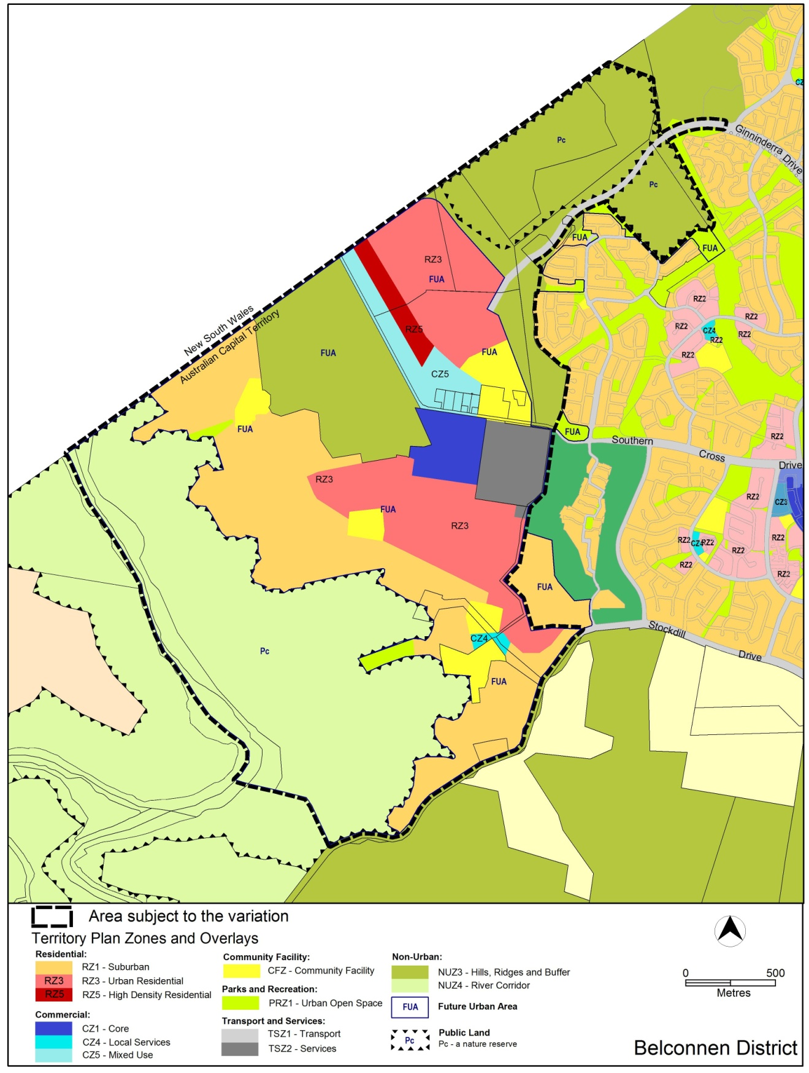
Figure 3 Territory Plan Zones Map changes
The Territory Plan is varied in all of the following ways:

- At 10 Precinct Maps and Codes, Belconnen District Map and Code

Substitute Belconnen District Map
With Appendix A

- At 14 Structure Plans

Substitute ‘14.1 Structure Plan West Belconnen’
With Appendix B

- At 15 Concept Plans – Precinct Codes for Section 93 of the Planning and Development Act 2007

Insert West Belconnen Concept Plan, Appendix C

Interpretation service
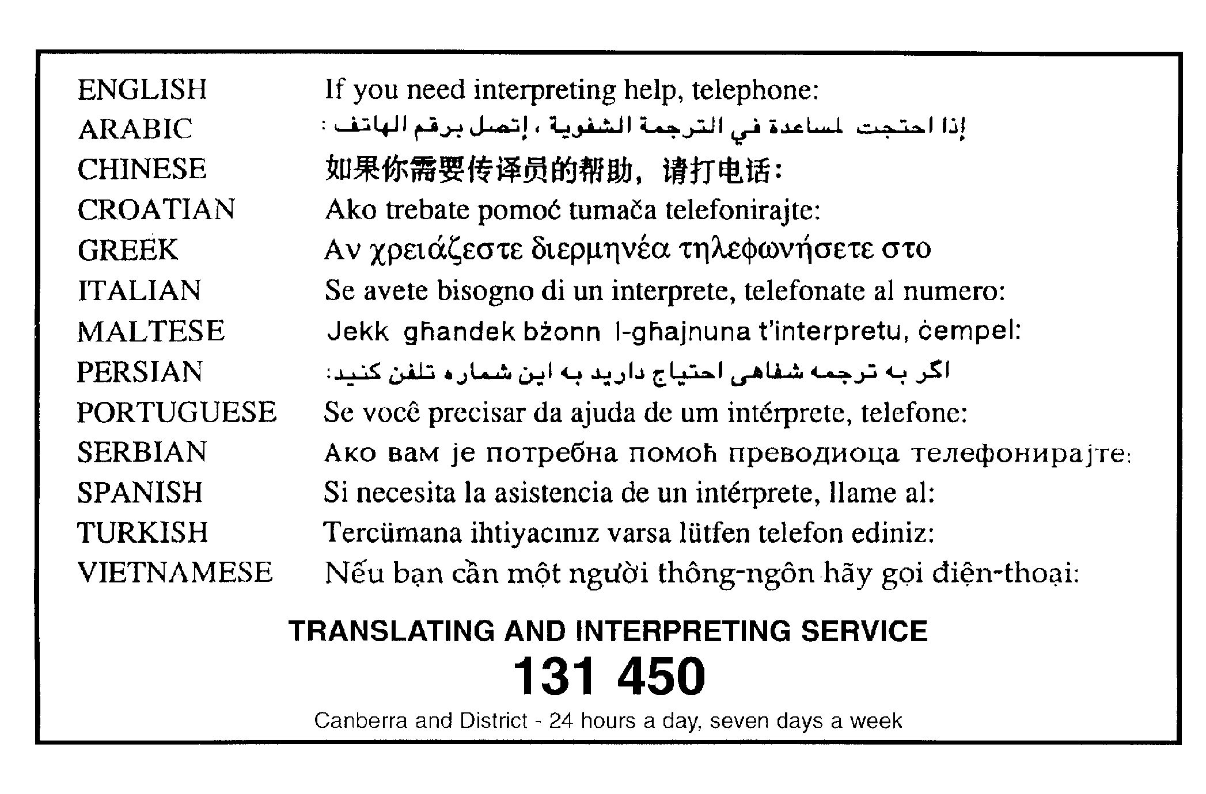

Appendix A

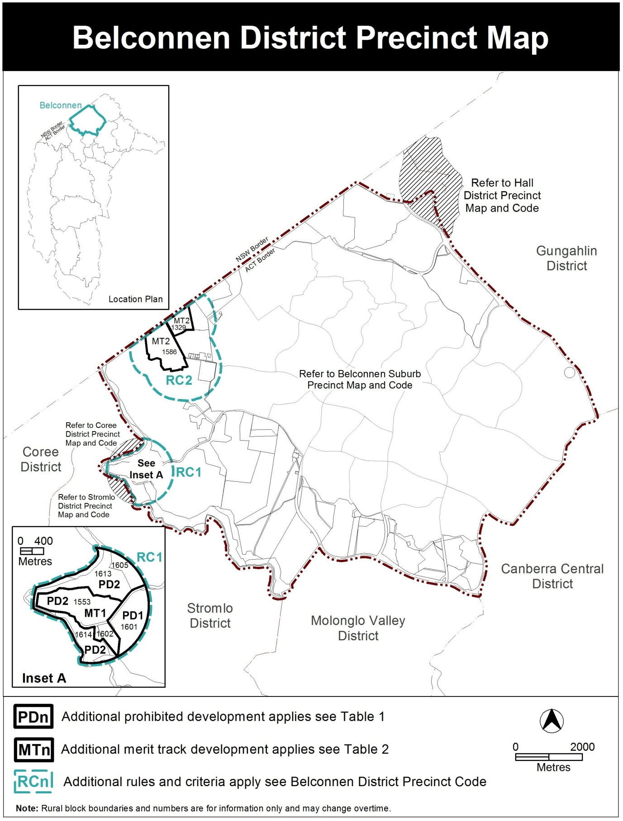

Appendix B

Structure Plan

West Belconnen

Land located West of
Macgregor and Holt in the district of Belconnen

1. INTRODUCTION
This structure plan sets out the principles and policies that apply to the West Belconnen future urban area in accordance with section 91 of the Planning and Development Act 2007.

A concept plan for West Belconnen, which is deemed to be a precinct code under the Planning and Development Act 2007, has been prepared for the area subject to this structure plan.

2. APPLICATION
This structure plan applies to the future urban area in Figure 1. Land that ceases to be part of the future urban area through the application of s96 of the Planning and Development Act 2007 ceases to be affected by this structure plan.

3. PROHIBITED DEVELOPMENT
For the purposes of s136(2) of the Planning and Development Act 2007, development by an entity is not prohibited, provided that the land on which the development is proposed was transferred to the entity by a Territory authority for the purpose of land development.

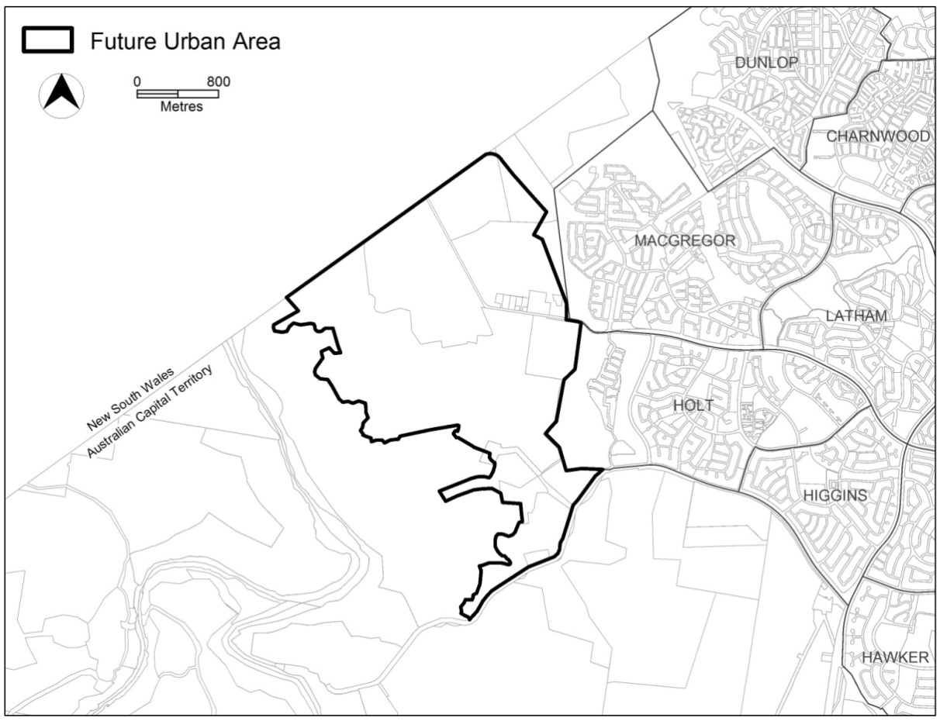
Figure 1: Future urban area at commencement of the West Belconnen Structure Plan
4. GENERAL PRINCIPLES AND POLICIES
The planning principles and policies for the broad structure are that:
1. development should encourage an environment that facilitates sustainability in terms of ecological, cultural, heritage, social and economic considerations;
2. the landscape setting and values of the site should be recognised and enhanced. Existing significant landscape features will be retained and protected;
3. local neighbourhoods should be designed to encourage non-car based trips and focussed on an activity node of an appropriate type and scale, such as a commercial centre, park or community facility;
4. residential areas should be based on a series of inter-connected suburbs (each generally containing 3 or 4 neighbourhoods) typically adjoining a primary school site and open space corridor;
5. the development’s group centre should be well located on a major road in order to serve multiple suburbs to ensure the long term viability of the centre;
6. the provision of community and recreation facilities should be provided in a manner that is accessible, flexible, co-located, clustered, adaptable, visible and sustainable;
7. an integrated cycling route network should be created within and between communities consistent with ACT and national standards;
8. the open space system should form a continuous network of spaces that contains a hierarchy and sequence of destinations eg. centres, schools, parks, community facilities, ovals and ponds;
9. the road hierarchy should be clearly legible and provide good and safe access to all users and encourage high levels of active and public transport usage;
10. the links between sustainable urban water management and potential impacts on flora, fauna, heritage and the conservation corridor should be recognised. Furthermore, appropriate sustainable urban water management measures will be implemented to manage runoff and reduce the number of run-off days to replicate, as closely as possible, pre-development peak flows protect the river corridor, water quality and downstream ecology.
11. Aboriginal and historic heritage place and objects will be recognised and significant sites conserved in public open space where appropriate.
12. Development shall provide for and be integrated with adjacent urban development in the ACT and the proposed future development, immediately adjacent in New South Wales.
13. Sustainable development and climate change adaptation is to be taken into consideration with the application of no regrets and inter-generational equity principles.

5. PRINCIPLES FOR THE DEVELOPMENT OF WEST BELCONNEN FUTURE URBAN AREA
The development will accord with the principles contained in the Statement of Strategic Directions.
6. POLICIES FOR THE DEVELOPMENT OF WEST BELCONNEN FUTURE URBAN AREA

6.1 General
14. Urban development will be generally in accordance with the zones applying to the future urban area, as shown on the Territory Plan map.
Notes:
1. The future urban area will diminish as development proceeds. Land that ceases to be part of the future urban area through the application of s96 of the Planning and Development Act 2007 ceases to be affected by this structure plan.
2. The nature and extent of zones under the Territory Plan are confirmed after land ceases to be part of the future urban area.
15. The local neighbourhood is to be generally based on a walkable radius of around 400 metres from an activity node such as a park, bus stop, mixed use development or community facility.

6.2 Concept plan
16. A concept plan(s), which is deemed to be a precinct code under the Planning and Development Act 2007, will be prepared.

6.3 Social principles
17. Provision will be made for a range of housing types, densities and affordability, to meet changes in household and community needs and encourage the formation of a diverse community.
18. Higher density development will be encouraged within and near the group centre and in other suitable locations well served by public transport and maximising accessibility to services, facilities and employment.
19. Provision will be made for aged care and special needs housing.
20. Community facility sites will be located close to public transport and generally in places where, for reasons of convenience and safety, people have cause to congregate. Particularly shopping centres and schools.
21. Neighbourhoods will be planned to encourage walking and cycling to reduce vehicle dependence, with a legible and permeable hierarchy of roads, conveniently located commercial and community facilities, a network of open spaces, an on and off road system for pedestrians and cyclists where appropriate and provision for accessible public transport.
22. The location, design and siting of development will promote community vitality, safety and equity of access (for people with limited mobility).
23. Development outcomes are to adhere with Government affordable housing strategies and policies.

6.4 Economic principles
24. Infrastructure and services will be provided and managed in a cost effective manner taking into account whole-of-life and whole-of-system costs.
25. The group centre will be located near a major road and provide the main concentration of employment, commercial and community activities in the area. The centre will be well serviced by public transport and link effectively with the wider pedestrian and cycling network.
26. The group centre is to be designed as a mixed use facility and supported by residential development with flexibility to evolve and meet changing community needs over time.

6.5 Environment protection
27. The landscape setting and values of West Belconnen will be recognised and sensitively incorporated into the urban design of the area. This includes the visual connection to the range of hills immediately west of the Murrumbidgee River, the distant Brindabella Ranges and the group of hills to the north of Ginninderra Creek.
28. Exceptional trees, significant trees and tree stands will be retained and integrated into the urban fabric through inclusion in open space, parks, streets and other areas wherever possible.
29. Best practice water sensitive urban design principles will be adopted at all levels of the development to minimise potable water usage, manage overland flows, protect water quality and aquatic habitat in the Murrumbidgee River and Ginninderra Creek.
30. Subdivision design will facilitate energy efficient housing in accordance with current best practice and evolving approaches.
31. Aboriginal and European heritage places will be recognised and significant sites conserved in a manner agreed by the ACT Heritage Unit and in consultation with Registered Aboriginal Organisations.
32. Bushfire risk assessments and management plans will be prepared and implemented in accordance with relevant Government guidelines for bushfire mitigation.
33. Areas of high conservation value will be protected from development, and the impact of adjacent urban development minimised, through suitable mechanisms including the provision of buffers where required.
34. Hills, Ridges and Buffer areas are to be generally excluded from development except those uses permitted under the Territory Plan for the zoning.

6.6 Landscape and Open Space Principles
35. Development will be planned to respond to the topography of the area by minimising cut and fill, responding to key features (i.e. vistas, drainage lines and topography) and minimising visual impacts of the development.
36. Buffer zones will be provided in areas adjacent to existing development and major roads.
37. The Murrumbidgee River corridor is recognised as an important natural and cultural asset to the ACT and wider region. It will be planned as an integral part of the National Capital Open Space System by providing for continuity of recreation use with surrounding open space and the river corridor.
38. The environmental quality, landscape setting and natural and cultural attributes of the Murrumbidgee River corridor will be reinforced by the provision of a conservation area on the eastern side of the river.
39. Provision will be made in the conservation corridor to create a balance between spaces allocated for recreational activities and protecting the area’s natural and cultural values in a sensitive manner.
40. Open space will be incorporated as an integrated hierarchical system which provides for diversity of sport and recreational activities, offers opportunities for flexible and shared use of space, contributes to the legibility and character of urban development and assists in the effective management of stormwater including encouraging onsite infiltration.
41. Playing fields will be provided in central locations and typically colocated with schools to maximise access and usage, where required.
42. Provision will be made for open space links between the Murrumbidgee River Corridor, Ginninderra Creek and Strathnairn Village suitable for cycling, pedestrian and equestrian use.
43. Provision will be made for open space links to the Molonglo River Corridor and to the existing off road path network in Belconnen for the purposes of pedestrian, equestrian and cycle use.

6.7 Urban design principles
44. Subdivision design and layout will maximise access to ‘special places’ to enhance character of West Belconnen and contribute to a sense of place. Special places include the Murrumbidgee River Corridor, Strathnairn Village, the group and local centres, neighbourhood activity nodes, active and passive open spaces, riparian (creek and drainage) corridors and other open space corridors.
45. Subdivision and detailed planning will provide for quality design outcomes within residential areas, centres and activity nodes, along principal approach routes and in the interface between public and private spaces (including shared spaces and spaces surrounding buildings).
46. Subdivision and detailed planning will maximise solar access, while being innovative in responding to topographic and planning constraints.
47. Road and other transport links will provide for high levels of accessibility to areas within West Belconnen and in surrounding areas. This will be partially achieved through links to the existing arterial road network surrounding the West Belconnen development.

6.8 Housing
48. The West Belconnen development area will provide opportunities for housing choice, land use diversity and broad ranging affordability.
49. The development area may incorporate site specific provisions to enable innovative and sustainable approaches to housing and built form.

6.9 Transport planning principles
50. Current and projected traffic flows on adjacent arterial roads and the wider road network in surrounding areas will be considered in the design of the road network for the West Belconnen development.
51. The road network is to be designed to support the future expansion of the rapid transport corridor.
52. The transport network will encourage modal shift in support of Transport for Canberra.

6.10 Belconnen land fill
53. A master plan is to be prepared for the land fill site that will determine uses and activities within the site, which will be subject to an appropriate audit process and approval of the Environment Planning Authority. The master plan will inform future Territory Plan zonings for the land.
7. POLICIES FOR THE DEVELOPMENT OF THE WEST BELCONNEN DEVELOPMENT AREA
7.1 General
54. Urban development will be generally in accordance with the zones applying to the future urban area shown on the Territory Plan map.
Notes:
1. The future urban area will diminish as development proceeds. Land that ceases to be part of the future urban area through the application of s96 of the Planning and Development Act 2007, ceases to be affected by this structure plan.
2. The nature and extent of zones under the Territory Plan are confirmed after land ceases to be part of the future urban area.

55. The local neighbourhood is to be generally based on a walkable radius of around 400 metres from an activity node such as a park, bus stop, shops, community facility or school.
56. The West Belconnen development area will provide opportunities for housing choice, land use diversity and broad ranging affordability.
57. The development area may incorporate site specific provisions to enable innovative and sustainable approaches to housing and built form.

7.2 Concept plans
58. Concept plans (which are deemed to be precinct codes under the Planning and Development Act 2007) may be prepared where departures from the relevant development codes are proposed. Such matters as higher development densities, response to slope and orientation, increased building heights, and contemporary best practice for energy efficiency, water efficiency and solar access, could be included.

7.3 Conservation Corridor
59. A conservation corridor will be created and managed in accordance with the commitments agreed under the approved West Belconnen Strategic Assessment and the Strategic Bushfire Management Plan Version 3 (or its successor).
60. A plan that prescribes management conditions for the conservation corridor shall be prepared by the entity responsible for its management. The management plan will include comprehensive provisions giving weight to each of conservation of threatened species and ecological communities; water quality monitoring and management; bushfire protection; heritage values; and recreation use.
61. The management plan will prescribe management arrangements and controls that may be applied to infrastructure to be installed in the corridor.
62. The management plan shall be prepared in consultation with relevant agencies and stakeholder groups and will be updated as required.
63. The conservation corridor is recognised as an important natural and cultural asset to the ACT and region. It will be planned as an integral part of the National Capital Open Space System by providing for continuity of recreation use with surrounding open space and the Murrumbidgee River corridor.

7.4 Environment Protection
64. The development is to be generally contained to the area north of Stockdill Drive, east of the Murrumbidgee River, south of Ginninderra Creek and extending to the ACT/NSW border.
65. Clearance zones will be imposed as overlay controls that preclude sensitive uses in areas situated in the vicinity of existing uses with odour, air quality or noise impacts. Clearance zones will remain in place, pending removal or amelioration of the environmental impact, subject to an appropriate audit process and to the satisfaction of the Environmental Protection Authority.
66. The visual connection to important hills is to be maintained. These include the range of hills immediately west of the Murrumbidgee River and group of hills to the north of Ginninderra Creek.
67. Where appropriate, the width of the road reservation is to allow for the retention or establishment of large trees to visually reinforce the major route.
68. Areas with high conservation value and heritage value will be protected from development where possible, and the impact of adjacent urban development minimised through suitable mechanisms, including the provision of appropriate buffers.
69. The Murrumbidgee River corridor and associated conservation area are to be managed to protect water quality, classified species and communities, bird habitats, high value woodlands and grasslands, and natural and cultural assets.
70. In subdivision design, larger lots will generally be situated on steeper/ constrained land to appropriately respond to topography, minimise cut and fill and maximise tree retention.
71. Land use zones within the Belconnen land fill site (Block 1586 Belconnen) will be determined through a master plan for the site, subject to an appropriate audit process and approval of the Environment Protection Authority.
72. Appropriate buffer areas will be imposed as overlay controls that preclude sensitive land uses in areas situated in the vicinity of existing uses with odour and noise impacts. Where appropriate, buffers may apply temporarily, pending removal or appropriate amelioration of the noise or odour impact.
73. Where appropriate, noise abatement measures will be implemented to address impacts on residents of adjacent suburbs where new roads or upgrades to existing roads result in unacceptable impacts to existing levels of amenity.

7.5 Bushfire Management
74. Leading practice bushfire risk management is to be implemented in all stages of planning (including subdivision) in accordance with the Strategic Bushfire Management Plan Version 3 (or its successor) and policies.
75. The staging of development is to be undertaken in a manner that minimises bushfire risk to residents and accords with agreed bushfire mitigation measures.
76. Provision will be made in the conservation corridor for recreational activities appropriate to the characteristics of the river and adjacent land, and in a manner that provides bushfire protection and reinforces and protects the natural and cultural values of the river corridor.
77. The inner asset protection zone is to be located outside the river corridor boundary, within the urban area.

7.6 Heritage
78. Conservation Management Plans are to be prepared for Aboriginal heritage places and objects.

7.7 Residential
79. Zones will be allocated by a technical amendment to the Territory Plan under s96 of the Planning and Development Act 2007 in accordance with the following principles:
(a) Suburban scale housing is to be the dominant housing type.
(b) Medium density housing, which may include a higher built form is to be located on land near major transport routes, commercial centres, at activity nodes, and in locations with higher amenity.
(c) Residential mixed use (ie. residential and commercial or residential and community facilities) to be located near the group centre, and in areas with high amenity.
80. Precinct codes will be assessed by the relevant Authority against any relevant Government affordable housing policies or strategies.
81. Subdivision design will facilitate energy efficient housing consistent with current best practice and in a manner sensitive to West Belconnen site conditions, amenity and cost.
82. Opportunities for special dwellings and supportive housing are to be provided.
83. Noise abatement measures will be incorporated into the design of residential buildings along major roads and adjacent to other substantial noise sources, where appropriate.
84. An edge road, landscape buffer or other suitable interface treatment are to be provided along the eastern edge of the development area between adjacent suburbs and the eastern boundary of the West Belconnen development.
85. The group centre is to be located adjacent to a major arterial road. The centre will be a major focus for commercial and community activity, accommodating supermarkets and a range of other retail, commercial, business services and community facilities. Opportunities for higher density housing will be provided within, and adjacent to, the group centre.
86. Commercial uses, generally of a non-retail nature, may be located within the CZ5 zone to the north west and east of the group centre, along Parkwood Road and in the Belconnen Land Fill site. These uses may be associated with residential development. Any changes to existing land uses within the Belconnen Land Fill site will be determined through a master plan for the site, subject to an appropriate audit process and approval of the Environment Protection Authority.
87. Minor commercial and retail uses may be located throughout the development in response to market and community needs, provided that the proposed use is consistent with Territory Plan zone provisions and objectives.

7.8 Sustainable Development
88. In considering how to respond to climate change, implement a green infrastructure approach to the planning of unleased territory land.

7.9 Open space and recreation
89. The provision of open space for active recreation will generally accord with the relevant Territory guidelines.
90. Strong recreational links are to be facilitated within West Belconnen and surrounding suburbs to allow safe, appropriate and convenient access to the Murrumbidgee River and conservation corridor.
91. Playing fields, ovals and district parks will, where possible, be located on flatter land, accessible to movement systems, and possibly co-located with schools. They will be edged by a local street and provide parking where practicable on edge streets to avoid large surface car parks.
92. Land with suitable topographic characteristics, adjacent to nominated school sites is to be reserved for school ovals, except where district playing fields are already identified adjacent to the school sites.
93. Land with suitable topographic characteristics is to be reserved for the provision of district level playing fields.
94. Opportunities are to be explored at the concept plan stage for restricted access recreation sites eg. enclosed ovals and special use sporting clubs.
95. Local parks are to be provided that incorporate remnant tree stands where possible, and will generally be edged by streets, not back or side fences.
96. The Bicentennial National Trail will be provided through and around the development.

7.10 Community facilities
97. Where appropriate, group and local centres and activity nodes are to provide sites for community facilities.
98. Sites will be allocated for schools.
99. Community facilities sites, including community centres and the like may be allocated within or adjacent to residential land consistent with Territory Plan zone provisions and objectives.
100. Special Fire Protection Developments are not permitted adjacent to the River Corridor boundary without the approval of the Emergency Services Agency.
101. The Strathnairn Arts Facility is to be retained with an appropriate interface with adjacent development. Limited additional commercial and community uses are to be provided to permit the Facility to expand in the future as well as to service the adjacent development, providing that arts remains as the pre-eminent use on the land.
102. The Belconnen Farm heritage site will be developed and managed in accordance with a conservation management plan to be approved for the site and in addition but without compromising the intent of the conservation management plan will provide for limited commercial and community related activities associated with the adjacent development.

7.11 Stormwater management
103. A water sensitive urban design (WSUD) strategy will be adopted to control stormwater runoff from the West Belconnen development. The strategy will comply with current ACT WSUD policy documents and will comprehensively address issues relating to the management of water quality control and minimise adverse impacts on flow regimes into the Murrumbidgee River and Ginninderra Creek. Flow regimes should reduce the number of run-off days to replicate, as closely as possible, pre-development peak flows.

7.12 Traffic management
104. Access to West Belconnen will be via existing roads Drake Brockman Drive, Southern Cross Drive and (subject to approval) Ginninderra Drive (see 109 in section 7.12). Where required, these roads will be augmented to cater for the additional traffic volumes and align with current sustainable transport policy and objectives.
105. Major roads within the development are to be generally designed as urban boulevards, with service streets and address frontages. Regular cross-streets are to be provided, consistent with traffic safety and efficiency, to minimise the effect of the arterials as a barriers between neighbourhoods.
106. Major roads through the development are to be designed to also accommodate traffic generated by the ultimate development adjacent in NSW.
107. An interconnected street system is to be provided that facilitates a choice of routes and legible way-finding, and is appropriately landscaped in accordance with its function and character.
108. Traffic volumes and congestion on the wider road network in existing areas of Belconnen will continue to be monitored and upgraded, as necessary, in order to maintain acceptable levels of capacity (in accordance with national standards) and align with relevant sustainable transport policy and objectives.
109. The extension of Ginninderra Drive and its alignment is subject to approval under the EPBC Act, as it impacts on the Jarramlee and West Macgregor environmental offset areas.
110. Implications for the wider road network should be given due consideration through ongoing traffic management and planning.

7.13 Transport
111. Shared paths (bicycle/pedestrian) will provide access to key features within West Belconnen including the conservation corridor, Murrumbidgee River and Molonglo River corridors, the group centre, schools and Strathnairn. The paths will also connect to existing shared paths that link West Belconnen with the wider Belconnen district, Canberra City and beyond.
112. The road layout is to be designed to enable expansion of the public transport system by creating a system which uses the new West Belconnen arterial as part of a public transport spine to link West Belconnen with the surrounding Belconnen district, Kippax Group Centre and beyond.

7.14 Tourist and Recreation Facilities
113. The proposed conservation corridor and Murrumbidgee River offer opportunities for research, education, recreation and ecotourism. The potential of these places will be further explored as part of a separate master planning exercise.

7.15 Emergency Services Facilities
114. Facilities to be provided as required.

7.16 Infrastructure and Services
115. Provision will be made for the construction of infrastructure as required and to the satisfaction of the Territory.
116. All infrastructure provision including water supply for fire fighting purposes shall comply with the Strategic Bushfire Management Plan Version 3 (or its successor).
117. Easements around electrical infrastructure are to be provided to the satisfaction of the Territory.
118. A site will be allocated for the provision of a zone substation and associated infrastructure, to the satisfaction of the Territory.
119. Appropriate interface treatments should be provided between electrical substation sites and adjacent development areas, to the satisfaction of the ACT Planning and Land Authority and electrical infrastructure asset owners.

West Belconnen Concept Plan

Table of Contents

Part A – Land Use 5
1. Land Use Plan 5
Part B - Subdivision 8
2. Dwelling Yield 8
3. Belconnen Land Fill Site Master Plan 8
4. Bushfire 8
5. Horse Trails 9
6. Equestrian Facilities 9
7. Urban Edge 9
8. Conservation Areas 10
9. Environment Protection Biodiversity and Conservation Act requirements 10
10. Aboriginal Heritage Places and Objects 10
11. Interface with Woodhaven Green Residential Estate 10
12. Interface with Strathnairn Arts Precinct (Block 1332 Belconnen) 10
13. Interface with Billabong Aboriginal Development Corporation (Block 1420 Belconnen) 11
14. Delineation of the ACT and NSW Border 11
15. Street Network Hierarchy 11
16. Electrical Infrastructure 12
17. Belconnen Farm Heritage Precinct 12
18. Sewer Vents 13
19. Lower Molonglo Water Quality Control Centre Clearance Zone 13
20. Schools 13
21. Community Facility Sites 13
22. Commercial Centres 13
23. Little Eagle Clearance Zone 13
24. Stormwater Management 14
25. Flooding 14
26. Climate Change 15
27. Recreation Facilities 15
28. Wood Heaters 15
29. Cat Containment 15

Purpose
The purpose of this plan is to:
- guide the design and assessment of estate development plan (subdivision proposals) development applications in West Belconnen
- inform the delineation of Territory Plan land use zones at the time when a parcel of land ceases to be part of the future urban area following approval of an estate development plan
- guide the development of individual blocks in concert with other relevant codes under the Territory Plan
- guide the development and management of the public domain
- ensure that planning and development is consistent with commitments made under the West Belconnen Strategic Assessment
- ensure that the development appropriately consider adjacent development in NSW and that the border interface is appropriately recognised and designed

Desired planning outcomes
The purpose of the development controls (i.e. rules and criteria) is to:
- provide diverse housing zones, types and densities to meet the changing needs of the community
- allow for zoning to accommodate increased residential densities and building heights generally close to public transport routes and retail/commercial centres (where provided)
- provide for community facilities and retail/commercial uses
- provide development types on the urban edge that minimise impacts on river and creek corridors and provide opportunity to connect with ecological values within the Murrumbidgee River corridor
- provide safe, compact, walkable residential precincts with convenient vehicular, pedestrian, cycle and public transport access to recreational, retail/commercial and community facilities
- encourage walking, cycling and the use of public transport
- provide a legible road network that integrates safe and adequate pedestrian and cycle access to the precinct and connectivity to adjacent areas
- retain significant elements of the site as part of the urban open space network that connects to adjacent suburbs and areas with public access and high levels of amenity and safety
- provide for effective buffers and relationships between residential development and nature reserves
- provide a river corridor conservation zone
- ensure protection of areas or items of heritage significance
- employ leading practice stormwater management measures and apply water sensitive urban design principles
- minimisation of all impacts to adjacent nature reserve areas
- Provide appropriate bushfire mitigation management
- Provide for clearance zones that limit the development of sensitive uses in areas affected by noise, odour and air quality issues, and to provide for the adjustment of clearance zones when appropriate
- Provide for clearance zones that limit development so as to protect the vulnerable little eagle and a poultry facility from zoonotic impacts, and to provide for the adjustment of clearance zones when appropriate – zoonosis is the process whereby disease is transferred from one species to another
- The West Belconnen development area will provide opportunities for housing choice, land use diversity and broad ranging affordability
- The development area may incorporate site specific provisions to enable innovative and sustainable approaches to housing and built form.
- Provide for the retention of higher quality existing trees whilst allowing for removal of poorer quality trees where retention is not feasible
- Provide a development including subdivision, built form, materials, open space and green infrastructure that responds to climate change and reduces the city heat effect

Code hierarchy
- This concept plan is a precinct code under the Planning and Development Act 2007.
- More than one type of code may apply to a particular development proposal. Occasionally inconsistencies between the provisions arise, particularly where a precinct code seeks to apply special provisions in response to particular local circumstances or planning issues.
- Where this occurs, a precinct code prevails over a development code and a general code, but only to the extent of the inconsistency.

Part A – Land Use
Rules | Criteria

1. Land Use Plan
R1  Residential zones shown on a land use plan lodged with an Estate Development Plan are consistent with the Territory Plan map. | C1  Residential zones are consistent with the objectives of the zone and achieve all of the following:  - reasonable mix of zones to support diversity in housing type  - provide for housing affordability  - provide for changing demographic needs of the community  - increased density and building heights near collector roads  - increased density and building heights near commercial centres  - increased density and building heights in close proximity to public transport  - consistency with the desired planning outcomes.
R2  No residential use is permitted within the clearance zones as shown in Figure 1 Clearance Zone Map A and Figure 2 Clearance Zone Map B. | C2  Clearance zones may be adjusted, subject to an appropriate audit process and approval of the Environment Protection Authority.
R3  Block 1332 Belconnen (the Strathnairn Arts Precinct) is to have a community facility zone shown on a land use plan lodged with an Estate Development Plan that is consistent with the Territory Plan map. | C3  This is a mandatory requirement. There is no applicable criterion.
There is no applicable rule. | C4  Block 1332 Belconnen (the Strathnairn Arts Precinct) may include the following uses:  - Craft workshop  - Place of assembly  - Produce market  - Restaurant (limited to a maximum of 250m² for the entire block)  - Shop (limited to a maximum of 100m² for the entire block but excluding uses that are ancillary to the main use of the land for arts and craft)
There is no applicable rule. | C5  Belconnen Farm Heritage Precinct may include uses as the following:  - Craft workshop  - Place of assembly  - Produce market  - Restaurant (limited to a maximum of 250m² for the entire block)  - Shop (limited to a maximum of 100m² for the entire block but excluding uses that are ancillary to the main use of the land for arts and craft)  - Business agency (limited to a maximum 500m² for the entire block)
R6  Community facility zone shown on a land use plan lodged with an Estate Development Plan is consistent with the Territory Plan map. | C6  Community facility zone is consistent with the objectives of the zone and achieve all of the following:  - adjacent to the collector road  - in close proximity to public transport  - in close proximity to commercial zones, if provided  - encourage co-location and/or clustering of facilities  - suitable to accommodate relevant facilities in accordance with the Community and Recreation Facilities Location Guidelines General Code  - consistent with the recommendations of a community and social needs assessment, endorsed by the relevant authorities (e.g. the Environment and Planning Directorate and the Education and Training Directorate)  - consistency with the desired planning outcomes.
R7  No community use is permitted within the clearance zones as shown in Figure 1 Clearance Zone Map A and Figure 2 Clearance Zone Map B. | C7  Clearance zones may be adjusted, subject to an appropriate audit process and approval of the Environment Protection Authority.
R8  Parks and recreation (PRZ1 urban open space) zone shown on a land use plan lodged with an Estate Development Plan is consistent with Territory Plan map. | C8  Urban open space is consistent with the objectives of the zone and achieves all of the following:  - retention of cultural heritage items  - retention of mature trees, consistent with an agreed tree and landscape strategy  - opportunities for pedestrian and cycle paths to connect to activity nodes within the estate, and to the existing networks in adjoining suburbs  - provides opportunities for local recreation  - provision is to be consistent with the recommendations of a sporting and recreation needs assessment and the community needs assessment (as required), endorsed by Sport and Recreation and Strategic Planning  - consistency with the desired planning outcomes.
R9  Commercial zones shown on a land use plan lodged with an Estate Development Plan is consistent with the Territory Plan map. | C9  Commercial zones are consistent with the objectives of the zone and achieves all of the following:  - adjacent to a collector road with public transport capability  - high accessibility for pedestrians, cyclists and vehicles  - provides services and facilities for the local community  - In close proximity to a community facility zone  - consistent with a commercial and retail needs assessment  - consistency with the desired planning outcomes.
R10  Land use zones within the Belconnen land fill site (Block 1586 Belconnen) as indicated in Figure 1 will be determined through a master plan for the site, subject to an appropriate audit process and approval of the Environment Protection Authority.  Possible new zonings through a master planning process may include Industrial (IZ2 mixed use) and commercial zonings. | This is a mandatory requirement. There is no applicable criterion.
R11  Non urban (NUZ4 - River corridor) zone shown on a land use plan lodged with an Estate Development Plan is consistent with Territory Plan map. | This is a mandatory requirement. There is no applicable criterion.
R12  Transport and Services (TSZ2 Services) zone shown on a land use plan lodged with an Estate Development Plan is consistent with the Territory Plan map. | C12  The Services zone is consistent with the objectives of the zone.
R13  Residential, community and other sensitive uses are not permitted within the clearance zones associated with Parkwood Egg Farm, the Belconnen Land Fill and the Green waste facility, as shown in Figure 1. | C13  Clearance zones may be adjusted subject to an appropriate audit process and approval of the Environment Protection Authority.
R14  In addition to the above provision, whilst the Parkwood Egg Farm is operating, no new ponds, wetlands and the like are permitted within 800m from buildings housing poultry without the endorsement of the Environment Protection Authority. | This is a mandatory requirement. There is no applicable criterion.

Part B - Subdivision
Rules | Criteria

2. Dwelling Yield
R15  The maximum dwelling yield is 6500 dwellings. | C15  The maximum number of dwellings is subject to review and may be altered at the discretion of the Planning and Land Authority ten years after the approval of this concept plan and thereafter at five year intervals.

3. Belconnen Land Fill Site Master Plan
R16  A master plan is to be prepared for the land fill site that will identify future uses and activities to the satisfaction and endorsement of the relevant authority. | This is a mandatory requirement. There is no applicable criterion.

4. Bushfire
R17  A bushfire risk assessment that also takes into consideration the risk from New South Wales and along the river corridors is to be undertaken.  The assessment is to take into consideration topography, urban edge conditions, and proposed land management practices within the adjacent river corridor.  The assessment and required mitigation measures (such as required construction standards under AS3959 Construction of Buildings in Bushfire-Prone Areas) are to be approved by the Emergency Services Agency. | This is a mandatory requirement. There is no applicable criterion.
R18  No development is permitted within 300m of the ACT / NSW border (Figure 1) until a formal agreement has been entered into with the adjacent NSW land owner(s), to ensure that bushfire and fuel management will be undertaken consistent with ACT standards to the satisfaction of the Emergency Services Agency. | This is a mandatory requirement. There is no applicable criterion.

5. Horse Trails
There is no applicable rule. | C19  The provision of the Bicentennial National Trail and local horse trails are to be appropriately provided and endorsed by the relevant authority.  Trails should endeavour to avoid conflict with pedestrians and cyclists, where ever possible.

6. Equestrian Facilities
There is no applicable rule. | C20  Any recommendation following an ACT strategic horse paddock review undertaken by the Environment and Planning Directorate are to be implemented.

7. Urban Edge
There is no applicable rule. | C21  The urban edge achieves all of the following:  - a clear and manageable boundary between the Murrumbidgee River, Ginninderra Creek and the urban area  - continuous edge streets (or equivalent treatments approved by the Emergency Services Agency / ACT Rural Fire Service), bushfire protection zones, and controlled vehicular access points to Murrumbidgee River and Ginninderra Creek for bushfire management and general maintenance are provided  - measures are provided to minimise the impact on Pink-Tailed Worm Lizard habitat and Box Gum Woodland from stormwater runoff, edge road earthworks, trunk infrastructure, fire protection, and pedestrian and cycle paths  - continuous shared pedestrian and cycle path infrastructure is provided along the urban edge  - trunk infrastructure services are integrated with paths and recreational networks, where possible.

8. Conservation Areas
R22  Areas of conservation will be protected from development with the impact of urban development and infrastructure minimised, through suitable mechanisms to the satisfactions of the Conservator of Flora and Fauna. | This is a mandatory requirement. There is no applicable criterion.

9. Environment Protection Biodiversity and Conservation Act requirements
R23  Development is not inconsistent with the Environment Protection Biodiversity and Conservation Act 1999 and the approved Strategic Assessment under Part 10 of the Act to protect Matters of National Environmental Significance. | This is a mandatory requirement. There is no applicable criterion.

10. Aboriginal Heritage Places and Objects
R24
Identified Aboriginal heritage places and objects are to be managed in accordance with Heritage Act 2004 provisions.

11. Interface with Woodhaven Green Residential Estate
R25  The interface between the estate and the adjacent Woodhaven Green residential estate is to provide for integration between the two estates with appropriate road and path connections. | This is a mandatory requirement. There is no applicable criterion.

12. Interface with Strathnairn Arts Precinct (Block 1332 Belconnen)
R26  The interface with the Strathnairn Arts Precinct will have regard for compatibility between adjacent land uses:  BUFFER: A buffer zone or other appropriate treatment is required between Strathnairn and adjacent development to provide acoustic and visual separation from surrounding roads and other estate infrastructure. The buffer will enable continued passive artistic endeavour at the site and measures shall be external to the Strathnairn site boundary.  ACCESS: Provide one primary (public use) and one secondary (user and emergency egress) point of access to the Precinct consistent with outcomes of the Strathnairn 2015 Master Plan. | This is a mandatory requirement. There is no applicable criterion.

13. Interface with Billabong Aboriginal Development Corporation (Block 1420 Belconnen)
R27  The interface between the estate and the Billabong Aboriginal Development Corporation on Block 1420 Belconnen (see Figure 2) will have regard to compatibility between adjacent land uses and the activities that are undertaken on the block. | This is a mandatory requirement. There is no applicable criterion.
R28  Subdivision design for the (adjacent) estate is to be configured to provide the opportunity for possible future integration of Block 1420 Belconnen into the estate. | This is a mandatory requirement. There is no applicable criterion.

14. Delineation of the ACT and NSW Border
R29  The alignment of the ACT/NSW border through the estate will be a recognisable linear open space element in the estate design. | This is a mandatory requirement. There is no applicable criterion.

15. Street Network Hierarchy
R30  Connections to the arterial road connections are to be consistent with Figure3.  The extension of Ginninderra Drive requires the separate approval of the Commonwealth under the Environment Protection Biodiversity and Conservation Act 1999. | This is a mandatory requirement. There is no applicable criterion.
R31  Main roads (arterial and collector) through the estate are to be designed to accommodate development from adjacent NSW. | This is a mandatory requirement. There is no applicable criterion.
R32  Provision is to be made for at least two road connections into the adjoining NSW. These roads are to be connected into the main roads within the ACT. | C32  The number of road connections can be reviewed consistent with a master plan and approved by Territory and Municipal Services Directorate.

16. Electrical Infrastructure
R33  Easements (or reservation) associated with electrical infrastructure, such as overhead power lines, are to be endorsed by the Planning and Land Authority whilst taking advice from the operators of the TransGrid and/or ActewAGL networks, as required, and by the ACT Government’s Technical Regulator who will audit the infrastructure design concepts process. | This is a mandatory requirement. There is no applicable criterion.
R34  Residential and other sensitive uses in the vicinity of Transgrid Canberra Substation and the (proposed) new ActewAGL zone substation will have regard to recommendations of a noise assessment, community safety and public health requirements including electromagnetic frequency (EMF) assessment, to the satisfaction of the Planning and Land Authority taking advice from the operators of the TransGrid and/or ActewAGL networks.  The endorsement of the ACT Government’s Technical Regulator who will audit the infrastructure design concepts process will also be required. | This is a mandatory requirement. There is no applicable criterion.
There is no applicable rule. | C35  Appropriate interface treatments are to be provided between electrical substation sites and adjacent development areas, to the satisfaction of the Planning and Land Authority taking advice from electrical infrastructure asset owners.

17. Belconnen Farm Heritage Precinct
R36  The Belconnen Farm heritage precinct (Figure 2) is to be protected consistent with a conservation management plan approved by the Heritage Council. | This is a mandatory requirement. There is no applicable criterion.
There is no applicable rule. | C37  An appropriate interface treatment is to be provided between the Farm and adjacent development, to the satisfaction of the Planning and Land Authority and ACT Heritage.

18. Sewer Vents
R38  No recreation activity that will encourage people to congregate within 130m of the sewer vent within the river corridor is permitted. | C38  A reduction in the dimension may be permitted with the endorsement of Actew Water / Icon Water.
R39  An odour assessment will be undertaken to identify any required clearance zones or mitigation measures associated with the existing sewer vents within the development area to the satisfaction of Icon Water. | This is a mandatory requirement. There is no applicable criterion.

19. Lower Molonglo Water Quality Control Centre Clearance Zone
R40  Development is to be consistent with the additional rules and criteria that apply to the Lower Molonglo Water Quality Control Centre specified in the Belconnen District Precinct Map and Code. | This is a mandatory requirement. There is no applicable criterion.

20. Schools
R41  School sites are to be provided at locations and sizes shown on Figure 3. | C41  The provision and number of schools may be adjusted through an assessment that is endorsed by the Department of Education and Training.

21. Community Facility Sites
R42  A community and social needs (including community garden, urban agriculture and recreation needs) assessment report is to be prepared to determine and prescribe the future needs within the development and adjacent. The assessment is to be endorsed by the relevant authority.  Provision is required to be made within the development to accommodate the identified community uses. | This is a mandatory requirement. There is no applicable criterion.

22. Commercial Centres
There is no applicable rule. | C43  A minimum of one commercial group centre is to be located centrally within the development.  Additional commercial local centres are to be considered to meet the needs of convenient access to retail and services for local catchments.

23. Little Eagle Clearance Zone
R44  No development including infrastructure and construction related activities will be permitted within 200m of the Little Eagle nesting tree and foraging area indicated in Figure 1. | C44  Urban development is not permitted until such time as research on the Little Eagle has been completed and confirms that the site is suitable for development.

24. Stormwater Management
R45  The development is required to comply with the ACT Waterways: Water Sensitive Urban Design Code, including the following targets:  - Regional and catchment wide water quality targets;  - Mains water use reduction target;  - On-site retention target;  - On-site detention target. | This is a mandatory requirement. There is no applicable criterion.
R46  Stormwater management measures are required to be incorporated into the development to protect water quality of the Murrumbidgee River and Ginninderra Creek to the satisfaction and endorsement of the Environment Protection Authority. | This is a mandatory requirement. There is no applicable criterion.
R47  Stormwater management measures are required to protect Pink-Tailed Worm Lizard habitat and other environmentally sensitive habitats. | This is a mandatory requirement. There is no applicable criterion.
There is no applicable rule. | C48  Development is undertaken in a manner consistent with the objectives of the ACT Basin Priority project, in particular to maintain and improve water quality in ACT, and downstream, waterways.  Note: This development is within one of the six priority catchments for the ACT Basin Priority Project which is progressing options for water quality management to maintain and improve environment, economic and social outcomes with a water quality focus, in ACT and region and downstream waterways.

25. Flooding
R49  All leased land is required to be above the 1% Annual Exceedance Probability (AEP).  Note: The 1% AEP was previously the 1:100 flood line. | This is a mandatory requirement. There is no applicable criterion.
There is no applicable rule. | C50  Land use for areas above the 1% AEP and within the floodplain (defined as the Probable Maximum Flood extent) should be assessed against the nature of the development and the flood risk.

26. Climate Change
There is no applicable rule. | C51  Development is to be subject to a system of rating that measures the sustainability aspects of the development to the satisfaction of the Territory agency responsible for sustainability and climate change.

27. Recreation Facilities
R52  One district level sporting field complex and associated facilities of a minimum 15 hectares is to be provided in a central location with good access to the road network to the satisfaction of the relevant authority. | C52  Subject to a sports fields review endorsed by the relevant authority, the provision within the estate may be removed, if the facilities are being provided elsewhere in the district.
R53  An active and passive recreation needs assessment is to be undertaken to determine the future needs within the estate and in adjacent areas. The assessment is to take into account the sporting fields review and any alternative sporting recreation model including community recreation irrigated park. The assessment will be endorsed by the relevant authority.  Provision will be made within the development to accommodate the identified recreation needs / uses. | This is a mandatory requirement. There is no applicable criterion.

28. Wood Heaters
R54  A restriction on wood heaters applies in West Belconnen. A Development Application for the installation of a solid fuel heating system will be required to be submitted to the Planning and Land Authority for assessment under the Planning and Development Act 2007. | This is a mandatory requirement. There is no applicable criterion.

29. Cat Containment
R55  The provisions of Domestic Animals Act relating to cat containment apply. | This is a mandatory requirement. There is no applicable criterion.

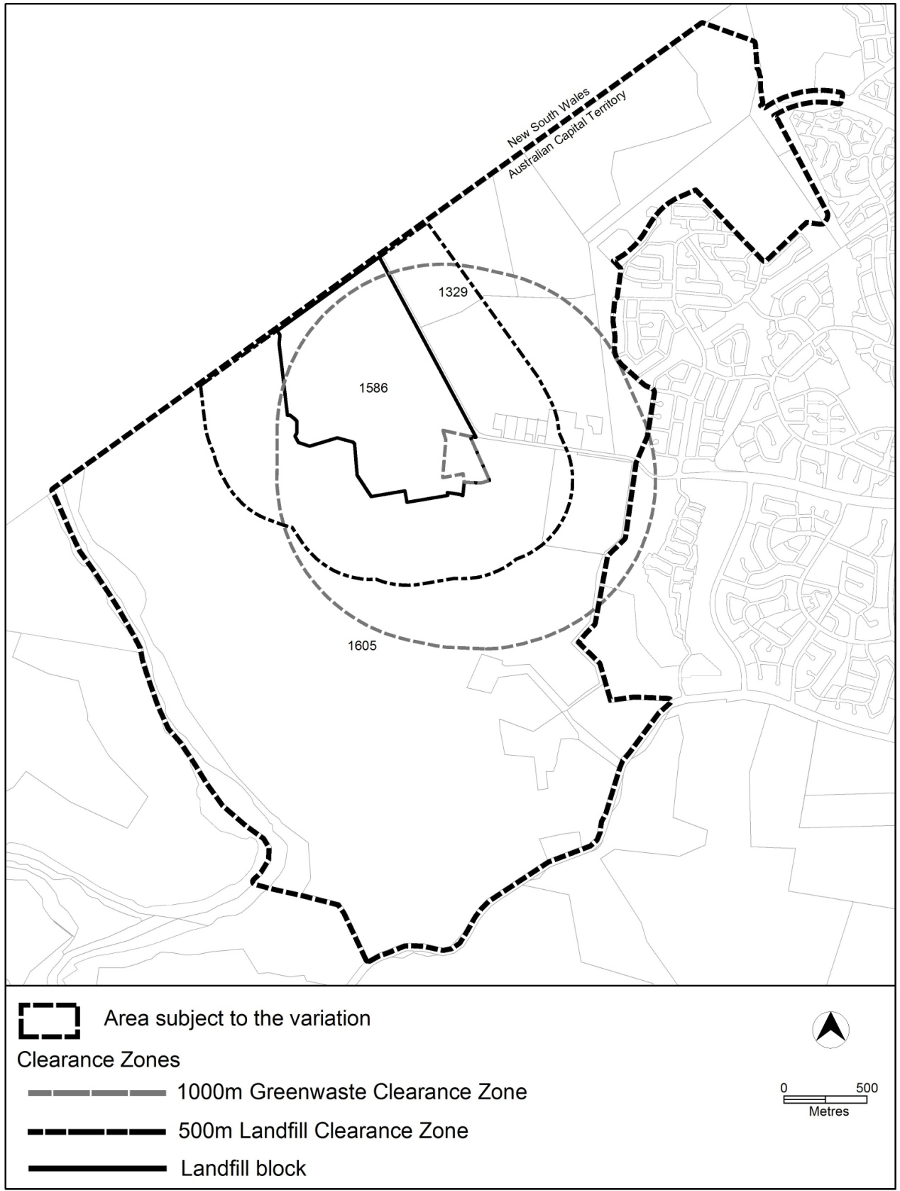

Figure 1 Clearance Zone Map A
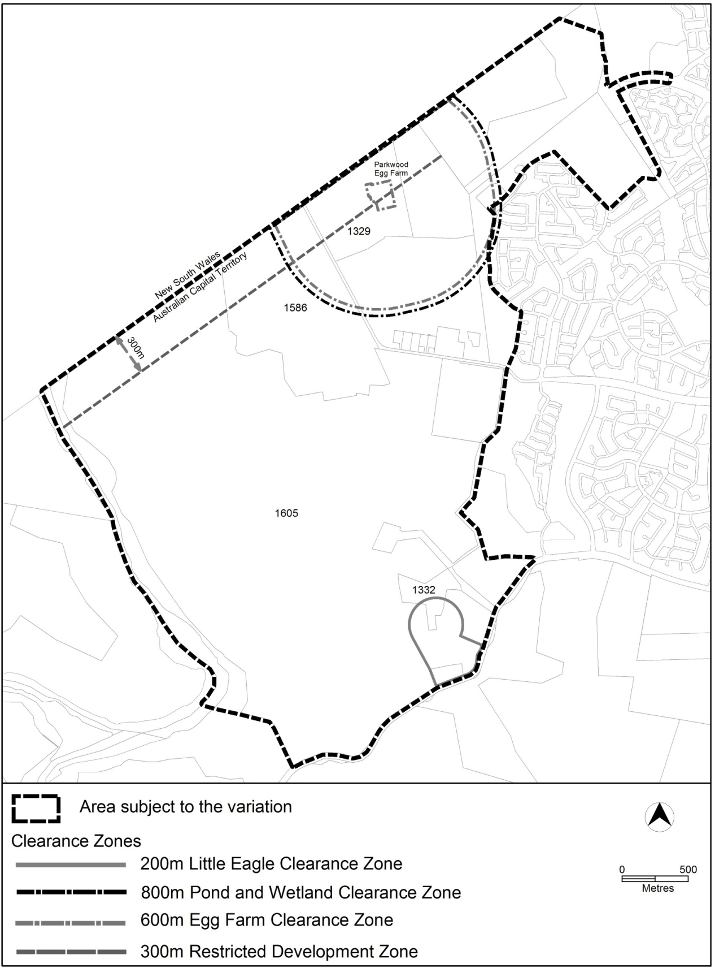

Figure 2 Clearance Zone Map B
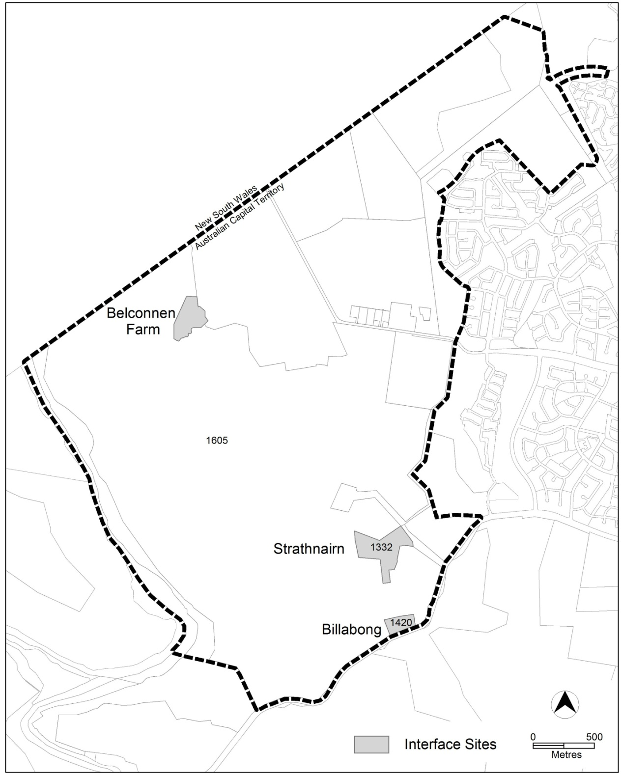

Figure 2 Interface Sites
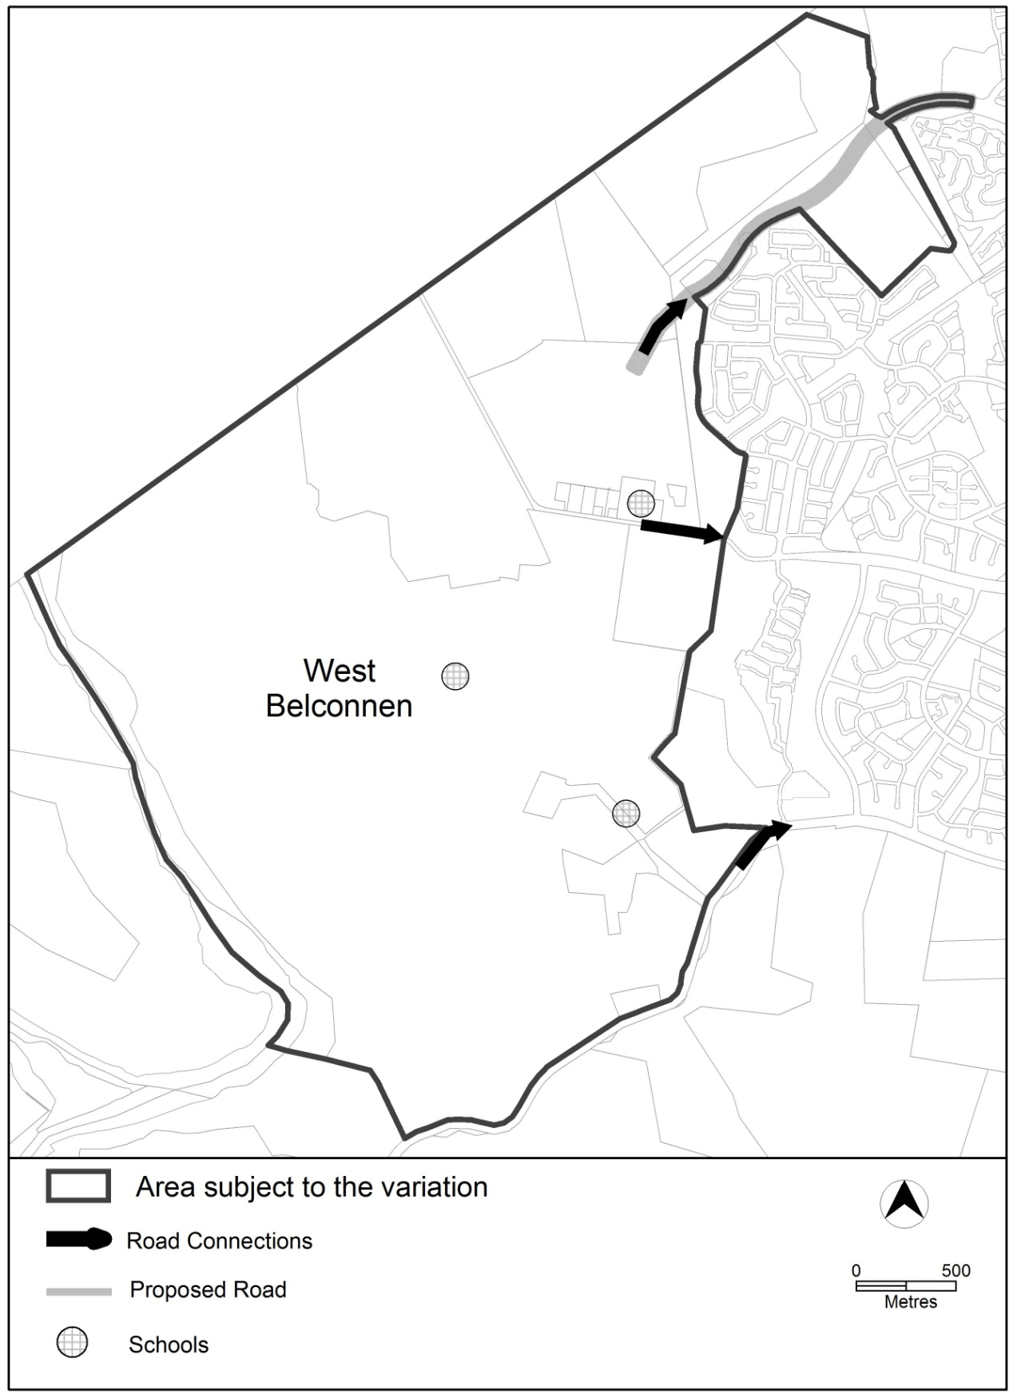

Figure 3 School and Road Connections

