Australian Capital Territory

Planning and Development (Technical Amendment—Rezoning of FUA) Plan Variation 2015 (No 1)*

Notifiable Instrument NI2015—334

Technical Amendment No 2014-22
made under the
Planning and Development Act 2007, section 89 (Making technical amendments)

This technical amendment commences on 26 June 2015.

Variation No 2014-22 to the Territory Plan has been approved by the planning and land authority.

Jim Corrigan
Delegate of the planning and land authority
22 June 2015

Planning & Development Act 2007

Technical Amendment
to the Territory Plan
Variation 2014-22

Rezoning of land within the future urban area
of north Weston to permit a service station and fast food restaurant

June 2015

Commencement version

Table of Contents

1. INTRODUCTION 2
1.1 Purpose 2
1.2 Public consultation 2
1.3 National Capital Authority 2
1.4 Process 2
1.5 Types of technical amendments under the Act 3
2. EXPLANATION 4
2.1 Amendments to Territory Plan map 4
2.2 Amendments to North Weston Concept Plan 8
3. TECHNICAL AMENDMENT 13
3.1 Territory Plan Map 13
3.2 North Weston Concept Plan 13

- INTRODUCTION
  - Purpose
This technical amendment makes the following changes to the Territory Plan.
Territory Plan map
- Rezoning of land within the future urban area of North Weston on the Territory Plan Map from:
  - residential RZ1 zone to commercial CZ3 services zone and CZ5 mixed use zone
  - Commercial CZ5 mixed use zone to residential RZ4 zone
North Weston Concept Plan

- Changes to Map 1 – North Weston Concept Plan
- Changes to Part 2 Specific Policies section 22 Streets paragraph 12
- Changes to Part 2 Specific Policies section 2.5 Mixed use development and paragraph 29

  - Public consultation
Under section 88 of the Planning and Development Act 2007 (the Act) this type of technical amendment is subject to limited public consultation. The public was notified through a newspaper notice. At the conclusion of the limited consultation period, any representations were considered by the planning and land authority (the Authority) within the Environment and Planning Directorate. The Authority then determines a day when the technical amendment is to commence by way of a commencement notice.

  - National Capital Authority
The National Capital Authority has been advised of this technical amendment.

  - Process
This technical amendment has been prepared in accordance with section 87 of the Planning and Development Act 2007 (the Act). Comments received from the public and the National Capital Authority were taken into account before the planning and land authority “made” the technical amendment under section 89 of the Act. The planning and land authority must now notify the public of its decision.

  - Types of technical amendments under the Act
The following categories of technical amendments are provided under section 87 of the Act:
(a) a variation (an error variation) that –
- would not adversely affect anyone’s rights if approved; and
- has as its only object the correction of a formal error in the plan

(b) a variation (a code variation) that –
- would only change a code; and
- is consistent with the policy purpose and policy framework of the code; and
- is not an error variation
(c) a variation in relation to a future urban area under section 95 (Technical amendments – future urban areas);
(d) a variation in relation to an estate development plan under section 96 (Effect of approval of estate development plan);
(e) a variation to change the boundary of a zone or overlay under section 96A (Rezoning – boundary changes);
(f) a variation required to bring the territory plan into line with the national capital plan;
(g) a variation to omit something that is obsolete or redundant in the territory plan;
(h) a variation to clarify the language in the territory plan if it does not change the substance of the plan;
(i) a variation to relocate a provision within the territory plan if the substance of the provision is not changed.
Following each item in Part 2 Explanation of this technical amendment is a statement of compliance against the specific criteria for the relevant category of technical amendment.
TA2014-22 has been prepared in accordance with section 87 (b) and (c) of the Act.

- EXPLANATION
This part of the technical amendment document explains the changes to be made to the Territory Plan, the reasons for the change, and a statement of compliance against the relevant section of the Act.

  - Amendments to Territory Plan map

Rezoning of land within the future urban area of North Weston shown on the Territory Plan map

Residential RZ1 to Commercial CZ3 Services

There is currently only one service station servicing Weston Creek and the emerging suburbs of the Molonglo Valley district. This service station is located in the Weston group centre. Studies have shown that demand for this service station often results in cars queuing down the street, causing traffic impacts and delays. The ACT Government is preparing a master plan for the Weston group centre, and one of the key actions proposed in the master plan for the group centre is to identify a site for an additional service station for Weston Creek and Molonglo Valley residents.

The preferred site for the additional service station and co-located fast food restaurant has been identified by the Government as part Block 1218 Weston Creek located in north Weston, accessed off Cotter Road (an arterial road) at the intersection with Kirkpatrick Street. The site was selected based on a Site Selection and Commercial Feasibility Study and in consultation with various Government agencies, surrounding lessees and service station operators. The site is in a central location that is convenient for both Weston Creek and Molonglo Valley residents. A buffer (with landscaping and a local road) is proposed between the site and residential development to the west to protect the amenity of adjoining residents.

The initial traffic impact assessment concluded that the key intersections of Cotter Road/Kirkpatrick Street/Dargie Street and Kirkpatrick Street/Kirkpatrick Street will continue to operate satisfactorily following full development of the subject site.

The proposed use of the site is not inconsistent with the intent of the relevant structure plan (Molonglo and North Weston) and associated concept plan (North Weston Concept Plan) and would not adversely impact on the planning of the North Weston area.

This technical amendment has been prepared to change the future urban area (FUA) zoning for part Block 1218 Weston Creek from residential RZ1 zone to commercial CZ3 services zone to permit a service station and fast food restaurant on the site. In order to ensure the viability of the service station and in line with current service station models, it is proposed the service station and fast food restaurant be co-located.

Residential RZ1 to Commercial CZ5 Mixed Use and Community Facilities (CFZ)

It is also proposed to amend the current location of the commercial CZ5 mixed use zone in North Weston and relocate it to the northern side of Kirkpatrick Street in close proximity to the service station site. This would effectively contain the activity node including the CZ3 site to one location on the corner of Kirkpatrick Street and Cotter Road which has good access and visibility.

The previous CZ5 parcel of land will be rezoned to RZ4 to reflect and be compatible with surrounding RZ4 zoning adjacent to the Weston Creek Pond.

A block of RZ1 land adjacent to the new location for the CZ5 site is also proposed to be rezoned to Community Facilities (CFZ) Zone to enable the establishment of some community uses within the activity node.

Existing Territory Plan map

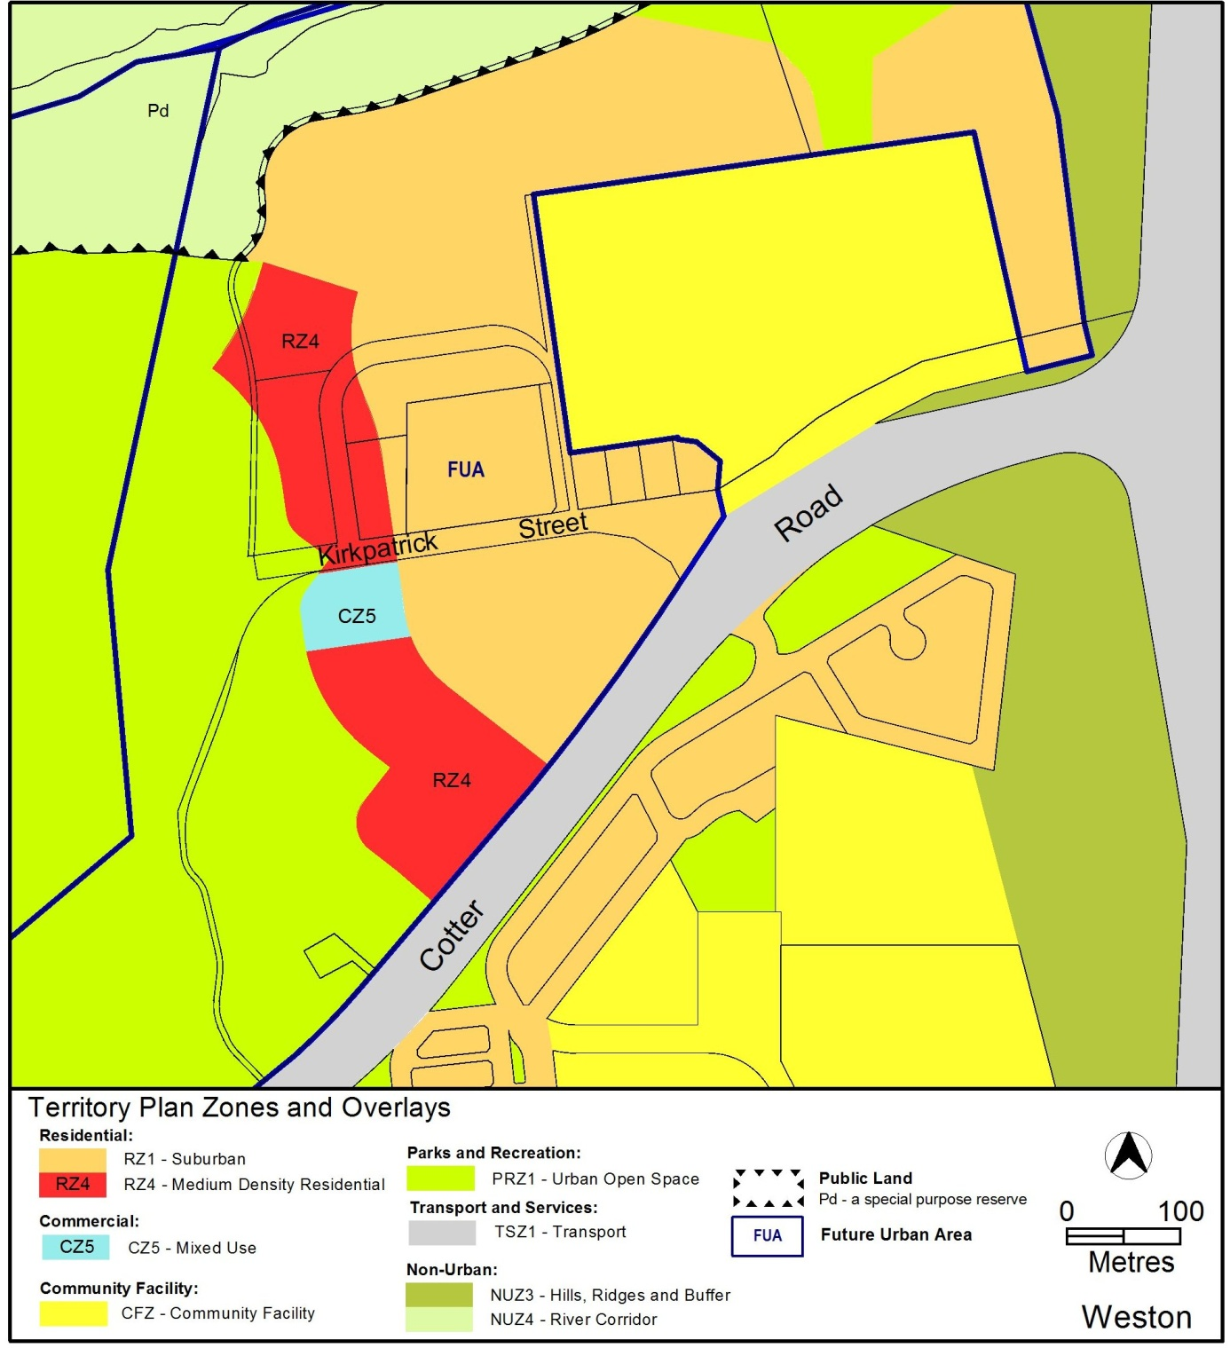
Proposed Territory Plan map

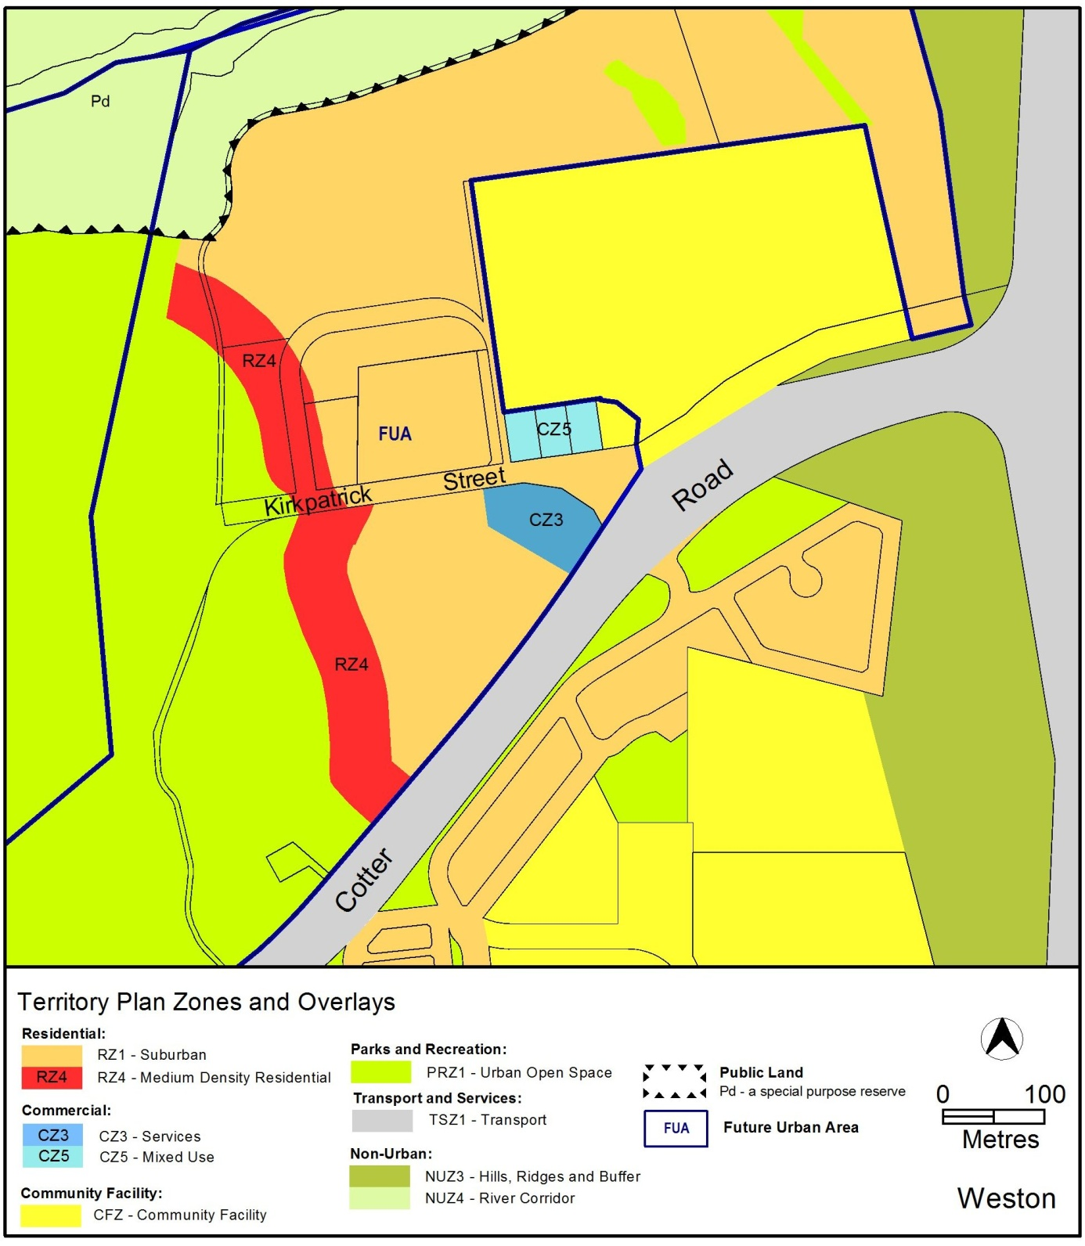

  - Amendments to North Weston Concept Plan
The Structure Plan for Molonglo and North Weston (the Structure Plan) completed in 2008 sets out the principles and policies that apply to the Molonglo Valley and North Weston future urban area. The Structure Plan includes the suburb of North Weston and the North Weston Concept Plan (the Concept Plan) provides the general and specific policies for the preferred development outcomes for the new suburb.

The proposed changes to the Concept Plan are considered to be consistent with the principles and policies of the Structure Plan. In particular the social, economic and urban design principles of the Structure Plan are relevant including sections 4.2.3; 4.2.5; 4.3.12; 4.3.13; 4.3.14; 4.6.32.

The North Weston Concept Plan is proposed to be amended in the following ways, in line with the changes to the future urban area rezoning on the Territory Plan Map:

2.2.1 Introduction: Map 1 – North Weston Concept Plan
Changes to Map 1 to reflect amended future urban area zones:

Current Map 1 (see over page)

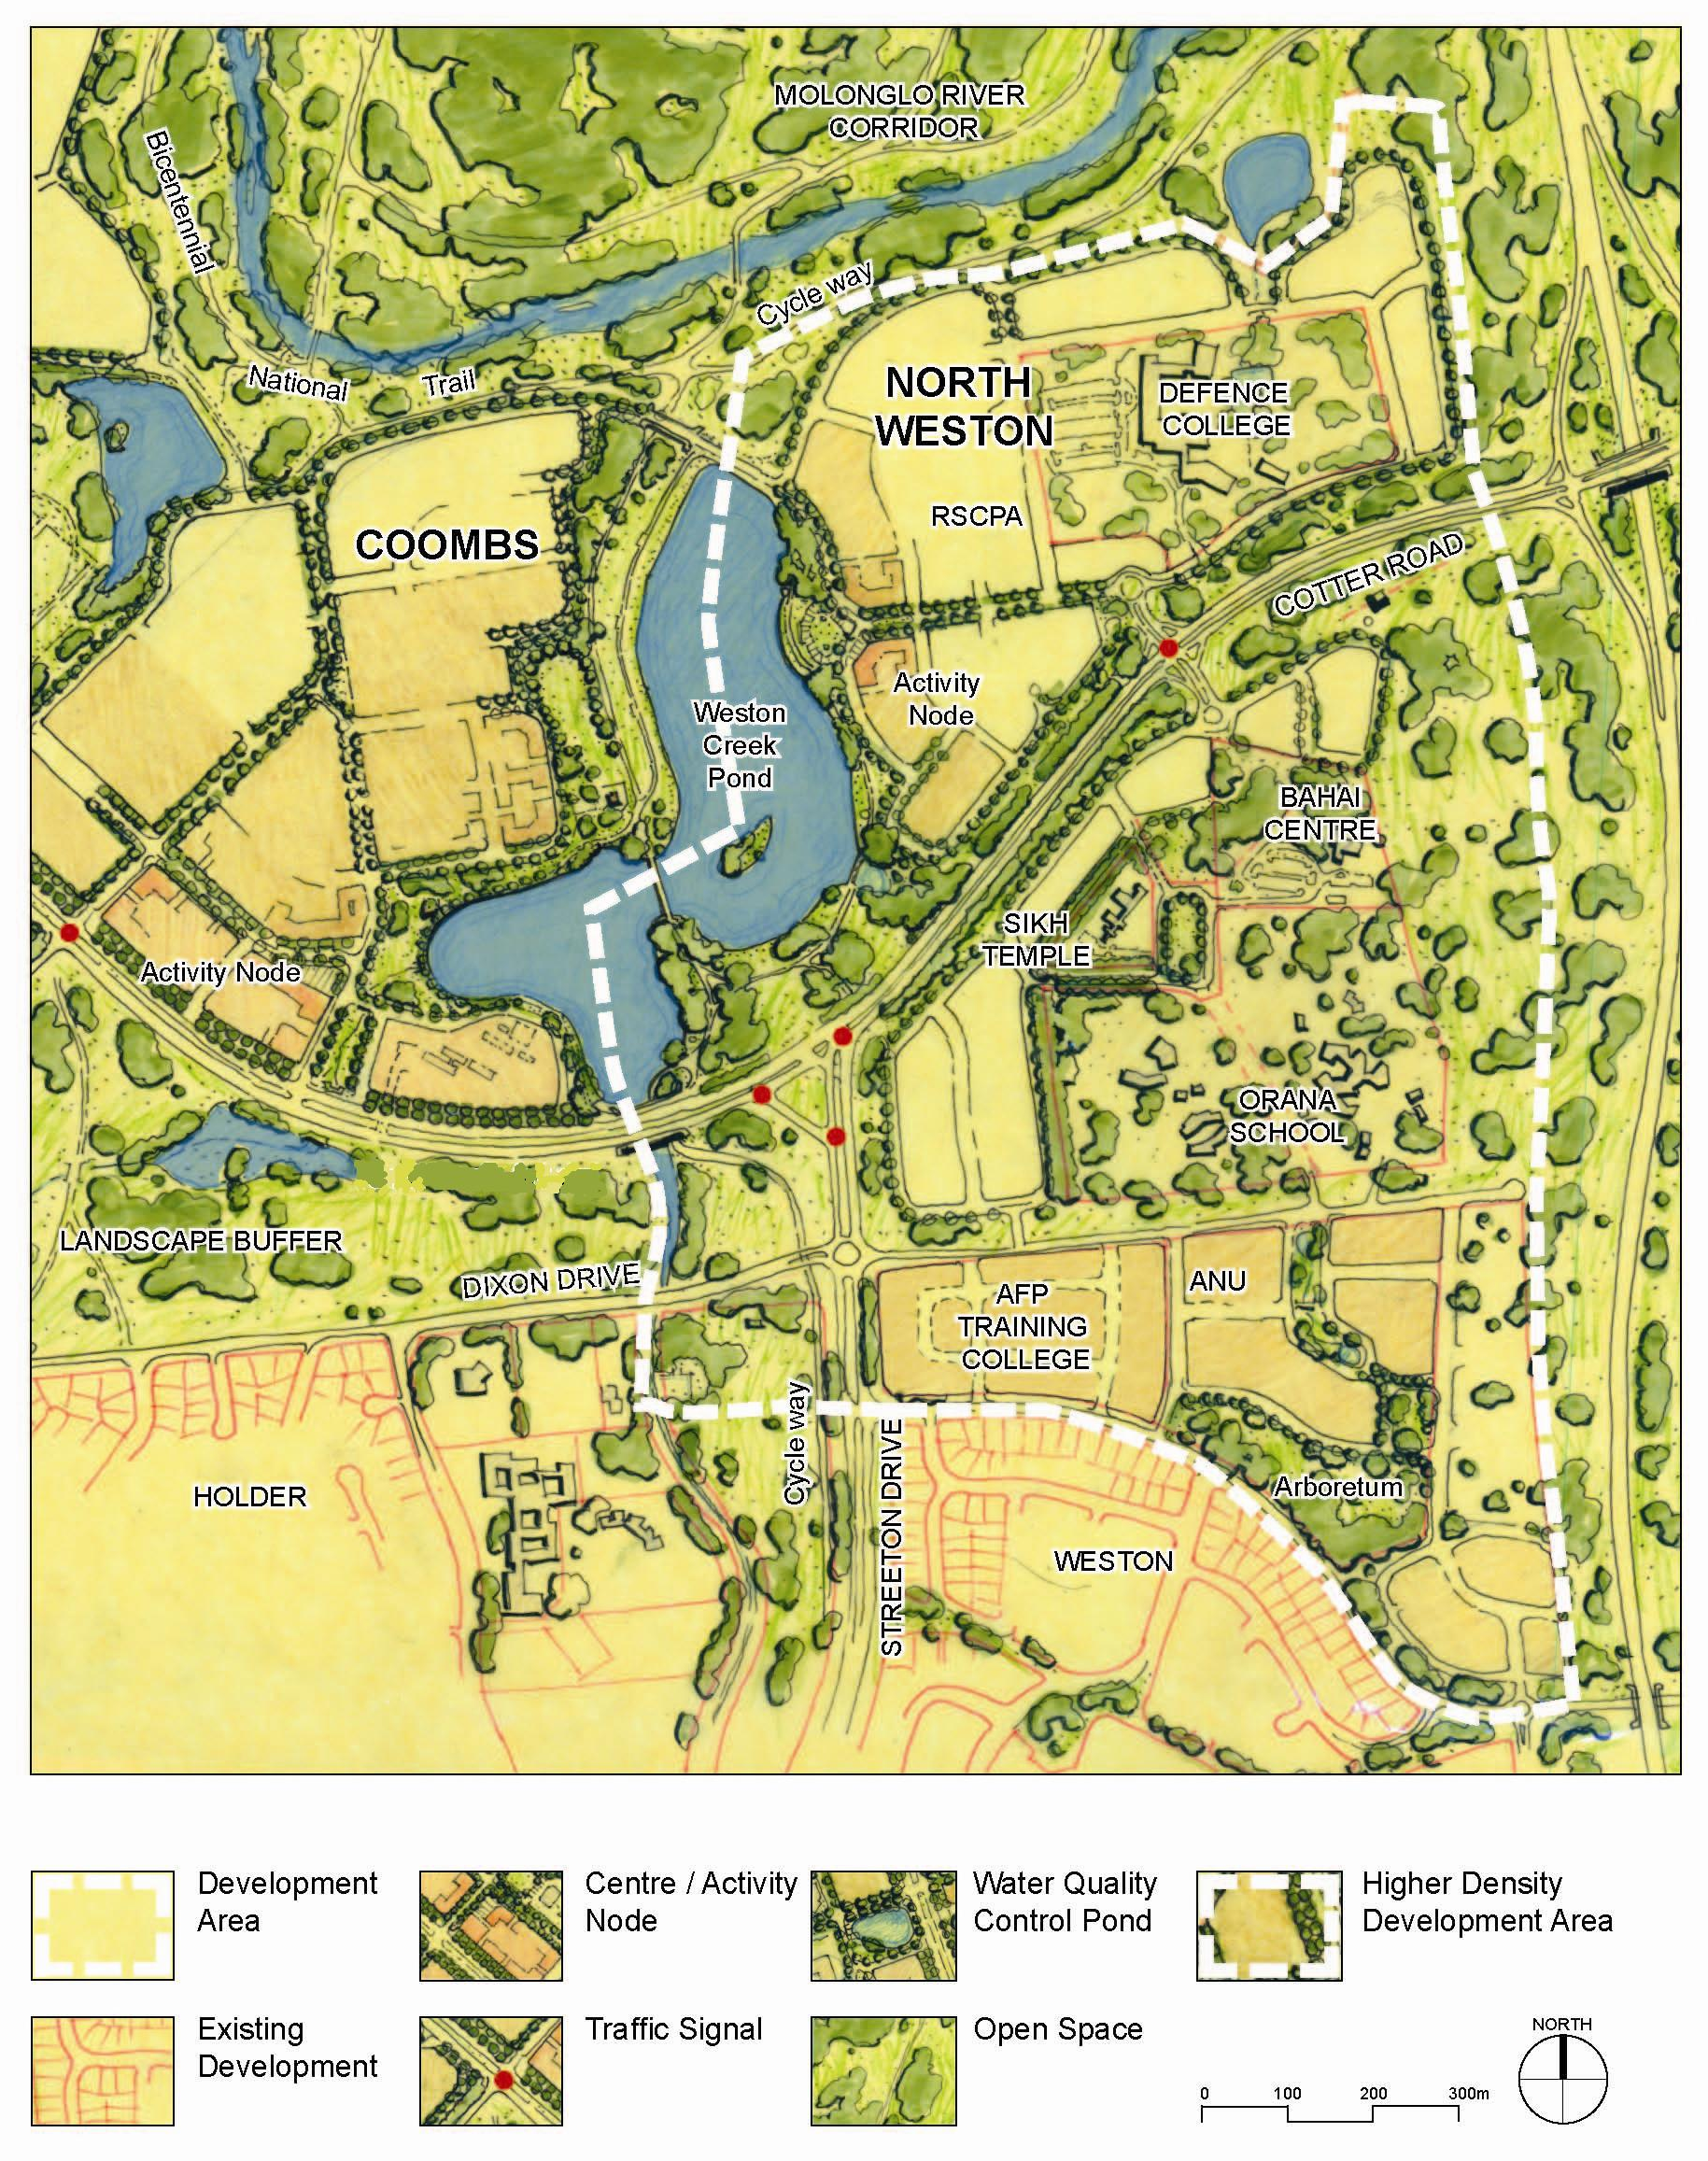

Map 1 – North Weston Concept Plan

Proposed Map 1:

Map 1 – North Weston Concept Plan

2.2.2 Part 2: Specific Policies; Section 2.2: Streets; paragraph 12

Amend the wording to reflect the changes to the road design that have already been completed for the Weston Creek Pond, which deletes the proposed collector road from Coombs crossing the pond embankment.

Current wording:

12. The primary vehicle access to the development north of Cotter Road will be via a formal approach route, on the alignment of Kirkpatrick Street, directly linking to the proposed activity node on the eastern side of Weston Creek Pond. This route will have a road reservation of a minimum 24 metre width, suitable for buses, and will link with the proposed collector road from Coombs crossing the pond embankment.
Proposed wording:

12. The primary vehicle access to the development north of Cotter Road will be via the alignment of Kirkpatrick Street. This route will have a road reservation of a minimum 24 metre width, suitable for buses.

2.2.3 Part 2: Specific Policies; Section 2.5: Mixed use development; paragraph 29

Current wording:

2.5 Mixed use development

29. Mixed use development incorporating commercial and residential uses are to be accommodated on the site zoned CZ5 on the eastern side of the Weston Creek Pond, in a building of minimum 2 storeys, maximum 4 storeys, with ground floor accommodation suitable for shop(s), café/restaurant(s), small office(s).

Proposed wording:

2.5 Commercial and mixed use development

29. A service station and fast food restaurant are to be accommodated on the site zoned CZ3 on the corner of Cotter Road and Kirkpatrick Street. Mixed use development incorporating commercial and residential uses are to be accommodated on the site zoned CZ5 in a building of minimum 2 storeys, maximum 4 storeys, with ground floor accommodation suitable for shop(s), café/restaurant(s), small office(s).

Compliance with the Planning and Development Act 2007

Section | Statement
S95(1) a variation (a rezoning of FUA variation) that -
- would only rezone land in a future urban area, and establish or vary a precinct code in relation to the land; and | This technical amendment only proposes to rezone land that is within the future urban area of North Weston as shown on the Territory Plan map and the North Weston Concept Plan has been varied in accordance with the rezoning of the future urban area land.
- is consistent with the Structure plan for the FUA | The proposed amendment is considered to be consistent with the purpose of the Structure Plan for Molonglo and North Weston as identified above.

- TECHNICAL AMENDMENT
This section of the technical amendment document provides the actual instructions for implementing the changes to the Territory Plan.

  - Territory Plan Map
Substitute the ‘Subject Area’ on the Territory Plan map:

  - North Weston Concept Plan

- North Weston Concept Plan – Introduction: Map 1 – North Weston

Substitute

Map 1 – North Weston Concept Plan

- North Weston Concept Plan – Section 2 Specific Policies; Sub-section 2.2 Streets; Paragraph 12

Substitute

12. The primary vehicle access to the development north of Cotter Road will be via the alignment of Kirkpatrick Street. This route will have a road reservation of a minimum 24 metre width, suitable for buses.

- North Weston Concept Plan – Section 2 Specific Policies; Sub-section 2.5 Mixed use development

Substitute

2.5 Commercial and mixed use development

29. A service station and fast food restaurant are to be accommodated on the site zoned CZ3 on the corner of Cotter Road and Kirkpatrick Street. Mixed use development incorporating commercial and residential uses are to be accommodated on the site zoned CZ5 in a building of minimum 2 storeys, maximum 4 storeys, with ground floor accommodation suitable for shop(s), café/restaurant(s), small office(s).

Interpretation service
