Australian Capital Territory
Planning and Development (Plan Variation No 347) Notice 2015
Notifiable Instrument NI2015-447
made under the
Planning and Development Act 2007, section 76(3)

- Name of instrument
This instrument is the Planning and Development (Plan Variation No 347) Notice 2015.*

- Plan Variation No 347
On 27 July 2015, the Minister for Planning approved a draft of the attached plan variation to the Territory Plan (Annexure A) under s76 (3).

Jim Corrigan
Delegate of the Planning and Land Authority
29 July 2015

Planning and Development Act 2007

Variation to the
Territory Plan
No 347

University of Canberra
Block 1 Section 3 Bruce

Final variation prepared under s76 of the
Planning and Development Act 2007

This page is intentionally blank.

Contents

1.0 EXPLANATORY STATEMENT 1
1.1 Background 1
1.2 Summary of the Proposal 2
1.3 The National Capital Plan 3
1.4 Site Description 3
1.5 Current Territory Plan Provisions 5
1.6 Changes to the Territory Plan 6
1.7 Consultation on the Draft Variation 6
1.8 Revisions to the Draft Variation Recommended to the Minister 6
2.0 VARIATION 7
2.1 Variation to the Territory Plan 7

This page is intentionally blank.

- EXPLANATORY STATEMENT
  - Background
The University of Canberra (UC) opened in 1968 as the Canberra College of Advanced Education, the first centre for adult education (CAE) in Australia. In1990 the UC was re-created as a university as a part of national educational reforms. Today the UC is one of the major tertiary education establishments within the Australian Capital Territory (ACT) and Australia.
As a highly competitive market, elite universities around the world provide a range of first-class services and facilities to attract the best students and staff. These facilities include not only educational or residential accommodation but also strong links with industry and convenient commercial services. Recognising this shift in tertiary services and expectations, UC has prepared a master plan which sets out their future vision for the campus. The Urban Plan, which is informed by the UC master plan, sets out more detailed, shorter term goals which are to be achieved.
For UC to continue its growth and remain competitive as an elite education provider the planning controls which govern development on the campus must be broadened. This broadening of planning controls will allow UC to pursue commercial opportunities that benefit education and research on the Bruce campus as well as the broader community. Opportunities such as these are being pursued by other universities within Australia and around the world currently, such as the Australian National University, Monash University and Macquarie University.
The UC is a unique case in terms of land use planning by virtue of the University of Canberra Act 1989 (the Act). The Act sets out the powers and functions of the university and also regulates development on the campus. Due to UC’s importance to Canberra the Act requires involvement of the ACT Government with respects to certain functions, such as appointments to the UC Council, controls and limitations on aspects of the universities activities and development. As such the ACT Government has a relatively larger degree of control over the UC and therefore the UC Bruce Campus when compared to almost all other development areas within the ACT. Decision making bodies within the UC can further restrict and regulate development undertaken on campus through not only the Territory Plan but also internal design standards and governance rules. This additional level of control means that the Territory Plan is not required to be as prescriptive when referring to development of the UC Bruce campus.
This variation to the Territory Plan is one part of a suite of changes being made to legislation and requirements which relates to the University of Canberra For instance the ACT Government has enacted legislative changes to the Act in relation to the university’s powers which will allow more flexible leasing arrangements and the ability for the UC to commercialise some of its underutilised assets.

  - Summary of the Proposal
Variation 347 implements key findings of the University of Canberra Master Plan and supporting documents. The variation was undertaken to:
- broaden the Territory Plan uses allowed on the university site by permitting a number of uses associated with the operation of a contemporary university as merit track assessable development;
- incorporate provisions for, and create greater, certainty in relation to building heights;
- incorporate additional design provisions and general requirements;
- limit the scale of non-student residential development to 3 300 dwellings;
- limit the gross floor area per SHOP to 200m² and per supermarket to 1000m²;
- an overall gross floor area limit for SHOP (including supermarket) of 4000m² for the site;
- limit the scale of non-university related public agency and business agency to 2000m²;
- limit the scale of non-university related office to 5000m² per office;
- limit overall gross floor area limit for non-university related office of 30 000m² for the site;
- allow for a more qualitative approach to assessing multi unit housing

  - The National Capital Plan
The Australian Capital Territory (Planning and Land Management) Act 1988 established the National Capital Authority (NCA) with two of its functions being to prepare and administer a National Capital Plan (NCP) and to keep the NCP under constant review and to propose amendments to it when necessary.
The NCP, which was published in the Commonwealth Gazette on 21 January 1990 is required to ensure that Canberra and the Territory are planned and developed in accordance with their national significance. The Planning and Land Management Act 1988 also required that the Territory Plan is not inconsistent with the NCP.
In accordance with section 10 of the Australian Capital Territory (Planning and Land Management) Act 1988, the National Capital Plan defines the planning principles and policies for Canberra and the Territory, for giving effect to the object of the NCP and sets out the general policies to be implemented throughout the Territory, including the range and nature of permitted land uses.
It also sets out the detailed conditions of planning, design and development for areas that have special significance to the National Capital known as designated areas and identifies special requirements for the development of some other areas.

  - Site Description
The subject area is located in the division of Bruce, specifically block 1 section 3. The site is generally bordered by Ginninderra Drive to the north, Haydon Drive to the east, College Street to the south and Aikman Drive to the west.
The site is currently occupied by the University of Canberra campus which has a number of buildings (educational, administrative and student accommodation) and open spaces (including sporting ovals and facilities).
One of the student accommodation buildings is registered on the Heritage register, as it has been identified as having heritage significance.
The site is currently zoned CFZ Community Facility Zone under the Territory Plan.
The location of the site can be seen in Figure 1.

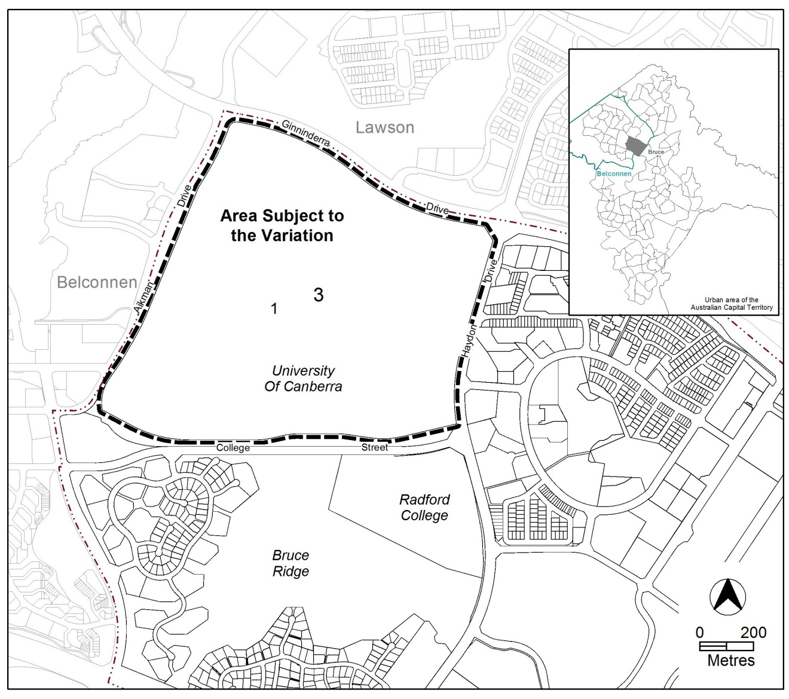FFigure 1 Location Plan

  - Current Territory Plan Provisions
The Territory Plan map for the area subject to this variation is shown in Figure 2.

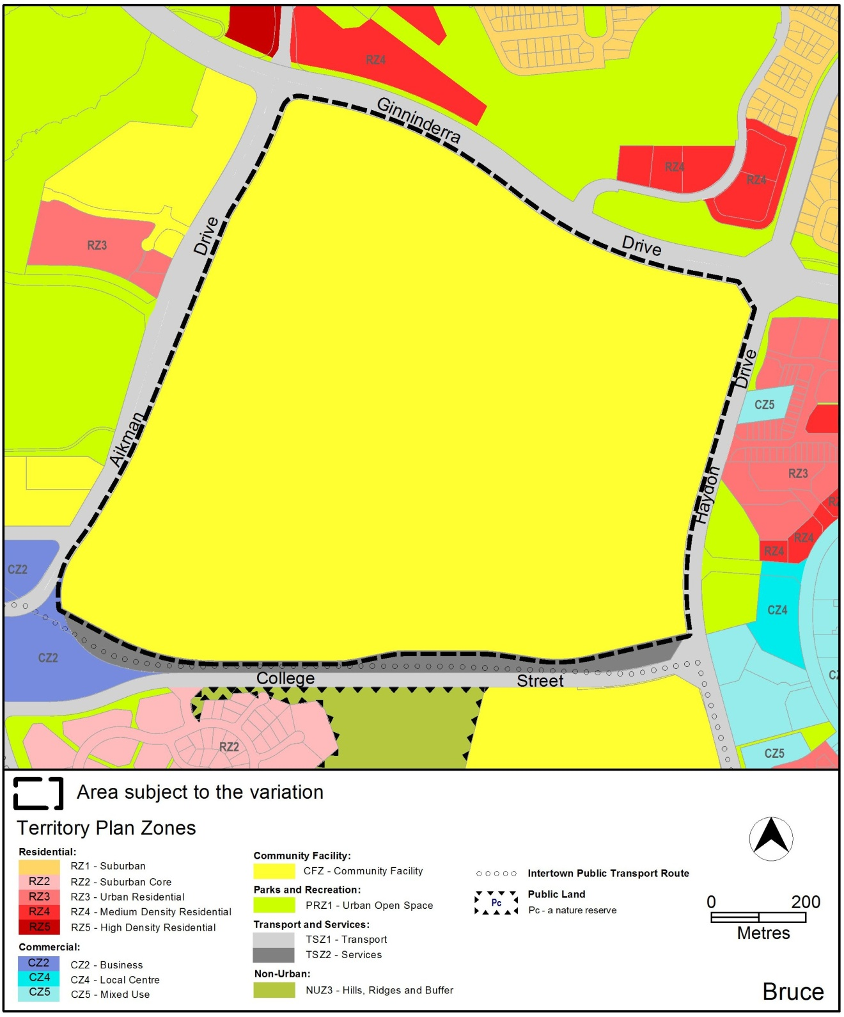FFigure 2 Territory Plan Zones Map
  - Changes to the Territory Plan
Detailed changes to the Territory Plan are noted in section 2 of this document.

  - Consultation on the Draft Variation
Variation No 347 (V347) was released for public comment between 14 May 2015 and 29 June 2015. A consultation notice under section 63 of the Planning and Development Act 2007 (P&D Act) was published on the ACT Legislation Register on 14 May 2015 and in The Canberra Times on 16 May 2015.
A total of seven written submissions and one petition were received during the public consultation period. One written submission was received a day late and was accepted. Of the submissions received 3 of them and 1 partition were from the public, 3 were from commercial entities and 2 were from professional/industry bodies.
Main issues raised by submitters included:
- allowing non-university related uses was not intended;
- DV would create undue competition for the Belconnen Town Centre and offend the established commercial hierarchy;
- building heights are excessive;
- objection to certain uses permitted by DV347, particularly produce market;
- subdivision of the land will diminish the capacity for the University of Canberra to operate;
- doubts about the physical relationship between development on the University of Canberra and integration with the Belconnen Town Centre; and
- heritage values on the site have not been adequately assessed and addressed

The above issues were considered and are detailed in a report on consultation. Changes were informed by the issues raised. The outcomes of consultation were considered by the Minister responsible for planning prior to approval of this variation.

  - Revisions to the Draft Variation Recommended to the Minister
No changes were made to the draft variation recommended to the Minister.
2. VARIATION
  - Variation to the Territory Plan

The Territory Plan map is varied in all of the following ways:

Variation to the Bruce precinct map and code Map
- Precinct maps and codes – Bruce precinct map and code

Substitute the following for the nominated attachment:

Bruce precinct map and development tables – Attachment A

Add the nominated attachment to the end of the Bruce Precinct Code:

Bruce precinct code – ‘RC4 Canberra University’ – Attachment B
Interpretation service
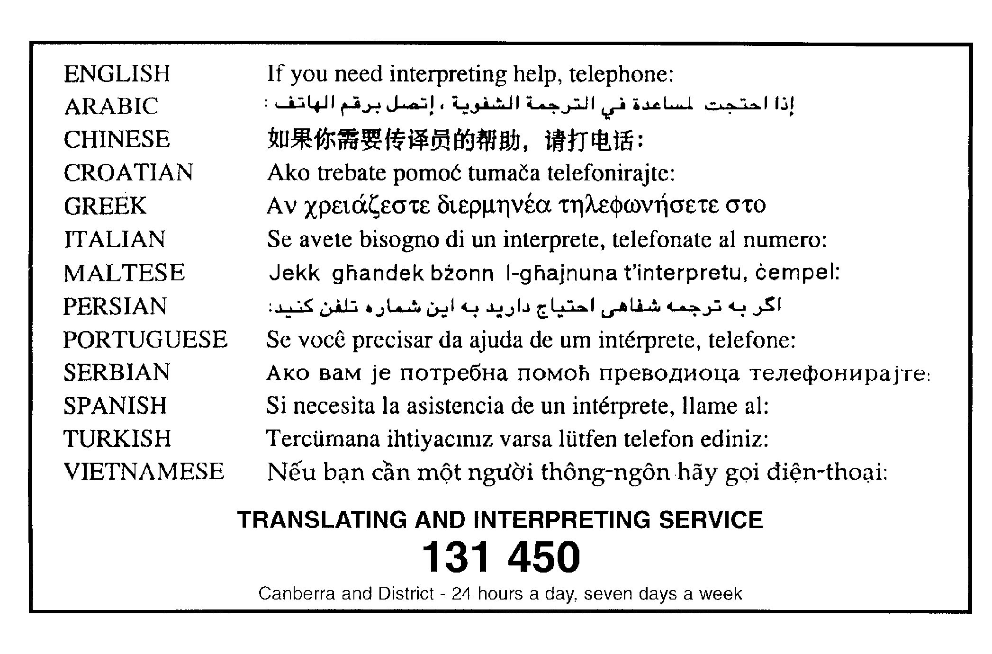

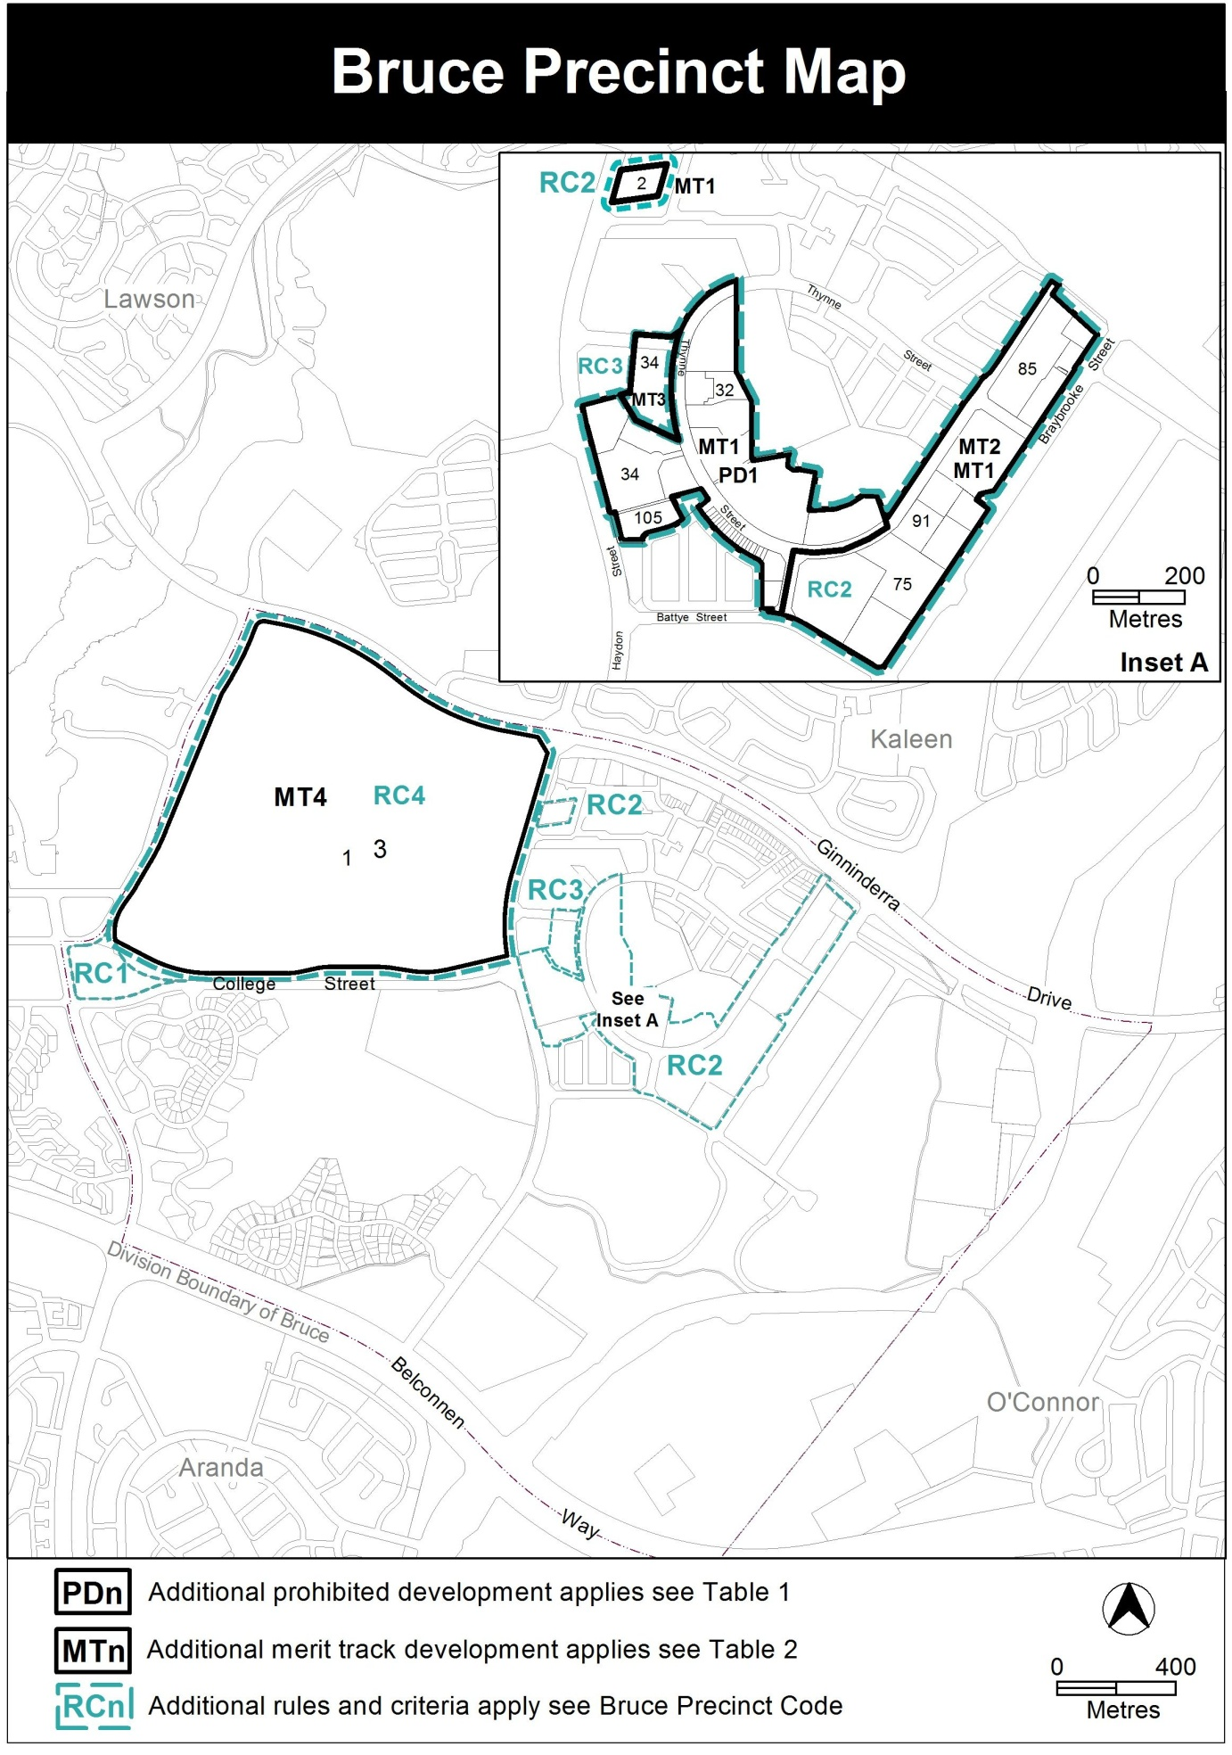

Assessment Tracks

The following tables identify the additional prohibited development and additional merit track development for blocks and parcels shown in the Bruce Precinct Map (identified as PDn or MTn). Development that is exempt from requiring development approval, other prohibited development and the minimum assessment track applicable to each development proposal is set out in the relevant zone development table.

The following tables constitute part of the relevant zone development table.

Table 1 – Additional prohibited development
Additional prohibited development
Suburb precinct map label | Zone | Development
PD1 | CZ5 | hotel

Table 2 – Additional merit track development
Additional merit track development that may be approved subject to assessment
Suburb precinct map label | Zone | Development
MT1 | CZ5 | defence installation drink establishment  light industry place of assembly  scientific research establishment  store warehouse
MT2 | CZ5 | club
MT3 | CZ4 | drink establishment
MT4 | CFZ | car park  club  commercial accommodation unit  communications facility  craft workshop  drinks establishment  financial establishment  hotel  indoor entertainment facility  light industry  motel  multi-unit housing  nature conservation area  place of assembly  playing field  pedestrian plaza  produce market  public transport facility  restaurant  scientific research establishment  service station  serviced apartment  SHOP  store  veterinary hospital

Additional rules and criteria
This part applies to blocks and parcels identified in the Bruce Precinct Map (RCn). It should be read in conjunction with the relevant zone development code and related codes.

RC4 – University of Canberra
This part applies to blocks and parcels identified in area RC4 shown on the Bruce Precinct Map.
- General Development Controls
Rules | Criteria
  - Storage
There is no applicable rule. | Where the proposed development requires open areas for storage of goods and materials, adequate provision is included in the design and layout of the site and should not encroach on car parking, driveways or landscape areas and be adequately screened from public view so it does not detract from the development or its surroundings.
  - Traffic Generation
There is no applicable rule. | The existing road network can accommodate the amount of traffic that is likely to be generated by the development.
  - Vehicular Access
This rule applies to all development not covered by the Parking and Vehicle Access General Code for the Community Facility Zone  Development complies with the Parking and Vehicle Access General Code for ‘Commercial CZ5 mixed use zone’  Where not covered elsewhere by this rule, parking requirements for development is subject to individual assessment. | This is a mandatory requirement. There is no applicable criterion.
  - Noise
This rule applies to any of the following:  - club  - drinks establishment  - emergency services facility  - hotel  - indoor recreation facility  - indoor entertainment facility  - outdoor recreation facility  - restaurant  Development complies with a noise management plan prepared by a suitably qualified person and endorsed by the Environment Protection Authority (EPA).  The noise management plan will detail the proposed design, siting and construction methods that will be employed to ensure compliance with the Environment Protection Regulation 2005, based on the estimated noise levels when the facility is used. | This is a mandatory requirement. There is no applicable criterion.
  - Wind
There is no applicable rule. | This criterion applies to buildings with a height of building greater than 19m but less than 28m.  The wind patterns associated with the proposed building will not unreasonably reduce the safety and comfort of people in the public realm or other open spaces associated with the development, compared with a similar building on the site with a height of building of 19m.  Compliance with this criterion will be demonstrated by a wind assessment report prepared by a suitably qualified person.
This rule applies to buildings with a height of building greater than 28m  As a consequence of the proposed development wind speeds do not exceed 16 m/s for all adjacent streets, public places and pedestrian areas.  Compliance with this rule is demonstrated by a wind assessment report prepared by a suitably qualified person. | This is a mandatory requirement. There is no applicable criterion.
  - Landscaping
There is no applicable rule. | This criterion applies to all uses, excluding multi unit housing.  Landscaping associated with the development achieves all of the following:  - responds to site attributes, including streetscapes and landscapes of documented heritage significance  - appropriate scale relative to the road reserve width and building bulk  - vegetation types and landscaping styles which complement the landscape character of the campus  - integration with park , reserves and public transport corridors  - does not adversely affect the structure of the proposed buildings or adjoining buildings  - contribution to energy efficiency and amenity by providing substantial shade in summer, particularly to west-facing windows, open car park areas, winter sunlight to outdoor and indoor living areas  - minimises the risk of damage to above and underground utilities and screen aboveground utilities  - provides adequate site lines for vehicles and pedestrians, especially near street corners and intersections  - does not obscure or obstruct building entries, paths and driveways to reduce the safety and security.

- Use
Rules | Criteria
  - SHOP – floor area limit
The maximum gross floor area per SHOP (excluding supermarket): 200m2 | SHOPs are limited to a scale appropriate to providing convenience shopping and personal services for the local workforce, students and residents.
The maximum gross floor area per supermarket: 1000m2 | This is a mandatory requirement. There is no applicable criterion
The maximum gross floor area for all SHOP’s (including supermarket): 4000m2. | - ...  The maximum gross floor area for all SHOP’s (including supermarket) is limited to a scale that is appropriate to provide convenience shopping and personal services for the local workforce, students and residents or must not have a material adverse impact on the Belconnen Town Centre and other surrounding commercially viable group and local centres.
  - Produce Market
There is no applicable rule. | Produce market is limited to a scale appropriate to providing convenience shopping and personal services for the local workforce, students and residents or must not have a material adverse impact on similar uses within the Belconnen Town Centre.
  - Business Agency, Public Agency and Office
Rule 4 of the Community Facility Zone Development Code does not apply. | This is a mandatory requirement. There is no applicable criterion.
This rules applies to any of the following:  - business agency  - public agency  The maximum gross floor area per business agency or public agency is: 2000m2  This rule does not apply where a business agency or public agency is considered an ancillary use to the use of the land as an educational establishment.  Note: This rule applies instead of R5 of the Community Facility Zone Development Code. | Where a business agency or public agency are not considered ancillary to the use of the land as an educational establishment a report must be prepared by a suitably qualified person demonstrating that the proposal will not have a material adverse impact on the Belconnen Town Centre.
This rule applies to office. This rule does not apply where an office is a part of an educational establishment or is an ancillary use to the use of the land as an educational establishment.  The maximum gross floor area per office is: 5000m2  Note: This rule applies instead of R5 of the Community Facility Zone Development Code. | Where a office is not considered as :  - a ancillary use to the use of the land as an educational establishment; or  - part of an educational establishment.  A report must be prepared by a suitably qualified person demonstrating that the proposal will not have a material adverse impact on the Belconnen Town Centre.
This rule applies to office.  The maximum gross floor area for all office is: 30 000m2  This rule does not apply where an office is a part of an educational establishment or is an ancillary use to the use of the land as an educational establishment.  Note: this rule applies instead of R5 of the Community Facility Zone Development Code. | Where a office is not considered as :  - a ancillary use to the use of the land as an educational establishment; or  - part of an educational establishment.  A report prepared by a suitably qualified person and endorsed by the Strategic Planning Branch demonstrating that the cumulative impacts of additional office development will not have a material adverse impact on Belconnen Town Centre.

- Buildings
Rules | Criteria
  - Height of buildings
The maximum height of building is 15m  Note: This rule replaces any other height rule mentioning height of building in metres or storeys. | The height of a building, may be increased:  - up to 28m, where the development complies with all of the following:  - minimises detrimental impacts, including overshadowing and excessive scale; and  - provides reasonable solar access to pedestrian areas, surrounding residential dwellings and their associated private open space.  - up to 40m, where the development complies with all of the following:  - a) i. and a) ii. of this criteria;  - the building responds to topography by limiting excessive building heights in elevated areas; and  - where two or more buildings above 30m are within close proximity to one another they do not create excessive bulk and scale or are not the dominant built form.
  - Street Address
There is no applicable rule. | All buildings within 50m of a front boundary must provide to the street frontage:  - an interesting and/or articulated façade particularly to the front boundary;  - clearly identified public pedestrian access points;  - with either:  - no loading docks facing the front boundary; or  - loading docks that do not dominate the street frontage and do not conflict with parking or pedestrian movements in front of the building.
  - Building design and materials
There is no applicable rule. | This criterion applies to all development excluding multi unit housing.  Buildings are designed and built to achieve all of the following:  - a positive contribution to the amenity and character of adjacent public spaces  - interesting, functional and attractive facades that contribute positively to the build form and pedestrian experience; and  - articulated building forms  Note: This criterion applies instead of rules and criteria relating to materials and finishes in the Community Facility Zone Development Code.

- Residential Development
Rules | Criteria
  - Non-Student Accommodation
This rule applies to multi unit housing.  This rule does not apply to hotel, motel or commercial accommodation unit.  Maximum number of dwellings that are not classified as ‘student accommodation’ for the University of Canberra’ on the site does not exceed 3 300. | This is a mandatory requirement. There is no applicable criterion.
  - Multi Unit Housing
Multi unit housing or residential components of commercial mixed use comply with the Residential Zones – Multi Unit Housing Development Code. | Multi unit housing or residential components of commercial mixed use must be designed and built to comply with all of the following:  - Development is innovative, including high quality architectural design and materials, interesting facades which offer passive surveillance and easily distinguishable building entries  - Development is designed and built to a very high environmentally sustainable standard and may including the use of sustainable materials, embodied energy, renewable energy sources and rainwater capture  - Development is sensitive to its surroundings considering design, materials, height, bulk and scale  - Development provides reasonable solar access to the main daytime living areas and private open space of proposed dwellings  - Retains reasonable solar access to adjoining dwellings and their associated private open space  - Development provides suitable private open space which is easy to access and high quality landscaped area which break up excessive non-permeable surfaces  - Development provides adequate site open space, communal areas and high quality landscaping for all residents  - Development provides adequate privacy to residents of the proposal and adjoining (wholly or partially) residential buildings  - Vehicular parking, including visitor parking and access, is not a dominant feature or are obscured from public view  - Development provides reasonable levels of residential amenity waste management and other services  - Development must comply with the following provisions of the Multi Unit Housing Development Code that relate to:  - ‘Adaptability of dwelling for use by people with a disability’  - ‘Noise attenuation – external sources’  - ‘Heritage’  - ‘Tree Protection’  - ‘Water Sensitive Urban Design’  - Part D ‘Endorsement by government agencies (entities)  Note: If the development complies with this criterion the Multi Unit Housing Development Code, unless otherwise stated by this criterion, does not apply.

- Other Development Controls
Rules | Criteria
  - Water sensitive urban design
This rule applies to sites 5000m2 or larger, excluding multi unit housing.  The average annual storm water pollutant export is reduced for all of the following:  - suspended solids by at least 60 percent  - total phosphorous by at least 45 percent  - total nitrogen by at least 40 percent  compared with an urban catchment with no water quality management controls.  Note: Compliance with this rule is demonstrated by a water sensitive urban design outcomes plan endorsed by a suitably qualified person.  Note: Multi unit housing will need to comply with the rules and/or criteria (where relevant) for Water sensitive urban design located in the multi unit housing development code. | This is a mandatory requirement. There is no applicable criterion
This rule applies to sites 2000m2 or larger, excluding multi unit housing.  Storm water management complies with one of the following:  - the capacity of the existing pipe (minor) storm water connection is not exceeded in 1-in-10 year storm event and the capacity of the existing major overland storm water system is not exceeded in the 1-in-100 year storm event  - the 1-in-5 year and 1-in-100 year storm water peak run off does not exceed pre-development levels.  Note: Compliance with this rule is demonstrated by a water sensitive urban design outcomes plan endorsed by a suitably qualified person  Note: Multi unit housing will need to comply with the rules and/or criteria (where relevant) for Water sensitive urban design located in the multi unit housing development code. | This is a mandatory requirement. There is no applicable criterion
This rule applies to sites 2000m2 or larger, excluding multi unit housing.  Provision is made for one or more of the following:  - the storage of storm water equivalent to at least 1.kl per 100m2 of impervious area and its release over a period of 1 to 3 days  - runoff peak flow for the 3 month ARI storm to be no more than pre-development levels and release of captured flow over a period of 1 to 3 days.  Note: Compliance with this rule is demonstrated by a water sensitive urban design outcomes plan endorsed by a suitably qualified person  Note: Multi unit housing will need to comply with the rules and/or criteria (where relevant) for Water sensitive urban design located in the multi unit housing development code. | This is a mandatory requirement. There is no applicable criterion
This rule applies to all development excluding multi unit housing.  Evidence is provided that shows the development achieves a minimum 40% reduction in mains water consumption compared to an equivalent development constructed in 2003 using the ACTPLA on-line assessment tool or another tool as included in the Water Ways: water Sensitive Urban Design General Code. The 40% target is met without any reliance on landscaping measures to reduce consumption.  This requirement does not apply for extensions with an increase in the combined roof area, driveway, car maneuvering areas and car parking areas of less than 25% of the original area.  Note: Multi unit housing will need to comply with the rules and/or criteria (where relevant) for Water sensitive urban design located in the multi unit housing development code. | This is a mandatory requirement. There is no applicable criterion
There is no applicable rule. | Underground piping of natural storm water overland flow paths is minimised.
  - Endorsement by government agencies (entities)
This rule applies to all development excluding multi-unit housing.  Uses applicable to this rule complies with the Commercial Zones Development Code Part G – Endorsement by government agencies | This is a mandatory requirement. There is no applicable criterion
  - Endorsement by government agencies (entities)
This rule applies to a development that has one or more of the following characteristics:  - requires groundwork within the tree protection zone of a protected tree  - is likely to cause damage to or removal of any protected trees  The authority shall refer the development application to the Conservator of Flora and Fauna  Notes:  1. Under the Planning and Development Regulation 2008 a development application for a declared site under the Tree Protection Act 2005, must be referred to the Conservator of Flora and Fauna.  2. The authority will consider any advice from the Conservator of Flora and Fauna before determining the application in accordance with the Planning and Development Act 2007.  3. Protected tree and declared site are defined under the Tree Protection Act 2005. | This is a mandatory requirement. There is no applicable criterion
  - Heritage
In accordance with section 148 of the Planning and Development Act 2007, applications for developments on land or buildings subject to provisional registration or registration under s.41 of the Heritage Act 2004 was accompanied by advice from the Heritage Council stating that the development meets the requirements of the Heritage Act 2004. | If advice from the Heritage Council is required however not provided, the application will be referred to the Heritage Council and its advice considered before the determination of the application.

