Australian Capital Territory
Planning and Development (Plan Variation No 327) Notice 2015
Notifiable Instrument NI2015-449
made under the
Planning and Development Act 2007, section 76(3)

- Name of instrument
This instrument is the Planning and Development (Plan Variation No 327) Notice 2015.*

- Plan Variation No 327
On 27 July 2015, the Minister for Planning approved a draft of the attached plan variation to the Territory Plan (Annexure A) under s76 (3).

Jim Corrigan
Delegate of the Planning and Land Authority
29 July 2015

Planning and Development Act 2007

Variation to the
Territory Plan
No 327

Capital Metro - Light Rail Stage 1
Gungahlin to Civic

July 2015

Final variation prepared under s76 of the
Planning and Development Act 2007

This page is intentionally blank.

Contents

1. EXPLANATORY STATEMENT 1
1.1 Background 1
1.2 Summary of the Proposal 2
1.3 The National Capital Plan 3
1.4 Site Description 4
1.5 Current Territory Plan Provisions 6
1.6 Changes to the Territory Plan 13
1.7 Consultation on the Draft Variation 13
1.8 Revisions to the Draft Variation Recommended to the Minister 13
2. VARIATION 14
APPENDIX 1 Proposed Territory Plan Zone Maps 18

This page is intentionally blank.

- EXPLANATORY STATEMENT
  - Background
The Capital Metro - Light Rail Stage 1 Gungahlin to Civic project is the first light rail development in the ACT. It includes a 12 kilometre light rail service linking the City to Gungahlin and associated infrastructure works along the existing transport corridors of Hibberson Street, Flemington Road, Federal Highway and Northbourne Avenue.
There have been numerous transport planning studies that have considered the inclusion of a light rail network in Canberra. Transport for Canberra - Transport for a Sustainable City (2012-2031) has specifically identified light rail to be introduced over time on the current frequent network of the City’s public transport system. The Gungahlin to City corridor incorporating Northbourne Avenue was identified by Transport for Canberra to be the initial focus for the implementation of new rapid transit in the City for the medium to long term.
All of the previous transport planning studies included considerations of public transport and land use integration along with extensive public consultation. The concept of light rail in Canberra has been investigated for some time. However the current Territory Plan does not contain any specific definitions of light rail and its associated works. Variation Territory Plan Number 327 (V327) aims to establish definitions for light rail and associated key infrastructure components to remove any potential ambiguity around the permissibility of the development of light rail in the ACT and to establish a clear assessment path for future light rail proposals.
The Light Rail Stage 1 Gungahlin to Civic project is proposed to be predominately located within the existing road corridors running down the central road medians. The light rail alignment follows the existing Inter-Town Public Transport Route as identified in Transport for Canberra 2012-2013. The majority of the project falls in the existing TSZ1 Transport Zone (light rail line) and IZ1 General Industrial Zone (light rail depot). The project also includes slight encroachments on surrounding zones particularly at the depot location and locations requiring more space for proposed access points, intersections and the inclusion of the light rail within the central road medians. These sites, predominately at Section 231 Gungahlin, the land surrounding Exhibition Park in Canberra (EPIC), the access to Yowani Country Club and Lyneham Sports Precinct, are rezoned (refer to the specific block information below).

  - Summary of the Proposal
The variation makes the following changes to the Territory Plan to enable the development of a light rail system from Gungahlin to Civic:
- Introduce the terms ‘Light rail’ and ‘Light rail depot’ to the Territory Plan. This includes:
- Adding ‘Light rail’ and its definition as a sub-category in the definition for ‘Public transport facility’;
- Amending the definition of ‘Railway use’ to exclude ‘Light rail’;
- Amending the definition of ‘Road’ to include ‘light rail tracks’;
- Amending the definition of ‘Municipal depot’ to cover vehicles and light rail vehicles; and
- Adding ‘Light rail depot’ under Common Terminology for ‘’Municipal depot’.
- Rezone parcels of land on a number of blocks to TSZ1 Transport Zone to allow for undertaking light rail associated road works. The rezoned sites include some blocks that have subsequently been retired due to processes outside the variation to the Territory Plan. In this regard, the Territory Plan maps in this variation prevail regardless of the specific block and section numbers. The rezoning includes :
- Part block 1 section 231 Gungahlin, (now part of block 2, section 231 Gungahlin) currently zoned as CZ2 Business Zone and PRZ1 Urban Open Space Zone.
- Parts of block 1 (now block2) section 60, block 1 section 74 and block 1 section 76 Lyneham and parts of block 3 (now blocks 1, 4 and 5) section 15 and block 1 section 42 (now block 4 section 42) Mitchell, currently zoned as NUZ3 Hills, Ridges and Buffer Zone. The Pc Nature Reserve Overlay will be removed from these sites as required by the Conservator of Flora and Fauna.
- Parts of blocks 797 (now part of Gungahlin block 850) and 798 Gungahlin, and parts of block 2 (now blocks 5 and 6) section 61, block 5 (now block 6) section 72, block 1 (now block 2) section 75, blocks 5 (now block 23), 19 (now block 24), 20 (now block 25) and 21 (now block26) section 71 Lyneham, currently zoned as NUZ1 Broadacre Zone.
- Part block 4, section 67 Lyneham, currently zoned as PRZ2 Restricted Access Recreation Zone.
- Part block 49 (now blocks 50,51and 52) section 59 Lyneham, currently zoned as PRZ1 Urban Open Space Zone.
- An area currently zoned NUZ1 Broadacre between block 22 section 71 Lyneham and Flemington Road
- Amend TSZ1 Transport Zone Objective b) to cover ‘light rail’ to ensure that any light rail developments are consistent with relevant zone objectives.
- Rezone a small triangular area in block 1 section 42 Mitchell from NUZ3 Hills Ridges and Buffer Zone to IZ1 General Industry Zone to accommodate the proposed light rail depot. The Pc Nature Reserve Overlay over the site is removed.

  - The National Capital Plan
The Australian Capital Territory (Planning and Land Management) Act 1988 established the National Capital Authority (NCA) with two of its functions being to prepare and administer a National Capital Plan (NCP) and to keep the NCP under constant review and to propose amendments to it when necessary.
The NCP, which was published in the Commonwealth Gazette on 21 January 1990 is required to ensure that Canberra and the Territory are planned and developed in accordance with their national significance. The Planning and Land Management Act 1988 also required that the Territory Plan is not inconsistent with the NCP.
In accordance with section 10 of the Australian Capital Territory (Planning and Land Management) Act 1988, the National Capital Plan defines the planning principles and policies for Canberra and the Territory, for giving effect to the object of the NCP and sets out the general policies to be implemented throughout the Territory, including the range and nature of permitted land uses.
It also sets out the detailed conditions of planning, design and development for areas that have special significance to the National Capital known as designated areas and identifies special requirements for the development of some other areas.

  - Site Description
The rezoned sites are show in Figure 1 and described below.
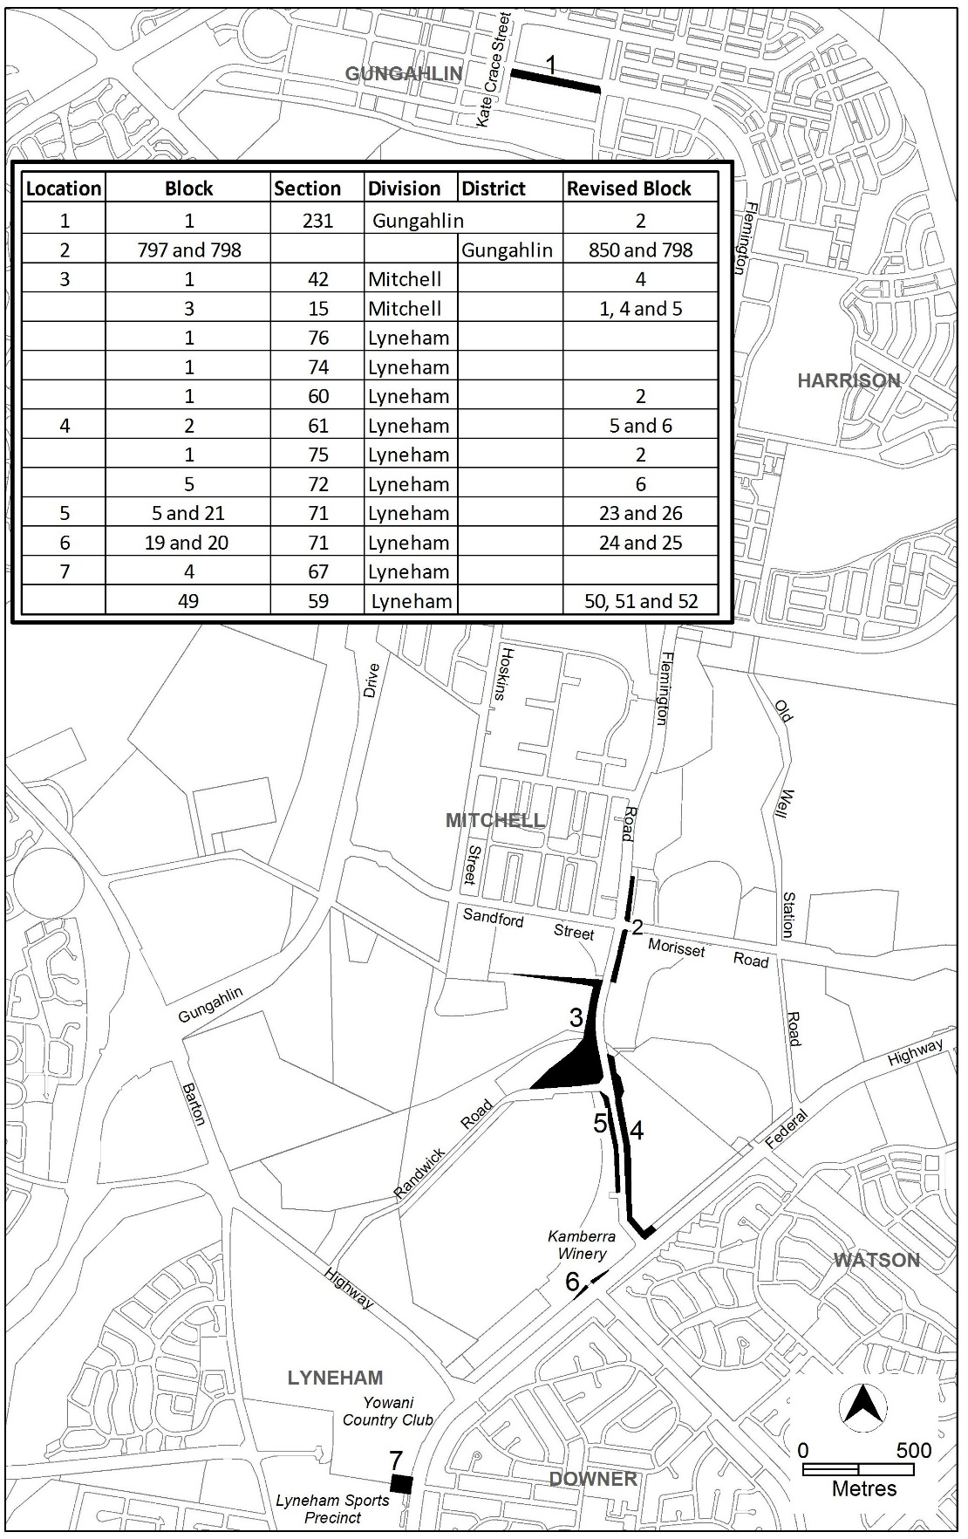
Figure 1 Site Plan

- Part block 1 section 231 Gungahlin (now part of block 2 section 231 Gungahlin)
This site is located along Flemington Road and immediately east of Kate Crace Street. It is currently in CZ2 Business Zone and PRZ1 Urban Open Space Zone. This block is unleased Territory land and managed by Land Development Agency. At present there are no active development proposals over it.
- Parts of blocks 797 (now Part of block 850 Gungahlin) and 798 Gungahlin
These two sites are located at the intersection of Flemington Road, Sandford Street and Morisset Road and are currently in NUZ1 Broadacre Zone. The blocks are vacant unleased Territory land and managed by the Territory and Municipal Service Directorate (TAMS).
- Parts of block 1 section 42 (now block 4 section 42) and block 3 (now blocks 1, 4 and 5) section 15 Mitchell
Block 1 section 42 and block 3 section 15 are located west of Flemington Road and covered by two zones: NUZ3 Hills Ridges and Buffer Zone for the majority of the land and IZ1 General Industry Zone for a small section at the north end of the blocks.
The blocks are unleased Territory land and managed by TAMS. The Pc Nature Reserve Overlay applies over block 1 section 42 in NUZ3 Zone which is known as the Crace Grassland Nature Reserve. The portion of land to be rezoned from NUZ3 Zone to IZ1 Zone includes some lowland woodland which has been assessed as being substantially and severely modified.
- Parts of block 2 (now blocks 5 and 6) section 61, block 5 (now block 6) section 72, block 1 (now block 2) section 75, Lyneham
These blocks are located east of Flemington Road and north of the corner of Flemington Road and Federal Highway. They are currently zoned as NUZ1 Broadacre Zone. Block 2 section 61 and block 1 section 75 Lyneham are unleased Territory land and managed by TAMS. Block 5 section 72 Lyneham is known as the EPIC site and is covered by the Exhibition Park Corporation Act 1976.
- Parts of block 1 (now block 2) section 60, blocks 5 (now block 23) and 21(now block 26) section 71, block 1 section 74 and block 1 section 76 Lyneham
These sites are located at the intersection of Randwick Road and Flemington Road. The small section in block 1 section 60 for rezoning is currently in NUZ3 Hills, Ridges and Buffer Zone with a Pc Nature Reserve Overlay over it. It is on unleased Territory land and managed by TAMS.
The existing Pc overlay also covers block 1 section 74 and block 1 section 76 Lyneham and block 1 section 42 Mitchell. These sites contain an area that adjoins the site on block 1 section 60 and has been used for a storm water pond and past spoil dumping. The Conservator of Flora and Fauna has advised that this area is neither used for nature conservation nor managed as part of the nature conservation estate.
The sites in section 71 are zoned as NUZ1 Broadacre Zone. These two blocks are unleased Territory land and managed by TAMS. Block 21 section 71 is currently used as the EPIC temporary car park.

- Parts of blocks 19 (now block 24) and 20 (now block 25) section 71, Lyneham
These two sites are located along Federal Highway and adjacent to the access to Kamberra Winery. The blocks are currently zoned as NUZ1 Broadacre Zone. They are unleased Territory land and managed by TAMS.
An area between block 18 section 71 Lyneham and Flemington Road is currently zoned NUZ1 Broadacre.
- Parts of block 4 section 67 and block 49 (now blocks 50,51and 52) section 59 Lyneham
Block 4 section 67 is currently zoned as PRZ2 Restricted Access Recreation Zone. It is in the Yowani Country Club site which is under a private lease.
Block 49 section 59 is currently zoned as PRZ1 Urban Open Space Zone. It is in the Lyneham Sports Precinct which supports several existing sporting and community groups. The block is unleased Territory land and managed by TAMS.

  - Current Territory Plan Provisions
    - Definitions
The Territory Plan currently does not specifically define ‘Light rail’ nor ‘Light rail depot’. The current definitions of the terms subject to change due to the introduction of ‘Light rail’ and ‘Light rail depot’ to the Territory Plan are as follows:
Public transport facility means the use of land for the assembly, transport or dispersal of passengers travelling by any form of public transport, whether or not such public transport is provided by a public or private agency, and excludes any facilities required for the parking, and manoeuvring of any public transport vehicle.

Railway use means any of the following uses:
- a railway line for passenger and/or freight movement;
- a railway station;
- a railway freight terminal; and/or
- a railway equipment maintenance depot;
and includes land and reservations of land set aside for railway purposes.

Municipal depot means the use of land for the storage of any plant, machinery or materials used in the course of a municipal undertaking, whether or not facilities are included for the parking, servicing and repair of plant or machinery.

Some Common Terminology for Municipal depot includes the following:

Bus depot
Parks maintenance depot
Street cleaning depot
Works depot

Road means any way or street (so called), whether in existence or under reserve, open to the public which is provided and maintained for the passage of vehicles, persons and animals and which may include footpaths, community paths, bus lay-bys and turning areas, or traffic controls.

    - TSZ1 Transport Zone – Zone Objectives
The current zone objective b) for TSZ1 Transport Zone is as follows:

b) Ensure that major roads and transport infrastructure are developed in a comprehensive manner, including the provision of appropriate landscaping, street furniture and lighting, traffic control devices, and noise attenuation measures

    - Territory Plan Zones Map
The sites subject to this variation in the Territory Plan zones map are shown in Figure 2 – Figure 6.
The zoning changes to the sites shown in Figure 2 – Figure 6 are proposed to accommodate light rail associated road works which are defined either as ‘minor road’ or ‘major road’. Both ‘minor road’ and ’major road’ are currently permitted under the existing zones. The rationale for rezoning these sites is to avoid confusion. Because the road works are associated with the light rail development, it could be seen as being part of ‘light rail’ rather than as road works. Although ‘light rail’ is not expressly defined in the Territory Plan, it could potentially be perceived as ‘Public transport facility’ which is prohibited under the existing zones.

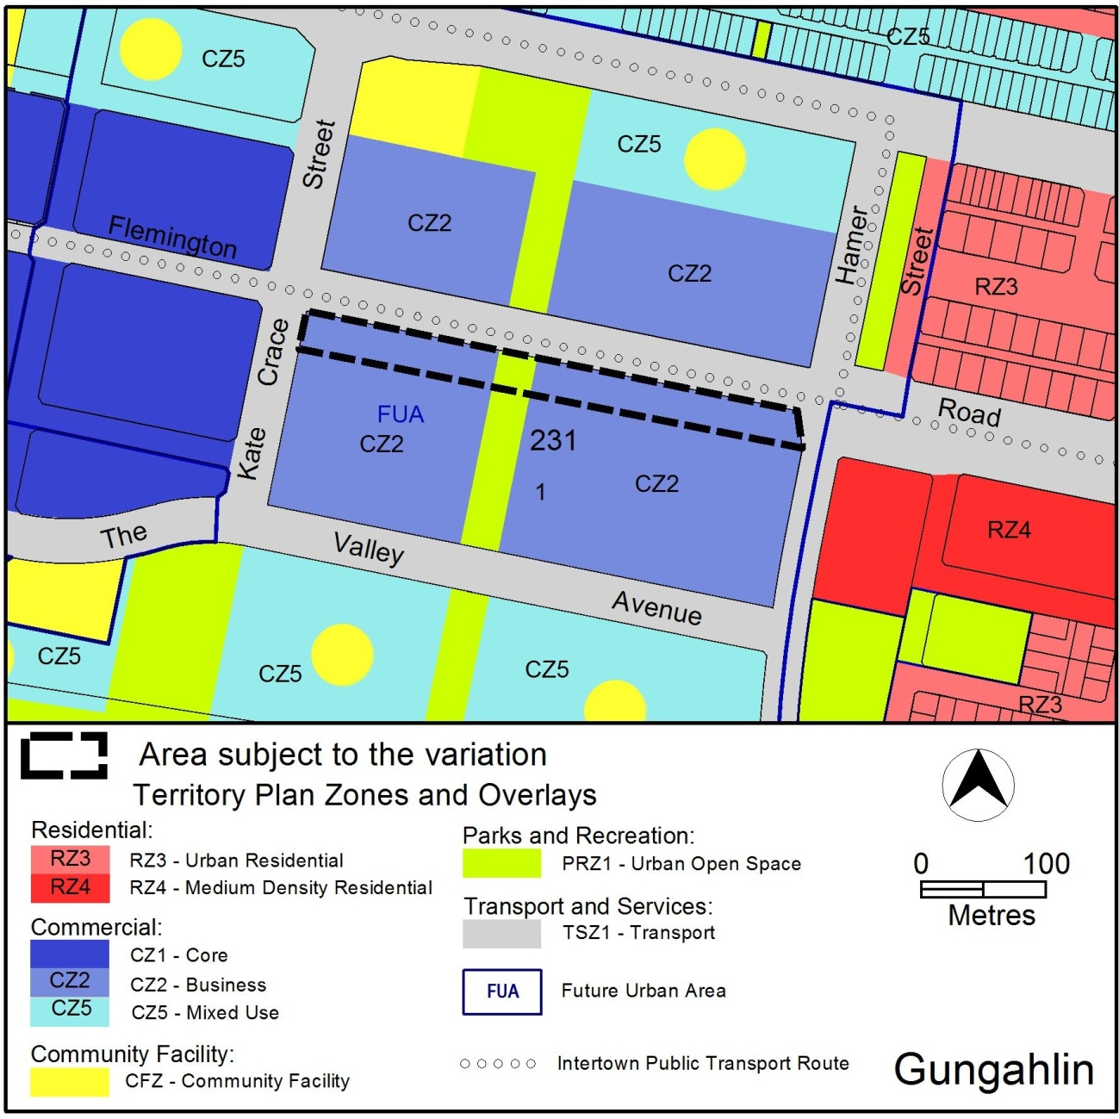
Figure 2 Territory Plan Zones Map
(Part block 1 (now bock 2) section 231 Gungahlin)

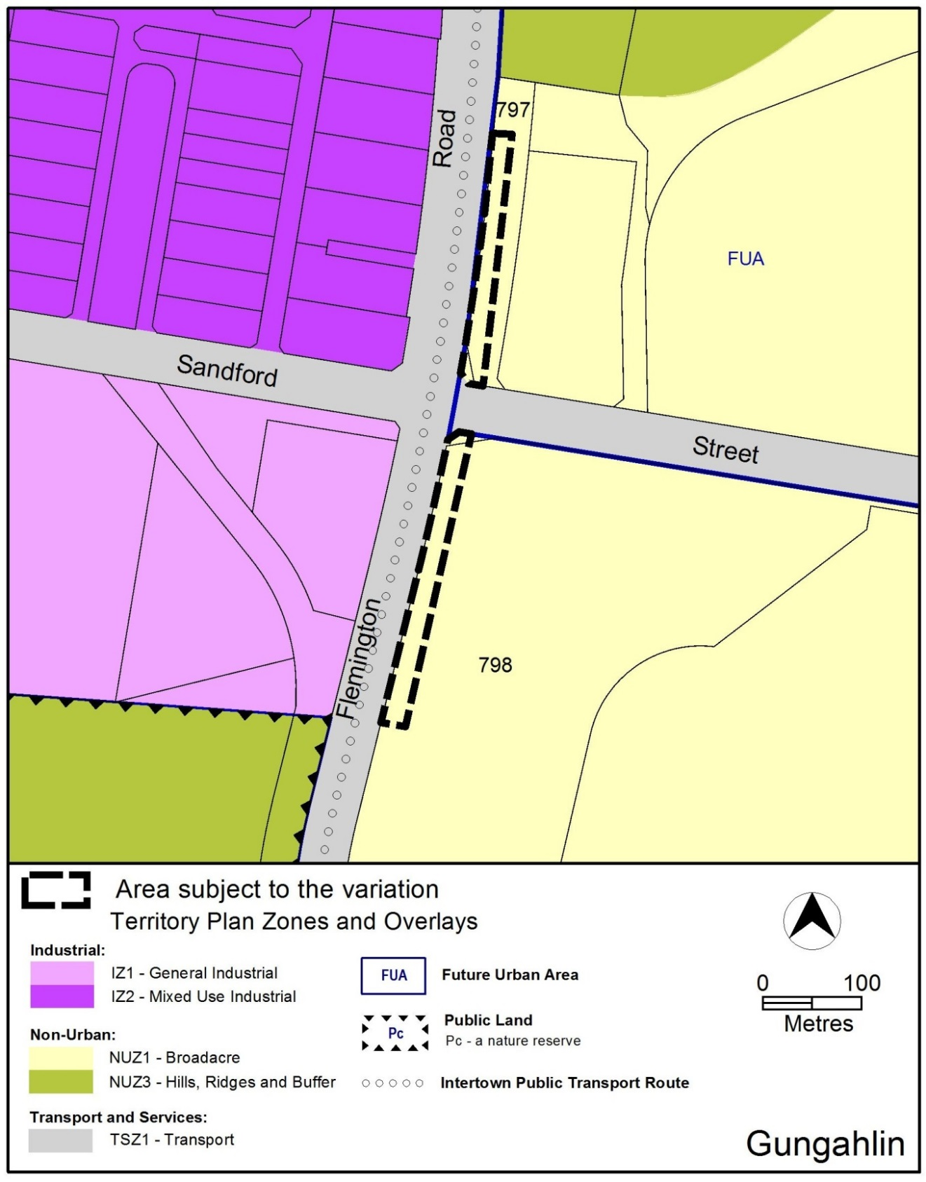
Figure 3 Territory Plan Zones Map
(Parts of rural blocks 797 (now part of block 850) and 798 Gungahlin)

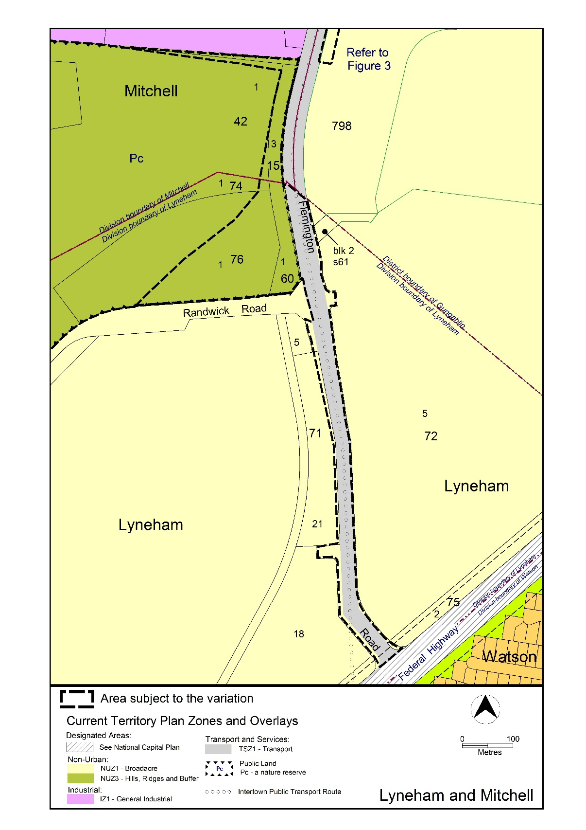
Figure 4 Territory Plan Zones Map
(Parts of block 1 (now block 2) section 60, block 2 (now blocks 5 and 6) section 61, blocks 5 (now block 23) and 21 (now block 26) section 71, block 5 (now bock 6) section 72, block 1 section 74, block 1 (now block 2) section 75, block 1 section 76 Lyneham and block 1 section 42 (now block 4 section 42), block 3 (now blocks 1, 4 and 5) section 15 Mitchell)
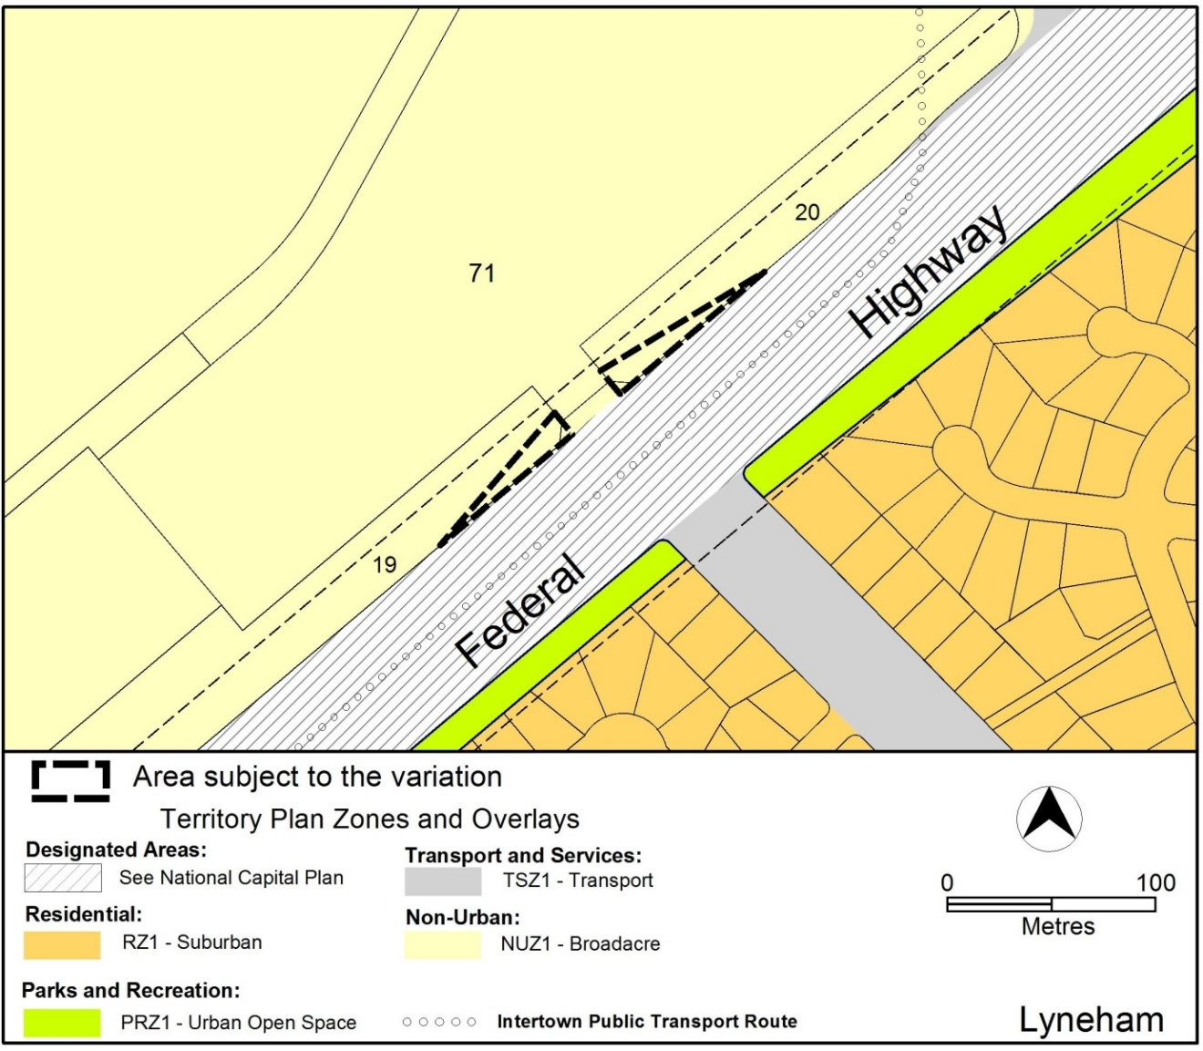
Figure 5 Territory Plan Zones Map
(Parts of blocks 19 (now block 24) and 20 (now block 25) Section 71 Lyneham)

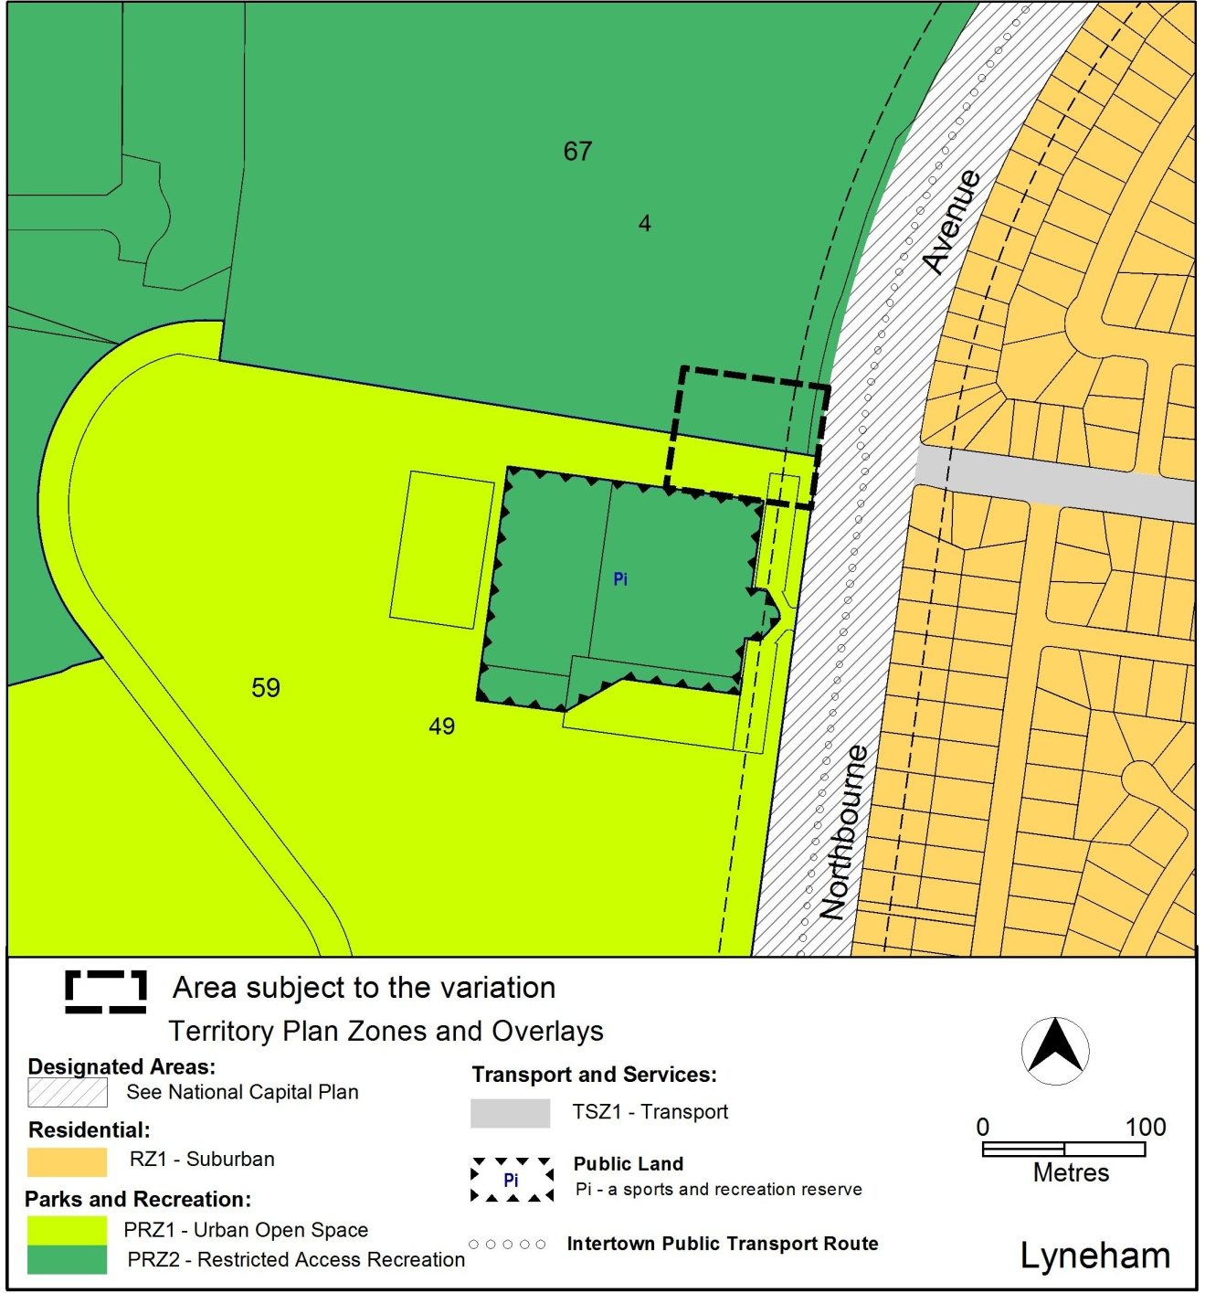
Figure 6 Territory Plan Zones Map
(Parts of block 4 section 67 and block 49 (now blocks 50,51and 52) section 59 Lyneham)

The draft variation maps indicate the proposed zone boundaries as accurately as possible but may be subject to adjustments following the completion of the final design. This includes recent changes to the cadastral maps, altering some blocks numbers.

  - Changes to the Territory Plan
Detailed changes to the Territory Plan are noted in section 2 of this document.

  - Consultation on the Draft Variation
Draft Variation No 327 (DV327) was released for public comment between 29 August and 15 October 2014. A consultation notice under section 63 of the Planning and Development Act 2007 (P&D Act) was published on the ACT Legislation Register on 29 August 2014 and in The Canberra Times on 29 August and 6 September 2014 respectively.
A total of 10 written submissions were received with the majority expressing views against the proposal to develop light rail.
Main issues raised by submitters included:
- opposition to the light rail proposal
- potential impact on equestrian use in Mitchell
- potential impact on block 601 Gungahlin
- potential impact on blocks 1 and 4 section 5 Mitchell

The above issues were considered and are detailed in a report on consultation. No changes were made as a result of consultation. The outcomes of consultation were considered by the Minister responsible for planning prior to approval of this variation.

  - Revisions to the Draft Variation Recommended to the Minister
Some changes were made to adjust the proposed TSZ1 zone on both sides of Flemington Road near EPIC in order to provide a consistent road alignment and at one instance to keep a clear zoning boundary in that area (see Figure 9).
- VARIATION

  - Variation to the Territory Plan Map
The Territory Plan is varied in all of the following ways:

Variation to the Territory Plan map
- Territory Plan Map

Substitute with Figure 7 – Figure 11 for the areas shown as subject to the variation
Remove Pc Nature Reserve Overlay from the area subject to this variation in parts of block 1 section 60, block 1 section 74, block 1 section 76 Lyneham and block 1 section 42, block 3 section 15 Mitchell
  - Variation to the Territory Plan Code

Variation to the Territory Plan TSZ1 Transport Zone – Zone Objectives
- TSZ1 Transport Zone – Zone Objective b)

Substitute Zone Objective b) with the following

b) Ensure that major roads, light rail and transport infrastructure are developed in a comprehensive manner, including the provision of appropriate landscaping, street furniture and lighting, traffic control devices, and noise attenuation measures

Variation to the Territory Plan Definitions (13.1)
- Definition of Public transport facility

Insert in the sub-category of Public transport facility the following:
Light rail means a system for the provision of light rail public transport services, including tracks, catenaries, supports for tracks and catenaries, stops, access to stops, signalling and other control facilities and other facilities and equipment associated with the provision of those services.
The term excludes light rail depot and electrical substation facilities.
- Definition of Railway use

Substitute the definition of ‘Railway use’ with the following:
Railway use means any of the following uses:
- a railway line for passenger and/or freight movement;
- a railway station;
- a railway freight terminal; and/or
- a railway equipment maintenance depot;
and includes land and reservations of land set aside for railway purposes.

The term excludes light rail.
- Definition of Municipal depot

Insert in the Common Terminology for Municipal depot the following:
Light rail depot
Substitute the definition of ‘’Municipal depot’ with the following:
Municipal depot means the use of land for the storage of any plant, machinery, vehicles, light rail vehicles or materials used in the course of a municipal undertaking, whether or not facilities are included for the parking, servicing and repair of plant, machinery or vehicles.
- Definition of Road

Substitute the definition of ‘Road’ with the following
Road means any way or street (so called), whether in existence or under reserve, open to the public which is provided and maintained for the passage of vehicles, persons and animals and which may include footpaths, community paths, bus lay-bys, light rail tracks, turning areas, or traffic controls.

Interpretation service
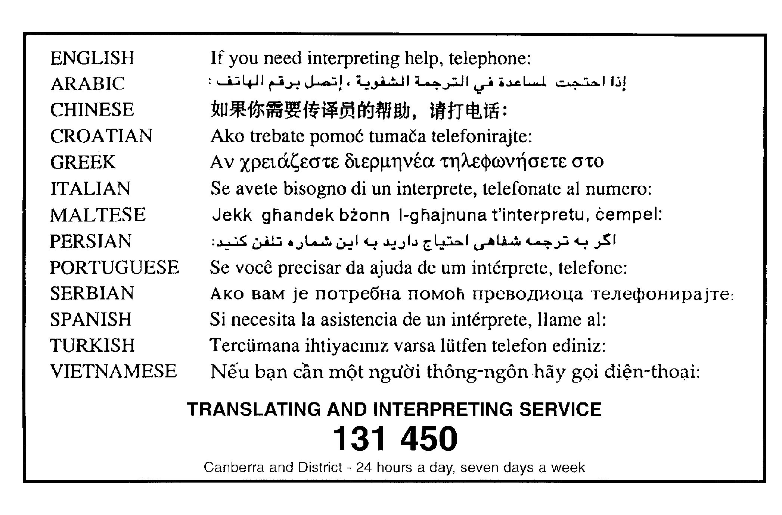

This page is intentionally blank.

APPENDIX 1 Proposed Territory Plan Zone Maps
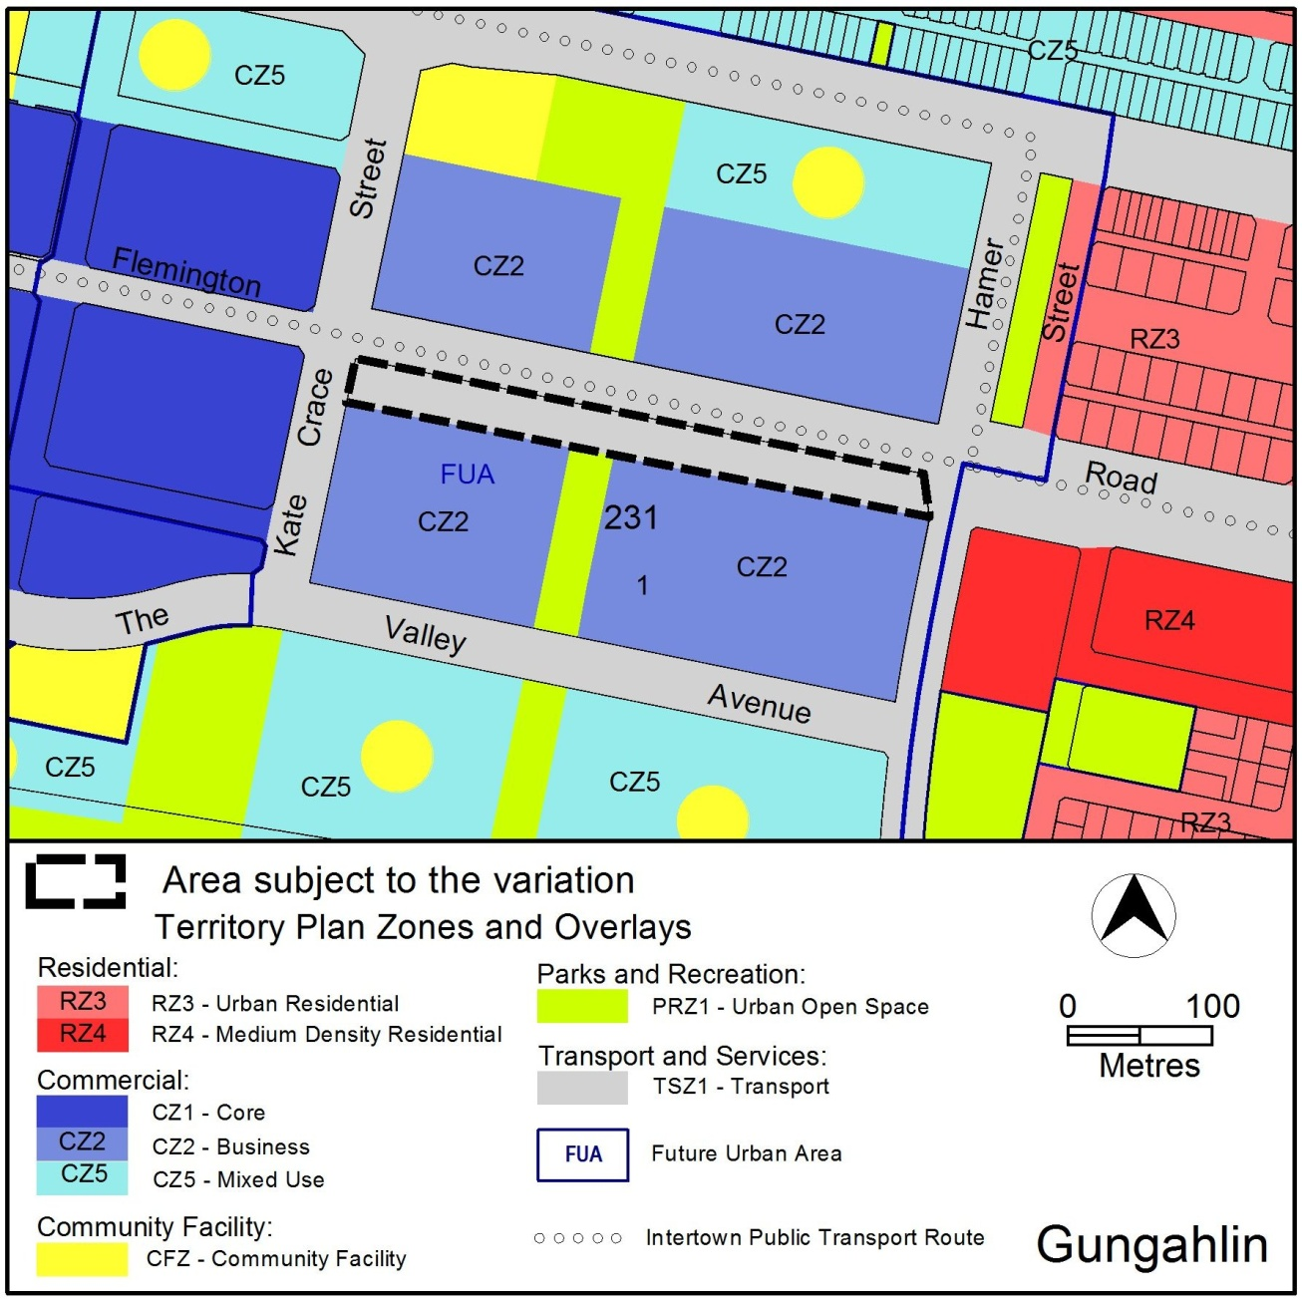
Figure 7 Proposed Territory Plan Zones Map
(Part block 1 (now block 2) section 231 Gungahlin)
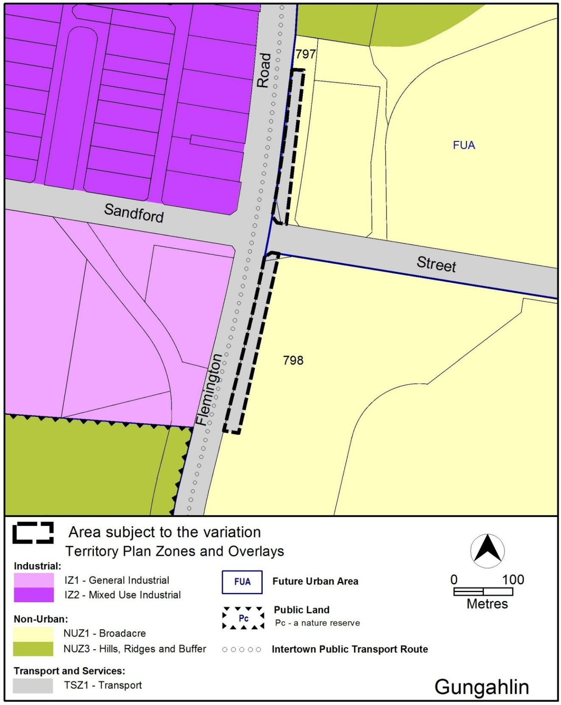
Figure 8 Proposed Territory Plan Zones Map
(Parts of rural blocks 797 (now block 850) and 798 Gungahlin)
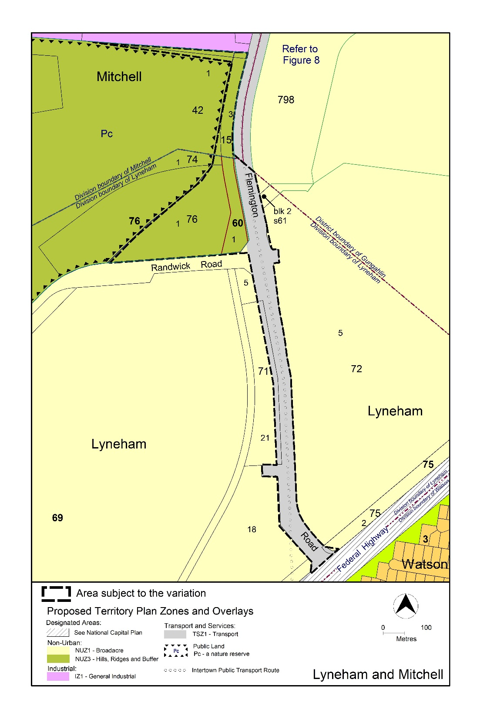
Figure 9 Proposed Territory Plan Zones Map
(Parts of block 1 (now block2) section 60, block 2 (now blocks 5 and 6) section 61, blocks 5 (now block 23) and 21(now block 26) section 71, block 5 (now block6) section 72, block 1 section 74, block 1(now block 2) section 75, block 1 section 76 Lyneham and block 1 (now block 4) section 42, block 3 (now blocks 1,4 and 5) section 15 Mitchell)
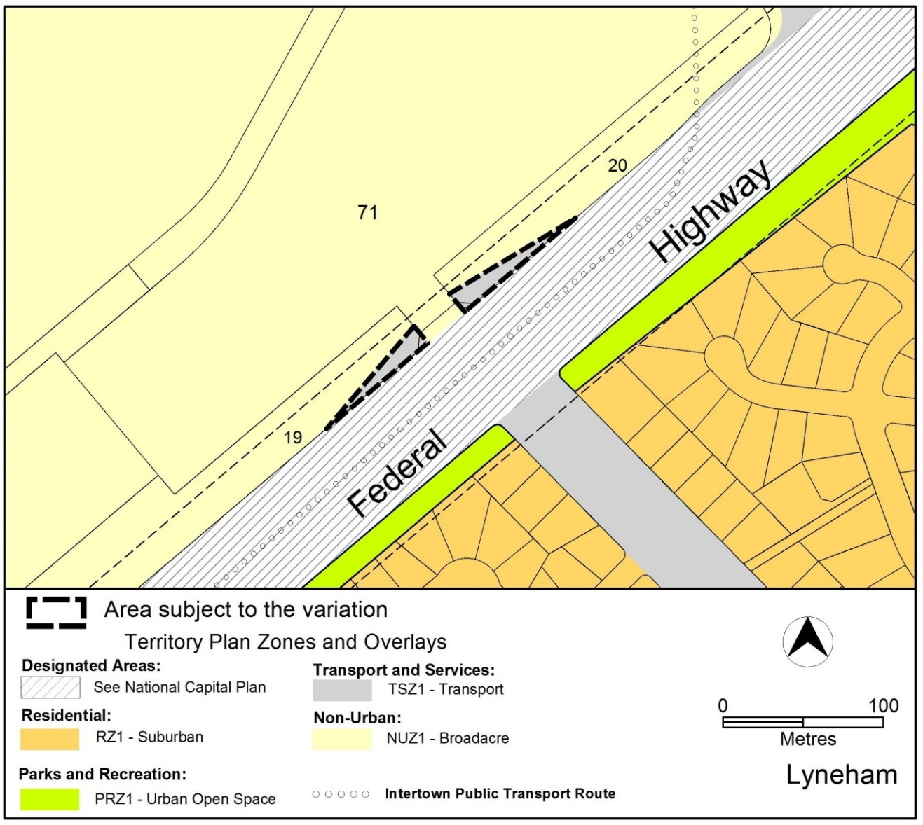
Figure 10 Territory Plan Zones Map
(Parts of blocks 19 (now block24) and 20 (now block 25) Section 71 Lyneham)
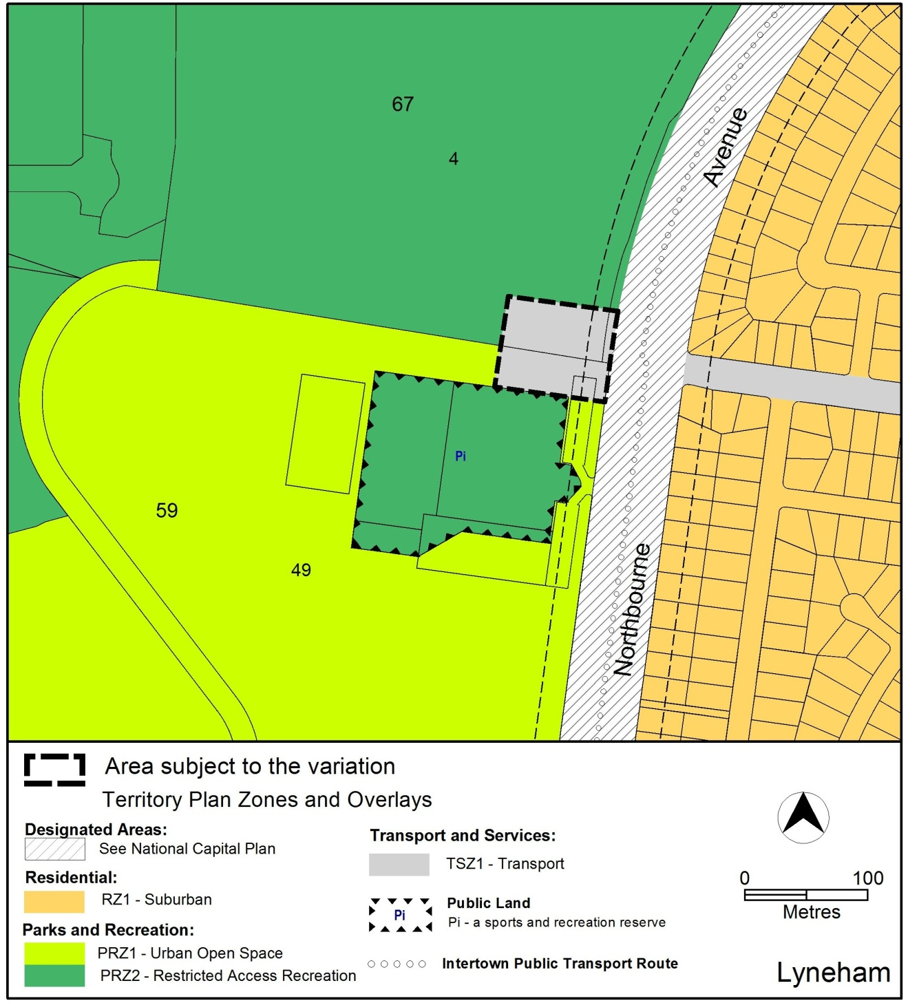
Figure 11 Territory Plan Zones Map
(Parts of block 4 section 67 and block 49 (now blocks 50,51and 52) section 59 Lyneham)

