Australian Capital Territory
Planning and Development (Draft Variation No 340) Consultation Notice 2015
Notifiable instrument NI2015—630
made under the
Planning and Development Act 2007, section 63 (Public consultation—notification) and section 64 (Public consultation—notice of interim effect etc)

Under the Planning and Development Act 2007 (the Act), section 63(1), the planning and land authority has prepared Draft Variation No 340 to the Territory Plan – Structure Plan, Concept Plan, Holt Precinct Code and Zone changes section 99 part of blocks 15 and 16 (see Annexure A).
Draft Variation No 340 to the Territory Plan proposes to:
- Rezone approximately 3.4ha of part of block 16 from residential RZ1 suburban zone to the PRZ2 restricted access recreation zone.
- Rezone approximately 0.4ha of two small parts of block 15 from the PRZ2 restricted access recreation zone to the residential RZ1 suburban zone.
- Amend the future urban area boundary to reflect the proposed residential estate boundaries.
- Remove the structure plan and concept plan requirements relating to the relocation and undergrounding of the transmission lines, the relocation of the golf course club house and the previously proposed commercial elements.
- Consequentially amend the Holt precinct map to remove provisions for a shop on the site.
- Consequential amendments to the Holt precinct map and code, the structure plan and the concept plan for the site to reflect the above changes.
- Amend the wording in the Structure Plan in relation bushfire building requirements consistent with best practice.
- Add the PRZ1 urban open space zone to the zoning options within the transmission line corridor contained in the concept plan.

The draft variation and planning report are available online at www.act.gov.au/draftvariations until the closing date for written comments.

Printed copies of the draft variation and planning report are available for inspection and purchase at the Environment and Planning Directorate Customer Service Centre, 16 Challis Street, Dickson, Monday to Friday (except public holidays) between 8:30am and 4:30pm. Please call 6207 1923 to arrange a copy for purchase.

Written comments from the public are invited from the public by Monday 21 December 2015.

Comments should include reference to the draft variation, your name and contact details, and be addressed to the Territory Plan Unit.

Comments can be:
- emailed to terrplan@act.gov.au
- mailed to Territory Plan Comments, GPO Box 158, Canberra, ACT 2601
- delivered to EPD’s Customer Service Centre at 16 Challis Street, Dickson

Copies of written comments will be made publicly available 10 working days after the closing date for no less than 15 working days at EPD’s Customer Service Centre in Dickson and may be published on EPD’s website.

Comments made available will include personal contact details unless excluded under section 411 or 412 of the Act. A request for exclusion under these sections must be in writing, clearly identifying what you are seeking to exclude and how the request satisfies the exclusion criteria.

Effect of the draft variation

Section 65 of the Act does not apply in relation to the draft variation so it does not have interim effect. The current Territory Plan will continue to apply while the variation remains in draft form.

Jim Corrigan
Delegate of the ACT Planning and Land Authority
4 November 2015

Planning and Development Act 2007

Draft
Variation to the
Territory Plan
No 340

Structure Plan, Concept Plan, Holt Precinct Code and Zone Changes – Holt section 99 part blocks 15 and 16
(Belconnen Golf Course)

November 2015

Draft variation for public consultation prepared
under s60 of the Planning and Development Act 2007

This page is intentionally blank.

Contents

1. INTRODUCTION 1
1.1 Summary of the Proposal 1
1.2 Outline of the process 2
1.3 Public Consultation 3
2. EXPLANATORY STATEMENT 4
2.1 Background 4
2.2 Site Description 5
2.3 Current Territory Plan Provisions 6
2.4 Proposed Changes 7
2.4.1 Proposed Changes to the Territory Plan Map 7
2.4.2 Proposed Changes to Territory Plan 7
2.5 Reasons for the Proposed Draft Variation 8
2.6 Planning Context 8
2.6.1 National Capital Plan 8
2.6.2 Territory Plan 9
2.7 Interim Effect 9
2.8 Consultation with Government Agencies 9
3. DRAFT VARIATION 12
3.1 Variation to the Territory Plan Map 12
3.2 Variation to the Territory Plan 13

This page is intentionally blank.

- INTRODUCTION
  - Summary of the Proposal
The draft variation seeks to amend the Structure Plan, Concept Plan and zone boundaries applying to parts of blocks 15 and 16, section 99 Holt. These planning provisions were introduced into the Territory Plan through variation 298 (V298) in February 2011. Since the introduction of the provisions, block 11 has been retired and replaced with blocks 15 and 16, section 99 Holt.
A number of recent activities have prompted DV340. These are:
- The electricity provider needs to ensure capacity to meet electricity demand. In this regard, options to relocate or underground the transmissions lines are no longer feasible.
- Plans to relocate the current golf club house have also subsequently been revised.
This means that the proponent no longer intends to redevelop the land within the existing transmission line corridor or to replace the existing club house with a community centre and shop. Rather, the land will be reverted back to the PRZ2 restricted access recreation zone. The land will be used for golf course, club house and a community activity centre, all of which are permissible development in the proposed PRZ2 restricted access recreation zone. It is important to note that the change in zoning for the transmission lines does not alter the requirements for easements to protect the corridor and to separate residential areas from the transmission lines.
The Territory Plan provisions applying to the site are proposed to be revised in the following ways:
- Rezone approximately 3.4ha of part of block 16 from residential RZ1 suburban zone to the PRZ2 restricted access recreation zone.
- Rezone approximately 0.4ha of two small parts of block 15 from the PRZ2 restricted access recreation zone to the residential RZ1 suburban zone.
- Amend the future urban area boundary to reflect the proposed residential estate boundaries.
- Remove the structure plan and concept plan requirements relating to the relocation and undergrounding of the transmission lines, the relocation of the golf course club house and the previously proposed commercial elements.
- Consequentially amend the Holt precinct map to remove provisions for a shop on the site.
- Consequential amendments to the Holt precinct map and code, the structure plan and the concept plan for the site to reflect the above changes.
In addition to the above, a minor amendment has been made to the structure plan in relation to bushfire requirements. In this regard, the structure plan now has a broad requirement for buildings in bushfire areas, with the detailed requirements remaining in the concept plan. This amendment brings the wording of the structure plan up to current standards and best practice. It does not alter the policy intent, requirements or application of the bushfire provisions.
Lastly, the concept plan has been amended to allow the parks and recreation PRZ1 urban open space zoning to be implemented within the transmission line corridor. The current provisions only allow for the transport and services TZ2 zone and the PRZ2 restricted access recreation zone within this corridor. However, it is common practice to allow urban open space in these corridors and this is facilitated by the proposed changes to the concept plan.

  - Outline of the process
The Commonwealth’s Australian Capital Territory (Planning and Land Management) Act 1988 allows for the Legislative Assembly to make laws to establish a Territory Planning Authority and for that Authority to prepare and administer a Territory Plan. The Planning and Development Act 2007 (the Act) establishes the planning and land authority as the Authority which prepares and administers the Territory Plan, including continually reviewing and proposing amendments as necessary. The functions of the planning and land authority are administered by the Environment and Planning Directorate (EPD).
The Territory Plan is comprised of a written statement and a map. The written statement contains a number of parts, namely governance; strategic directions; zones (including objectives and development tables and zone or centre development codes); precinct codes; general codes; overlays; definitions; structure plans, concept plans and development codes for future urban areas.
The Territory Plan Map graphically represents the applicable land use zones (under the categories of residential, commercial, industrial, community facility, urban parks and recreation, transport and services and non urban), precincts and overlays. The zone, precinct and overlay requirements are detailed in the volumes of the Territory Plan.
Draft variations to the Territory Plan are prepared in accordance with the Act. Following the release of the draft variation under section 63 of the Act, submissions from the public are invited. At the conclusion of the consultation period the EPD submits a report on consultation and a recommended final variation to the Minister responsible for planning for approval. The Minister has the discretion to determine if referral to the Legislative Assembly standing committee responsible for planning is warranted prior to approval, depending on the nature and significance of the proposal. If the draft variation is referred to the committee by the Minister or otherwise, the Minister must consider the findings of the committee before deciding whether to approve the draft variation. If the Minister approves the variation, the variation and associated documents will be tabled in the Legislative Assembly. Unless disallowed by the Legislative Assembly within five sitting days, the variation commences on a day nominated by the Minister.

  - Public Consultation
Written comments about the draft variation are invited from the public by Monday 21 December 2015.
Comments should include reference to the draft variation, your name and contact details, and be addressed to the Territory Plan Section.
Comments can be:
- emailed to terrplan@act.gov.au
- mailed to Territory Plan Section, GPO Box 158, Canberra, ACT 2601
- delivered to EPD’s Customer Service Centre at 16 Challis Street, Dickson
Copies of written comments will be made available (unless excluded) for public inspection for no less than 15 working days starting 10 working days after the closing date for comment. The comments will be available at EPD’s customer service centre in Dickson and may be published on EPD’s website.
Comments made available will include personal contact details unless excluded under section 411 or 412 of the Planning and Development Act 2007. A request for exclusion under these sections must be in writing, clearly identifying what you are seeking to exclude and how the request satisfies the exclusion criteria.

Further Information
The draft variation and background document are available online at www.act.gov.au/draftvariations until the closing date for written comments.
Printed copies of the draft variation (this document) and background documents are available for inspection and purchase at the Environment and Planning Customer Service Centre, 16 Challis Street, Dickson, Monday to Friday (except public holidays) between 8:30am and 4:30pm. Please call 6207 1923 to arrange a copy for purchase.

- EXPLANATORY STATEMENT
  - Background
The redevelopment of the site was enshrined in Territory Plan variation 298 (V298) which commenced in 2011. This variation:
- introduced a structure plan and a concept plan for Holt section 99 block 16 (part of the retired block 11) that:
  - requires the relocation and undergrounding of the overhead transmission lines
  - requires a community activity centre to be on the site of the existing golf club house with additional use of SHOP within Holt section 99 block 16 (previously block 11).
In the intervening time period, planning for the transmission lines now means there are limited options to relocate or underground the transmissions lines as was originally intended. Additionally, plans to relocate the current golf club house have been revised. This means that the proponent no longer intends to redevelop the land within the existing transmission line corridor or to replace the existing club house with a community centre and shop. This has resulted in the need to vary the Territory Plan to reflect these changes to the proposal.
It is important to note that since V298, urban development on land surrounding has been proposed. Planning for this development is not yet finalised or approved. However, if approved this would result in significant upgrades to Stockdill Drive and could accommodate a second access to the subject site off Stockdill Drive. While this does not directly impact on DV340 which would result in a decrease in the extent of urban development on the site, it would inform the Estate Development Plan by ensuring the settlement pattern can accommodate the secondary access point in the future.
Planning for the urban development of the land surrounding the site also includes services such as schools and commercial uses. Ultimately this development, if approved, could provide greater access to services for the future residents of section 99.

  - Site Description
The site is identified in Figure 1 below and is part of blocks 15 and 16 (previously block11) section 99 Holt, off Stockdill Drive.
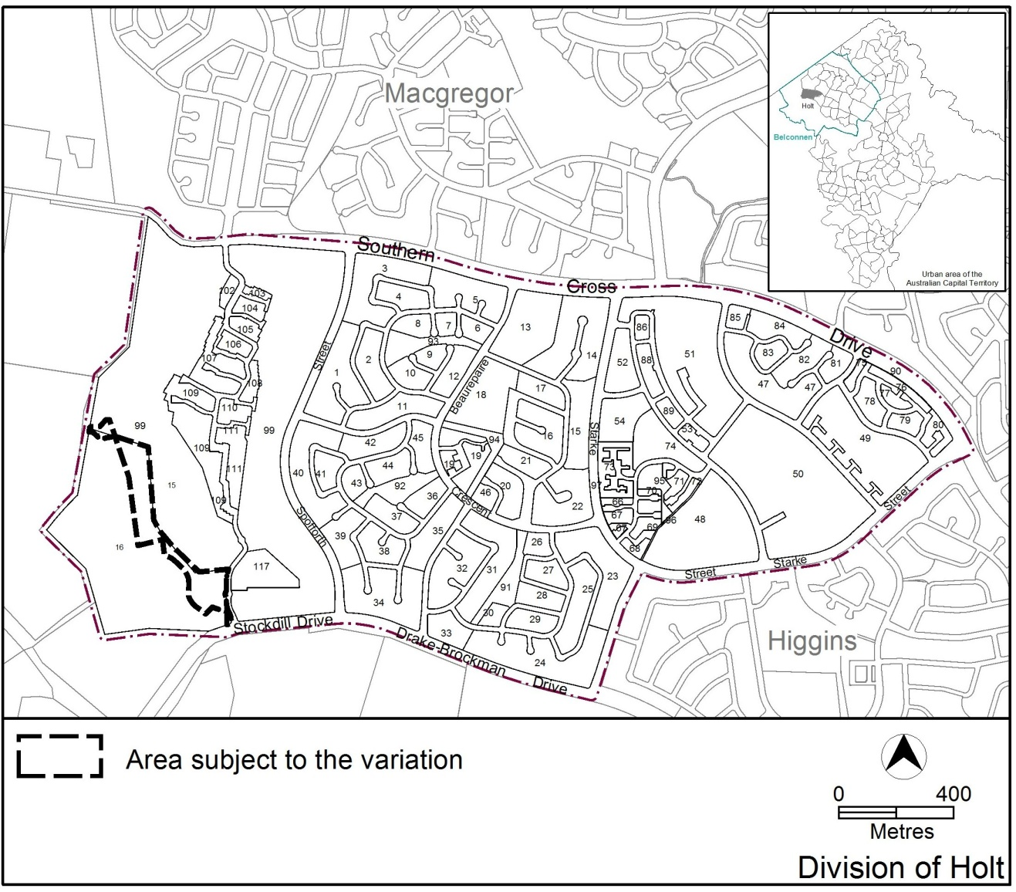
Figure 1 Site Plan

  - Current Territory Plan Provisions
The current Territory Plan map zones for the area subject to this variation are shown in Figure 2.
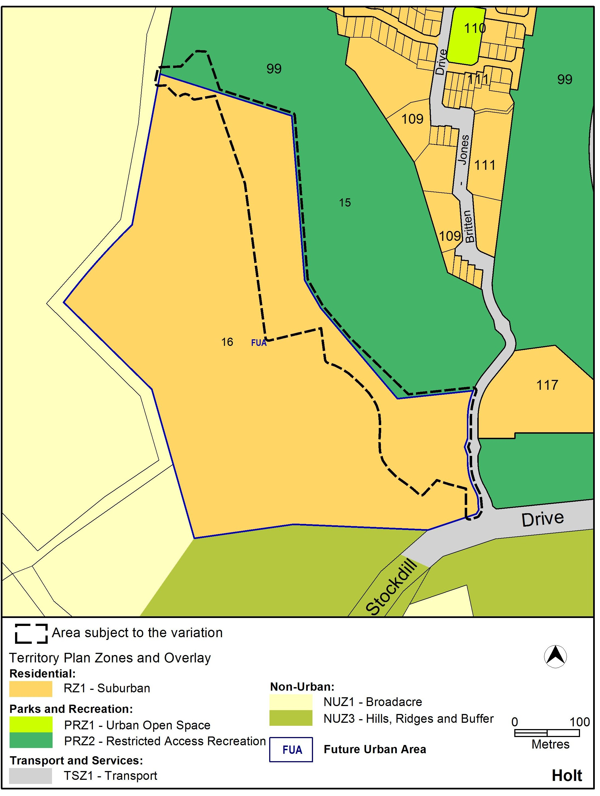
Figure 2 Territory Plan Zones Map
  - Proposed Changes
    - Proposed Changes to the Territory Plan Map
The proposed changes to the Territory Plan map are indicated in Figure 3 at Part 3 of this document and are detailed as follows:
- Rezone part of block 16 from residential RZ1 suburban zone to the PRZ2 restricted access recreation zone.
- Rezone two small parts of block 15 from the PRZ2 restricted access recreation zone to the residential RZ1 suburban zone.
- Extend the future urban area (FUA) boundary to include the small part of block 15 that will be included in the residential RZ1 suburban zone and an additional part of block 15 at its western edge to reflect the proposed residential estate boundaries.
The draft variation map indicates the proposed zone boundaries as accurately as possible but may be subject to adjustments following detailed surveys.

    - Proposed Changes to Territory Plan
It is proposed to amend the Territory Plan in the following ways:
- Structure Plan for Holt section 99 block 11 (now blocks 15 and 16 section 99 Holt):
  - Delete item 5.5 infrastructure to remove the requirement for the relocation and undergrounding of the overhead transmission lines
  - Delete item 5.6 relating to development of a community activity centre and shop.
  - Consequential amendments to reflect the revised boundaries of the estate.
  - Consequential amendments to remove reference to block 11 which is now a retired block.
  - Rewording of the provisions for bushfire building requirements (section 5.3) consistent with the level of detail ordinarily included in structure plans.
- Concept Plan for Holt section 99 block 11 (now includes blocks 15 and 16 section 99 Holt):
  - Delete item 2 in relation to the community precinct (Rule R2 and criterion C3)
  - Delete item 6 in relation to infrastructure (Rule R9)
  - Delete Part C building and structure (Rule R11)
  - Amend Figure 2 to remove reference to undergrounding of the overhead transmission lines and the area proposed for the community activity centre.
  - Consequential amendments to reflect the revised boundaries of the estate.
  - Consequential amendments to remove reference to block 11 which is now a retired block.
  - Inclusion of the PRZ1 urban open space zone as an option for zoning within the transmissions line corridor (Rule R1)
- Holt Precinct Code:
  - Amend the Holt Precinct Map and Table 2 to remove the MT1 area.

  - Reasons for the Proposed Draft Variation
The reasons for the draft variation are as follows:
- The proposed changes to the future development of the site do not alter the overall redevelopment for residential purposes.
- The proposed changes represent a reduction in the area to be redeveloped for residential purposes.
- The proposed changes remove the potential commercial uses originally proposed on the site.
- The area subject to the proposed changes is adjacent to and consistent with the use of the Golf Course now and in the future.

  - Planning Context
    - National Capital Plan
The Australian Capital Territory (Planning and Land Management) Act 1988 established the National Capital Authority (NCA) with two of its functions being to prepare and administer a National Capital Plan (NCP) and to keep the NCP under constant review and to propose amendments to it when necessary.
The NCP, which was published in the Commonwealth Gazette on 21 January 1990, is required to ensure that Canberra and the Territory are planned and developed in accordance with their national significance. The Planning and Land Management Act 1988 also required that the Territory Plan is not inconsistent with the NCP.

    - Territory Plan
Statement of Strategic Directions
The proposal is consistent with the Territory Plan’s statement of strategic directions in terms of environmental, economic and social sustainability and spatial planning and urban design principles.
The proposal represents a reduction in the area of the proposed residential redevelopment in response to changes to the provision of electricity infrastructure across the site and changes to the operation of the adjoining existing golf club.

  - Interim Effect
Section 65 of the Planning and Development Act 2007 does not apply in relation to the draft variation so it does not have interim effect. The current Territory Plan will continue to apply while the variation remains in draft form.

  - Consultation with Government Agencies
The EPD is required to, in preparing a draft variation under section 61(b) consult with each of the following in relation to the proposed draft variation:
- the national capital authority
- the conservator of flora and fauna
- the environment protection authority
- the heritage council
- if the draft variation would, if made, be likely to affect unleased land or leased public land – each custodian for the land likely to be affected

National Capital Authority
The National Capital Authority provided the comments on 1 October 2015 as follows:
“Section 99 is identified as being within Urban Areas of the General Policy Plan – Metropolitan Canberra of the National Capital Plan (the Plan). The land is outside Designated Areas of the Plan and therefore the ACT Government has detailed planning responsibility of the site.

The NCA has no objection the Draft Variation.”

Response
The comments of the National Capital Authority are noted.

Conservator of Flora and Fauna
The Conservator of Flora and Fauna made the following comments on
13 October 2015
The variation can be supported.
Response
The comments are noted.

Environment Protection Authority
The Environment Protection Authority provided the following comments on
13 October 2015
As previously advised, noise emissions from the Belconnen sub-station and the golf club may affect nearby residences and would require a noise assessment to ensure the residential blocks are not affected by noise. Further, the impacts from noise and air emissions including odour from any commercial, rural and utility activities in the area should be assessed to ensure appropriate buffers from these activities.

The Environment Protection Authority has previously endorsed a Contamination Management Plan {CMP} for the proposed residential development in July this year. However as the new proposal includes two small parts of Block 15 Section 99 Holt, Environment Protection requires those parts of Block 15 to be included in the CMP (Annex E to Planning Report).

An updated CMP must be forwarded to the EPA for review and endorsement prior to the commencement of development works at the site.

Response
The comments from the Environment Protection Authority are noted and have been forwarded to the Planning Delivery Section of the Environment and Planning Directorate for consideration in relation to the development plans for the estate and any other relevant development applications.

Heritage Council
The Heritage Council provided the following comments on 16 October 2015.
The Council understands that the Draft Variation proposes to:
- Subdivision of Block 16 Section 99 Holt for residential blocks.
- Contain 350 units or dwellings.
- A future heritage survey will form a part of future works in the area

The Council does not object to Draft Variation 340 subject to:
- Detailed heritage studies being undertaken on the proposed development.
- Management of the Aboriginal artefact located within the outer asset protection zone shall form a part of the heritage studies, future management of this artefact require further consideration and potential management options.
- The Council endorsing heritage studies on the proposed development.
- The Draft Planning Report, June 2015, adequately addresses the Council's concerns over the heritage item RD9; noting that the removal of RD9 is not the responsibility of the Council.
- Clarification of whether there are any areas of unmodified landscape is required.
- The potential for unrecorded Aboriginal culturally scarred trees needs to be addressed, particularly in reference to Representative Aboriginal Organisation involvement.
- The previous heritage assessment needs to be adequately referenced.
- Reference to an Unanticipated Discovery Plan to be prepared and approved by Council is required.

Response
The comments from the ACT Heritage Council are noted and have been forwarded to the Planning Delivery Section of the Environment and Planning Directorate for consideration in relation to the development plans for the estate and any other relevant development applications.
- DRAFT VARIATION
  - Variation to the Territory Plan Map
The Territory Plan is varied as identified in Figure 3.
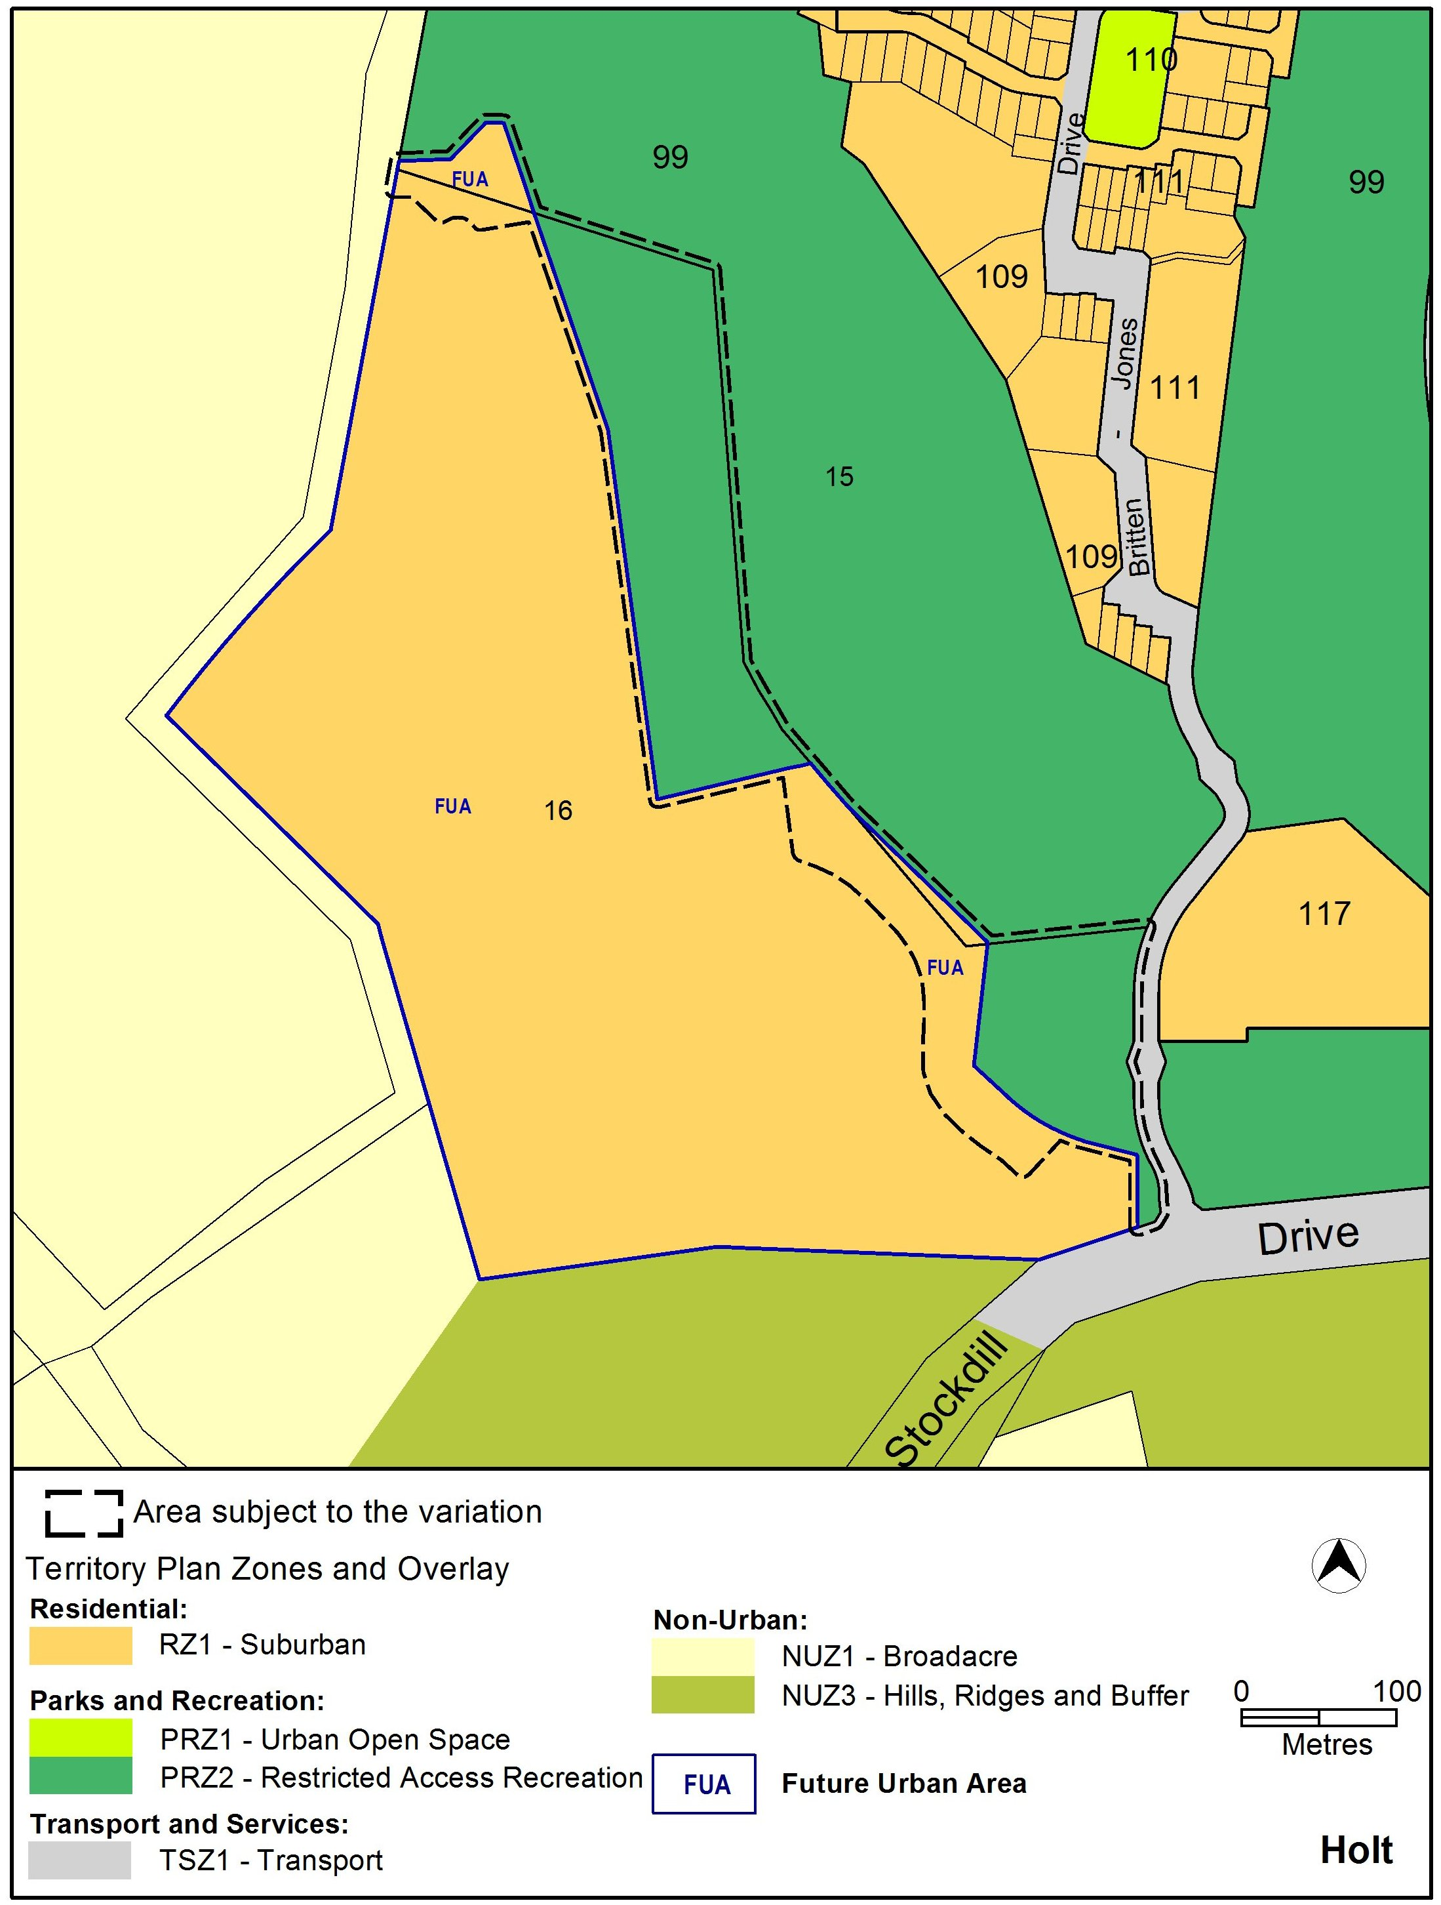

Figure 3 – amendment to the Territory Plan map
  - Variation to the Territory Plan
The Territory Plan is varied in all of the following ways:

Variation to the Structure Plan for Holt section 99 block 11 (Belconnen Golf Course)
- After structure plan for Lawson South

Substitute the existing Structure Plan with
Holt section 99 (Belconnen Golf Course) (see Appendix A)

Variation to the Concept Plan for Holt section 99 block 11 (Belconnen Golf Course)
- After concept plan for Lawson South

Substitute the existing Concept Plan with
Holt section 99 (Belconnen Golf Course) (see Appendix B)

Variation to the Holt Precinct Map and Code
- Holt precinct map

Substitute with the following
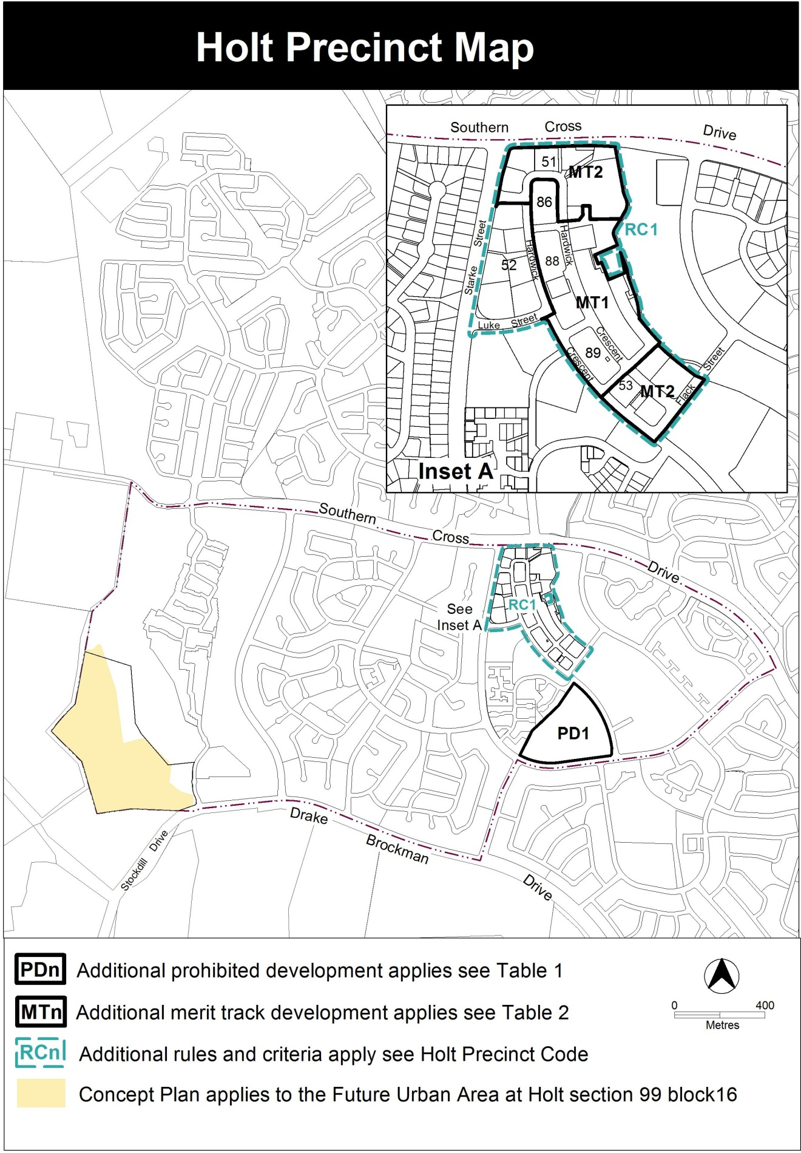

- Table 2 – additional merit track development

Substitute with the following

Table 2 – Additional merit track development
Additional merit track development that may be approved subject to assessment
Suburb precinct map label | Zone | Development
MT1 | CZ1 | industrial trades municipal depot  store
MT2 | CZ2 | funeral parlour light industry service station veterinary hospital

Interpretation service
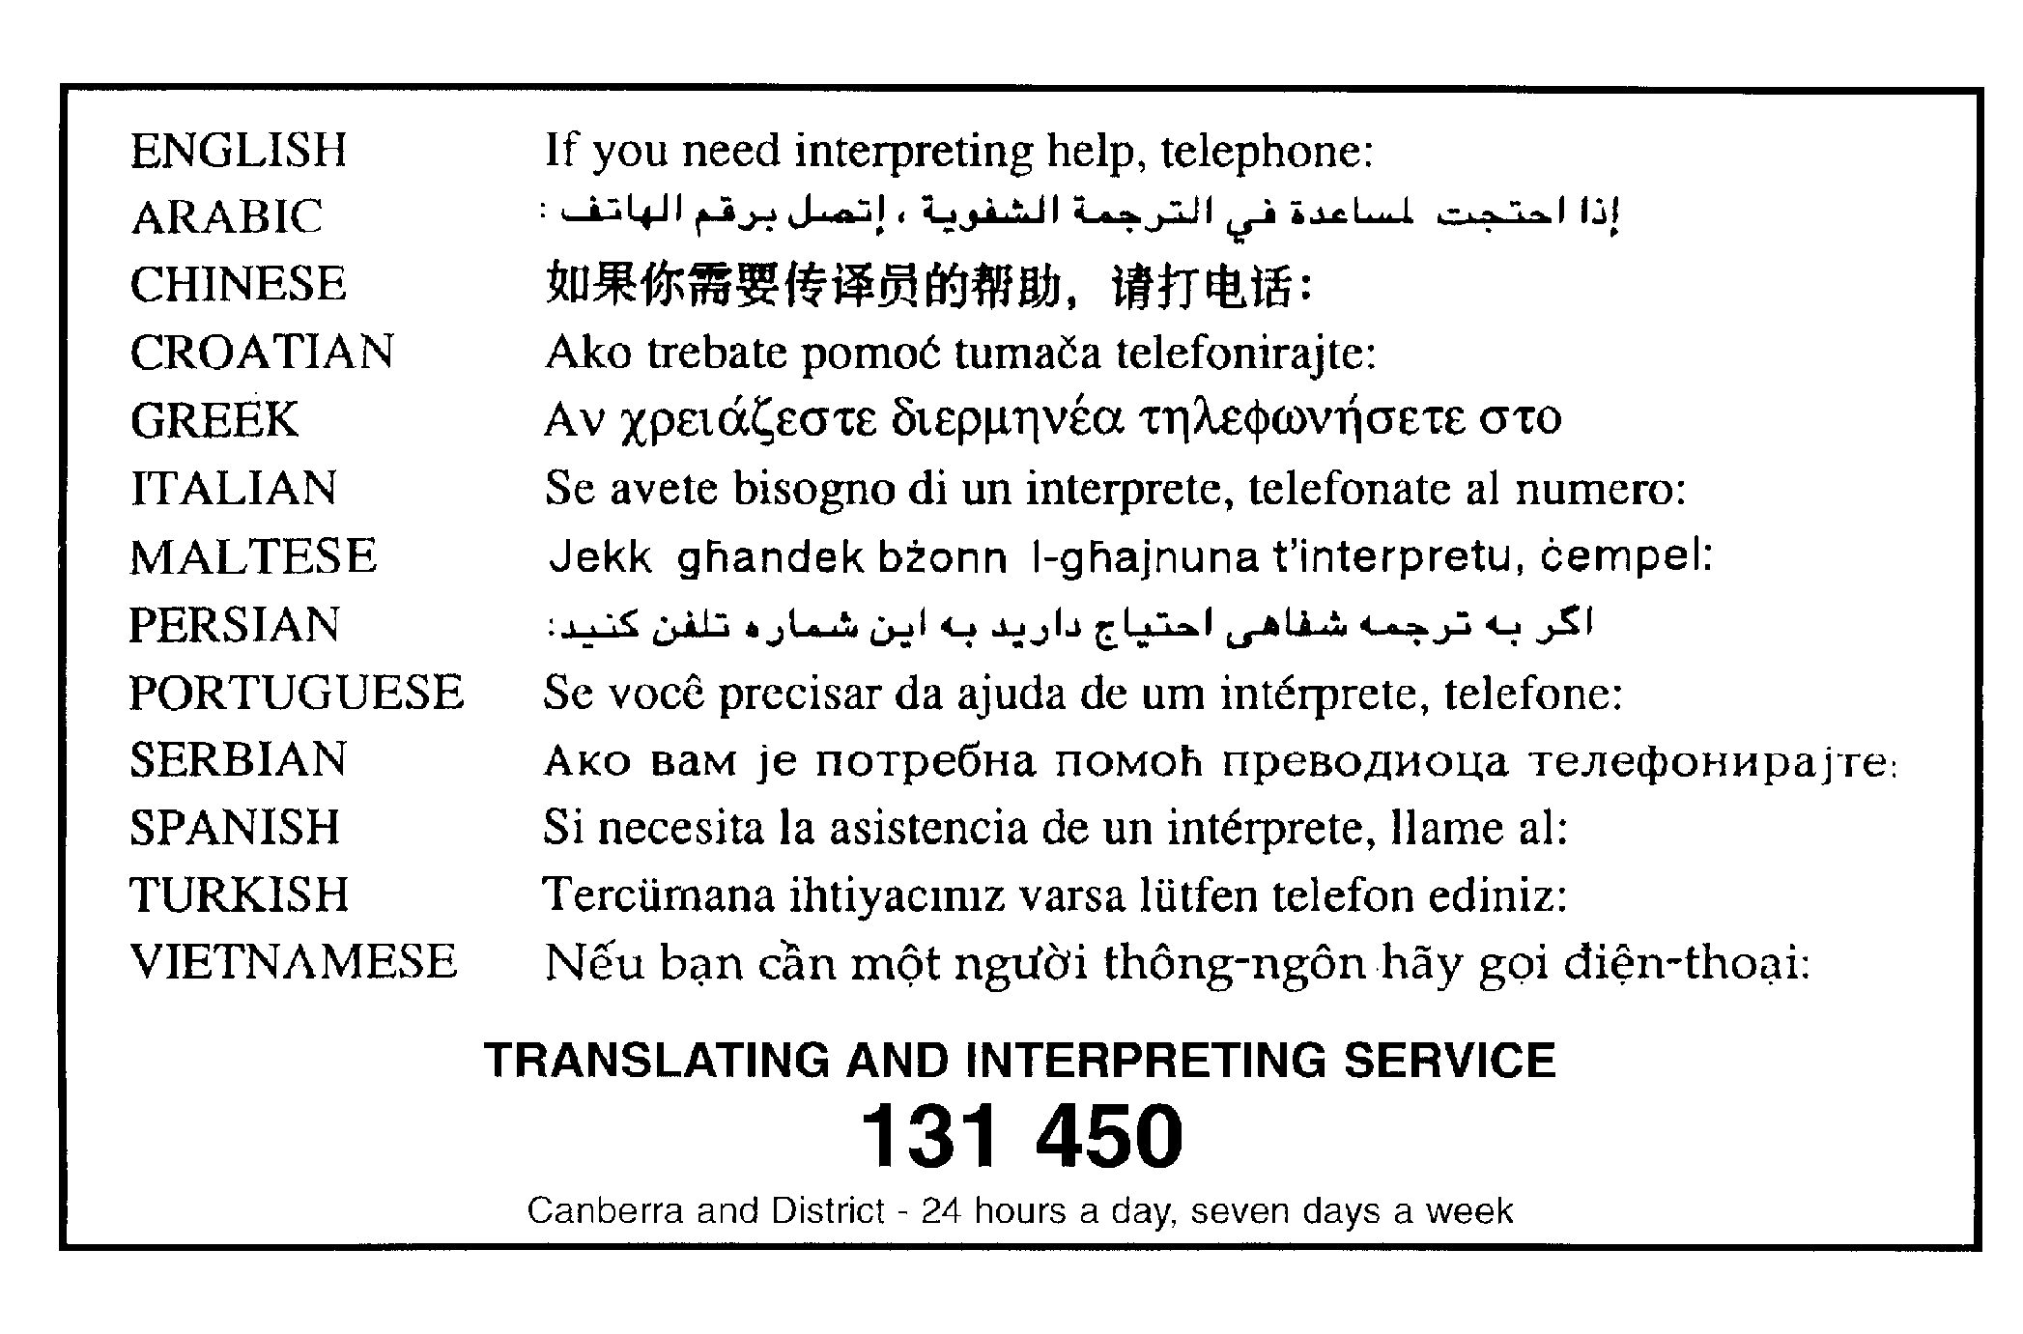

Appendix A: DV340 – Holt Section 99 Structure Plan

Holt part section 99 (Belconnen Golf Course) Structure Plan

INTRODUCTION
This structure plan sets out the principles and policies that apply to development at the future urban area on section 99 Holt in accordance with section 91 of the Planning and Development Act 2007.

APPLICATION
This structure plan applies to the future urban area shown in Figure 1. Land that ceases to be part of the future urban area after the application of section 96 of the Planning and Development Act 2007 ceases to be affected by this structure plan.

PROHIBITED DEVELOPMENT
For the purposes of section 136(2) of the Planning and Development Act 2007, development by an entity that is not the Territory or Territory entity is not prohibited.

PRINCIPLES FOR THE DEVELOPMENT OF FUTURE URBAN AREA

1. The development will accord with the principles contained in the Statement of Strategic Directions in the Territory Plan (see figure 1).

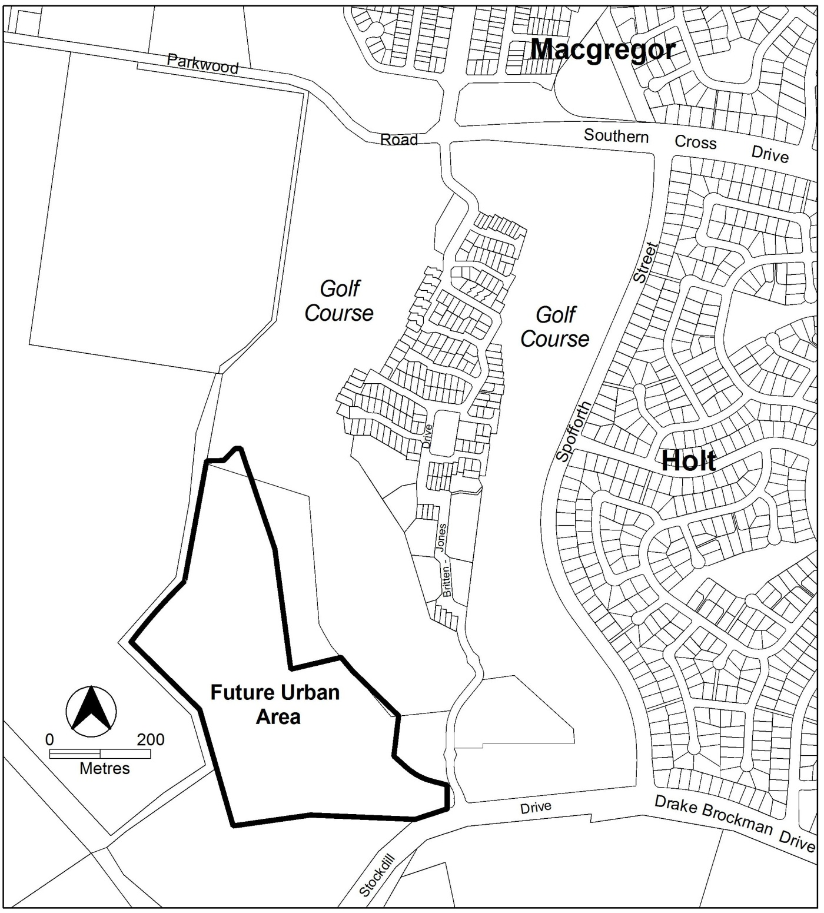

Figure 1: Future urban area at commencement of Holt section 99 Structure Plan

POLICIES FOR THE DEVELOPMENT OF FUTURE URBAN AREA
  - General
- Residential development within the future urban area shown in Figure 1 will be in accordance with the residential RZ1 suburban zone in the Territory Plan.
Notes:
  - The future urban area will diminish as development proceeds. Land that ceases to be part of the future urban area through the application of s96 of the Planning and Development Act 1997 ceases to be affected by this structure plan.

  - The nature and extent of the RZ1 zone under the Territory Plan will be confirmed after land ceases to be part of the future urban area.

Bushfire protection
3. Buffers for bushfire protection are to be provided to the satisfaction of the Emergency Services Agency (ESA) along the western and southern boundaries of the site.

Residential
4. Dwellings abutting the rural interface be constructed to satisfy the relevant Bushfire Attack Levels of Australian Standard of construction of buildings in bushfire-prone areas (AS 3959: 2009) or as agreed by the ESA.

Road and movement network
- The estate is to be provided with an entrance from Stockdill Drive and not from Britten Jones Drive.
- An access way for cycle use and pedestrians is to provide a connection between the main entry off Stockdill Drive to the nearest bus stop.
- A secondary access point to the site for emergency access and egress is to be located and constructed to the satisfaction of ESA.

Open space and landscape
- The provision for open space for active recreation will accord with the relevant Territory guidelines.
- Landscape buffers will be provided to screen urban development from Stockdill Drive.

Appendix B – DV340 – Holt, part section 99, concept plan

Holt part section 99 (Belconnen Golf Course) Concept Plan

Contents
Introduction 1
Part A – Land use 3
Part B – Subdivision 5

Introduction

Application
This plan applies to land at Holt section 99 (part) in the district of Belconnen, as shown on Figure 1.

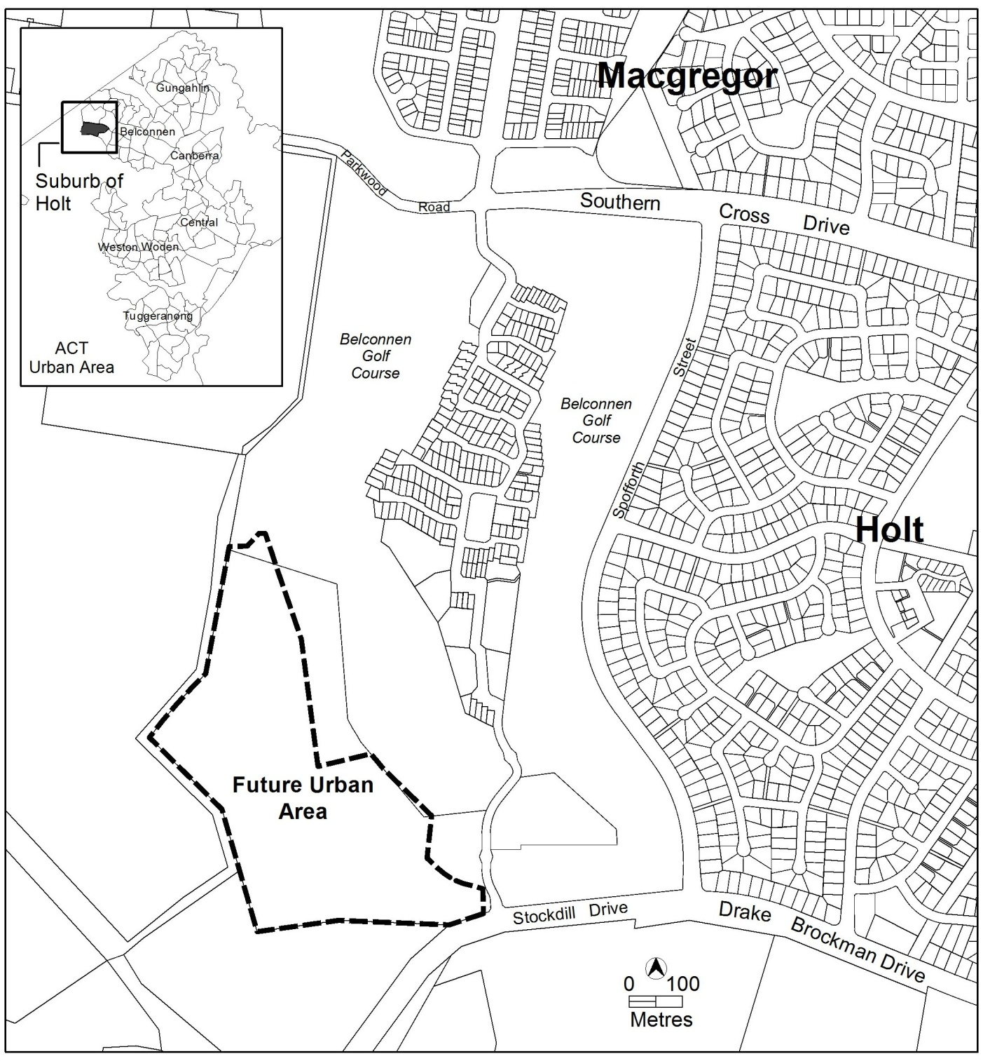

Figure 1: Location of Holt section 99 in district of Belconnen

Part A Land Use and Part B Subdivision of this plan apply only to the future urban area (FUA) within Holt section 99 (part). The FUA will be removed following the approval of the estate development plans and finalisation of the zone boundary under section 96 of the Planning and Development Act 2007.

This plan contains rules, which provide definitive controls for development, and criteria, which provide provisional controls for development. In some instances rules are mandatory. Mandatory rules are marked by the words “This is a mandatory requirement. There is no applicable criterion” in the criteria column. Non-compliance with a mandatory rule will result in the refusal of a development application. In other instances the words “There is no applicable rule”. In this case the proposal is assessed against the relevant criterion. Where both rule and criterion apply, compliance with the rule is deemed to satisfy the particular requirement.

Purpose
The purpose of this plan is to:
- guide the design and assessment of estate development plans (subdivision proposals) at Holt section 99 part.
- guide the development of individual blocks in concert with other relevant codes under the Territory Plan

Desired planning outcomes
The purpose of the development controls (i.e. rules and criteria) is to:
- provide diverse housing types, densities and affordability to meet the changing needs of households and to encourage the formation of a diverse community
- ensure the appropriate protection of existing high value trees
- incorporate principles of contemporary best practice for energy efficiency, water conservation, solar access and ecological sustainability
- provide a legible road network that integrates safe and adequate pedestrian and cycle access throughout the site and connectivity to adjacent areas
- employ stormwater management measures
- encourage efficient use of water through water sensitive urban design
- adopt bushfire protection measures appropriate to the site

Code hierarchy
This concept plan is deemed to be a precinct code under section 93 of the
Planning and Development Act 2007.

More than one type of code may apply to a particular development proposal. Occasionally inconsistencies between the provisions arise, particularly where a precinct code seeks to apply special provisions in response to particular local circumstances or planning issues. Where this occurs, a precinct code prevails over a development code and a general code, but only to the extent of the inconsistency.

Part A – Land use
Note: The land referred to in this part is shown on Figure 2.
Rules | Criteria
1. Land use plan
R1  The land use plan submitted with an estate development plan (EDP) is to show an easement for the 132kV transmission line within a transport and services TSZ2 services zone, parks and recreation PRZ1 urban open space zone or PRZ2 restricted access recreation zone and the remaining land within the future urban area overlay as RZ1 suburban zone. | This is a mandatory requirement. There is no applicable criterion.

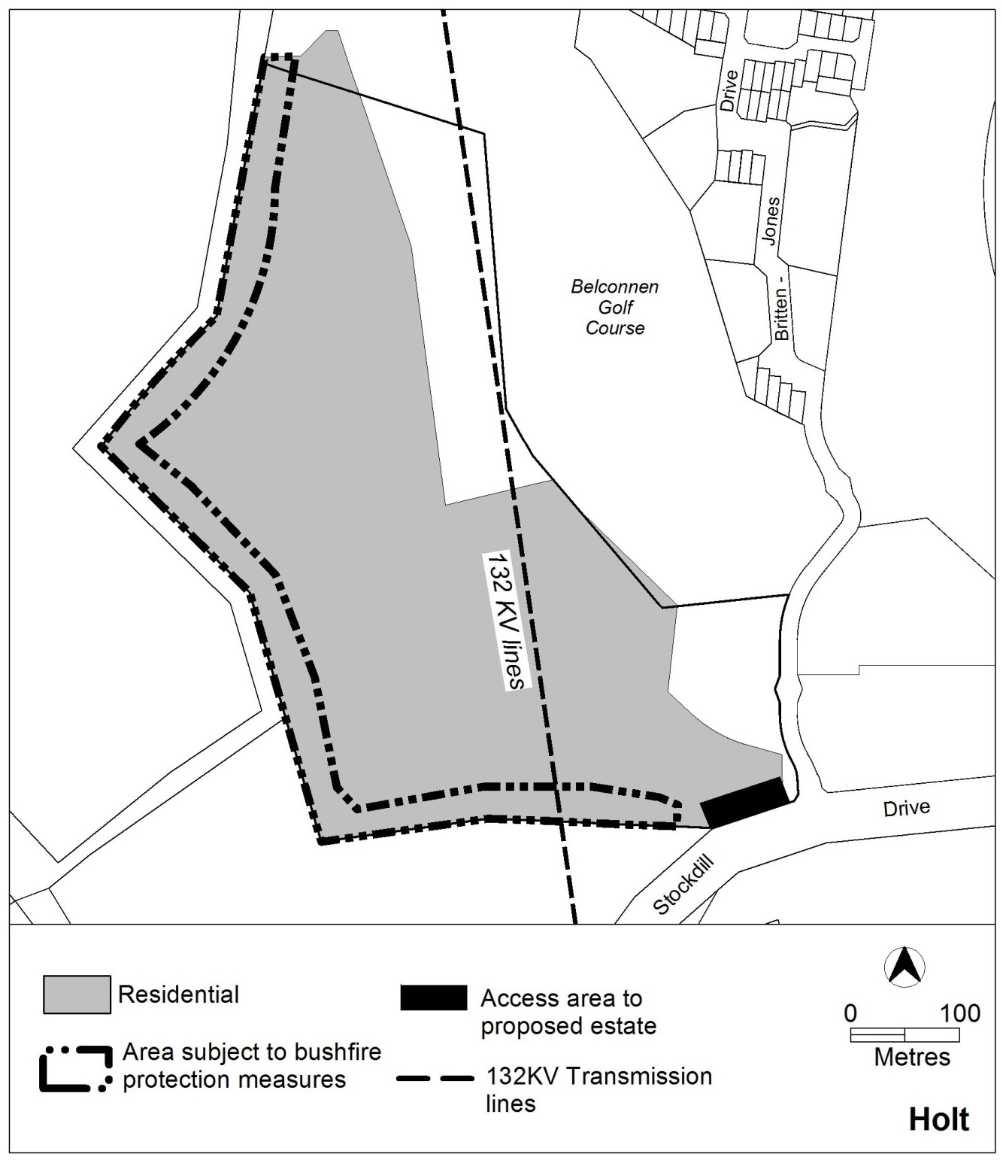

Figure 2: Concept Plan for Holt section 99

Part B – Subdivision
Note: This part should be read in conjunction with:
Estate Development Code
Guidelines for the Preparation of Estate Development Plans Water Ways: Water Sensitive Urban Design General Code.
Rules | Criteria
2. Dwelling yield
R2  The estate provides a range of dwelling types, densities and block sizes which results in the construction of between 300 and 350 dwellings. | This is a mandatory requirement. There is no applicable criterion.
3. Bushfire protection
R3  EDP identifies the bushfire protection measures, including higher construction standards required of buildings in bushfire prone areas as endorsed by the ACT Emergency Services Agency. | This is a mandatory requirement. There is no applicable criterion.
4. Road network
R4  The entrance to the estate is to be located off Stockdill Drive within the area shown in Figure 2. | This is a mandatory requirement. There is no applicable criterion.
There is no applicable rule. | C5  The development is to incorporate a continuous pathway, which provides a slope which allows access for persons with a disability, between the estate and the location of the closest bus stop.
R6  A second vehicular access point to the estate for emergency use is to be provided and endorsed by the ACT Emergency Services Agency. | This is a mandatory requirement. There is no applicable criterion.

5. Open space and landscaping
There is no applicable rule. | C7  A buffer area is provided between Stockdill Drive and residential blocks which contains landscape treatment of a similar scale and width as the existing treatment for the perimeter of the  golf course.

