Australian Capital Territory

Planning and Development (Technical Amendment—Moncrieff) Plan Variation 2016 (No 3)

##### **Notifiable Instrument NI2016—596**

**Technical Amendment No 2016-15**

made under the

Planning and Development Act 2007, s 89 (Making technical amendments) and s 96 (Effect of approval of estate development plan)

1. **Name of instrument**

This instrument is the *Planning and Development (Technical Amendment—Moncrieff) Plan Variation 2016 (No 3)*.

**2 Technical amendment**

I am satisfied under section 89 (1) (a) of the *Planning and Development Act 2007* (the *Act*) that the Moncrieff plan variation is a technical amendment to the Territory Plan.

**3 Commencement**

This instrument commences on the day after notification.

**4 Meaning of *Moncrieff plan variation***

For this instrument:

***Moncrieff plan variation*** means the Technical Amendment to the Territory Plan, Variation 2016-15, in the schedule.

*Note:* No consultation was required in relation to the Moncrieff plan variation under section 87 of the Act.

Brett Phillips

Delegate of the planning and land authority

26 October 2016

ACTGov_EPD_inline_black

Planning & Development Act 2007

Technical Amendment

to the Territory Plan

Variation 2016-15

Future urban area variation

October 2016

*This page is left intentionally blank*

Table of Contents

[1. INTRODUCTION 3](#_Toc463865664)

[1.1 Purpose 3](#_Toc463865665)

[1.2 Public consultation 3](#_Toc463865666)

[1.3 National Capital Authority 3](#_Toc463865667)

[1.4 Process 3](#_Toc463865668)

[1.5 Types of technical amendments under the Act 4](#_Toc463865669)

[2. EXPLANATION 5](#_Toc463865670)

[2.1 Territory Plan Map 5](#_Toc463865671)

[2.2 Moncrieff Precinct Map and Code 7](#_Toc463865672)

[3. TECHNICAL AMENDMENT 12](#_Toc463865673)

[3.1 Territory Plan Map 12](#_Toc463865674)

[3.2 Moncrieff Precinct Map and Code 13](#_Toc463865675)

*This page is left intentionally blank*

1. INTRODUCTION
   1. Purpose

This technical amendment makes the following changes to the Territory Plan:

*Territory Plan Map*

* The Territory Plan map is varied to remove the Future Urban Overlay from section 33 in the Division of Moncrieff.

*Moncrieff Precinct Map and Code*

* The Moncrieff Precinct Map is varied to include section 33.
* Amend existing Figure 2.
* Amend existing rule R3 regarding vehicular access
* Include new rule which relates to deep root planting zone.
  1. Public consultation

Under section 87 of the Planning and Development Act 2007 (the Act) this type of technical amendment is not subject to public consultation.

* 1. National Capital Authority

The National Capital Authority does not need to be advised of this technical amendment as per 1.2.

* 1. Process

This technical amendment has been prepared in accordance with section 87 and made in accordance with section 89 of the *Planning and Development Act 2007* (the Act).

* 1. Types of technical amendments under the Act

The following categories of technical amendments are provided under section 87 of the Act:

1. Each of the following territory plan variations is a ***technical amendment*** for which no consultation is needed before it is made under section 89:

(a) a variation (an ***error variation)*** that –

1. would not adversely affect anyone’s rights if approved; and
2. has as its only object the correction of a formal error in the plan;

(b) a variation to change the boundary of a zone or overlay under section 90A (Rezoning – boundary changes);

(c) a variation, other than one to which subsection (2) (d) applies, in relation to an estate development plan under section 96 (Effect of approval of estate development plan);

(d) a variation required to bring the territory plan into line with the national capital plan;

(e) a variation to omit something that is obsolete or redundant in the territory plan.

1. Each of the following territory plan variations is a ***technical amendment*** for which only limited public consultation is needed under section 90:
2. a variation (a ***code variation***) that –
3. would only change a code; and
4. is consistent with the policy purpose and policy framework of the code; and
5. is not an error variation;
6. a variation to change the boundary of a zone under section 90B (Rezoning – development encroaching on adjoining territory land);
7. a variation in relation to a future urban area under section 90C (Technical amendments – future urban areas);
8. a variation in relation to an estate development plan under section 96 (Effect of approval of estate development plan) if it incorporates an ongoing provision that was not included in the plan under section 94 (3) (g);
9. a variation to clarify the language in the territory plan if it does not change the substance of the plan;
10. a variation to relocate a provision within the territory plan if the substance of the provision is not changed.

TA2016-15 has been prepared in accordance with section 87 (1) (c).

1. EXPLANATION

This part of the technical amendment document explains the changes to be made to the Territory Plan.

* 1. Territory Plan Map

**Variation to the Territory Plan**

The Territory Plan map is varied to identify the zones that apply to land ceasing to be in a future urban area.

*Existing Territory Plan Map*

*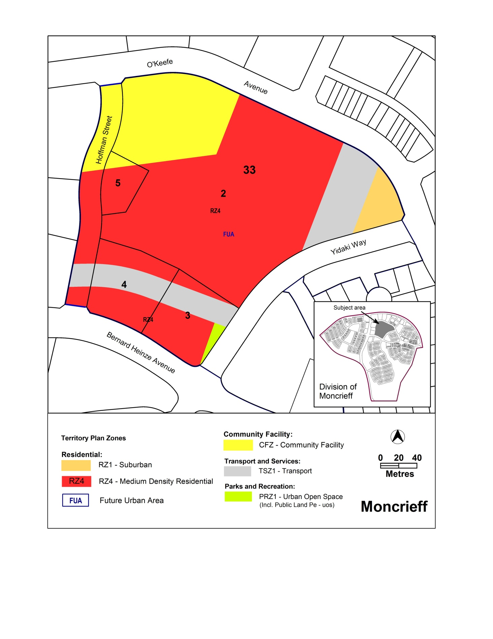*

*Proposed Territory Plan Map*

*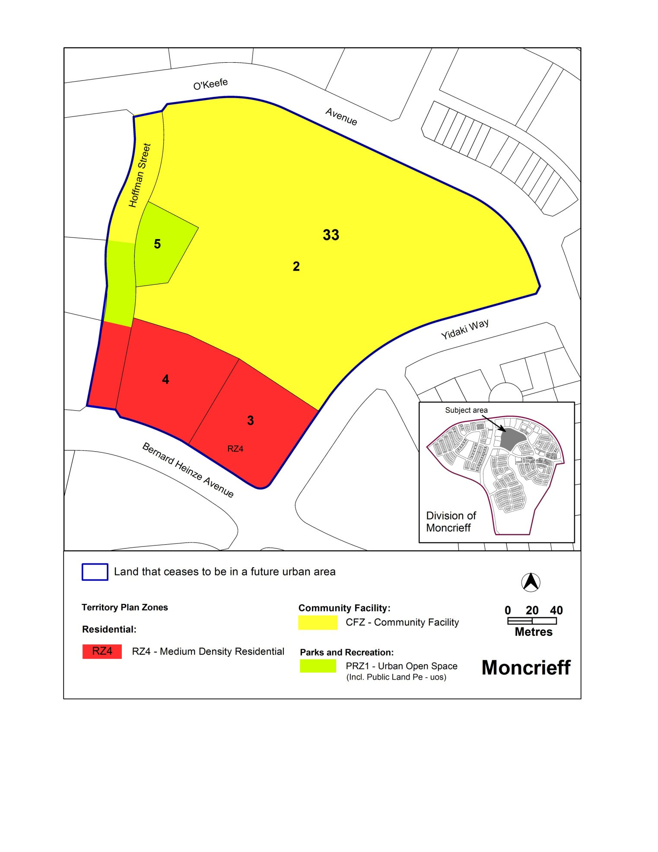*

* 1. Moncrieff Precinct Map and Code

**Variation to the Moncrieff Precinct Map and Code**

The Moncrieff precinct map and code is varied to incorporate ongoing block specific provisions.

**2.2.1 Moncrieff Precinct Map**

*Existing Moncrieff precinct map*

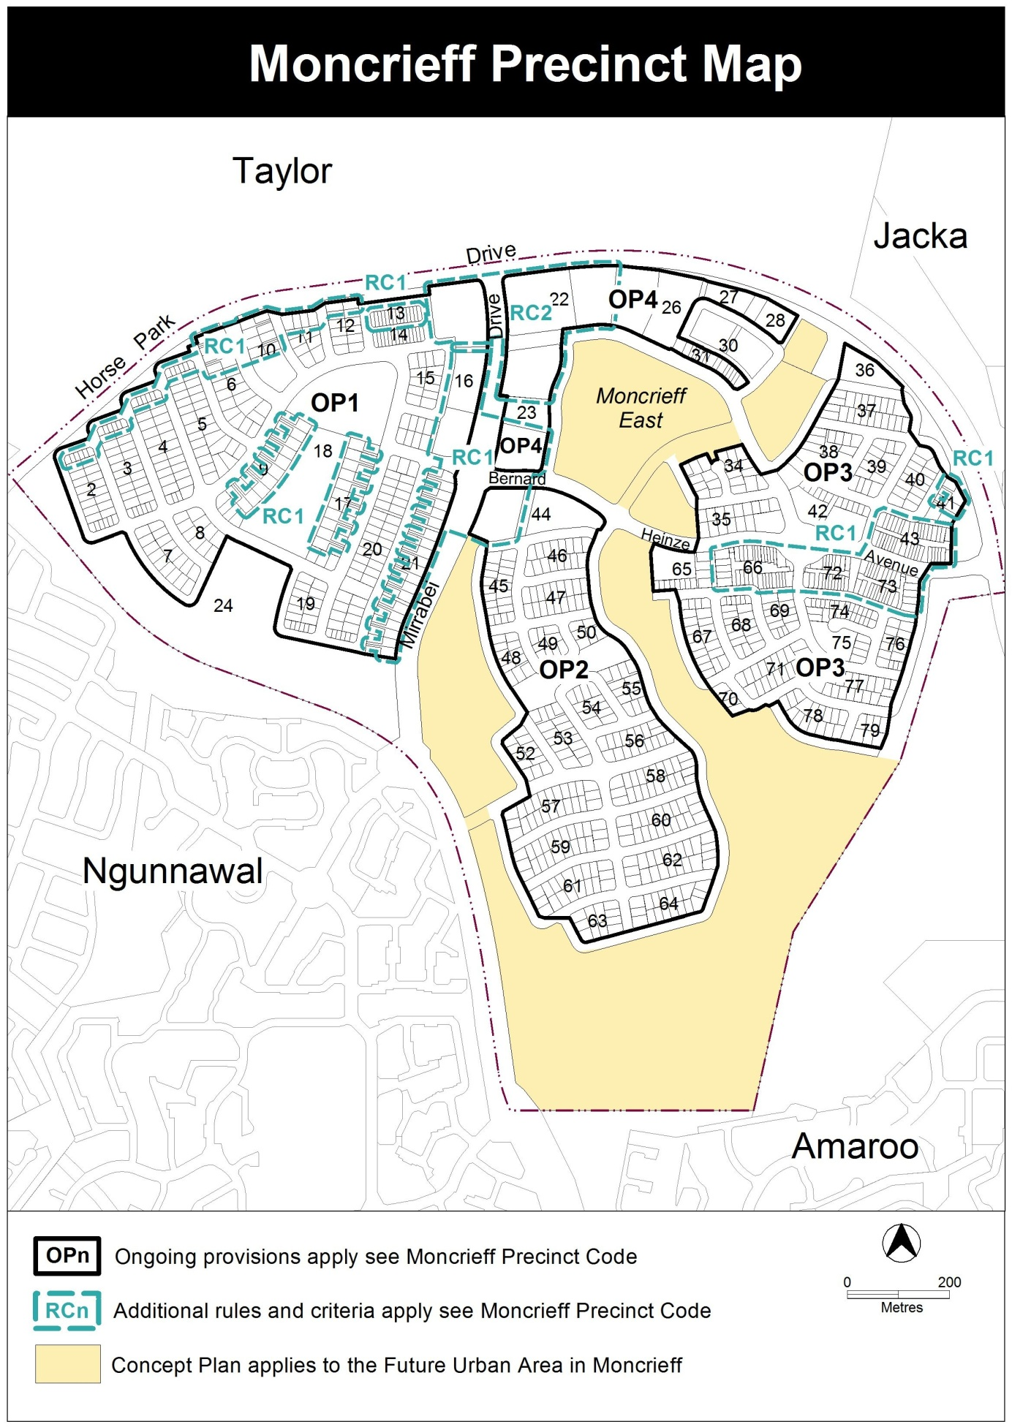

*Proposed Moncrieff precinct map*

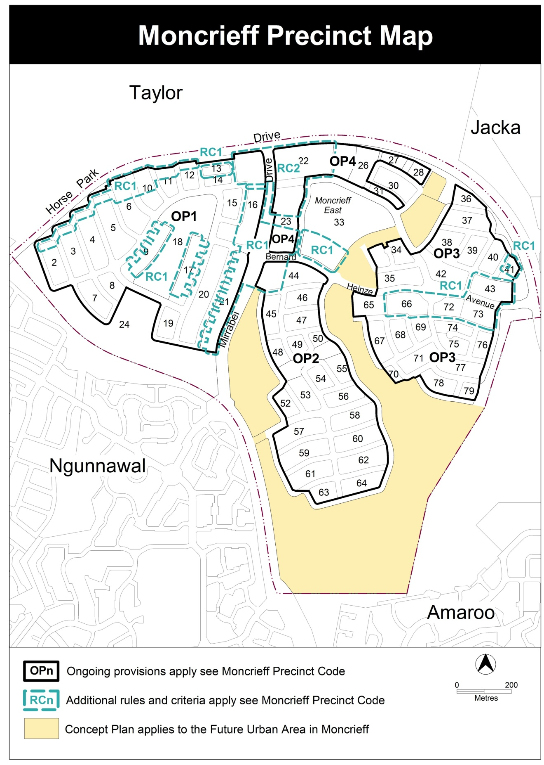

**2.2.2 Figure 2 – Moncrieff residential area 2**

*Substitute* existing figure 2 to show rules and criteria for amended RC1 area.

*Existing Figure 2*

*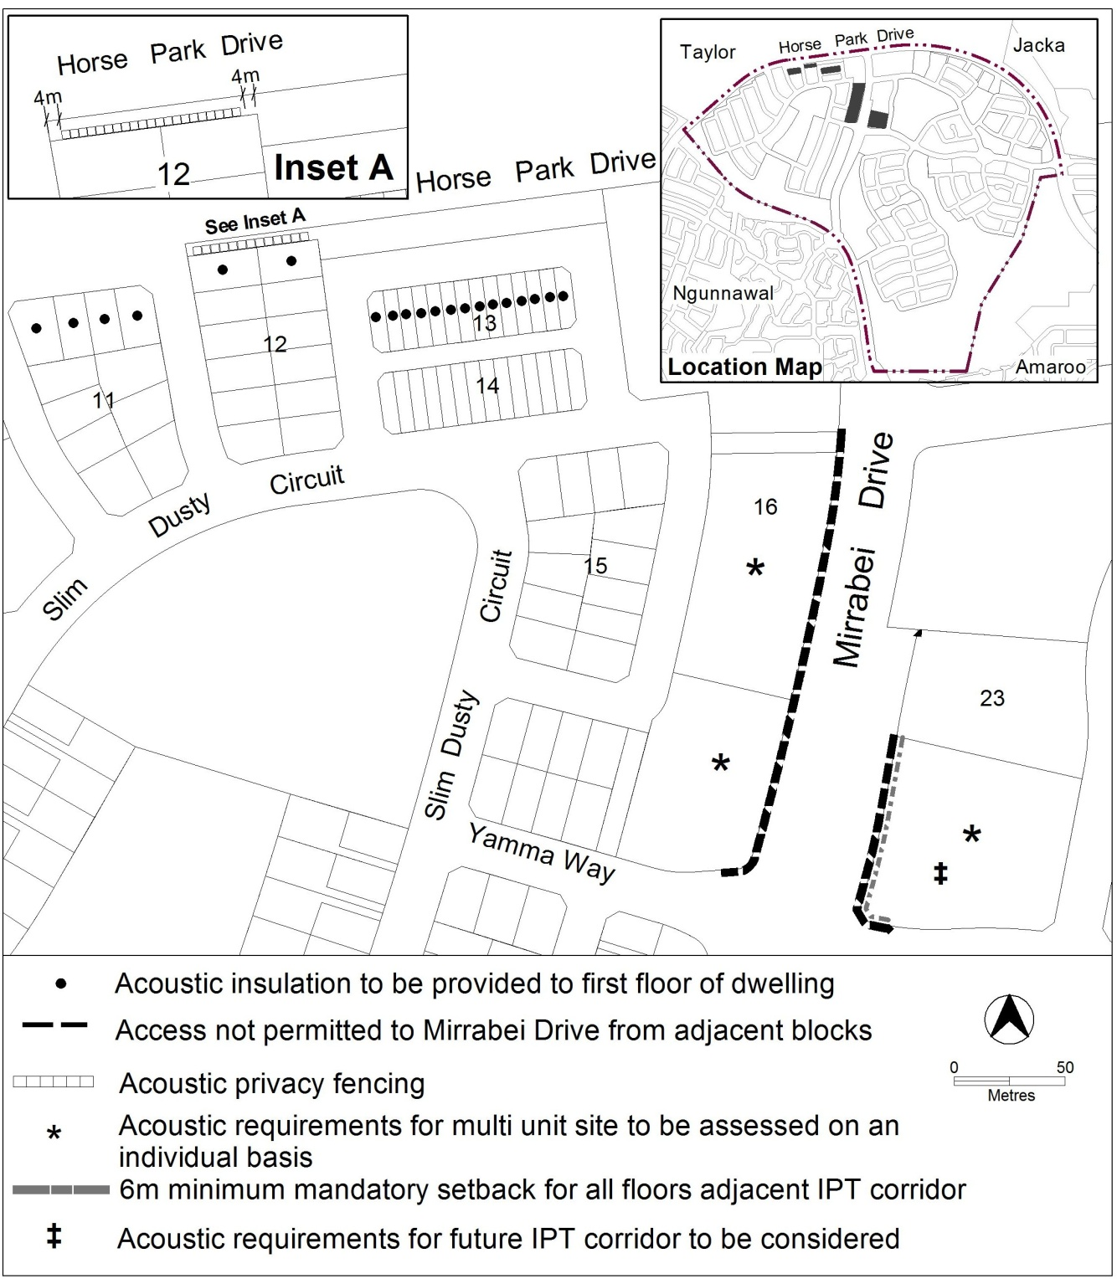*

*Proposed Figure 2*

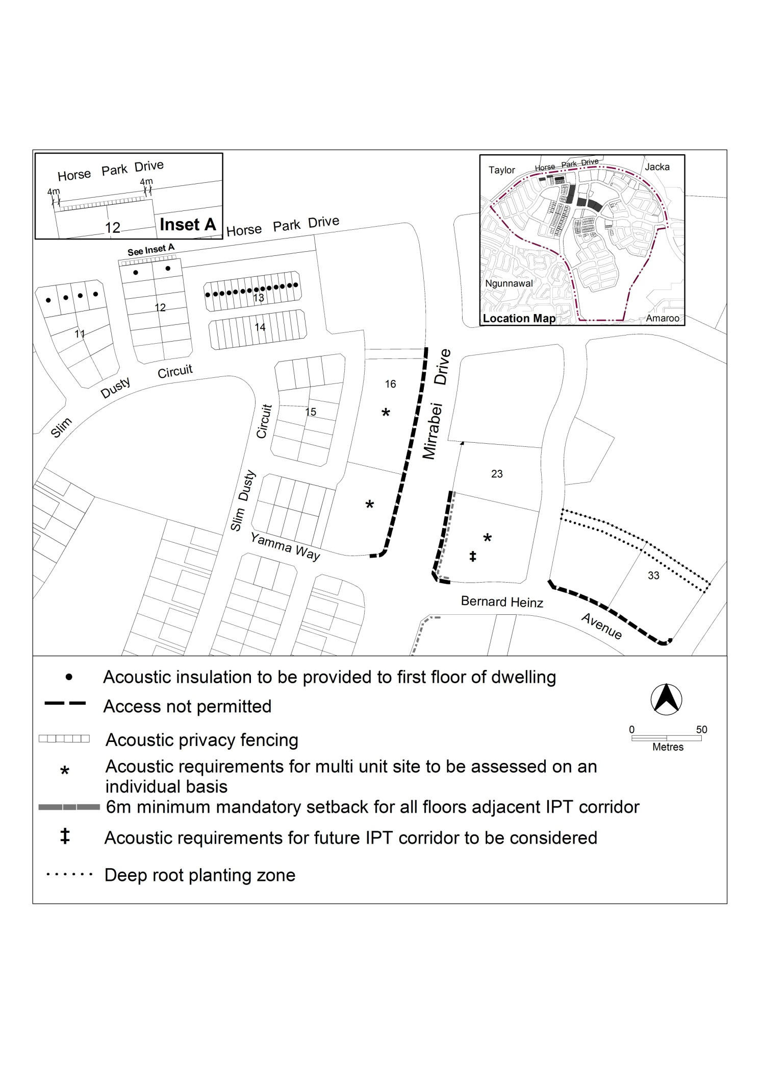

**2.2.3 RC2 – Commercial and Community Facilities Zones**

Insert new rules and criteria into the Moncrieff precinct map and code. These changes reflect the outcomes of the assessment of the estate development plan for Moncrieff.

*Proposed new provisions*

1. Building and site controls

| Rules | Criteria |
| --- | --- |
| R3  This rule applies to blocks or parcels in locations identified in Figures 2 and 3.  Access is not permitted to Mirrabei Drive or Bernard Heinz Avenue from adjacent blocks. | This is a mandatory requirement. There is no applicable criterion. |

| Rules | Criteria |
| --- | --- |
| R8a  This rule applies to blocks or parcels in locations identified in Figure 2.  Minimum 10m wide deep root planting zone to be provided and comply with the following:  a. No buildings or structures are located within the deep root planting zone. This includes any basements.  b. Trees species and spacing, approved by EPD, to be provided within the deep root planting zone, using semi-mature stock with a minimum mature height of 5m to provide a visual screen between the residential and adjacent community uses. | This is a mandatory requirement. There is no applicable criterion. |

1. TECHNICAL AMENDMENT

This section of the technical amendment document provides the actual instructions for implementing the changes to the Territory Plan.

* 1. Territory Plan Map

1. Territory Plan Map

*The Territory Plan map is varied as indicated below to identify the zones that apply to the land ceasing to be in a future urban area.*



* 1. Moncrieff Precinct Map and Code

1. Moncrieff Precinct Map

*Substitute*



1. Additional rules and criteria, RC1 – Residential, Element 1: Building and site controls, rule R3

*Substitute*

| Rules | Criteria |
| --- | --- |
| R3  This rule applies to blocks or parcels in locations identified in Figures 2 and 3.  Access is not permitted to Mirrabei Drive or Bernard Heinz Avenue from adjacent blocks. | This is a mandatory requirement. There is no applicable criterion. |

1. Additional rules and criteria, RC1 – Residential, Element 1: Building and site controls

*Insert*

| Rules | Criteria |
| --- | --- |
| R8a  This rule applies to blocks or parcels in locations identified in Figure 2.  Minimum 10m wide deep root planting zone to be provided and comply with the following:  a. No buildings or structures are located within the deep root planting zone. This includes any basements.  b. Trees species and spacing, approved by EPD, to be provided within the deep root planting zone, using semi-mature stock with a minimum mature height of 5m to provide a visual screen between the residential and adjacent community uses. | This is a mandatory requirement. There is no applicable criterion. |

1. Figure 2 Moncrieff residential area 2

*Substitute*

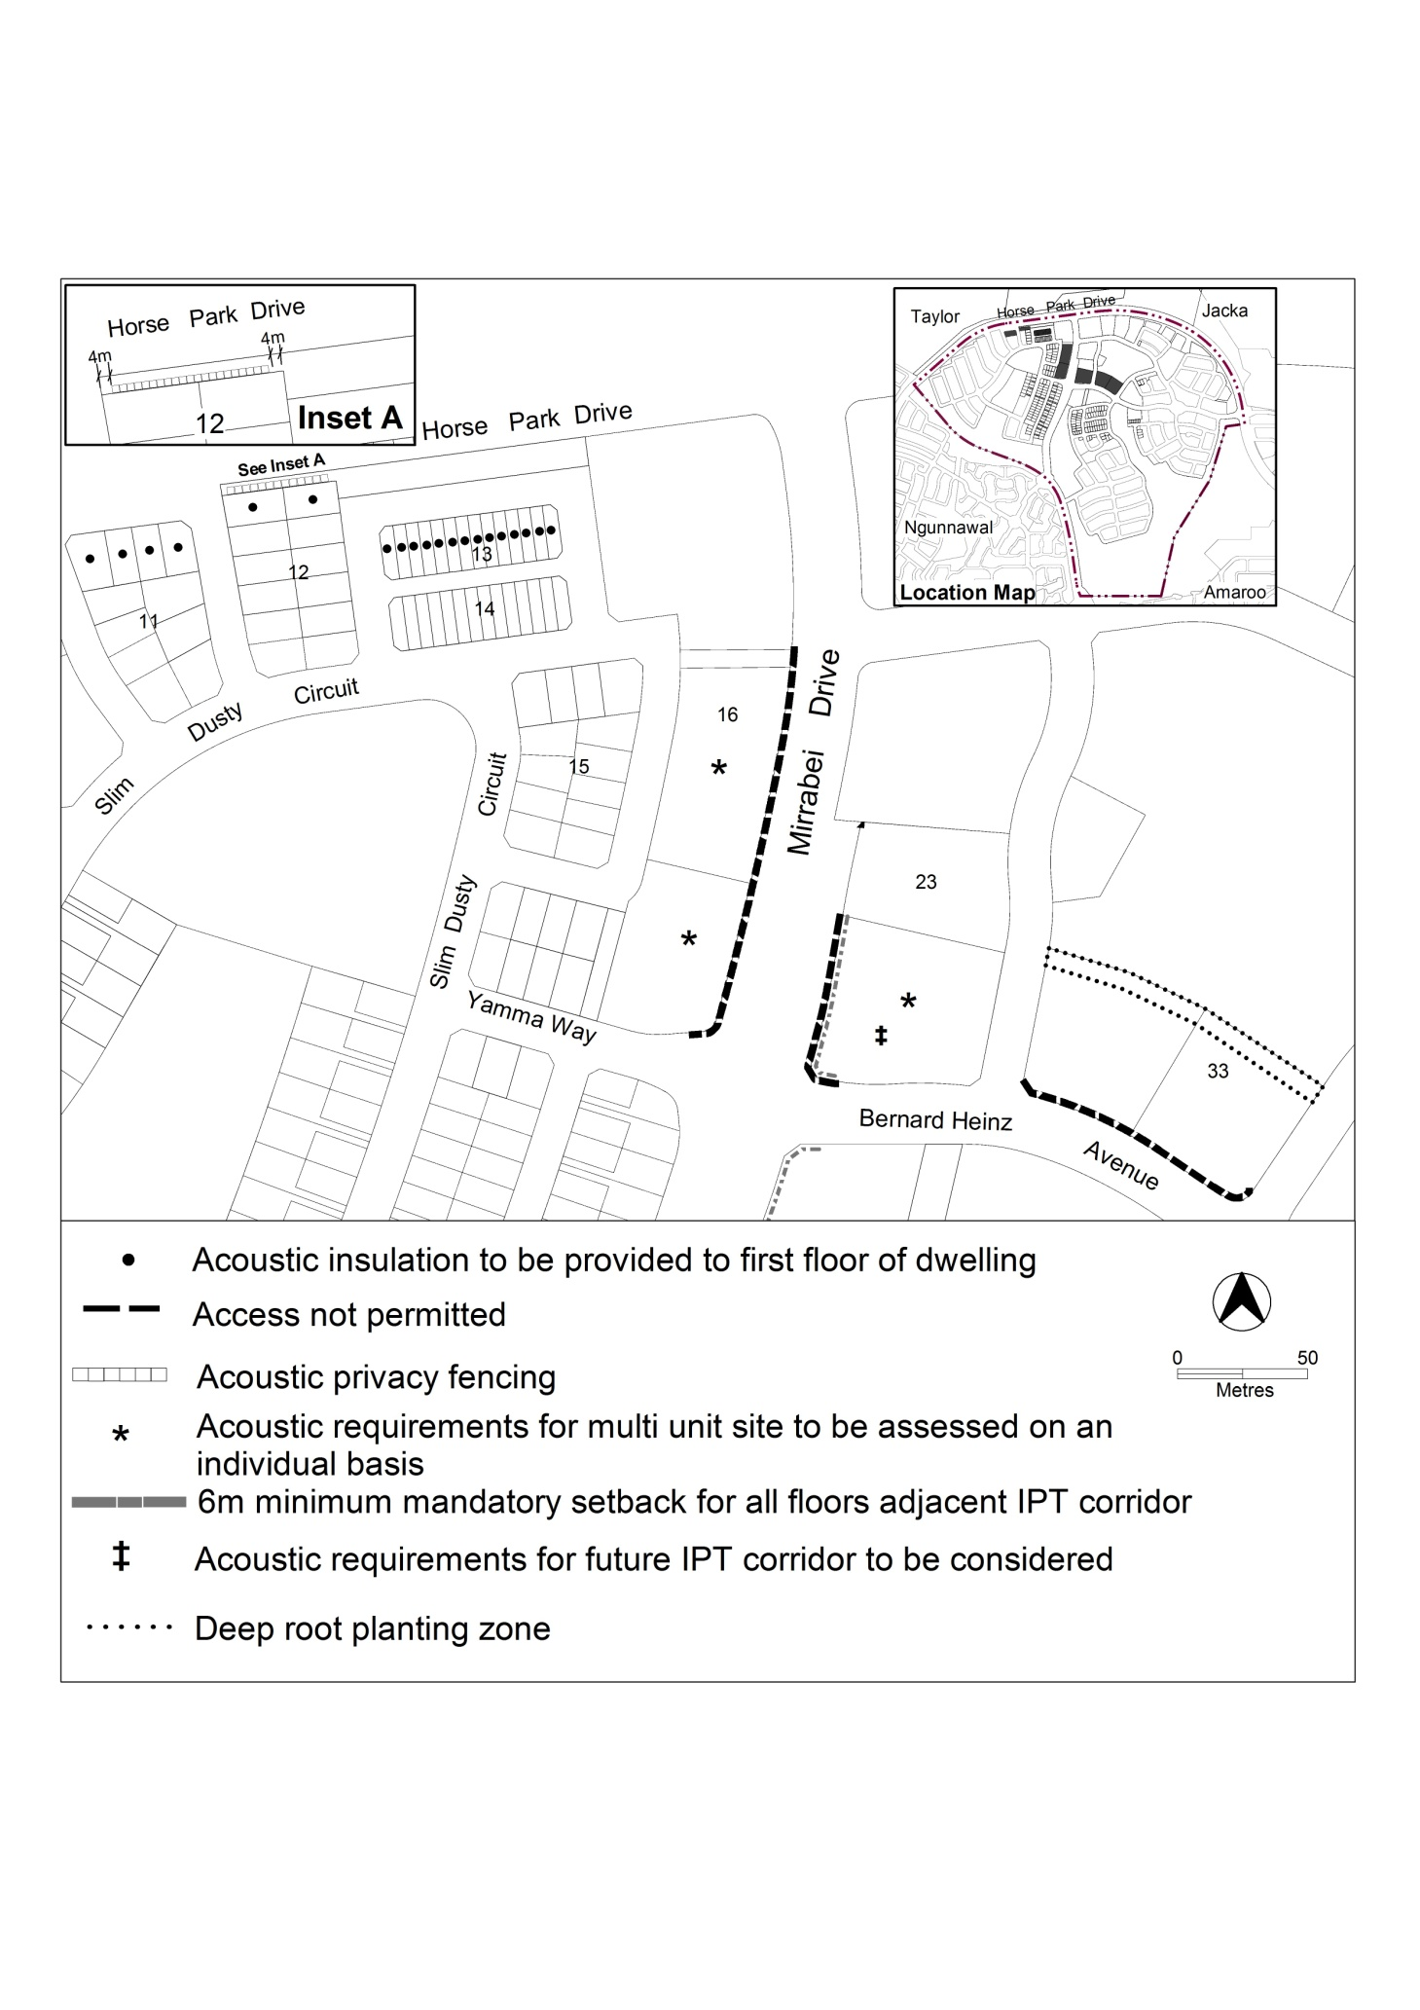

Interpretation service

