Australian Capital Territory
Planning and Development (Plan Variation No 341) Approval 2016*

Notifiable Instrument NI2016—66
Made under the
Planning and Development Act 2007, section 76(3)(a) (Minister’s powers in relation to draft plan variations)

1 Name of instrument
This instrument is the Planning and Development (Plan Variation No 341) Approval 2016.
2 Approval of draft plan variation
(1) I hereby APPROVE pursuant to section 76(3)(a) of the Planning and Development Act 2007 the draft plan variation No 341 to the Territory Plan.

(2) In this section:

Draft plan variation No 341 to the Territory Plan means the draft plan variation in the schedule.

Mick Gentleman MLA
Minister for Planning and Land Management

Dated this 10th day of February year 2016

Planning and Development Act 2007

Variation to the
Territory Plan
No 341

Gungahlin bus station – change to Public Land ‘Pe’ urban open space overlay for part of Boulevard Park, Gungahlin Town Centre

February 2016

Final variation prepared under s76 of the
Planning and Development Act 2007

This page is intentionally blank.

Contents

1. EXPLANATORY STATEMENT 1
1.1 Background 1
1.2 Summary of the proposal 2
1.3 National Capital Plan 3
1.4 Site Description 4
1.5 Current Territory Plan Provisions 5
1.6 Changes to the Territory Plan Map 6
1.7 Consultation on the Draft Variation 7
1.8 Revisions to the Draft Variation Recommended to the Minister 7
2. VARIATION 8
2.1 Variation to the Territory Plan 8

This page is intentionally blank.

- EXPLANATORY STATEMENT
  - Background
The district of Gungahlin has experienced substantial growth in the past decade. To accommodate this growth and respond to the increased transport needs of the Gungahlin community the ACT Government is implementing a light rail connection between the city and Gungahlin town centre. Capital Metro, the government agency responsible for the facilitation of the light rail and route corridor envisage that a terminus for the light rail will be located on Hibberson Street near Gungahlin Place (see Figure 1). Residents of Gungahlin suburbs can travel to this terminus via other transport modes, including bus, to catch the light rail into the city. Providing seamless and efficient connections and integration with the terminus will be central to the operation of the light rail and overall transport network.
In June 2015, Roads ACT commissioned a detailed planning exercise to provide recommendations for the integration of the bus and light rail modes within Gungahlin town centre. The review evaluated potential bus route options, bus station arrangements, bus layover locations and associated supporting infrastructure to develop a preferred bus network for the town centre. Gungahlin Place between Hibberson Street and Ernest Cavanagh Street was identified as the preferred location for the new bus station (see Figure 1).
To accommodate proposed plans for the layout of the future Gungahlin town centre bus station, the existing verges along the median pedestrian plaza in Gungahlin Place will need to be moved to allow space for bus stops and a lane of traffic.
The underlying zoning of the pedestrian plaza, known as Gungahlin Boulevard Park, is commercial CZ1 core zone with a Public Land ‘Pe’ urban open space overlay. The overlay is subject to a plan of management which restricts use of the open space to public and community use including activities of interest to the community and hosting of special events.
The development of the new bus station will involve works partially within Block 1 Section 36, Block 1 Section 37 and Block 1 Section 38 Gungahlin within the bounds of the Pe overlay. Although the underlying CZ1 zone allows for a ‘public transport facility’, this is inconsistent with the current use of the land as described in the Plan of Management for Urban Open Space and Public Access Sportsgrounds in the Gungahlin Region for Gungahlin Boulevard Park. See:
http://www.legislation.act.gov.au/di/2007-298/20080307-35549/pdf/2007-298.pdf
In order to facilitate the development of the bus station in the preferred location, it is proposed to adjust the ‘Pe’ overlay by reducing its coverage in the CZ1 zone over the subject blocks to allow the optimum positioning of bus platforms and a lane of traffic. This requires a change to the Territory Plan map to adjust the overlay which will be undertaken through this variation process.
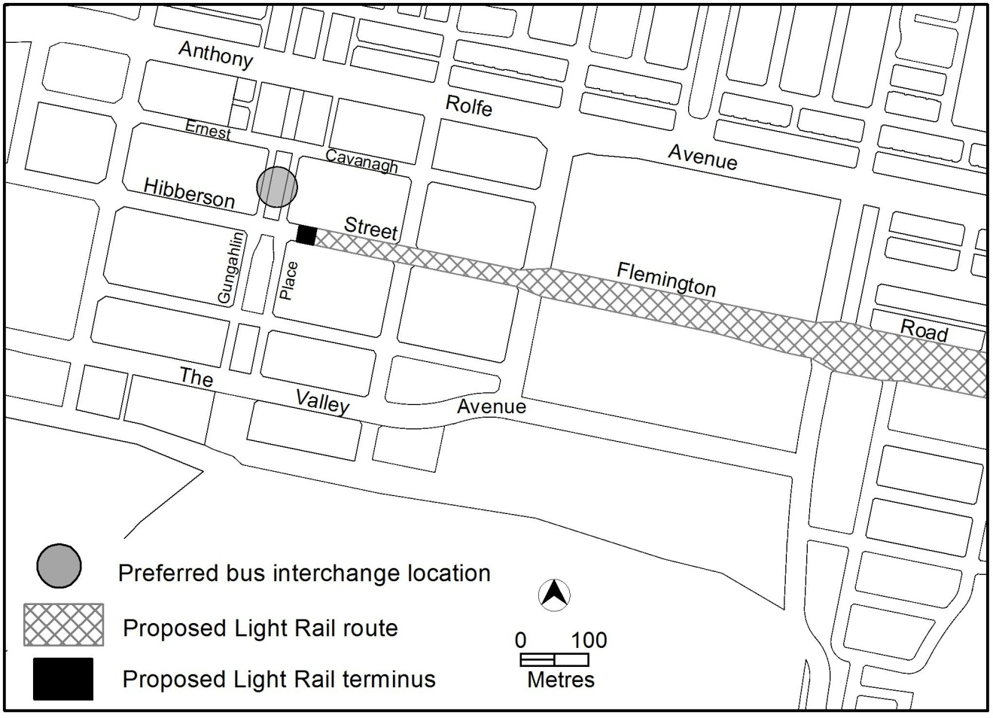
Figure 1: Proposed light rail terminus and preferred bus station location
Further information and background studies to support the proposed changes referred to in this draft variation can be found in the Gungahlin Bus Planning Report available at:
http://www.planning.act.gov.au/tools_resources/legislation_plans_registers/plans/territory_plan/draft_variations_to_the_territory_plan

  - Summary of the proposal
The variation reduces the Public Land ‘Pe’ urban open space overlay over parts of Boulevard Park in the Gungahlin town centre to permit the location of a bus station in close proximity to the proposed light rail terminus in Hibberson Street. The bus station will be located in Gungahlin Place and the road and pedestrian plaza (Boulevard Park) will need to be modified to accommodate the construction of the bus station. Parts of adjacent blocks to the north and south which also have a ‘Pe’ overlay will also be adjusted to accommodate changed intersection configurations and signalisation.

  - National Capital Plan
The Australian Capital Territory (Planning and Land Management) Act 1988 established the National Capital Authority (NCA) with two of its functions being to prepare and administer a National Capital Plan (NCP) and to keep the NCP under constant review and to propose amendments to it when necessary.
The NCP, which was published in the Commonwealth Gazette on 21 January 1990 is required to ensure that Canberra and the Territory are planned and developed in accordance with their national significance. The Planning and Land Management Act 1988 also required that the Territory Plan is not inconsistent with the NCP. The area covered by this variation is within urban areas identified in the NCP.
In accordance with section 10 of the Australian Capital Territory (Planning and Land Management) Act 1988, the National Capital Plan defines the planning principles and policies for Canberra and the Territory, for giving effect to the object of the NCP and sets out the general policies to be implemented throughout the Territory, including the range and nature of permitted land uses.
It also sets out the detailed conditions of planning, design and development for areas that have special significance to the National Capital known as designated areas and identifies special requirements for the development of some other areas

  - Site Description
The subject blocks are Block 1 Section 36, Block 1 Section 37 and Block 1 Section 38 all of Gungahlin. See Figure 2 Location Plan.
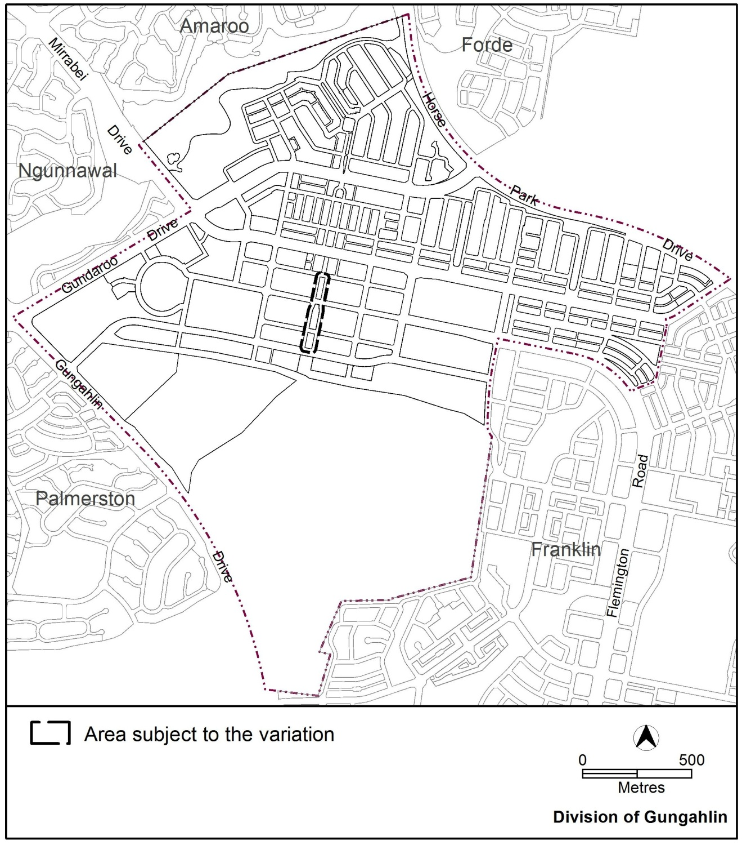
Figure 2 Location Plan

  - Current Territory Plan Provisions
The Territory Plan map zone and overlay for the area subject to this variation is shown in Figure 3.
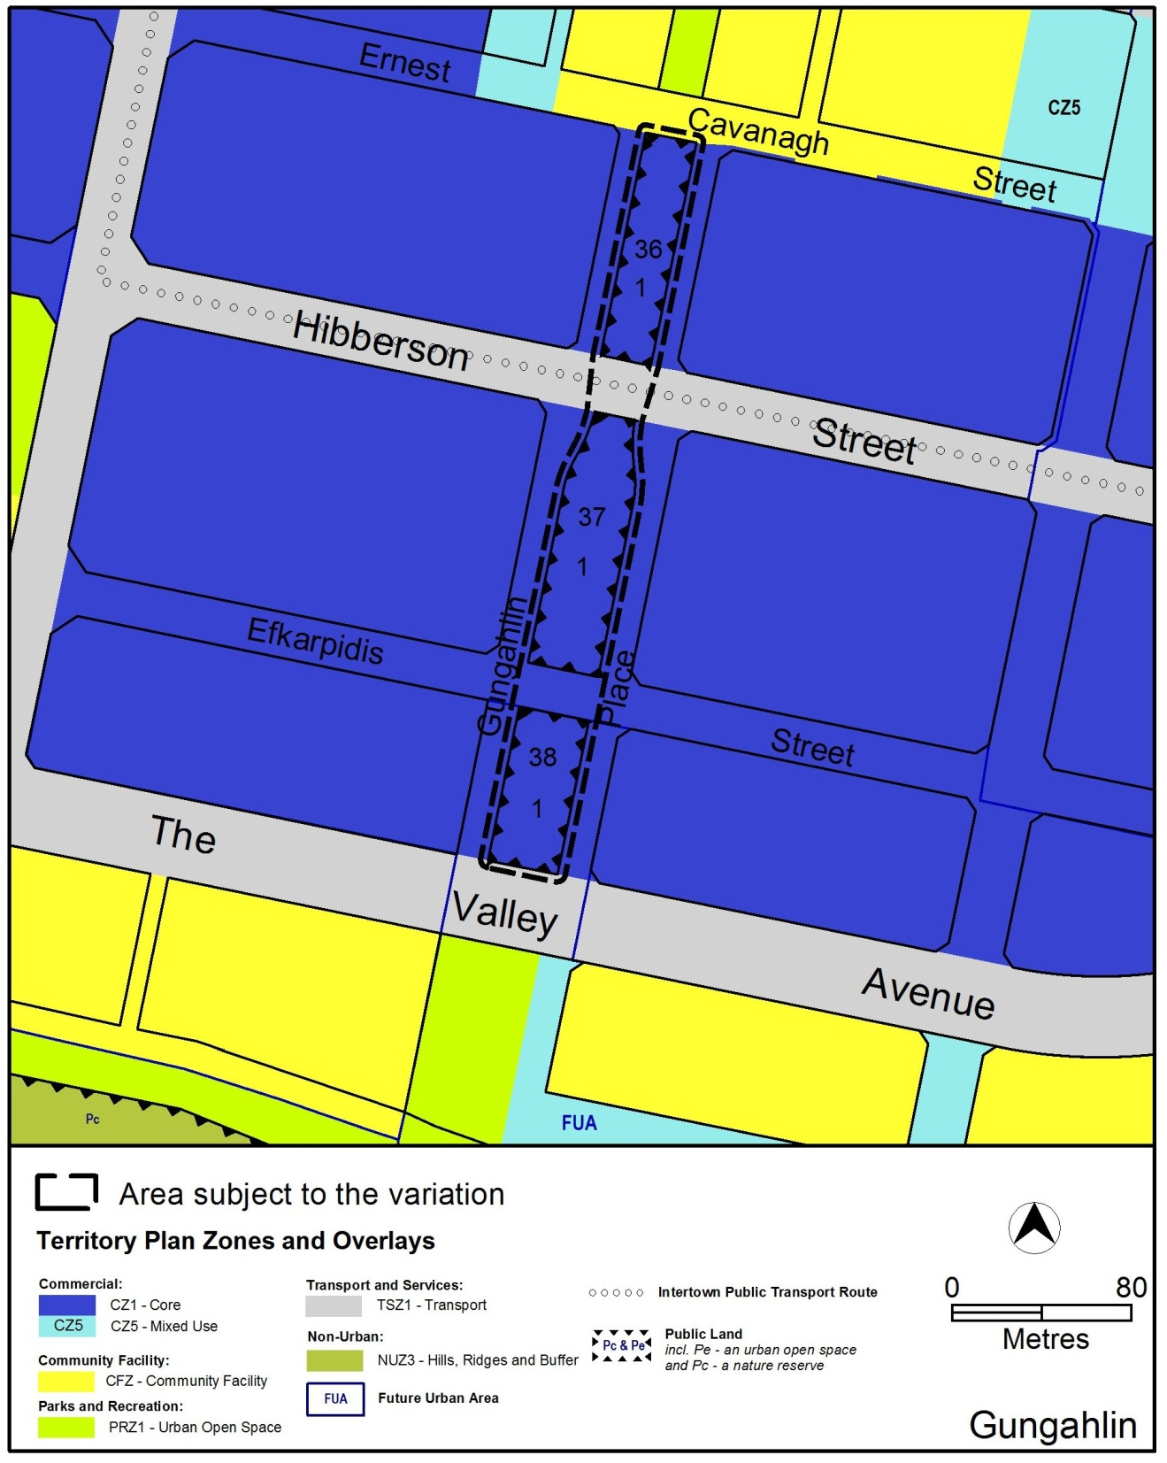
Figure 3 Territory Plan Zones Map

  - Changes to the Territory Plan Map
The changes to the Territory Plan map are indicated in Figure 4 and are detailed as follows:
Remove the Public Land ‘Pe’ urban open space overlay from part Block 1 Section 36, part Block 1 Section 37 and part Block 1 Section 38 Gungahlin.
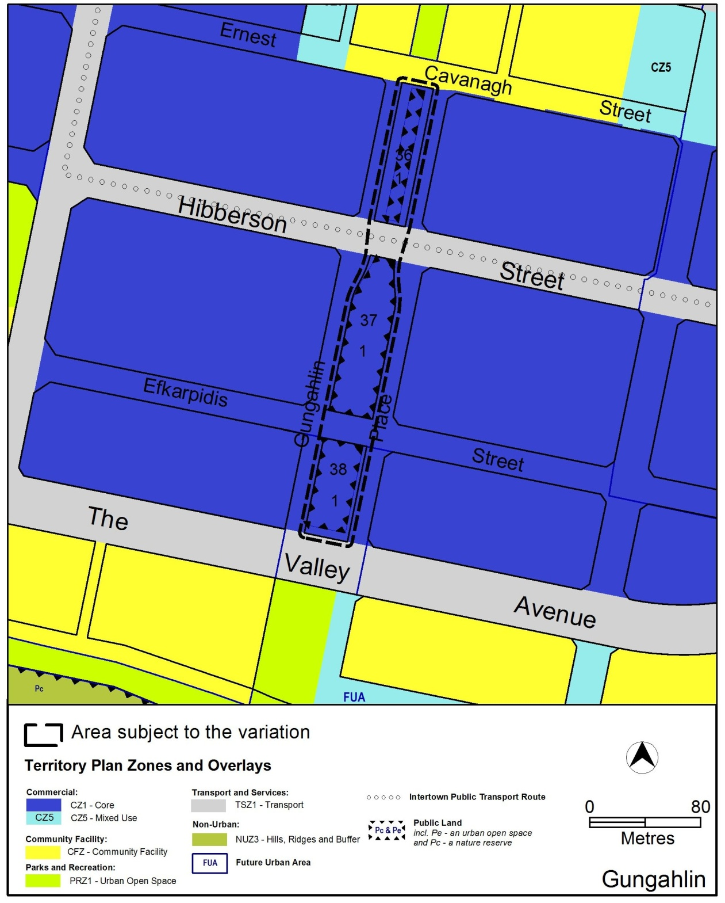
Figure 4 Proposed Territory Plan Map
The variation map indicates the proposed zone boundaries as accurately as possible but may be subject to adjustments following detailed surveys.
  - Consultation on the Draft Variation
Draft Variation No 341 (DV341) was released for public comment between 10 November 2015 and 23 December 2015. A consultation notice under section 63 of the Planning and Development Act 2007 (P&D Act) was published on the ACT Legislation Register on 10 November 2015 and in The Canberra Times on 11 November 2015.
At the close of public consultation no written submissions had been received from the public on DV341.
  - Revisions to the Draft Variation Recommended to the Minister
No changes were made to the draft variation recommended to the Minister.

- VARIATION
  - Variation to the Territory Plan
The Territory Plan is varied in all of the following ways:

Variation to the Territory Plan map
Substitute

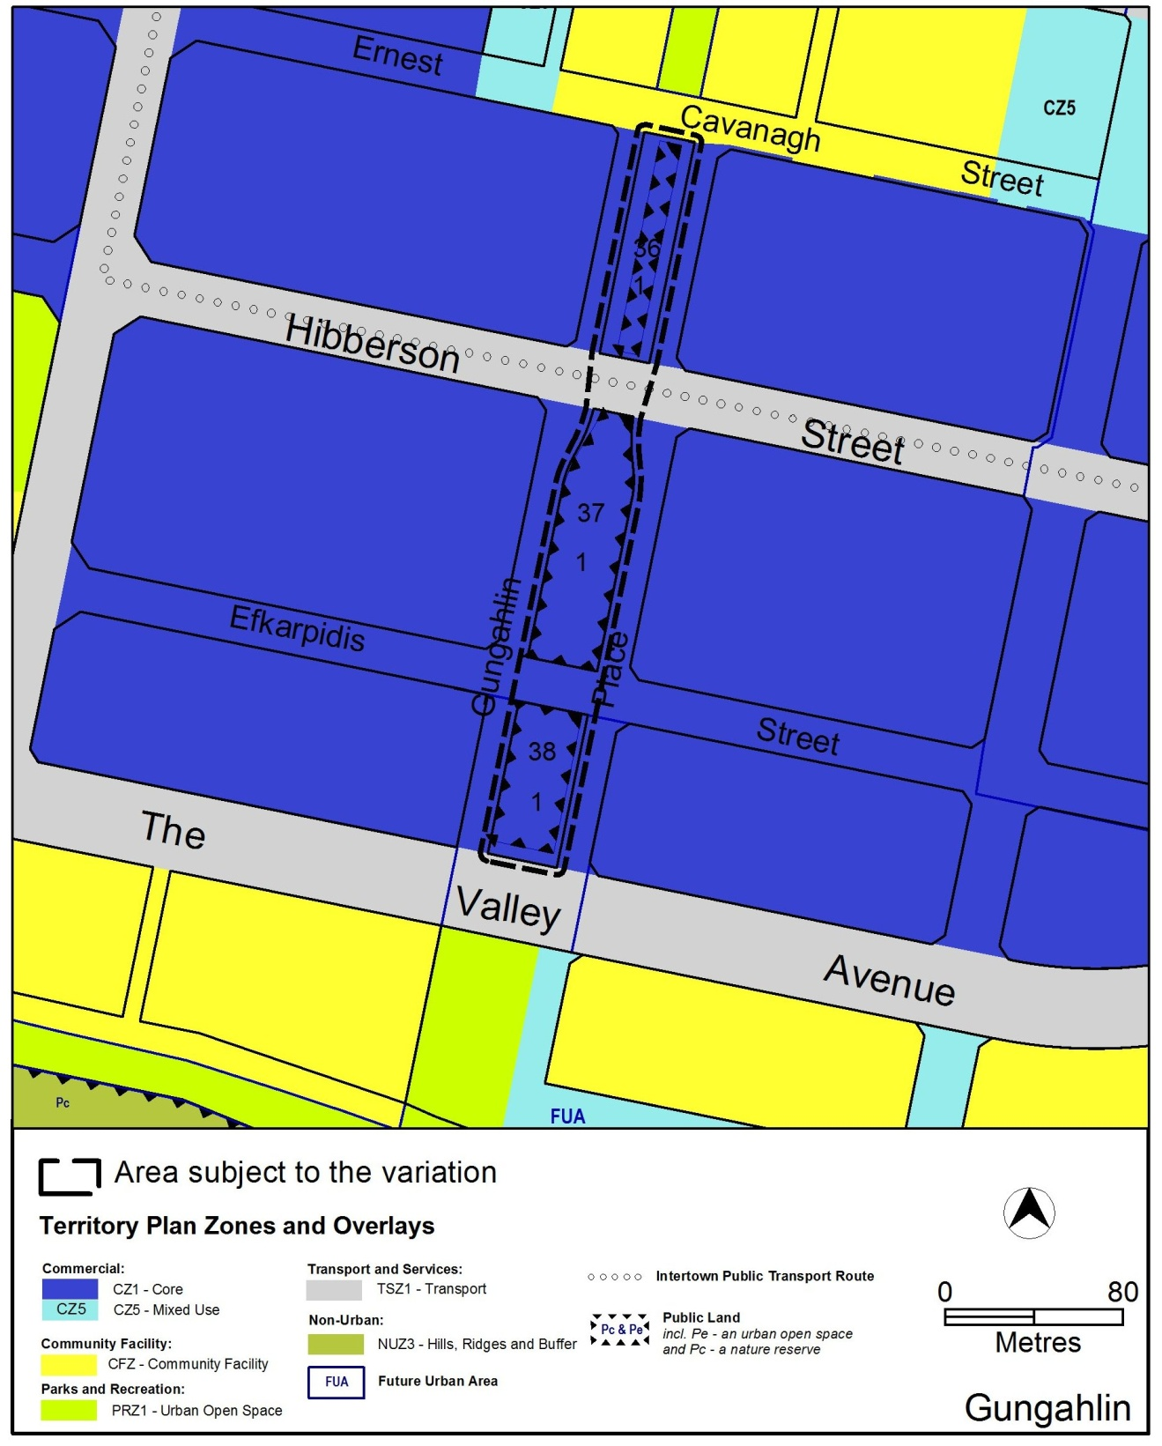

Interpretation service
