Australian Capital Territory
Planning and Development (Draft Variation No 344) Consultation Notice 2017
Notifiable instrument NI2017—106
made under the
Planning and Development Act 2007, s 63 (Public consultation—notification) and s 64 (Public consultation—notice of interim effect etc)

1 Name of instrument
This instrument is the Planning and Development (Draft Variation No 344) Consultation Notice 2017.
2 Draft variation to the Territory Plan
The planning and land authority (the Authority) has prepared a draft plan variation No 344 – Woden town centre (the Draft Variation) to vary the Territory Plan. The Draft Variation contains changes to zones within the Division of Phillip and amendments to the Phillip precinct map and code.
3 Documents available for public inspection
(1) The Authority gives notice that the following documents are available for public inspection and purchase:
(a) the Draft Variation; and
(b) the background papers relating to the Draft Variation.
(2) Copies of the documents mentioned in section 3(1) are available for inspection and purchase at Access Canberra, Environment, Planning and Sustainable Development Directorate (EPSDD) Shopfront, Ground Floor South, Dame Pattie Menzies House, 16 Challis Street, Dickson, Monday to Friday (except public holidays) between 8:30am and 4:30pm for the period commencing on the day this notice commences and ending on 21 April 2017 (the Consultation Period).
(3) Copies of the documents mentioned in section 3(1) are also available for inspection during the Consultation Period online at http://www.planning.act.gov.au/tools_resources/legislation_plans_registers/plans/territory_plan/draft_variations_to_the_territory_plan
Invitation to give written comments
(1) The Authority invites written comments about the Draft Variation during the Consultation Period. Comments should include reference to the Draft Variation and be addressed to the Territory Plan Section of the Environment, Planning and Sustainable Development Directorate. Please also provide your name and contact details to assist in the assessment of the comments provided and to enable the Authority to contact you in relation to your comments, if required.
(2) Written comments should be provided to the Authority by:
(a) email to terrplan@act.gov.au; or
(b) mail to Territory Plan Section, EPSDD, GPO Box 158, Canberra, ACT 2601; or
(c) hand delivery to Access Canberra, EPSDD Shopfront, Ground Floor South, Dame Pattie Menzies House, 16 Challis Street, Dickson.
5 Public inspection of written comments
(1) Copies of written comments about the Draft Variation given in response to the invitation in section 4, or otherwise, or received from the National Capital Authority will be available (unless exempted) for public inspection for a period of at least 15 working days starting 10 working days after the day the consultation period ends at Access Canberra, EPSDD Shopfront, Ground Floor South, Dame Pattie Menzies House, 16 Challis Street, Dickson, Monday to Friday (except public holidays) between 8:30am and 4:30pm and may be published on the EPSDD website at www.planning.act.gov.au.
(2) You may apply under section 411 of the Planning and Development Act 2007 (the Act) for part of your consultation comments to be excluded from being made available to the public. A request for exclusion under this section must be in writing, clearly identifying what you are seeking to exclude and how the request satisfies the exclusion criteria. Please note that your name and contact details and other personal information will not be made public unless you request otherwise.
6 Effect of the draft plan variation
Section 65 of the Act does not apply in relation to the Draft Variation and therefore it does not have interim effect. The current Territory Plan will continue to apply while the Draft Variation remains in draft form.
7 Obtaining further information
Further information about the Draft Variation can be obtained through email correspondence with the Territory Plan Section, EPSDD, at Terrplan@act.gov.au, a reference to the Draft Variation should be included in any email.

8 Meaning of draft plan variation No 344 – Woden town centre
In this instrument:
Draft plan variation No 344 – Woden town centre means the draft plan variation in the schedule.
Note 1: Your personal information will be managed in accordance with the Information Privacy Act 2014 and the EPSDD Information Privacy Policy which are available through the EPSDD website.

Brett Phillips
Delegate of the planning and land authority
01 March 2017

Planning and Development Act 2007

Draft
Variation to the
Territory Plan
No 344

Woden Town Centre:
Zone changes and amendments to the Phillip precinct map and code

March 2017

Draft variation for public consultation prepared
under s60 of the Planning and Development Act 2007

This page is intentionally blank.

Contents

1. INTRODUCTION 1
1.1 Summary of the Proposal 1
1.2 Outline of the process 1
1.3 This document 3
1.4 Public Consultation 3
2. EXPLANATORY STATEMENT 5
2.1 Background 5
2.2 Site Description 5
2.3 Current Territory Plan Provisions 6
2.4 Proposed Changes 8
2.4.1 Proposed Changes to the Territory Plan Map 8
2.4.2 Proposed Changes to Territory Plan 8
2.5 Reasons for the Proposed Draft Variation 9
2.6 Planning Context 10
2.6.1 National Capital Plan 10
2.6.2 Territory Plan 10
2.7 Interim Effect 13
2.8 Consultation with Government Agencies 14
3. DRAFT VARIATION 19
3.1 Variation to the Territory Plan map 19
3.2 Variation to the Territory Plan written statement 20

This page is intentionally blank.

- INTRODUCTION
  - Summary of the Proposal
The draft variation incorporates the recommendations of the approved Woden Town Centre master plan to provide guidance on the desired future built form and character of the centre as it develops over the next 10 to 20 years.
DV344 rezones selected areas, including parts of the open space area south of the Callum Offices to permit community facilities, upgrading the residential zoning of land in Woden Green near the corner of Hindmarsh Drive and Callum Street as well as land along Athllon Drive to permit higher density development. DV344 includes rezoning of the open space shared path along Athllon Drive and Swinger Hill from residential to urban open space to ensure the active travel path is retained.
DV344 introduces building heights to the centre potentially up to 28 storeys, as well as selected sites where marker buildings will be permitted to assist the identification of the centre. Built form provisions are included nominating building setbacks and active frontage requirements to ensure interesting and safe public spaces for pedestrians. Awning requirements are also included to ensure all weather protection along the main pedestrian areas.
DV344 retains the existing planning requirements for community facilities to be provided within the centre, and proposes additional community facility land for future facilities. The draft variation also includes heritage requirements for the protection of the Callum Offices heritage character through height controls around the offices.
  - Outline of the process
The Commonwealth’s Australian Capital Territory (Planning and Land Management) Act 1988 allows for the Legislative Assembly to make laws to establish a Territory Planning Authority and for that Authority to prepare and administer a Territory Plan. The Planning and Development Act 2007 (the Act) establishes the planning and land authority as the Authority which prepares and administers the Territory Plan, including continually reviewing and proposing amendments as necessary. The functions of the planning and land authority are administered by the Environment, Planning and Sustainable Development Directorate (EPSDD).
The Territory Plan is comprised of a written statement and a map. The written statement contains a number of parts, namely governance; strategic directions; zones (including objectives and development tables and zone or centre development codes); precinct codes; general codes; overlays; definitions; structure plans, concept plans and development codes for future urban areas.
The Territory Plan Map graphically represents the applicable land use zones (under the categories of residential, commercial, industrial, community facility, urban parks and recreation, transport and services and non urban), precincts and overlays. The zone, precinct and overlay requirements are detailed in the volumes of the Territory Plan.
Draft variations to the Territory Plan are prepared in accordance with the Act. Following the release of the draft variation under section 63 of the Act, submissions from the public are invited. At the conclusion of the consultation period the EPSDD submits a report on consultation and a recommended final variation to the Minister responsible for planning for approval. The Minister has the discretion to determine if referral to the Legislative Assembly standing committee responsible for planning is warranted prior to approval, depending on the nature and significance of the proposal. If the draft variation is referred to the committee by the Minister or otherwise, the Minister must consider the findings of the committee before deciding whether to approve the draft variation. If the Minister approves the variation, the variation and associated documents will be tabled in the Legislative Assembly. Unless disallowed by the Legislative Assembly within five sitting days, the variation commences on a day nominated by the Minister.

  - This document
This document contains the background information in relation to the proposed variation. It comprises the following parts
Part 1 This Introduction
Part 2 An Explanatory Statement, which gives reasons for the proposed variation and describes its effect
Part 3 The Draft Variation, which details the precise changes to the Territory Plan that are proposed
  - Public Consultation
Written comments about the draft variation are invited from the public by 21 April 2017.
Comments should include reference to the draft variation and be addressed to the Territory Plan Section. Please also provide your name and contact details to assist in the assessment of the comments provided, and to enable EPSDD to contact you in relation to your comments, if required. Your personal information will be managed in accordance with the Information Privacy Act 2014 and the EPSDD Information Privacy Policy, which is available for viewing on EPSDD’s website.
Comments can be:
- emailed to terrplan@act.gov.au
- mailed to Territory Plan Section, GPO Box 158, Canberra, ACT 2601
- delivered to the Access Canberra EPSDD Customer Service Centre at 16 Challis Street, Dickson
- made on the ‘Have Your Say’ website: https://www.yoursay.act.gov.au/
Copies of written comments will be made available for public inspection for no less than 15 working days starting 10 working days after the closing date for comment. The comments will be available at the Access Canberra EPSDD customer service centre in Dickson and may be published on EPSDD’s website. Comments made available will not include personal contact details unless you request otherwise.
A request may be made for parts of a submission to be excluded under section 411 or 412 of the Planning and Development Act 2007. A request for exclusion under these sections must be in writing, clearly identifying what parts of your submission you are seeking to exclude and how the request satisfies the exclusion criteria.

Further Information
The draft variation and background documents are available online at www.act.gov.au/draftvariations until the closing date for written comments.
Printed copies of the draft variation (this document) and background documents are available for inspection and purchase at the Access Canberra EPSDD Service Centre, 16 Challis Street, Dickson, Monday to Friday (except public holidays) between 8:30am and 4:30pm. Please call 6207 1923 to arrange a copy for purchase.

- EXPLANATORY STATEMENT
  - Background
Draft Variation 344 incorporates the recommendations of the 2015 Woden town centre master plan, which builds on the 2004 Woden town centre master plan. While a number of recommendations from the 2004 master plan have been realised, there have been a number of strategic planning documents released since then, such as the ACT Planning Strategy, which recommend the consideration of urban intensification measures for the centre. This initiated the review of the town centre planning provisions and preparation of the master plan. The review has also considered additional measures for inclusion in the Phillip precinct code, such as nominating maximum building heights for the town centre and identifying new development opportunities in the centre.
  - Site Description
The subject area is the Woden town centre. The area includes part of the Athllon Drive corridor, Phillip service trades area, town centre core, the recreation precinct north of Launceston Street and a portion of the residential area located east of Callam Street.
The centre has a significant employment base within the ACT with Commonwealth departments and retail being the largest employer. The centre also contains a number of important community, education and recreation uses including Woden Community Services, child care facilities, health related facilities, Woden Library, Canberra College, Canberra Institute of Technology, Eddison Park, pocket parks and ovals.
Distant views of the centre are dominated by Lovett Tower, which is the tallest building in the centre. The building can be seen from several vantage points in Canberra, including Red Hill lookout and the National Arboretum.
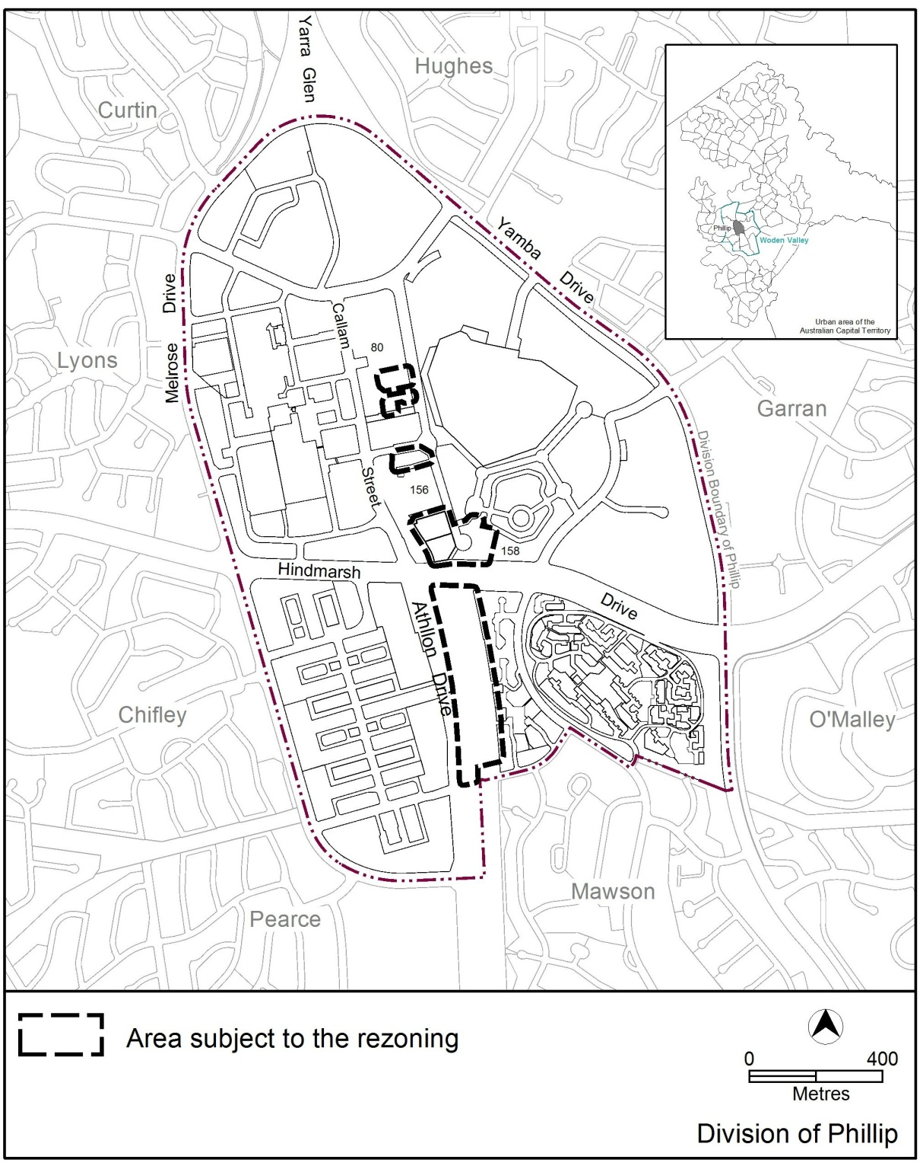
Figure 1: Location map and areas subject to rezoning
  - Current Territory Plan Provisions
The town centre is predominately zoned commercial core CZ1 and commercial business CZ2, while the trades and services area is zoned commercial service trades CZ3. Other land subject to this variation is the RZ4 zoned residential land located close to the corner of Callam Street and Hindmarsh Drive, public open space PRZ1 and CFZ community facility land beside Callam Street, and the existing RZ2 suburban core zoned land along Athllon Drive. The Territory Plan map zones for the area subject to this variation are shown in Figure 2.
The town centre is subject to the Commercial Zone development code and the Phillip precinct map and code, while the adjoining residential areas are subject to the Residential Zones Development code, Single Dwelling Housing development code and the Multi Unit Housing development code. The community facility land is subject to the Community Facility Zones development code, with the public open space subject to the Parks and Recreation Zone development code.
The general codes may also apply.
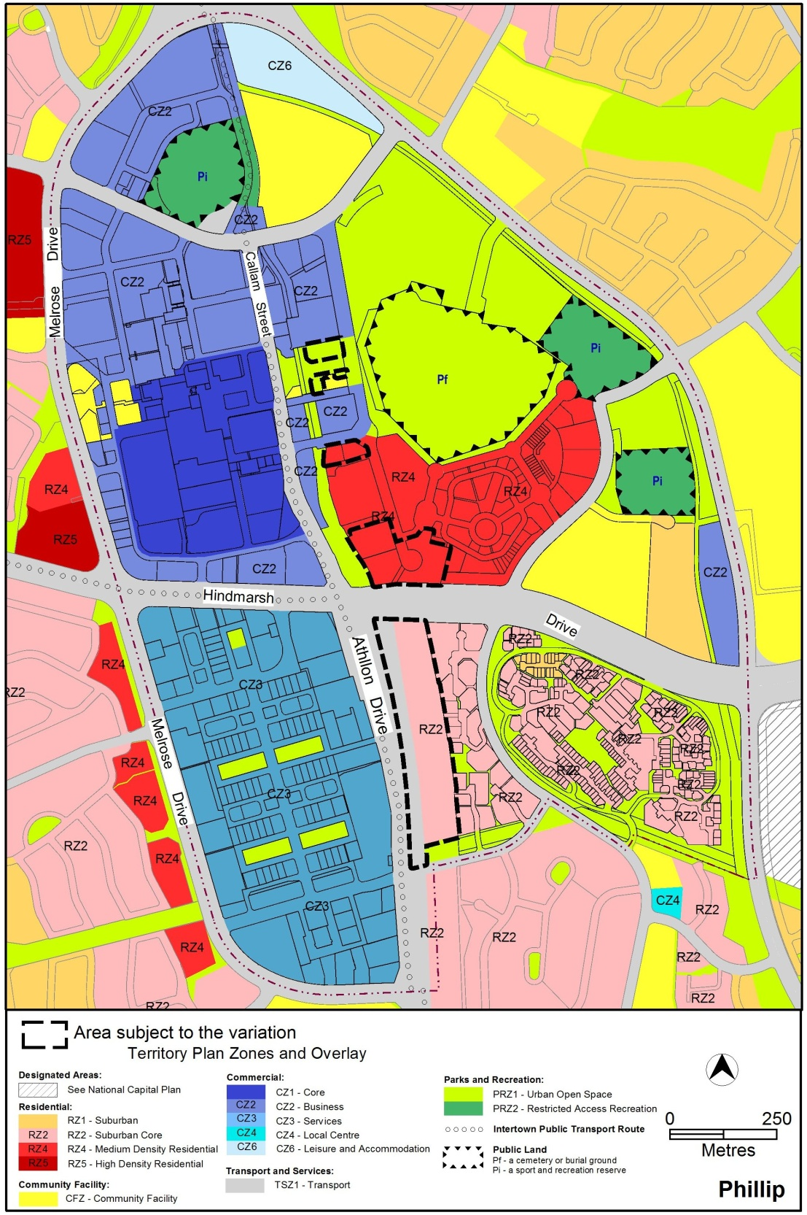
Figure 2 Area subject to rezoning
  - Proposed Changes
    - Proposed Changes to the Territory Plan Map
The proposed changes to the Territory Plan map are indicated in Figure 3 at Part 3 of this document and are detailed as follows:
- rezoning several RZ4 medium density residential zoned blocks located directly to the north east of the Hindmarsh Drive and Callum Street intersection to RZ5 high density residential zone;
- rezoning parts of the Woden Town Park from PRZ1 urban open space zone to CFZ community facility zone;
- rezoning the north western corner of the RZ4 medium density residential zoned land east of Callum Street to CZ2 commercial office zone;
- rezoning the area containing the active travel shared path adjacent to Swinger Hill from RZ2 suburban core residential to PRZ1 urban open space; and
- rezoning part of the Athllon Drive corridor from RZ2 suburban core residential zone and TSZ1 transport services zone to RZ5 high density residential zone.
In addition, the division boundaries of Phillip and Mawson will need to be realigned to accommodate the residential zone located along Athllon Drive. The process to amend the division boundaries will be undertaken separately to this draft variation.
The draft variation map indicates the proposed zone boundaries as accurately as possible but may be subject to adjustments following detailed surveys.
    - Proposed Changes to Territory Plan
It is proposed to amend the Phillip precinct map by:
- including an RC3 (rule and criteria) area for land outside of the current RC1 commercial area, namely the residential zoned land along Hindmarsh Drive and Athllon Drive, to permit specific provisions to be included in the precinct code for these areas that are not part of the commercial portion of the centre;
- Removing the additional merit track provision ‘corrections facility’ MT4 from the Phillip service trades area as this use is inconsistent with the desired future character of the area;
- introducing a new prohibited development provision PD3 in the Phillip service trades area adjoining Melrose Drive and Athllon Drive for residential use and commercial accommodation. These uses will be prohibited to protect the existing service trades area from incompatible adjoining development; and
- introducing a new prohibited development provision PD4 in the Phillip service trades area at the corner of Athllon Drive and Parramatta Street for residential use. This use will be prohibited to protect the existing service trades area from incompatible development. Commercial accommodation is retained as this use has been approved as part of a development on this site.
It is proposed to amend the Phillip precinct code by:
- nominating building heights between 6, 12, 16 and 24 storeys for selected areas within the centre, building setbacks to control the built form of higher buildings, and requirements for awnings along main pedestrian routes;
- introducing an allowance for proposed development within selected areas to increase building heights up to an additional four storeys provided building hierarchy is maintained and development is close to public transport stops;
- permitting four storey development within the central CZ3 service trades area, up to five storeys where development addresses Townshend Street, Colbee Court or Dundas Court, and up to six storeys where development addresses Altree Court;
- nominating areas requiring active frontages where ground floor uses and features attract pedestrians and provide passive surveillance into and out of the building;
- ensuring residential development incorporates noise mitigation measures where necessary to minimise road noise impacts; and
- ensuring development retains solar access to public spaces and residential development.
The proposed precinct code also retains a number of existing provisions in the existing precinct code relating to the retention of existing community recreational facilities, replacing public car parking as part of development over nominated car parking areas, and permitting additional uses in car parking areas, but only where part of a structured car park.
  - Reasons for the Proposed Draft Variation
The reasons for the draft variation are to vary the Territory Plan in accordance with the recommendations of the Woden town centre master plan to:
- permit increased levels of residential development along identified public transport routes, including the potential for marker buildings at the entrance intersections to the town centre;
- permit the development of additional community facilities close to the town centre;
- ensure building design and heights within the centre are of an appropriate scale and relate to the existing centre layout, improve the built form interface with the public domain, and to provide a measure of certainty for the community as to the intended built form;
- provide direction on the desired built form outcome while still ensuring adequate flexibility for innovative building design;
- encourage development which promotes pedestrian activity, through shopfronts, glazing and entrances to the street to improve the life of the public areas in the centre, and to ensure development provides all weather protection for pedestrians in these areas; and
- permit moderate levels of residential development within the central service trades area and restrict commercial accommodation and residential use around the outer edge of the CZ3 area to protect the existing service trades uses in the centre.
  - Planning Context
    - National Capital Plan
The Australian Capital Territory (Planning and Land Management) Act 1988 established the National Capital Authority (NCA) with two of its functions being to prepare and administer a National Capital Plan (NCP) and to keep the NCP under constant review and to propose amendments to it when necessary.
The NCP, which was published in the Commonwealth Gazette on 21 January 1990 is required to ensure that Canberra and the Territory are planned and developed in accordance with their national significance. The Planning and Land Management Act 1988 also required that the Territory Plan is not inconsistent with the NCP.
    - Territory Plan
Statement of Strategic Directions
The proposal is consistent with the Territory Plan’s statement of strategic directions in terms of environmental, economic and social sustainability and spatial planning and urban design principles.
1.9 Urban expansion will be contained in order to minimise impacts on valuable natural and rural areas.
The proposal is consistent with this principle as it encourages higher density development within an existing urban area, which assists in containing the spread of the urban area to accommodate Canberra’s growing population.
1.10 Integrated land use and transport planning will seek to maximise accessibility and transport efficiency, reduce energy consumption, support the preferred pattern of development, promote safety, safeguard environmental quality, and minimise greenhouse gas emissions.
DV344 is consistent with this principle as it encourages higher density development along an identified rapid public transport route and close to an inter-town bus interchange and pedestrian/cycle network, and includes provisions for passive surveillance of public areas
1.12 Planning policies will facilitate the widest possible range of commercial, retail, industrial, rural, tourism, and other forms of economic activity in order to promote new investment and a more diversified economy, to underpin employment growth, and to respond to changing economic opportunities.
The draft variation encourages greater diversity of development within the town centre and improves employment opportunities consistent with this principle.
1.13 The characteristics of the city that contribute to economic growth: Canberra’s role as the national capital and the seat of Federal Parliament; the ease of getting around the city; the safe and clean environment; and the vibrancy of centres as places of social, cultural and business exchange, will be enhanced.
The proposal is consistent with this principle as it proposes new provisions to enhance Woden town centre as a social, cultural and business hub for the surrounding area.
1.18 Provision will be made for a comprehensive range of readily accessible community, cultural, sporting and recreational facilities, distributed according to the varying needs of different localities and population groups. In major centres and developing areas, sites will be safeguarded where necessary for particular community needs.
DV344 is consistent with this principle through retaining the restriction on residential development close to the Phillip Oval to reduce potential conflict in uses and allow for sporting activities to continue, and potentially increase in the future. The draft variation also retains the existing provisions requiring development in the northern part of the centre to retain the swimming pool and ice skating rink.
2.1 Canberra will continue to develop as a series of discrete urban areas within a landscape setting of hills, ridges and other open spaces. Each town will offer a diversity of housing types; the broadest possible range of employment opportunities; and convenient, linked access to retail centres, community facilities and open space.
DV344 is consistent with this principle as it contains development within the existing urban area, encourages a range of dwelling types and sizes and includes provisions to improve pedestrian connections through the centre by requiring awnings or colonnades along main pedestrian routes.
The proposed precinct code responds to the town centre’s landscape setting by introducing building height controls, and encouraging building design that reduces the bulk and scale of development onto the streets, parks and public spaces.
2.3 Commercial and retail activity will be concentrated in centres and other planned nodes of intensive activity that are well served by public transport to ensure an efficient pattern of development. Primary emphasis will be placed on strengthening and enhancing existing and new centres and nodes, including improved urban design and encouragement of more mixed-use development.
DV344 is consistent with this principle as it contains commercial development within the existing centre footprint, adjoining the inter-town bus interchange and reserves the public transport corridor along Callam Street and Athllon Drive to allow for future inter-town public transport. The draft variation aims to strengthen the viability of the centre through improved urban design and encouragement of a greater range of mixed use development within the centre.
2.5 A wide range of housing types will be permitted in identified residential areas close to commercial centres and some major transport routes to increase choice; maximise opportunities for affordable housing; and secure some intensification of development consistent with maintaining residential amenity. Outside of these areas, planning policies will protect the typically low density, garden city character of Canberra’s suburban areas.
DV344 is consistent with this principle as it includes the rezoning of a portion of RZ4 and RZ2 land to RZ5 to permit higher density development along the main inter-town transport route and close to the commercial town centre.
2.6 Higher density development will be encouraged within and near major centres, and in other suitable locations that are well served by public transport.
DV344 is consistent with this principle through the encouragement of higher density development within and adjacent to the town centre and inter-town public transport route.
2.7 Development will be planned to encourage use of public transport, walking and cycling, including commuter cycling. Routes will be reserved for an enhanced inter-town public transport system. Requirements for vehicle parking will be related to commercial needs and transport policy objectives.
DV344 is consistent with this principle as it contains commercial development within the existing centre footprint, adjoining the inter-town bus interchange and reserves the public transport corridor along Callam Street and Athllon Drive to allow for future public transport. The draft variation aims to strengthen the viability of the centre through improved urban design and encouragement of a greater range of mixed use development within the centre, particularly along main pedestrian routes.
2.14 Policies and procedures to promote high quality, creative design of development, urban spaces and landscape settings will be applied throughout the Territory, and innovation encouraged, in keeping with the spirit of the National Capital as an exemplar of best practice. Particular care will be taken to ensure high-amenity, quality design outcomes within residential areas, heritage areas, major centres and activity nodes, and along principal approach routes. The relationship between the public and private realms will also be emphasised in terms of the design quality of precincts and shared spaces, including spaces around buildings, as well as that of individual developments.
DV344 is consistent with this principle through provisions encouraging high quality design that responds to the pedestrian scale, provides interest in the built form, and enhances the public realm adjoining buildings through active commercial frontage requirements as well as the requirements for awnings or colonnades along main pedestrian routes. DV344 also ensures landscaped areas and parks are provided as part of selected developments.
  - Interim Effect
Section 65 of the Planning and Development Act 2007 does not apply in relation to the draft variation so it does not have interim effect. The current Territory Plan will continue to apply while the variation remains in draft form.

  - Consultation with Government Agencies
The EPSDD is required to, in preparing a draft variation under section 61(b) consult with each of the following in relation to the proposed draft variation:
- the national capital authority
- the conservator of flora and fauna
- the environment protection authority
- the heritage council
- if the draft variation would, if made, be likely to affect unleased land or leased public land – each custodian for the land likely to be affected
Please note:
An early version of DV344, based on the draft Woden town centre master plan, was initially referred to ACT Government agencies in September 2014 for comment. The revised draft variation, incorporating the recommendations of the final Woden master plan, was released for comment in November 2015. The original comments have been retained, except where replaced by more recent comments.

National Capital Authority
The National Capital Authority provided the following comments on 9 October 2014:
“The subject site of DV344 is located within an Urban Area as identified in the General Policy Plan (Metropolitan Canberra) of the Plan. The site is outside Designated Areas and is not subject to Special Requirements.

The draft variation is not inconsistent with the Plan.”
Response
The comments are noted.
Conservator of Flora and Fauna
The Conservator of Flora and Fauna made the following comments on 15 October 2014:

DV. 344 Woden Town Centre and DV. 345 Mawson Group Centre.
“Where it is intended in the Master Plans to have areas remain as either 'public space' or 'open space' for recreational and exercise opportunities, or the retention of pedestrian routes, then it is recommended that the opportunity be taken to have these areas either shown in the Precinct Code for that purpose, or the areas zoned as urban open space. This will ensure that these areas are protected into the future and not be subject to development.

It is also recommended that the need for shade in the public realm areas is recognised, with the requirement for areas to be provided for deep rooted planting in the Centres that will allow for the establishment of large trees, including street trees. If this requirement is not mandated, then it will not occur, and shade will become increasingly more important in the future with the increased temperatures due to climate change. It is noted that there is this requirement in the Precinct Code for Woden Town Centre for 'secondary active frontages' but the Town Centre would benefit from this being expanded to other areas, particularly proposed pedestrian routes.

The requirement for areas to be provided for deep rooted planting along the Athllon Drive corridor is important to maintain connectivity through this area for birds.”

The Conservator provided additional comments on 2 December 2015:
“I note that the previous Conservator, Ms Ann Lyons Wright, provided comments on these variations and I reiterate her comments as I am of the view that the retention of areas for deep rooted plantings is of paramount importance, both to provide connectivity and to ensure that the cooling effects of trees are catered for in a warming climate.
The need for shade in the public realm areas needs to be recognised, and the Precinct Codes should include a requirement for areas to be provided for deep rooted planting in the Centres. If this requirement is not mandated, then it may not occur.
Urban trees can provide a multitude of benefits apart from cooling, including leaf interception of rainfall and localised infiltration of runoff from the hard surfaces, habitat for wildlife, and aesthetic value.
Where it is intended in the Master Plans to have areas remain as either 'public space' or 'open space' for recreational and exercise activities, or the retention of pedestrian routes, then it is recommended that these areas are either shown in the Precinct Code for that purpose, or the areas are zoned as urban open space. This will ensure that these areas are protected into the future and not be subject to development.”
Response
The draft variation incorporates the recommended zoning changes from the approved master plan, including areas of open space proposed to be zoned as PRZ1 – urban open space, and areas to be retained for pedestrian activity.
Opportunities/measures for responding to climate change, such as increasing the level of deep root planting areas for trees in public spaces, are currently being investigated at the broader policy level to ensure consistent provisions apply Territory wide.
In addition, landscaping works within unleased Territory land undertaken by or on behalf of the Territory is generally exempt from requiring development approval, therefore introducing new Territory Plan provisions may not necessarily provide any direct benefit on public works.
The shared path connecting Woden to Mawson is proposed to be rezoned from RZ2 suburban core residential to PRZ1 urban open space to ensure the important active travel path is retained, along with sufficient space for landscaping adjacent to the path.
Environment Protection Authority
The Environment Protection Authority provided the following comments on 31 May 2016:
“The Environment Protection Authority would support the rezoning of the road reserve between Yarralumla Creek and Swinger Hill as well as Phillip, Block 36 Section 80 subject to assessment demonstrating the land is fit for the proposed new uses from a contamination perspective. The assessment must be completed by a suitably qualified and experienced environmental consultant and be endorsed by the Environment Protection Authority prior to rezoning.”
Response
A contamination assessment will be undertaken for each of the identified sites prior to the sites being rezoned.
Heritage Council
The Heritage Council provided the following comments on 8 December 2015:
“Review of the ACT Heritage Register identifies that no registered or recorded heritage places or objects occur within the DV344 subject area, although Callum Offices - a registered heritage place - are adjacent open space proposed for rezoning. DV344 includes a requirement that development in Section 80, Phillip, that is higher than the three storey Callum Offices is to be setback from Callum Offices at least one metre for each metre of height greater than that of the Callum Offices main roof (Requirement C13). This requirement reflects prior ACT Heritage advice on appropriate development in the vicinity of Callum Offices, issued in October 2014.
Following review of DV344, ACT Heritage also identifies the following heritage matters which should be further considered:
- The 'Woden Town Centre Master Plan' (November 2015) identifies that Arabanoo Park may have some heritage value and should be subject to further heritage assessment. DV344 proposes to vary part of Arabanoo Park from 'Urban Open Space' to 'Community Facility'; and an assessment of the heritage value of Arabanoo Park should be undertaken to determine whether this proposed change may have a detrimental heritage effect; and
- The "Town Centres Master Plan. Woden Town Centre. Mawson Town Centre. Aboriginal Cultural Heritage Assessment. Draft Report" (Navin Officer Heritage Consultants, August 2014) identifies a potential archaeological deposit (PAD) within the DV344 subject area, in open space to the east of Athllon Drive, where Aboriginal places and objects may occur. The report also recommends that any proposed development of this area be preceded by a program of archaeological survey and test excavation. ACT Heritage has sought further information on this PAD area to inform and support the assessment, as prior heritage investigations of the locality did not identify this area as a PAD. Following submission of this report to the ACT Heritage Council, additional heritage assessment and management actions may be identified for the PAD area prior to the proposed change to open space to the east of Athllon Drive.”
Response
The comments are noted. Further discussions will be held with ACT Heritage to resolve the issue of Arabanoo Park. If further heritage assessment indicates that the proposed rezoning of the park will have a detrimental heritage effect, this component of the variation will be removed prior to the variation being finalised.
In regards to the potential archaeological deposit (PAD) along Athllon Drive, a provision has been included in the proposed code requiring development applications in the affected area to be referred to the Heritage Council for advice to be considered in the assessment of the application. This provision may be removed or amended by way of future technical amendment if future investigations reveal no archaeological deposits in the area.
Land Custodian – Transport Canberra and City Services
The land custodian provided the following comments on 13 October 2014:
“General comment:
- Residential buildings within shopping precincts and transport corridors must have noise attenuation to manage noise complaints resulting from buses and general maintenance and servicing of the centre. Consideration should be given to the addition of a ‘rule and/or ‘criteria’ in the relevant precinct codes making reference to addressing potential noise conflicts arising from development.
Woden Master Plan
- Covering the public open spaces as part of future development to make Woden centre into an arcade style centre, would change the maintenance arrangements from public to privately owned areas.”
The land custodian provided additional comments on 8 December 2015:
- All habitable development needs to be above the 1 in 100 year Average Recurrence Interval flood.
- There is to be no direct access to major arterials such Athllon Drive. If required a full signalised intersection is to be provided.
- There should be no additional access roads within 250metres of an existing intersection.
- Cullen Tenax, a rare plant, is located in one of the areas of Variation to the territory plan. The area is along Athllon Drive directly opposite Parramatta Street. TAMS would suggest that EPD may have some more input about this site.
Response
In response to the concern regarding potential noise conflicts, a rule and criterion has been included requiring the preparation of a noise management plan for development addressing the main or arterial roads. Where a development does not provide a report, the application will be referred to TCCS for advice.
DV344 does not propose covering the public spaces, except where cantilevered awnings are required over pedestrian paths in primary active frontage areas.
A provision has been included in the precinct code to ensure residential development is prohibited within 1-in-100 year flood levels.
DV344 indicates a potential new road linking to Athllon Drive at the Shea Street and Athllon Drive signalised intersection in accordance with the master plan recommendations. Any future changes to the intersection would require TCCS endorsement for approval.
The location of the noted Cullen Tenax is within the area covered by DV345 Mawson group centre. A response to this issue is covered in the DV345 draft variation document.

- DRAFT VARIATION
  - Variation to the Territory Plan map
The Territory Plan map is varied as indicated in figure 3.
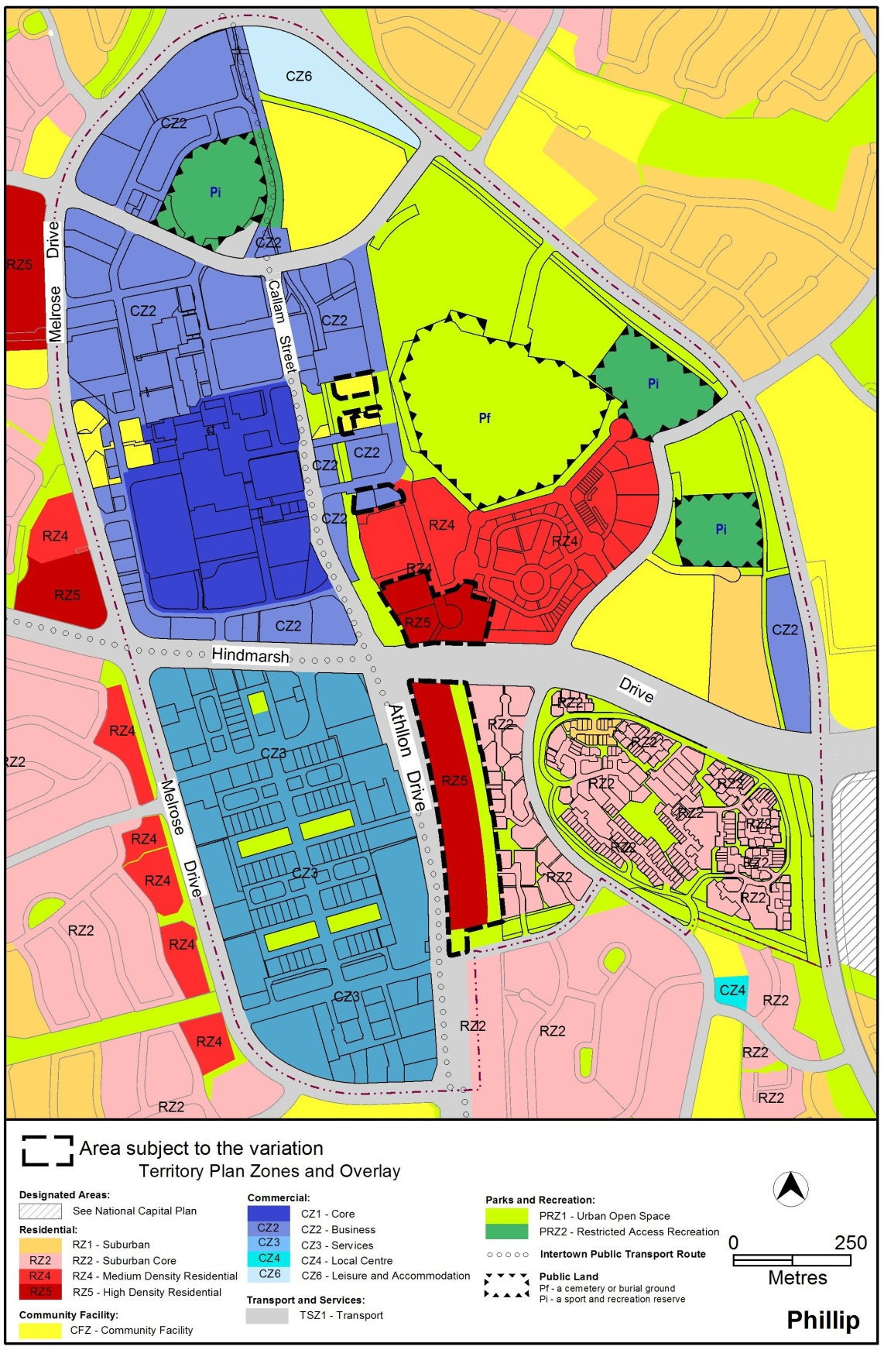
Figure 3: Areas subject to rezoning
  - Variation to the Territory Plan written statement
The Territory Plan written statement is varied as follows:

Variation to the Phillip precinct map and code
- Precinct maps and codes, Phillip precinct map and code
substitute the following with the nominated attachment:
Phillip precinct map and development tables with Attachment A
RC1 – Woden Town Centre with Attachment B
renumber:
the element, sub element heading, rule, criteria and figure numbering within the existing RC2 section to accommodate the new RC1 numbering
insert:
Attachment C RC3 – Callam Street/Athllon Drive Corridor after RC2 section

Interpretation service
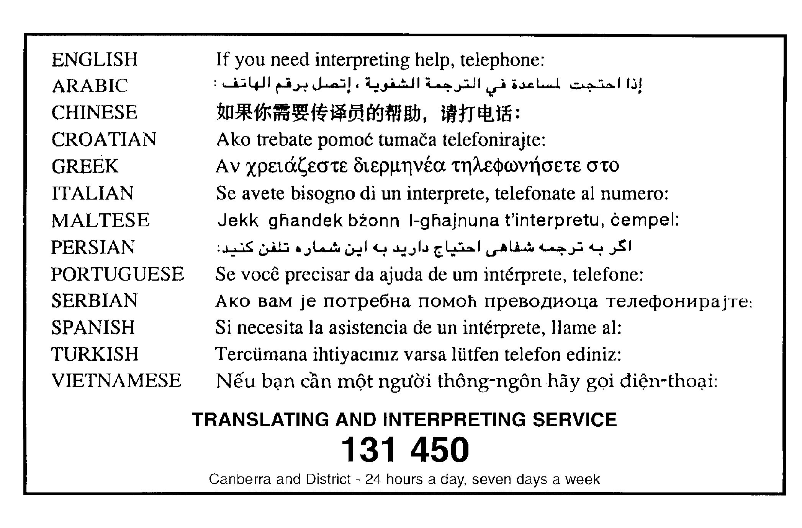

This page is intentionally blank.

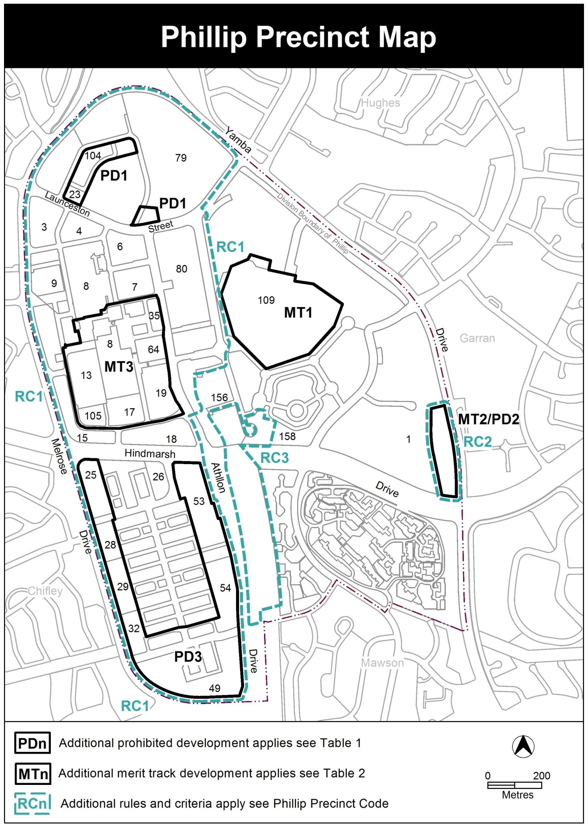

Assessment Tracks

The following tables identify the additional prohibited development and additional merit track development for blocks and parcels shown in the Phillip Precinct Map (identified as PDn or MTn). Development that is exempt from requiring development approval, other prohibited development and the minimum assessment track applicable to each development proposal is set out in the relevant zone development table.

The following tables constitute part of the relevant zone development table.

Table 1 – Additional prohibited development
Additional prohibited development
Suburb precinct map label | Zone | Development
PD1 | CZ2 | RESIDENTIAL USE
PD2 | CZ2 | drink establishment  indoor recreation facility  restaurant (except where ancillary to other permitted use)  SHOP  tourist facility
PD3 | CZ3 | RESIDENTIAL USE  COMMERCIAL ACCOMMODATION

Table 2 – Additional merit track development
Additional merit track development that may be approved subject to assessment
Suburb precinct map label | Zone | Development
MT1 | PRZ1 | cemetery
MT2 | CZ2 | scientific research establishment
MT3 | CZ1 | produce market

Additional rules and criteria
This part applies to blocks and parcels identified in the Phillip Precinct Map (RCn). It should be read in conjunction with the relevant zone development code and related codes.
RC1 – Woden Town Centre
This part applies to blocks and parcels identified in area RC1 shown on the Phillip Precinct Map. RC1 includes the Woden Town Centre.
- Use
Rules | Criteria
  - Ground floor use
This rule applies to sites in CZ1 with boundaries to primary active frontages shown in figure 1.  Only the following uses are permitted along the primary active frontage at the ground floor level:  - business agency  - club  - COMMUNITY USE  - drink establishment  - financial establishment  - hotel  - indoor entertainment facility  - indoor recreation facility  - public agency  - restaurant  - SHOP | This is a mandatory requirement. There is no applicable criterion.
There is no applicable rule. | This criterion applies to sites in CZ2 and CZ3 with boundaries to primary active frontages shown in figure 1.  Buildings incorporate uses on the ground floor that generate activity in the public space.
  - SHOP – CZ2 – floor area limit
This rule applies to CZ2.  The maximum gross floor area of any SHOP is 200m².  For Block 13 Section 81 Phillip, the maximum gross floor area of supermarket is 1500m². | SHOPS are limited to a scale appropriate to providing convenient shopping and personal services for the local workforce and residents.  This criterion does not apply to Block 13 Section 81 Phillip.

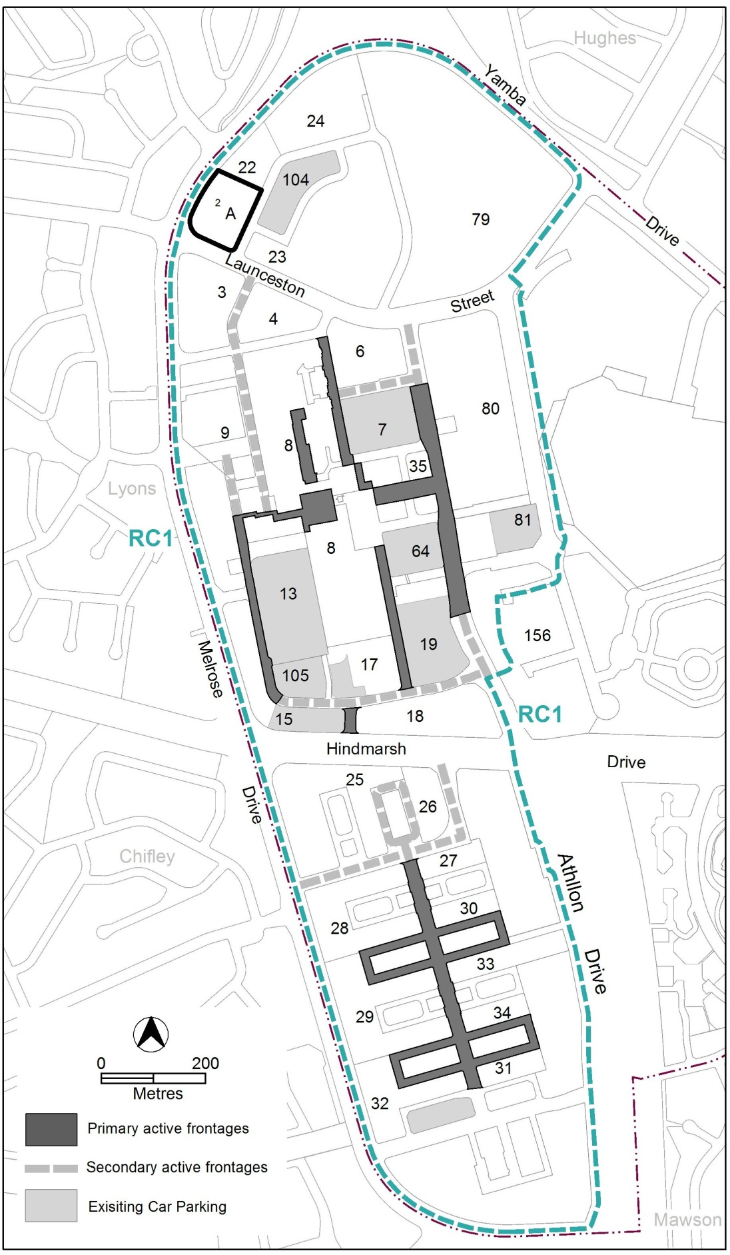
- Existing car parks, active frontages and community recreation facilities

Rules | Criteria
  - Permissible use restrictions
This rule applies to area ‘a’, ‘b’ and area ‘e’ in figure 2.  RESIDENTIAL USE is only permitted above the first floor level. | This is a mandatory requirement. There is no applicable criterion.
This rule applies to development in section 7.  The following uses are only permitted within 36m of the Callam Street road reserve:  - RESIDENTIAL USE  - COMMERCIAL ACCOMMODATION USE | This is a mandatory requirement. There is no applicable criterion.
  - NON RETAIL COMMERCIAL USE – Phillip Oval
There is no applicable rule. | This criterion applies to sections 23 and 104.  NON RETAIL COMMERCIAL USE is only permitted where it is demonstrated to be compatible with the operation of a day and night sporting oval.
  - Development on nominated car parking areas
This rule applies to the shaded blocks shown in figure 1 noted as existing parking.  Development complies with all of the following:  - the existing number of car parking spaces is retained on the site and made available for public use at all times  - provides car parking that is generated by the development on site in accordance with the Parking and Vehicular Access General Code in addition to the spaces required by item a) | Development achieves all of the following:  - any additional parking provision requirements (under the Parking and Vehicular Access General Code) for the development  - makes a substantial contribution to the long term parking supply for the town centre as endorsed by the Territory
  - Additional development – Phillip swimming and ice skating centre
This rule applies to area ‘A’ in figure 1.  Development complies with all of the following:  - provides or retains an ice skating rink suitable for national ice hockey competition  - provides or retains a 50–metre public pool with direct public address to Irvine Street  - development for other uses involves redevelopment of the pool as an indoor facility | This is a mandatory requirement. There is no applicable criterion.

- Buildings
Rules | Criteria
  - Building heights
This rule applies to CZ1 and CZ2.  The maximum height of building for the areas shown in figure 2 is:  - for area ‘a’, 24 storeys  - for area ‘b’, 16 storeys  - for area ‘c’, 12 storeys  - for area ‘d’, 6 storeys  Plant room set back a minimum of 3m from the building facade of the floor immediately below is not included in the number of storeys. | The maximum height of building for one building tower element per block in areas ‘a’, ‘b’ and ‘c’ may be increased by an additional four storeys where development achieves all of the following:  - the development maintains the building height hierarchy of the centre by retaining the taller buildings at the middle of the town centre; and  - development is close to public transport stops and stations.  Note: This criterion does not apply to area ‘d’.
There is no applicable rule. | For development that is 12 storeys and above, the applicant shall provide a visual assessment that:  - Provides a description of the project an assessment of the physical and visual environment (local context) for the site and surrounding areas including existing landform, vegetation, land use, cycle and pedestrian connections, streetscape and nearby developments  - Provides analysis and relevant illustrations of the key views and approach roads to the proposed development that addresses potential impacts that the development could have on the surrounding landscape character and visual amenity  - Provides evidence and supporting material that outlines how the development has been designed to respond to the local context, mitigate any impacts on the broader landscape setting and visual environment and how it responds to the town centre skyline.
There is no applicable rule. | This criterion applies to development in the area indicated by an asterisk shown in figure 2.  One higher building element up to 24 storeys may be permitted where development complies with all of the following:  - is set back from each road frontage  - does not significantly overshadow nearby residential development.
There is no applicable rule. | Development in section 80 that is higher than the Callum Offices is setback from Callum Office building at least one metre for each metre of height greater than that of the Callum Offices main roof.
There is no applicable rule. | A marker building in section 81 is permitted up to RL670AHD provided development does not adversely impact on surrounding residential development through overshadowing, the existing community path is retained and that it provides active use at the ground floor level facing Wilbow Street.
This rule applies to CZ3.  The maximum height of building for area ‘e’ and area ‘f’ shown in figure 2 is four storeys:  Plant room set back a minimum of 3m from the building facade of the floor immediately below is not included in the number of storeys. | In area ‘e’:  - five storeys is permitted where development complies with all of the following:  - development fronts on to Townshend Street, and either Colbee Court or Dundas Court  - the fifth storey is setback a minimum of 3 metres from the front boundary  - six storeys is permitted for development facing Altree Court.  Plant room set back a minimum of 3m from the building facade of the floor immediately below is not included in the number of storeys.
This rule applies to CZ3.  The portion of development above the first floor fronting on to Grenville Court, Prospect Court, Bellona Court or Devine Court is set back a minimum of 6m from the street front boundary. | This is a mandatory requirement. There is no applicable criterion.
  - Solar access
There is no applicable rule. | Development retains reasonable solar access to:  - dwellings on adjoining blocks and their associated private open space  - the town square and main pedestrian spine shown in figure 4.
  - Built form
This rule applies to development in CZ1 and CZ2 addressing:  - Bowes Street  - Furzer Street  Buildings are set back a minimum of four metres from the front boundary adjoining each street at the ground floor level, up to 12 storeys. The minimum front setback for development above 12 storeys is 6m. | Building setbacks:  - provide sufficient space for large canopy street trees  - provide reasonable space for pedestrians and cyclists  - are consistent with the front boundary setbacks of existing adjacent buildings; and  - do not prejudice the future development of adjoining sites.
This rule applies to development in CZ1 and CZ2 addressing:  - the pedestrian spine shown in figure 4  - Callam Street  - Corinna Street  - Easty Street  - Irving Street  - Matilda Street  - Melrose Drive  - Wilbow Street  Buildings are built to the front boundary at the ground floor level. The minimum front setbacks above ground floor level are:  - 0m for the portion of development up to 22m above datum ground level  - 3m for the portion of development above 22m up to 12 storeys  - 6m for the portion of development above 12 storeys. | Minor departures from the building setbacks are permitted at the ground level where development:  - contributes to the pedestrian orientated environment  - reflects the existing street character  - accommodates active uses, building entrances, public amenities and landscaped areas.  Minor departures from the building setbacks are permitted for the portion of development above 12 storeys where the building is designed to limit the building floor plate size of the tower to reduce the bulk and scale of the development and allow for solar access on to the public spaces, streets and adjacent development.
This rule applies to development in CZ1 and CZ2 addressing the town square.  Buildings are built to the front boundary at the ground floor level. The minimum front setbacks above ground floor level are:  - 0m for the portion of development up to 12m above datum ground level  - 6m for the portion of development above 12m up to 12 storeys  - 9m for the portion of development above 12 storeys. | Minor departures from the building setbacks are permitted at the ground level where development:  - contributes to the pedestrian orientated environment  - reflects the existing street character  - accommodates active uses, building entrances and landscaped areas.  Minor departures from the building setbacks are permitted for the portion of development above 12 storeys where the building is designed to limit the building floor plate size of the tower to reduce the bulk and scale of the development and allow for adequate solar access on to the town square.
This rule applies to development in CZ1 and CZ2 addressing Bradley Street.  The minimum front setbacks are:  - 0m for the portion of development up to 12m above datum ground level  - 3m for the portion of development above 12m up to 9 storeys  - 6m for the portion of development above 9 storeys. | Minor departures from the building setbacks are permitted at the ground level where development:  - contributes to the pedestrian orientated environment  - reflects the existing street character  - accommodates active uses, building entrances and landscaped areas.
There is no applicable rule. | This criterion applies to development 10 storeys or more in height.  Development consists of:  - a building base or podium that defines entrances and is designed to reduce the impact of podium parking on the public realm  - a middle section setback from the podium to reduce apparent bulk and scale and provide visual separation from the podium; and  - the building top section designed to screen plant and building services, and create an integrated and appropriate conclusion to the building form.
This rule applies to section 7.  Redevelopment complies with the following:  - a publicly accessible lane is provided in the location shown in figure 4  - a publicly accessible landscaped area with a minimum width of 20m is provided adjoining and parallel to the Matilda Street road reserve as shown by the hatched area in figure 4. | This is a mandatory requirement. There is no applicable criterion.

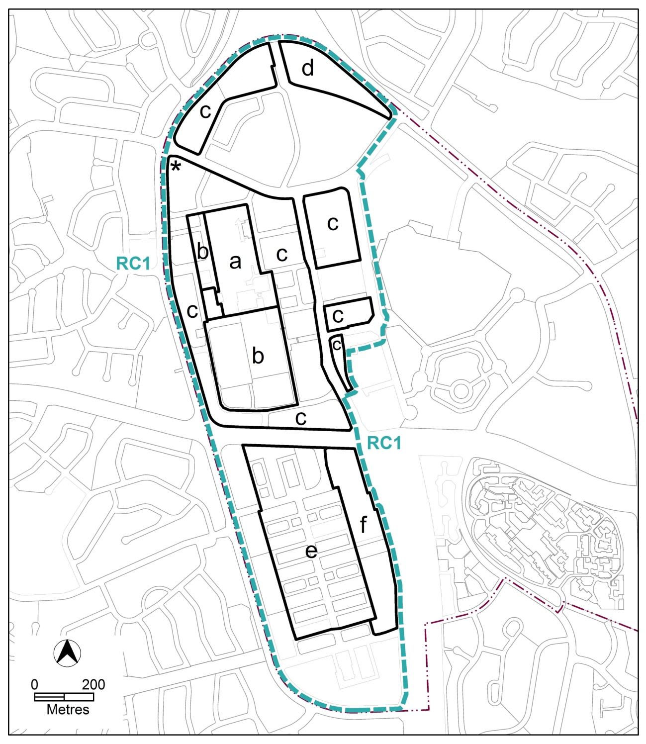
- Building heights and marker buildings
Rules | Criteria
There is no applicable rule. | Buildings are to achieve a high standard of design quality demonstrated through the following:  - Building are designed to include a range of high quality building materials and colours that are consistent with adjacent development and that contribute to a pedestrian scale, particularly at the lower levels of the building  - Buildings are designed to be well articulated to reduce the bulk and scale of development and provide architectural expression in the built form  - Buildings include elements that improve the use and performance of the building, such as wintergarden balconies and passive surveillance of primary and secondary active frontage streets and places  - Providing effective sun shading to areas of west facing glazing and balconies, through measures such as overhangs, adjustable external screens or vegetation.  - Providing a greater range of apartment types, such as dual-key, cross-over, shop-top and apartments suitable for families.  - Providing green infrastructure, such as roof top planting, green walls, deep root planting areas and garden areas incorporating shrubs and rain gardens.  - Podium carparks are sleeved by apartments or commercial uses when facing active frontage streets.  - Podium carparks are designed to be easily adapted to alternative future uses, such as providing suitable floor to ceiling heights  - Plant rooms that are integrated or concealed within building form.

Rules | Criteria
This rule applies to development addressing primary active frontages in CZ3.  The minimum floor to ceiling height at the ground floor is 3.6m. | Floor to ceiling heights:  - contribute to natural ventilation  - promote penetration of daylight  - are adaptable for commercial uses.
There is no applicable rule. | Above ground structured car parks comply with all of the following:  - incorporate commercial tenancies at ground floor along the front boundary  - use high quality architectural elements, landscaping and green infrastructure to screen the structures from public spaces and streets  - pedestrian access points are well lit and clearly visible from the street, and  - where publicly accessible parking is provided, ensures direct public access to and from the car parking to the public space.
There is no applicable rule. | Multi unit residential development contains a range of 1, 2 and 3 bedroom dwellings.
  - Active frontages
For buildings located along primary active frontage areas shown in figure 1, ground floor frontages and building designs comply with all of the following:  - buildings incorporate clear display windows and shop fronts at the ground floor level  - buildings incorporate direct pedestrian access at grade with the verge level for access and egress for persons with disabilities  - any small areas of walls without windows contain displays, showcases and/or public art, with a maximum of 30% blank frontage per tenancy. | Buildings achieve all of the following:  - direct pedestrian access from main pedestrian areas  - avoid extensive lengths of blank walls unrelieved by doors, display windows or the like.
This rule applies to residential development adjoining primary and secondary active frontages shown in figure 1.  Development includes balconies and/or windows to main living areas addressing the public space/street. | Residential development provides opportunities for passive surveillance of public spaces.

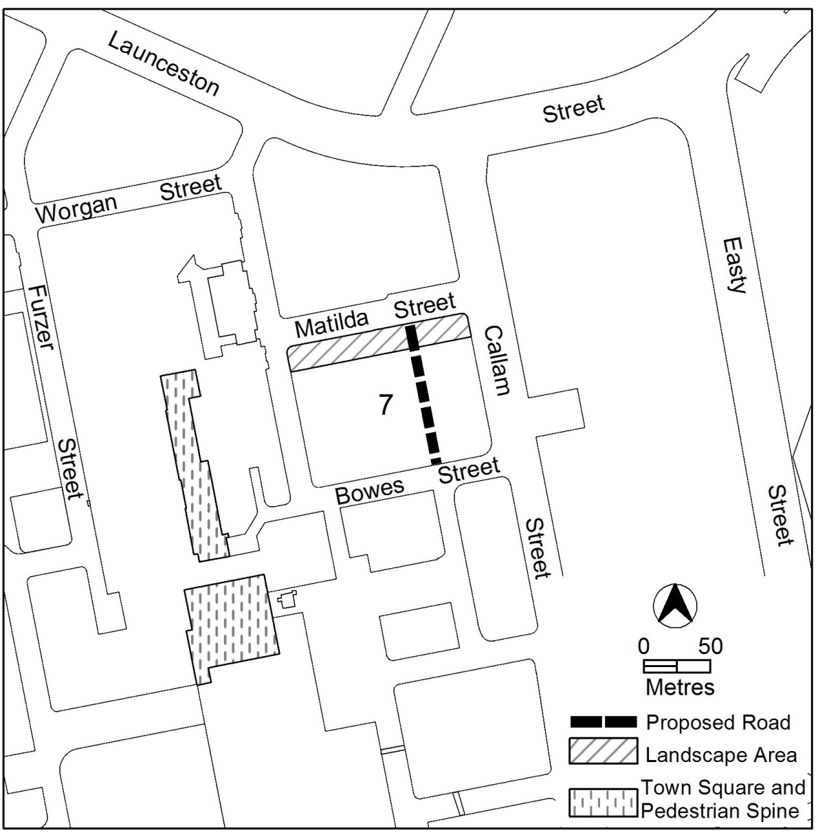

Rules | Criteria
For buildings located along secondary active frontage areas shown in figure 1, ground floor frontages and building design complies with all of the following:  - buildings incorporate clear display windows and shop fronts at the ground floor level  - buildings incorporate direct pedestrian access at grade for access and egress for persons with disabilities. | Development at ground level achieves all of the following:  - is adaptable for commercial use  - where building access is provided, direct pedestrian access at street level  - provide opportunities for views into and out of the building.
There is no applicable rule. | Extensive lengths of blank facades, open structured car parks and loading docks are not located along primary active frontage areas, and do not dominate secondary active frontage areas shown in figure 1.
There is no applicable rule. | Utility infrastructure, such as electricity substations and water boosters, located along primary active frontages are minimised and/or screened where possible.
  - Landscape zone
This rule applies to secondary active frontages shown in figure 1.  Where a building frontage is greater than 30m in length and active uses are not incorporated on the ground floor, a landscaped area with a minimum depth into the block of 3m from the front boundary is provided for a minimum of 20% of the length of the front boundary.  Planting is wholly contained within the leased block boundaries.  Note: It is the responsibility of the lessee to ensure that any proposed plantings do not conflict with existing services. | Landscaped areas are provided along secondary frontages to soften the street environment and add points of interest. The landscaped areas are integrated with the adjacent verge level, and contained wholly within the block boundaries.
  - Awnings
This rule applies to buildings fronting:  - Ball Street  - Bradley Street  - Brewer Street  - Callam Street  - Colbee Court  - Corinna Street  - Dundas Court  - Townshend Street  - bus interchange.  - town square  - pedestrian spine  Buildings provide a continuous awning along the entire length of the front boundary with a minimum:  - height from datum ground level of 3.2m, and  - depth from the building facade of 3m. | Protection from the natural elements is provided along pedestrian movement corridors by incorporating:  - continuous awnings that are compatible with existing structures  - shelter that allows for street trees and other landscaping  - visually safe and amenable shelter design.
  - Screening
There is no applicable rule. | Waste collection areas are screened from public view.
  - Driveways
No new driveways are permitted along:  - Callam Street  - Launceston Street.  - Melrose Drive  - Townshend Street  Note: Replacement or relocation of existing driveways is not restricted by this rule. | This is a mandatory requirement. There is no applicable criterion.

RC3 – Callam Street/Athllon Drive Corridor
This part applies to blocks and parcels identified in area RC3 shown on the Phillip Precinct Map.
- Buildings
Rules | Criteria
  - Number of storeys
This rule applies to area ‘a’ in figure 4.  The maximum number of storeys is 6. | A marker building is permitted up to RL648AHD where development:  - provides an appropriate transition in height from the existing development to the north  - does not adversely impact on surrounding residential development through overshadowing  - includes all of the following:  - a building base or podium that defines entrances and is designed to reduce the impact of podium parking on the public realm  - a middle section setback from the podium to reduce apparent bulk and scale and provide visual separation from the podium  - a top section designed to screen plant and building services, and create an integrated and appropriate conclusion to the building form; and  - areas of deep root planting at the ground level.
This rule applies to area ‘b’ in figure 4.  The maximum number of storeys is 4. | Building heights may be increased to 6 storeys where development:  - provides an appropriate transition in height from the existing adjoining development  - does not adversely impact on surrounding residential development through overshadowing and overlooking; and  - includes areas for deep root planting.
This rule applies to area ‘c’ in figure 4.  The maximum number of storeys is 3, except where within 52m of Yarralumla Creek centre line, where the maximum number of storeys is 6. | This is a mandatory requirement. There is no applicable criterion.
  - Setback
The minimum front building setback to block boundaries addressing Athllon Drive is 4m. | Building frontages to Athllon Drive provide a landscaped setting.

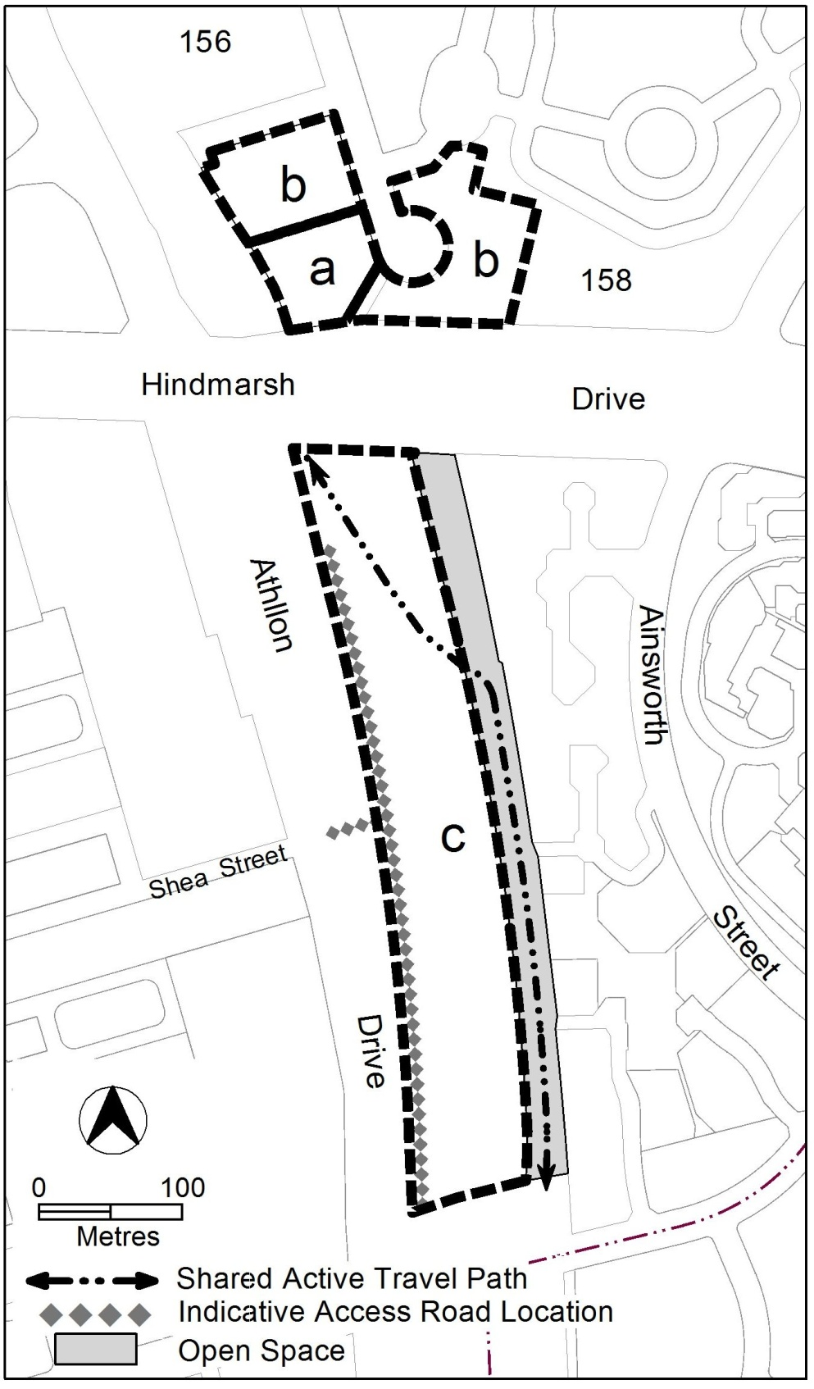

Rules | Criteria
  - 1 in 100 year flood levels
There is no applicable rule. | This criterion applies to area ‘C’ in figure 4.  Residential development is not permitted within the 1 in 100 year flood level of Yarralumla Creek.
  - Vehicle access
There is no applicable rule. | This criterion applies to area ‘C’ in figure 4.  Development incorporates the indicative access road in the location shown.
  - Open space interface
This rule applies to area ‘c’ in figure 4.  Development retains the existing shared active travel path connection to the Hindmarsh Drive underpass. | Any changes to the existing shared active travel path alignment complies with all of the following:  - retains easy and direct continuous active travel connection between Woden town centre and Mawson group centre  - are endorsed by TCCS.
This rule applies to area ‘c’ in figure 4.  Development along the open space area and shared active travel path provides all of the following:  - addresses the open space and shared active travel path with windows to habitable rooms, balconies and areas of open space adjoining the shared boundary  - openings for direct pedestrian access to the shared active travel path. | Development provides passive surveillance and pedestrian access to the shared active travel path and open space area.

- Heritage
  - Potential archaeological deposits
There is no applicable rule. | This criterion applies to area ‘C’ in figure 4.  Development applications will be referred to the ACT Heritage Council, and its advice considered before the determination of the application.

