Australian Capital Territory
Corrections Management (Mobile Phone Detector) Policy Revocation 2019
Notifiable instrument NI2019-210
made under the
Corrections Management Act 2007, s 14 (Corrections policies and operating procedures)

1 Name of instrument
This instrument is the Corrections Management (Mobile Phone Detector) Policy Revocation 2019.

2 Commencement
This instrument commences on the day after its notification day.
3. Revocation
This instrument revokes the Corrections Management (Mobile Phone Detector) Policy 2011 [NI2011-136].

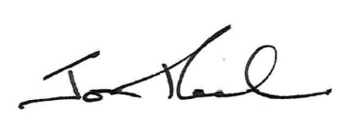

Jon Peach
Executive Director
ACT Corrective Services
11 April 2019

