Australian Capital Territory

Nature Conservation (Greater Glider) Conservation Advice 2019

Notifiable instrument NI2019–232
made under the
Nature Conservation Act 2014, s 90C (Conservation advice)

- Name of instrument
This instrument is the Nature Conservation (Greater Glider) Conservation Advice 2019.
- Commencement
This instrument commences on the day after its notification day.
- Conservation advice for the Greater Glider
Schedule 1 sets out the conservation advice for the Greater Glider (Petauroides volans).

Arthur Georges
Chair, Scientific Committee
1 May 2019
Schedule 1
(see s 3)

Conservation Advice
Greater Glider
Petauroides volans

Conservation Status
The Greater Glider Petauroides Volans (Kerr, 1792) is recognised as threatened in the following jurisdictions:
International Vulnerable, International Union of Conservation of Nature (IUCN) Red List
National Vulnerable, Environment Protection and Biodiversity Conservation Act 1999
Vulnerable, The Action Plan for Australian Mammals 2012
ACT Vulnerable, Nature Conservation Act 2014
NSW Endangered Populations, Biodiversity Conservation Act 2016
VIC Vulnerable, Advisory List of Threatened Fauna in Victoria 2013
QLD Vulnerable, Nature Conservation Act 1992

CRITERIA
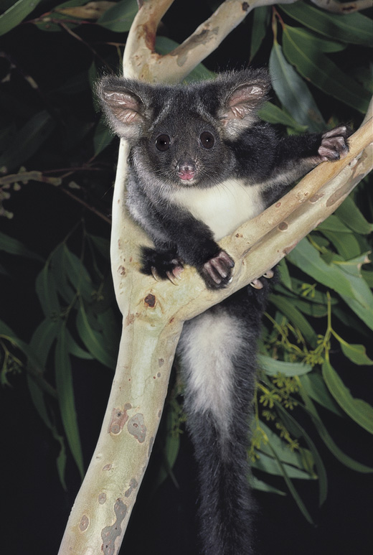
The Greater Glider is listed as Vulnerable in the ACT Threatened Native Species List under IUCN Criterion A — A2(b)(c), A3(b)(c), A4(b)(c). The factors that make it eligible include: a substantial reduction (>30%) in numbers over three generation lengths (22 years) that is: ongoing due to habitat loss, fragmentation, extensive fire and some forestry practices; and likely to be exacerbated by climate change (Kearney et al. 2010).

DESCRIPTION AND ECOLOGY
The Greater Glider is an arboreal nocturnal marsupial and is the largest gliding possum in Australia, with a head-body length of 35−46 cm and a long furry tail measuring 45−60 cm. The Greater Glider has thick fur that increases its apparent size. Its fur colour is white or cream below and varies from dark grey, dusky brown to light mottled grey and cream above. It has large furry ears, a short snout and a non-prehensile tail (McKay 2008).
Females give birth to single young from March to June, sexual maturity is reached in the second year, longevity has been estimated at 15 years (Tyndale-Biscoe and Smith 1969; McKay 2008; Harris and Maloney 2010) and generation length is likely to be 7−8 years (Burbidge and Woinarski 2016).
Greater Glider (Pavel German - AustralianNature.com)

Distribution and Habitat
The Greater Glider is restricted to eastern Australia, occurring from the Windsor Tableland in north Queensland through to central Victoria (Wombat State Forest), ranging from sea level to 1200 m above sea level. Kearney et al. (2010) predicted a ‘stark’ and ‘dire’ decline, ‘almost complete loss’, for the northern subspecies Petauroides volans minor if there is a 3°C temperature increase.
In the Australian Capital Territory (ACT), the Greater Glider has been recorded in the Namadgi National Park and Tidbinbilla Nature Reserve (Lintermans 1993). In a post-fire fauna study undertaken by the ACT Government (Carey et al. 2003), spotlight sightings were recorded in the Warks Road and Moonlight Hollow Road area of the Lower Cotter catchment, including 13 Greater Gliders in a one kilometre section near Warks Camp. In a follow up study of arboreal mammals in 2014 (including surveys of 10 transects covering over 140km) three Greater Gliders were observed on the Camelback Fire Trail at Tidbinbilla; four on the Bendora Return and Moonlight Hollow transects (including the Warks Road area); and one on each of the Honeysuckle and Mount Franklin Road transects (Snape et al. 2015). This study established a baseline for future surveys of all arboreal species in the Namadgi/Tidbinbilla areas and proposed surveys across all ten transects should occur at intervals of 5–10 years.
The species prefers taller, montane, moist eucalypt forests with relatively old large trees and abundant large hollows where it shelters during the day (Woinarski et al. 2014). The Greater Glider favours forests with a diversity of eucalypt species, due to seasonal variation in its food-tree species (Kavanagh 1984).

Threats
Threats to the Greater Glider are outlined in the Commonwealth Conservation Advice (TSSC 2016) which are drawn from Woinarski et al. (2014) and include:
- habitat loss, fragmentation through clearing
- inappropriate fire regimes
- climate change reducing habitat suitability.
Cumulative effects of these are a major threat to large native hollow-bearing trees on which the species relies (TSSC 2016).

Major Conservation Objectives
The priority management objectives are to manage threats to secure or increase overall population size and maintain viable subpopulations at all known localities (Woinarski et al. 2014).

Conservation Issues and Proposed Management Actions
Recommended management actions are provided and prioritised in the Commonwealth Conservation Advice (TSSC 2016) and Mammal Action Plan (Woinarski et al. 2014). The most suitable habitat for this species exists in reserved areas. It is therefore unlikely that further areas will need to be protected for the conservation of this species. However, the following actions may be relevant to Greater Glider habitat in the ACT:
- reduce the frequency and intensity of prescribed burns in suitable habitat
- Assess habitat requirements including investigating the numbers, densities and types of hollow-bearing trees and mix of food-tree species that must be retained to ensure viable populations.
- continue survey program established in 2014
- establish monitoring program to monitor the abundance and size structure of critical habitat tree species, and their responses to management including before and after prescribed burns; continue to model impacts of wildfire on population viability and the incidence of wildfire within the species’ range
- assess relative impacts of threats and effectiveness of mitigation activities including assessing the impacts of fire management (prescribed burning programs) on habitat, hollow availability, preferred tree species, and glider population size.

Other Relevant Advice, plans or Prescriptions
- Commonwealth Conservation Advice — Greater Glider (TSSC 2016)
- The Action Plan for Australian Mammals 2012 (Woinarski et al. 2014)

Listing Background
The Greater Glider was listed as Vulnerable under the Environment Protection and Biodiversity Conservation Act 1999 (EPBC Act) on 5 May 2016. In 2019, under the Nature Conservation Act 2014, the ACT Scientific Committee recommended the Greater Glider be listed in the Vulnerable category in the ACT Threatened Native Species List to align with the EPBC Act listing.

References
Atlas of Living Australia (ALA) 2018. Atlas of Living Australia. http://www.ala.org.au/
Burbidge AA and Woinarski J 2016. Petauroides volans. The IUCN Red List of Threatened Species 2016. http://dx.doi.org/10.2305/IUCN.UK.2016-1.RLTS.T40579A21963210.en
Carey A, Evans M, Hann P, Lintermans M, MacDonald T, Ormay P, Sharp S, Shorthouse D, Webb, N 2003. Wildfires in the ACT 2003: Report on initial impacts on natural ecosystems. Technical Report 17. Environment ACT, Canberra.
Harris JM and Maloney S 2010. Petauroides volans (Diprodontia: Pseudocheiridae). Mammalian Species 42: 207–219. https://academic.oup.com/mspecies/article/42/866/207/2642969
Kavanagh R P 1984. Seasonal changes in habitat use by gliders and possums in southeastern New South Wales. In Possums and Gliders (eds A. P. Smith & I. D. Hume) pp. 527-543. Surrey Beatty and Sons, Chipping Norton.
Kearney MR, Wintle BA, and Porter WP 2010. Correlative and mechanistic models of species distribution provide congruent forecasts under climate change. Conservation Letters 3: 203-213.
Lintermans M 1993. The vertebrate fauna of the Gudgenby region, Australian Capital Territory: A review. Technical Report 1. ACT Parks and Conservation Service, Canberra.
McKay G M 2008. Greater Glider Petauroides volans. In The Mammals of Australia. Third edition. (Eds S Van Dyck & R Strahan), 240-242. Reed New Holland, Sydney.
Snape M, Stevenson B and Evans M 2015. Arboreal mammal spotlight survey 2014. Technical Report 30. Environment and Planning Directorate, ACT Government, Canberra.
Threatened Species Scientific Committee (TSSC) 2016. Approved Conservation Advice for Petauroides volans (Greater Glider). Department of the Environment. Australian Government, Canberra.
Tyndale-Biscoe CH and Smith RFC 1969. Studies on the marsupial glider, Schoinobates volans (Kerr). II. Population structure and regulatory mechanisms. Journal of Animal Ecology 38(3): 637–650. https://www.jstor.org/stable/3040
Woinarski JCZ, Burbidge AA and Harrison PL 2014. The Action Plan for Australian Mammals 2012. CSIRO Publishing, Collingwood.

Further Information
Further information on this species or other threatened species and ecological communities can be obtained from Environment, Planning and Sustainable Development Directorate (EPSDD).
Phone: (02) 132281, EPSDD Website: http://www.environment.act.gov.au/cpr

