Australian Capital Territory

Nature Conservation (Regent Honeyeater) Conservation Advice 2019

Notifiable instrument NI2019–252
made under the
Nature Conservation Act 2014, s 90C (Conservation advice)

1 Name of instrument
This instrument is the Nature Conservation (Regent Honeyeater) Conservation Advice 2019.

2 Commencement
This instrument commences on the day after its notification day.

3 Conservation advice for the Regent Honeyeater
Schedule 1 sets out the conservation advice for the Regent Honeyeater (Anthochaera phrygia).

Arthur Georges
Chair, Scientific Committee
1 May 2019
Schedule 1
(see s 3)

Conservation Advice
Regent Honeyeater
Anthochaera phrygia

Conservation Status
The Regent Honeyeater Anthochaera phrygia (Shaw, 1794) is recognised as threatened in the following jurisdictions:
International Critically Endangered, International Union of Conservation of Nature (IUCN) Red List
National Critically Endangered, Environment Protection and Biodiversity Conservation Act 1999
Critically Endangered, Action Plan for Australian Birds 2010
ACT Critically Endangered, Nature Conservation Act 2014
NSW Critically Endangered, Biodiversity Conservation Act 2016
VIC Threatened, Flora and Fauna Guarantee Act 1988
Critically Endangered, Advisory List of Threatened Vertebrate Fauna 2013
QLD Endangered, Nature Conservation Act 1992
SA Endangered, National Parks and Wildlife Act 1972

ELIGIBILITY
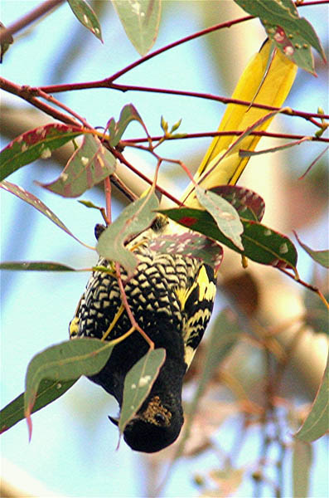
The Regent Honeyeater is listed as Critically Endangered in the ACT Threatened Native Species List under IUCN Criterion A —A2a. The factors that make it eligible include a very severe population decline (≥80%) over the past three generations (24 years) and the decline and its cause have not ceased (Department of the Environment (DoE) 2015).

DESCRIPTION AND ECOLOGY
The Regent Honeyeater is a striking, medium-sized honeyeater measuring 20–23 cm in length and weighing 31–50 g. It has predominantly black plumage and its tail and wing feathers are edged with bright yellow. Its body feathers are broadly edged in pale yellow, except for the head and neck. A large patch of yellow-pink, bare, warty skin surrounds each eye. The overall visual impression is a blackish bird boldly embroidered with yellow and with brilliant yellow flashes in the wings and tail (Pizzey 1981, Menkhorst 1993). Females are smaller and duller than males while juveniles are browner (Birdlife International 2018).
Adult Regent Honeyeater (Geoffrey Dabb – Canberra Birds)
The Regent Honeyeater is an irruptive and nomadic species. Its dynamic movements are predominantly governed by the availability of nectar (DoE 2016), particularly flowering eucalypts including Yellow Box (Eucalyptus melliodora) and Mugga Ironbark (E. sideroxylon), as well as mistletoe (mainly Needle-leaf Mistletoe (Amyema cambagei)) (Higgins et al. 2001, DoE 2016). It is conspicuous and often vocal when congregating at food sources.
There was an unusual breeding event in the ACT, in spring 1995, when four pairs of Regent Honeyeaters nested in Yellow Box – Blakely’s Red Gum Grassy Woodland near north Watson. Seven were captured and colour banded. Two of these birds were later observed in the Capertee Valley, 270 km from the banding location (D. Geering pers. comm. in ACT Government 1999).
The Regent Honeyeater typically nests in the canopy of mature trees, including eucalypts (e.g. Yellow Box and Mugga Ironbark), Rough-barked Apple (Angophora floribunda), and River She-oak (Casuarina cunninghamiana). The cup-shaped nest, of bark or coarse dry grass bound with cobweb, is usually placed in the fork of branches. The species primarily nests from September to November, but later in the ACT (December–January) (Wilson 1984). Nesting often occurs in loose colonies, but solitary nesting has become more common due to a critically small population (pers comm. L Rayner 2018). Pairs will aggressively defend their breeding territory against predators and co-occurring nectarivores. The female incubates an average of two eggs and both adults feed nectar, lerp and invertebrates to the young (ACT Government 1999; Higgins et al. 2001).

Distribution and Habitat
The Regent Honeyeater is endemic to mainland south-east Australia. It has a patchy distribution that extends from south-east Queensland, through NSW and the ACT, to central Victoria and is probably now extinct in South Australia (DoE 2015). Bendigo, in central Victoria, is now the western limit of its distribution (Franklin et al. 1987). On the western edge of its NSW range, it occurs as far inland as Narrabri, Warrumbungle National Park, Dubbo, Parkes and Finley. There are only a small number of breeding sites where inter-annual abundance is highly variable and occurrence is irregular.
The Regent Honeyeater is most commonly associated with woodland dominated by box-ironbark and dry sclerophyll forest, but also occurs in riparian vegetation and lowland coastal forest. The species has also been recorded in paddock trees, roadside reserves, travelling stock routes and in planted vegetation in parks and gardens (DoE 2016).
The 2016 National Recovery Plan did not identify the ACT as a key area used by the Regent Honeyeater for foraging and/or breeding. Key breeding areas include the Bundarra–Barraba, Mudgee–Wollar, Capertee Valley and Hunter Valley regions in NSW (Crates et al. 2018) and the Chiltern and Lurg–Benalla regions of north-east Victoria (DoE 2016).
The ACT region lies at the maximum altitudinal limit of the distribution of the Regent Honeyeater and the honeyeater is a rare visitor (Taylor and Canberra Ornithologists Group (COG) 1992). In this region, Regent Honeyeaters favour Yellow Box–Blakely’s Red Gum Grassy Woodland along the lower slopes of Mt Ainslie and Mt Majura, extending through Mulligans Flat Nature Reserve to the Sutton and Lake George areas. Historically, the species was fairly common in the ACT around Black Mountain, Murrumbidgee River, Tharwa, Castle Hill, and suburban Canberra (ACT Government 2004).
There has been a decline in records of Regent Honeyeaters in the ACT region since the 1960s (ACT Government 1999).The species was regularly reported in small numbers between 1964 and 1969, however, no birds were recorded between 1969 and 1974. Since 1974, records are often of single birds or pairs, except for small flocks in 1995 when four pairs bred in the North Watson area (Bounds et al. 1996). In 1998, three pairs were recorded in Mulligans Flat Nature Reserve and one pair at Gooroo (where an unsuccessful breeding attempt took place) (COG 2000). Regent Honeyeaters are now rarely observed in the ACT (Figure 1, Table 1).
Figure 1: Distribution of Regent Honeyeater records in the ACT region – 1982–2017
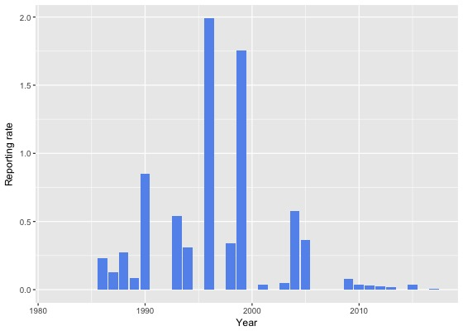
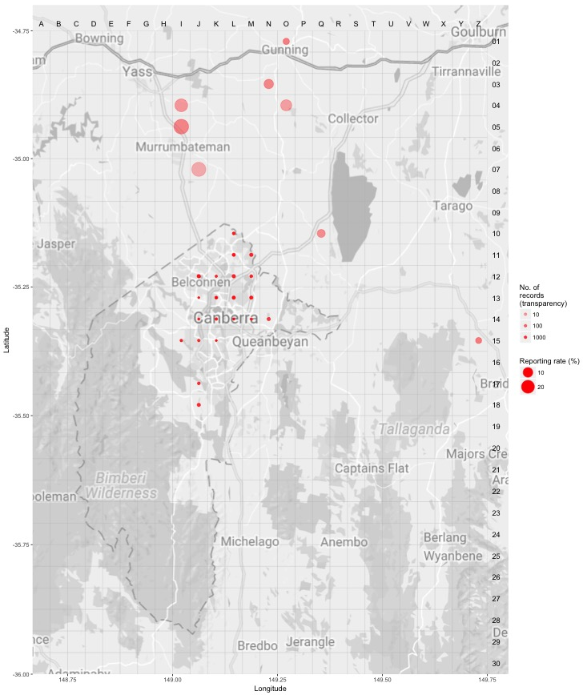
Source: Canberrabirds.org.au (2018). Note: Reporting rate (%) is the proportion of all surveys in which the species was present. These data were collected by volunteer birdwatchers using various survey methods and, on some occasions, more than one person may have recorded bird sightings on the same day, which may skew the data.
Table 1: Recent sightings of the Regent Honeyeater in the ACT.
Area | Numbers | Month | Reference
Mt Ainslie | 1 | January 2004 | COG 2005
Campbell Park | 3 | September 2004 | COG 2006
Australian National University | 2 | April 2005 | COG 2006
Cooleman Ridge | 1 | September 2008 | COG 2010
Florey | 1 | August 2009 | COG 2011
Florey | 1 | September 2009 | COG 2011
Greenway | 1 | October 2014 | COG 2016
Jerrabomberra Wetlands | 1 | May 2015 | COG 2016
Australian National University | 1 | November 2016 | COG 2018
Source: COG (2006–2018)
The critical habitat features for the Regent Honeyeater in the ACT include large, mature, flowering eucalyptus on fertile soils. Yellow Box as one of the key habitat species (ACT Government 2004). The species also feeds on nectar from mistletoes (Taylor and COG 1992) and on various species of eucalypts and grevilleas planted in urban areas (ACT Government 2004).

Threats
The decline of the Regent Honeyeater is largely attributed to the clearing, fragmentation and degradation of woodland dominated by box-ironbark (DoE 2016).
Regent Honeyeaters have declined at a faster rate than sympatric honeyeater species (DoE 2016). This may be driven by demographic allee effects that compromise positive population growth (that is, they may only thrive in flocks of greater size than exist today; Crates et al. 2017). The species also faces competition at suitable breeding sites, particularly from large-bodied, sometimes super-abundant, nectarivores such as Noisy Miners (Manorina melanocephala) and high rates of nest predation, predominantly by Pied Currawongs (Strepera graculina).

Major Conservation Objectives
The objectives of the National Recovery Plan (Department of the Environment 2016) are to:
- Reverse the long-term population trend of decline and increase the numbers of Regent Honeyeaters to a level where there is a viable, wild breeding population, even in poor breeding years.
- Enhance the condition of habitat across the Regent Honeyeater’s range to maximise survival and reproductive success, and provide refugia during periods of extreme environmental fluctuation.
The primary objective in the ACT is to protect Regent Honeyeater habitat through limiting clearance of suitable woodland habitat.

Conservation Issues and Proposed Management Actions
Conservation actions for the Regent Honeyeater include the following (ACT Government 2004):
- maintain woodland remnants and isolated paddock trees
- limit removal of live and dead timber
- reduce intensive grazing
- regenerate habitat
- minimise adverse effects of fire.

Other Relevant Advice, plans or Prescriptions
- ACT Woodland Conservation Strategy (ACT Government 2004)
- ACT Draft Woodland Conservation Strategy (ACT Government 2019)
- ACT Conservation Advice – Loss of Mature Trees (Scientific Committee 2018)
- National Recovery Plan for the Regent Honeyeater (DoE 2016)
- Commonwealth Conservation Advice for the Regent Honeyeater (DoE 2015)

Listing Background
The Regent Honeyeater was initially listed in the ACT as Xanthomyza phrygia as an Endangered species on 30 May 1997 in accordance with section 38 of the Nature Conservation Act 1980. At that time, the Flora and Fauna Committee (now Scientific Committee) concluded that the assessment satisfied the following criteria:
1.1 The species is known or suspected to occur in the ACT region and is already recognised as endangered in an authoritative international or national listing.
1.2 The species is observed, estimated, inferred or suspected to be at risk of premature extinction in the ACT region in the near future, as demonstrated by:
1.2.1 Current severe decline in population or distribution from evidence based on:
1.2.1.1 Direct observation, including comparison of historical and current records
1.2.1.3 Severe decline in quality and quantity of habitat.
1.2.6 Extremely small population.
This species was transferred from Endangered to Critically Endangered under the Environment Protection and Biodiversity Conservation Act 1999 (EPBC Act) on 8 July 2015 following assessment of new information by the Commonwealth Threatened Species Scientific Committee that it meets the IUCN Criterion A2(a) (Threatened Species Scientific Committee 2016).

Under the Nature Conservation Act 2014 the category of Critically Endangered was included in the Threatened Native Species List for the first time. In 2019, the ACT Scientific Committee recommended the Regent Honeyeater be listed in the Critically Endangered category to align with the EPBC Act listing.

References
ACT Government 1999. Regent Honeyeater (Xanthomyza phrygia): An endangered species. Action Plan No. 20. Environment ACT, Canberra.
ACT Government 2004. Woodlands for Wildlife: ACT Lowland Woodland Conservation Strategy. Action Plan No. 27. Environment ACT, Canberra.
ACT Government 2019. Draft ACT Woodland Conservation Strategy and Action Plans. Environment Planning and Sustainable Development Directorate, Canberra.
BirdLife International 2016. Anthochaera phrygia. The IUCN Red List of Threatened Species 2016. Accessed 22 August 2018 from: http://dx.doi.org/10.2305/IUCN.UK.2016-3.RLTS.T22704415A93967301.en.
BirdLife International 2018. Species factsheet: Anthochaera phrygia. Accessed 22 August 2018 from: http://datazone.birdlife.org/species/factsheet/regent-honeyeater-anthochaera-phrygia/text
Bounds J, Brookfield M & Delahoy M 1996. Observations of a breeding colony of four pairs of Regent Honeyeaters at North Watson, Canberra, in 1995–96. Canberra Bird Notes 21(3): 41–55.
Canberrabirds.org.au (2018). Regent Honeyeater Anthochaera phrygia data sheet. Accessed 22 August 2018 from: http://canberrabirds.org.au/wp-content/bird_data/603_Regent%20Honeyeater.html
COG 2000. Annual Bird Report: 1 July 1998 to 30 June 1999. Canberra Bird Notes 25(4): 127–184.
COG 2005. Annual Bird Report: 1 July 2003 to 30 June 2004. Canberra Bird Notes 30(1): 1–63.
COG 2006. Annual Bird Report: 1 July 2004 to 30 June 2005. Canberra Bird Notes 31(1): 1–68.
COG 2010. Annual Bird Report: 1 July 2008 to 30 June 2009. Canberra Bird Notes 35(1): 1–78.
COG 2011. Annual Bird Report: 1 July 2009 to 30 June 2010. Canberra Bird Notes 36(1): 1–78.
COG 2016. Annual Bird Report: 1 July 2014 to 30 June 2015. Canberra Bird Notes 41(1): 1–110.
COG 2018. Annual Bird Report: 1 July 2016 to 30 June 2017. Canberra Bird Notes 43(1): 1–110.
Crates R, Rayner L, Stojanovic D, Webb M, & Heinsohn, R 2017. Undetected allee effects in Australia’s threatened birds: implications for conservation. Emu—Austral Ornithology 117(3): 207—221.
Crates R, Rayner L, Stojanovic D, Webb M, Terauds A & Heinsohn R 2018. Contemporary breeding biology of critically endangered Regent Honeyeaters: implications for conservation. Ibis (in press).
Department of the Environment 2015. Approved Conservation Advice Anthochaera phrygia Regent Honeyeater. Department of the Environment, Commonwealth of Australia, Canberra.
Department of the Environment 2016. National Recovery Plan for the Regent Honeyeater (Anthochaera phrygia), Commonwealth of Australia, Canberra.
Franklin D, Menkhorst P and Robinson J 1987. Field surveys of the Regent Honeyeater (Xanthomyza phrygia) in Victoria. Australian Bird Watcher 12(3): 91–95.
Higgins PJ, Peter JM and Steele WK 2001. Handbook of Australian, New Zealand and Antarctic Birds. Vol.5 Tyrant-flycatchers to Chats. Oxford University Press, Melbourne.
Menkhorst P 1993. Regent Honeyeater Xanthomyza phrygia. Flora and Fauna Guarantee Action Statement No. 41. Department of Conservation and Natural Resources, Victoria.
Pizzey G 1981. A Field Guide to the Birds of Australia. Collins, Sydney.
Scientific Committee 2018. Conservation Advice – Loss of Mature Trees (including Hollow-bearing Trees) and Lack of Recruitment. ACT Government, Canberra.
Shaw G 1794. Zoology of New Holland, in Shaw, G. & Smith, JE (eds). Zoology and Botany of New Holland, and the isles adjacent. J Sowerby, London, 13.
Taylor M 1987. Murrumbidgee River Corridor survey – summary of results. Canberra Bird Notes 12(4): 110–131.
Taylor M and Canberra Ornithologists Group 1992. Birds of the Australian Capital Territory – An Atlas. Canberra Ornithologist Group and National Capital Planning Authority, Canberra.
Wilson SJ 1984. Painted Honeyeater, in Frith, HJ (ed). Birds in the Australian High Country (2nd Edition). Angus and Robertson, Sydney.

Further Information
Further information on the species or other threatened species and ecological communities can be obtained from the Environment, Planning and Sustainable Development Directorate (EPSDD).
Phone: (02) 132281, EPSDD Website: http://www.environment.act.gov.au/cpr

