Australian Capital Territory
Corrections Management (Prisoner At Risk, Court Transport Unit) Policy Revocation 2020
Notifiable instrument NI2020-16
made under the
Corrections Management Act 2007, s 14 (Corrections policies and operating procedures)

1 Name of instrument
This instrument is the Corrections Management (Prisoner At Risk, Court Transport Unit) Policy Revocation 2020.

2 Commencement
This instrument commences on the day after its notification day.
3. Revocation
This instrument revokes the Corrections Management (Prisoner At Risk, Court Transport Unit) Policy 2008 [NI2008-454].

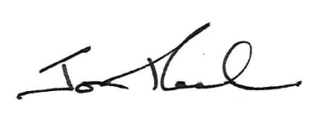

Jon Peach
Executive Director
ACT Corrective Services
8 January 2020

