Australian Capital Territory
Corrections Management (Prisoner Mail) Policy Revocation 2020
Notifiable instrument NI2020-193
made under the
Corrections Management Act 2007, s14 (Corrections policies and operating procedures)

1 Name of instrument
This instrument is the Corrections Management (Prisoner Mail) Policy Revocation 2020.
2 Commencement
This instrument commences on the day after its notification day.
3 Revocation
This instrument revokes the Prisoner Mail Policy in the following instrument Corrections Management Policies and Operating Procedures 2017 (No 2) [NI2017-55].

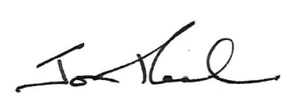
Jon Peach
Commissioner
ACT Corrective Services
30 March 2020

