Australian Capital Territory
Veterinary Practice (Acting Registrar) Appointment 2020 (No 1)*

Notifiable Instrument NI2020–212
made under the
Veterinary Practice Act 2018, s 104 (Appointment of registrar)

1 Name of instrument
This instrument is the Veterinary Practice (Acting Registrar) Appointment 2020 (No 1).
2 Commencement
This instrument commences on the day after the day it is made.
3 Acting registrar
The ACT Veterinary Practitioners Board appoints Michael Gavin to act as Registrar for the board during any period, or during all periods, when the Registrar is for any reason unable to perform the functions of the office.

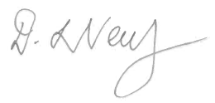
Dr Debbie Neutze
President
ACT Veterinary Practitioners Board
02 April 2020

