Australian Capital Territory

Nature Conservation (Brush-tailed Rock-wallaby) Conservation Advice 2020

Notifiable instrument NI2020–786
made under the
Nature Conservation Act 2014, s 90C (Conservation advice)

1 Name of instrument
This instrument is the Nature Conservation (Brush-tailed Rock-wallaby) Conservation Advice 2020.

2 Commencement
This instrument commences on the day after its notification day.

3 Conservation advice for Brush-tailed Rock-wallaby
Schedule 1 sets out the conservation advice for Brush-tailed Rock-wallaby (Petrogale penicillata).

Arthur Georges
Chair, Scientific Committee
8 December 2020
Schedule 1
(see s 3)

Conservation Advice
brush-tailed rock-wallaby –
Petrogale penicillata

Conservation Status
The Brush-tailed Rock-wallaby Petrogale penicillata (Gray, 1825) is recognised as threatened in the following jurisdictions:
International Vulnerable, International Union for Conservation of Nature (IUCN) Red List
National Vulnerable, Environment Protection and Biodiversity Conservation Act 1999
Vulnerable, The Action Plan for Australian Mammals 2012
ACT Endangered, Nature Conservation Act 2014
NSW Endangered, Biodiversity Conservation Act 2016
QLD Vulnerable, Nature Conservation Act 1992
VIC Threatened, Flora and Fauna Guarantee Act 1988
Critically Endangered, Advisory List of Threatened Vertebrate Fauna in Victoria 2013

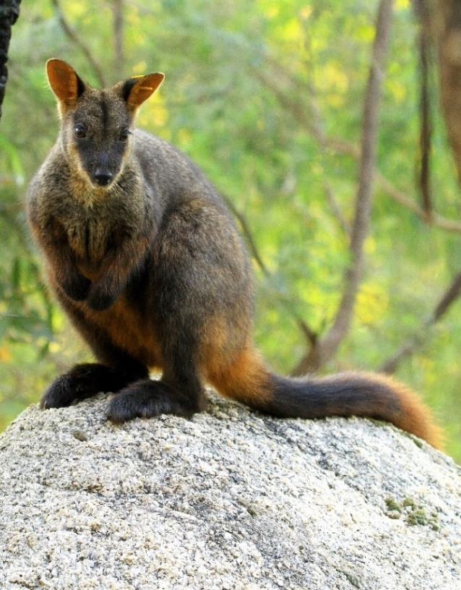
ELIGIBILITY
The factors that make the Brush-tailed Rock-wallaby eligible for listing as Endangered in the ACT Threatened Native Species List are included in the Listing Background section below.

DESCRIPTION AND ECOLOGY
The Brush-tailed Rock-wallaby is a member of the kangaroo family Macropodidae and one of 16 known rock-wallaby species. The species possesses a long tail (regularly exceeding the body length) with a prominent brush on the distal third of its length (Eldridge and Close 2008). The pelage is brown above, tending to grey on the shoulders and reddish on the rump and hind quarters (Eldridge and Close 2008). Adult males have an average mass of 7.9 kg and an average length of 557mm, while adult females are slightly smaller with an average mass of 6.3 kg and an average length of 53 mm (Eldridge and Close 2008).
Brush-tailed Rock-wallaby (© ACT PCS Wildlife Team – Tidbinbilla Nature Reserve)
Like other rock-wallaby species, Brush-tailed Rock-wallabies exhibit several morphological features that are adaptations for living in rugged terrain. These include extensive muscular development in the hind quarters and intricately granulated patterns on the soles of their feet for moving through steep, rocky habitats (Eldridge and Close 2008).
Adult female Brush-tailed Rock-wallabies produce an average of 1.2 young per year over their reproductive period, around 2-10 years of age (Taggart et al. 1997). Hazlitt et al. (2004) found that the species forms female-based family groups that are closely related and usually number between 4-10 animals. They form close, polygynous bonds with a single male whose range is slightly larger than that of the females’. Like other members of the Macropididae, they exhibit embryonic diapauses. Generation length is estimated at 7–8 years (Woinarski et al. 2014).
Tuft et al. (2011) examined the diet of the species over two years and in three colonies across NSW, found it broadly employed a generalist strategy across populations and a more specialised strategy at finer geographic scales. Both Short (1989) and van Eeden et al. (2011) found that the species is predominantly a grazer of monocots and forbs but also browses on trees and shrubs to supplement their diet.
Browning et al. (2001) suggested the species be managed as three distinct Evolutionarily Significant Units (ESUs), and Hazlitt et al (2014) confirmed three geographically discrete and genetically divergent lineages within Brush-tailed Rock-wallabies. These ESUs are geographically defined and termed as northern, central and southern. The ACT population was likely to be part of the southern ESU (Paplinska et al. 2011).

Distribution and Habitat
The species was originally distributed throughout the temperate zone of the Great Dividing Range (GDR) from the Grampians in western Victoria to the range west of Brisbane in Queensland. The former range extended across the western fall of the GDR as far as Cobar in NSW and Injune in Queensland (Short and Milkovits 1990). In the ACT, the species is presumed to be extinct in the wild, with the last confirmed sighting occurring at Wallaby Rocks at Tidbinbilla Nature Reserve (TNR) in 1959 (Ormay 1996). However, the discovery of rock-wallaby skeletal remains in Namadgi National Park (NNP) suggest a more recent occurrence (Reside and Martin 1996). The nearest known extant colonies to the ACT are at Nattai National Park (156 km NNE of Canberra) and in Kangaroo Valley (187 km ENE of Canberra). There is a conservation breeding program underway at TNR.
There has been a dramatic decline in the distribution and abundance of the species, especially in Victoria, and in western and southern NSW, where its range has been severely reduced (Short and Milkovits 1990). Except for populations in the Warrumbungle Ranges, the species is now absent from the western slopes and plains of NSW. The geographic range since European settlement is estimated to have been reduced by 50-90% (Short and Milkovits 1990). The species is considered locally common only in the north-eastern part of its range (Hill 1991). Aside from a very small reintroduced colony in western Victoria only one other colony of around 49 animals is now known to exist in that state (Victoria State Government 2020).
A study by Murray et al. (2008) found that at a landscape scale the strongest predictor for contemporary presence of the species across 200 sites in northern NSW and south-east Queensland was erodible geological formations. They also found that at a site level the primary determinant of presence was high rock complexity. Important features include, an abundance of refugia in the form of caves and overhangs, basking sites such as rock ledges and general northerly aspects. Surveys during the 1990s of sites of historic distribution in NNP and TNR (ACT Government 2015) found that sites in the ACT had similar values to those in other parts of the species range.
The 2019-20 bushfires in southern and eastern Australia had severe impacts on the habitat of the Brush-tailed Rock-wallaby, and the species was one of many identified by the Wildlife and Threatened Species Bushfire Recovery Expert Panel to require urgent management intervention (DAWE 2020). It is estimated that the locations of more than 80 percent of all known records of the Brush-tailed Rock-wallaby in NSW were affected by bushfires (Mo et al. 2020).

Threats
Threats to the species are detailed in the Action Plan for the Species (ACT Government 2015) and include:
- introduced predators, particularly the red fox (Vulpes vulpes)
- introduced competitive herbivores, particularly Goats (Capra hircus) and Rabbits (Oryctolagus cuniculus)
- wildfire and drought
- human disturbance of habitat
- disease
- hunting (historic).

Major Conservation Objective
The priority management objective is to contribute to the maintenance of long term, viable wild populations of the species across its former range, including the ACT. The objective is to be achieved through:
- promoting and participating in a program of research, aimed at increasing the survival of reintroduced populations and improving outcomes for the recovery of the species
- identifying and protecting habitat critical to survival of the species in the ACT in preparation for possible future reintroductions
- co-operating with state and local government agencies and key stakeholders in formulating and implementing conservation measures
- increasing community awareness of the need to protect the species and its habitat and supporting related community-based conservation action.

Conservation PRIORITIES
As the species is considered extinct in the wild in the ACT, the priorities for conservation in the ACT relate to:
- supporting the extralimital conservation of the species through involvement in state and national recovery teams
- research with a focus on improving the recovery outlook for the species through enhancing the survivorship of reintroduced populations (e.g. enhancing predator avoidance behaviours, habitat improvement strategies, improved morphological adaptations for wild reintroductions etc.)
The ACT – specifically at TNR – is contributing to the conservation of this species through a breeding program and the establishment of an insurance population that will also serve as a source of animals for reintroductions, both within the ACT and other jurisdictions. This population will also provide opportunities for scientific research including improving our understanding of the ecology of this species and how to better prepare individuals for wild release.
Proposed future management actions include:
- measure and report the impact of current dingo baiting regimes on dingo and fox populations in NNP and TNR and aim to enhance predator control to assist in the conservation of critical weight range mammals (including the Brush-tailed Rock-wallaby)
- collaborate with local and interstate researchers on reintroduction projects
- contribute to the conservation of the taxon across its current and former range through engagement with the national and state recovery teams
- deliver and develop an education program, making use of the captive colony and interpretive material
- develop a potential reintroduction program for the ACT.

Other Relevant Advice, plans or Prescriptions
- ACT Action Plan for the Brush-tailed Rock-wallaby (ACT Government 2015)
- National Recovery Plan for the Brush-tailed Rock-wallaby (Menkhorst and Hynes 2010)
- Conserving Threatened Species – Brush-tailed Rock-wallaby (Victoria State Government 2020)
- NSW Saving our Species Strategy – Brush-tailed Rock-wallaby (NSW Government 2020)
- Management Interventions for 119 Priority Animal Species (DAWE 2020)
- The Action Plan for Australian Mammals (Woinarski et al. 2012)

Listing Background
The Brush-tailed Rock-wallaby was listed in the ACT as an Endangered species on 27 December 1996 in accordance with section 38 of the Nature Conservation Act 1980. At that time, the Flora and Fauna Committee (now the Scientific Committee) concluded that the assessment satisfied the following criteria:
1.2 Species was observed, estimated, inferred, or suspected to be at risk of premature extinction in the ACT region in the near future, as demonstrated by:
1.2.1 Current severe decline in population or distribution from evidence based on:
1.2.1.1 Direct observation, including comparison of historical and current records.
1.2.1.5 Severe threats from herbivores, predators, parasites, pathogens, or competitors.
The Brush-tailed Rock-wallaby is eligible for listing as Vulnerable under the Environment Protection and Biodiversity Conservation Act 1999 (EPBC Act) as, prior to the commencement of the EPBC Act, it was listed as Vulnerable under the Endangered Species Protection Act 1992 (Cwlth).

References
ACT Government 2015. Brush-tailed Rock-wallaby (Petrogale penicillata): an endangered species. Action Plan No 22 (Version 2). Environment Planning and Sustainable Development Directorate, Canberra.
Browning TL, Taggart DA, Rummery C, Close RL and Eldridge MDB 2001. Multifaceted genetic analysis of the “Critically Endangered” Brush-tailed Rock-wallaby Petrogale penicillata in Victoria, Australia: implications for management. Conservation Genetics 2: 145–156.
Department of Agriculture, Water and the Environment (DAWE) 2020. Wildlife and threatened species bushfire recovery research and resources. Australian Government. Available from: http://www.environment.gov.au/biodiversity/bushfire-recovery/research-and-resources.
Department of Agriculture, Water and the Environment (DAWE) 2020. Revised provisional list of animals requiring urgent management intervention. Australian Government. https://www.environment.gov.au/system/files/pages/ef3f5ebd-faec-4c0c-9ea9-b7dfd9446cb1/files/provisional-list-animals-requiring-urgent-management-intervention-20032020.pdf.
Eldridge MDB and Close RL 2008. Brush-tailed Rock-wallaby Petrogale penicillata, in van Dyke S and Straghan R. The Mammals of Australia. New Holland Reed, Chatswood.
Hazlitt SL, Eldridge MDB and Goldizen AW 2004. Fine-scale spatial genetic correlation analyses reveal strong female philopatry within a Brush-tailed Rock-wallaby colony in southeast Queensland. Molecular Ecology 13(12): 3621–3632.
Hazlitt SL, Goldizen AW, Nicholls JA and Eldridge MDB 2014. Three divergent lineages within an Australian marsupial (Petrogale penicillata) suggest multiple major refugia for mesic taxa in southeast Australia. Ecology and Evolution 4(7): 1102–1116.
Hill FAR 1991. A research recovery plan for the Brush-tailed Rock-wallaby Petrogale penicillata (Gray 1825) in south-eastern Australia. Unpublished report to ANPWS, Department of Conservation and Environment, Melbourne.
Mo M, Roache M, Reid T, Oliver DL, Broome L, Fawcett A, Howard K, Thomas P, Tracey S, Andersen G and Lowry R 2020. Corporate support for threatened species recovery efforts: three case studies from the 2019-20 Australian bushfire season. Australian Zoologist doi: https://doi.org/10.7882/AZ.2020.031.
Menkhorst P and Hynes E 2010. National Recovery Plan for the Brush-tailed Rock-wallaby Petrogale penicillata. Department of Sustainability and Environment, East Melbourne.
Murray JV, Low Choy SL, McAlpine CA, Possingham HP, and Goldizen AW 2008. The importance of ecological scale for wildlife conservation in naturally fragmented environments: A case study of the Brush‑tailed Rock-wallaby (Petrogale penicillata). Biological Conservation 141(1): 7–22. https://doi.org/10.1016/j.biocon.2007.07.020.
NSW Government 2020. Saving our Species Strategy – Brush-tailed Rock-wallaby Petrogale pencillata. Office of Environment and Heritage. https://www.environment.nsw.gov.au/savingourspeciesapp/project.aspx?ProfileID=10605 Accessed November 2020.
Ormay P 1996. Status of the Brush-tailed Rock-wallaby, Petrogale penicillata, in the Australian Capital Territory. Technical Report No. 13. ACT Parks and Conservation Service, Canberra.
Paplinska JZ, Taggart DA, Corrigan T, Eldridge MDB and Austin JJ 2011. Using DNA from museum specimens to preserve the integrity of evolutionarily significant unit boundaries in threatened species. Biological Conservation 144(1): 290–297.
Reside J and Martin R 1996. The status of the Brush-tailed Rock-wallaby Petrogale penicillata in the Australian Alps National Parks. A report to the Australian Alps Liaison Committee.
Short J 1989. The diet of the Brush-tailed Rock-wallaby in New South Wales. Australian Wildlife Research 16(1): 11–18.
Short J and Milkovits G 1990. Distribution and status of the Brush-tailed Rock-wallaby in south-eastern Australia. Australian Wildlife Research 17(2): 169–179
Taggart DA, Schultz D, White C, Whitehead P, Underwood, G and Phillips, K 1997. Cross-fostering, growth and reproductive studies in the Brush-tailed Rock-wallaby, Petrogale penicillata (Marsupialia: Macropodidae): efforts to accelerate breeding in a threatened marsupial species. Australian Journal of Zoology 53(5): 313–323.
Tuft KD, Crowther MS and McArthur C 2011. Multiple scales of diet selection by Brush-tailed Rock-wallabies (Petrogale penicillata). Australian Mammalogy 33(2): 169–180.
van Eeden L, Stefano J and Coulson G 2011. Diet selection by the Brush-tailed Rock-wallaby (Petrogale penicillata) in East Gippsland, Victoria. Australian Mammalogy 33(2): 162–168.
Victoria State Government 2020. Conserving threatened Species – Brush-tailed Rock-wallaby (Southern ESU) Petrogale penicillate, Department of Environment, Land, Water and Planning. https://www.environment.vic.gov.au/conserving-threatened-species/threatened-species-fact-sheets/brush-tailed-rock-wallaby.
Woinarski JCZ, Burbidge AA and Harrison PL 2014. The Action Plan for Australian Mammals 2012. CSIRO Publishing, Collingwood.

Further Information
Further information on the related Action Plan or other threatened species and ecological communities can be obtained from: Environment, Planning and Sustainable Development Directorate (EPSDD).
Phone: (02) 132281, EPSDD Website: http://www.environment.act.gov.au/cpr

