Australian Capital Territory
Planning and Development (Plan Variation No 360) Approval 2020

Notifiable instrument NI2020-82
made under the
Planning and Development Act 2007, s 76 (Minister’s powers in relation to draft plan variations)

1 Name of instrument
This instrument is the Planning and Development (Plan Variation No 360) Approval 2020.
2 Commencement
This instrument commences on the day after its notification day.
3 Approval of draft plan variation
(1) I approve under section 76 (2) (a) of the Planning and Development Act 2007 the draft plan variation No 360 to the Territory Plan.
(2) In this section:
draft plan variation No 360 to the Territory Plan means the draft plan variation in the schedule.

Mick Gentleman MLA
Minister for Planning and Land Management
4/02/2020

Planning and Development Act 2007

Variation to the
Territory Plan
360

Molonglo River Reserve – changes to public land reserve overlay boundaries and minor zone adjustment

January 2020

Final variation prepared under s76 of the
Planning and Development Act 2007

Contents

1. EXPLANATORY STATEMENT 1
1.1 Background 1
1.2 Summary of the Proposal 2
1.3 The National Capital Plan 3
1.4 Current Territory Plan Provisions 5
1.5 Changes to the Territory Plan 6
1.6 Consultation on the Draft Variation 7
1.7 Revisions to the draft variation recommended to the Minister 7
1.8 Revisions to the final variation 7
2. DRAFT VARIATION 8
2.1 Variation to the Territory Plan 8

- EXPLANATORY STATEMENT
  - Background
The Molonglo River Reserve (the Reserve) is a new reserve that follows the Molonglo River from Scrivener Dam downstream to the intersection with the Murrumbidgee River Corridor Reserve. It includes three current reserves – Kama Nature Reserve, Lower Molonglo River Corridor Nature Reserve and Molonglo River Special Purpose Reserve, and brings them together with some new areas to create the Molonglo River Reserve. The Molonglo River Park in East Molonglo is also included in the Reserve.
The Reserve has high conservation value and will also be a central landscape feature and recreation destination for residents of the Molonglo Valley urban development area.
Section 315 of the Planning and Development Act 2007 (the Act) provides for the reservation of public land for a range of purposes and objectives for management. These public land reserve areas are shown on the Territory Plan Map by way of public land reserve overlays and cover wilderness areas, national parks, nature reserves, and sport and recreation reserves to name a few. The draft Management Plan for the Molonglo River Reserve is a statutory plan required under the Act and defined as a ‘reserve management plan’ in the Nature Conservation Act 2014. Its purpose is to give clear direction on how the biodiversity, land and waters of the Molonglo River Reserve will be used and managed to satisfy both nature conservation and recreation objectives.
The Molonglo River Reserve Draft Reserve Management Plan (the Plan) was released for public consultation from 8 February 2018 until 23 March 2018. All submissions were considered and the Plan was revised in response to the comments received.
Draft Variation to the Territory Plan 360 (DV360) has been prepared in response to a request by the Conservator of Flora and Fauna to amend the Molonglo River Reserve public land reserve overlay boundaries for the area of the reserve. The changes to the type and location of the public land reserve overlay boundaries on the Territory Plan map are to ensure they align with the requirements in the Plan for the particular uses assigned to the land within the reserve corridor.
The change to the boundaries also reflects the outcomes of the Molonglo Valley Strategic Assessment for the Molonglo River Reserve which was undertaken by the ACT Government in 2010.
The NES Plan details the ACT Government’s commitments to protect matters of national significance within the strategic assessment area.
The Plan provides for the Molonglo River Reserve to be predominantly nature reserve, with two areas of special purpose reserve where recreational activities will be located. This is to ensure that areas of high conservation value are protected into the future in accordance with the NES Plan.
In order to finalise the Plan, the public land reserve overlay provisions need to be amended to comply with the legislative requirement that the Plan describes how the planning and development objectives for the reserve are to be implemented or promoted in the reserve. The management objectives as provided by the Planning and Development Act 2007 for an area of nature reserve is to conserve the natural environment, and to provide for public use of the area for recreation, education and research, whereas the objectives for special purpose reserve are to provide for public and community use of the area for recreation and education. The corresponding public land reserve overlays shown on the Territory Plan Map for these areas are ‘Pc – a nature reserve’ and ‘Pd – a special purpose reserve’ respectively.
The Conservator of Flora and Fauna has also requested that the proposed changes incorporate part of Block 485 Stromlo into the reserve system as it contains an important Aboriginal cultural site. It is proposed to include the block under the public land reserve ‘Pc – a nature reserve’ overlay on the Territory Plan Map so that it can be managed in accordance with the Plan that covers the area. The Conservator has also requested that the subject land be rezoned from non-urban zone NUZ2 Rural zone to NUZ4 River Corridor zone in this location to better reflect the management of the area as part of the Molonglo River Reserve.
The changes proposed in this draft variation will fulfil the requirements for the Plan to be finalised and take effect.
  - Summary of the Proposal
This draft variation proposes to make changes to the public land reserve overlay boundaries and a minor zone adjustment on the Territory Plan Map for the area of the Molonglo River Reserve. These amendments are necessary in order to align the Territory Plan Map with the provisions in the Molonglo River Reserve – Reserve Management Plan. The changes will fulfil the requirements for the Reserve Management Plan to be finalised and take effect.
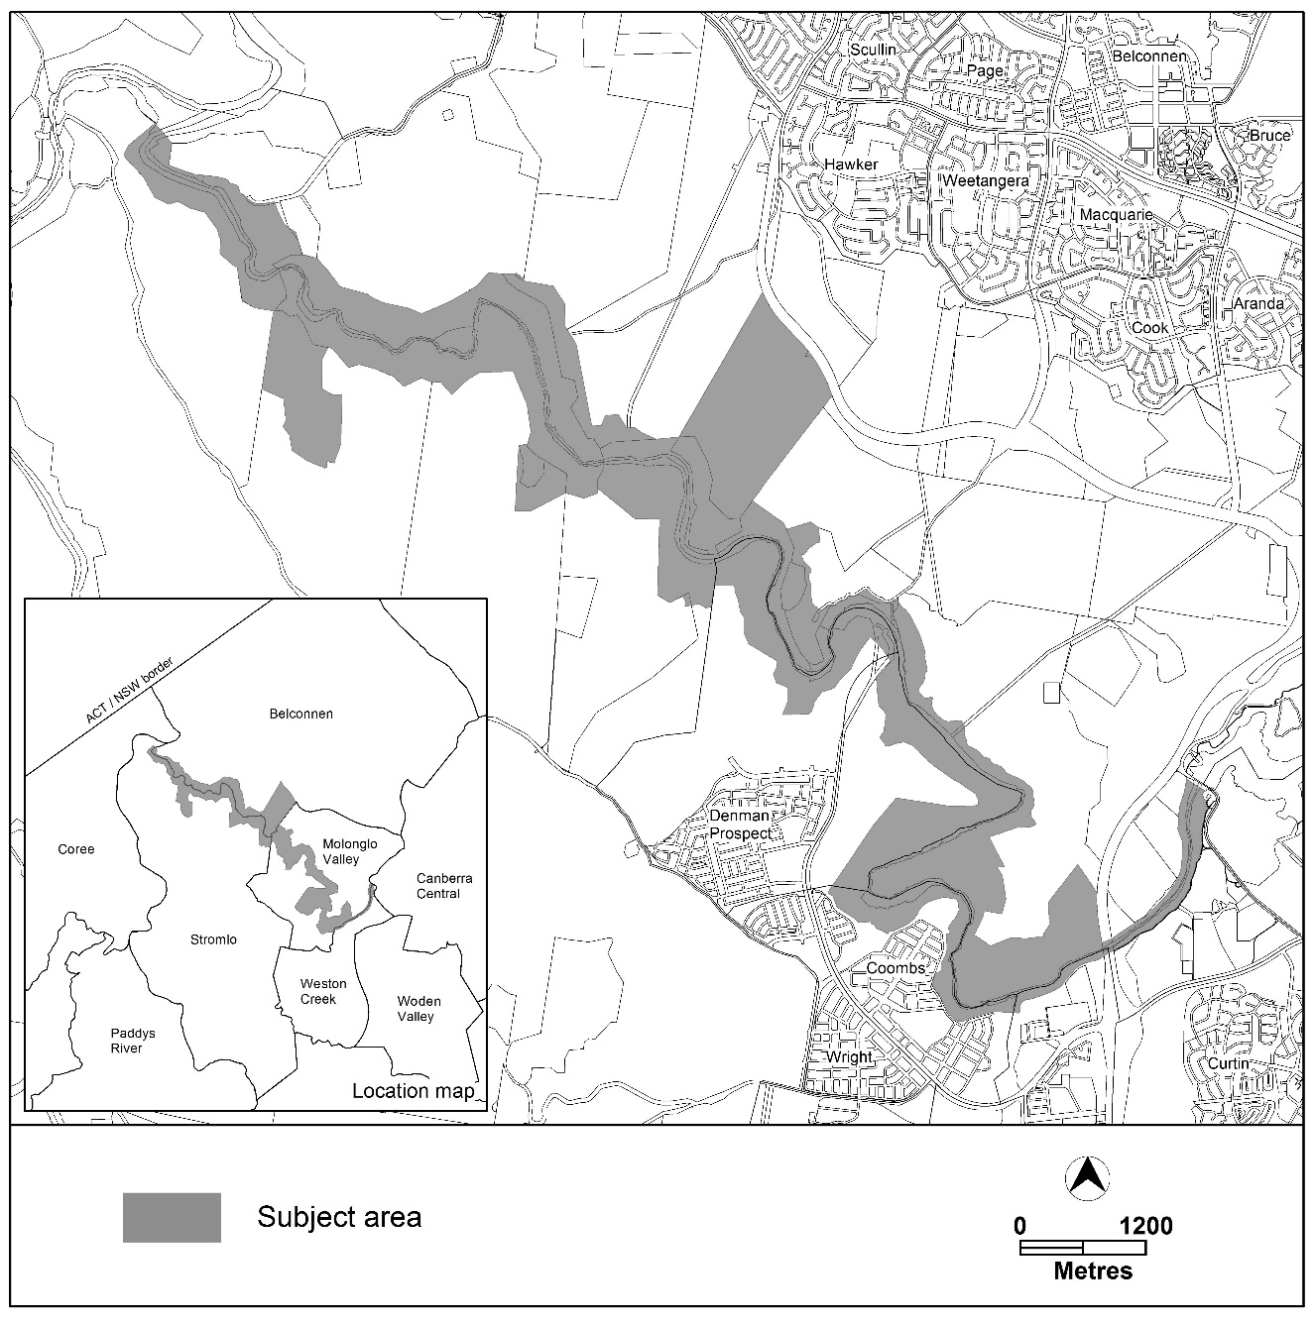
Location Plan
  - The National Capital Plan
The Australian Capital Territory (Planning and Land Management) Act 1988 established the National Capital Authority (NCA) with two of its functions being to prepare and administer a National Capital Plan (NCP) and to keep the NCP under constant review and to propose amendments to it when necessary.
The NCP, which was published in the Commonwealth Gazette on 21 January 1990 is required to ensure that Canberra and the Territory are planned and developed in accordance with their national significance. The Planning and Land Management Act 1988 also required that the Territory Plan is not inconsistent with the NCP.
In accordance with section 10 of the Australian Capital Territory (Planning and Land Management) Act 1988, the National Capital Plan defines the planning principles and policies for Canberra and the Territory, for giving effect to the object of the NCP and sets out the general policies to be implemented throughout the Territory, including the range and nature of permitted land uses.
It also sets out the detailed conditions of planning, design and development for areas that have special significance to the National Capital known as designated areas and identifies special requirements for the development of some other areas.

  - Current Territory Plan Provisions
The current Territory Plan map shows the existing zones and public land overlays applying to the land subject to this draft variation.

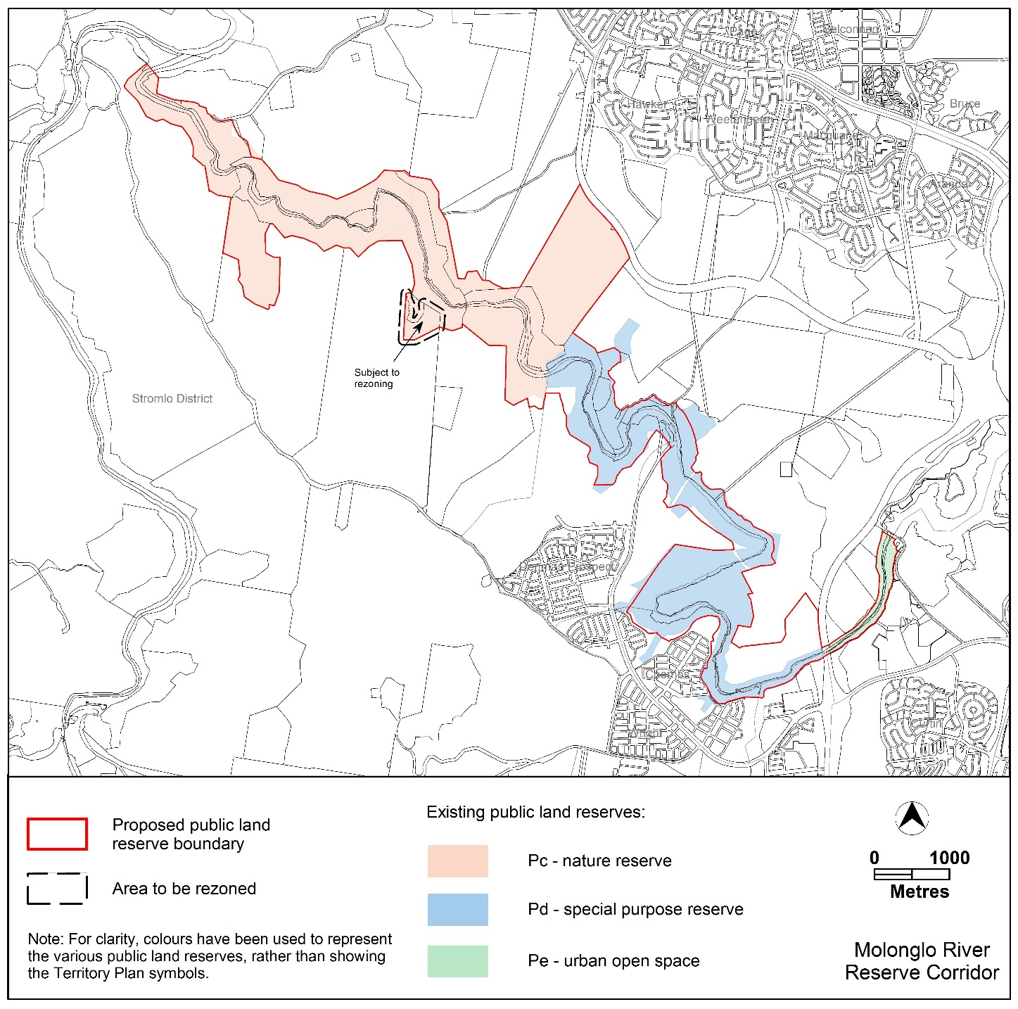
Figure 1 Current Territory Plan Map using colours for information purposes

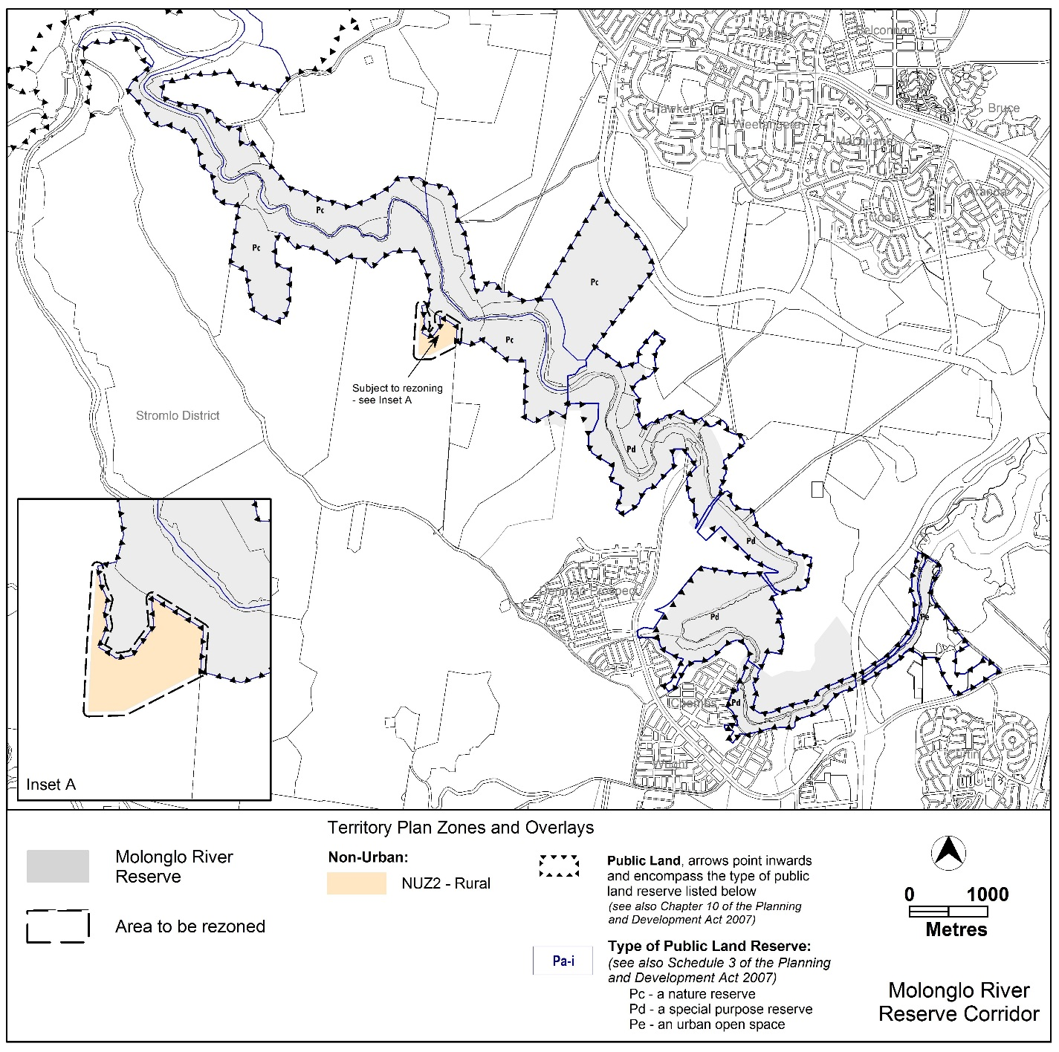

Figure 2 Existing Territory Plan Map using symbols as per Map legend

  - Changes to the Territory Plan
Detailed changes to the Territory Plan are noted in section 2 of this document.

  - Consultation on the Draft Variation
DV360 was released for public comment between 23 November 2018 and 1 February 2019. A consultation notice under section 63 of the Planning and Development Act 2007 (P&D Act) was published on the ACT Legislation Register on 23 November 2018.
Two written submissions were received on the draft variation.
Main issues raised by submitters were:
- concerns about the proposed development on the Coombs peninsula and the effect on wildlife, specifically platypus in the Molonglo River, and the location of the proposed development in a bushfire prone area; and
- concerns that the public reserve will not be wide enough to maintain environmental and public reserve functions.
The above issues were considered and are detailed in a report on consultation, which is available at www.act.gov.au/recommendedvariations. The Minister considered the outcomes of consultation prior to approval of this draft variation.
  - Revisions to the draft variation recommended to the Minister
No changes were made to the draft variation recommended to the Minister.

  - Revisions to the final variation
No changes were made to the final variation as a result of the Government Response to the Standing Committee on Planning and Urban Renewal Report 9. The Government Response was tabled in the Legislative Assembly on the 26 November 2019, and is available on the Standing Committee’s webpage for DV360 at:
https://www.parliament.act.gov.au/in-committees/standing-committees-current-assembly/standing-committee-on-planning-and-urban-renewal/draft-variation-to-the-territory-plan-no-360-

- DRAFT VARIATION
  - Variation to the Territory Plan
The Territory Plan is varied in all of the following ways:

Variation to the Territory Plan Map
- Molonglo River Corridor

Substitute
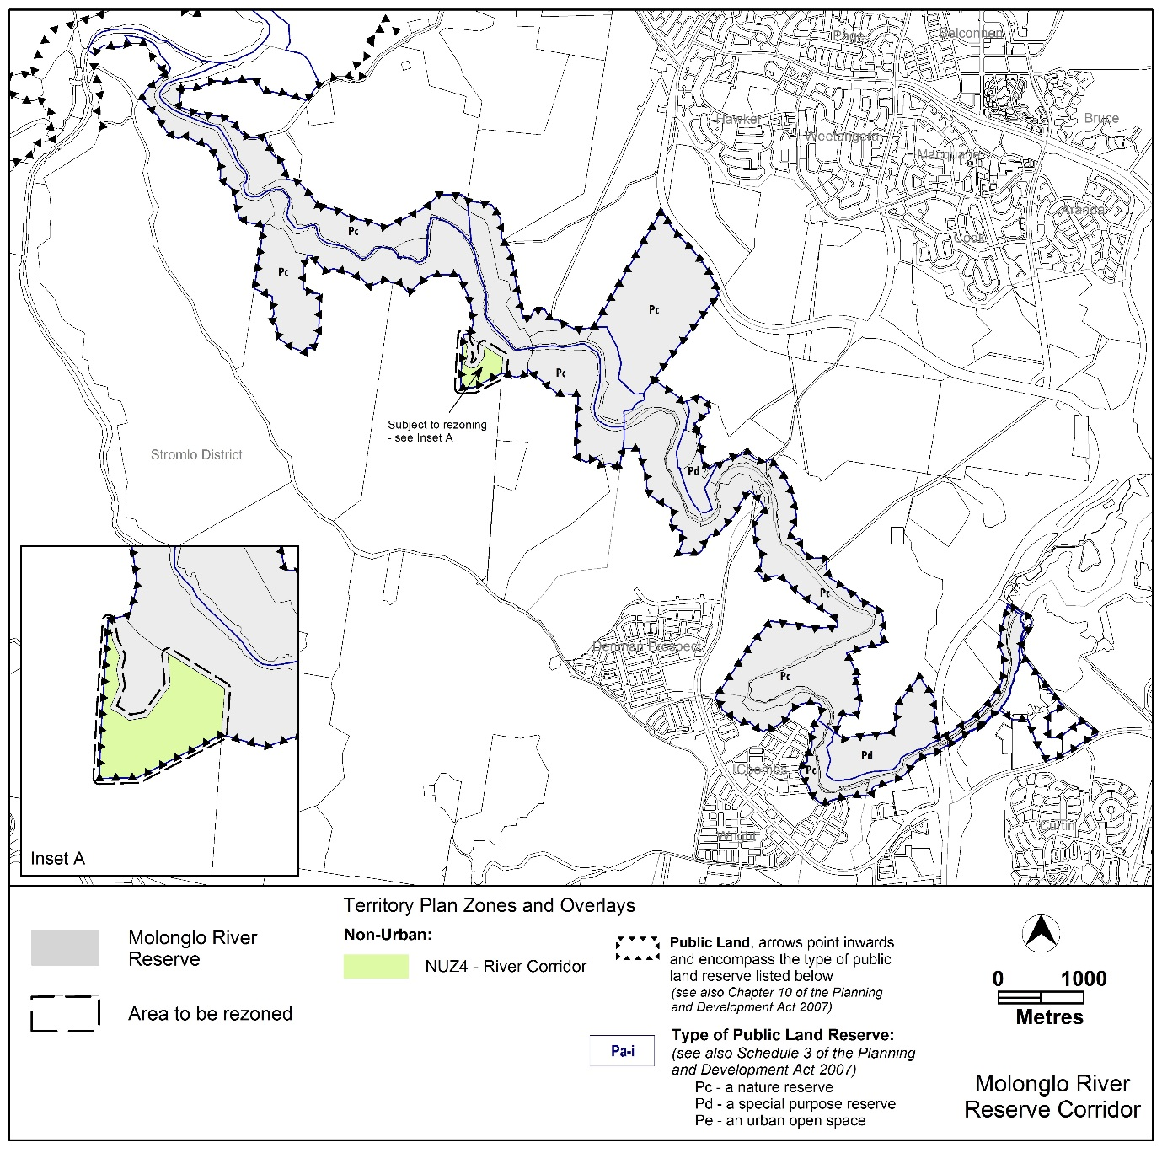

Interpretation service
