Australian Capital Territory

Nature Conservation (Glossy Black- cockatoo) Conservation Advice 2023

Notifiable instrument NI2023–220
made under the
Nature Conservation Act 2014, s 90C (Conservation advice)

1 Name of instrument
This instrument is the Nature Conservation (Glossy Black-cockatoo) Conservation Advice 2023.

2 Commencement
This instrument commences on the day after its notification day.

3 Conservation advice for Glossy Black-cockatoo
Schedule 1 sets out the conservation advice for Glossy Black-cockatoo (Calyptorhynchus lathami lathami).

4 Revocation
The Nature Conservation (Glossy Black-cockatoo) Conservation Advice 2019 (NI2019-248) is revoked.

Arthur Georges
Chair, Scientific Committee
14 April 2023
Schedule 1
(see s 3)

Conservation Advice
Glossy black-cockatoo (south-eastern) –
Calyptorhynchus lathami lathami

Conservation Status
The Glossy Black-cockatoo (south-eastern) sub-species Calyptorhynchus lathami lathami (Temminck, 1807) is recognised as threatened in the following jurisdictions:
International Vulnerable, International Union for the Conservation of Nature Red List (species listed)
National Vulnerable, Environment Protection and Biodiversity Conservation Act 1999
ACT Vulnerable, Nature Conservation Act 2014
NSW Vulnerable, Biodiversity Conservation Act 2016 (species listed)
QLD Vulnerable, Nature Conservation Act 1992 (species listed)
VIC Critically Endangered, Flora and Fauna Guarantee Act 1988 (species listed)

ELIGIBILITY
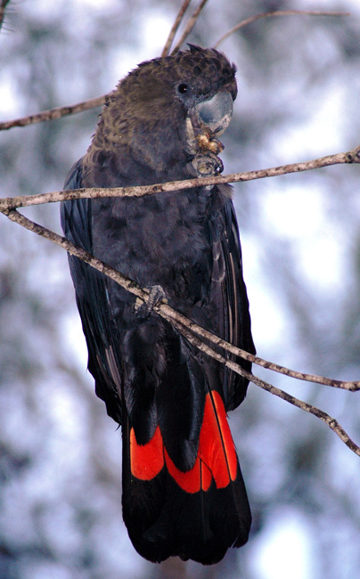
The Glossy Black-cockatoo (south-eastern) is listed as Vulnerable in the ACT Threatened Native Species List under IUCN Criterion A — A2bc+3b+4bc and Criterion C — C1+C2a(ii) due to a declining population, extent of occurrence (EOO), area of occupancy (AOO), and small population size at the national level (Attachment A). The subspecies has undergone a substantial reduction (30–50%) over the last 12 years (three generations) (Cameron et al. 2021) mostly caused by the 2019–2020 bushfires, and a result of historical and ongoing habitat loss. Both EOO and AOO are contracting, and the estimated total number of mature individuals is 7,500 and is declining rapidly (Cameron et al. 2021).

DESCRIPTION AND ECOLOGY
The Glossy Black-cockatoo is the smallest of the black cockatoos, with an average length of 48 cm, a wingspan of 90 cm and weighing around 425 g. The adult male has dusky blackish-brown plumage on the head, breast and belly and is dull black on the back and tail. The tail has distinctive solid bright red panels. The crest is inconspicuous and the bulbous bill, eye ring and legs are dark grey. The female is similar in appearance to the male except for irregular yellow patches around the neck and head, and orange/red tail panels. Immature birds of both sexes have fine yellow spotting on the face, shoulder and underwing, large spots or bars on the underbody and broad bars in the tail panel. (Forshaw 1989; Crome and Shields 1992; Flegg and Longmore 1994; Higgins 1999; Cameron 2007).
Glossy Black-cockatoo (Stuart Harris – Canberra Birds)
The Glossy Black-cockatoo is a social bird, typically observed in pairs or family groups. These small groups often aggregate to form larger feeding flocks. Diet is highly specialised, with birds feeding almost exclusively on the seeds of a range of she-oak species (Forshaw 1989; Cameron 2007). In the ACT region, their food trees are largely restricted to mature age Drooping She-oaks (Allocasuarina verticillata) (Holiday 2004). Feeding is concentrated in larger stands of she-oaks, which reduces the need to move between trees and may offer energy benefits and reduced risk of predation (Cameron et al. 2006). The species is highly selective of both the trees and the cones they favour, often showing fidelity to particular trees in which they have foraged previously (Pepper et al. 2000).
Breeding in the NSW region occurs from March to August and is thought to be timed with the presence of cones on their local feed-tree species (Clout 1989; Crome and Shields 1992; Cameron 2007; Cameron 2009). A single egg is laid and incubated for 30 days, during which time the female usually remains on the nest and is fed by the male (Garnett et al. 1999). The nestling fledges after about 90 days, a longer nestling period than has been recorded for any other parrot (Garnett et al. 1999). The juvenile associates with its parents for at least the first year following fledging, in which time it learns to forage (Forshaw 1989; Cameron 2007).

Distribution and Habitat
The Glossy Black-cockatoo (south-eastern) is patchily distributed at low densities across south-eastern Australia (Figure 1) from central Queensland to East Gippsland in Victoria, and inland to the southern tablelands and central-western plains of NSW, with a small population in the Riverina. Their highest densities occur east of the Great Dividing Range with a more scattered distribution inland (Forshaw 1989; Garnett 1992). They are also occasionally recorded well beyond their usual range suggesting that the species moves between different areas when necessary (Garnett and Crowley 2000; Forshaw 2002).
Recent climate adaptation modelling of suitable habitat by the NSW Government and others (Garnett et al 2013; Graham et al. 2019) suggest that while the ACT is currently considered to have low-moderate climate suitability for the sub-species, the whole of the ACT is projected to become more climatically suitable for the Glossy Black-cockatoo under climate change (Rogers et al. 2022).
The first published record of the Glossy Black-cockatoo in the ACT was in 1946 and the species was subsequently recorded occasionally throughout the 1970s and 1980s. The Mount Majura – Mount Ainslie complex is an important local refuge for the species (Holiday 2004). Sightings of the species in the ACT are rare, though a relatively high number of sightings were reported from the Majura Range in 2003 and 2004. The highest single count of the species recorded in the ACT was 16 birds on Majura Range in 2004 (Holiday 2004). The first record of breeding in the ACT was on Mount Majura in 2004 (Lenz et al. 2004). Reporting rates in the ACT region (Figure 2) have dropped in the past decade, with no sightings between 2016 and 2019 and no breeding records since 2010–11 (COG 2018, Dabb 2020).
Records of the species over the last 30 years are sparse, intermittent and are likely individuals travelling further afield when pushed to search for food sources. Despite the very rare breeding record (only five records in the ACT over the past 40 years), it has not been established that a small population is resident in the ACT, and it is possible that only wandering individuals from the main area of the coastal population further east, have been recorded in the ACT (Dabb 2020).
A pair of Glossy Black-cockatoos was seen in the western part of Mount Majura feeding on Drooping She-oak (Allocasaurina verticillata) on 29 May 2020 and three Glossy Black-cockatoos were reported feeding in a Drooping She-oak on Mount Ainslie on 2 June 2020 (Canberra Nature Map 2022). Subsequent searches failed to locate the birds and it was noticed that there was a poor production of cones in the area with those seen being generally opened, old or withered (Dabb 2020). A pair was sighted in Stirling in August 2021 feeding on likely planted Drooping She-oaks. A pair of was also recently recorded in Mount Taylor Nature Reserve in December 2021, with three birds flying over Kambah in February 2022 and a pair in and near Mount Majura Nature Reserve in February and September to November 2022 feeding on a good supply of Drooping She-oak cones (Canberra Nature Map 2022).
Figure 1: Modelled Distribution of the Glossy Black-cockatoo (south-eastern) (Source: DCCEEW 2022)
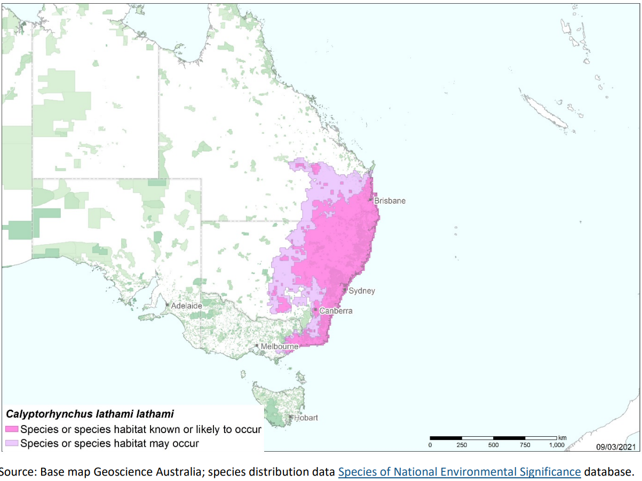
The Glossy Black-cockatoo nests in hollows in large eucalypts in woodland and open forests up to 1000 metres elevation. They utilise large, high, near-vertical hollows in aging or standing dead eucalypt trees and have been recorded nesting in Blakely’s Red Gum in the ACT (Scientific Committee 2018). They nest close to each other, which means they need breeding habitat with a relatively high density of suitably-sized hollows.
Mapping of vegetation communities in 2018 identified 670 ha of high quality foraging habitat of forest dominated by Drooping She-oak (Allocasuarina verticillata) for Glossy Black-cockatoos in the ACT and 5,018 ha of moderate quality foraging habitat containing lower densities of Drooping She-oak (ACT Government 2018).
Figure 1: Distribution of Glossy Black-cockatoo records in the ACT region – 1982–2017
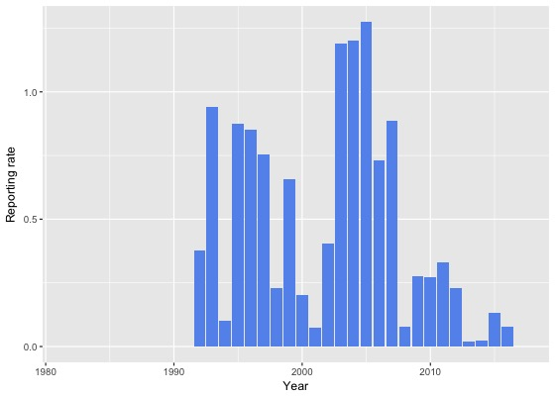
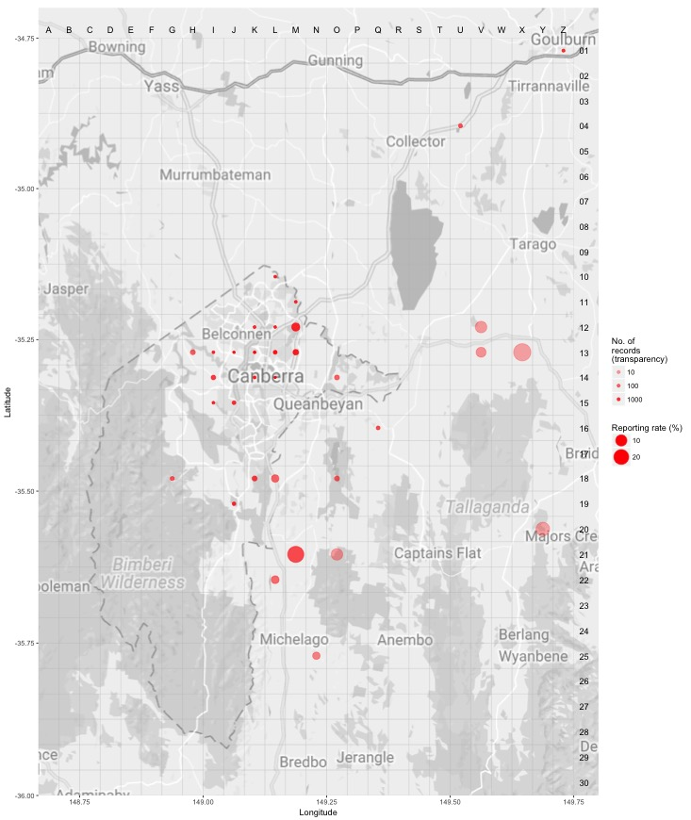
Source: Canberrabirds.org.au (2022). Note: Reporting rate (%) is the proportion of all surveys in which the species was present. These data were collected by volunteer birdwatchers using various survey methods and on some occasions more than one person may have recorded bird sightings on the same day, which may skew the data.

Threats
The main apparent threat to the Glossy Black-cockatoo is the degradation, loss and fragmentation of foraging and breeding habitat. In particular, the loss of canopy seed banks of feed trees by clearing or regular burning, as well as poor regeneration of these trees due to grazing, can significantly reduce available food sources. Loss of hollow-bearing nesting trees within the proximity of feed tree stands is also likely to be a significant impediment to successful breeding (Garnett and Crowley 2000; Mooney and Pedler 2005; Morgan et al. 2015).
Drooping She-oak (Allocasuarina verticillata) is killed by crown fires. In the ACT, vegetation community mapping shows that 67% of all high-quality foraging habitat and 82% of all moderate quality foraging habitat was burnt in the 2003 wildfires. While these areas are regenerating well, it will take a number of years (>25yrs) for the trees to reach their maximum cone-bearing potential resulting in the numbers of Glossy Black-cockatoos not expected to improve in the ACT for some years to come. Improvement focuses on core stepping-stones of habitat with significant plantings of feed trees undertaken across reserves in the ACT.
The areas of habitat in Namadgi National Park, including Mt Tennent and the hills surrounding the Naas Valley, were impacted by the 2020 Orroral fire. Frequent fires and droughts can significantly impact the habitat of the Glossy Black-cockatoo and the likelihood of the species presence in the ACT. The Parks and Conservation Service (PCS) work to protect Drooping She-oak when it undertakes burning activities and these are guided by ecological guidelines (ACT Government 2009, ACT Government 2019b) that call for patchy burning, retention of mature trees and 25-year gaps between planned fires. Protected areas of habitat are identified in the development of Bush Fire Operational Plans (ACT Government 2018).
Predation and competition for nest sites by Brush-tailed Possums (Trichosurus vulpecula) severely impacted breeding success of the Kangaroo Island sub-species in the past (Garnett et al. 1999; Mooney and Pedler 2005; Morgan et al. 2015) and has potential to affect birds in the ACT region. Successful protection of nesting trees from possums, in addition to restoration of habitat and provision of nest boxes, has reversed a decline in the Kangaroo Island sub-species (Mooney and Pedler 2005; Morgan et al. 2015). It is unknown to what extent competition for nest hollows from other Psittaciformes, such as Galahs, corellas and Sulphur-crested Cockatoos, may affect Glossy Black-cockatoos.
Illegal harvesting is a potential concern as there is evidence suggesting that Glossy Black-cockatoos from the Riverina district in NSW have been trapped for the illegal bird trade (OEH 2018).
The Glossy Black-cockatoo is also likely to be at risk from the effects of climate change, as the range of its main feed tree species is likely to be altered under high CO₂ emission scenarios (Harris et al. 2012). In a report by the University of Queensland examining impacts of climate change on two cockatoo species, expert elicitation identified extreme fire events as the most severe threat to Glossy Black-Cockatoos in the near and far future scenarios, impacting resources such as: abundance of food trees; abundance of large, hollow-bearing nest trees; proximity of breeding habitat to food resources, food tree age structure, patch size of feeding habitat, and juvenile/fledgling survival. The impact of drought on breeding habitat, the quality of feeding trees, the proximity of breeding habitat to surface water, and on the direct survival of adults and juveniles and fledglings was also identified as a key threat. Habitat loss and degradation, with other threats, will be exacerbated over time without management intervention (Rogers et al. 2022).
Exposure to extreme heat events is also likely to pose an acute risk to the Glossy Black-cockatoo, particularly in the western part of its range, as observed in other species including those of Psittaciformes. For example, during a single heatwave event in south-western WA in 2010, 208 endangered Carnaby’s cockatoos (Calyptorhynchus latirostris) died, succumbing to heat stress when air temperatures exceeded 47ºC, with carcasses recovered at two sites (McKechnie et al. 2012, Saunders et al. 2011). Widespread mortality on extreme hot days, sometimes involving millions of individual birds and other fauna, is not a new phenomenon in Australia (McKechnie et al. 2012). However, the increasing frequency and intensity of extreme heat events represent a novel and growing threat.

Major Conservation Objectives

The primary objective should be to maintain feeding habitat for Glossy Black-cockatoos in the ACT, to provide potential resources for breeding to occur, and to be responsive to opportunities to improve feeding and breeding habitat based on projections under realistic climate change scenarios.

Conservation PRIORITIES
The conservation actions are detailed in the Action Plan (ACT Government 2013) and progress report (ACT Government 2018). Conservation priorities in the ACT should be to:
- protect (especially mature hollow-bearing trees), manage and monitor habitat, including to minimise inter-specific nest hollow competition
- maintain areas of Drooping She-oak, protecting trees from high intensity and high frequency wildfire and to ensure hazard reduction activities do not impact tree canopy, as per recommendations (ACT Government 2009)
- explore opportunities for planting Drooping She-oak in the urban environment, noting that the species in coastal areas will use remnant food trees after urban development but are thought typically to avoid urban areas (Rogers et al. 2022)
- undertake research to understand the attributes that determine desirable/ideal foraging habitat and specific local factors that determine preference for certain trees and food cones (Rogers et al. 2022)
- gather appropriate data for, and undertake, habitat modelling under reasonable climate change scenarios to predict future likely responses that will impact the species and to allow current management interventions to be responsive to future environmental change; particular attention should be paid to capitalizing on the change in climate that will make the ACT more suitable for breeding populations of this species and the species more resistant to extreme climatic events
- record any sightings, especially potential breeding pairs
- encourage and support the continuation and further development of community-based conservation activities.

Other Relevant Advice, plans or Prescriptions
- ACT Glossy Black-cockatoo Action Plan (ACT Government 2013)
- ACT Conservation Advice – Loss of Mature Trees (Scientific Committee 2018)
- ACT Woodland Conservation Strategy (ACT Government 2004)
- ACT Draft Woodland Conservation Strategy (ACT Government 2019a)
- Glossy Black-cockatoo Conservation Guidelines (Glossy Black Conservancy 2010)
- Commonwealth Conservation Advice Glossy Black-cockatoo (south-eastern) (DCCEEW 2022)
- Commonwealth Conservation Advice Glossy Black-cockatoo (Kangaroo Island) (TSSC 2016)

Listing Background
The Glossy Black-cockatoo was listed in the ACT as a Vulnerable species on 23 August 2010 in accordance with section 38 of the Nature Conservation Act 1980. The Flora and Fauna Committee (now Scientific Committee) concluded that at that time the assessment satisfied the criteria:
2.2 The species is observed, estimated, inferred or suspected to be at risk of premature extinction in the ACT region in the medium-term future, as demonstrated by:
2.2.4 Seriously fragmented distribution for a species currently occurring over a moderately small range or having a moderately small area of occupancy within its range.
In 2019, the listing was amended from the species to the sub-species (that occurs in the ACT) under the Nature Conservation Act 2014.
The Glossy Black-cockatoo (south-eastern) is listed as a Vulnerable subspecies under the Environment Protection and Biodiversity Conservation Act 1999 (EPBC Act), effective 10 August 2022. It is assessed as Vulnerable under Criterion 1 (A2bc+3b+4bc) and Criterion 3 (C1+C2a(ii)) of the EPBC Act.

Action Plan Decision
An Action Plan for this species is in place in the ACT (ACT Government 2013) under the Nature Conservation Act 2014 and is being reviewed by the ACT Scientific Committee this year (2023). The Committee will make a recommendation about the continuation of that plan during that review.
The Commonwealth Minister for the Environment made the decision that a National Recovery Plan is required for the sub-species (DCCEEW 2022). In the review of the ACT Action Plan the decision to continue that action plan should be subject to drawing from the National Recovery Plan for this species and subject to any necessary changes highlighted in the second 5-yearly progress report on that action plan (Conservator of Flora and Fauna in prep.) and the review by the Committee.

References
ACT Government 2004. Woodlands for Wildlife: ACT Lowland Woodland Conservation Strategy. Action Plan No. 27. Environment ACT, Canberra.
ACT Government 2009. Allocasuarina verticillata in the northern ACT – distribution, habitat and management. Unpublished internal report 12/2009 prepared by Schweickle L and Baines G. Research and Planning, Parks Conservation and Lands, Territory and Municipal Services, ACT Government, Canberra.
ACT Government 2013. Glossy Black-cockatoo Calyptorhynchus lathami Action Plan. Action Plan No. 33. ACT Government, Canberra.
ACT Government 2018. Unpublished progress report – Glossy Black-cockatoo Calyptorhynchus lathami Action Plan No. 33. Environment Planning and Sustainable development Directorate, ACT Government, Canberra.
ACT Government 2019a. Draft ACT Woodland Conservation Strategy and Action Plans. Environment Planning and Sustainable Development Directorate, ACT Government, Canberra.
ACT Government 2019b. Ecological Guidelines for Fire, Fuel and Access Management Operations. Environment Planning and Sustainable Development Directorate, ACT Government, Canberra. https://www.environment.act.gov.au/__data/assets/pdf_file/0009/1483830/Ecological-Guidelines-2019-ver-1.3.pdf
BirdLife International 2022. Calyptorhynchus lathami. The IUCN Red List of Threatened Species 2022: e.T22684749A211747693. https://dx.doi.org/10.2305/IUCN.UK.2022-1.RLTS.T22684749A211747693.en. Accessed on 24 August 2022.
Cameron M 2007. Cockatoos. In: Australian Natural History Series. CSIRO Publishing, Collingwood.
Cameron M 2009. The influence of climate on Glossy Black-cockatoo reproduction. Pacific Conservation Biology 15: 597–607.
Cameron M, Castley G, Teixiera D, Menkhorst PW & Garnett ST 2021. South-eastern Glossy Black Cockatoo Calyptorhynchus lathami lathami. In The Action Plan for Australian Birds 2020. (Eds ST Garnett and GB Baker) CSIRO Publishing, Melbourne.
Cameron M and Cunningham RB 2006. Habitat selection at multiple spatial scales by foraging Glossy Black-cockatoos. Austral Ecology 31: 597–607.
Canberrabirds.org.au 2018. Canberra Birds Glossy Black-cockatoo Calyptorhynchus lathami data sheet. Accessed 15 November 2018 from: http://canberrabirds.org.au/wp-content/bird_data/265_Glossy%20Black-Cockatoo.html
Canberra Nature Map (CNM) 2022. Calyptorhynchus lathami – Glossy Black-cockatoo sightings – naturemapr.org. https://canberra.naturemapr.org/species/2265
Clout MN 1989. Foraging Behaviour of Glossy Black-cockatoos. Australian Wildlife Research 16: 467–473.
COG 2018. Annual Bird Report: 1 July 2016 to 30 June 2017. Canberra Bird Notes 43(1): 1–110.
Crome F and Shields J 1992. Parrots and Pigeons of Australia. Angus and Robertson, Sydney.
Dabb G. 2020. A Short discussion about Casuarinas and birds, in particular the Glossy Black-cockatoo Calyptorhynchus Lathami. Canberra Bird Notes 45(2): 183-192. https://canberrabirds.org.au/wp-content/uploads/2020/07/CBN-45-2-final-2.pdf
Department of Climate Change, Energy, the Environment and Water 2022. Conservation Advice for Calyptorhynchus lathami lathami (South-eastern Glossy Black-cockatoo). Department of Climate Change, Energy, the Environment and Water (Commonwealth), Canberra. http://www.environment.gov.au/biodiversity/threatened/species/pubs/67036-conservation-advice-10082022.pdf
Flegg J and Longmore N 1994. Photographic Field Guide: Birds of Australia. Reader's Digest (Australia) Pty Ltd, Sydney.
Forshaw J 2002. Australian Parrots (Third ed.). Alexander Editions, Robina.
Forshaw JM 1989. Parrots of the World (Third ed.). Landsdowne Editions, Willoughby.
Garnett S 1992. Threatened and Extinct birds of Australia. Royal Australasian Ornithologists Union (RAOU) Report 82.
Garnett ST and Crowley GM. 2000. The Action Plan for Australian Birds. Environment Australia, Canberra.
Garnett S, Franklin D, Ehmke G, VanDerWal J, Hodgson L, Pavey C, Reside AE, Welbergen J, and Butchart S 2013. Climate change adaptation strategies for Australian birds. National Climate Change Adaption Research Facility.
Garnett ST Pedler LP and Crowley GM 1999. The breeding biology of the Glossy Black-cockatoo, Calyptorhynchus lathami, on Kangaroo Island, South Australia. Emu 99: 262–79.
Garnett ST, Szabo JK and Duston G 2011. The Action Plan for Australian Birds 2010. CSIRO Publishing and Birds Australia, Melbourne.
Glossy Black Conservancy 2010. Glossy Black-cockatoo Conservation Guidelines for South-Eastern Queensland and Far North-Eastern New South Wales. Glossy Black Conservancy.
Graham EM, Reside AE, Atkinson I, Baird D, Hodgson L, James CS, and VanDerWal JJ 2019. Climate change and biodiversity in Australia: a systematic modelling approach to nationwide species distributions. Australasian Journal of Environmental Management 26(2):112–123.
Harris JB, Fordham DA, Mooney PA, Pdeler LP, Araujo MB, Paton DC, Brook BW 2012. Managing the long-term persistence of a rare cockatoo under climate change. Journal of Applied Ecology 49(4): 785–794.
Higgins PJ 1999. Handbook of Australian, New Zealand and Antarctic Birds (Vol. 4 Parrots to Dollarbird). Oxford University Press, South Melbourne.
Holiday S 2004. The Glossy Black-cockatoo in the Australian Capital Territory. Canberra Bird Notes 29: 126–130.
Lenz M, Dabb G, Green T, Gourlay T, Holliday S, Buckley P and Oren Y 2004. First record of the Glossy Black-cockatoo breeding in the Australian Capital Territory. Canberra Bird Notes 29: 131–136.
McKechnie AE, Hockey PAR and Wolf BO 2012. Feeling the heat: Australian land birds and climate change. Emu 112(2): i–vii.
Mooney PA and Pedler LP 2005. Recovery Plan for the South Australian Sub-species of the Glossy Black-cockatoo (Calyptorhynchus lathami halmaturinus): 2005–2010. Glossy Black-cockatoo Recovery Program. Department for Environment and Heritage, Kangaroo Island.
Morgan D, Barth M and Kinloch M 2015. The South Australian sub-species of the Glossy Black-cockatoo (Calyptorhynchus lathami halmaturinus) Strategic Plan 2015–2020. Natural Resources, Kangaroo Island.
NSW Office of Environment and Heritage (OEH) 2018. Glossy Black-cockatoo – profile. Accessed 14 November 2018 from: https://www.environment.nsw.gov.au/threatenedSpeciesApp/profile.aspx?id=10140
Pepper JW, Male TD and Roberts GE 2000. Foraging ecology of the South Australian Glossy Black-cockatoo (Calyptorhynchus lathami halmaturinus). Austral Ecology 25: 16–24.
Rogers A, Reside A, Cooney R, Brawata R, Rutherford C, Melton C and Watson J 2022. Securing species in a time of climate change. Species-based climate change adaptation planning for Gang-gang Cockatoo and Glossy Black-Cockatoo. Unpublished report. University of Queensland.
Saunders DA, Mawson P and Dawson R 2011. The impact of two extreme weather events and other causes of death on Carnaby’s Black Cockatoo: a promise of things to come for a threatened species? Pacific Conservation Biology 17(2): 141–148. https://www.publish.csiro.au/PC/PC110141
Schodde R, Mason IJ and Wood JT 1993. Geographical differentiation in the Glossy Black-cockatoo Calyptorhynchus lathami (Temminck) and its history. Emu 93: 156–166.
Scientific Committee 2018. Conservation Advice – Loss of mature native trees (including hollow bearing trees) and a lack of recruitment. Environment Planning and Sustainable Development Directorate, ACT Government, Canberra.
Temminck CJ 1807. Catalogue Systématique du Cabinet d'Ornithologie et de la Collection de Quadrumanes de Crd. Jb. Temminck. Avec une courte description des oiseaux non-descrits suivi: d'une nôte d'oiseaux doubles et de quelques autres objets d'histoire naturelle offerts en éxchange. C. Sepp, Amsterdam.
Threatened Species Scientific Committee (TSSC) 2016. Conservation Advice Calyptorhynchus lathami halmaturinus Glossy Black-cockatoo (Kangaroo Island). Department of the Environment, Canberra.

Further Information
Further information on the Action Plan or other threatened species and ecological communities can be obtained from: Environment, Planning and Sustainable Development Directorate (EPSDD).
Phone: (02) 132281, EPSDD Website: https://www.environment.act.gov.au/

Attachment A: Listing Assessment (DCCEEW 2022)

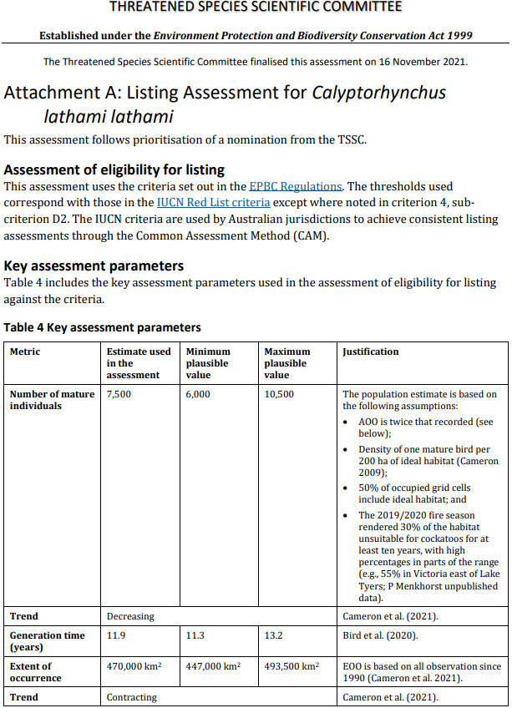
Threatened Species Scientific Committee
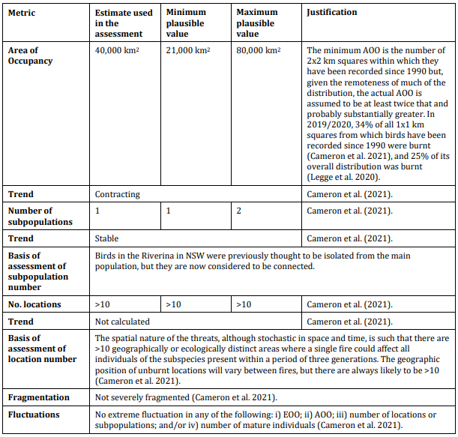

Threatened Species Scientific Committee
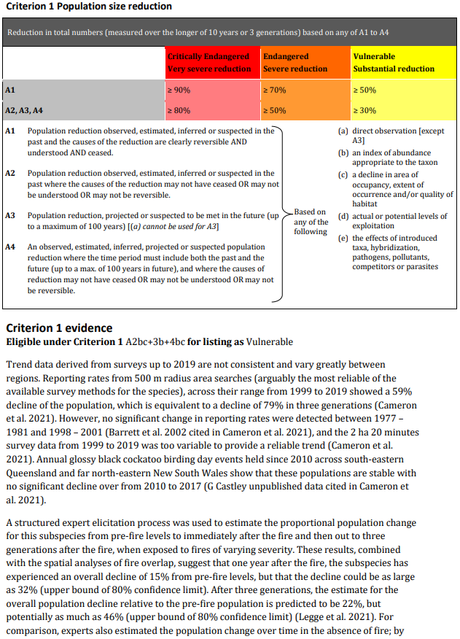

Threatened Species Scientific Committee
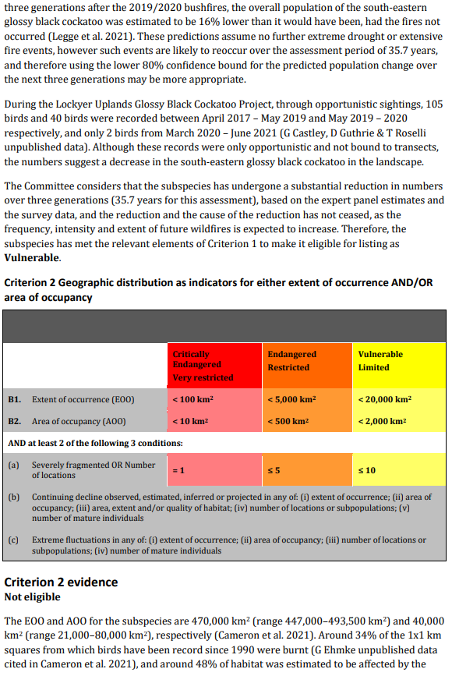

Threatened Species Scientific Committee
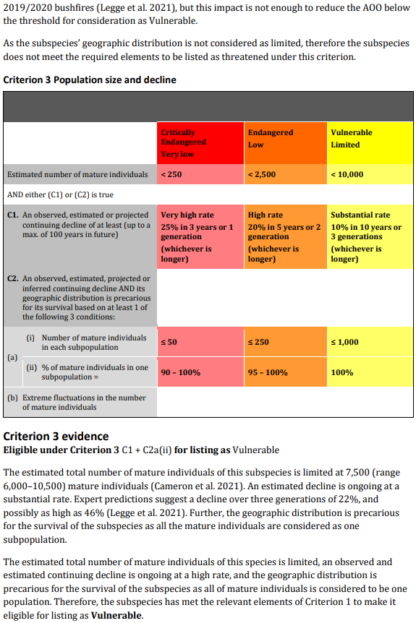

Threatened Species Scientific Committee
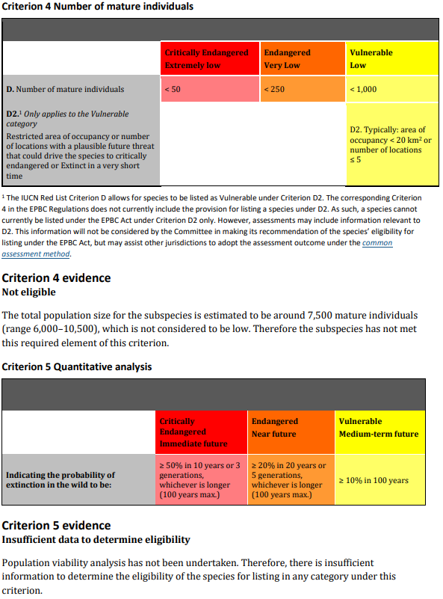

Threatened Species Scientific Committee
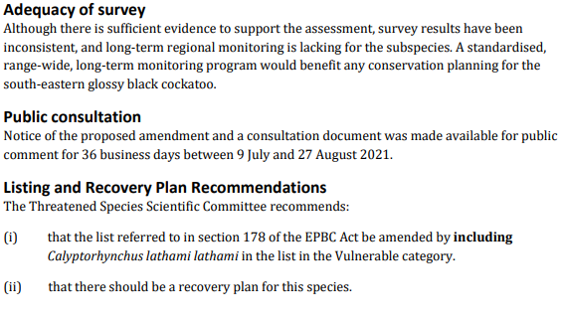

Threatened Species Scientific Committee

