Australian Capital Territory
Planning and Development (Technical Amendment—Lawson) Plan Variation 2023 (No 1)

Notifiable instrument NI2023—645
Technical Amendment No 2023-09
made under the
Planning and Development Act 2007, s 89 (Making technical amendments)

- Name of instrument
This instrument is the Planning and Development (Technical Amendment—Lawson) Plan Variation 2023 (No 1).
2 Commencement
This instrument commences on the day after its notification day.
3 Technical amendment
I am satisfied under section 89 (1) (a) of the Planning and Development Act 2007 that the Lawson plan variation is a technical amendment to the Territory Plan.
4 Dictionary
In this instrument:
Lawson plan variation means the technical amendment to the Territory Plan, variation 2023-09, in the schedule.
Note: No consultation was required in relation to the Lawson plan variation under the Act, s 87.
Freya O’Brien
Delegate of the planning and land authority
17 October 2023

Planning & Development Act 2007

Technical Amendment
to the Territory Plan
Variation 2023-09

Future urban area variation and changes to the Lawson Precinct Map and Code

October 2023

This page is left intentionally blank

Table of Contents
1. INTRODUCTION 4
1.1 Purpose 4
1.2 Public consultation 4
1.3 National Capital Authority 4
1.4 Process 4
1.5 Types of technical amendments under the Act 5
2. EXPLANATION 6
2.1 Territory Plan Map 6
2.2 Lawson Precinct Map and Code 8
3. TECHNICAL AMENDMENT 11
3.1 Territory Plan Map 11
3.2 Lawson Precinct Map and Code 12

This page is left intentionally blank
- INTRODUCTION
  - Purpose
This technical amendment makes the following changes to the Territory Plan:
Territory Plan Map
- The Territory Plan map is varied to remove the future urban area overlay from land in the division of Lawson, as identified in Part 2 of this document.
Lawson Precinct Map and Code
- The Lawson Precinct Map and Code is amended to include ongoing provisions, as described in Part 2 of this document.

  - Public consultation
Under section 87(1)(c) of the Planning and Development Act 2007 (the Act) this type of technical amendment is not subject to public consultation.

  - National Capital Authority
The National Capital Authority does not need to be advised of this technical amendment as per 1.2.

  - Process
This technical amendment has been prepared in accordance with section 87 and made in accordance with section 89 of the Act.
  - Types of technical amendments under the Act
The following categories of technical amendments are provided under section 87 of the Act:
- Each of the following territory plan variations is a technical amendment for which no consultation is needed before it is made under section 89:
(a) a variation (an error variation) that –
- would not adversely affect anyone’s rights if approved; and
- has as its only object the correction of a formal error in the plan;
(b) a variation to change the boundary of a zone or overlay under section 90A (Rezoning – boundary changes);
(c) a variation, other than one to which subsection (2)(d) applies, in relation to an estate development plan under section 96 (Effect of approval of estate development plan);
(d) a variation required to bring the territory plan into line with the national capital plan;
(e) a variation to omit something that is obsolete or redundant in the territory plan.
- Each of the following territory plan variations is a technical amendment for which only limited public consultation is needed under section 90:
- a variation (a code variation) that –
- would only change a code; and
- is consistent with the policy purpose and policy framework of the code; and
- is not an error variation;
- a variation to change the boundary of a zone under section 90B (Rezoning – development encroaching on adjoining territory land);
- a variation in relation to a future urban area under section 90C (Technical amendments – future urban areas);
- a variation in relation to an estate development plan under section 96 (Effect of approval of estate development plan) if it incorporates an ongoing provision that was not included in the plan under
section 94(3)(g);
- a variation to clarify the language in the territory plan if it does not change the substance of the plan;
- a variation to relocate a provision within the territory plan if the substance of the provision is not changed.
TA2023-09 has been prepared in accordance with section 87(1)(c) of the Act.
- EXPLANATION
This part of the technical amendment document explains the changes to be made to the Territory Plan.
  - Territory Plan Map
Variation to the Territory Plan
The Territory Plan map is varied to identify the zones and overlays that apply to land ceasing to be in a future urban area.
Lawson - Existing Territory Plan Map
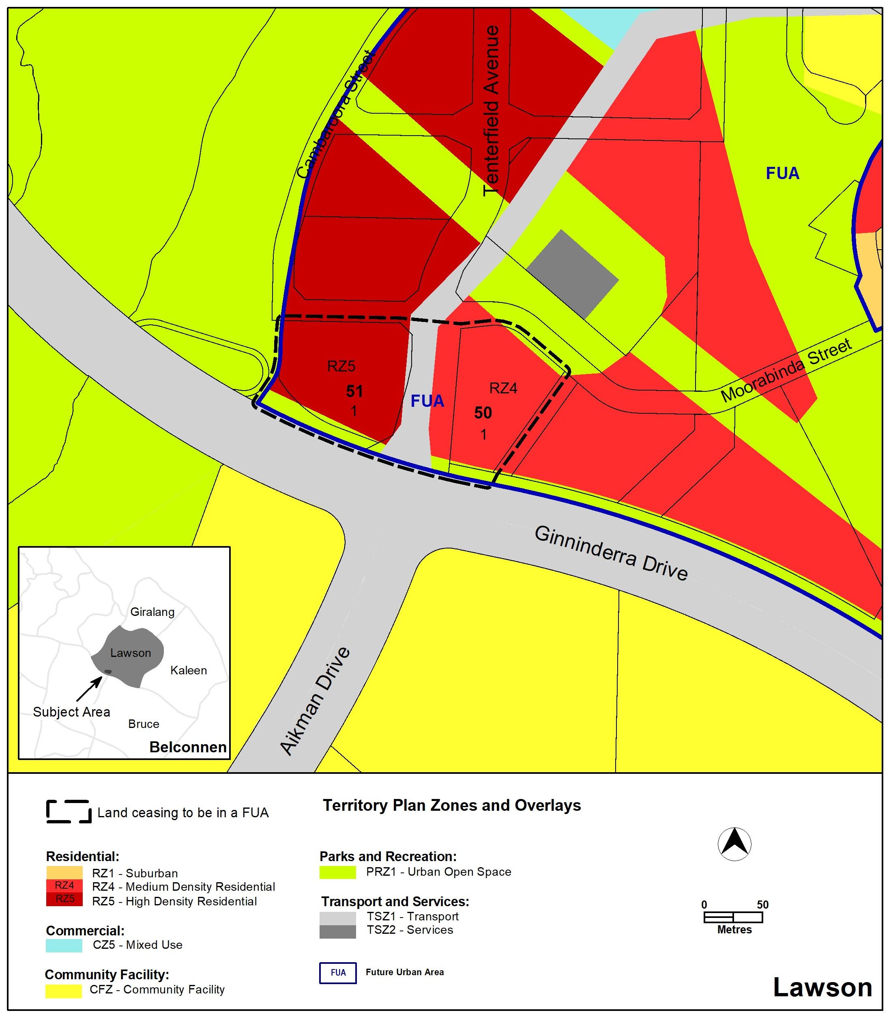

Lawson - Proposed Territory Plan Map
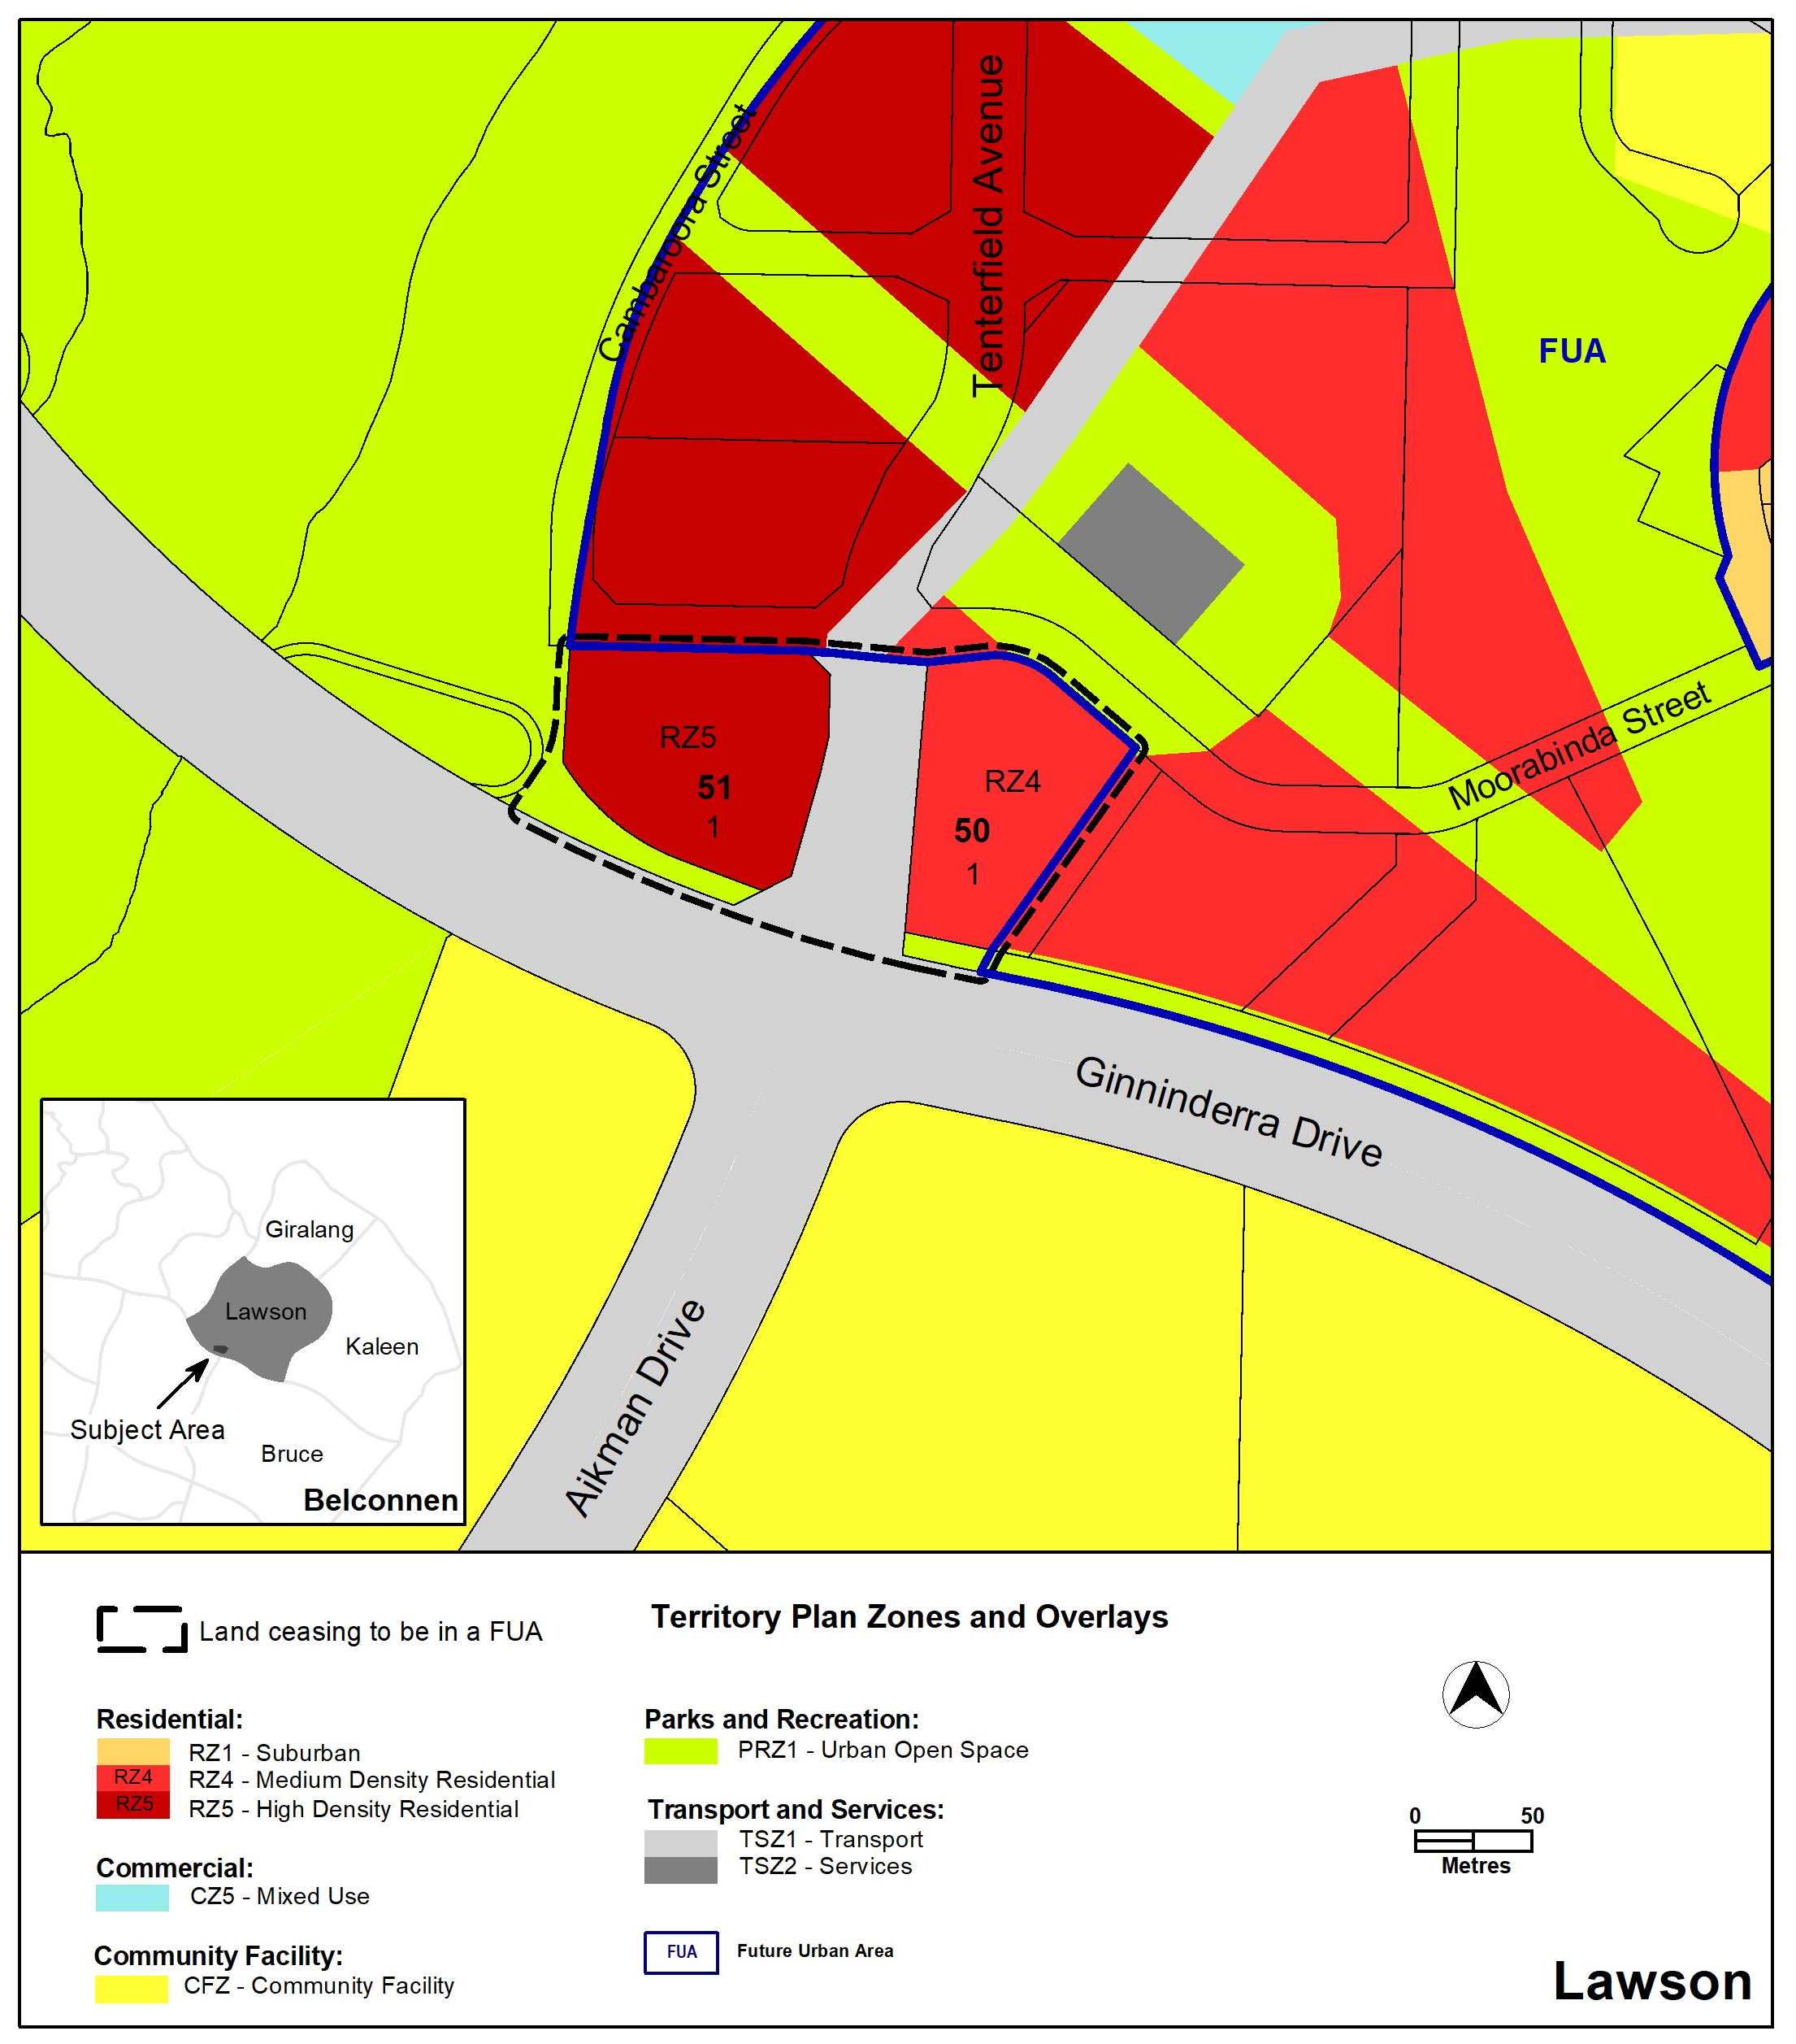

  - Lawson Precinct Map and Code
Variation to the Lawson Precinct Map and Code
The Lawson Precinct Map and Code is varied to incorporate rules and criteria and ongoing block specific provisions that are consistent with the approved estate development plan.

2.2.1 Lawson Precinct Map
Existing Lawson Precinct Map
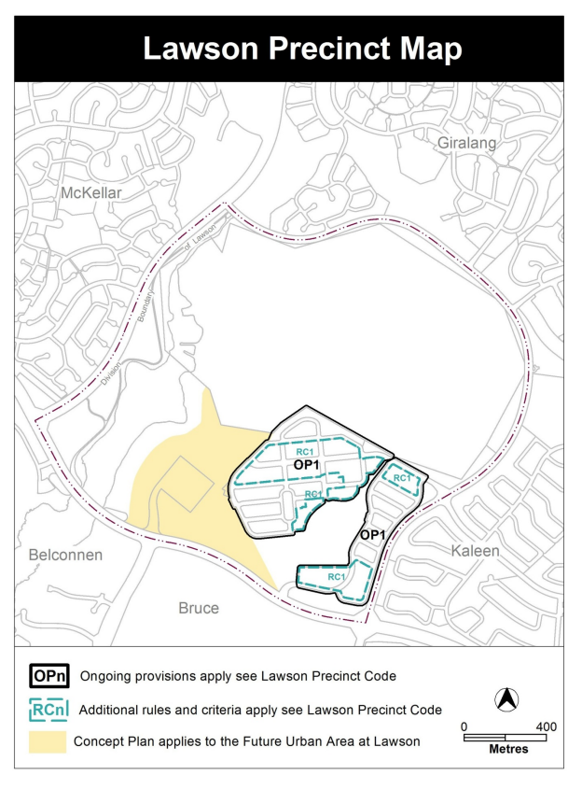
Proposed Lawson Precinct Map
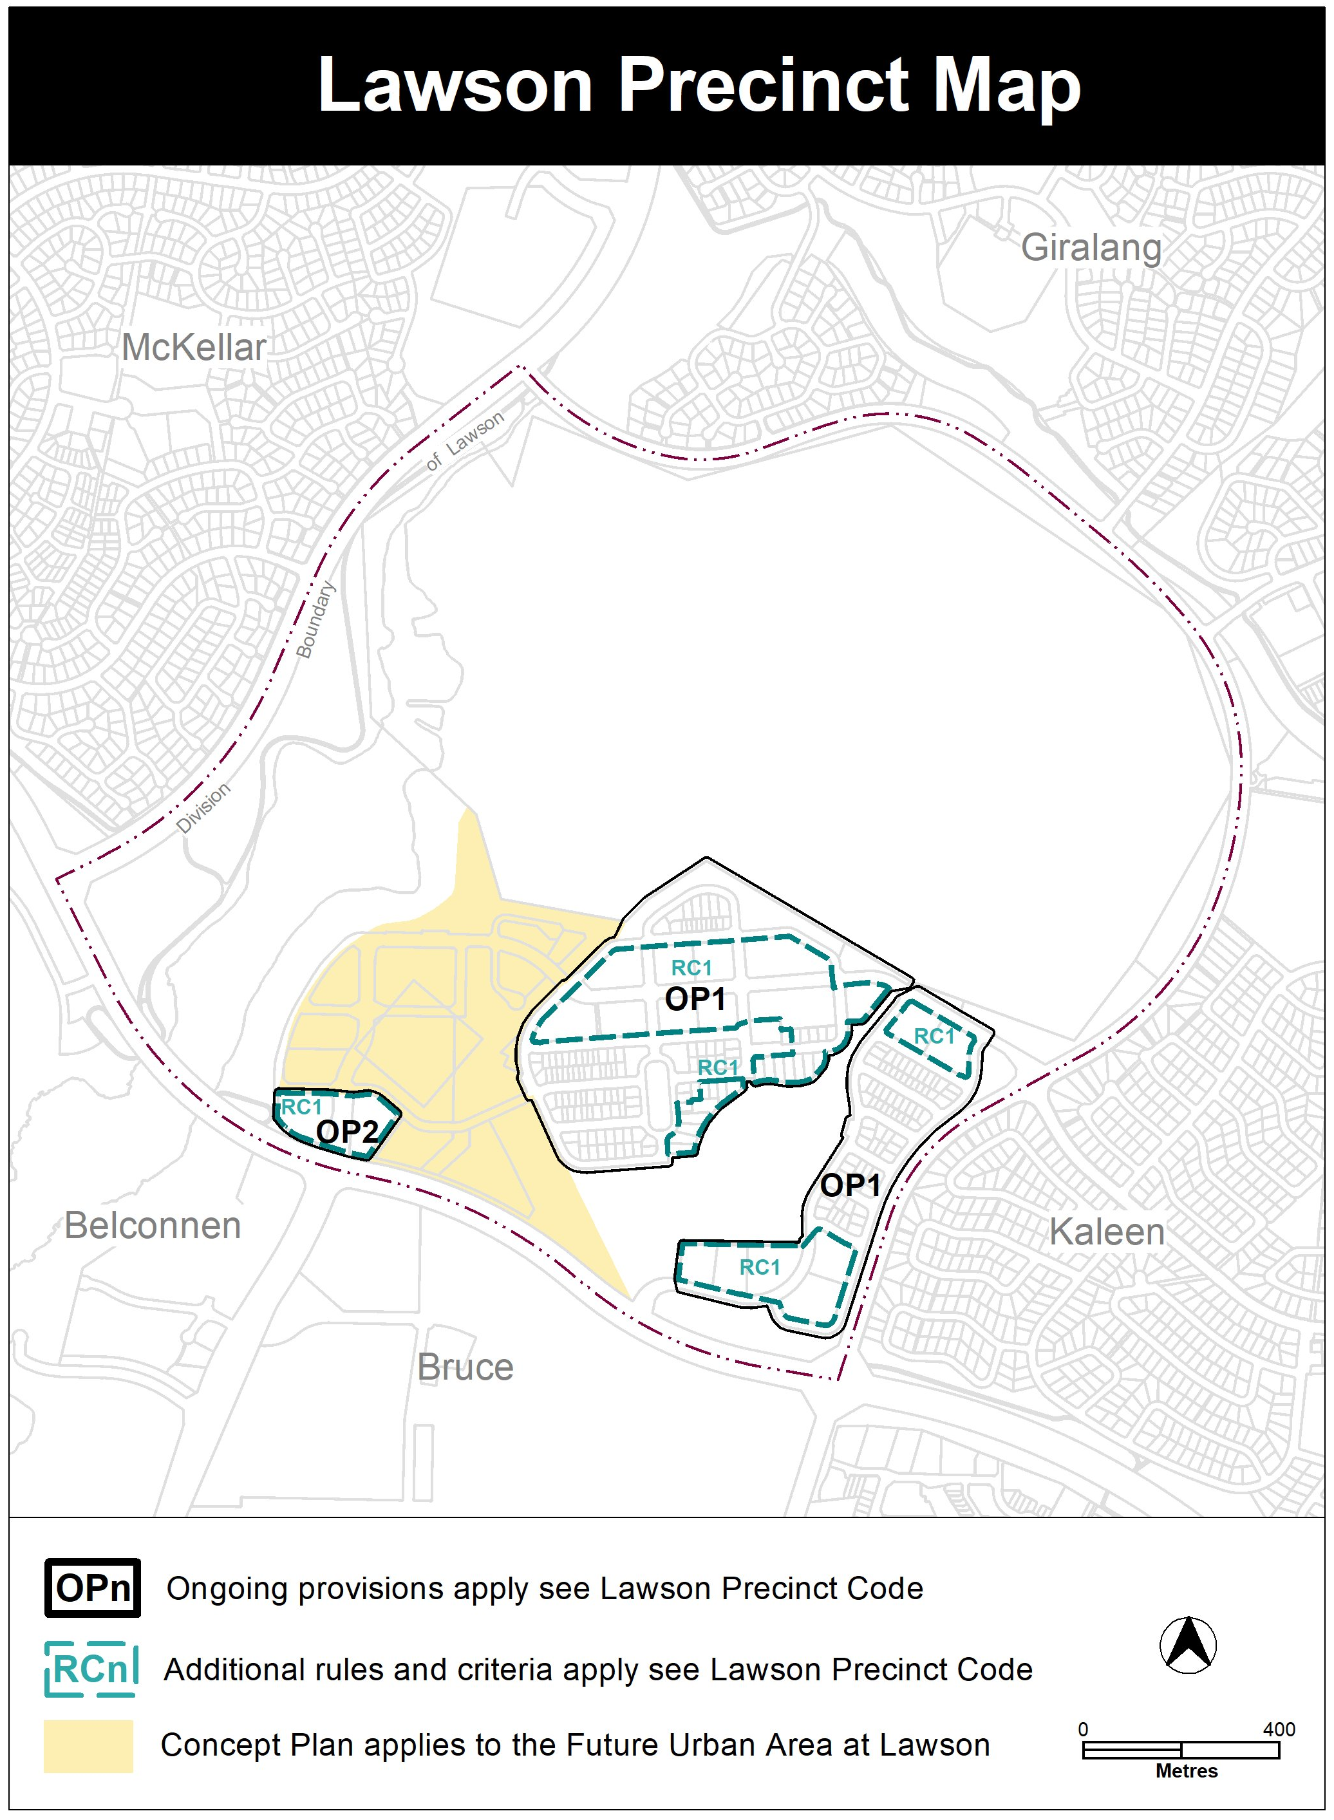

Lawson Precinct Code
This technical amendment makes the following changes to the Lawson Precinct Code:
- substitute rule R1 to include reference to new Figure 1a
- insert new rule R1a mandating building height requirements for specified areas in new Figure 1a
- insert new Element 3: Earthing requirements
- insert new rule R4 mandating earthing requirements for specified areas in new Figure 1a
- insert new Figure 4 to show ongoing provisions

- TECHNICAL AMENDMENT
This section of the technical amendment document provides the actual instructions for implementing the changes to the Territory Plan.
  - Territory Plan Map
- Territory Plan Map
The Territory Plan map is varied as indicated below to identify the zones and overlays that apply to the land ceasing to be in a future urban area.

  - Lawson Precinct Map and Code
- Lawson Precinct Map

Substitute
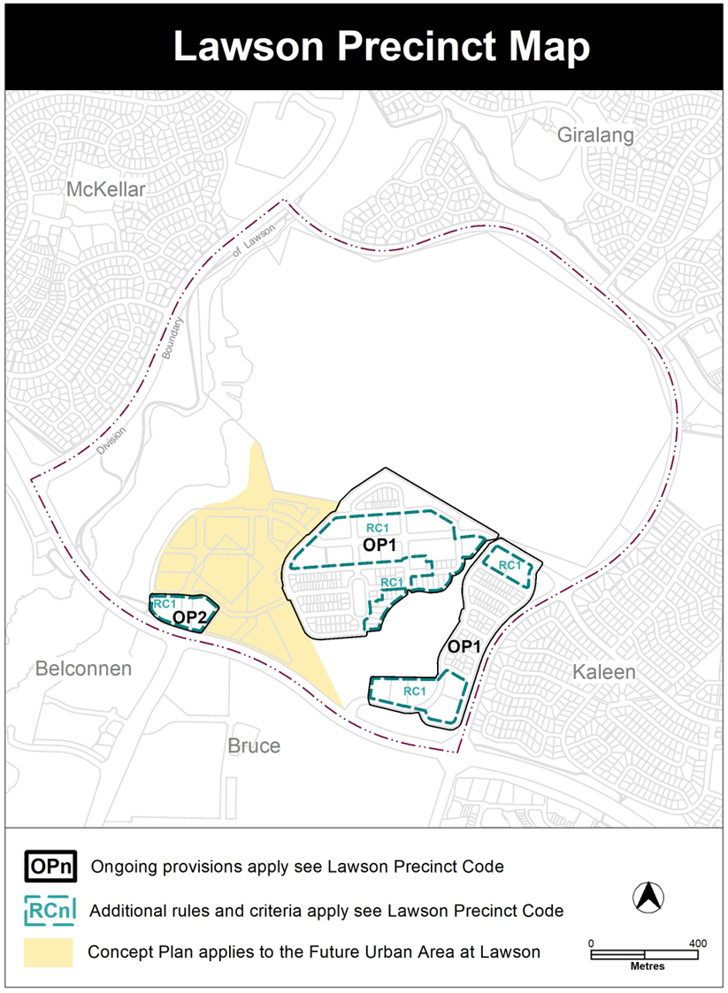
- Additional Rules and Criteria, RC1 – Lawson residential estate, Element 1: Building Heights, 1.1 Number of storeys, rule R1

Substitute

R1  The following rule applies to area A in Figure 1 and Figure 1a:  The minimum number of storeys for buildings is this location is 2. | This is a mandatory requirement. There is no applicable criterion.

- Additional Rules and Criteria, RC1 – Lawson residential estate, Element 1: Building Heights, 1.1 Number of storeys, new rule R1a

Insert

R1a  The following rule applies to area B in Figure 1a:  The minimum number of storeys for buildings in this location is 4 and maximum number of storeys is 6. | This is a mandatory requirement. There is no applicable criterion.

- Additional Rules and Criteria, RC1 – Lawson residential estate, new Element 3: Earthing requirements, 3.1 Earthing requirements, rule R4

Insert

Element 3: Earthing requirements

3.1 Earthing requirements
R4  This rule applies to blocks or parcels in locations identified in Figure 1a.  Additional earthing requirements to the satisfaction of Evoenergy. | This is a mandatory requirement. There is no applicable criterion.

- Additional Rules and Criteria, RC1 – Lawson residential estate, new Figure 1a

Insert after existing Figure 1

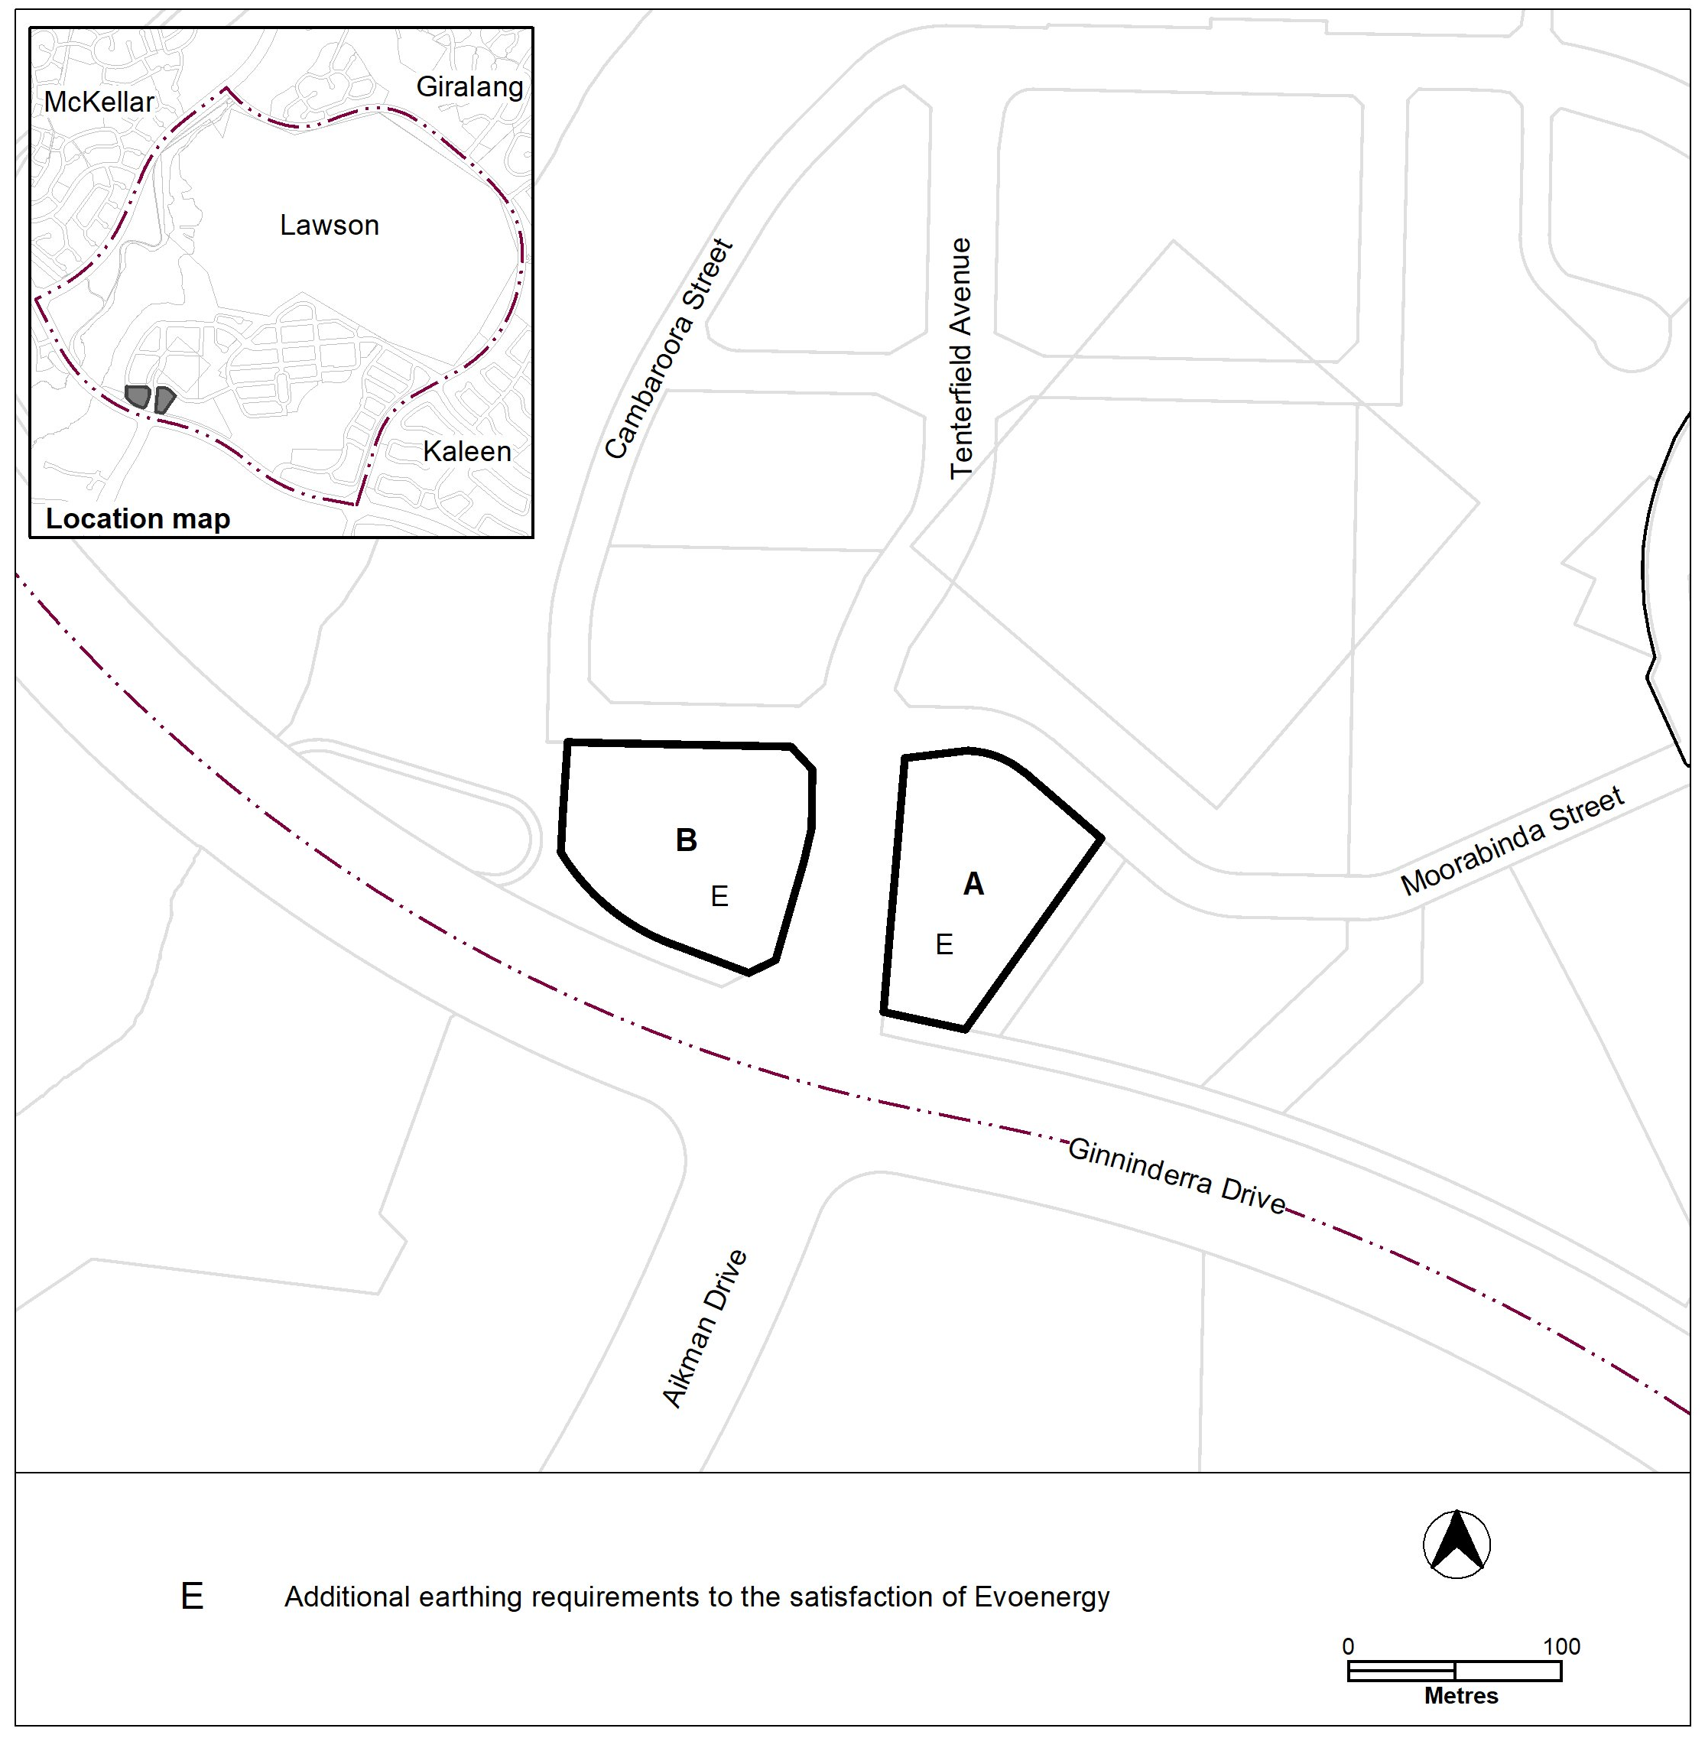

Figure 1a

- Other ongoing provisions, new OP2 – Lawson residential area

Insert

OP2 – Lawson residential area

This part applies to blocks and parcels identified in area OP2 shown on the Lawson Precinct Map.

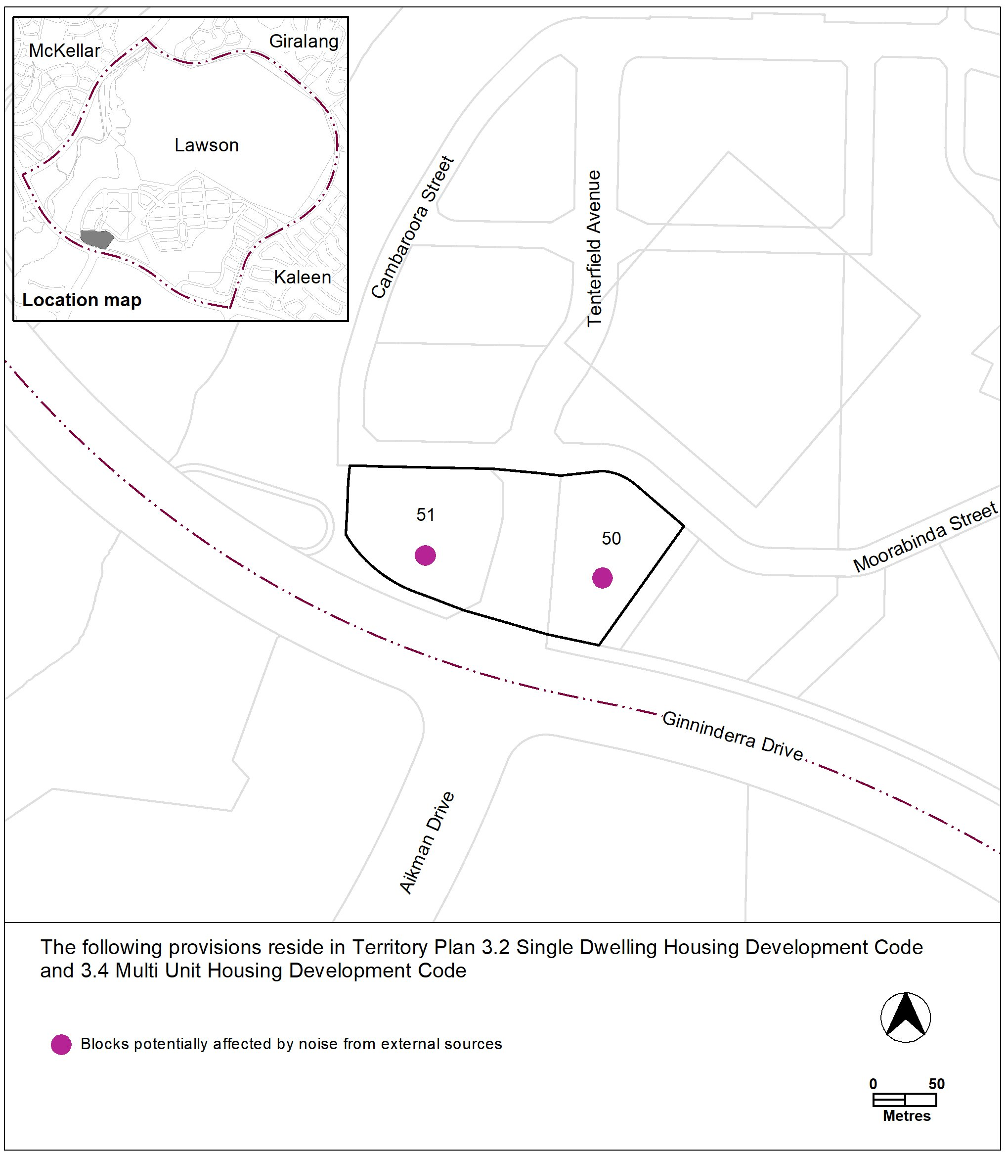
Figure 4

Interpretation service
