Australian Capital Territory
Corrections Management (Transitional Release Detainees Exiting TRC) Operating Procedure 2023
Notifiable instrument NI2023–89
made under the
Corrections Management Act 2007, s14 (Corrections policies and operating procedures)

1 Name of instrument
This instrument is the Corrections Management (Transitional Release Detainees Exiting TRC) Operating Procedure 2023.
2 Commencement
This instrument commences on the day after its notification day.
3 Operating Procedure
I make this operating procedure to facilitate the effective and efficient management of corrections services.

Ray Johnson ^{APM}
Commissioner
ACT Corrective Services
15 February 2023

OPERATING PROCEDURE | Transitional Release Detainees Exiting TRC
OPERATING PROCEDURE NO. | D26.15
SCOPE | Transitional Release
STATEMENT OF PURPOSE
To provide instructions to Custodial Officers working in the Transitional Release Centre (TRC) on the process of detainee’s exiting the TRC back into the community.
PROCEDURES
- 24 hours prior to Release
  - The TRC Custodial Officer must contact AMC Admissions to confirm discharge for the following day, and ensure all necessary paperwork has been prepared and completed by the Admissions Custodial Officer (CO) 2.
  - The TRC Custodial Officer must contact AMC Health to ensure all necessary discharge paperwork is completed, and arrange a mutually agreeable time to escort the detainee into AMC Health to complete the health discharge by a Senior Nurse and issue any medications and/or scripts.
  - The TRC Custodial Officer must contact JACS Finance to arrange for the discharge finance statement and to transfer detainee prison funds into an external account using the F1.F2: Detainee request for external payment form on CORIS. This form is to be scanned and emailed to finance at JACS_AMCFinance@act.gov.au.
  - TRC staff must confirm the detainee has transport arranged upon discharge from the TRC. If the detainee does not have transport arranged and there are no other suitable options, a cab charge can be organised through AMC Executive Support.

- Day of Release
  - The TRC Custodial Officer must contact AMC Admissions to confirm discharge and paperwork are ready, and must arrange to meet with the detainee and the CO4 at AMC Gatehouse Visits Reception. The CO4 must explain the conditions of release to the detainee and sign off on discharge paperwork (aim for discharge between 9-9:30 before AMC discharges).
  - The TRC Custodial Officer must ensure the detainee’s room is cleaned of any unnecessary items and rubbish, searched, and secured. The detainee must not re-enter the room once vacated.
  - The detainee must place all prison laundry items into plastic bags and leave in the TRC stairwell.
  - The TRC Custodial Officer must ensure the detainee returns their room key (if one was issued) and place the key back into the TRC key safe. If a detainee fails to return a room key, the TRC Custodial Officer must email AMC Facilities Management to arrange for a replacement key.
  - The TRC Custodial Officer must check the detainee’s personal property, including items in the valuables bag, against the property summary sheet on CORIS and print off the discharge property sheet. This must be signed by the detainee and TRC Custodial Officer.
  - Detainees must collect all of their personal property and take it with them upon discharge from the TRC. Uncollected property left at the TRC for more than six (6) months may be disposed of in accordance with section 28 of the Uncollected Goods Act 1996 (ACT).
  - Transitional Release staff MUST provide the detainee with the TRC and Reintegration Unit contact numbers. These Units can assist the detainee should they require assistance or support post-release.
  - Once the CO4 has discharged the detainee, the detainee must be escorted back to TRC to collect their personal property, and to be picked up by the agreed party. The detainee must not enter any pod outside of the TRC staff pod once officially released.

- Post Release
  - The TRC Custodial Officer must remove the detainee’s information from the muster book and TRC board.
  - The TRC Custodial Officer must note the detainee’s discharge in the logbook and highlight this entry.
  - The TRC Custodial Officer must ensure the detainee’s bagged laundry items are delivered to stores, who must return them to the AMC laundry.
  - A final search of the detainee’s vacated room must be conducted by the TRC Custodial Officer. The room must be secured on completion of the search.
  - The TRC Custodial Officer must case note on CORIS all relevant information about the discharge, including the room search, key return etc.

- Detainees returned to the AMC
  - If a detainee is returned to the AMC from the TRC in line with the Transitional Release – Breach of Transitional Release rules and/or conditions Operating Procedure, the Transitional Release Officer must complete section 2.2 to 2.5 and 3.1 to 3.5 of this operating procedure.

RELATED DOCUMENTS
- Transitional Release Policy
- Transitional Release – Breach of Transitional Release rules and/or conditions Operating Procedure

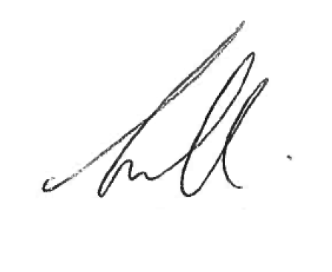
Narelle Pamplin
Assistant Commissioner Offender Reintegration
ACT Corrective Services
25 January 2023

Document details
Criteria | Details
Document title: | Transitional Release Detainees Exiting TRC Operating Procedure 2023
Document owner/approver: | Assistant Commissioner Offender Reintegration, ACT Corrective Services
Date effective: | The day after the notification date
Review date: | 3 years after the notification date
Responsible Officer: | Senior Director Offender Reintegration
Compliance: | This operating procedure reflects the requirements of the Corrections Management (Policy Framework) Policy 2022

Version Control
Version no. | Date | Description | Author
V1 | October-22 | First Issued | L Spulak

