Australian Capital Territory
Heritage (Decision about Provisional Registration of Majura House and Property) Notice 2024
Notifiable instrument NI2024–177
made under the
Heritage Act 2004, s 34 (Notice of decision about provisional registration)

1 Name of instrument
This instrument is the Heritage (Decision about Provisional Registration of Majura House and Property, Majura) Notice 2024.
2 Decision about provisional registration
On 9 April 2024, the ACT Heritage Council (the council) decided to provisionally register Majura House and Property, blocks 716 and 715, Majura (the place).
3 Registration details of the place
The registration details of the place are in the schedule.
4 Reasons for the decision
The council decided to provisionally register the place because it is satisfied on reasonable grounds that it is likely to have heritage significance as it is likely to meet one or more of the heritage significance criteria the Heritage Act 2004, section 10. A detailed statement of reasons, including an assessment against the heritage significance criteria, is provided in the schedule.
5 Date of provisional registration
The date of provisional registration is 10 April 2024 (being the day after the council entered into the heritage register the registration details for the place together with an indication that the registration is provisional).
6 Indication of the council’s intention
The council intends to decide whether to register the place under the Act, division 6.2 during the period of provisional registration.
7 Invitation to make written comments during public consultation period
(1) The council invites written comments about the registration of the place. Any written comments must be made within 4 weeks after the day this notice is notified.
(2) Written comments can be provided to the council by the following methods:
(a) mail to
The Secretary
ACT Heritage Council
GPO Box 158
CANBERRA ACT 2601
(b) email to heritage@act.gov.au

Duncan Marshall AM
Chair
ACT Heritage Council
9 April 2024

Schedule

(See sections 3 and 4)

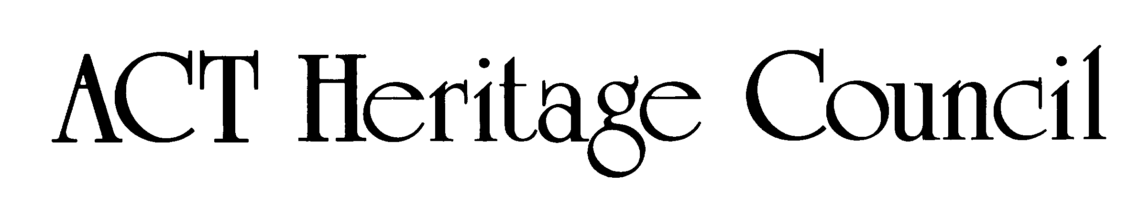
AUSTRALIAN CAPITAL TERRITORY
HERITAGE REGISTER
(Provisional Registration)

For the purposes of s33 of the Heritage Act 2004, a provisional entry to the heritage register has been prepared by the ACT Heritage Council for the following place:

MAJURA HOUSE AND PROPERTY

BLOCKS 716 & 715, MAJURA
DATE OF DECISION
9 April 2024
DATE OF PROVISIONAL REGISTRATION
10 April 2024 Notifiable Instrument: 2024–
PERIOD OF EFFECT OF PROVISIONAL REGISTRATION
Start Date: 10 April 2024 End Date: 9 September 2024

Extended Period (if applicable) Start Date ________ End Date ________

Copies of the Register Entry are available for inspection at ACT Heritage. For further information please contact:

The Secretary

ACT Heritage Council

GPO Box 158

CANBERRA ACT 2601

Telephone 13 22 81

This statement refers to the location of the place as required in s12(b) of the Heritage Act 2004.

LOCATION OF THE PLACE

Majura House and Property, Blocks 715 and 716, Majura.

This statement refers to the heritage significance of the place as required in s12(d) of the Heritage Act 2004.
STATEMENT OF HERITAGE SIGNIFICANCE

Majura House and Property together, are a rare surviving example of a mid-19th century worker’s homestead on a working farm. The construction of the original cottage was closely associated with the pastoral history of the very prominent Duntroon Estate, of which it formed a part. The house is one of the oldest surviving habitable structures in the ACT. After the formation of the Federal Capital Territory and the termination of the freehold status of the land, the Mayo family acquired the lease to Majura House and the surrounding lands. At that time several generations of the Mayo family had been employees of the Campbell family, who owned Duntroon, and family members had been resident in the house for some time. They and their descendants would remain at Majura House and Property through the twentieth century until it changed ownership in 1981. The Mayo family and the subsequent owners continued to use the Property for farming, thus creating a continuity with the 19th century history of the Duntroon Estate and early colonial settlement of the Majura Valley. The property demonstrates a way of life, custom and function as a continuing working farm and is the oldest surviving remnant of the original Duntroon Estate that has maintained this role and function.

This statement refers to the description of the place as required in s12 of the Heritage Act 2004. The attributes described in this section form part of the heritage significance of the place. For the purposes of s12 of the Heritage Act 2004, the boundary of the place is at Image 1.

DESCRIPTION OF PLACE

Majura House is a stone cottage with a slab-built annexe built on the Duntroon estate in the latter half of the 19th century. The rural setting of the property on Blocks 715 & 716 demonstrates continuity of land use between the 19th century pastoral context and the transition to the Federal Capital. The Property and associated buildings demonstrate the evolution of a family held rural property until it was sold in 1981.

Majura House and Property, consists of the following attributes of heritage significance:
- The original 19th century stone-walled house and the associated annexe made of vertical slab timbers;
- The 19th century brick-lined well;
- The open rural setting of Blocks 715 and 716;
- The block boundaries for Blocks 715 and 716 (formerly Block 59), Majura; and
- The 20th century remains of agricultural structures including the slab and galvanised iron woolshed, turkey shelters, old stock shed/dairy, single-bail dairy/milking shed, worker’s toilet, slab shed, old winnowing shed, chaffing hut, sheep dip, and the mature landscape setting around house. Other ruins and equipment remains add to the character, but are not considered important to the significance of the place.

CONSERVATION OBJECTIVE

The guiding conservation objective is that Majura House and Property shall be conserved and appropriately managed in a manner respecting its heritage significance.

The ACT Heritage Council may adopt heritage guidelines applicable to the place under s25 of the Heritage Act 2004.

For further information on guidelines applicable to the place, or for advice on proposed works or development, please contact ACT Heritage on 13 22 81.

REASON FOR PROVISIONAL REGISTRATION

The Council has assessed the Majura House and Property, Majura against the heritage significance criteria and is satisfied that the place is likely to have heritage significance when assessed against criteria [a, b, and d] under s10 of the Heritage Act 2004.
ASSESSMENT AGAINST THE HERITAGE SIGNIFICANCE CRITERIA

The Council’s assessment against the criteria specified in s10 of the Heritage Act 2004 is as follows.

In assessing the heritage significance of Majura House and Property, Majura, the Council considered:
- the original nomination and documentary evidence supplied by the nominator;
- the Council’s Heritage Assessment Policy (March 2018);
- information provided by site inspections on 2 December 2020, 15 June 2021 and 9 February 2024 by representatives of ACT Heritage and Heritage Council;
- the report by ACT Heritage titled, Background Information Majura House and Property, March 2024, containing photographs and information on history, description, condition and integrity; and

Pursuant to s10 of the Heritage Act, a place or object has heritage significance if it satisfies one or more of the following criteria. Future research may alter the findings of this assessment.
importance to the course or pattern of the ACT’s cultural or natural history;
The Council has assessed Majura House and Property against criterion (a) and is satisfied that the place is likely to meet this criterion.
The continuous occupation of Majura House and the use of the surrounding property for mixed agriculture demonstrates a continuity in function and land use from the time the house was constructed, originally as a worker’s residence on the Duntroon Estate, in the mid-19th century until the present. This continuous use is evident in the physical fabric of the house and outbuildings and is important for illustrating the pre-Federal Capital Territory origins of Canberra, continuing into its significant role in primary production on the periphery of the Capital that helped support the city's development. The tradition of mixed agriculture is a link to the early farming legacy of the ACT region, first established with the grants of lands by the Crown to Robert Campbell, the basis upon which the Duntroon Estate was established.
The surviving stone and timber structure of Majura House has high significance as the oldest surviving habitable structure in the Majura Valley and one of the oldest in the ACT as well as evincing continual use and upgrades over time which characterise the growth and expansion of small-holding farms as they became more successful with time. Although the exact date of construction for Majura House is not known, it was most likely built sometime between 1840 and 1860. The significance of the house lies not in its formal architectural merit but as evidence of rural vernacular architecture, and its relationship to the structures on site which together evince the traditions of change and subsistence mixed agriculture which continue to be strong on the property. The well, which may represent a rare surviving example of its type, supplied water to the house and is representative of the 19th century lifestyle.
Majura House and Property is representative of worker’s residences on the formative land grant that established European settlement in the area, the Duntroon Estate. Early colonial settlement in the Canberra region consisted of a number of large rural estates, of which Duntroon was one of the oldest, largest and most prominent. The Campbells of Duntroon are known to have settled their employees on leased tracts of land within the estate. Majura House was one such residence.
The current boundaries of the Majura House property reflect the transition of the lease from a holding within the larger Duntroon estate to the smaller lease upon formation of the Federal Capital Territory. Continuity is maintained at this time by the continued residence of the Mayo family, which meant that there was little change in the land use and function. The block division reflected the blocks that the family had been farming prior to formation of the FCT. Although the property has since been intersected by the Majura Parkway the outer boundaries of the two blocks are otherwise unchanged from what was shown on plans showing the original divisions of the Federal Capital Territory.
The open rural setting of the associated lease is reflective of the continual land use for mixed agricultural purposes since the early 1830s. Moreover, various structures built upon the property are testament to the evolution of a rural property in the ACT from the 19th Century up until the current day.
has uncommon, rare or endangered aspects of the ACT’s cultural or natural history;
The Council has assessed Majura House and Property against criterion (b) and is satisfied that the place is likely to meet this criterion.
The original vernacular structure of Majura House and its continuing presence within a working farming landscape serve as a demonstrable link to the rural lifestyle that was characteristic of the Canberra region in the 19th century. The Campbells of Duntroon made a significant contribution to the development of the ACT and the environment. Majura House and Property clearly demonstrates the role of farming in the region since the early 19th century. These working properties are increasingly rare and the integrity of Majura House and Property create a unique site with high integrity. Very few comparable examples of working rural homesteads exist in Canberra today.
Comparable examples are increasingly uncommon and are becoming endangered in the ACT and surrounding area, particularly as Canberra continues to expand. The collection of structures onsite such as the dairy, well and woolshed, demonstrate a distinctive way of life that has existed at this location for over 180 years. This length of association stems from the early 19th century settlement of the Campbell family, their tenants and more recent owners to use the land to run sheep and grow crops well into the 21st century. The property provides evidence of behaviours, lifestyle and routines of farming life and associated land uses still in continuous use today. Once common land use practices in the area, the property is now a rare and remarkably intact example of the early farming practices of working families in the ACT.
In comparison to Majura House and Property, Mugga Mugga (c.1838) and Blundells Cottage (c. 1859) are surviving examples of other rural homesteads on the former Duntroon Estate. However, Majura House and Property is the only example that has been both continuously occupied and continues to maintain its original function as a homestead associated with a farming property. Other rural homesteads have disappeared or do not retain heritage significance due to their ruinous state, such as Majura Stone Cottage. Duntroon Dairy (1832), Duntroon House (1833) and the Oaks (1837) are other surviving examples of buildings associated with the Duntroon Estate, but they had very different functions compared to that of the worker’s cottages.
Early buildings were also constructed within the Canberra region outside of the Duntroon Estate. Woden Homestead (c. 1832) shares common elements of heritage importance with Majura House and Property. In both cases, the structures are still occupied and remain as part of functioning farms. However, Woden Homestead developed as the main homestead associated with a large pastoral estate not a worker’s cottage like Majura House and Property, thus each place in its turn represents a different social class in 19th century rural lifestyle. Other early- to mid-19th century buildings survive on former rural estates in the region, such as Lanyon (c. 1830s) and Tuggeranong (barn c. 1840), but they are not residences that demonstrate the same continuity with the working-class pastoral origins as Majura House and Property.
potential to yield important information that will contribute to an understanding of the ACT’s cultural or natural history;
The Council has assessed Majura House and Property against criterion (c) and is not satisfied that the place is likely to meet this criterion.
There is insufficient evidence before the Council to suggest that the place will provide significant new information contributing to a wider understanding of the ACT’s cultural or natural history. While the site contains elements of potential cultural remains such as the demolished kitchen, possible military use of the site as evidenced by fox holes, possible pastoral furrows, and rubbish and residue from 180 years of farming use, there is nothing to suggest that the physical remains of these functions could contribute further information to our understanding of the ACT’s cultural history.
importance in demonstrating the principal characteristics of a class of cultural or natural places or objects;
The Council has assessed Majura House and Property against criterion (d) and is satisfied that the place is likely to meet this criterion.
This place is representative of the principal class of a small-scale rural property used for mixed agriculture, that demonstrates both change and continuity over an extended period from the mid-19th century until the late-20th century. It is particularly important in demonstrating a rural continuity between the pre-Federal Capital Territory pastoral leases and the rural leases that were then obtained by the family already resident on the land.
Majura House and Property demonstrate the characteristics of its class through the vernacular architecture of a mid-19th century rural worker’s homestead, reflecting the traditions of self-sufficiency and adaptation of the tenants. Whilst there have been alterations over time to the original homestead its integrity remains as a pioneer structure of continuous use and occupation, demonstrating an unusual example of its class.
As a rare example of a mixed agricultural property dating from the 19th century to the present, Majura House and Property represent the development of agricultural, engineering and architectural practices in the Majura Valley.
importance in exhibiting particular aesthetic characteristics valued by the ACT community or a cultural group in the ACT;
The Council has assessed Majura House and Property against criterion (e) and is not satisfied that the place is likely to meet this criterion.
There is no evidence before the Council indicating the ACT community or a cultural group in the ACT values any extant aesthetic qualities of Majura House and Property. The property is not publicly accessible and, although the original part of the homestead remains standing, at present it is largely obscured from view by a series of extensions that have surrounded the original cottage.
importance in demonstrating a high degree of creative or technical achievement for a particular period;
The Council has assessed Majura House and Property against criterion (f) and is not satisfied that the place is likely to meet this criterion.
Vernacular architecture utilising locally available resources, such as cut stone and slab timbers, were relatively commonly built by 19th Century colonial settlers. This vernacular architecture tended to be of fairly simple design and, while resourceful for the time, there is no indication that it included significant examples of creative or technical achievements.
has a strong or special association with the ACT community, or a cultural group in the ACT for social, cultural or spiritual reasons;
The Council has assessed Majura House and Property against criterion (g) and is not satisfied that the place is likely to meet this criterion.
There is no evidence before the Council suggesting a strong or special association between Majura House and Property and the ACT Community or a cultural group in the ACT. For the purposes of this criterion, the ACT community is taken to encompass the broad community of the ACT. Moreover, the attachment of the ACT community to the place must be demonstrable or valued, and enduring. At this time, it cannot be demonstrated that Majura House it is well known within the broader ACT community.
has a special association with the life or work of a person, or people, important to the history of the ACT.
The Council has assessed Majura House and Property against criterion (h) and is not satisfied that the place is likely to meet this criterion.
The Mayo family were associated with Majura House and property for over 120 years and their association is important to the history of the place. However, there is no evidence that suggests that the association is of greater significance than that of other families who settled in the ACT region in the 19th Century. The family did not shape or influence the pattern of development or the course of the history of the ACT.
The association with the Campbell family is strong however the Campbells owned much of the land in the valley, and this Property holds no special association to the Campbells that make it significant under this criterion.
SITE PLAN
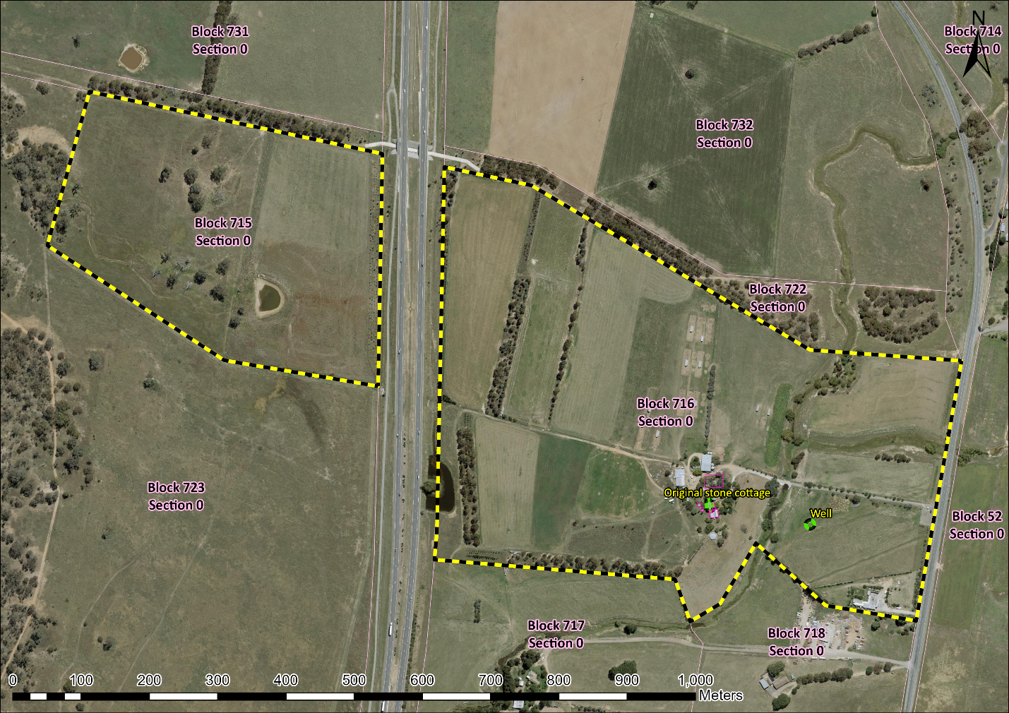
Image 1 Majura House and Property site boundary

