Australian Capital Territory

**Gaming Machine (Peripheral Equipment) Approval 2024 (No 5)**

**Notifiable instrument NI2024-190**

made under the

**Gaming Machine Act 2004, section 69 (Approval of gaming machines and peripheral equipment)**

**1 Name of instrument**

This instrument is the *Gaming Machine (Peripheral Equipment) Approval 2024 (No 5)*

**2 Commencement**

This instrument commences the day after the date of notification.

1. **Approval**

I approve the peripheral equipment described in the attached Schedule to this instrument.

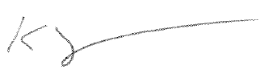

Karl Somers

Delegate

ACT Gambling and Racing Commission

15 April 2024

For further information please contact the approved supplier.

|  |  |
| --- | --- |
| IGT (Australia) Pty Ltd | |
| Subject: New Rev8 Link Progressive Jackpot System | |
| System Name | Standard LPJS – Hyper Hits Respins Link |
| Specification Numbers | 18.YA020 |
| System Name: | Rev 8 (T2E) Link Progressive Jackpot Controller  System |
| Jackpot Theme: | Hyper Hits Respins |
| Application Reference Number | 18-A1394/S01 |