Australian Capital Territory
Casino Control Regulation 2006
SL2006-8
made under the
Casino Control Act 2006
Republication No 2
Effective: 2 October 2018
Republication date: 2 October 2018
Last amendment made by A2018-33

About this republication
The republished law
This is a republication of the Casino Control Regulation 2006, made under the Casino Control Act 2006 (including any amendment made under the Legislation Act 2001, part 11.3 (Editorial changes)) as in force on 2 October 2018. It also includes any commencement, amendment, repeal or expiry affecting this republished law to 2 October 2018.
The legislation history and amendment history of the republished law are set out in endnotes 3 and 4.
Kinds of republications
The Parliamentary Counsel’s Office prepares 2 kinds of republications of ACT laws (see the ACT legislation register at www.legislation.act.gov.au):
- authorised republications to which the Legislation Act 2001 applies
- unauthorised republications.
The status of this republication appears on the bottom of each page.
Editorial changes
The Legislation Act 2001, part 11.3 authorises the Parliamentary Counsel to make editorial amendments and other changes of a formal nature when preparing a law for republication. Editorial changes do not change the effect of the law, but have effect as if they had been made by an Act commencing on the republication date (see Legislation Act 2001, s 115 and s 117). The changes are made if the Parliamentary Counsel considers they are desirable to bring the law into line, or more closely into line, with current legislative drafting practice.
This republication does not include amendments made under part 11.3 (see endnote 1).
Uncommenced provisions and amendments
If a provision of the republished law has not commenced, the symbol U appears immediately before the provision heading. Any uncommenced amendments that affect this republished law are accessible on the ACT legislation register (www.legislation.act.gov.au). For more information, see the home page for this law on the register.
Modifications
If a provision of the republished law is affected by a current modification, the symbol M appears immediately before the provision heading. The text of the modifying provision appears in the endnotes. For the legal status of modifications, see the Legislation Act 2001, section 95.
Penalties
At the republication date, the value of a penalty unit for an offence against this law is $150 for an individual and $750 for a corporation (see Legislation Act 2001, s 133).

Australian Capital Territory
Casino Control Regulation 2006
made under the
Casino Control Act 2006

Contents
Page
1 Name of regulation 2
3 Dictionary 2
4 Notes 2
5 Prescribed functions—Act, s 41 and dict, def prescribed function 2
6 Area to be designated casino—Act, s 62 (1) 3
7 Core trading hours—Act, s 68 (4), def core trading hours 4
7A Document of identification—Act, s 78, def document of identification, par (b) 4
8 Kinds of cheque to be accepted—Act, s 112 (1) (b) (i) 4
9 How to accept cheque—Act, s 112 (1) (b) (ii) 5
10 Amount prescribed for scheme—Act, dict, def commission-based player scheme, par (b) 5
Schedule 1 Designation of casino 6
Part 1.1 First floor 6
Part 1.2 Ground floor 7
Part 1.3 Basement 8
Dictionary 9
Endnotes
1 About the endnotes 10
2 Abbreviation key 10
3 Legislation history 11
4 Amendment history 11
5 Earlier republications 12

Australian Capital Territory
Casino Control Regulation 2006

made under the
Casino Control Act 2006

1 Name of regulation
This regulation is the Casino Control Regulation 2006.

3 Dictionary
The dictionary at the end of this regulation is part of this regulation.
Note 1 The dictionary at the end of this regulation defines certain terms used in this regulation, and includes references (signpost definitions) to other terms defined elsewhere.
For example, the signpost definition ‘commission-based player scheme—see the Act, dictionary’ means that the term ‘commission-based player scheme’ is defined in that dictionary and the definition applies to this regulation.
Note 2 A definition in the dictionary (including a signpost definition) applies to the entire regulation unless the definition, or another provision of the regulation, provides otherwise or the contrary intention otherwise appears (see Legislation Act, s 155 and s 156 (1)).

4 Notes
A note included in this regulation is explanatory and is not part of this regulation.
Note See the Legislation Act, s 127 (1), (4) and (5) for the legal status of notes.

5 Prescribed functions—Act, s 41 and dict, def prescribed function
The following functions are prescribed as functions that may be performed by a casino employee in relation to the operation of the casino:

(a) the conduct of gaming in the casino;

(b) the organisation, administration and management of commission-based player schemes;

(c) the organisation and conduct of casino marketing schemes;

(d) the storage, exchange and counting of money and chips in the casino, other than in relation to the supply of food or beverages;

(e) the movement of money and chips in the casino, other than in relation to the supply of food or beverages;

(f) the storage of gaming equipment in the casino;

(g) the security of the casino and its operations;

(h) the surveillance of the casino and its operations;

(i) the use and storage of security equipment;

(j) the use of surveillance equipment;

(k) the storage of surveillance equipment;

(l) computer systems maintenance and support in the casino;

(m) the unsupervised maintenance and repair of gaming equipment;

(n) the unsupervised maintenance and repair of security and surveillance equipment in the casino;

(o) the unsupervised access to administrative and financial information relating to the operation of the casino other than access by external auditors or company directors of the licensee or of the licensee’s beneficial owners;

(p) the supervision of anything mentioned in paragraphs (a) to (o);

(q) management roles in the casino, including functions that include making decisions that involve the exercise of discretions that substantially affect, or could affect, the operation of the casino.

6 Area to be designated casino—Act, s 62 (1)
The areas outlined in bold on the plan in schedule 1, part 1.1, part 1.2 and part 1.3 are designated to be the casino.

7 Core trading hours—Act, s 68 (4), def core trading hours
The core trading hours are between midnight and 2 am and between 5 pm and midnight on any day.

7A Document of identification—Act, s 78, def document of identification, par (b)

(1) An Australia Post Keypass ID is prescribed.

(2) In this section:
Australia Post Keypass ID, for a person, means identification issued by Australia Post that includes the following about the person:

(a) the name of the person;

(b) a photo of the person;

(c) the date of birth of the person.
Note An Australia Post Keypass ID may be in electronic form (see Legislation Act, dict, pt 1, def document).

8 Kinds of cheque to be accepted—Act, s 112 (1) (b) (i)
A cheque that meets the following requirements is prescribed:

(a) the cheque is drawn in favour of the casino licensee or the person who presents the cheque;

(b) the cheque is not postdated;

(c) for a redeeming cheque—the cheque is not dated earlier than the date of the most recent of the cheques to be redeemed.

9 How to accept cheque—Act, s 112 (1) (b) (ii)
A casino licensee who accepts a cheque must—

(a) be satisfied about the identity of the person who presents the cheque; and

(b) keep a record of—

(i) any proof of identity that the person shows to the licensee; and

(ii) any inquiry the licensee makes to verify the person’s identity; and

(c) comply with any control procedures for accepting cheques.

10 Amount prescribed for scheme—Act, dict, def commission-based player scheme, par (b)
The prescribed amount is $1 500.

Schedule 1 Designation of casino
(see s 6)

Part 1.1 First floor
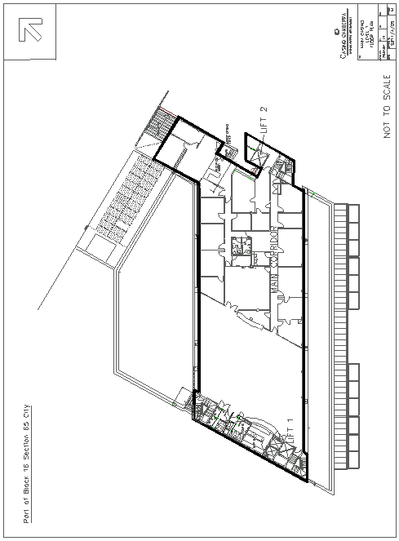

Part 1.2 Ground floor
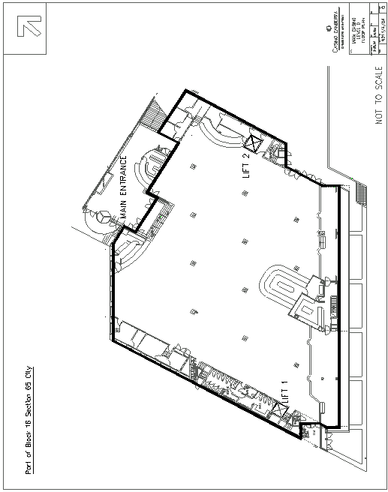

Part 1.3 Basement
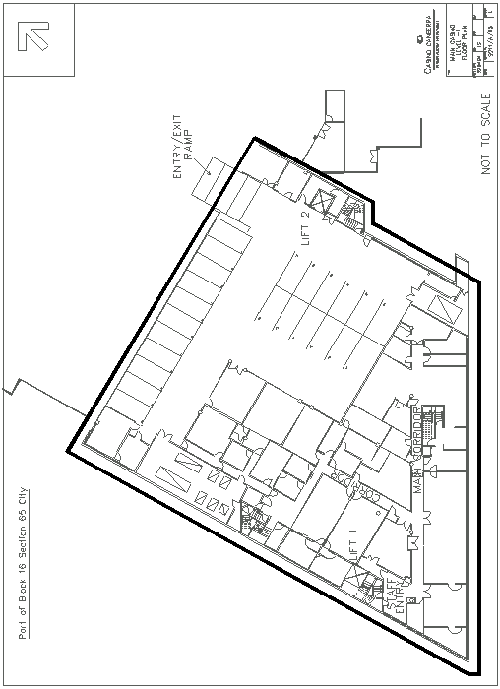

Dictionary
(see s 3)
Note 1 The Legislation Act contains definitions and other provisions relevant to this regulation.
Note 2 For example, the Legislation Act, dict, pt 1, defines the following terms:
• Act
• function
• must (see s 146)
• prescribed.
Note 3 Terms used in this regulation have the same meaning that they have in the Casino Control Act 2006 (see Legislation Act, s 148). For example, the following terms are defined in the Casino Control Act 2006, dict:
• control procedures
• gaming
• gaming equipment.
commission-based player scheme—see the Act, dictionary.
prescribed function—see the Act, dictionary.

Endnotes
1 About the endnotes
Amending and modifying laws are annotated in the legislation history and the amendment history. Current modifications are not included in the republished law but are set out in the endnotes.
Not all editorial amendments made under the Legislation Act 2001, part 11.3 are annotated in the amendment history. Full details of any amendments can be obtained from the Parliamentary Counsel’s Office.
Uncommenced amending laws are not included in the republished law. The details of these laws are underlined in the legislation history. Uncommenced expiries are underlined in the legislation history and amendment history.
If all the provisions of the law have been renumbered, a table of renumbered provisions gives details of previous and current numbering.
The endnotes also include a table of earlier republications.
2 Abbreviation key

A = Act | NI = Notifiable instrument
AF = Approved form | o = order
am = amended | om = omitted/repealed
amdt = amendment | ord = ordinance
AR = Assembly resolution | orig = original
ch = chapter | par = paragraph/subparagraph
CN = Commencement notice | pres = present
def = definition | prev = previous
DI = Disallowable instrument | (prev...) = previously
dict = dictionary | pt = part
disallowed = disallowed by the Legislative | r = rule/subrule
Assembly | reloc = relocated
div = division | renum = renumbered
exp = expires/expired | R[X] = Republication No
Gaz = gazette | RI = reissue
hdg = heading | s = section/subsection
IA = Interpretation Act 1967 | sch = schedule
ins = inserted/added | sdiv = subdivision
LA = Legislation Act 2001 | SL = Subordinate law
LR = legislation register | sub = substituted
LRA = Legislation (Republication) Act 1996 | underlining = whole or part not commenced
mod = modified/modification | or to be expired

3 Legislation history
Casino Control Regulation 2006 SL2006-8
notified LR 21 March 2006
s 1, s 2 commenced 21 March 2006 (LA s 75 (1))
remainder commenced 1 May 2006 (s 2 and see Casino Control Act 2006 A2006-2, s 2 and CN2006-6)
as amended by
Red Tape Reduction Legislation Amendment Act 2018 A2018-33 pt 5
notified LR 25 September 2018
s 1, s 2 commenced 25 September 2018 (LA s 75 (1))
pt 5 commenced 2 October 2018 (s 2 (1))
4 Amendment history
Commencement
s 2 om LA s 89 (4)
Document of identification—Act, s 78, def document of identification, par (b)
s 7A ins A2018-33 s 74

5 Earlier republications
Some earlier republications were not numbered. The number in column 1 refers to the publication order.
Since 12 September 2001 every authorised republication has been published in electronic pdf format on the ACT legislation register. A selection of authorised republications have also been published in printed format. These republications are marked with an asterisk (*) in column 1. Electronic and printed versions of an authorised republication are identical.

Republication No and date | Effective | Last amendment made by | Republication for
R1  1 May 2006 | 1 May 2006–  1 Oct 2018 | not amended | new regulation

© Australian Capital Territory 2018

