Building (Asbestos Warning Notice Form) Approval 2025

approval statement for

Approved form AF2025-24

made under the

Building Act 2004, s 151 (Approved forms); and
Building (General) Regulation 2008, Section 18A (5) (Building approval applications—asbestos warning notices—Act, s 152 (3) (b)) and revokes 2017-82

1 Name of instrument

This instrument is the Building (Asbestos Warning Notice Form) Approval 2025*.

2 Commencement

This instrument commences 30 days after the day it is notified on the ACT legislation register.

3 Approval

The form below is approved as the asbestos warning notice for the Building (General) Regulation 2008, Section 18A. The wording in the form below may be varied to suit the relevant circumstances of a plan to which it applies, provided the varied wording has the same general meaning as the form below.

4 Brief explanatory statement

The Building (General) Regulation 2008, Section 18A and Section 151, in combination with this approved form, requires building certifiers to mark plans with an asbestos warning notice in the form approved herein, in the relevant Section 18A circumstances, before marking the plans with a building approval or with an amendment to a building approval. Section 18A also prohibits marking plans with the warning except as required under that section.
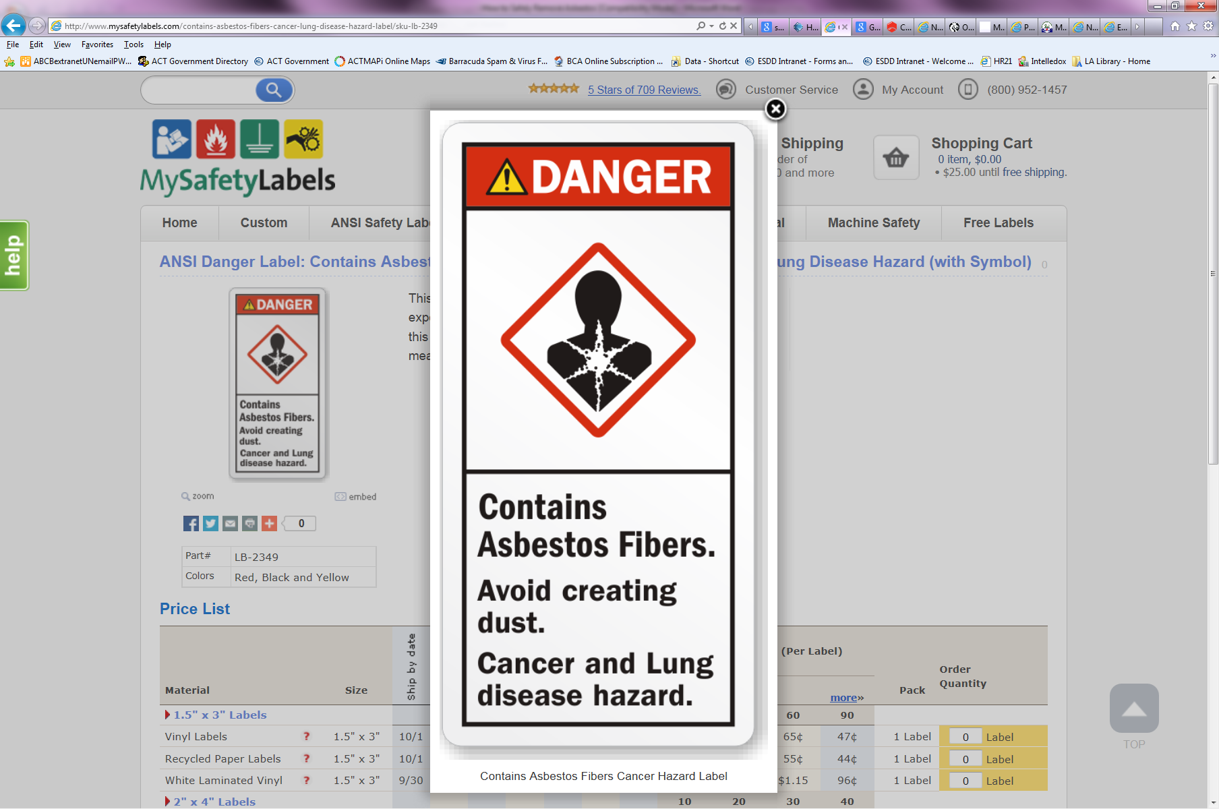
ASBESTOS
The building to which
this plan relates might
contain microscopic
loose asbestos fibres that may cause fatal disease if breathed in.

Nick Lhuede
ACT Construction Occupations Registrar
15 September 2025

Form, not less than 50 mm from top to bottom; red, black and white →

