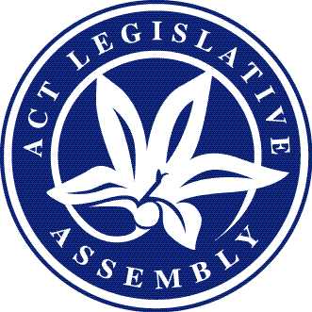

LEGISLATIVE ASSEMBLY FOR THE AUSTRALIAN CAPITAL TERRITORY
Application to broadcast, film or take photographs in the Assembly precincts*
approval statement for
Approved form AF2024-2
made under the
Legislative Assembly (Broadcasting) Act 2001—Section 10—Approved forms

1 Name of instrument
This instrument is the Application to broadcast, film or take photographs in the Assembly precincts.
2 Commencement
This instrument commences on the day after its notification.
3 Approval
The attached form, Application to broadcast, film or take photographs in the Assembly precincts, is approved and revokes the existing form AF2020-1.

Tom Duncan
Clerk of the Legislative Assembly

21 March 2024

