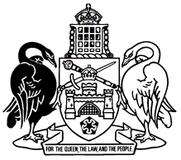

Human Rights Act 2004

Compatibility Statement

In accordance with section 37 of the Human Rights Act 2004 I have examined the Motor Accident Injuries Bill 2019. In my opinion the Bill, as presented to the Legislative Assembly, is consistent with the Human Rights Act 2004.

............................................................
Gordon Ramsay MLA
Attorney-General

