Australian Capital Territory

Road Transport (General) - Declaration that the road transport legislation does not apply to certain roads and road related areas 2002
(No 5)
Disallowable instrument DI2002—157
made under the
Road Transport (General) Act 1999, s12 (Power to include or exclude areas in road transport legislation)

I declare that the road transport legislation does not apply to the roads or road related areas used or impinged on by any competing vehicle participating in a ‘green’ special stage of the 2002 Light Car Club of Canberra Classic Rally on 17 August 2002.
For this declaration, the following definitions apply:
Competing vehicle means:
Any vehicle used for participating in a ‘green’ special stage of the 2002 Light Car Club of Canberra Classic Rally.
‘Green’ special stage means:
The period from the time when a special stage is declared to be active for rally competition until the time when course control for that special stage is declared closed.

Special stage means:
(a) The competitive route for the following special stages shown on Map 1, described as:

• Special stage 1 (SS1) – Cottage 5;

• 

Special stage 2 (SS2) – Oakey Creek I; and

• 

Special stage 6 (SS6) – Oakey Creek II;

(b) The competitive routes for the following special stage shown on Map 2, described as:

•
(c) The competitive route for the following special stage shown on Map 3, described as:

•
(d) The competitive route for the following special stages shown on Map 4, described as:

•
Special stage 5 (SS5) – Crusher;

Special stage 4 (SS4) – Padovans Reverse; and

Special stage 3 (SS3) – Blue Range I; and

•

Special stage 7 (SS7) – Blue Range II.

This declaration has effect during the competitive ‘green’ special stages of the 2002 Light Car Club of Canberra Classic Rally on 17 August 2002. Indicative start times for vehicles participating in each ‘green’ special stage and indicative start control closure times for each ‘green’ special stage are set out in the attached Itinerary.

Bill Wood Minister for Urban Services
14 August 2002

MAP 1

Competitive routes for:
•  Special Stage 1 (SS1) – Cottage 5
•  Special Stage 2 (SS2) – Oakey Creek I
•  Special Stage 6 (SS6) – Oakey Creek II

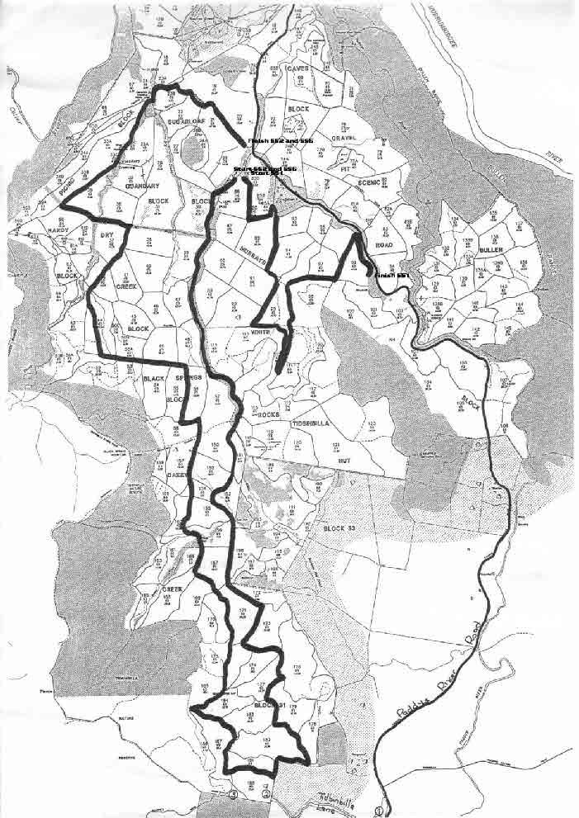
MAP 2

Competitive route for:
•  Special Stage 5 (SS5) – Crusher

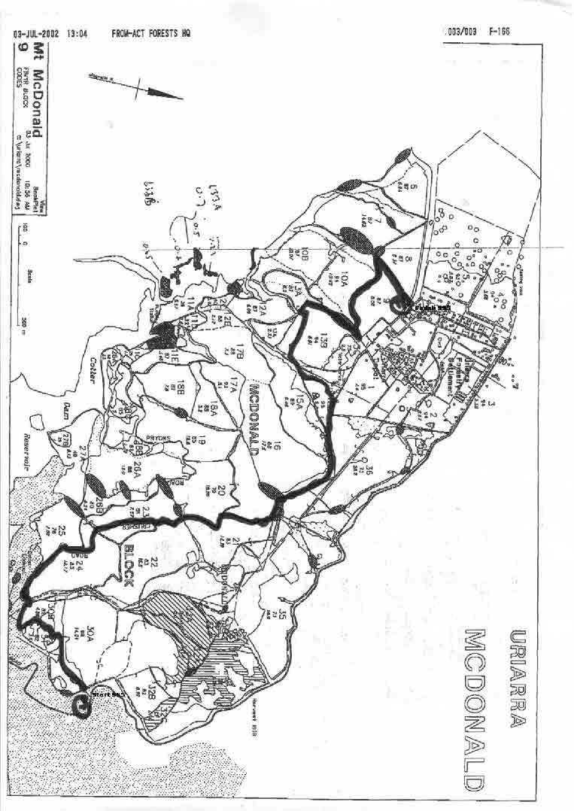
MAP 3

Competitive route for:
•  Special Stage 4 (SS4) – Padovans Reverse

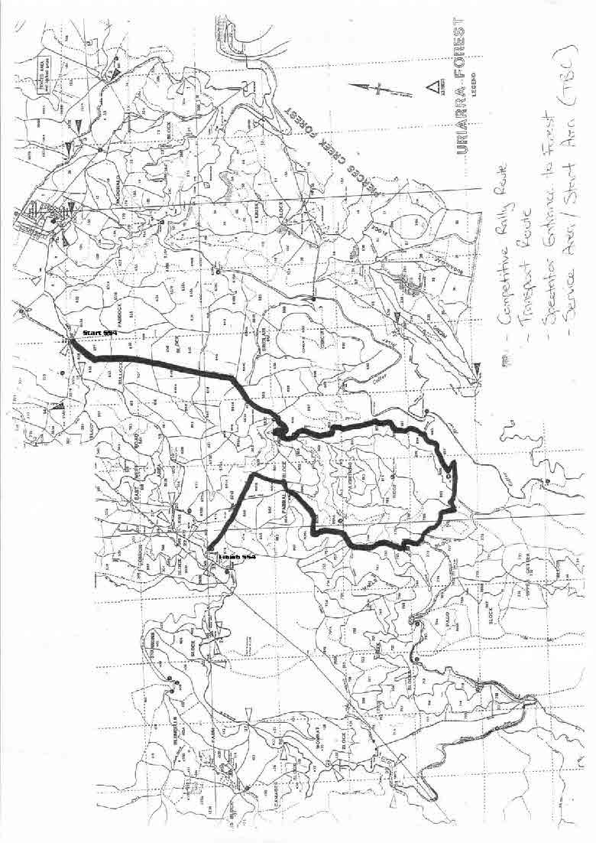
MAP 4

Competitive routes for:
•  Special Stage 3 (SS3) – Blue Range I
•  Special Stage 7 (SS7) – Blue Range II

