Australian Capital Territory
Major Events Security Declaration 2008 (No 2)*
Disallowable instrument DI2008—59
made under the
Major Events Security Act 2000, s 4 (Declaration of major events)

1. Under section 4 of the Major Events Security Act 2000 (the Act) the Olympic Torch Relay (specified in Schedule 1) at the venue (specified in Schedule 3) is a major event for the purposes of the Act.

2. This declaration is in force for the period commencing at 12.01 am on 24 April 2008 and concluding at 11.59 pm on 24 April 2008.

3. Under section 7 of the Act the statutory conditions of entry to the venue are stated to be as follows:
- a person seeking to enter or remain in the venue shall, if asked by a police officer, permit a search to be made of his or her personal property;
- a person seeking to enter or remain in the venue shall, if asked by a police officer, permit a frisk search to be made of his or her person; and
- a person shall not take into or possess in the venue a prohibited item.

4. For the purposes of this declaration:
- the description of the event is specified in Schedule 1;
- the proposed times and dates of the event are specified in Schedule 1;
- the prohibited items are those specified in Schedule 2; and
- the location of the venue is specified in Schedule 3:

5. Some of the venues contain restricted areas.

Declared by us, the Executive of the Australian Capital Territory:

Simon Corbell Jon Stanhope
Attorney General Minister
15 April 2008 15 April 2008

Schedule 1 –
Declaration made under s. 4 of the Major Events Security Act 2000

1. Description of the event

Beijing 2008 Olympic Torch Relay

2. Times and dates of the event

The proposed times and dates of the event:

- Commencement of pre-launch program at 6.15am on 24 April 2008
- Commencement of official program at 8.30am on 24 April 2008
- Commencement of torch relay at 9.00am on 24 April 2008
- Torch relay route on 24 April 2008
- Final community celebrations on 24 April 2008

Schedule 2 –
Declaration made under s. 4 of the Major Events Security Act 2000

PROHIBITED ITEMS

Glass items, other than optical lenses and items containing food or beverages for infants;
Cans, other than those containing food or beverages for infants;
Prohibited weapons and prohibited articles under the Prohibited Weapons Act 1996;
Knives, including knives under the Crimes Act 1900;
Firearms under the Firearms Act 1996 excepting those carried lawfully by law enforcement officers performing duties at, or as part of the event;
Fire extinguishers and any other material contained within a receptacle that is likely to be used as a fire retardant except those lawfully in the possession of emergency services personnel;
Paint stored in any type of container (including balloons, tins and aerosol cans);
Flares, fireworks, explosives, smoke bombs, petrol and dangerous goods under the Dangerous Substances Act 2004 excepting those fireworks authorized lawfully by those persons contracted to participate in formal proceedings relating to the event;
Controlled drugs and plants under Schedules 1 & 2 of the Criminal Code Regulations 2005 that includes prohibited substances, plants and drugs of dependence; and
Balls, eggs, paint bombs and any similar item that is likely to be used as a projectile.

Schedule 3 –
Declaration made under s. 4 of the Major Events Security Act 2000

Venue

The venue comprises the places and roads in Central Canberra described in the attached map.
See attachment for map and description

Some of the venues for this event contain restricted areas.

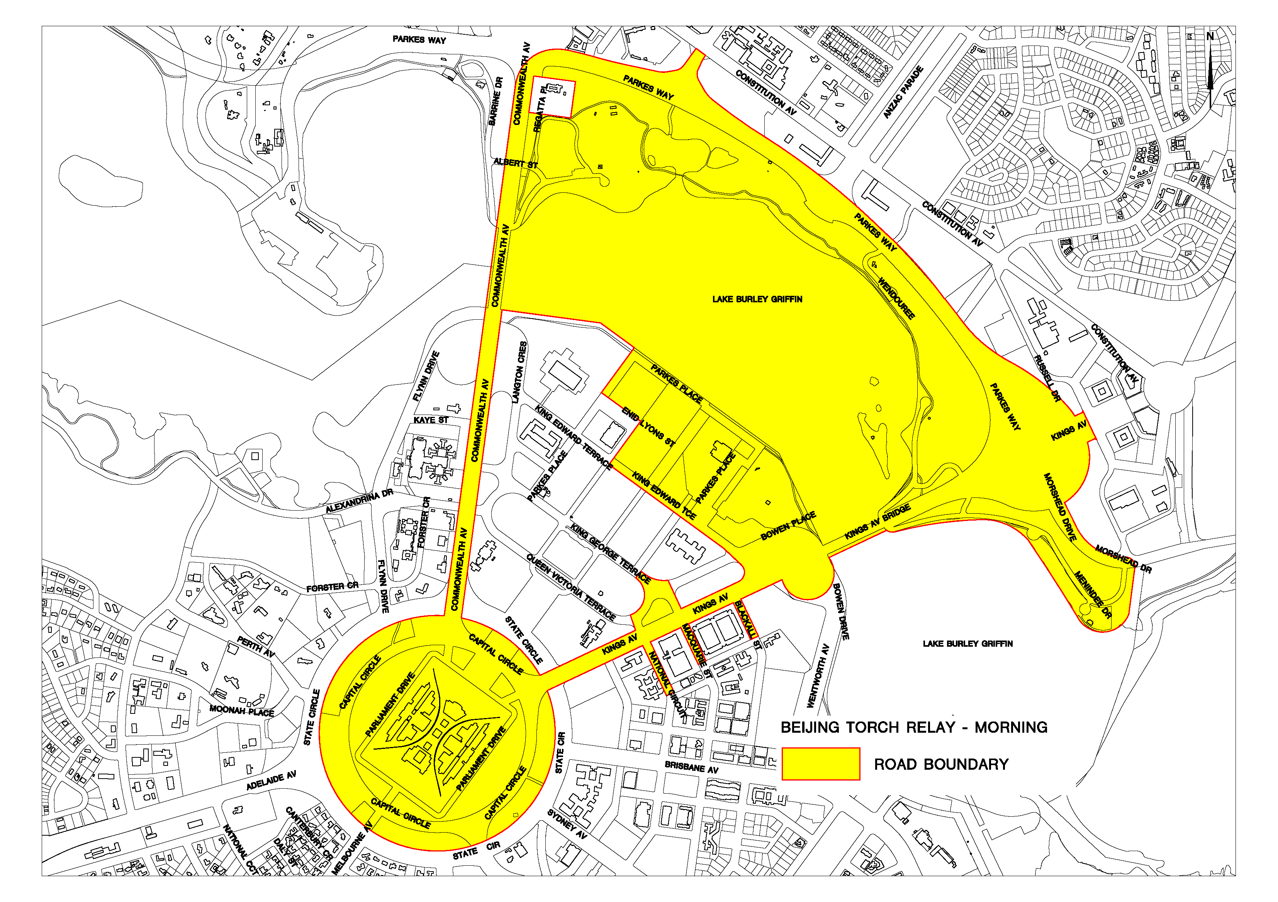
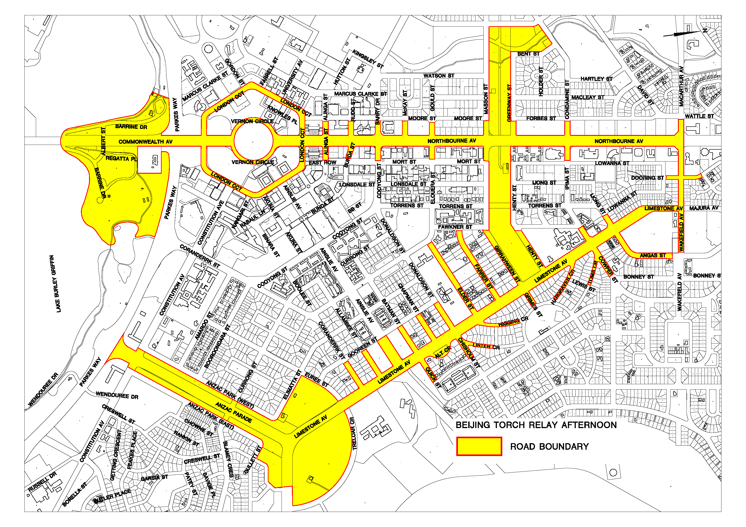

Beijing Olympics Torch Relay – Canberra, 24 April 2008

Description of route/s and additional areas for Declaration under the Major Events Security Act 2000

The declaration will apply to the route of the Torch relay and includes the principal roads, adjacent roads up to the first intersection, and adjacent public open spaces.

All roads include the road related areas, as defined in the Australian Road Rules February 2008 version.

All public open spaces are defined by Section and, where appropriate, Block number.

The declaration does not apply to leased land.

Torch Relay – Declaration of the Route/Venue

Section 57, Parkes bounded by King Edward Terrence and Parkes Place including Reconciliation Place and Commonwealth Place, but excluding Questacon (Section 57, Block 1)

Lake Burley Griffin, Central Basin (Section 54).

Commonwealth Park, Section 48 Parkes, including Rond Place.

Parkes Way from Kings Avenue to Commonwealth Avenue.

Coranderrk Street between Constitution Avenue and Parkes Way.

Commonwealth Avenue.

Commonwealth Avenue Bridge.

Kaye Street between Commonwealth Avenue and Flynn Drive.

Coronation Drive between Commonwealth Avenue and Flynn Drive.

Queen Victoria Terrace between Commonwealth Avenue and Parliament Square.

Capital Hill, including all areas bounded by State Circle.

Kings Avenue.

National Circuit between Walpole Crescent and Bligh Street.

Macquarie Street between Broughton and Kings Avenue.

King George Terrace between Parkes Place and Kings Avenue.

Blackall between Broughton Street and Kings Avenue.

King Edward Terrace between Dorothy Tangney Place and Kings Avenue.

Bowen Place.

Kings Avenue Bridge.

Morshead Drive between Kings Avenue and Russell Drive.

Grevillia Park (Sections 33, 34 and 35, Barton).

Kings Park (Sections 52 and 47, Parkes).

Anzac Parade.

The area bounded by Constitution Avenue, Anzac Park (West), Elimatta Street, Euree Street , Treloar Crescent, Creswell Street, Gullett Street, and Anzac Park (East) and including the Australian War Memorial.

Limestone Avenue.

Coranderrk Street between Limestone Avenue and Gooreen Street.

Allambee Street between Limestone Avenue and Gooreen Street.

Ainslie Avenue between Limestone Avenue and Gooreen Street.

Batman Street between Limestone Avenue and Gooreen Street.

Quick Street between Limestone Avenue and Howe Crescent.

Chapman Street between Limestone Avenue and Gooreen Street.

Alt Crescent.

Donaldson Street between Limestone Avenue and Gooreen Street.

Chisholm Street between Limestone Avenue and Patterson Street.

Lister Crescent between Chisholm Street and Drake Street.

Higgins Crescent.

Elder Street between Limestone Avenue and Elouera Street.

Farrer Street between Limestone Avenue and Fawkner Street.

Grimes Street.

Girrahween Street between Limestone Avenue and Fawkner Street.

Henty Street between Limestone Avenue and Wise Street.

Hargraves Crescent.

Ipima Street between Limestone Avenue and Wise Street.

Cowper Street between Limestone Avenue and Foveaux Street.

Toms Crescent.

Ijong Street Limestone Avenue and Lowanna Street.

Angas Street Limestone Avenue and Wakefield Avenue.

Wakefield Avenue between Angas Street and Northbourne Avenue.

Dooring Street between Lowanna Street and McGowan Street.

Macarthur Avenue between Northbourne Avenue and David Street.

Northbourne Avenue.

Condamine Street between Northbourne Avenue and Forbes Street .

Ipima Street between Northbourne Avenue and Lowanna Street.

Greenway Street between Northbourne Avenue and Forbes Street.

Haig Park – Section 66, Turner; Section 8, Block 7, Braddon and Section 14, Braddon.

Masson Street between Northbourne Avenue and Moore Street.

Girrahween Street between Northbourne Avenue and Mort Street.

Gould Street between Northbourne Avenue and Moore Street.

Elouera Street between Northbourne Street and Mort Street.

MacKay Street between Northbourne Avenue and Moore Street.

Barry Drive between Northbourne Avenue and Moore Street.

Cooyong Street between Northbourne Avenue and Mort Street

Rudd Street between Northbourne Avenue and Moore Street.

Bunda Street between Northbourne Avenue and Mort Street.

Alinga Street between Moore Street and Mort Street.

London Circuit.

Vernon Circle.

City Hill – Section 34, City.

Commonwealth Avenue.

Barrine Drive.

Regatta Place.

Commonwealth Park (Sections 2, 44 and 45 Parkes, excluding the Archbishop’s Residence Section 2 Block 1, Parkes.).

Acton Park (Sections 35, 75 and 87, Acton).

Kuttabul Place.

Albert Street.

