Australian Capital Territory

Planning and Development
(Amount payable for, and period of, further rural lease) Determination 2009 (No 1)

Disallowable Instrument DI2009–38

made under the

Planning and Development Act 2007, section 280 (Amount payable for further rural lease) and section 281 (Period of further rural lease)

- Name of Instrument

This Instrument is the Planning and Development (Amount payable for, and period of, further rural lease) Determination 2009 (No 1).

- Commencement

The instrument commences on the day after it is notified

3. Interpretation

In this Instrument:

“further lease” means a further rural lease to be granted pursuant to section 254 of the Planning and Development Act 2007;

“Map” means the Maximum Rural Lease Term Map in Schedule 1;

“Territory owned improvement” means any improvements on the land, the subject of a lease to which section 254 of the Planning and Development Act 2007 applies, and referred to in section 289 (a) (i) or (ii) of that Act, at the date of surrender or expiry of the lease.

- Amount payable for further rural lease

I determine, pursuant to section 280 of the Planning and Development Act 2007, that the amount payable for a further lease is in accordance with Attachment A.

- Period of further rural lease

I determine, pursuant to section 281 of the Planning and Development Act 2007, the period for the term of a further lease of land coloured in a particular colour in the Map to be the period specified immediately adjacent to that colour in the Legend of the Map.

Andrew Barr MLA
Minister for Planning

16 March 2009

ATTACHMENT A
________________________________

1. Subject to paragraph 2, where the period for the term of a further lease, in accordance with this Determination, is greater than 20 years, the amount payable by a lessee for the further lease is:

(1)

(a) if the lessee applies for a further lease on or before the relevant date in Schedule 2 and accepts an offer of a further lease within 3 months of the offer being made:

(i) except for a further lease of land depicted in a colour (other than white) in Schedule 4 – calculated in accordance with the relevant formulae specified in Schedule 3, and

(ii) for a further lease of land depicted in a colour (other than white) in Schedule 4 – calculated in accordance with the relevant formulae specified in Schedule 5; or

(b) in any other case– the market value of the land; and

(2) in addition to the amount payable in accordance with subparagraph (1)(a) or (b), an amount equal to the value of the Territory owned improvements (other than timber treatment).

2. A lessee will not be required to make any payment of an amount under paragraph 254 (1) (e)(ii) of the Planning and Development Act 2007 for a further lease, for a term greater than a period of 20 years, if the lessee has previously paid to the Commonwealth, the Territory or the planning and land authority:

(1) the market value, at the time of the grant, for a lease granted under section 161 of the Land (Planning and Environment) Act 1991 or section 238 of the Planning and Development Act 2007 over the same land; or

(2) an amount calculated in accordance with an amount condition for a further lease granted under section 171A of the Land (Planning and Environment) Act 1991 over the same land; or

(3) an amount paid for a further lease granted under section 254 of the Planning and Development Act 2007 over the same land.

3. Where a further lease, for a term greater than a period of 20 years, is to be granted subject to the payment of an amount determined under this Determination, the lessee must nominate by which of the following methods the lessee will pay the determined amount:

(1) as a lump sum; or

- in quarterly instalments in advance over a period of 30 years at a fixed interest rate of 8% per annum on reducing balances; or

(3) as a partial lump sum with the remaining balance payable in quarterly instalments over 30 years at a fixed interest rate of 8% per annum on reducing balances.

4. Where the period for the term of a further lease, in accordance with this Determination, is 20 years or less, the rent payable by a lessee is:

(1) if the lessee applies for a further lease on or before the relevant date in Schedule 2 and accepts an offer of a further lease within 3 months of the offer being made, the relevant formulae in Schedule 6; or

(2) in any other case, 5% of the market value of any Territory owned improvements comprising dwellings, plus 3% of the market value of any other Territory owned improvements, plus 3% of the unimproved value of the land, as defined in the Rates Act 2004.

- For a lease to which paragraph 4 applies, the planning and land authority may review the market value of land and improvements and adjust the rent accordingly once every three years.

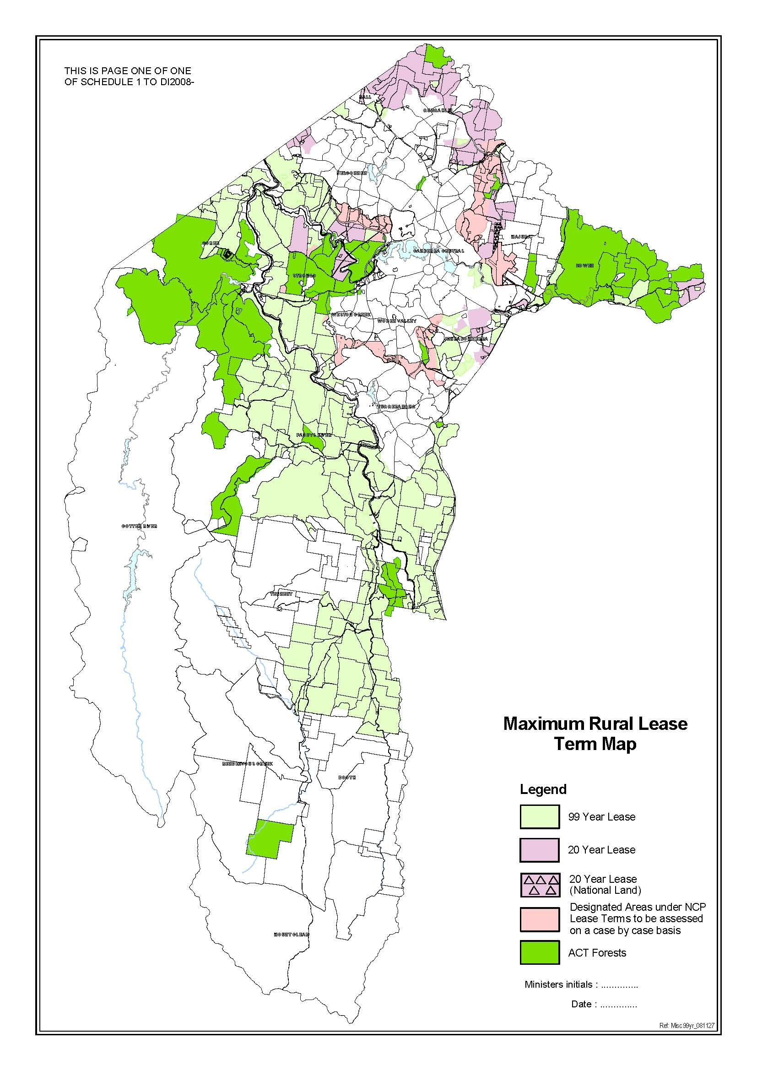

SCHEDULE 2 – RELEVANT DATES FOR ATTACHMENT A

The relevant date for paragraphs 1 and 4 of Attachment A of this Determination is:

(1) for land within Region 1: 30 June 2004;

(2) for land within Region 2: 30 June 2004;

(3) for land within Region 3: 30 June 2005;

(4) for land within Region 4: 31 December 2005; or

(5) for land within Region 5: 30 June 2009

(6) for land in other regions of the ACT: 30 June 2004

In this Schedule 2, Region 1 means the land listed as follows:

District/Division Block

Belconnen All, excluding Blocks 50, 1329 and 1541

Booth All

Coree All, excluding Block 65

Fyshwick Block 3 Section 52, Block 6 Section 59, Block 8 Section 59, Block 3 Section 73 and Block 1 Section 78 only

Kowen All

Majura Blocks 55, 56, 57, 60 and 513 only

Paddys River All

Stromlo All

Tennent All

Tuggeranong All

Weston Creek All

In this Schedule 2, Region 2 means the land listed as follows:

District/Division Block

Belconnen Block 50 only

Coree Block 65 only

Gungahlin All

Hall Block 8 Section 23 only

Majura All, excluding Blocks 55, 56, 57, 60 and 513

Symonston Block 1 Section 103, Block 5 Section 103, Block 7 Section 103 and Block 8 Section 103 only

In this Schedule 2, Region 3 means the land listed as follows:

District/Division Block

Hume All

Jerrabomberra All

Symonston All, excluding Block 1 Section 103, Block 5 Section 103, Block 7 Section 103 and Block 8 Section 103

In this Schedule 2, Region 4 means the land listed as follows:

District/Division Block

Belconnen Block 1541 only

Narrabundah Block 4 Section 129 only

In this Schedule 2, Region 5 means the land listed as follows:

District/Division Block

Harrison Block 12 Section 5 only

SCHEDULE 3 - FORMULAE FOR FURTHER RURAL LEASES FOR A PERIOD GREATER THAN 20 YEARS

Definitions

“DSE” means Dry Sheep Equivalent.

“ha” means hectare.

“value” means a value determined by the Planning and Land Authority.

Formula 1

1. Subject to paragraphs 1(2) and 1(3), for areas greater than 16 hectares, inclusive of the right for a principal dwelling the following formulae apply:

(1) more than 16 ha and no more than 80 ha $190 per DSE less 15% for
ACT factors = $162/DSE

(2) more than 80 ha and no more than 600 ha $160 per DSE less 15% for
ACT factors = $136/DSE

(3) more than 600 ha and no more than 1000 ha $150 per DSE less 15% for
ACT factors = $128/DSE

(4) more than 1000 ha $130 per DSE less 15% for
ACT factors = $110/DSE

2. Where there is no right to a dwelling, the values will be reduced by 7.5%.

3. For the second and each additional dwelling, an additional amount of $16,615 per dwelling is added (representing an annual rent of $1,000.00 capitalised over 99 years).

Formula 2

For leases of 16 ha or less not containing the right to a dwelling, excluding leases in Pialligo and all other leases in areas other than those within a “broadacre” or “rural” designation under the Territory Plan:

$235/DSE less 15% for ACT factors = $200/DSE

Formula 3

1. For leases of 16 ha or less containing a right to one dwelling, excluding leases in Pialligo and all other leases in areas other than those within a “broadacre” or “rural” designation under the Territory Plan:

(1) subject to paragraph 2, up to 8 ha $2,500 per annum capitalised at 6% over 99 years less 15% for ACT factors = $37,400; or

(2) subject to paragraph 2, from 8 ha to 16 ha $3,000 per annum capitalised at 6% over 99 years less 15% for ACT factors = $42,400; and

2. For the second and each additional dwelling, an additional amount of $16,615 per dwelling is payable.

Formula 4

For leases under 16 ha and not within a “broadacre” or “rural” designation under the Territory Plan, the existing rent capitalised over 99 years at 6% pa less 15% for ACT factors.

Formula 5

1. Subject to paragraphs 2 and 3, the added land value for horse agistment and related activities is a sliding scale based on the percentage of the land’s carrying capacity used for horses for agistment purposes as follows:

(1) if 1% to 20% of total equivalent carrying capacity is used for horses for agistment purposes – add 10% to primary production value;

(2) if more than 20% but not more than 50% of total equivalent carrying capacity is used for horses for agistment purposes – add 20% to primary production value; or

(3) if more than 50% of total equivalent carrying capacity is used for horses for agistment purposes – add 30% to primary production value.

2. For all leases of 16 ha or less, the addition of 30% to the DSE rate, or capitalised site value, as appropriate.

3. The portion of the property used for primary production purposes will be calculated by applying DSE values in Formula 1.

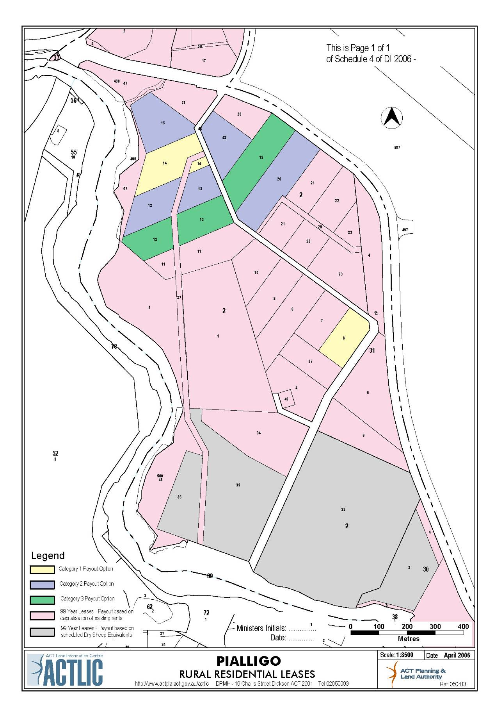

SCHEDULE 5 - FORMULAE FOR FURTHER RURAL LEASES IN PIALLIGO

Leases which include non-primary production commercial lease purpose clauses

The amount to be paid for further leases with wholly non-primary production, commercial purposes, or a combination of primary production and commercial purposes, in accordance with the following Categories listed in Schedule 4 is:

Category 1 - $97,750;

Category 2 - $86,250; or

Category 3 - $80,500.

99 year leases with payment based on existing rents capitalised

The amount to be paid for further leases shown in Schedule 4 as being based on existing rents capitalised is:

Existing rents capitalised over 99 years at a rate of 6% pa.

99 year leases with payment based on Dry Sheep Equivalent value

The amount to be paid for leases listed in Schedule 4 as being based on DSE values in Formula 1 of Schedule 3 is - payment in accordance with the relevant formula in Schedule 3.

SCHEDULE 6 - FORMULAE FOR FURTHER RURAL LEASES FOR 20 YEARS OR LESS

Definitions

“DSE” means Dry Sheep Equivalent.

“ha” means hectare.

“value” means a value determined by the Planning and Land Authority.

Formula 1

1. Subject to 2 and 3, for areas greater than 16 ha, inclusive of the right for a principal dwelling:

(1) more than 16 ha and no more than 80 ha $190 per DSE less 15% for
ACT factors = $162/DSE

(2) more than 80 ha and no more than 600 ha $160 per DSE less 15% for
ACT factors = $136/DSE

(3) more than 600 ha and no more than 1000 ha $150 per DSE less 15% for
ACT factors = $128/DSE

(4) more than 1000 ha $130 per DSE less 15% for
ACT factors = $110/DSE

2. Where there is no right to a dwelling, the values will be reduced by 7.5%.

3. For the second and each additional dwelling, an additional amount of $16,615 per dwelling is added (representing an annual rent of $1,000 capitalised at 6% over 99 years).

Formula 2

For leases of land greater than 16 ha, annual rent will be charged at 3% of the land value, derived from the DSE values in Formula 1 and Formula 7, plus an annual rent of 3% will be charged for the value of any Territory owned improvements comprising farm buildings and dwellings on the land (excluding fencing, water and pasture improvements).

Formula 3

Subject to Formula 7, for leases of 16 ha or less not containing the right to a dwelling, excluding leases in Pialligo and all other leases of land in areas other than those within a “broadacre” or “rural” designation under the Territory Plan:

$235/DSE less 15% for ACT factors = $200/DSE

Formula 4

For leases of land of 16 ha or less containing a right to one dwelling (adjusted for ACT factors), excluding leases of land in Pialligo and all other leases in areas other than those within a “broadacre” or “rural” designation under the Territory Plan:

(1) subject to paragraph (3), up to 8 ha $2,500 per annum capitalised at 6% over 99 years less 15% = $37,400;

(2) subject to paragraph (3), from 8 ha to 16 ha $3,000 per annum capitalised at 6% over 99 years less 15% = $42,400;

(3) for the second and each additional dwelling, an additional amount of $16,615 per dwelling is payable (representing an annual rent of $1,000 capitalised at 6% over 99 years).

Formula 5

For leases of land of 16 ha or less and not within a “broadacre” or “rural” designation under the Territory Plan, the existing rent capitalised over 99 years at 6% pa less a 15% deduction for ACT factors.

Formula 6

For leases of land of 16 ha or less and within a “broadacre” or “rural” designation under the Territory Plan, the annual rent is 3% of the land value derived from application of Formula 3, Formula 4 or Formula 5, as applicable, and of Formula 7; plus an annual rent of 3% of the value of any Territory owned improvements comprising farm buildings and dwellings (exclusive of fencing, water and pasture improvements).

Formula 7

1. Subject to paragraphs 2 and 3, the added land value for a horse agistment and related activities is a sliding scale based on the percentage of a property’s carrying capacity used for horses for agistment purposes as follows:

(1) if 1% to 20% of total equivalent carrying capacity is used for horses for agistment purposes – add 10% to primary production value;

(2) if more than 20% but not more than 50% of total equivalent carrying capacity is used for horses for agistment purposes – add 20% to primary production value;

(3) if more than 50% of total equivalent carrying capacity is used for horses for agistment purposes – add 30% to primary production value.

2. For all leases of land of 16 ha or less, the addition of 30% to the DSE value, or capitalised site value, as appropriate.

3. The portion of the property used for primary production purposes will be calculated by applying the DSE values in Formula 1.

