Australian Capital Territory

**Planning and Development (Albert Hall) Land Management Plan 2016\***

**Disallowable instrument DI2016–78**

made under the

**Planning and Development Act 2007, s 327 (Draft land management plan–Minister to approve, return or reject)**

**1 Name of instrument**

This instrument is the *Planning and Development (Albert Hall) Land Management Plan 2016.*

**2 Commencement**

This instrument commences on the day after its notification day.

**3 Approval**

I approve the draft land management plan for the Albert Hall contained in the schedule.

*Note 1: A draft land management plan approved by the Minister under section 327(3) of the Planning and Development Act 2007 (the Act) is a land management plan.*

*Note 2: A land management plan is a disallowable instrument (see section 328 of the Act)*

Mick Gentleman MLA   
Minister for Planning and Land Management

6 June 2016

ACTGov_inline_293

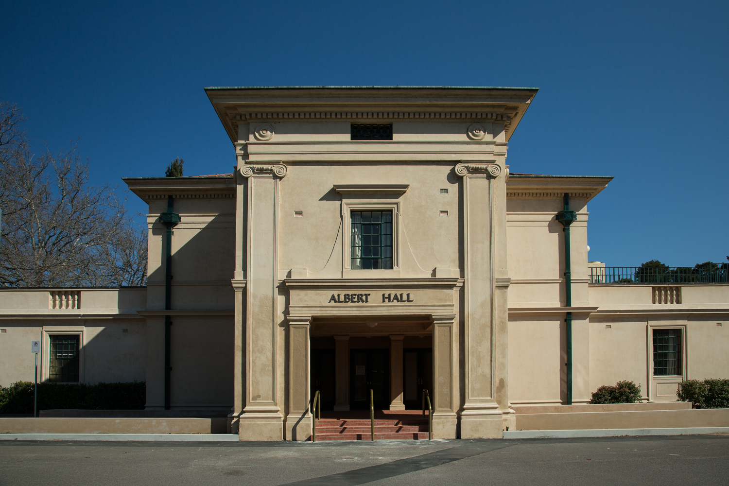

Chief Minister, Treasury and Economic Development Directorate

Land Management Plan for the

Albert Hall, Canberra, ACT

June 2016

|  |
| --- |
|  |

ISBN 0 642 606501

© Australian Capital Territory, Canberra June 2016

Publication No 16/0493

Material in this publication may be reproduced provided due acknowledgement is made.

Produced for the Chief Minister, Treasury and Economic Development Directorate by Publishing Services.

Enquiries about this publication should be directed to the Chief Minister, Treasury and Economic Development Directorate, GPO Box 158, Canberra City, 2601

http://www.act.gov.au/budget

Telephone: Canberra 13ACT1 or 13 22 81

Contents

Acknowledgement 1

1. Land Management Plan 2

1.1 Introduction 3

1.2 Vision 7

1.3 Land Management Plan Objectives 7

1.4 Uses 8

1.5 Management 11

1.6 Actions 13

1.7 Monitoring, Reporting and Review 16

2. Context for Land Management Plan 18

2.1 Locational Context 19

2.2 Historic Context 20

2.3 Description of the Building and Site 21

2.4 Previous and Potential Uses 24

2.5 Community Engagement Outcomes 27

2.6 Financial Context 29

2.7 Summary of Constraints and Opportunities 33

Appendix A: Statement of Heritage Significance 35

Appendix B: Usage Analysis 36

Appendix C: Action Timeframes 37

Appendix D: Record of Minor Amendments 39

# Acknowledgement

This Plan has been developed with significant assistance from a number of members of the Canberra community including organisations and individuals with a passion for this building, local business and officers within the ACT Government.

* Executive and members of Friends of the Albert Hall Incorporated who have been a significant contributor and partner with the ACT Government in initiating, developing and completing the Plan.
* Members of the community who attended and contributed to the various consultation processes during and following the development of the draft Plan.
* Community members of the Reference Group from The Molonglo Group; Canberra Convention Bureau; and Friends of the Albert Hall Inc.
* ACT Government members of the Reference Group.
* Consultants: Elton Consulting and Godden Mackay Logan for their assistance in undertaking community consultation and developing the information and final report.
* ACT Government staff working on the project from Territory and Municipal Services and Chief Ministers, Treasury and Economic Development Directorates.

We wish to acknowledge the time and effort these people have put into the planning and discussion leading to the development and refinement of the Plan over a number of years. The final outcome reflects the collated input of these people.

# Land Management Plan

[

Figure 1: Heart Foundation Gala Fundraising Dinner 2010

(Image courtesy of Earlybird Marketing and Events)

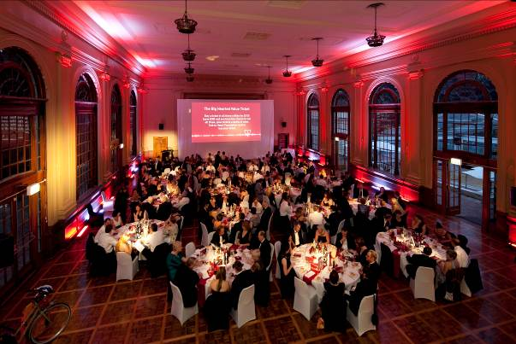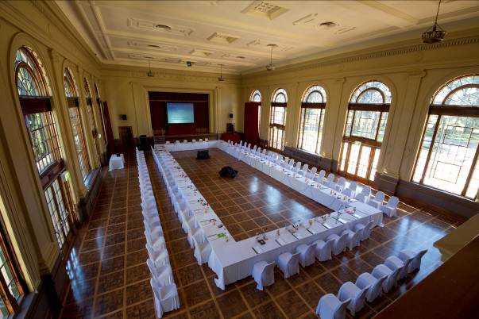

Figure 2: Albert Hall laid out for the Mint Director’s Conference 2010

(Image courtesy the Royal Australian Mint)

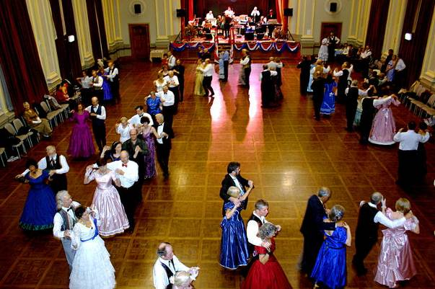

Figure 3: Gala Ball held at Albert Hall 2010

(Image courtesy the Monaro Folk Society)

## Introduction

The Albert Hall is located on Block 1, Section 39, Division of Yarralumla, District of Canberra Central, with a street address of 100 Commonwealth Avenue. The site is bounded by Commonwealth Avenue to the east, Flynn Drive to the north and west and Kaye Street to the south. The site area is shown in Figure 5.

Albert Hall is located in a Designated Area under the *Australian Capital Territory (Planning and Land Management) Act 1988 (Cwlth)*. This means that decisions about the use and development of the land are made by the National Capital Authority. The overarching planning policy applicable to the site under the National Capital Plan is that “Albert Hall may be used as a cultural facility and for ancillary short-term commercial/retail activities”.

The current public land overlay for the Albert Hall site under the ACT Government’s Territory Plan is ‘Pd - Special Purpose Reserve’. Details of the management objective and how this will be implemented is covered in this Land Management Plan.

Section 321 of the *Planning and Development Act 2007* requires that “the custodian for an area of public land must prepare a draft land management plan for the area”. In addition, a new draft Land Management Plan may be prepared “if the custodian considers the existing Land Management Plan is outdated”.

Section 320 of the Act specifies that a Land Management Plan must: “a) identifies the area; and b) describes how the management objectives for the area are to be implemented or promoted in the area”.

During development of the Plan the *Planning and Development Act* 2007 was amended including some changes to legislative provisions regarding Land Management Plans (formerly Plans of Management). At the time of developing the Draft Plan of Management Section 323 of the Act requires that the proponent of a final draft Land Management Plan must undertake a public consultation process for no less than 15 working days then make copies available “to an appropriate committee of the Legislative Assembly”. Community Consultation on the Draft Land Management Plan was undertaken by Territory and Municipal Services Directorate (the proponent) April to June 2012. Subsequently the Plan was referred to the Standing Committee on Planning, Environment and Territory and Municipal Services on 14 August 2014. The Standing Committee tabled Report 11 on its Inquiry in November 2015.

The Act also requires that a Land Management Plan be reviewed at least once every 10 years or when the existing Land Management Plan is no longer deemed appropriate for the land.

This is the first Land Management Plan prepared for Albert Hall and its site area. As required in the Act, this Land Management Plan applies to the entirety of the site. The primary focus is, however, on the building and its immediate surrounds as these elements are most actively used by the community. The broader landscape, along with the heritage considerations at the site, is considered in detail in the Conservation Management Plan. Future plans of management may include greater detail on the landscape context of the building.

### Structure

This document contains two main sections. Section 1 contains the Land Management Plan itself. It includes the vision and objectives for the management of Albert Hall, as well as descriptions of the primary and ancillary uses of the building and management arrangements. Section 1 also contains a list of proposed actions, linked to each of the objectives for the management of the building.

Section 2 sets out the context for the Land Management Plan. It includes:

* A description of the Hall’s locational context
* An overview of the historic significance of the Hall
* A description and analysis of the building and its site
* An analysis of previous and potential uses of the building
* An overview of the outcomes of the community engagement process’
* A description of the financial context relating to the management of the building and its surrounds.

Section 2 concludes with a summary of constraints and opportunities arising from the analysis of the Hall’s context, which provided the framework for the preparation of this Land Management Plan.

### The Site

Block 1, Section 39, Yarralumla contains a number of elements covered by the Land Management Plan. The site is detailed in Figure 5 and 6 on page 5.

* Albert Hall: The Building was constructed in 1927-28 and is the primary and most actively used element on the site. It includes landscaping to the North and the South to the Road Reserve. The building itself it utilised by a range of individuals and organisations such as: community, cultural, private and commercial activities. The building is a significant focus of the Land Management Plan.
* Kaye Street Depot: This Municipal depot is located at the rear of the site near Flynn Drive. The depot remains largely in its original form and is screened on three sides by large trees. At the time of preparing the Land Management Plan, this depot rented by the National Capital Authority for storage and the operation of its grounds management functions.
* Northern and Western Landscape: This area consists of a plantation of pine trees and open grassland.
* Eastern Landscape: This area consists of the semi-circle landscape setting between Commonwealth Avenue and the semi-circular access road off Kaye Street it includes two large Atlas Cedars and the sundial. It also includes two flag poles and spot lighting.
* Interior Road: Un-named.

### Process

The first stage in developing a Land Management Plan for Albert Hall was the preparation by heritage consultants Godden Mackay Logan (GML) of *Albert Hall: A Heritage Context for Community Engagement*. This document was completed in April 2011 and reviews a wide range of background documentation regarding the constraints and opportunities relating to Albert Hall. It also considered a variety of future uses and management models. The landscape plan, at the time, was covered in detail in the Conservation Management and Landscape Plan 2007, prepared by Peter Freeman Pty Ltd Conservation Architects and Planners Consultants Team.

The next stage in the development of this Land Management Plan was to engage with the Canberra community and other stakeholders. This process was undertaken by Elton Consulting on behalf of the ACT Government. The outcomes of this stage of the process were documented in a detailed Community Engagement Final Outcomes Report, which is summarised in Section 2.5.

Elton Consulting prepared the first draft of the Plan of Management and was informed by the GML Report, *Albert Hall: A Heritage Context for Community Engagement,* engagement outcomes and further research and analysis. Public consultation on the Draft Plan of Management was undertaken in May 2012 for a period of 6 weeks. This final Land Management Plan takes account of much of the feedback received. A separate report on the consultation is available.

The Standing Committee on Planning, Environment and Territory and Municipal Services published *Report 11 Inquiry into Draft Plan of Management for the Albert Hall* in November 2015. The Committee made eight recommendations. The ACT Government agreed to six recommendations and noted two. This Land Management Plan was updated in 2016 to take account of the ACT Government response to the Report and to ensure the Plan provided contemporary information.

### Objectives



Figure 4: Land Management Plan objectives

The ACT Government has set out three main objectives for the preparation and implementation of the Land Management Plan for Albert Hall. These were to:

* Ensure the preservation of an important community and cultural asset
* Ensure continued community access
* Deliver these objectives in a financially sustainable way.

These objectives, and their interaction, are illustrated in Figure 4.

### Management

Since its construction the Albert Hall has been managed by the Commonwealth and ACT Governments. Various parts of ACT Government have managed Albert Hall since self government in 1988. The ACT Property Group, located in the Chief Minister, Treasury and Economic Development Directorate at the time of preparing this Land Management Plan, has been the custodian since 2007. Various levels of resources have been provided for this function.

Albert Hall was managed by a private contractor from 1997 – 2007 on behalf of the ACT Government. Following expiration of this contract the ACT Government resumed responsibility for managing and hiring the facility.

At the time of preparing this Land Management Plan, ACT Property Group, Chief Minister, Treasury and Economic Development Directorate, ACT Government managed the building, maintenance, bookings and promotions for the site.

### Heritage

Albert Hall is widely recognised for its heritage significance. The building was listed on the ACT Heritage Register in 2001 and this listing was modified in 2010 to include the Hall’s surrounding landscape setting. The heritage listed area now comprises all of Block 1, Section 39 in the Division of Yarralumla, as illustrated in Figure 5.

The Statement of Heritage Significance prepared as part of the ACT Heritage Register states, in part, that the aesthetic significance of Albert Hall “...is embodied in the architecture, the landscape and the interior design of the place...Albert Hall was the ‘cultural hearth’ of the early Federal Capital and, as such, remains highly valued...Albert Hall continues to have social and cultural value as a setting for a range of different purposes attracting large gatherings, and aesthetic value in its lakeside setting”. The full Statement of Heritage Significance is contained in Appendix A.

Albert Hall is also listed on the Register of the National Estate, Australian Institute of Architects Register of Significant Twentieth-Century Architecture and National Trust of Australia Heritage Register.

A detailed *Conservation Management Plan* was prepared for Albert Hall and its surrounds by Philip Leeson Architects Pty Ltd in collaboration with Dr Lenore Coltheart and Peter Freeman. The Conservation Management Plan was approved by the ACT Heritage Council 1 June 2015. The *Conservation Management Plan* contains a detailed historical overview of the site, as well as a description and analysis of the building and its surrounds. The *Conservation Management Plan* includes a series of conservation policies, which guide the use of and any changes or improvements to the building. This document is reviewed every five years..

When considering matters relating to Heritage aspects of the Albert Hall, where there is inconsistency, the Heritage listing and *Conservation Management Plan* take precedence over the Land Management Plan.

Use of the Albert Hall must occur in a manner that does not compromise or damage the heritage status or heritage fabric of the site. This may limit the manner in which hirers use the building, or require additional arrangements to protect the site. This Land Management Plan, along with actions and Action Plans arising from the Land Management Plan should not be inconsistent with the *Conservation Management Plan.*

### Public Land Management Objective

The Territory Plan has classified block 1 section 39 Yarralumla as Public Land. The public land overlay for the Albert Hall site under the ACT Government’s Territory Plan at the time of this Plan is shown in Figure 6. The category and management objective for this land is:

*Pd - Special Purpose Reserve - to provide for public and community use of the area for recreation and education.*

The Vision at 1.2 and Land Management Plan Objectives in section 1.3 of this Plan detail how the Public Land Management Objective will be achieved. The Plan will ensure that the site continues to provide for public and community use of the area for recreation and education purposes. Further detail on how this will be achieved is provided in this Plan including the Actions at 1.6.

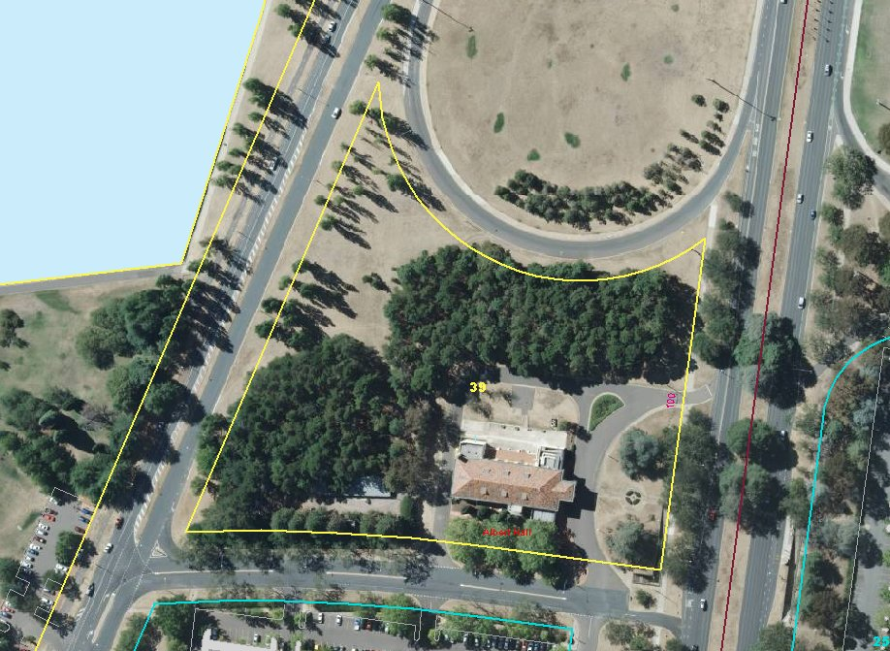

Figure 5: Land Management Plan site area (Block 1, Section 39, Division of Yarralumla)

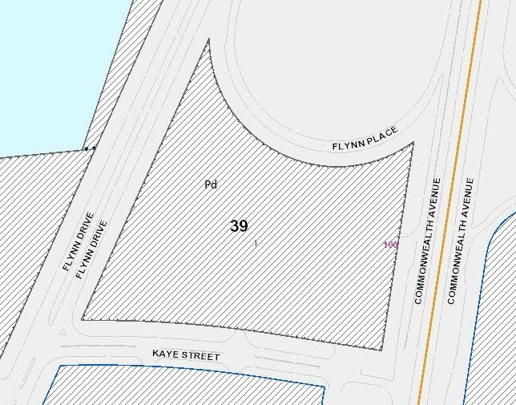

Figure 6: Public land overlay for the Albert Hall site under the *Territory Plan*

## Vision

As part of the community engagement process for the preparation of this Land Management Plan, community members were asked to consider their vision for the management of Albert Hall and the surrounding site.

The vision which emerged from the engagement process, as well as the associated research and analysis, is as follows:

Albert Hall is widely used by a diverse range of Canberrans for community, cultural and civic activities. The building is recognised for its heritage character and highly valued for its elegance and ambience.

Albert Hall is widely used by a diverse range of Canberrans for community, cultural and civic activities. The building is recognised for its heritage character and highly valued for its elegance and ambience.

## Land Management Plan Objectives

The objectives for the management of Albert Hall are:

1. To recognise, protect and communicate the heritage significance of the building and its site
2. To ensure the building is affordable and accessible for use by a wide variety of individuals and community groups
3. To provide a functional and comfortable performance space, particularly for use by local cultural groups
4. To respect and retain the high level of social and cultural attachment to the Hall
5. To attract a new generation of Canberrans to use and engage with the building
6. To ensure the management and maintenance of the building and surrounding site can be achieved in a financially sustainable way.

The Land Management Plan Objectives have been drafted to met the Vision, the management objective set by the public land overlay category along with the community’s and ACT Government’s priorities for the site.

## Uses

### Primary Uses

The following table outlines the primary uses envisaged for Albert Hall. The Primary uses are those that will assist in achieving the vision and objectives for the management of the building and should occur more frequently. The primary uses should also be the focus of any marketing and promotional activities. The primary uses are also those which are able to be undertaken without significant changes or improvements to the Hall and its surroundings.

It should be noted that the uses described here relate only to the hire of Albert Hall. As detailed in Section 1.1, the overarching use of the building and its site are prescribed by the National Capital Plan and the Territory Plan.

The primary uses listed here are particularly focused on events and activities which are provided by local, civic, community and cultural groups and which ensure a high level of accessibility by a wide audience.

Uses such as large charitable events, conferences and trade fairs have been nominated as ancillary as they would require additional services or structures to be held at the Albert Hall. These uses could, in the future, become primary uses if funding were available for the necessary building upgrades.

|  |  |  |
| --- | --- | --- |
| Use | Examples | Comments |
| Cultural Events  (Local) | * dances * musical performances * theatrical performances * exhibitions * concerts * movie screenings * filming movies and documentaries * children’s entertainment * book launches * rehearsals | Where the use is organised by a local government, or community and/or cultural group.  Where the use is organised by a museum, gallery or similar cultural organisation for the purposes of a temporary exhibition.  Where the rehearsal is related to a performance to be staged at Albert Hall. |
| Civic Ceremonies and Events (Public) | * public hearings * public meetings * citizenship ceremonies * awards ceremonies | Where the use is organised by a Government agency or civic body, and the event is of a public nature, or able to be attended by members of the general community. |
| Civic Ceremonies and Events (Private) | * embassy events * civic receptions * governmental meetings * Christmas parties | Where the use is organised by a Government agency, embassy or similar group and is of a private nature, unable to be attended by members of the general community. |
| Charitable Events  (Small) | * dinners * fund raisers | Where the use is organised by or on behalf of a not-for-profit or charitable organisation. |
| Heritage Events | * lectures * seminars * meetings * festivals | Where the use is organised by a Government agency or not-for-profit organisation or similar body or individual and is able to be attended by members of the general community |
| Educational Activities | * university exams * graduations * school concerts, speech days or assemblies * Public Lectures, seminars, workshops * Professional conferences | Where the use is organised by a reputable education provider or similar body. |
| Community Activities and Events | * meetings and shows * markets and fairs * exhibitions * performances * fundraisers * dances and entertainment | Where the use is organised by a community organisation for the benefit of a target or broader group in the ACT community and region |
| Private Functions | * weddings * parties * memorial/funeral services * balls and dances * banquets and dinners | Where the use is of a private nature, unable to be attended by members of the general public. |
| Commercial Events | * fairs * sales * auctions | Where the use is for an event with a strong focus on community attendance and participation; where the event promotes and includes local community and commercial organisations; and/or; When the event theme is heritage in nature eg. Antiques, historical items, themed performances |
| Smaller Conferences and Trade Fairs | * conferences * trade fairs | Where the activity can be accommodated using existing facilities or temporary installations. |

### Ancillary Uses

The following table outlines the ancillary uses envisaged for Albert Hall. These uses, though consistent with the vision and objectives for the management of the building, should occur less frequently. These uses may require additional facilities to be sourced as they are not provided by the Albert Hall.

|  |  |  |
| --- | --- | --- |
| Use | Examples | Comments |
| Charitable Events  (Large) | * dinners * fund raisers | Where the use is organised for the benefit of or on behalf of a not-for-profit or charitable organisation. |
| Major Conferences and Trade Fairs | * conferences * trade fairs |  |
| Cultural Events  (Local) | * rehearsals | Where the rehearsal is related to a performance to be staged at another venue. |
| Cultural Events  (Interstate and International) | * dances * musical performances * theatre performances * rehearsals * exhibitions * movie screenings * filming movies, documentaries and commercials * children’s entertainment * book launches | Where organised by interstate and international groups and organisations. |
| Commercial Events | * fairs * sales * auctions | Where the activity is commercial in nature and inconsistent with the heritage character of the building. |
| Depot | * storage of plant and equipment * provision of Municipal Services | Use of the main building as a depot is not permissible. Use of the rear buildings as a depot is not a desirable use of the site in the medium to longer term. |
| Temporary Cafe | * coffee cart * café * restaurant * wine bar | Only Short term, temporary uses of this nature is permitted in the current Albert Hall building.  Ancillary cafe services associated with an event hire continue to be permissible as part of the overarching event/hire. |
| Private or community events | * parties * sporting events * dance parties | Not to occur where there is a risk to the Heritage fabric. |
|  |  |  |

## Management

### ACT Government

The ACT Government will remain responsible for the overall management of Albert Hall and its surrounds. The specific part of the ACT Government responsible for managing the building may change over the timeframe for this plan and may differ from that responsible for managing the surrounding landscaped areas of the site.

### Management Reference Group

A reference group will be established to provide ongoing input into the management of Albert Hall. The reference group would have an advisory role, with final decisions about operational matters and management of the building and its surrounds remaining with the ACT Government. This Albert Hall Management Reference Group will be established within 12 months of notification of the Land Management Plan.

The Albert Hall Management Reference Group will contain a balanced representation, including from community and heritage groups, as well as regular users of the building. Consideration will be given to representation being sought from other interested parties, including cultural groups, commercial users, event managers and young people with an interest in the Albert Hall. Members of the previous Capital Works Reference Group and Land Management Plan Reference Group will be considered in selecting appropriate and interested parties for the Management Reference Group.

In order to ensure the reference group has a clear purpose, formal Terms of Reference will be prepared, adopted and periodically reviewed. The role of the reference group will include providing input into:

* maintenance priorities
* venue management arrangements
* preparation and prioritisation of action plans related to more detailed management matters

A meeting schedule will be established and agendas and minutes prepared and distributed. Secretariat support will be provided by the ACT Government area responsible for the ongoing management of Albert Hall.

The Reference Group will meet at least once every six months.

### User Forums or Surveys

In addition to establishing a Management Reference Group, regular forums may be undertaken with users of Albert Hall. These would provide an opportunity for users to raise issues or make suggestions about the management of Albert Hall.

Alternatively, users may be more formally surveyed periodically to gain feedback on the management and maintenance of Albert Hall.

User feedback will be sought annually through surveys and/or user forums.

### Venue Management

Venue management comprises of four key functions. While each function is related to the others, they can be undertaken by different management units of the ACT Government with appropriate arrangements in place. These are defined as:

* Marketing – Promotion of the site, hiring and heritage interpretation.
* Booking – Management of bookings for use of the facility
* On-site Support – Orientation, induction, onsite supervision during events, set-up and pack-up of furniture services and on call arrangements.
* Maintenance – On call reactive and planned maintenance of the facility

One of the clear priorities which emerged throughout the engagement process associated with the preparation of this Land Management Plan was the need for dedicated venue management. This could take the form of:

* A janitor or similar on-call resource with limited responsibilities relating to the set up, pack up and cleaning of the Hall as well as support in an emergency; or
* A multi skilled resource able to oversee set up, pack up and cleaning as well as undertaking wider duties relating to the booking, marketing and programming of the venue.

If a multi skilled resource were adopted, as well as providing an improved service to Hall users the role would be expected to increase the use of Albert Hall and thus assist in ensuring its ongoing financial viability.

From indicative financial modelling, it would appear financially viable to trial the establishment of some form of venue management resource. The role may initially be on a part time basis, with hours increasing over time as the usage increases. The ACT Government expects that any arrangements would be funded through hire and ancillary fees applicable to the venue. Further work will be undertaken during the term of this Land Management Plan to consider and financially model the options and reach a decision on what, if any, additional arrangements will be implemented.

Some of the activities undertaken by the dedicated venue management resource, or by a combination of roles, may include:

* managing the booking of the Hall for events and activities within agreed parameters
* providing detailed information to potential hirers about the facilities available
* setting out and returning chairs and tables
* explaining lighting and stage systems
* ensuring the Hall is left clean, tidy and undamaged at the end of a hire period
* being on-call to provide assistance in the event of an emergency
* preparing or procuring a marketing and promotions plan
* implementing a marketing and promotions plan
* providing access and security arrangements to hirers and others needing to access the Hall.

### Hire Costs and Arrangements

The costs of hiring Albert Hall are set by the ACT Government on an annual basis and included in the ACT Government’s schedule of fees and charges – Administrative Fees. Fees and Conditions of Hire are published on an ACT Government website to enable hirers to access this information.

Use of the Hall by multiple hirers is problematic due to the shared entrance and facilities, along with the lack of sound proofing between sections of the building. During the term of the Land Management Plan the ACT Government will, however, explore the viability of hiring smaller sections of the venue during low demand periods.

A lower Community Rate will continue to be available to Incorporated Associations renting the facility for an activity linked to the purpose and objectives of the organisation. This rate will be a minimum of 20 per cent lower than the rate for commercial hirers. The ACT Government will also consider providing a limited number of discounted or sponsored hires each year for charitable purposes.

The ACT Government expects that the facility will operate in a financially sustainable manner. Whilst aiming to ensure the venue is available and accessible for the community, hire fees will be set at a level that broadly recovers the operation and management costs of the facility. However, it is not expected that hire fees will cover all costs of Albert Hall, for example capital improvements.

The Hiring Arrangements Action Plan will detail operational matters, rates and booking arrangements for the venue including provision of any discounted or subsidised hire rates. This Plan will also detail management of bookings including maximum timeframes for making different types of bookings including multiple day and recurring events.

### Kitchen and Catering Facilities

Sections 2.3.2 and 2.4.2 provide some detail on matters raised during the consultation regarding the kitchen facilities and option of an onsite cafe. The existing kitchen provides hirers with the ability to undertake a level of self-catering for events, or a separate event specific facility may be established. The ability to self cater is highly valued by users of the Hall and provides a fund raising option for some events.

The Conservation Management Plan 2015 recognises the option of establishing a separate building on the broader site to provide corporate conference and catering facilities that could also service hirers utilising the main Hall. However, this would be subject to detailed consideration, Capital funding and planning approval.

The current land use under the National Capital Plan is detailed in section 1.1. As an onsite cafe may be viewed to be ‘permanent commercial’ it may not comply with this land use.

For the term of this Land Management Plan the following principles will apply in relation to kitchen and catering facilities at The Albert Hall:

* Self-catering kitchen facilities will be maintained and available to hirers;
* Hirers may establish temporary food sales or catering facilities directly associated with the function or event within the existing kitchen or on the broader site.
* The ACT Government will not consider a permanent or ongoing commercial cafe/catering option within the current building or site.

## Actions

The following is a list of actions which will assist in meeting the objectives for the management of Albert Hall over the next 10 years. The actions under each objective are presented in a general order of priority. As many of the actions will assist in achieving multiple objectives, many actions are included more than once in the following list.

The ACT Government, in consultation with the Management Reference Group, will review, refine and add to this list over time, as well as assigning timelines and responsibilities to actions.

During the term of this plan, action plans will be developed for the following areas:

* Management
* Hiring arrangements
* Building and grounds (Upgrades and Maintenance)
* Marketing and promotion
* Heritage matters

The need for other Action Plans may be identified by the ACT Government or the Management Reference Group during the term of the Land Management Plan.

Actions will be delivered over the following time frames:

* Short term – 1 – 3 years
* Medium term – 4 – 7 years
* Long term – 8 – 10 years

**Annexure C** provides a list of the actions detailed below and implementation timeframes.

**Objective 1: To recognise, protect and communicate the heritage significance of the building and its site**

**Operational actions to support the objective:**

1. Formalise and communicate and where appropriate consult upon the Maintenance as part of the Building and Grounds Action Plan for Albert Hall
2. Gain input on the priorities in the Building and Grounds Action Plan from the Management Reference Group and, potentially, through the user forums or surveys
3. Ensure the Conservation Management Plan remains up to date and is approved by the ACT Heritage Council.
4. Prepare a Heritage Matters Plan, including interpretive signage.

**Potential capital works to support the objective:**

1. Implement the Heritage Interpretation strategy arising from the Heritage Matters Action Plan
2. Improve the gardens surrounding the building in accordance with the Conservation Management Plan and Building and Grounds Action Plan.

**Objective 2: To ensure the building is affordable and accessible for use by a wide variety of individuals and community groups**

**Operational actions to support the objective:**

1. Develop a Hiring Arrangements Action Plan encompassing operational matters, rates, booking arrangements
2. Implement improvements to venue management
3. Prepare a detailed Operations Manual
4. Implement an online booking system
5. Commence regular user forums or surveys
6. Develop and implement a Parking Strategy.

**Potential capital works to support the objective:**

1. Enhance air conditioning in the Hall.

**Objective 3: To provide a functional and comfortable performance and exhibition space, particularly for use by local cultural groups**

**Operational actions to support the objective:**

1. Include at least one representative from a local cultural group on the Management Reference Group
2. Improve and rationalise arrangements for the storage of furniture and other items throughout the Hall
3. Improve the backstage area, including resolving issues related to the location and frequency of use of the organ
4. Commence regular user forums or surveys.

**Potential capital works to support the objective:**

1. Install a data projector and screen or implement alternate arrangements whereby users are able to source and connect their own equipment
2. Improve the lighting system or implement alternate arrangements whereby users are able to source and connect their own equipment
3. Install an improved sound system or implement alternate arrangements whereby users are able to source and connect their own equipment.

**Objective 4: To respect and retain the high level of existing social and cultural attachment to the Hall**

**Operational actions to support the objective:**

1. Establish a Management Reference Group to provide ongoing input into the management of Albert Hall
2. Involve community members in the development of Heritage Interpretation Strategy
3. Develop and promote a program of events and activities targeted at people with an existing connection to Albert Hall.

**Objective 5: To attract a new generation of Canberrans to use and engage with the building**

**Operational actions to support the objective:**

1. Include at least one younger person on the Management Reference Group, ideally with a connection to the venue
2. Develop and promote a program of events and activities targeted at children and young people
3. Increase the online presence of Albert Hall, including by increasing the quality and quantity of information provided on the website
4. Implement an online booking system
5. Ensure that the Marketing and Promotions Plan includes actions targeted at children and young people.

**Objective 6: To ensure the management and maintenance of the building and surrounding site can be achieved in a financially sustainable way**

**Operational actions to support the objective:**

1. Engage a resource with responsibilities for increasing the usage of Albert Hall, in accordance with the primary and ancillary uses
2. Prepare and implement a Marketing and Promotion Action Plan
3. Improve the way in which venue hire is recorded, analysed and reported
4. Increase the online presence of Albert Hall, including by increasing the quality and quantity of information provided on the website
5. Consider trialling a coffee cart or similar small scale, temporary food and/or beverage vendor on the site

A number of actions were detailed in the 2012 draft of the Land Management Plan but were been resolved prior to final publication of the Plan:

* Improve disability access within the building (Objective 2): An accessible entrance to the building was installed in 2014.
* Review the Conditions of Hire, including the clauses relating to Public Liability Insurance (Objective 2): Revised Conditions of Hire were issued in 2016.
* Undertake an oral history project to document local memories of Albert Hall (Objective 4): This was completed as part of the publication written by Dr Lenore Coltheart, 2014

## Monitoring, Reporting and Review

### Monitoring and Reporting

Progress in implementing this Land Management Plan will be monitored by the ACT Government area responsible for the ongoing management of Albert Hall and by the Management Reference Group.

It is expected that progress be monitored at least once a year by the relevant ACT Government area, preferably at the conclusion of the financial year.

Reports on the implementation of the Land Management Plan will also be provided to the Management Reference Group and included in the Annual Report of the relevant ACT Government area.

### Review

As required in Section 332A of the *Planning and Development Act 2007*, this Land Management Plan will be reviewed at least once every 10 years.

It is expected there may be technical variations to this Land Management Plan, as provided for in the Act, within the 10 year timeframe. The Land Management Plan may be updated during its term for minor and technical matters such as changes in ACT Government structure or land management matters. Any changes will be clearly identified in an Annexure.

If the understanding on which the Land Management Plan was prepared is materially altered, such as by the significant alteration of the *Conservation Management Plan* or other related document, the Land Management Plan may be reviewed sooner than the 10 year timeframe.

### Indicators

The following are some long term, high level indicators by which the success of this Land Management Plan can be assessed.

* The overall use of Albert Hall is increased
* The use of Albert Hall by community groups is increased
* The use of Albert Hall by local cultural groups is increased
* The level of maintenance of Albert Hall is sustained
* The Management Reference Group meets at least once every six months
* A user forum or survey is undertaken at least once every year.

The ACT Government, in consultation with the Management Reference Group, will develop a set of quantitative indicators and/or targets to assist in measuring the implementation of the Land Management Plan and associated actions in more detail.

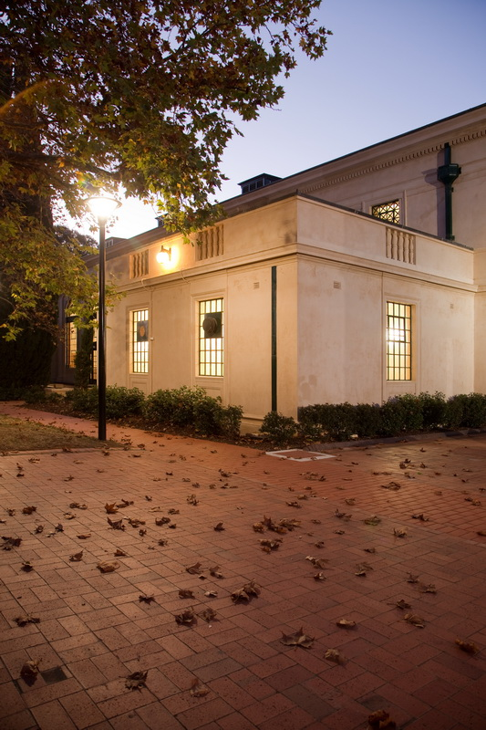

Figure 7: South-East corner of Albert Hall

(Image courtesy of Geoff Comfort – copyright reserved)

# Context for Land Management Plan

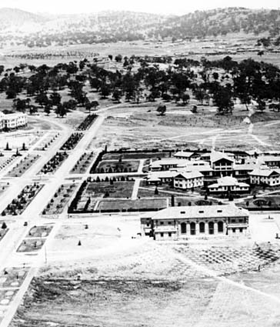

Figure 8: Albert Hall within its context in 1929

## Locational Context

Albert Hall is located at 100 Commonwealth Avenue on Block 1, Section 39, Division of Yarralumla, District of Canberra Central. The site is bounded by Commonwealth Avenue to the east, Flynn Drive to the north and west and Kaye Street to the south (see Figure 4). To the west and north Albert Hall is surrounded by Lennox Gardens and Flynn Place. Beyond these areas of open space is Lake Burley Griffin. To the east, beyond Commonwealth Avenue, is a car park and to the south, beyond Kaye Street, is the Hyatt Hotel Canberra. The wider locational context of Albert Hall includes the National Library of Australia, Treasury Buildings, Old Parliament House and a number of embassies and government offices. Albert Hall is therefore located within a precinct of nationally significant buildings, but is not within walking distance of Canberra’s primary areas of community and cultural activity. The wider context of Albert Hall is illustrated at Figure 9.

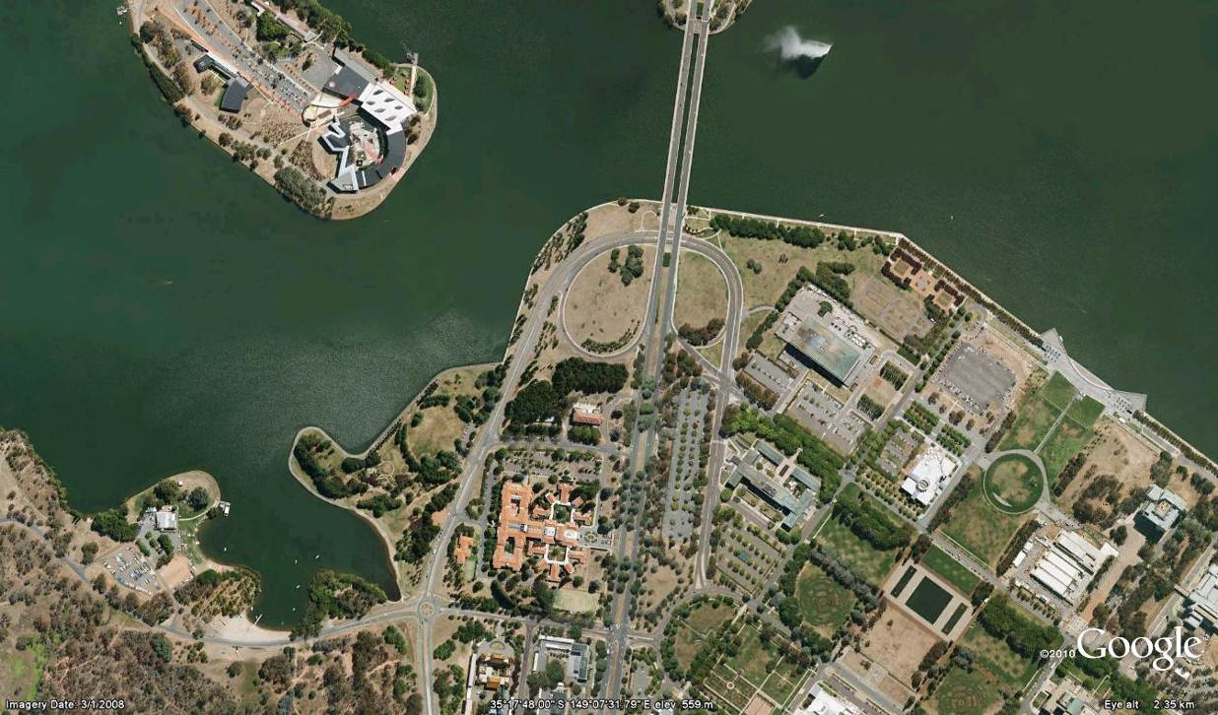

Figure 9: Location of Albert Hall within its wider context

Vehicle access to Albert Hall is from Kaye Street. A semicircular drive provides direct access to the front of the building and a small number of parking spaces. The rear of the building, which is used to provide access to the backstage area, is also accessible from Kaye Street. Immediately behind Albert Hall, and within the curtilage of the site, is a depot managed by the ACT Government that at the time of developing this Plan had a non-ACT Government tenant.

A large car parking area, owned by the ACT Government, is located on the southern side of Kaye Street and is used by visitors to both Albert Hall and the Hyatt Hotel Canberra. Albert Hall is also accessible via public transport and is located on bus routes including 2, 300 (also known as the ‘Blue Rapid Service’), 312, 314, 316, 318 and 319 and 932. Weekday services on the Blue Rapid route are every 5-15 minutes, while weekend services on the 932 route are hourly.

### Opportunities and Constraints

Opportunities related to Albert Hall’s location include:

* Located in a historic part of Canberra
* Able to view, and be viewed from, other Canberra landmarks
* On one of Canberra’s primary roads, less than five minutes from the city centre by car
* Located adjacent to a large area of public parking
* Reasonably well served by public transport, although the frequency of weekend services could be improved.

Constraints related to Albert Hall’s location include:

* Relatively isolated from Canberra’s primary areas of community and cultural activity
* Isolated from frequent pedestrian and cyclist traffic.

## Historic Context

### Design and Construction

Albert Hall was designed in 1926 and constructed in 1927-28. It was one of the first civic buildings in the new Australian capital and was named after the Royal Albert Hall in London, which was itself conceived by and named after Prince Albert, the husband of Queen Victoria.

Albert Hall is an important example of the architectural style known as Federal Capital. The Federal Capital style is unique to Canberra and is associated with the early development of the city from 1911-1939. Other well known buildings in the Federal Capital style include Old Parliament House and Acton House. The Hyatt Hotel Canberra, which neighbours Albert Hall, is another prominent example of the Federal Capital style.

In keeping with the Federal Capital style, Albert Hall looks symmetrical and quite formal, but is decorated with restrained details such as the columns and circular motifs on the front of the building (GML 2011). Other notable architectural features are the full height arched timber windows, which provide excellent natural light inside the auditorium, and the internal mouldings and light fittings.

### Significant Fittings and Features

The Conservation Management Plan assesses and prioritises the significance of various elements, features and inclusions of The Albert Hall.

The many significant fittings and features contained within The Albert Hall include:

* the arch windows and doors
* the parquetry floor
* the light fittings, particularly the suspended lights in the main auditorium (note replica fittings)
* the film projection facilities and equipment.

While it is not significant to the Albert Hall, it is also the location for a 1932 Compton Gold theatre pipe organ, which was installed in Albert Hall in 1978.

Parts of the surrounding landscape also have heritage significance, including:

* the two Atlantic Cedars to the east of the Hall
* the sundial and pedestal, as well as the former rose gardens, to the east of the Hall
* the Pine trees and London Plane trees to the south of the Hall.

### Refurbishments

Four significant refurbishments of Albert Hall have occurred since its construction, in 1949, 1959 and 1990/91 (GML 2011). Most recently, Albert Hall was significantly refurbished between 2009 and 2013. The details of the refurbishment are documented in Section2.3.

### Further Information

The history of Albert Hall is detailed in a range of studies, including:

* Philip Leeson Architects (2015) *Conservation Management Plan*
* Lenore Coltheart (2008) ‘Grand days at the Albert Hall, Part I, 1920s-1940s’ in *Canberra Historical Journal* August 2008
* Lenore Coltheart (2009) ‘More grand days at the Albert Hall, 1940s-1960s’ in *Canberra Historical Journal* October 2009
* Lenore Coltheart (2010) ‘Of the People: Canberra’s Albert Hall, Part 3, 1960s-1980s’ in *Canberra Historical Journal* May 2010
* Godden Mackay Logan (2011) *Albert Hall: A Heritage Context for Community Engagement*.
* Lenore Coltheart (2014) *Albert Hall: The Heart of Canberra.*

The National Archives of Australia *Fact Sheet 250* provides an overview of the history of Albert Hall. The fact sheet is available online at [www.naa.gov.au/collection/fact-sheets/fs250.aspx](http://www.naa.gov.au/collection/fact-sheets/fs250.aspx) . The National Archives of Australia also has a collection of correspondence, photographs, plans and drawings relating to Albert Hall.

In addition, the ACT Heritage Library has prepared a ‘place story’ on Albert Hall and has a collection of materials relevant to its history.

### Opportunities and Constraints

Opportunities related to Albert Hall’s historic context include:

* Historic significance of the building and its surrounds.
* its value to the local community
* further oral history of users about the place of The Albert Hall in the social history of early Canberra
* Increased historic interpretation within and around the building

## Description of the Building and Site

### Exterior of Building

Albert Hall is a symmetrical building which is T-shaped in plan (see Figures 10 and 11). The building is constructed of rendered masonry with terracotta tiled roof (GML 2011). As part of the refurbishments undertaken in 2009-11, the exterior of the building was repainted and the roof retiled. In 2013 the entrance was modified to provide a sloped access allowing people of all abilities to use the front entrance doors.

The exterior of Albert Hall also features:

* A large **northern terrace** which was originally much narrower and was extended in 1959 and, from a heritage perspective, is considered unsympathetic. The terrace can be directly accessed from the main hall. The northern terrace was repaved in as part of the 2009-11 refurbishments. The original design did not provide level access and was not universally accessible, however this has been modified with recent paving and provides a level of accessibility. As it is north facing, the terrace receives full sun for much of the year. The lighter coloured paving identifies the less sympathetic extension to the north terrace.
* A smaller **southern terrace**, which is brick paved and is also accessible via doors from the main hall. Being on the southern side of the building and surrounded by mature plantings, the southern terrace is shaded for much of the year.

### Ground Floor of Building

The ground floor of Albert Hall contains:

* A **porte-cochere**, originally constructed with entrance to the building via three stairs flanked by brass handrails. The stairs, were one of the original heritage features of the building. The entrance was modified in 2013 to create a ramped entrance through the porte-cochere. This provides level access into the building with the stairs recreated under the eastern arch.
* A **foyer** or ‘crush’ area of approximately 50m2, which also contains a telephone booth which was added in 1990. This area can hold up to 40 people. The foyer was repainted during the refurbishment of 2009-11 and the air conditioning improved.
* A **lecture room** of approximately 100m2 which is currently used as a meeting room, tea room and supper room. This space can accommodate up to 70 people. Like the foyer, the lecture room was repainted during the refurbishment of 2009-11 and the heating and air conditioning upgraded.
* A small **kitchen** to the north of the lecture room, which was also renovated in 2009-11. Improvements undertaken at that time included total replacement of benches and cupboards, refinishing the front facing the lecture room, replacing the refrigerator and oven, as well as changes to the floor surface. The kitchen has been renovated to a semi-commercial standard but lacks some elements of a fully commercial kitchen. As a result some Hall users, particularly for weddings, conferences, dinners and other large catered events, erect a temporary kitchen on the northern terrace.
* Male and female **cloak rooms and toilets**, as well as powder rooms, closets and a toilet for people with disabilities are located to the south of the foyer. These spaces were upgraded as part of the 2009-11 refurbishments. The male cloak rooms and toilets are entered via stairs and are therefore not universally accessible.
* A **main hall** or auditorium of approximately 340m2 which can seat up to 450 people or accommodate up to 900 people for dancing or at a standing event. The main hall contains many heritage features, including the parquetry sprung floor, wall and ceiling mouldings and arched, full height windows and doors. Improvements to the space undertaken in 2009-11 include: recasting the suspended lights; installing additional electrical supply to the centre area of the Hall; painting the walls and ceiling; polishing the floor; and replacing the curtains.
* The **stage and orchestra pit**, the latter of which is concealed in the floor. The stage space is 18.8m2. The stage curtains are of crimson velvet and were replaced as part of the refurbishment undertaken in 2009-11. The stage and orchestra pit are not universally accessible at this time. The theatre organ is permanently installed at the rear of the stage, removing approximately 25% of the stage depth. The organ is wheeled forward for performances. The age and quality of the stage lighting and sound equipment is variable and concerns have been raised about its suitability for contemporary performances and events (see Section 2.5).
* The **backstage areas and dressing rooms**. The dressing rooms have toilets and showers, which were installed in 1990 and were not included in the more recent refurbishments.
* An **under stage storage area** which currently contains the previous stage curtains and storage for seating and tables.

### Upper Floor of Building

The upper floor of Albert Hall is accessed via a staircase located on the southern side of the foyer. It contains:

* A tiered **gallery** which overlooks the main hall and can seat up to 128 people. This seating was installed some time ago and remains in relatively good condition. Leather seating was repaired and heating and cooling in the gallery space were upgraded during the refurbishment of 2009-11.
* A **lounge** located to the east of the gallery, over the entrance portico. This space was used as an office by the previous manager but is currently available for use as a lounge area during events and performances and for the storage of chairs and other equipment.
* A **storage space** located to the north of the gallery.
* A small **projection room**, which contains a 1959 film projector. The projector is apparently able to accommodate contemporary film, but has not been used or tested in recent years.

### Opportunities and Constraints

Opportunities related to the building and site include:

* Future use of lounge on upper floor
* Future use of projection room on upper floor.
* Future use of the Lecture Room
* Opportunity for hire of separate sections of the facility
* Future redevelopment of the broader site as detailed in the CMP.
* Improving access for people with a disability to the stage

Constraints related to the building and site include:

* Lack of access for people with a disability to some parts of the building
* Lack of commercial kitchen facilities
* Current location of the Theatre Organ on the stage affecting the usable space
* Size and set up of the stage for theatrical activities
* Lack of modern data projection facilities
* Age and quality of lighting and sound facilities
* Lack of air conditioning in the main Hall
* Usability of film projection equipment
* Storage of equipment in an ad hoc fashion in multiple parts of the building
* Lack of access to basement storage area from main Hall area and stage
* Shared toilet and entrance facilities affecting ability to accommodate multiple hires.

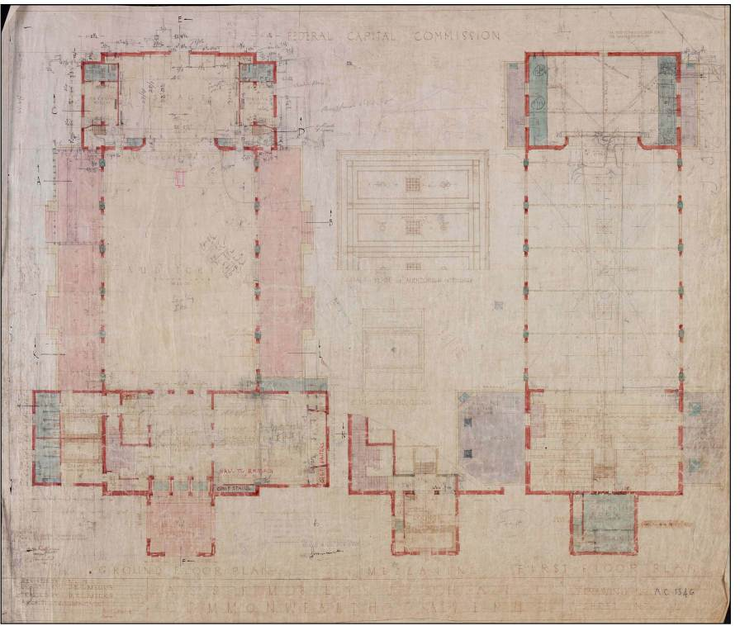

Figure 10: Plan of Albert Hall 1927

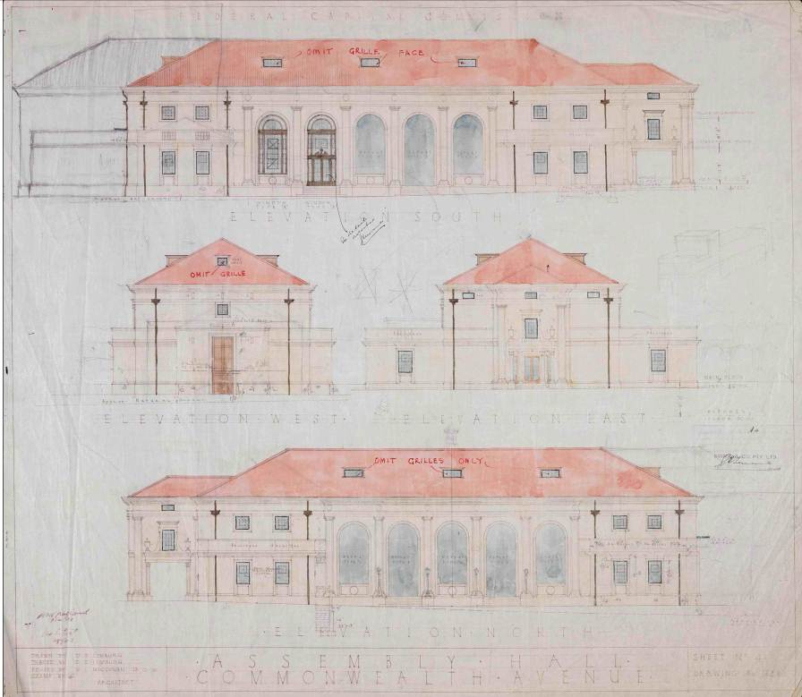

Figure 11: Elevation of Albert Hall 1927

## Previous and Potential Uses

### Previous Uses

Throughout much of its history, Albert Hall has hosted a wide range of uses. At its opening it was promoted as “a suitable habitat for the promulgation of cultural activities” and “would come to be home to the centre of Australian musical life” as part of the developing community (Canberra Times March 12 1928:4). In its early years, Albert Hall was a ‘stand-in’ before the building of national institutions such as the Australian War Memorial, the National Library of Australia, the Australian National University and the National Gallery of Australia” (Freeman 2007: 6). The building housed concerts, exhibitions, balls, dances, school socials, films, shows, conferences, fairs, festivals and a variety of musical and theatrical performances.

Albert Hall was also once regularly used for civic events such as citizenship ceremonies, elections, public hearings, political speeches and congresses for professional organisations. It appears the Hall was used far less frequently for commercial activities, although it was the location of land lease auctions in the 1970s.

Many of these uses continue into the 21st century. Appendix B lists the uses of Albert Hall in 2010/11, to 2014/15. Albert Hall was privately managed from 1997-2007 and was undergoing refurbishment for parts of 2009-11, as such complete hire records only became available from 2010/11 onwards.

In 2010/11, Albert Hall was used for 132 days. As measured by the number of days hire, the building was most frequently used for commercial events, such as fairs and sales. This was due largely to the Hall being used for multiple consecutive days during the year by several long term Hall hirers. The second most frequent use during this time was for cultural events by local groups, including dances, musical and theatrical performances and exhibitions. Other relatively frequent activities included private functions, conferences, trade fairs and exams. In 2011/12 and 2012/13 the usage by hirers increased considerably, with 191 and 204 days hired respectively. In 2013/14 and 2014/15 the number of hire days has settled at an average of around 185 hire days per year.

The way in which the hirer data is recorded makes it difficult to undertake a precise analysis of the timing of events and activities. It appears that a significant majority of hirers booked the Hall for both the day and night, with relatively few bookings for the day or night only. There are few recorded examples of multiple hirers on one day, either consecutively (over the course of a day) or concurrently (in different parts of the building, such as the meeting room and main hall).

Concurrent hire of the Hall would be difficult, due to the building’s layout and the fact that most users of the main hall would also want access to the kitchen. However consecutive hire, such as in the morning and at night, should be both possible and desirable.

In terms of the spread of bookings over the week, 51 of the 132 days on which the Hall was hired in 2010/11 were for weekend hire. The Hall was thus hired on 51 of the 104 possible weekend days in 2010/11 (a usage rate of 49%) and 81 of the 260 possible weekdays (a usage rate of 31%). In 2011/12 the overall Hall usage rate was 55% of the year and increased to 58% in 2012/13. In 2014/15 the overall usage rate was 47% with a total of 172 days booked over the year with 99 of 261 weekdays and 73 of 104 weekend days booked. There is therefore still considerable scope to increase the usage of Albert Hall on both weekends and weekdays.

### Potential Uses

As is outlined in the following section and in the Community Engagement Final Outcomes Report, the consultation process associated with this Land Management Plan included discussion on potential uses for Albert Hall. In general, the proposed uses were very similar to those which have occurred in the past. Community members mentioned dances, concerts, balls, exhibitions and a wide variety of performances as being appropriate for Albert Hall. Civic events such as public meetings and citizenship ceremonies were also suggested, as were private events such as weddings.

The Friends of Albert Hall provided an indicative list of potential uses of Albert Hall, which was compiled in 2007 but nonetheless remains relevant. In addition to the uses noted above, potential uses suggested by the Friends included:

* ballet and other dance classes and recitals
* book launches
* entertainment for children, particularly during the day
* entertainment for frail aged adults, particularly during the day
* filming
* memorial services
* movie screenings and festivals, particularly of vintage movies
* organ recitals
* rehearsal space for music, dance and theatre groups
* school balls.

The other potential additional use raised during the community engagement process was the addition of a café. As is outlined in the following section, there was some support for this idea, particularly if the café were housed in an ancillary building, rather than within Albert Hall itself. It has also been noted that other cultural facilities of a similar age to Albert Hall, such as Old Parliament House, host a café. GML’s report states that “in Commonwealth Avenue area there is a lack of modest café/food and beverage outlets. A small café associated with the Hall using the terrace in summer could find local custom” (2011: 35).

One of the constraints of the Albert Hall site is, however, that it has a low level of passing pedestrian traffic, due particularly to its location (see figure 5). For a café to be successful on the site, it may therefore need to rely significantly on the patronage of people who are specifically visiting Albert Hall. This is unlikely to be financially feasible unless there were an increase in activity at the Hall. The other constraint regarding this option is that self-catering is highly valued by a number of hirers, which the Government has recognised in this Plan. One possible approach could be to trial a coffee cart or other small scale, temporary food or beverage vendor and use the results of the trial to inform a detailed feasibility study for a café on the site.

### Comparative venues

GML’s (2011) *Albert Hall: A Heritage Context for Community Engagement* contains a comparative assessment of 42 venues in Canberra. The report notes that:

* There are a large number of performance spaces in Canberra, but most of these are much larger or smaller than Albert Hall. The Erindale Theatre, The Q in Queanbeyan and the Playhouse Theatre (which is part of the Canberra Theatre Centre) have a similar capacity, but offer higher standards of lighting, sound and other equipment, as well as a bar and catering facilities
* There are numerous exhibition and gallery spaces in Canberra, many of which are part of national institutions. There may, however, be an ongoing role for Albert Hall as a smaller venue for temporary exhibitions, particularly those relating to historical themes
* There are several church halls, such as St John the Baptist Church in Reid, St Andrews Church in Forrest and All Saints Church in Ainslie, which are able to host dances and community events. These offer more affordable hire rates than Albert Hall, presumably due to their smaller size and lower upkeep costs.

GML concludes that “where Albert Hall fills the market is in the intermediate-sized seating capacity for concerts, dances and theatre performances”. Variety shows, children’s performances and contemporary music are some of the other potential uses suggested.

The report also states that “no other venues have the combination of architectural elegance, historic prestige and heritage cache that Albert Hall has to offer: a market niche” (2011: 32).

### Opportunities and Constraints

Opportunities related to previous and potential uses include:

* Increasing the number and variety of events and activities staged at the Hall
* Increasing the number of times the Hall is used by consecutive hirers in one day
* Increasing the number of hires Monday to Thursday
* Making greater use of the theatre organ for events and performances
* Trialling a coffee cart or similar small scale, temporary food and/or beverage vendor on the site
* Investigating the feasibility of a café in an ancillary building
* Heritage character of Albert Hall fills a niche in the Canberra venues market.

Constraints related to previous and potential uses include:

* Lack of clear and complete hire data
* Lower standards of equipment and facilities than other performing arts venues in Canberra of a comparable size.
* Limitations in usable space on the stage due to the Theatre Organ

## Community Engagement Outcomes

### Community Engagement Process

The community engagement process associated with the preparation of a Land Management Plan for Albert Hall was held between early April and mid June 2011. The process involved five key engagement methodologies, being:

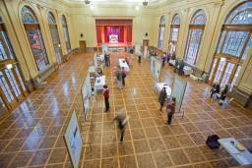

Figure 12: The layout of the Albert Hall Open House

* initial interviews with individuals and groups of stakeholders
* a Web Forum
* an Open House event
* a Community Workshop.

The key outcomes of the engagement process are summarised below. Full details are provided in the Community Engagement Final Outcomes Report.

### Community Engagement Outcomes

The engagement demonstrated that there was strong agreement that Albert Hall is a unique venue in Canberra due to its heritage character, ambiance, elegance and atmosphere. There was, however, a perception amongst some of the existing Hall users that the image of the building has been tarnished in the minds of Canberrans due to some of the previous uses and the ways in which they have been promoted.

There was also a high level of appreciation for the current standard of building presentation and maintenance, and participants in engagement activities frequently expressed the hope that the building will continue to be well maintained into the future. This was particularly evident in a mock budget exercise in the Community Workshop, in which commencing an increased regular maintenance schedule was ranked most highly by the majority of participants.

There was evidence throughout the engagement process that there remains a high level of social and cultural attachment to Albert Hall, particularly from older members of the community. One of the challenges for the future lies in honouring and retaining this existing connection, while also attracting a new generation of Canberrans to feel a sense of ownership of and engagement with Albert Hall.

Throughout the engagement process there was emerging agreement that there should be a combination of community, cultural and civic uses at Albert Hall, coupled with some commercial use. There was also a level of agreement that more active management arrangements would be desirable, preferably with an on-site, or at least on-call, resource. There was a strong view from some participants that Albert Hall should remain in public management, as well as a minority view that more professional, and potentially private, management is required. The desires for public management and professional venue expertise may not, however, necessarily be mutually exclusive. An additional, and related, consideration raised during the consultation process was the need to better market and promote Albert Hall.

At all stages in the engagement process, community, cultural and performing arts groups repeatedly expressed concern about the affordability of hire rates at Albert Hall, both currently and into the future. This issue was strongly connected in the minds of some participants with that of Public Liability Insurance (PLI) for private hirers, particularly for those wanting to hire the building for weddings, birthdays and similar events which was not available at the time of the consultation.

With the exception of ongoing maintenance, there was a reasonably wide range of views about the standard of facilities which should be provided at Albert Hall. This was particularly evident in the stakeholder interviews and in the Community Workshop. There was a high level of support in the Community Workshop mock budget exercise that enhancing heating and air conditioning in the auditorium is a priority for the future of the building. Participants also generally supported installing a data projection screen and capabilities, as well as upgrading the foyer and installing heritage interpretation signage. Attendees at the Community Workshop also appeared to support improvements to disability access. This issue was particularly emphasised in comments on The Riot ACT website, but was rarely mentioned in the Open House and Web Forum.

Views on other forms of improvements to Albert Hall varied. Community Workshop participants generally favoured a management model which combined affordable community and civic uses with active management and marketing associated. While there was ongoing support for use of Albert Hall as a performance venue, the many practical constraints the building currently has in staging high quality performances were emphasised. This echoed concerns expressed throughout the engagement process from performers and event organisers about the layout and usability of the stage, including sound and lighting arrangements.

Perspectives on potential improvements to the kitchen also varied. In the Community Workshop mock budget exercise, participants were virtually split on whether small improvements should be made to the kitchen, or whether it should be subject to a more significant improvement to a commercial standard. In addition, it was noted by some Hall users that recent changes to the floor surface in the kitchen have resulted in the kitchen bench height being difficult to work with.

There was some support for the establishment of a café, brasserie or other small dining venue at Albert Hall, both in the Web Forum and in the Community Workshop. Many of the people in the Community Workshop who supported this idea were clear that they supported it only if a café were housed in a stand alone building, rather than within the existing bounds of Albert Hall. There were, however, some concerns expressed that such a venue would not be profitable, due to the lack of pedestrian traffic through the site. There were also some participants in the Community Workshop who were worried that establishing a café may limit the self catering opportunities available to hirers, thus potentially increasing the total cost of hiring the Hall.

### Opportunities and Constraints

Opportunities identified during the community engagement include:

* Unique character, ambiance, elegance and atmosphere of the building
* Current standard of building presentation and maintenance, although this will need to be continued into the future
* Increasing and improving marketing and promotions, particularly via the website
* High level of social and cultural attachment to the building, particularly from older demographics
* Potential for a younger generation to use, and feel a greater sense of attachment to, the building.

Constraints identified during the community engagement include:

* Maintaining the affordability of hire rates for community and cultural groups, both now and into the future
* Public Liability Insurance arrangements for private hirers and some community groups was raised during the consultancy. However from July 2012, the ACT Property Group made available Public Liability Insurance at a fee to Individuals and Non Incorporated Community Entities using the venue.
* Lack of on site venue management
* Layout and usability of the stage for larger and higher profile performances and events
* Age and quality of lighting and sound facilities
* Lack of modern data projection facilities
* Lack of commercial kitchen facilities
* Height of the kitchen benches
* Lack of air conditioning in the main Hall
* Lack of disability access to the stage, basement and male toilets.

## Financial Context

### Operating expenditure and income

In 2010/11operating expenses for Albert Hall totalled $116,642, increasing by 33% to $155,303 in 2011/12 and 14% to $178,401 in 2012/13. The total costs in 2013/14 and 2014/15 are similar to 2012/13, however appear higher in the table below due to the inclusion of the management costs for the venue. These figures exclude all capital expenses for refurbishment of the Hall.

As detailed below the increased costs can be attributed to matters directly related to the level of usage such as cleaning and consumables, and additional maintenance and insurance costs. It should be noted that the figures for 2010-2013 do not include the cost of ACT Property Group staff allocated to management of the facility and booking services. However, this has been included in 2013/14 and 2014/15 expenses.

Income received from the hire of Albert Hall is as follows:

|  |  |  |  |  |  |  |
| --- | --- | --- | --- | --- | --- | --- |
| **Item** | **2010/11** | **2011/12** | **2012/13** | **2013/14** | **2014/15** | **% Change 2014/15 vs 5 yr average** |
| Hire fees | $130,800 | $199,738 | $222,080 | $205,232 | $192,049 | -6.4% |

A more detailed breakdown of expenses is as follows:

|  |  |  |  |  |  |  |
| --- | --- | --- | --- | --- | --- | --- |
| **Items** | **2010/11** | **2011/12** | **2012/13** | **2013/14** | **2014/15** | **% change 2014/15 vs 5 yr average** |
| Administration | $3,611 | $720 | $745 | $3,845 | $771 | -60% |
| Management ^ |  |  |  | $102,830 | $74,318 | N/A |
| Cleaning | $32,625 | $47,312 | $51,872 | $50,906 | $41,683 | -7% |
| Electrical Repairs | $321 | $1,925 | $341 | $342 | $255 | -60% |
| Electricity | $10,394 | $16,458 | $19,029 | $17,358 | $14,883 | -5% |
| Fire Protection | $3,308 | $3,537 | $3,207 | $3,349 | $3,118 | -6% |
| Gardening | $9,037 | $9,842 | $11,121 | $11,921 | $10,693 | 2% |
| Gas | $6,425 | $8,794 | $7,995 | $8,690 | $7,997 | 0% |
| Hygiene Services | - | $149 | $1,341 | $1,937 | $1,788 | 6% |
| Insurance Premium | - | - | $2,675 | $2,875 | $2,950 | 4% |
| Mechanical Repairs | $3,141 | $3,507 | $4,681 | $4,638 | $3,486 | -10% |
| Pest Control | - | $495 | $1,980 | $2,180 | $1,662 | 5% |
| Minor Repairs and Maintenance | $36,486 | $41,424 | $53,741 | $53,696 | $60,180 | 23% |
| Rubbish Removal | $2,673 | $4,541 | $6,515 | $6,979 | $8,422 | 45% |
| Security Repairs and Maintenance | $3,315 | $1,753 | $1,184 | $55 |  | N/A |
| Other Security | $504 | $875 | $1,045 | $3,156 | $1,600 | 11% |
| Toilet Requisites | $1,347 | $3,616 | $259 | $1,383 | $985 | -35% |
| Water Consumption | - |  | $424 | $1,332 | $2,490 | 76% |
| Water/Sewerage Rates | $3,375 | $9,536 | $10,246 | $4,060 | $4,172 | -34% |
| **Total** | **$116,642** | **$155,303** | **$178,401** | **$281,532** | **$241,453** | 24% |

Notes:

^ From 2013/14 ACT Property Group recognised the cost of staff managing the venue. The amount of staff time attributed to Albert Hall, as a proportion of all venues managed, is reflected in the table.

### Capital expenditure

Budgeting for capital improvements to Albert Hall occurs independently of the ongoing allocation of budgets for operating expenses. In 2009/10, a substantial capital budget of $2.723 million was allocated by the ACT Government for the refurbishment of Albert Hall. In 2010/11 the Commonwealth Government provided an additional $500,000 to the upgrade project budget. The Capital Works program was delivered from 2009 to 2012. The ACT Government allocated a further $145,000 in 2012/13 for improvements to the entrance to Albert Hall. The entrance renovation project was completed in 2013. The total Capital funding expended on the Albert Hall since 2009 is $3.368m.

The specific improvements funded by this capital expenditure are described as part of Section 2.3.

### Hire Fees for Albert Hall

The fees set for hire of Albert Hall in 2014/15 were as follows:

|  |  |  |
| --- | --- | --- |
| **Schedule** | **Full day hire 2014/15** | **Community day hire**  **2014/15** |
| Daily Rate (Mon-Thurs) | $1,308.00 | $855.00 |
| Daily Rate (Fri-Sun) | $2,344.00 | $1,545.00 |
| Daily Rate (Public Holidays) | $2,344.00 | $1,545.00 |
| Full Weekend (Fri-Sun) | $5,194.00 | $3,380.00 |
| Full Week (7 days) | $8,947.00 | $6,332.00 |
| Refundable Security Bond | $607.00 | $607.00 |

Of the hires during each financial year, a breakdown of the rate paid is presented below. The table details a shift in the type of hirer towards an increased number of private hirers (eg. Weddings, celebrations) and hires by incorporated community organisations. The data for 2010-2013 combines all full rate hirers into a single figure. This has been separated out from 2013/14. The Community Rate hire group is the largest of the four types of hirers.

|  |  |  |  |  |  |
| --- | --- | --- | --- | --- | --- |
| **Year** | **Full rate - Organisation** | **Full Rate – Private** | **Full Rate - Government** | **Community rate** | **Notes** |
| **2010/11** | 60% |  |  | 40% |  |
| **2011/12** | 54% |  |  | 46% | Of full rate hires  10% Private and 7% Government Hires |
| **2012/13** | 50% |  |  | 50% | Of full rate hires  17% Private and 5% Government |
| **2013/14** | 23% | 28% | 7% | 42% |  |
| **2014/15** | 33% | 19% | 6% | 42% |  |

It should be noted that:

* An additional booking fee of $250.00 is charged use of the grand piano
* There is currently no charge for use of the sound equipment or specialist lighting.
* The community rate for the hire of Albert Hall applies only to groups with an ACT Certificate of Incorporation.
* An hourly rate is available for part day hirers
* Hire fees have generally been indexed by the ACT Government specified CPI each year.

Retail use of the Hall by a single hirer is currently limited to four bookings per annum, with each booking not exceeding seven days in duration. The total number of days for which retail trading is permitted in the Hall over any 12 calendar months is 110. This limitation ensures that Hall hire is in accordance with the the overarching planning policy applicable to the site under the National Capital Plan, which states that “Albert Hall may be used as a cultural facility and for ancillary short-term commercial/retail activities”.

### Hire fees for comparative venues

Due to the wide variety of uses made of the building, it is difficult to directly compare fees for the hire of Albert Hall with other venues.

The fees for hire of selected other venues in ACT, NSW, WA and Victoria in 2015/16 are listed below. These rates are inclusive of GST. All of these spaces, with the exception of the Parkes Room at the Exhibition Park in the Canberra (EPIC) Conference Centre, are heritage venues with timber floors. All, with the exception of St John the Baptist Anglican Church, are government owned. They have a range of capacities (from 250 to 900) and management arrangements. Two of the venues (Parkes Room at the EPIC Conference Centre and the King’s Hall at Old Parliament House) have onsite caterers which must be used by hirers if food and beverages are provided as part of the event.

|  |  |  |  |  |  |
| --- | --- | --- | --- | --- | --- |
| **Venue** | **Owned By** | **Daily Community Rate** | | **Daily Commercial Rate** | |
|  |  | Weekday | Weekend | Weekday | Weekend |
| **Albert Hall (ACT)** | **ACT Government** | **$880** | **$1,590** | **$1,340** | **$2,402** |
| Leichhardt Town Hall (NSW) | Leichhardt Council | $544 | $819 | $1,088 | $1,638 |
| Bendigo Town Hall (Vic) | Bendigo City Council | $880 | $1,150 | $1,270 | $1,674 |
| Gordon Arthur Hall (ACT) | St John the Baptist Anglican Church | $720 | $720 | $720 | $720 |
| Granville Town Hall (NSW) | Parramatta City Council | $300 | $417 | $605 | $857 |
| Parramatta Town Hall (NSW) | Parramatta City Council | $352 | $514 | $703 | $1,029 |
| Parkes Room  EPIC Conference Centre (ACT) | ACT Government | $1,633 | | $2,183 | |
| King’s Hall  Old Parliament House (ACT) | Australian Government | $1,430 plus set up fee of $500 to $1,000 for non catered events | | | |
| Perth Town Hall | Perth Town Council | $1,673 | $1,673 | $2,111 | $2,111 |

There are a number of points to note about variations in hire fees. Like Albert Hall, all of the organisations listed above charge a refundable bond for some or all forms of hire. Some of the organisations listed above include Friday in the weekend rate, whereas others include it in the weekday rate. Where an hourly rate is charged, calculations have been based on a 10 hour period until Midnight.

St John the Baptist Anglican Church does not differentiate between community and commercial hirers, but does distinguish between long term and casual hire. In addition, it does not have a daily rate, but does charge for a maximum of nine hours of hire. The rates cited above are for nine hours of use at the casual hire rate. St John’s also charges an additional fee for public liability insurance cover of $30, as well as additional fees for using the kitchen, the public address system and piano.

Parramatta City Council has a complex, four tier pricing structure, as follows:

* Tier 1: eg. sales and exhibitions
* Tier 2: eg. social functions, businesses, State and Federal Government
* Tier 3: eg. church groups, political parties, clubs, funded community groups, Local Government
* Tier 4: eg. charities, non funded community groups, rallies/demonstrations, charity functions.

The community rates cited in the table above are as per Tier 4 and the commercial rates are as per Tier 2. Discounts of 5% are given by Parramatta City Council for local residents and/or annual hirers in some of these categories. A surcharge for casual hire (ie for groups without their own Public Liability Insurance) is charged at 50% of the first hour of hire. The rates cited above for hire of Parramatta Town Hall are for hire of the main hall only. Hire of other rooms within the building are charged separately. The Council are currently reviewing their policies regarding hall hire, and Parramatta Town Hall falls into this review. As a result potential Hirer’s will be required to submit an Expression of Interest form should they wish to book one of the venues.

EPIC does not differentiate between weekend and weekday hire rates. It does, however, charge a lesser daily rate of $1,320 if the function is catered (which is charged additionally). In addition, EPIC may be able to negotiate lower rates during off peak periods.

In addition to the rates cited above, hirers at Old Parliament House are charged for the use of security guards during evening and weekend functions. A large range of equipment (including a projection screen, microphones, public announcement system and theatrical lighting) is available for hire at an additional charge. Functions extending past midnight incur a surcharge of $150 per hour or part thereof.

Perth Town Hall has a fee structure using an hourly rate from 6am – 6pm, 6pm – Midnight and 12pm – 1am. Additional fees apply for items such as using the Main Hall and Lower Foyer together. Secondly, engagement of security – required when functions exceed more than 100 guests and functions after 6pm. A community rate of a 25% discount off the total hire fee is available to eligible groups. The hire fee comparison includes the minimum security charge and the chair set up cost.

Although not transparent in the documents analysed in the development of this document, the hire fees above indicate that some venues may receive financial support or subsidy for their management or operating costs from the governing organisation (eg. local or state Government). Local councils and religious organisations in particular view offering subsidised town hall rentals as part of the service they provide to their local community.

From this comparison, it is clear that there are therefore a very large range of detailed policy issues to be considered when setting hire and other fees for the use of venues such as Albert Hall.

In 2012/2013 the ACT Government made Public Liability Insurance for Individuals and Non Incorporated Community Hirers available at Albert Hall and the Yarralumla Woolshed for a set fee per event. During 2012/13, 9 Hirers took up this option at Albert Hall. In 2014/15 the rate was $250 per event and 13 hirers opted to use this insurance at this venue.

### Opportunities and Constraints

Opportunities relating to the financial context for Albert Hall include:

* Increasing the hire of Albert Hall and thus the income received
* Considering providing basic lighting and audio visual equipment and charging for the hire of higher level equipment.

Constraints relating to the financial context for Albert Hall include:

* Managing the budget process to gain funding for future refurbishments and other capital improvements
* Requirement for costs of Albert Hall to be recovered through hire fees
* Maintaining the affordability of hire rates for community and cultural groups, both now and into the future.

## Summary of Constraints and Opportunities

The opportunities and constraints arising from the context for Albert Hall are summarised in the table below. These are not listed in priority order, but rather in the order in which they appeared in the text. These opportunities and constraints form the framework for the Land Management Plan for Albert Hall, which is contained in the previous section of this document.

|  |  |
| --- | --- |
| Opportunities | Constraints |
| * Located in a **historic** part of Canberra * Able to view, and be viewed from, other Canberra **landmarks** * On one of Canberra’s primary **roads**, less than five minutes from the city centre by car * Located adjacent to a large area of **public parking** * Reasonably well serviced by **public transport**, although the frequency of weekend services could be improved * **Historic significance** of the building and its surrounds * Future use of **lounge** on upper floor * Future use of **projection room** on upper floor * Increasing the **number and variety of events** and activities staged at the Hall * Increasing the number of times the Hall is used by **consecutive hirers** in one day * Making greater use of the **theatre organ** for events and performances * Trialling a **coffee cart** or similar small scale, temporary food and/or beverage vendor on the site * Heritage character of Albert Hall fills a **niche in the Canberra venues market** * **Unique character**, ambiance, elegance and atmosphere of the building * Current standard of **building presentation and maintenance,** although this will need to be continued into the future * Increasing and improving **marketing and promotions**, particularly via the website * High level of **social and cultural attachment** to the building, particularly from older demographics * Potential for a **younger generation** to use, and feel a greater sense of attachment to, the building * **Increasing the hire** of Albert Hall and thus the income received * Considering providing **basic lighting and audio visual equipment** and **charging for the hire of higher level equipment**. | * Relatively isolated from Canberra’s primary areas of **community and cultural activity** * Isolated from frequent **pedestrian and cyclist traffic** * **Lack of disability access** to the stage, upstairs area, basement and male toilets. * Lack of **commercial kitchen facilities** * Size and set up of the **stage** for theatrical activities * Theatre organ reducing available space on the stage * Lack of modern **data projection facilities** * Age and quality of **lighting and sound facilities** * Lack of **air conditioning** in the main Hall * Usability of **film projection equipment** * **Storage** of equipment in an ad hoc fashion in multiple parts of the building * Lack of clear and complete historical **hire data** * Lower standards of **equipment and facilities** than other performing arts venues in Canberra of a comparable size * Maintaining the affordability of **hire rates** for community and cultural groups, both now and into the future * **Public Liability Insurance** arrangements for Commercial and Incorporated community groups * Lack of **on site venue management** * Height of the **kitchen benches** * Managing the budget process to gain **funding for future refurbishments** and other capital improvements * Requirement for **costs of Albert Hall to be recovered** through hire fees * Maintaining the **affordability of hire rates** for community and cultural groups, both now and into the future |

Appendices

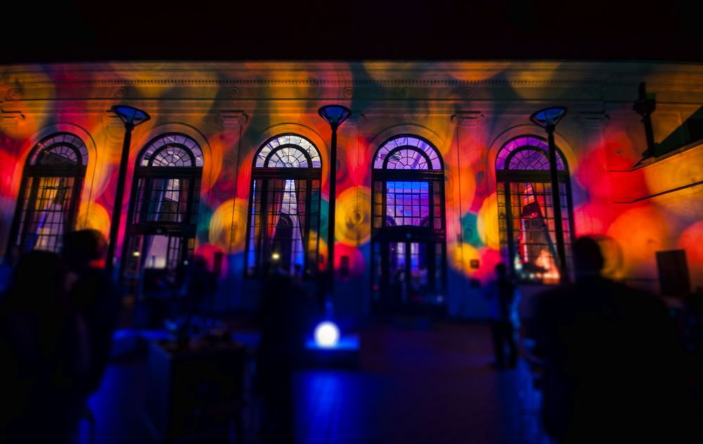

Figure 13: Music ACT Music Awards 2012:

(Image courtesy of Martin Ollman)

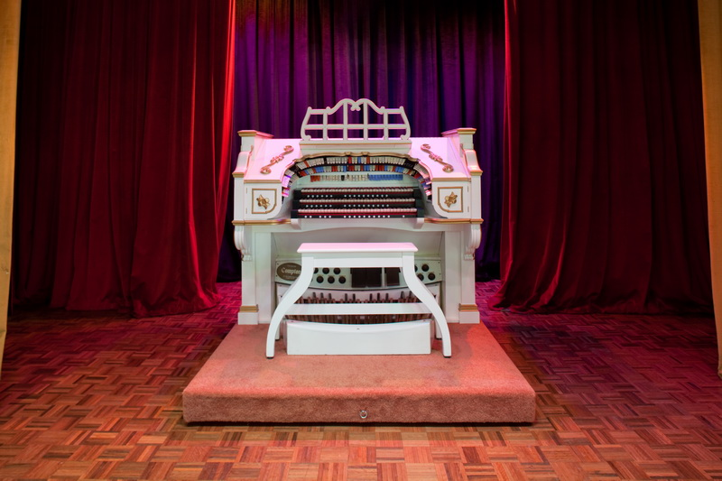

Figure 14: Compton Theatre Organ on display at the Albert Hall

(Image courtesy of Geoff Comfort – copyright reserved)

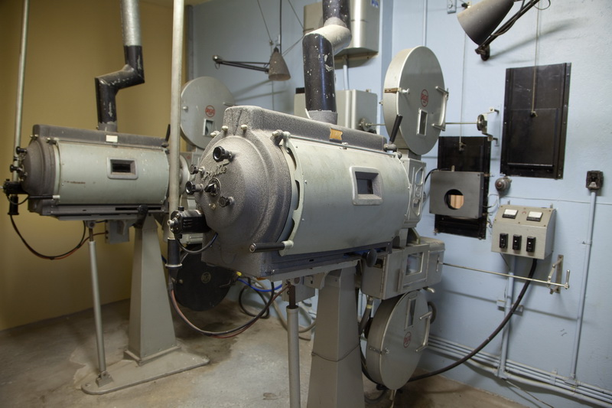

Figure 15: Projectors in situ at the Albert Hall

(Image courtesy of Geoff Comfort – copyright reserved)

# Appendix A: Statement of Heritage Significance

The following is the Statement of Heritage Significance which is part of the entry to the Heritage Register for the Albert Hall Heritage Precinct for the purposes of Section 41 of the *Heritage Act 2004*. The entry was registered on 15 September 2010.

Albert Hall is recognised as a prime example of the public architecture of the foundational Federal Capital era, 1911 to 1939. As with Old Parliament House, Albert Hall expresses the aim for a distinctive architectural character for Canberra equal to its role as the national capital.

This aesthetic significance is embodied in the architecture, the landscape and the interior design of the place. The Albert Hall precinct is, in built form, the embodiment of the early life of the Federal Capital, a life characterised by community involvement in civic events, and in the national and community life of the early Capital. Albert Hall was the ‘cultural hearth’ of the early Federal Capital, and as such, remains highly valued for that quality.

The naming of Albert Hall, an intentional association with the centre of the performing arts in London, and the British Commonwealth, was a statement of the importance of the arts in national life and testimony to Prime Minister Stanley Melbourne Bruce’s advocacy of Australian culture, an often-overlooked characteristic of his career as a statesman.

Albert Hall was a publicly constructed place of gathering for the Federal and local community of Canberra. It is notable as one of a number of halls constructed within the early Federal Capital [refer the Causeway, Ainslie, Acton and Kingston halls], but Albert Hall was intended to be the **‘**Assembly Hall’ for the city and community. It represents the intent of the early government to provide a community, public and cultural focus for the infant city. Albert Hall also has a role in signifying key events in Australian political and constitutional history, and our national cultural and professional history, and hence has clear associations with major political and community figures involved in those events (Freeman, P, 2007).

Albert Hall continues to have social and cultural value as a venue for a range of different purposes attracting large gatherings, and aesthetic value in its lakeside setting. The Hall is a landmark adjacent to the Parliamentary Triangle and the thoroughfare from City Hill to Parliament House.

# Appendix B: Usage Analysis

Between 1997 and 2007, Albert Hall was privately managed under contract with the ACT Government. Detailed hire records for this period are unavailable. The facility had periods of low or limited use during 2009-2011 due to a significant refurbishment of the building with the Hall fully available during 2010/11 onwards.

The table below outlines the types of uses which were made of the Albert Hall 2010/11 to 2014/15, listed in alphabetical order showing the number of days hire by category of use.

|  |  |  |  |  |  |  |
| --- | --- | --- | --- | --- | --- | --- |
| Use | Examples | 2010/11 | 2011/2012 | 2012/13 | 2013/14 | 2014/15 |
| Commercial Events | * fairs * sales | 58 | 73 | 54 | 37 | 46 |
| Conferences and Trade Fairs | * conferences * trade fairs | 10 | 1 | 0 | 6 | 8 |
| Educational and Associated Activities | * exams | 10 | 13 | 4 | 3 | 5 |
| Community Activities and Events | * markets and fairs * exhibitions * performances * dances/entertainment | N/A\* | N/A\* | N/A\* | 78 | 64 |
| Cultural Events  (Interstate and International Groups) | * concerts | 1 | 0 | 1 | 0 | 0 |
| Cultural Events  (Local Groups) | * dances * musical performances * exhibitions * balls | 31 | 60 | 95 | 17 | 14 |
| Charitable Events | * dinners * fund raisers | 1 | 17 | 13 | 3 | 3 |
| Civic Ceremonies and Events (Private) | * embassy events | 4 | 8 | 9 | 6 | 1 |
| Civic Ceremonies and Events  (Public) | * public meetings * awards ceremonies | 2 | 0 | 1 | 4 | 4 |
| Heritage Events | * lectures * seminars | 2 | 3 | 5 | 13 | 3 |
| Private Functions | * weddings * parties * funerals | 13 | 16 | 22 | 30 | 24 |
| **Total** |  | **132** | **191** | **204** | **197** | **172** |

\*The category of “Community Activities and Events” has been introduced to further identify non-commercial users.

# Appendix C: Action Timeframes

Each objective is supported by operational and potential capital works (CW) actions.

References in this Annexure are in accordance with Section 1.6 of the Land Management Plan

Capital Works initiatives subject to funding availability from the ACT Government or other sources. Timeframes provided below are indicative only for these items.

| **Objective** | **Action** | **Action Description** | **Timeframe** |
| --- | --- | --- | --- |
| 1 | a | * Formalise and communicate and where appropriate consult upon the Maintenance as part of the Building and Grounds Action Plan for Albert Hall | Short |
| 1 | b | * Gain input on the priorities in the Building and Grounds Action Plan from the Management Reference Group and, potentially, through the user forums or surveys | Short-medium |
| 1 | c | * Ensure the Conservation Management Plan remains up to date and is approved by the ACT Heritage Council. Note: current version approved 1 June 2015, due for review in 2020. | Medium |
| 1 4 | d and b | * Prepare a Heritage Matters Plan, including interpretive signage; and * Involve community members in the development of Heritage Interpretation Strategy | Medium |
| 1 | e (CW) | * Implement the Heritage Interpretation strategy arising from the Heritage Matters Action Plan | Medium |
| 1 | f. (CW) | * Improve the gardens surrounding the building in accordance with the Conservation Management Plan and Building and Grounds Action Plan. | Medium |
| 2 | a | * Develop a Hiring Arrangements Action Plan encompassing operational matters, rates, booking arrangements | Short |
| 2 | b | * Implement improvements to venue management | Medium |
| 2 | c | * Prepare a detailed Operations Manual | Short |
| 2 5 | d and d | * Implement an online booking system | Short |
| 2  3 | e and  d | * Commence regular user forums or surveys | Medium |
| 2 | f | * Develop and implement a Parking Strategy. | Short |
| 2 | g. (CW) | * Enhance air conditioning in the Hall. | Medium |
| 3 | a | * Include at least one representative from a local cultural group on the Management Reference Group | Short |
| 3 | b. (CW) | * Improve and rationalise arrangements for the storage of furniture and other items throughout the Hall | Medium |
| 3 | c. (CW) | * Improve the backstage area, including resolving issues related to the location and frequency of use of the organ | Long |
| 3 | e. (CW) | * Install a data projector and screen or implement alternate arrangements whereby users are able to source and connect their own equipment | Medium |
| 3 | f. (CW) | * Improve the lighting system or implement alternate arrangements whereby users are able to source and connect their own equipment | Medium |
| 3 | g. (CW) | * Install an improved sound system or implement alternate arrangements whereby users are able to source and connect their own equipment. | Medium |
| 4 | a | * Establish a Management Reference Group to provide ongoing input into the management of Albert Hall | Short |
| 4 | c | * Develop and promote a program of events and activities targeted at people with an existing connection to Albert Hall. | Short-Medium |
| 5 | a | * Include at least one younger person on the Management Reference Group, ideally with a connection to the venue | Short |
| 5 | b | * Develop and promote a program of events and activities targeted at children and young people | Short-Medium |
| 5 6 | c and d | * Increase the online presence of Albert Hall, including by increasing the quality and quantity of information provided on the website | Short |
| 5 | e | * Ensure that the Marketing and Promotions Plan includes actions targeted at children and young people. | Short |
| 6 | a | * Engage a resource with responsibilities for increasing the usage of Albert Hall, in accordance with the primary and ancillary uses | Medium |
| 6 | b | * Prepare and implement a Marketing and Promotion Action Plan | Short |
| 6 | c | * Improve the way in which venue hire is recorded, analysed and reported | Short |
| 6 | e | * Consider trialling a coffee cart or similar small scale, temporary food and/or beverage vendor on the site | Long |

**Actions will be delivered over the following time frames:**

|  |  |  |  |  |  |  |  |  |  |  |
| --- | --- | --- | --- | --- | --- | --- | --- | --- | --- | --- |
| Year | 1 | 2 | 3 | 4 | 5 | 6 | 7 | 8 | 9 | 10 |
| Priority | **Short** | | | **Medium** | | | | **Long** | | |

To support the operational objectives and actions, five Action Plans will be developed which will address a number of the actions detailed above. These will all be developed within the first three years after the Land Management Plan is published.

# Appendix D: Record of Minor Amendments

|  |  |  |  |
| --- | --- | --- | --- |
| **Date** | **Details of Amendment** | **Page/Section** | **Approval** |
|  |  |  |  |
|  |  |  |  |
|  |  |  |  |
|  |  |  |  |
|  |  |  |  |
|  |  |  |  |
|  |  |  |  |