Australian Capital Territory

Road Transport (General) Application of Road Transport Legislation Declaration 2019 (No 13)*

Disallowable instrument DI2019–279
made under the
Road Transport (General) Act 1999, section 12 (Power to include or exclude areas in road transport legislation)

1 Name of instrument
This instrument is the Road Transport (General) Application of Road Transport Legislation Declaration 2019 (No 13).

2 Commencement
This instrument commences on 31 December 2019.

Declaration
- We declare that the following provisions of the Road Transport (Road Rules) Regulation 2017 do not apply to the areas identified in Schedule 1 and Schedule 2 of this instrument during the periods identified in clause 4 (a) and (b):
- Section 205 (Parking for longer than indicated);
- Section 205A (Parking outside time indicated);
- Section 207 (Parking where fee payable);
- Section 208 (Parallel parking on road);
- Section 208A (Parallel parking in road related area);
- Section 211 (Parking in parking bay);
- Section 213I (Ticket parking – parking in space);
- Section 213J (Ticket parking – parking in space – motorbike);
- Section 213K (Ticket parking – display of ticket); and
- Section 213M (Ticket parking – maximum length of stay).
- We declare that the following provisions of the Road Transport (Road Rules) Regulation 2017 do not apply to the areas identified in Schedule 3 of this instrument during the period identified in clause 4 (c):
- Section 205 (Parking for longer than indicated);
- Section 205A (Parking outside time indicated);
- Section 208 (Parallel parking on road);
- Section 208A (Parallel parking in road related area); and
- Section 211 (Parking in parking bay).

Period of effect of Declaration
The declaration in clause 3 has effect during the following periods:
- The declaration has effect in the area identified in Schedule 1 during the period commencing at 7:00am on Tuesday, 31 December 2019 and ending at 10:00am on Wednesday, 1 January 2020.
- The declaration has effect in the areas identified in Schedule 2 during the period commencing at 2:00pm on Tuesday, 31 December 2019 and ending at 3:00am on Wednesday, 1 January 2020.
- The declaration has effect in the areas identified in Schedule 3 during the period commencing at 5:00pm on Tuesday, 31 December 2019 and ending 3:00am on Wednesday, 1 January 2020.

Expiry
This instrument expires on 2 January 2020.

Mick Gentleman MLA | Shane Rattenbury MLA
Minister for Planning and Land Management  16 December 2019 | Minister for Justice, Consumer Affairs, and Road Safety  16 December 2019

Schedule 1 (see clauses 3 (1) and 4)
The areas where the specified provisions of the road transport legislation are suspended are the areas marked by the yellow shading.

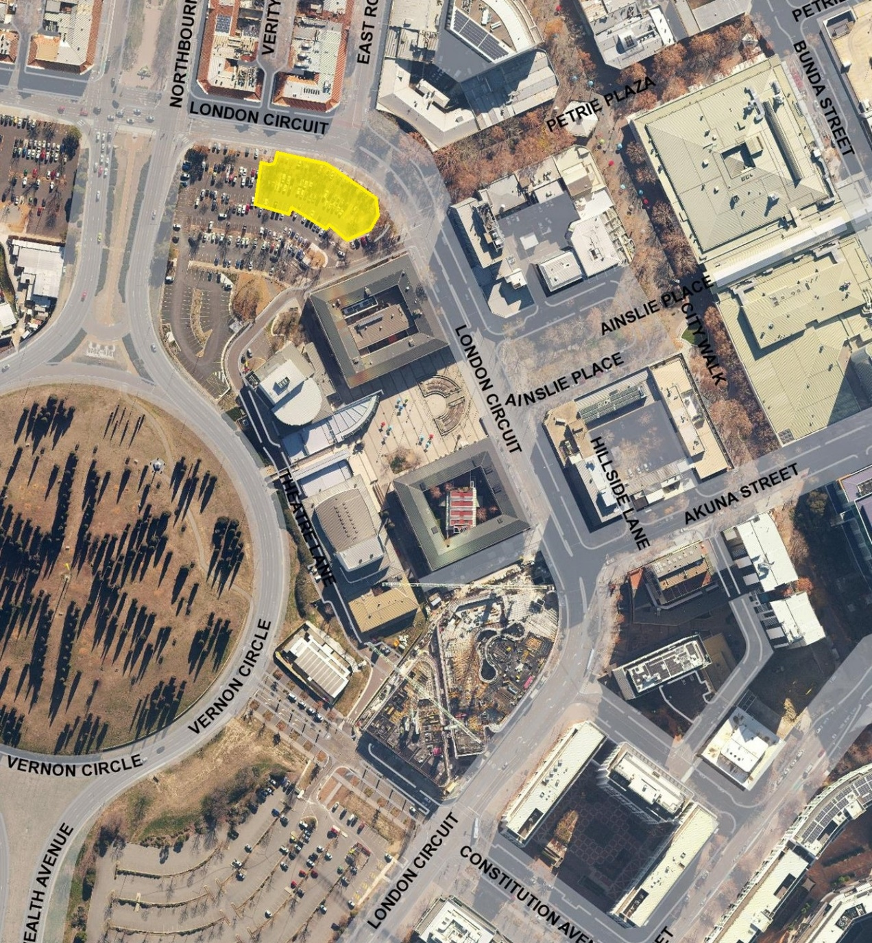

Schedule 2 (see clauses 3 (1) and 4)
The areas where the specified provisions of the road transport legislation are suspended are the areas marked by the yellow shading.

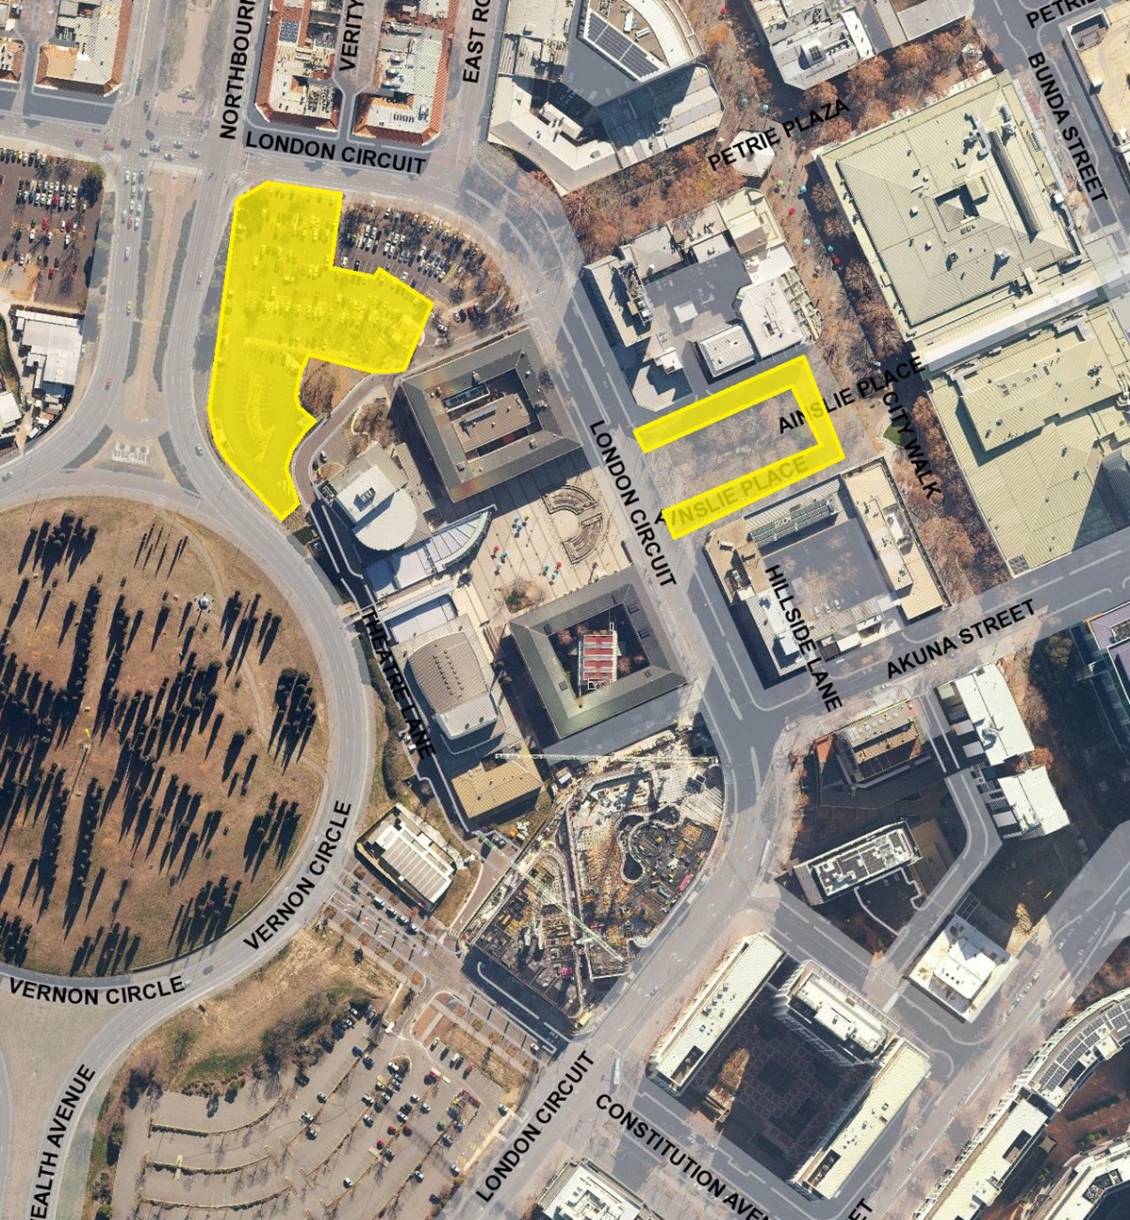

Schedule 3 (see clauses 3 (2) and 4)
The areas where the specified provisions of the road transport legislation are suspended are the areas marked by the yellow shading.
