Australian Capital Territory
Road Transport (General) Application of Road Transport Legislation Declaration 2022 (No 6)
Disallowable instrument DI2022–177
made under the
Road Transport (General) Act 1999, section 13 (Power to exclude vehicles, persons or animals from road transport legislation)

1 Name of instrument
This instrument is the Road Transport (General) Application of Road Transport Legislation Declaration 2022 (No 6).
2 Commencement
This instrument commences at 10:00am on 30 July 2022.
3 Declaration - Motor accident injury insurance
I declare that the Motor Accident Injuries Act 2019 does not apply to:
- a designated vehicle; or

- a motor vehicle involved in a motor accident with a designated vehicle;

while the designated vehicle is being used to participate in a special stage of the Motor Neurone Disease Research Australia - Canberra Rally 2022 for any period beginning on an event official declaring (in whatever manner the event official describes) the special stage active for a testing session, media event, corporate event day or rally competition and ending on an event official declaring the special stage inactive.
4 Declaration – other road transport legislation
I declare that the following road transport legislation does not apply to a designated vehicle or the driver of a designated vehicle, while participating in a special stage of the Motor Neurone Disease Research Australia - Canberra Rally 2022 for any period beginning on an event official declaring (in whatever manner the event official describes) the stage active for a testing session, media event, corporate event day or rally competition and ending on an event official declaring the stage inactive:
- Road Transport (Driver Licensing) Act 1999:
- Section 31 – Driver must be licensed
- Section 33A – Contravening interlock condition
- Road Transport (Vehicle Registration) Act 1999:
- Section 18 – Prohibition on using unregistered registerable vehicles or vehicles with suspended registration
- Road Transport (Vehicle Registration) Regulation 2000:
- Section 59 – Display of numberplates
- Section 60 – Using vehicle without numberplate etc
- Road Transport (Safety and Traffic Management) Act 1999:
- Section 5A – Races, attempts on speed records, speed trails etc
- Section 5B – Improper use of motor vehicle
- Section 7 – Furious, reckless or dangerous driving
- Section 8 – Menacing driving
- Road Transport (Road Rules) Regulation 2017:
- Part 3 – Speed Limits
- Part 4 – Making Turns
- Part 5 – Change of direction and stop signals
- Part 7 – Giving way
- Part 8 - Traffic signs and road markings
- Part 11 – Keeping left, overtaking and other driving rules –
    - Division 11.1 General
    - Division 11.2 Keeping to Left
    - Division 11.3 Overtaking
- Part 13 – Lights and warning devices
- Part 18 – Miscellaneous road rules –
- Section 288 – Driving on path
5 Definitions

In this instrument:

designated vehicle means any of the following vehicles:
(a) an event registered motor vehicle; or
(b) a promotional or official vehicle.

event registered motor vehicle means a vehicle entered to participate in the Motor Neurone Disease Research Australia - Canberra Rally 2022, and may be an unregistered, unidentified or uninsured motor vehicle.

Promotional or official vehicle means a registered vehicle being used for promotional or official purposes during the special stages.
event means the Motor Neurone Disease Research Australia - Canberra Rally 2022.
event official means an official for the event who holds an official’s licence from Motorsport Australia that authorises the official to declare event stages active or inactive.
registered means registered under the Road Transport (Vehicle Registration) Act 1999 or equivalent legislation.
special stage for the event, means a road or road related area identified as a special stage or power stage for the event outlined in the map at Schedule 1.

unidentified motor vehicle—see the Motor Accident Injuries Act 2019, section 327.

uninsured motor vehicle—see the Motor Accident Injuries Act 2019, section 325.
6 Expiry
This instrument expires at 6:00pm on 28 August 2022.

Chris Steel MLA
Minister for Transport and City Services
Special Minister of State

26 July 2022

Schedule 1 – Special stage
(see special stage, clause 5)

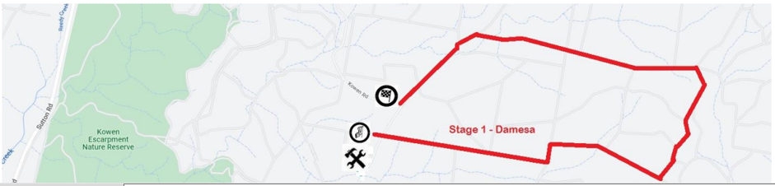

Schedule 1 – Special stage
(see special stage, clause 5)

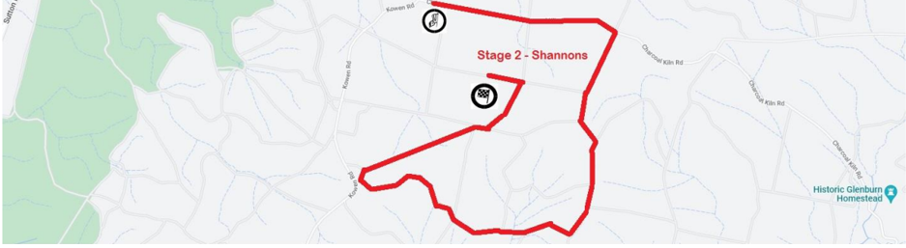

Schedule 1 – Special stage
(see special stage, clause 5)

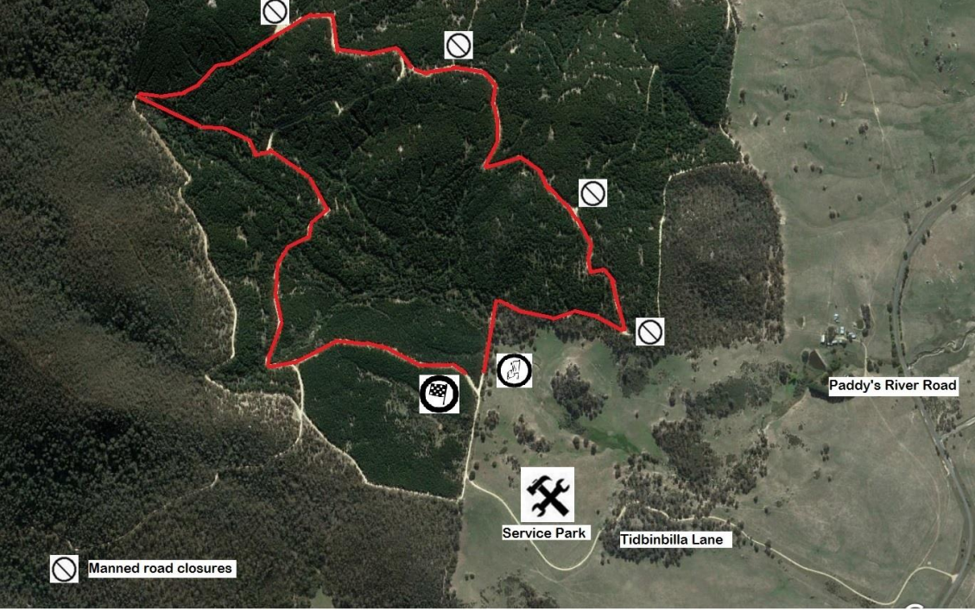

Schedule 1 – Special stage
(see special stage, clause 5)

