Australian Capital Territory
Animal Diseases (Exotic Disease Quarantine Area) Declaration 2024 (No 5)
Disallowable instrument DI2024–296
made under the
Animal Diseases Act 2005, s 19 (Exotic disease quarantine area)

1 Name of instrument
This instrument is the Animal Diseases (Exotic Disease Quarantine Area) Declaration 2024 (No 5).
2 Commencement
This instrument commences on the day after its notification day.
3 Declaration
I declare those parts of Macgregor, Macnamara and Strathnairn in the Australian Capital Territory indicated in the map at schedule 1 to be an exotic disease quarantine area (the control quarantine area).
4 Animals to which the declaration applies
This declaration applies to any animal of the avian species (bird).
5 Disease to which declaration relates
This declaration is made in relation to avian influenza (highly pathogenic) disease.
6 Restrictions on entry to, leaving and movement within the control quarantine area
The restrictions on the movement of declared animals, declared animal products and equipment used in the care of birds within, into, or out of the control quarantine area are set out in schedule 2.
7 Restrictions on sale
No restrictions apply to the sale in the ACT of a declared animal, declared animal product, or equipment used in the care of birds that is not subject to a movement restriction.
8 Authorisation
The chief veterinary officer may authorise movement of a declared animal or declared animal product or equipment used in the care of birds which would otherwise be unauthorised, if the Chief Veterinary Officer is reasonably satisfied that the authorisation is necessary for animal welfare or other reasons.
9 Definitions
In this instrument:
bird carcass includes the whole body of a bird either destroyed or that died in the field.
declared animal includes:
  - a bird;
  - an egg, embryo, ovum or sperm, or other product, of a bird from which another bird could be produced; and
  - a bird carcass other than a bird carcass purchased or obtained from a wholesaler or retail outlet.
declared animal product includes:
- feathers or skin of a bird;
- any meat, fat, or other food derived from a bird;
- any part of the viscera of a bird; and
- any manure, urine, blood, or bone, or secretion, or any other substance derived from a bird;
but does not include:
- eggs purchased or obtained from a wholesaler or retail outlet where the eggs have been disinfected at a grading facility;
- animal product purchased from a wholesaler and transported to a retailer for sale; or
- animal product purchased from a retailer (e.g. supermarket, grocer) and transported to a residence or business premises.
equipment used in the care of birds includes:
- live bird transport vehicles,
- machinery and vehicles used directly in husbandry of live birds,
- used coops, cages, crates,
- water and feed bowls,
- litter, and
- egg trays and fillers used for eggs
but does not include new coops, cages, crates, water and feed bowls, litter, or egg trays and fillers purchased from a retailer.
9 Revocation
This instrument revokes the Animal Diseases (Exotic Disease Quarantine Area) Declaration 2024 (No 3) (DI2024-203).
10 Expiry
This instrument expires on 27 December 2024.

Dr Kyeelee Driver
Delegate of the Minister for the Environment, Parks and Land Management

19 September 2024

Schedule 1 – Map of Control quarantine area
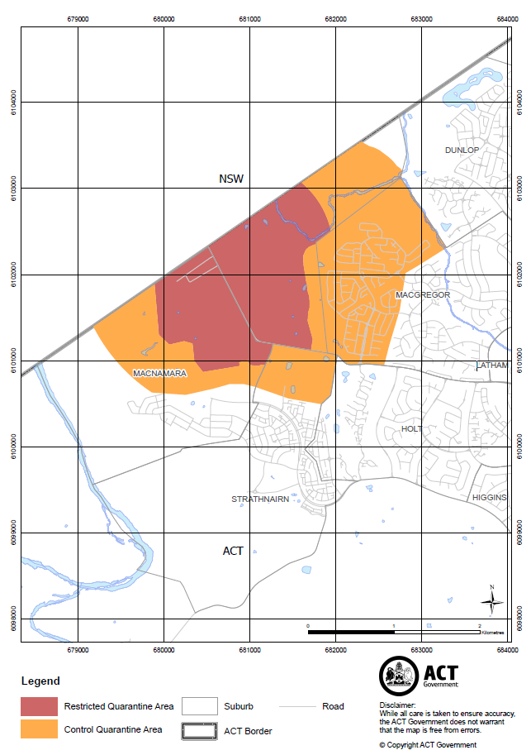

Schedule 2 – Restrictions on the movement of declared animals, declared animal products and equipment used in the care of birds.
- The movement of declared animals within, into, or out of the control quarantine area is prohibited.
- The movement of declared animal products within, into or out of the control quarantine area is prohibited, with the following exceptions:
- A person may move eggs from a farm within the control quarantine area to a grading facility on the following conditions:
  - Vehicles and equipment (including plastic fillers) are disinfected prior to leaving farm and at the grading facility
  - Any cardboard fillers or packaging are disposed of after movement
  - Driver does not exit the vehicle; and
- A person may move eggs from a grading facility withing the control quarantine area to retail on the following conditions:
  - Eggs are disinfected at grading facility
  - Vehicles and equipment, including plastic fillers, are disinfected at the grading facility prior to movement
  - Driver does not exit the vehicle.
- The movement of equipment used in the care of birds within, into or out of the control quarantine area is prohibited.
- The movement of feed, that has been in contact with declared animals, out of the control quarantine area is prohibited.
- The movement of new feed from feed mills into the control quarantine area is permitted on the following conditions:
- The feed mill must not be co-located with another poultry facility,
- the transport truck has no previous direct contact with poultry,
- the truck does not enter the production area, and
- the truck is decontaminated upon leaving the farm.

