Australian Capital Territory
Road Transport (General) Exclusion of Road Transport Legislation (Summernats) Declaration 2024 (No 1)
Disallowable instrument DI2024 - 320
made under the
Road Transport (General) Act 1999, sections 12 (Power to include or exclude areas in road transport legislation) and 13 (Power to exclude vehicles, persons or animals from road transport legislation)

1 Name of instrument
This instrument is the Road Transport (General) Exclusion of Road Transport Legislation (Summernats) Declaration 2024 (No 1).
2 Commencement
(1) This instrument (other than clause 3 and clause 6) commences on 1 January 2025.
(2) Clause 3 and clause 6 commence on 2 January 2025.
3 Declaration – Vehicle use
I declare that section 5B (Improper use of motor vehicle) of the Road Transport (Safety and Traffic Management) Act 1999 does not apply to a relevant vehicle while being used in the:
(a) declared drifting area for any period beginning on a drifting official declaring (in whatever manner the drifting official describes) the drifting course active for a testing session, media event or ticketed event and ending on a drifting official declaring the drifting course inactive; and
(b) declared power skid area for any period beginning on a power skid official declaring (in whatever manner the power skid official describes) the power skid course active for a testing session, media event or ticketed event and ending on a power skid official declaring the power skid course inactive.
4 Declaration – Vehicle registration and standards
I declare that the following road transport legislation does not apply to a relevant vehicle within the declared area of EPIC:
(a) Road Transport (Vehicle Registration) Act 1999:
      - Section 18 – Prohibition on using unregistered registrable vehicles or vehicles with suspended registration
      - Section 26 – Using certain defective vehicles
(b) Road Transport (Vehicle Registration) Regulation 2000:
      - Section 108 – Emission control systems to be fitted and properly maintained
      - Section 109 – Light motor vehicles not complying with sch 1
      - Section 110 – Light trailers not complying with sch 1
      - Section 111 – Light combinations not complying with sch 1
5 Declaration – Driver licences
I declare that the following road transport legislation applying to high powered vehicle restrictions on a person’s driver licence from another jurisdiction does not apply within the declared area of EPIC:
- Road Transport (Driver Licensing) Regulation 2000:
– Section 60 – Conditional licence holders to comply with conditions
6 Declaration – Disapplication of parking legislation at Gungahlin Park and Ride
I declare that the following provision of the Road Transport (Road Rules) Regulation 2017 does not apply to the Gungahlin Park and Ride, the area highlighted in red within Schedule 3 of this instrument:
- Section 185 – Stopping in permit zone
7 Declaration – Motor accident injuries insurance
I declare that the Motor Accident Injuries Act 2019 does not apply to:
(a) a designated vehicle; or
(b) a motor vehicle involved in a motor accident with a designated vehicle;
while the designated vehicle is within the declared area of EPIC.
8 Notes
A reference to an Act in this instrument includes a reference to the statutory instruments made or in force under the Act, including any regulation (see Legislation Act, s 104).
9 Definitions
In this instrument:
declared area, of EPIC, means the part of EPIC enclosed by the fence outlined in Schedule 1.
declared drifting area, of EPIC, means the part of EPIC highlighted in red in Schedule 2.
declared power skid area, of EPIC, means the part of EPIC highlighted in light blue in Schedule 2.
drifting official means a person who holds an official’s licence from Motorsport Australia that authorises the official to declare the drifting course active or inactive.
drifting course means a road or road related area used as a course designed and approved under the ‘Motorsport Australia Drifting Standing Regulations’.
designated vehicle means any of the following vehicles:
(a) a relevant vehicle;
(b) an unidentified motor vehicle; or
(c) an uninsured motor vehicle.
Note For the application of this clause to trailers, see the definitions of the relevant terms.
entrant motor vehicle means a motor vehicle or trailer that is entered in the event.
EPIC means Exhibition Park in Canberra.
event means the events known as Summernats 2025 Car Festival held at EPIC on 1 January 2025 to 6 January 2025 (inclusive).
power skid course means a road or road related area used as a course for participants to use designated vehicles not for their intended use.
power skid official means an area manager for the power skid course.
promotional vehicle means a motor vehicle or trailer that is categorised by Summernats Pty Ltd, ACN 48 139 042 961, as a promotional vehicle for the event.
relevant vehicle means—
(a) an entrant motor vehicle; or
(b) a promotional vehicle.
Note For the application of this clause to trailers, see the definitions of the relevant terms.
unidentified motor vehicle—see the Motor Accident Injuries Act 2019, section 327.
uninsured motor vehicle—see the Motor Accident Injuries Act 2019, section 325.
10 Expiry
(1) This instrument (other than clause 3 and clause 6) expires at 12:00pm on 6 January 2025.
(2) Clause 3 expires at 6:00pm on 5 January 2025.
(3) Clause 6 expires at 11:59pm on 5 January 2025.
Chris Steel MLA
Acting Minister for City and Government Services
Acting Minister for Finance
19 December 2024

Schedule 1

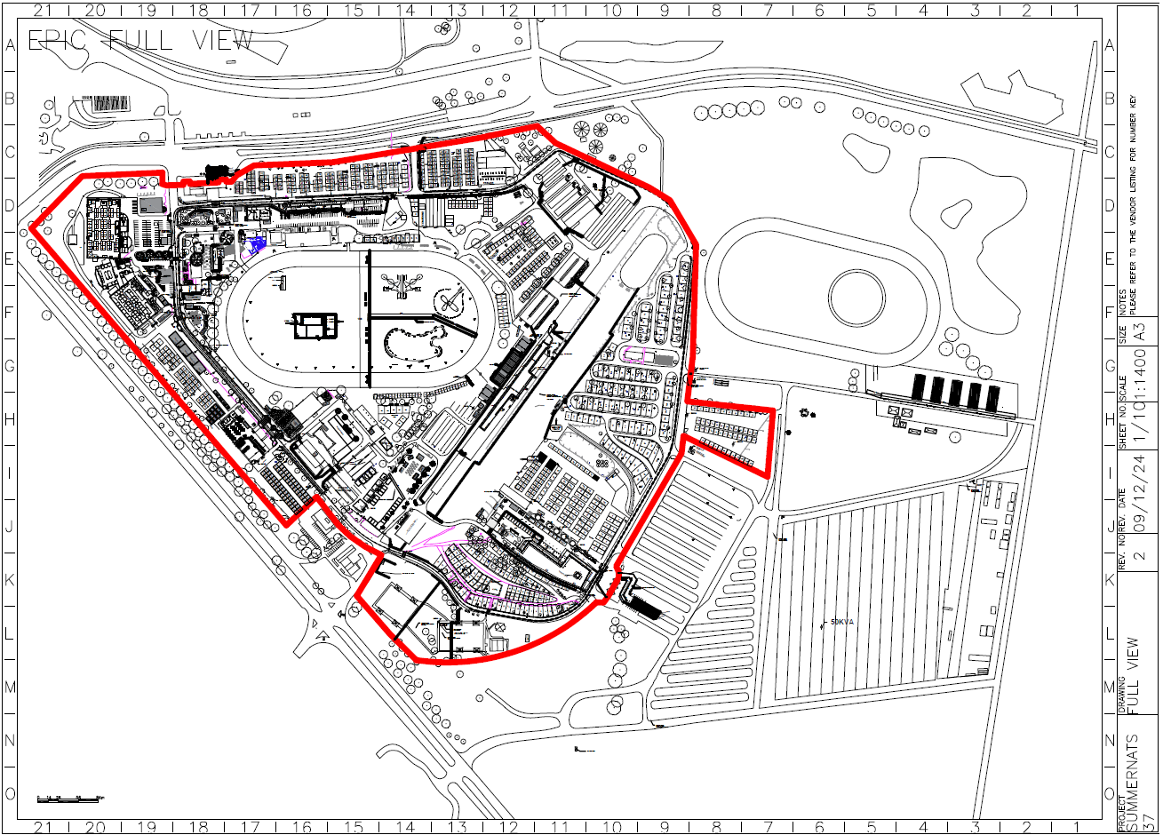

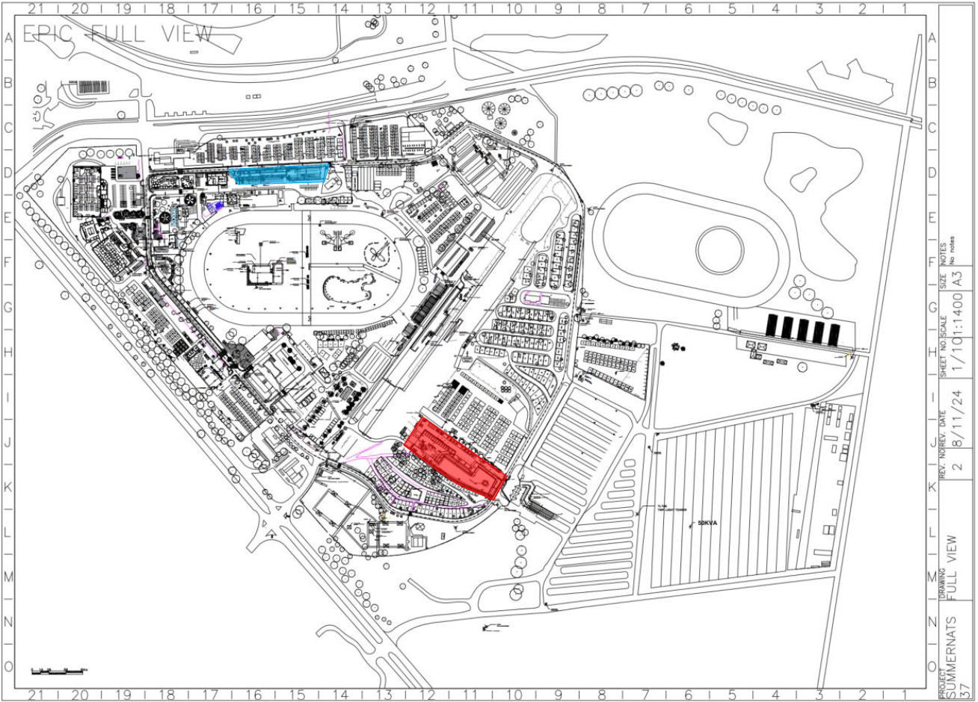
Schedule 2

Schedule 3
