Australian Capital Territory
Road Transport (General) Exclusion of Road Transport Legislation (Summernats) Declaration 2025
Disallowable instrument DI2025-318
made under the
Road Transport (General) Act 1999, s 12 (Power to include or exclude areas in road transport legislation) and s 13 (Power to exclude vehicles, persons or animals from road transport legislation)

1 Name of instrument
This instrument is the Road Transport (General) Exclusion of Road Transport Legislation (Summernats) Declaration 2025.
2 Commencement
(1) This instrument (other than sections 3, 6, and 7) commences on 7 January 2026.
(2) Sections 3, 6, and 7 commence on 8 January 2026.
3 Declaration—Vehicle use
I, as Minister for City and Government Services, declare that the Road Transport (Safety and Traffic Management) Act 1999, section 5B (Improper use of motor vehicle) does not apply to a relevant vehicle while being used in the:
(a) declared drifting area for any period beginning on a drifting official declaring (in whatever manner the drifting official describes) the drifting course active for a testing session, media event or ticketed event and ending on a drifting official declaring the drifting course inactive; and
(b) declared power skid area for any period beginning on a power skid official declaring (in whatever manner the power skid official describes) the power skid course active for a testing session, media event or ticketed event and ending on a power skid official declaring the power skid course inactive.
4 Declaration—Vehicle registration and standards
I, as Minister for City and Government Services, declare that the following road transport legislation does not apply to a relevant vehicle within the declared area of EPIC:
- Road Transport (Vehicle Registration) Act 1999:
(i) s 18 (Prohibition on using unregistered registrable vehicles or vehicles with suspended registration)
- s 26 (Using certain defective vehicles).
- Road Transport (Vehicle Registration) Regulation 2000:
      - s 108 (Emission control systems to be fitted and properly maintained)
      - s 109 (Light motor vehicles not complying with sch 1)
      - s 110 (Light trailers not complying with sch 1)
      - s 111 (Light combinations not complying with sch 1).
5 Declaration—Driver licences
I, as Minister for City and Government Services, declare that the following provision of the Road Transport (Driver Licensing) Regulation 2000 applying to high powered vehicle restrictions on a person’s driver licence from another jurisdiction does not apply within the declared area of EPIC:
(a) s 60 (Conditional licence holders to comply with conditions)
6 Declaration—Disapplication of parking legislation at Gungahlin Park and Ride
I, as Minister for City and Government Services, declare that the following provision of the Road Transport (Road Rules) Regulation 2017 does not apply to the Gungahlin Park and Ride, the area highlighted in red within schedule 3 of this instrument:
- s 185 (Stopping in permit zone).
7 Declaration—Disapplication of parking legislation at Spoering Street carpark, Phillip
I, as Minister for City and Government Services, declare that the following provisions of the Road Transport (Road Rules) Regulation 2017 do not apply to the Spoering Street carpark, the area highlighted in orange within schedule 4 of this instrument:
- s 205 (Parking for longer than indicated)
- s 205A (Parking outside time indicated)
- s 207 (Parking where fee payable)
- s 213C (Metered parking – parking fee)
- s 213D (Metered parking – maximum length of stay)
- s 213K (Ticket parking – display of ticket)
- s 213M (Ticket parking – maximum length of stay).
8 Declaration – Motor accident injuries insurance
I, as Minister of Finance, declare that the Motor Accident Injuries Act 2019 does not apply to:
(a) a designated vehicle; or
(b) a motor vehicle involved in a motor accident with a designated vehicle;
while the designated vehicle is within the declared area of EPIC.
9 Definitions
In this instrument:
declared area, of EPIC, means the part of EPIC enclosed by the fence outlined in schedule 1.
declared drifting area, of EPIC, means the part of EPIC highlighted in red in schedule 2.
declared power skid area, of EPIC, means the part of EPIC highlighted in light blue in schedule 2.
designated vehicle means any of the following vehicles:
(a) a relevant vehicle;
(b) an unidentified motor vehicle; or
(c) an uninsured motor vehicle.
Note For the application of this section to trailers, see the definitions of the relevant terms.
drifting course means a road or road related area used as a course designed and approved under the ‘Motorsport Australia Drifting Standing Regulations’.
drifting official means a person who holds an official’s licence from Motorsport Australia that authorises the official to declare the drifting course active or inactive.
entrant motor vehicle means a motor vehicle or trailer that is entered in the event.
EPIC means Exhibition Park in Canberra.
event means Summernats 2026 Car Festival held at EPIC on 7 January 2026 to 11 January 2026 (inclusive).
power skid course means a road or road related area used as a course for participants to use designated vehicles not for their intended use.
power skid official means an area manager for the power skid course.
promotional vehicle means a motor vehicle or trailer that is categorised by Summernats Pty Ltd, ABN 48 139 042 961, as a promotional vehicle for the event.
relevant vehicle means—
(a) an entrant motor vehicle; or
(b) a promotional vehicle.
Note For the application of this section to trailers, see the definitions of the relevant terms.
unidentified motor vehicle—see the Motor Accident Injuries Act 2019, s 327.
uninsured motor vehicle—see the Motor Accident Injuries Act 2019, s 325.
10 Expiry
(1) This instrument (other than section 3) expires at 11:59pm on 11 January 2026.
(2) Section 3 expires at 6:00pm on 11 January 2026.

Tara Cheyne MLA Rachel Stephen-Smith MLA
Minister for City and Government Services Minister for Finance
30 November 2025 11 December 2025

Schedule 1
(See s 9)

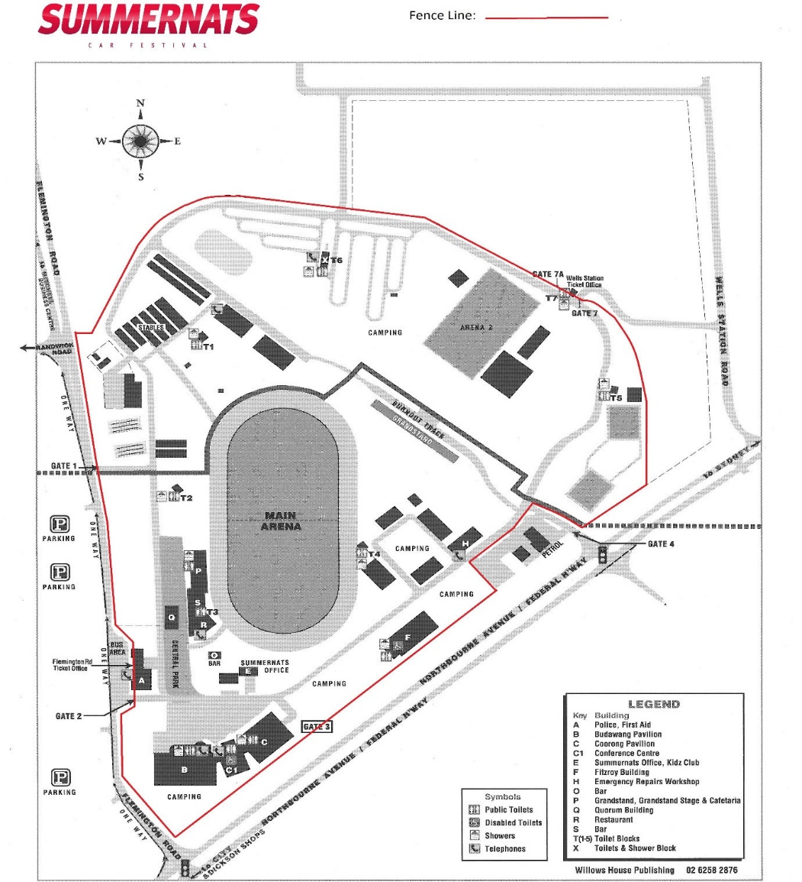

Schedule 2
(See s 9)

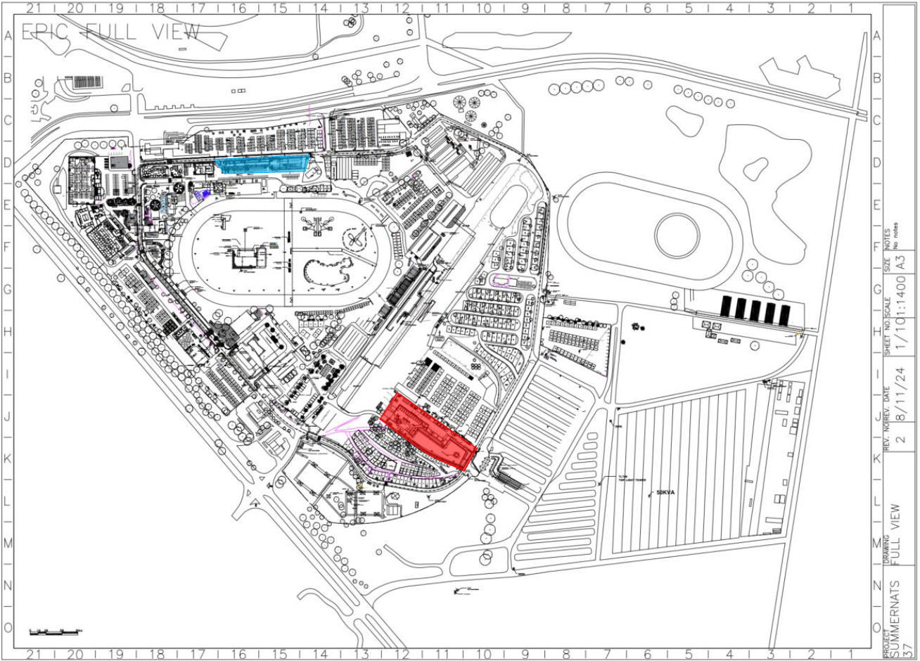

Schedule 3
(See s 6)

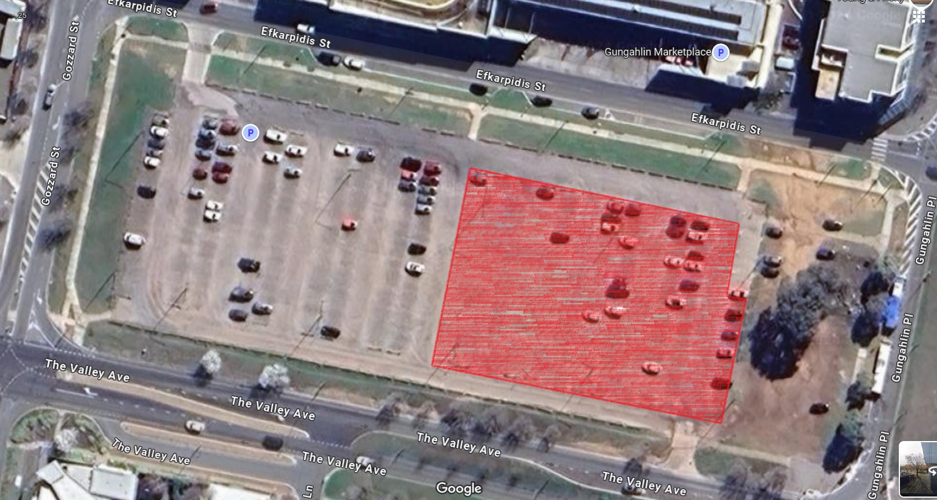

Schedule 4
(See s 7)

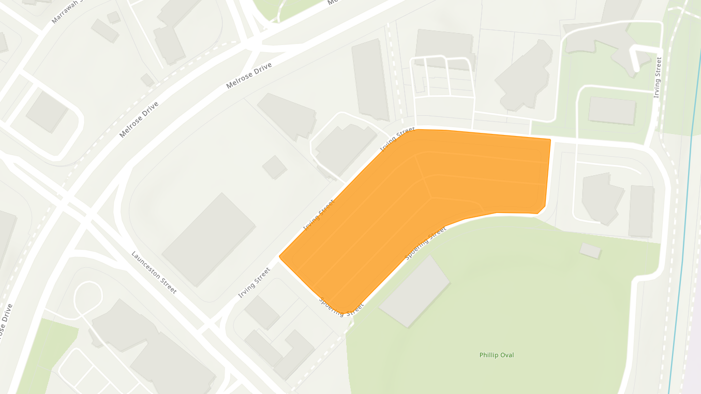
Note: For avoidance of doubt, the highlighted area includes the parallel parking spots in the anti-clockwise direction along Irving Street (only between the two intersections of Spoering Street) and Spoering Street, but does not include the parallel parking spots in the clockwise direction.

