Australian Capital Territory

Road Transport (General) Application of Road Transport Legislation (National Multicultural Festival) Declaration 2026

Disallowable instrument DI2026-5
made under the
Road Transport (General) Act 1999, s 12 (Power to include or exclude areas in road transport legislation)

1 Name of instrument
This instrument is the Road Transport (General) Application of Road Transport Legislation (National Multicultural Festival) Declaration 2026.

2 Commencement
This instrument commences at 6:00am on 27 January 2026.

3 Declaration—Disapplication of parking legislation for event preparation
- I declare that the disapplied no parking legislation, disapplied road path legislation and disapplied timed parking legislation do not apply to designated vehicles during the period commencing 6:00am on Tuesday, 27 January 2026 to 6:00pm Friday, 20 February 2026 within the areas highlighted in green in schedule 1.
- This declaration only applies while a designated vehicle is either:
- stopped or parked for a festival preparation purpose; or
- in motion over a path or nature strip in a built up area to access a location for a festival preparation purpose and the vehicle is travelling at no more than 5km/hr with hazard lights activated.

4 Declarations—Disapplication of parking legislation for Glebe Park Rotunda access, Civic Square, Convention zone and Akuna Street (North)
- I declare that the disapplied no parking legislation does not apply to a vehicle stopping or parking at the Civic Square lane for a festival preparation purpose during the period commencing at 6:00am on Wednesday, 28 January 2026 and ending at 6:00pm on Friday, 13 February 2026, except during late-night rideshare zone hours.
- I declare that the disapplied road path legislation does not apply to a vehicle within the Civic Square area for a festival preparation purpose during the period commencing at 8:00am on Thursday, 5 February 2026 and ending at 6:00pm on Tuesday, 10 February 2026, provided that the vehicle is stationary or is travelling at no more than 5km/hr with hazard lights activated.
- I declare that the disapplied no parking legislation does not apply to a vehicle stopping or parking for a festival preparation purpose at the Akuna Street north lane during the period commencing at 10:00pm on Wednesday, 4 February 2026 and ending at 6:00pm on Tuesday, 10 February 2026.
- I declare that the disapplied no parking legislation does not apply to a vehicle stopping or parking for a festival preparation purpose at the Rotunda access lane during the period commencing at 6:00pm on Saturday, 7 February 2026 and ending at 8:00pm on the same day.
- I declare that the disapplied no parking legislation does not apply to a vehicle stopping or parking for a festival preparation purpose at the Convention bus zone area during the period commencing at 12:00pm on Friday, 6 February 2026 and ending at 5:00pm on Sunday, 8 February 2026.
- I declare that the disapplied timed parking legislation does not apply to a vehicle stopping or parking at the Convention carpark area during the period commencing at 8:00am on Friday, 6 February 2026 and ending at 5:00pm on Monday, 9 February 2026.

5 Declaration—Disapplication of parking legislation at event location
I declare that the disapplied timed parking legislation does not apply to the areas identified in schedule 2 for the following periods:
- The area highlighted sky blue during the period commencing at 6:00am on Monday, 2 February 2026 and ending at 6:00pm on Friday, 13 February 2026;
- The area highlighted red during the period commencing at 8:00pm on Tuesday, 3 February 2026 and ending at 8:00pm Tuesday, 10 February 2026;
- The areas highlighted yellow during the period commencing at 4:00am on Thursday, 5 February 2026 and ending at 6:00am on Monday, 9 February 2026;
- The area highlighted orange during the period commencing at 8:00pm on Thursday, 5 February 2026 and ending at 6:00am on Monday, 9 February 2026;
- The area highlighted pink during the period commencing at 4:00am on Friday, 6 February 2026 and ending at 8:00pm on Sunday, 8 February 2026;
- The areas highlighted brown during the period commencing at 9:00am on Friday, 6 February 2026 and ending at 11:59pm on Sunday, 8 February 2026.

6 Definitions
In this instrument:
Akuna Street north lane means the road lane closest to Glebe Park for the area highlighted black in schedule 2.
Civic Square lane means the area highlighted blue in schedule 2.
Civic Square area means the area highlighted dark green in schedule 2.
Convention bus zone area means the area highlighted green in schedule 3.
Convention carpark area means the area highlighted dark red in schedule 3.
designated vehicles mean vehicles owned and operated by the following businesses or companies:
- Eclipse Lighting and Sound Pty Ltd (ABN: 49 147 994 367);
- AVL Australia (ABN: 47 109 066 390);
- Mashera Pty Ltd t/a Barlens Event Hire (ABN: 90 061 968 474);
- W.R. Electrical Pty Ltd t/a Affinity Electrical Technologies (ABN: 42 094 182 779); and
- Tone Mine Audio and Visual (ABN: 32 405 786 829).
disapplied no parking legislation means the following provisions of the Road Transport (Road Rules) Regulation 2017:
- section 168 (No parking sign);
- section 179 (Stopping in loading zone);
- section 182 (Stopping in taxi zone);
- section 183 (Stopping in bus zone);
- section 183A (Stopping public bus in bus zone);
- section 203 (Stopping in parking area for people with disabilities).
disapplied road path legislation means the Road Transport (Road Rules) Regulation 2017, section 197 (Stopping on path, dividing strip, nature strip, painted island or traffic island).
disapplied timed parking legislation means the following provisions of the Road Transport (Road Rules) Regulation 2017:
- section 205 (Parking for longer than indicated);
- section 205A (Parking outside time indicated);
- section 207 (Parking where fee payable);
- section 208 (Parallel parking on road (except in median strip parking area));
- section 208A (Parallel parking in road related area (except in median strip parking area));
- section 211 (Parking in parking bay);
- section 213I (Ticket parking – parking in space);
- section 213J (Ticket parking – parking in space – motorbike);
- section 213K (Ticket parking – display of ticket);
- section 213M (Ticket parking – maximum length of stay).
festival preparation purpose means either:
- installation or removal of infrastructure (including cool rooms) or decorations for the National Multicultural Festival 2026, or
- loading or unloading infrastructure, supplies, or equipment for the National Multicultural Festival 2026.
late-night rideshare zone hours means the:
- period commencing at 12.30am and ending at 6:00am daily; and
- date does not fall on Friday 6 February 2026, Saturday 7 February 2026, Sunday 8 February 2026, or Monday 9 February 2026.
Rotunda access lane means the road lane closest to Glebe Park for the area highlighted in dark purple in schedule 2.

7 Expiry
This instrument expires on 21 February 2026.
Tara Cheyne MLA
Minister for City and Government Services

16 January 2026

Schedule 1
(See s 3)

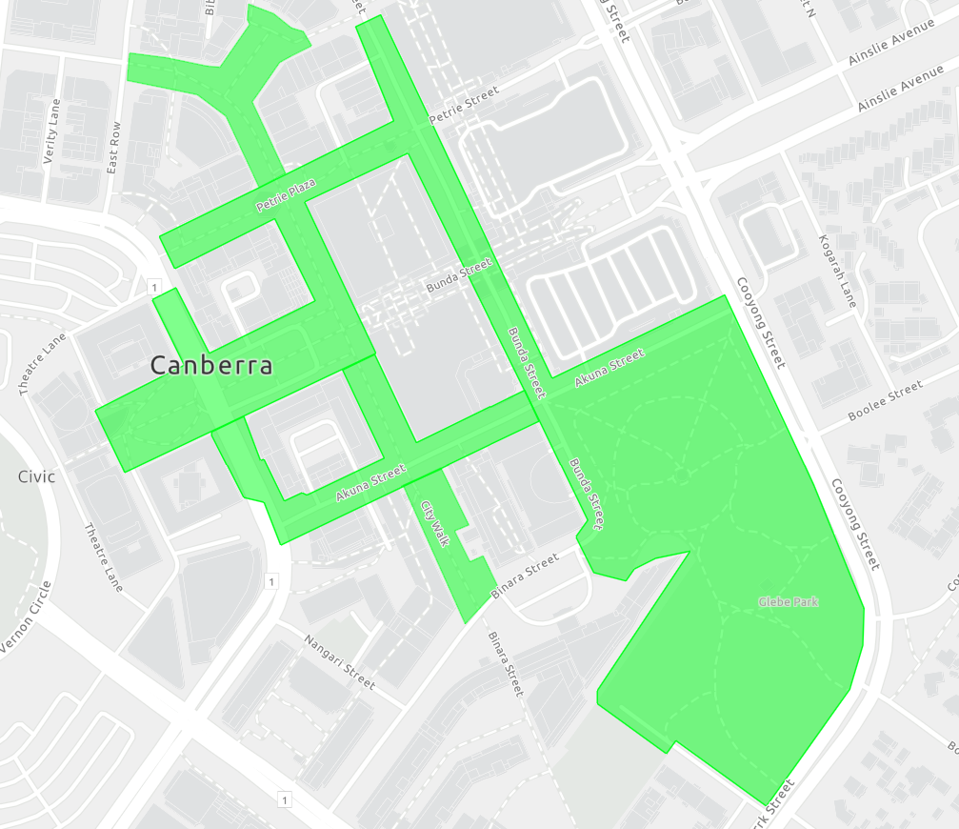

Schedule 2
(See ss 4 to 6)

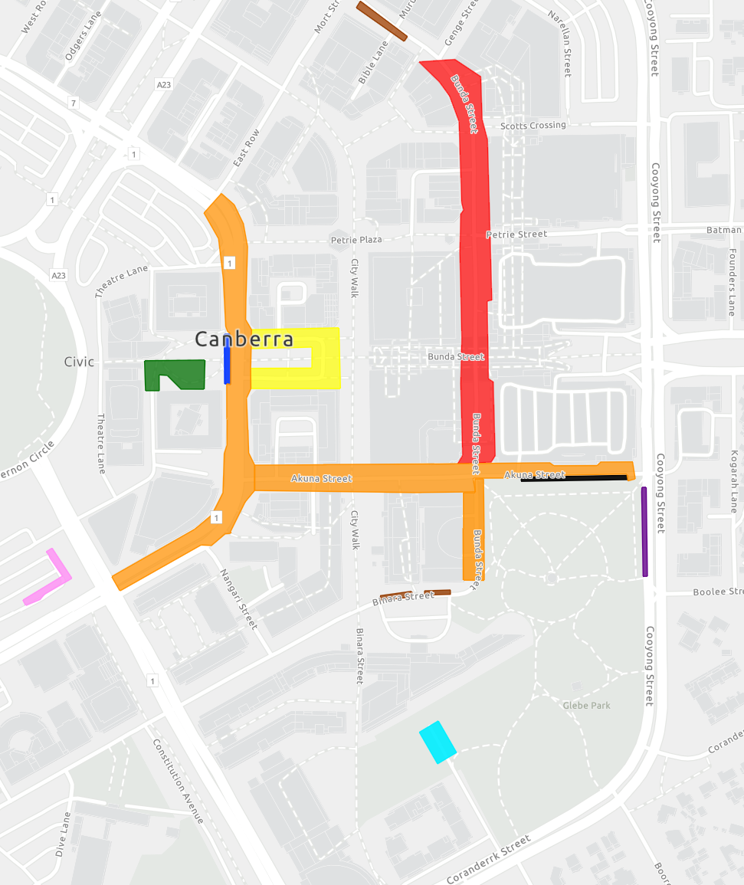
Schedule 3
(See ss 4, 6)

