2025

THE LEGISLATIVE ASSEMBLY FOR THE
AUSTRALIAN CAPITAL TERRITORY

ELEVENTH ASSEMBLY

PAYROLL TAX AMENDMENT BILL 2025

EXPLANATORY STATEMENT
and
HUMAN RIGHTS COMPATIBILITY STATEMENT
(Human Rights Act 2004, s 37)

Presented by
Chris Steel MLA
TREASURER
3 SEPTEMBER 2025

PAYROLL TAX AMENDMENT BILL 2025

The Bill is not a Significant Bill. Significant Bills are bills that have been assessed as likely to have significant engagement of human rights and require more detailed reasoning in relation to compatibility with the Human Rights Act 2004.

OVERVIEW OF THE BILL
The Bill amends the Payroll Tax Act 2011 to apply a new payroll tax rate of 8.75 per cent from 1 January 2026 and a split period calculation method to enable two payroll tax rates to apply within the 2025-2026 financial year.

The new rate and calculation method only applies to employers with Australia wide (or group Australia wide) wages of more than $150 million. The Bill identifies and specifically excludes universities with an ACT campus from the new provisions.

CONSULTATION ON THE PROPOSED APPROACH
Nil.

CONSISTENCY WITH HUMAN RIGHTS
There are no rights engaged under the Payroll Tax Amendment Bill 2025.

Payroll Tax Amendment Bill 2025

Human Rights Act 2004 - Compatibility Statement

In accordance with section 37 of the Human Rights Act 2004 I have examined the Payroll Tax Amendment Bill 2025. In my opinion, having regard to the Bill and the outline of the policy considerations and justification of any limitations on rights outlined in this explanatory statement, the Bill as presented to the Legislative Assembly is consistent with the Human Rights Act 2004.

………………………………………………….
Tara Cheyne MLA
Attorney-General

CLAUSE NOTES

Clause 1 Name of Act
This clause provides the name of the Act is the Payroll Tax Amendment Act 2025 (the Act).

Clause 2 Commencement
This clause provides for the commencement of the Act. The Act is taken to have commenced on 1 July 2025.
The retrospective commencement of the Bill facilitates a split period calculation method for the financial year beginning on 1 July 2025.
The effect of the split period calculation method for the 2025-2026 financial year is as follows.
- The first half of 2025-2026 will be calculated using the tax rate determined in the Taxation Administration (Amounts and Rates—Payroll Tax) Determination 2025 (DI2025-161) at 7.85 per cent.
- The second half of 2025-2026 will be calculated using the tax rate set by the Bill, 8.75 per cent.

The increased tax rate only applies to payroll tax liabilities from 1 January 2026, so there is no prejudicial effect.

Clause 3 Legislation amended
This clause identifies the legislation that will be amended in the Act, which is the Payroll Tax Act 2011.

Clause 4 Amount of payroll tax
New section 8 (2) and (3)
This clause inserts sections 8 (2) and (3), which provide that payroll tax payable by employers with total wages paid or payable of more than $150 million must be worked out in accordance with schedule 2A instead of schedules 1 and 2 for the financial year beginning on 1 July 2025.
The definition of total wages is defined in schedule 2A, section 2A.2(4) and outlines what the definition means for employers who are not a member of a group, or who are a member of a group with a designated group employer and without a designated group employer.

Clause 5 Motor vehicle allowances
New section 29 (6A)
This clause inserts sections 29 (6A) which provides that the business kilometres travelled in the financial year may also be worked out using the method as applied under schedule 2A, division 2A.2.5.

Clause 6 & 7 Calculation of correct amount of payroll tax
New Section 82 (1A)
New Section 82 (4)

Clause 6 inserts section 82 (1A) that states that the correct amount of payroll tax for the financial year beginning on 1 July 2025 is to be calculated using schedule 2A for employers with total wages of more than $150 million.
Clause 7 inserts a definition of ‘total wages’ just for the financial year beginning on 1 July 2025 again referring to schedule 2A.

Clause 8 New schedule 2A
This clause inserts schedule 2A, which provides special provisions for the 2025-2026 financial year. Schedule 2A only applies to an employer if their total wages (a defined term) paid or payable exceed $150 million for the year, or $12.5 million a month (being one-twelfth of $150 million).
Part 2A.1 Preliminary
2A.1 Definitions–sch 2A
Clause 2A.1 provides definitions for terms used in schedule 2A.
Notably, the definition of R:
- remains unchanged for the period 1 July 2025 to 31 December 2025. The rate determined under section 139 under the Taxation Administration Act 1999 (DI2025-161) at 7.85 per cent continues to apply; and
- introduces a new payroll tax rate of 8.75 per cent for the period 1 January 2026 to 30 June 2026.

The annual threshold amount remains unchanged and as determined under section 139 of the Taxation Administration Act 1999 (DI2025-161) at $2 million for the 2025-2026 financial year.
The definition of N means each of the periods beginning on:
- 1 July 2025 and ending on 31 December 2025; and
- 1 January 2026 and ending on 30 June 2026.

2A.2 Application–sch 2A
Clause 2A.2 provides that schedule 2A applies to an employer if the total wages paid or payable by the employer for the 2025-2026 financial year are more than $150 million.
Schedule 2A does not apply to:
- universities with an ACT campus, which are specifically listed; or
- employers with total wages, paid or payable, of $150 million or less.
If schedule 2A does not apply to an employer, schedules 1 and 2 remain unchanged and continue to apply. Noting that total wages, for employers who are part of a group, includes all group members wages, not just the employer’s wages.
Example 1
For the 2025-2026 financial year, an employer (or group employer) with total wages of:
- $160 million is to calculate payroll tax in accordance with Schedule 2A of the Payroll Tax Act 2011.
- $150 million is to calculate payroll tax in accordance with Schedule 1 and 2 of the Payroll Tax Act 2011. The rates in DI2025-161 will continue to apply.

Part 2A.2 Calculation of payroll tax liability
This part provides the method to calculate payroll tax under schedule 2A.
Division 2A.2.1 Preliminary
2A.3 Calculation of payroll tax for 2025-2026 financial year
Clause 2A.3 provides that the amount of payroll tax payable for the 2025-2026 financial year is the total of the amount of payroll tax payable for the:
- first half of the financial year (1 July 2025 to 31 December 2025); and
- second half of the financial year (1 January 2026 to 30 June 2026).

The purpose of splitting the calculation into two discrete periods within the
2025-2026 financial year is to ensure the higher payroll tax rate, set by schedule 2A, only applies from 1 January 2026.
Wages paid or payable for the first half of the 2025-2026 financial year are subject to the lower payroll tax rate determined under section 139 of Taxation Administration Act 1999 (DI2025-161). This ensures the payroll tax rate of 8.75 per cent, set by the Bill, does not have retrospective application despite the Bill being taken to have commenced on 1 July 2025.
Division 2A.2.2 Employers who are not members of a group
Clause 2A.4 specifies that this part of the schedule only applies to an employer who is not a member of a group.
Clause 2A.5 provides definitions for terms used in this part of the schedule.
- C means the number of days the employer that is not a member of a group paid or was liable to pay taxable wages or interstate wages during N.
- IW means the total interstate wages paid or payable by the employer that is not a member of a group during the split period (N).
- TA (or threshold amount) means the amount calculated by multiplying the annual threshold amount ($2 million) by C/365.
  - The inclusion of C here ensures that employers claiming the tax free threshold receive their full entitlement proportional to the number of days they paid or were liable to pay taxable wages or interstate wages during the split period (N).
- TW means the total taxable wages paid or payable by the employer that is not a member of a group during the split period (N).

Clause 2A.6 provides the following formula to work out the amount of payroll tax payable by an employer (who is not a member of a group).
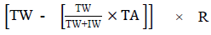
The formula is to be used twice as set out in clause 2A.3. Once for the first half of the financial year and again for the second half of the financial year. The amount payable for the 2025-2026 financial year is sum of the two calculations.
Example 2 – full year
An employer, who is not a member of a payroll tax group, paid total wages of $250 million in respect of the 2025-2026 financial year. They were an employer for the entire financial year (184 days in the first half and 181 days in the second half).

As the total wages are more than $150 million, schedule 2A applies. The employer’s payroll tax liability is calculated according to clause 2A.6, in two split periods with distinct tax rates.
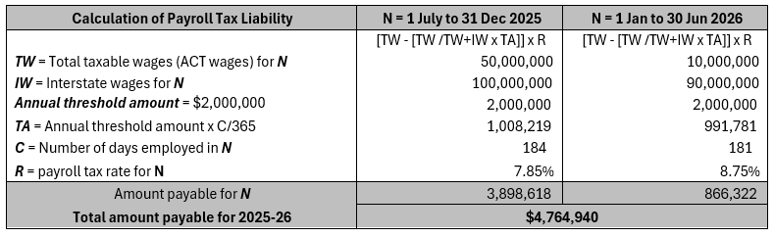

Example 3 – part year
An employer, who is not a member of a payroll tax group, paid total wages of $250 million in respect of the 2025-2026 financial year. They did not employ for the entire financial year. They employed for 184 days in the first half of the financial year and 90 days in the second half of the financial year.

As the total wages are more than $150 million, schedule 2A applies. The employer’s payroll tax liability is calculated according to clause 2A.6, in two split periods with distinct tax rates.

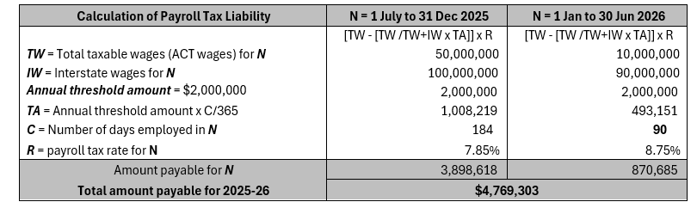

Division 2A.2.3 Groups with a designated group employer
Clause 2A.7 specifies that this part of the schedule only applies to an employer, who is a member of a group, that has a designated group employer.
Clause 2A.8 provides definitions for terms used in this division, which are similar to those used in clause 2A.5, but apply to the group.
Clause 2A.9 provides formulas to work out the amount of payroll tax payable by an employer who is a member of a group.
The formula at subclause:
(1) applies to the member of the group who is the designated group employer.
(2) applies to the each other member of the group (the employers who are not the designated group employer).
The formula is to be used twice as set out in clause 2A.3. Once for the first half of the financial year and again for the second half of the financial year. The amount payable for the 2025-2026 financial year is the sum of the two calculations.
Example 4 – full year
An employer is a member of a group that paid total wages of $250 million in respect of the 2025-2026 financial year. The employer is the group’s designated group employer. They also employed for the entire financial year (184 days in the first half and 181 days in the second half).

As the total wages are more than $150 million, schedule 2A applies. The employer’s payroll tax liability, as the designated group employer, is calculated according to clause 2A.9(1), in two split periods with distinct tax rates.

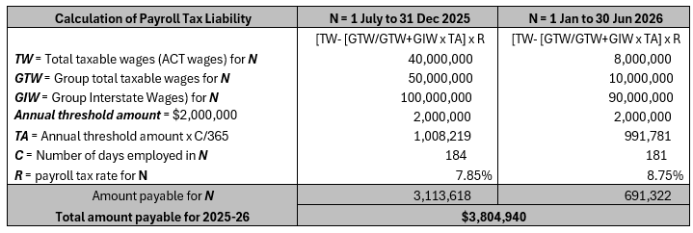
Example 5
An employer is a member of a group that paid total wages of $250 million in respect of the 2025-2026 financial year. The group has a designated group employer. The employer is not the designated group employer.

As the total wages are more than $150 million, schedule 2A applies. The employer’s payroll tax liability is calculated according to clause 2A.9(2), in two split periods with distinct tax rates.

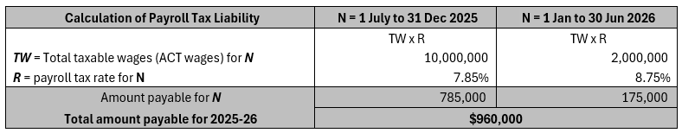

Division 2A.2.4 Groups with no designated group employer
Clause 2A.10 specifies that this part of the schedule only applies to an employer, who is a member of a group, that does not have a designated group employer.
Clause 2A.11 defines the term taxable wages for this part of the schedule.
Clause 2A.12 provides the formula to work out the amount of payroll tax payable by an employer as a member of a group.
The formula under this clause is to be used twice as set out in clause 2A.3. Once for the first half of the financial year and again for the second half of the financial year. The amount payable for the 2025-2026 financial year is the sum of the two calculations.
Example 6
An employer is a member of a group that paid total wages of $250 million in respect of the 2025-2026 financial year. The group does not have a designated group employer.

As the total wages are more than $150 million, schedule 2A applies. The employer’s payroll tax liability is calculated according to clause 2A.12, in two split periods with distinct tax rates.

Division 2A.2.5 Motor vehicle allowances
Clause 2A.13 provides that schedule 1, part 1.5 applies to schedule 2A for working out the number of business kilometres travelled in the 2025-2026 financial year.
Part 2A.3 Calculation of monthly payroll tax
Clause 2A.14 provides that monthly payroll tax is to be calculated under Schedule 2 of the Payroll Tax Act 2011 in relation to the 2025-2026 financial year.
It also provides that if the total taxable wages paid or payable by the employer, or the employer’s group, in a month are more than $12.5 million between 1 January and 30 June in the 2025-2026 financial year, R for the purpose of schedule 2, is 8.75 per cent. This only applies for the purpose of calculating the payroll tax payable for the period beginning on 1 January and ending on 30 June 2026.

