Australian Capital Territory
Heritage (Decision about Registration of the Elm Grove Homestead Precinct, Gungahlin) Notice 2008 (No 1)*
Notifiable Instrument NI 2008 - 264
made under the
Heritage Act 2004 s42 Notice of decision about registration

- Revocation
This instrument replaces NI2007 – 230

- Name of instrument
This instrument is the Heritage (Decision about Registration for the Elm Grove Homestead Precinct) Notice 2008 (No 1).

- Registration details of the place
Registration details of the place are at Attachment A: Register entry for Elm Grove Homestead Precinct.

- Reason for decision
The ACT Heritage Council has decided that the Elm Grove Homestead Precinct meets one or more of the heritage significance criteria at s 10 of the Heritage Act 2004. The register entry is at Attachment A.

- Date of Registration
26 June 2008.

The Secretary

ACT Heritage Council

GPO Box 158

CANBERRA ACT 2602

…………………..

Gerhard Zatschler
Secretary ACT Heritage Council
GPO Box 158, Canberra ACT 2602
26 June 2008

AUSTRALIAN CAPITAL TERRITORY

HERITAGE REGISTER
(Provisional Registration Details)

Place 20159

For the purposes of s. 33 of the Heritage Act 2004, an entry to the heritage register has been prepared by the ACT Heritage Council for the following place:

- ELM GROVE HOMESTEAD PRECINCT at 617 Gundaroo Road, Block 625 (part)
Harrison, Gungahlin, ACT

DATE OF REGISTRATION

Notified: 1.07.08 Notifiable Instrument: NI2008–264

Copies of the Register Entry are available for inspection at the ACT Heritage Unit. For further information please contact:

The Secretary
ACT Heritage Council
GPO Box 158, Canberra, ACT 2601

Telephone: 13 2281 Facsimile: (02) 6207 2229

IDENTIFICATION OF THE PLACE

- Elm Grove Homestead Precinct, part Block 625, Suburb of Harrison, District of Gungahlin, ACT.

HISTORY OF THE PLACE

The property of Elm Grove was established by James Gillespie, eldest son of John and Mary Ann Gillespie, on land adjoining his parent’s property, Horse Park that had been settled in 1852. With his wife Isabella, James Gillespie built a timber cottage in 1882 on Portion 186 Parish of Goorooyarroo, also acquiring the neighbouring portion 181. These made up a rectangular landholding known as “the home paddock”. James Gillespie lived on the Elm Grove property until he died in 1926 and Isabella until her death in 1938. Their son Harold Gillespie, born in 1890 lived at Elm Grove and worked the property until his death in 1974. Elm Grove was continually owned/occupied and farmed by the Gillespie family for about 100 years from initial purchase in 1880s until 1986 when the current lessees Mr and Mrs Carmody purchased the lease from the Gillespie family. James and Mary Gillespie occupied the adjoining Horse Park Homestead for 43 years from 1852 until their deaths in 1889 and 1895 respectively when the property was sold out of the family. Elm Grove Homestead is the property longest lived in and most strongly associated with the local Gillespie family.

The Gillespie family at both the Horse Park and Elm Grove properties pursued the common practice among small and medium scale graziers of building up their pastoral holdings by judicious acquisitions in the surrounding area. The settlement of the eldest son James at Elm Grove neighbouring his parent’s property at Horse Park is a typical and significant example of this practice in the pastoral development of the region

James Gillespie was a noted local personality involved with the establishment of the school at Mulligans Flat and regularly contributing a local news article titled Ginninderra Notes to the Goulburn Evening Penny Post under the pseudonym “The Wizard”. James Gillespie’s forty years’ of reporting for the Goulburn Evening Penny Post strengthened community development and political activism at the time, and now provides a unique record of district events.

From its first settlement the Elm Grove property was primarily farmed for sheep grazing to produce fine merino wool and cropping of hay. Over time and with the extension of farming operations into the neighbouring properties Mulligans Flat and Carrington purchased by Harold Gillespie, Elm Grove developed as a local wool production hub with its 1930s shearing shed being used for all the wool operations.

DESCRIPTION OF THE PLACE

The boundary of this listing is in accordance with the original land acquisition of the Elm Grove property, the home paddock, land portions 181 and 186, Parish of Goorooyarroo, County of Murray, acquired by James Gillespie in 1882 and comprising approximately 32 hectares. The land includes the original Elm Grove homestead, garden, exotic tree plantings, home paddock and farm outbuildings. The accompanying diagrams at the end of this document show the boundary and named features of the place.

The Elm Grove homestead consists of a weatherboard house painted a cream colour with green-coloured painted corrugated iron roof and red-coloured painted wooden eaves. The original dwelling was constructed around 1882 and was severely damaged by fire in 1911 but was rebuilt and extended with more recent renovations and minor alterations of new water tanks and new veranda on the southern side of the building. The present dwelling comprises nine rooms, including two bedrooms, study, toilet, bathroom, lounge, dining room, laundry and kitchen. There are four chimneys, three of brick set in colonial bond and the fourth of random rubble stone enclosed within timber vertical split slabs and palings. None of the chimneys are operational. A veranda runs along the north-eastern, south-western and north-western sides of the dwelling. The two phases of the homestead’s construction are easily discernable, the original cottage, facing northeast, being extended with a kitchen and lounge area, probably after the fire of 1911. In recent years the house has undergone considerable internal structural renovation and the exterior has been partly conserved, incorporating matching replacement materials where necessary. Inside all of the original surfaces have been covered rather than removed. A ruined timber outhouse remains to the southwest outside the homestead garden fence line.

In recent years the garden and paddock around the homestead have also undergone alteration and reconstruction process. The garden at Elm Grove appears to follow the original layout of the vernacular cottage garden set out by James and Mary Ann Gillespie, consisting not only of a productive orchard at the southwest but also a decorative flower garden in the northeast. The front flower garden has remnant garden beds constructed with concrete edges, the remains of a front fence and several remnant trees, including a grapevine. There are also new plantings. The remnants of the orchard exist in nine fruit trees but there is no evidence of the location of the kitchen garden. The garden also contains a garden shed and two rainwater tanks. A post and wire fence, including original wooden posts, encloses the whole with a well on the house fence line. Elm trees from which the property derives its name still exist. There are two large mature elm trees (Ulmus procera) flanking the driveway leading to the house that may date from the establishment of the property.

The main group of farm buildings is located to the northeast and comprises two timber and corrugated galvanised iron clad storage sheds and a timber, corrugated iron and fibro clad shearers’ quarters set near one of the main elm trees near the homestead entrance. Another group of three corrugated iron clad and timber framed storage sheds are located to the northeast of the shearers’ quarters. A ruined timber and corrugated iron stables building incorporating storage shed is located to the northeast of this group and has recently undergone considerable repairs. There is an associated but dilapidated post and rail stockyard to the northeast of the stables. To the northwest of the stables and close to the creek are two more small buildings, one a slab hut with corrugated iron roof and the other an open sided structure with a corrugated iron cladding to the back of the building. There is a large galvanised iron clad storage/machinery shed to the north of the home paddock near a dam. The corrugated iron clad shearing/wool shed, which is thought to date from the 1940s, and associated yards are located to the south-east of the homestead near the property entrance gateway and the fence line that is marked by a shelter belt of eucalypt trees.

The landscape setting is of cleared lower paddocks at the foot of steep forested hills to the north that form the ridgeline border of the ACT with NSW. To the south there are expansive views across Horse Park to Black Mountain and the Brindabella ranges.

STATEMENT ABOUT THE HERITAGE SIGNIFICANCE OF THE PLACE

Elm Grove Homestead Precinct with its homestead, garden, orchard, well, dam, agricultural sheds and associated yards demonstrates the way of life of a nineteenth and twentieth century small to medium sized pastoral property of the region, and the homestead complex, which has evolved over time, shows different building types and associated rural structures. While this rural lifestyle is evident in other rural properties in the local region, notably Well Station and Horse Park Homestead, these rural properties are a surviving remnant of the previously densely settled small holdings of this location which are now endangered by the encroachments of suburban development. The Elm Grove property is also significant as the only remaining working property within the Gungahlin area (in 2008) which still operates its original function of fine wool and hay production in a rural lifestyle that has continued since the Gillespie family occupied the area in the 1850s.

The Elm Grove homestead and farm have strong associations with the Gillespie family who occupied the property for nearly one hundred years and, together with the neighbouring Horse Park Homestead, demonstrate the means by which such pioneer families extended their pastoral ventures by setting up relatives on neighbouring lands.

Elm Grove Homestead Precinct has significance as part of local Aboriginal tradition.

ASSESSMENT AGAINST THE HERITAGE SIGNIFICANCE CRITERIA

Significance has been determined by research as accessed in the references section below. Future research may alter the findings of this assessment.

Pursuant to s.10 of the Heritage Act 2004, a place or object has heritage significance if it satisfies one or more of the following criteria:

- it demonstrates a high degree of technical or creative achievement (or both), by showing qualities of innovation, discovery, invention or an exceptionally fine level of application of existing techniques or approaches;
Elm Grove Homestead Precinct by itself exhibits a modest level of technical achievement showing qualities of functionality and adaptability in the everyday “make-do” elements typifying successful smaller rural enterprises rather than technical innovation or exceptionally fine level of application of techniques.

- it exhibits outstanding design or aesthetic qualities valued by the community or a cultural group;
While Elm Grove Homestead and its rural pastoral setting have distinct inherent aesthetic qualities, the low level of community awareness of the rural history of the ACT impedes community appreciation of the design qualities of smaller enterprises and of the aesthetics of their landscapes.

- it is important as evidence of a distinctive way of life, taste, tradition, religion, land use, custom, process, design or function that is no longer practised, is in danger of being lost or is of exceptional interest;
The Elm Grove Homestead Precinct is significant under this criterion as with its homestead, garden, orchard, well, dam, agricultural sheds and associated yards, it demonstrates the way of life of a small to medium sized pastoral property of the region. Elm Grove is one of few properties within the Gungahlin region that still operates its original function of fine wool and hay production in a rural lifestyle that has continued since the Gillespie family occupied the area in the 1850s. While this rural lifestyle was evident in the neighbouring rural properties of Well Station and Horse Park, the encroachments of urbanisation in the growing suburbs of Gungahlin has resulted in the cessation of their traditional pastoral function despite the preservation of their built fabric.

The Gillespie family continuously occupied Elm Grove for over 100 years from the 1880s to 1986 and under their ownership the pastoral complex has evolved and shows different building types and associated rural structures. Elm Grove as a functional rural property offers important evidence of life, domestic and agricultural labour, land use, design and functions on smaller rural properties from the 1880s to the 1980s. With Horse Park, it provides a picture of a family enterprise extending more than a century and a half. Elm Grove’s articulation with its adjacent ‘parent’ property, Horse Park, contributes to its significance under this criterion. These properties enhance interpretation of each other and together have the potential to promote understanding of a living pastoral and agricultural history of the ACT region, from the 19th to the 21st century.

Elm Grove also has evidence of Aboriginal settlement and utilisation of the environmental resources of the locality.

- it is highly valued by the community or a cultural group for reasons of strong or special religious, spiritual, cultural, educational or social associations;
Elm Grove Homestead Precinct is significant under this criterion as it has Aboriginal heritage sites found from a surface survey. The ACT Aboriginal community considers all archaeological evidence of the past occupation of the ACT by Aboriginal people to be significant. These Aboriginal sites are listed separately in the ACT Heritage Register. Further survey work may uncover further Aboriginal heritage at the Elm Grove Homestead Precinct.

- it is significant to the ACT because of its importance as part of local Aboriginal tradition;
Elm Grove Homestead Precinct is significant under this criterion as it has Aboriginal heritage sites found during a surface survey. The ACT Aboriginal community considers all archaeological evidence of the past occupation of the ACT by Aboriginal people to be significant. Aboriginal places have the capacity to demonstrate and provide information about ways in which Aboriginal people lived in the past. These sites are listed separately in the ACT Heritage Register. Further survey work may uncover further Aboriginal heritage at the Elm Grove Homestead Precinct.

- it is a rare or unique example of its kind, or is rare or unique in its comparative intactness;
Elm Grove Homestead Precinct is a good example of a small to medium scale late nineteenth/early twentieth century working rural property typical of the wool and cropping industry of the local area.

Elements such as the garden arrangement at the front of the homestead are of interest as evidence of the cottage garden designed in the late 1880s, directly reflecting the design of the original garden and retaining some of the original plantings, though as there are also new plantings, this element is not intact.

The importance of Elm Grove as a continuously working smaller property derives its importance not from individual elements but as the central home paddock set in a particularly striking cultural pastoral landscape setting.

- it is a notable example of a kind of place or object and demonstrates the main characteristics of that kind;
The Elm Grove Homestead Precinct with its homestead, surrounding outbuilding and paddocks, comprise a rural cultural landscape associated with farming and grazing practices typical of the small holding wool and cropping ventures set up in the region after the New South Wales Free Selection Acts of 1861.

Linking the two neighbouring properties of Elm Grove and Horse Park enhances the understanding of both as representative of successful smaller properties with a heavy dependence on family labour and endurance, and demonstrates a dynastic character usually associated with great estates. In addition, the integrity of Horse Park’s farming infrastructure and building types and the aesthetics of Elm Grove’s landscape setting demonstrate different characteristics of their kind while providing an example of properties with a shared history.

- it has strong or special associations with a person, group, event, development or cultural phase in local or national history;
Elm Grove Homestead Precinct is significant under this criterion as it has strong and special associations with the second generation of the pioneer Gillespie family who settled the district. Elm Grove is the second property occupied by the family and that occupied for the longest time. While the Horse Park Homestead Precinct was settled earlier by the first generation of the Gillespie family in the district, it was sold after forty years, whereas Elm Grove was retained in the family and farmed for nearly a century of continuous occupation from 1882-1974 by two further generations of the Gillespie family. Elm Grove was the home of James and Isabella (Jones) Gillespie, a noted local commentator, and his family for forty-four years and of his son Harold for 96 years. James Gillespie’s forty years’ of reporting for the Goulburn Evening Penny Post strengthened community development and political activism at the time, and now provides a unique record of district events. Together with the Horse Park property, Elm Grove has strong associations with the pastoral and agricultural history of the ACT.

The Gillespie family at both the Horse Park and Elm Grove properties pursued the common practice among small and medium scale graziers of building up their pastoral holdings by judicious acquisitions in the surrounding area. The settlement of the eldest son James at Elm Grove neighbouring his parent’s property at Horse Park is a significant example of this practice in the pastoral development of the region.

Elm Grove is also significant as it has associations with Aboriginal occupation of the locale. Surface survey of the home paddock and the wider area to the west has revealed several Aboriginal heritage sites. Further detailed survey is likely to uncover further sites.

- it is significant for understanding the evolution of natural landscapes, including significant geological features, landforms, biota or natural processes;
Not applicable.

- it has provided, or is likely to provide, information that will contribute significantly to a wider understanding of the natural or cultural history of the ACT because of its use or potential use as a research site or object, teaching site or object, type locality or benchmark site;
Elm Grove has the potential to contribute to a wider understanding of the cultural history of the ACT as a teaching site across a range of areas including Indigenous, pastoral and agricultural occupation; constitutional history; land tenure history; the Federal Capital Territory survey; forestry; and, because of the vistas afforded by its topography (as well as the tidemark of adjacent suburban development) the first century of planning the national capital. Its potential as a research site relates primarily to future archaeological evidence of Aboriginal occupation.

- for a place—it exhibits unusual richness, diversity or significant transitions of flora, fauna or natural landscapes and their elements;
Not applicable.

- for a place—it is a significant ecological community, habitat or locality for any of the following:
(i) the life cycle of native species;
(ii) rare, threatened or uncommon species;
(iii) species at the limits of their natural range;
- distinct occurrences of species.
Not applicable.

FEATURES INTRINSIC TO THE HERITAGE SIGNIFICANCE OF THE PLACE

Features intrinsic to the heritage significance of the place which require conservation include:
- Homestead and outhouses
- Gardens and orchard surrounding homestead, including garden edging, shed, fence line, well and water tanks
- Mature elm trees
- Farm buildings including storage and machinery sheds, slab hut, stables, shearers’ quarters, shearing/woolshed, stockyards and outer perimeter fence with eucalypt shelter belt
- Rural landscape of cropped and grazed lands within the perimeter fenceline

The wider cultural landscape of rural pastoral use and forested hills surrounding the Elm Grove Homestead Precinct, while being located outside the boundary of this listing, contribute to the heritage significance of the place, and major changes to this wider area should take account of and complement Elm Grove’s heritage significance.

REASON FOR PROVISIONAL REGISTRATION
Elm Grove Homestead Precinct has been assessed against the heritage significance criteria and been found to have heritage significance when assessed against four criteria under the ACT Heritage Act – criteria c), d), e) and h).

APPLICABLE HERITAGE GUIDELINES

With the adoption of the Heritage Guidelines under s27 of the Heritage Act 2004 they will be applicable to the conservation of the Elm Grove Homestead Precinct.

The guiding conservation objective is that the Elm Grove Homestead Precinct shall be conserved and appropriately maintained in a manner respecting its heritage significance and the features intrinsic to that heritage significance, and consistent with a sympathetic and viable use or uses. A conservation management plan (CMP) would help to guide its conservation and future use. Any works that have a potential impact on significant fabric which are necessary prior to the development of a CMP shall be guided by a professionally documented interim assessment and conservation policy relevant to that area or component (i.e. a Statement of Heritage Effects - SHE).

BACKGROUND

1. CONSULTATION WITH STAKEHOLDERS

The ACT Heritage Council undertook public consultation in 2007 in accordance with the provisions of the ACT Heritage Act 2004.

2. REFERENCES

ACT Planning and Land Authority, January 2006, Jacka Concept Plan, Draft.

Godden Mackay Logan Heritage Consultants, March 2006, Elm Grove Gungahlin Comparative Heritage Assessment, a report prepared for the ACT Heritage Unit – Environment ACT.

Godden Mackay Logan Heritage Consultants, May 2007, Elm Grove, Gungahlin, Additional Research and Validation of Significance Assessment, report prepared for Mr Paul Carmody

Gillespie, LL 1992, Ginninderra, Forerunner to Canberra, Canberra.

Navin Officer, Heritage Consultants Pty Ltd, July 2005, Elm Grove, North Canberra, Cultural Heritage Assessment, a report to AP and MP Carmody.

Navin Officer, Heritage Consultants Pty Ltd, January 2006, Elm Grove Gungahlin, ACT, a report to Mr and Mrs Carmody.

Pearson, M, Heritage Management Consultants, March 2002, Gungahlin Pastoral Places Comparative Assessment.

- MAPS AND IMAGES

MAP OF ELM GROVE HOMESTEAD PRECINCT
Showing main landscape and built features including eucalypt shelter belt on perimeter fence line at drive way entrance; wool shed and yards near main driveway entrance; centrally located homestead with outhouses, surrounding fenced gardens and mature Elm plantings, water tanks and well; sheds, shearers’ quarters, stables and slab hut to north east of homestead; large machinery and storage shed near home paddock fence boundary further north of dam.

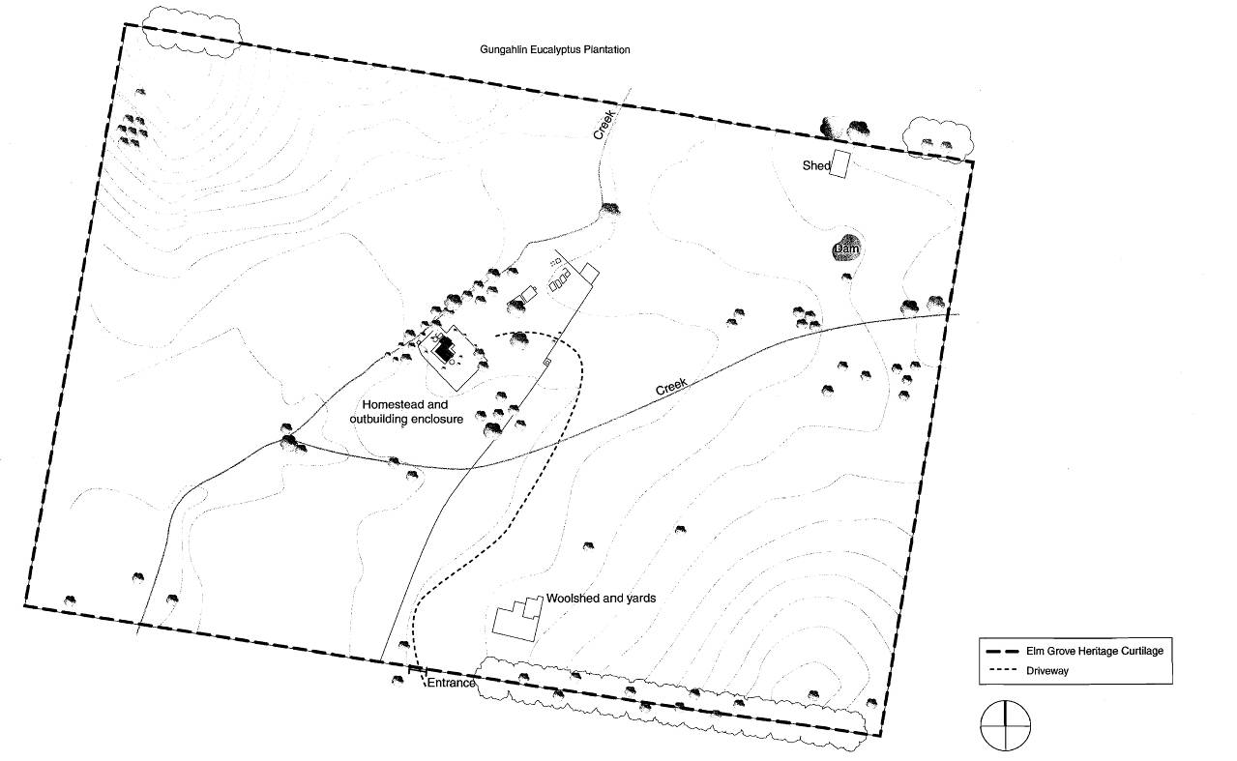

Elm Grove in relation to surrounding cultural landscape setting

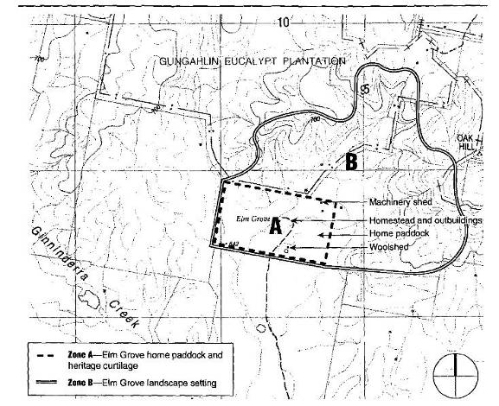Diagrams from: Elm Grove, Gungahlin, Comparative Heritage Assessment March 2006 by Godden Mackay Logan, for the ACT Heritage Unit.

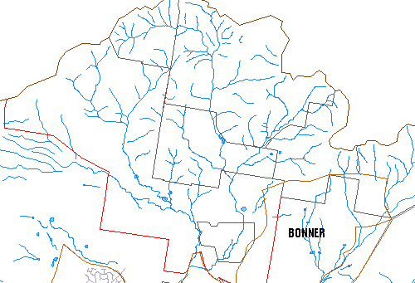
ELM GROVE HOMESTEAD PRECINCT Block 625 (part) Gungahlin

Location of ELM GROVE HOMESTEAD PRECINCT - Block 625 (part) Gungahlin
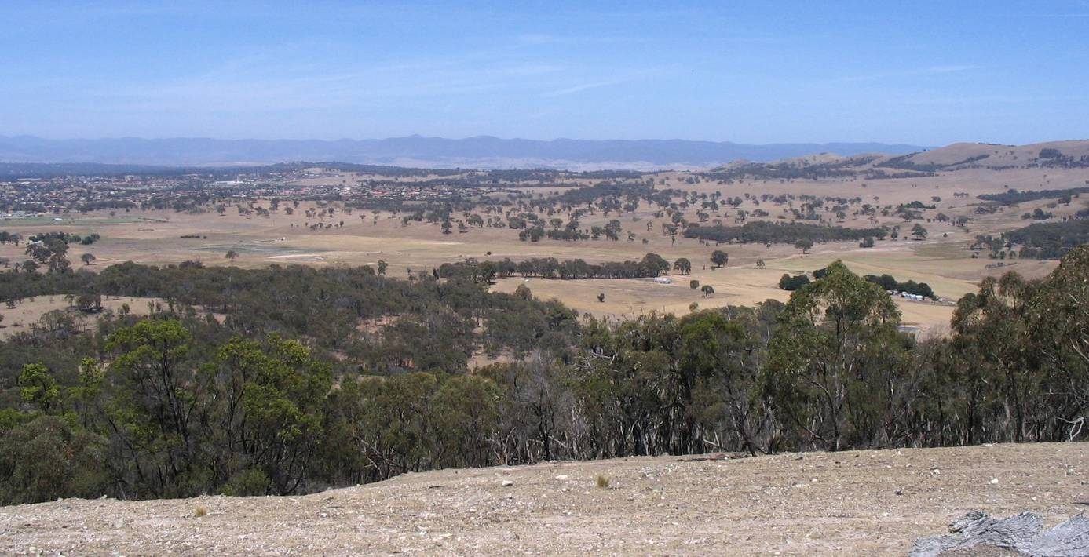

The Elm Grove Homestead Precinct viewed from the top of Oak Hill. Horse Park Homestead Precinct to the far left. Eucalypt shelter belt on Elm Grove home paddock fence line in the centre of the picture, with corrugated iron wool shed close by. Elm Grove Homestead with garden, elm trees and sheds further to right. Home Paddock dam visible, but machinery/storage shed to far right hidden by trees.

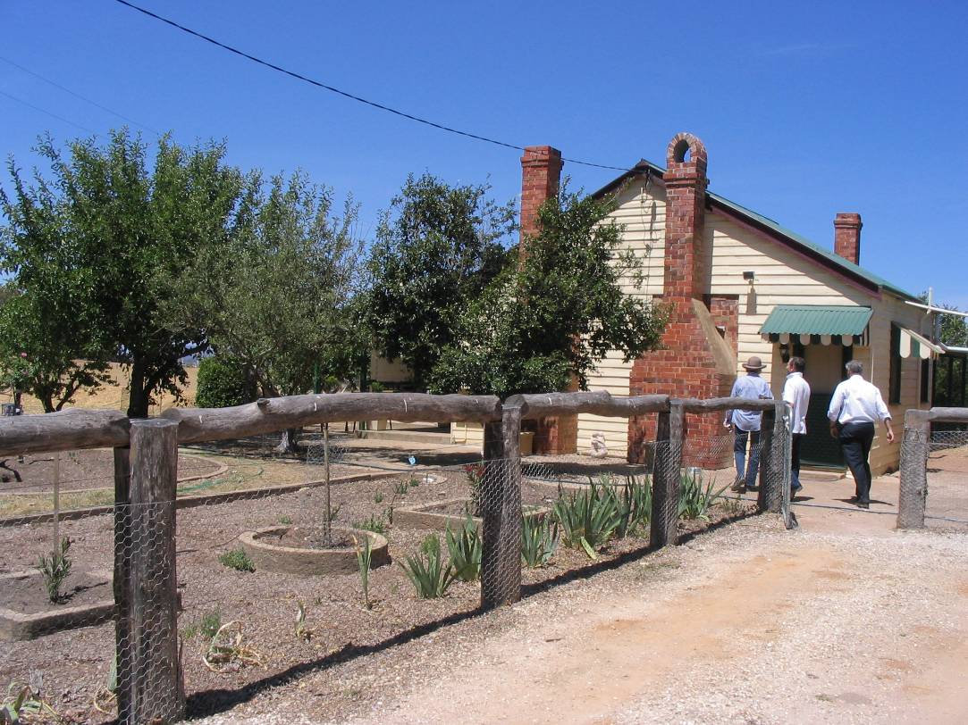

Elm Grove Homestead and garden showing garden edging.

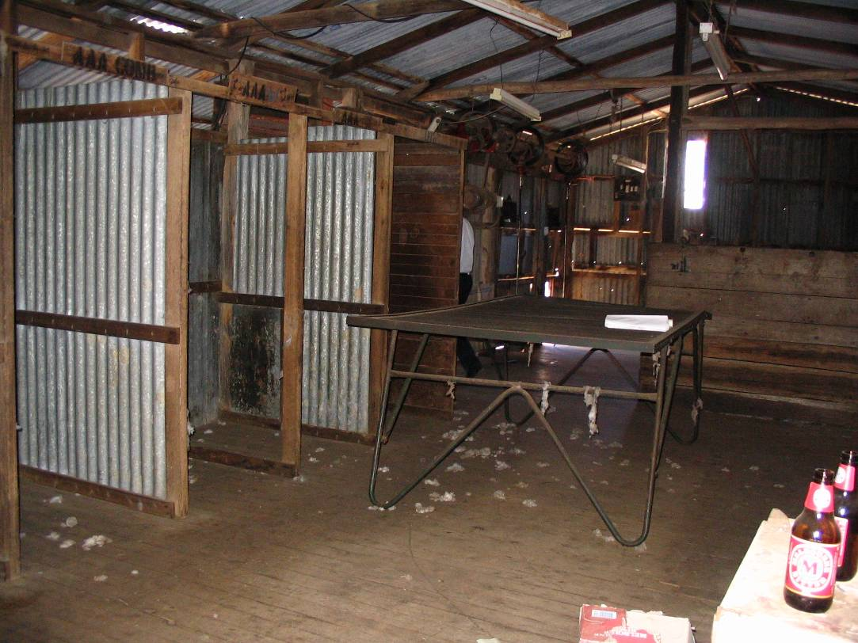

Interior of Elm Grove Woolshed.
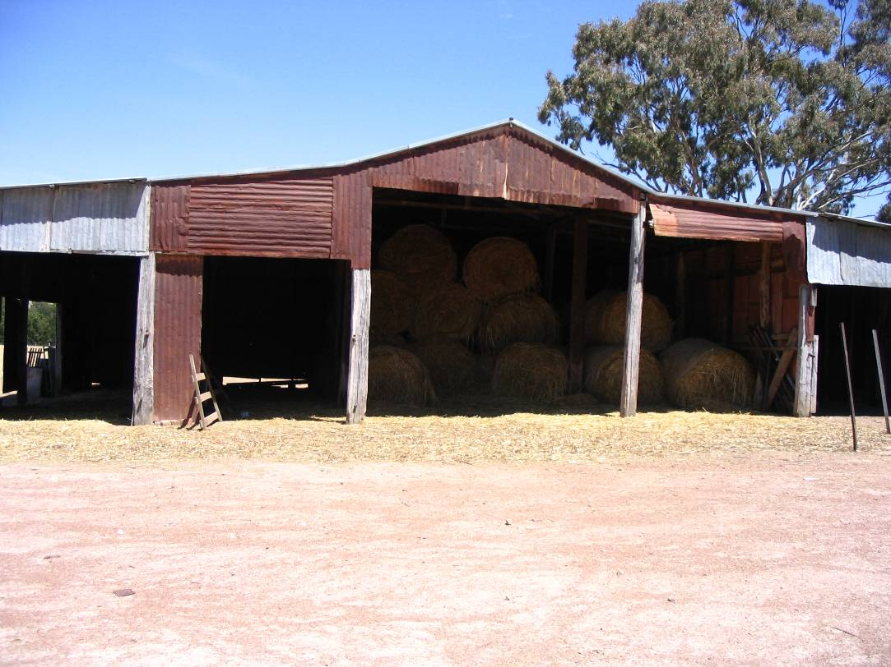

Elm Grove Machinery/Storage Shed on north-east boundary of home paddock

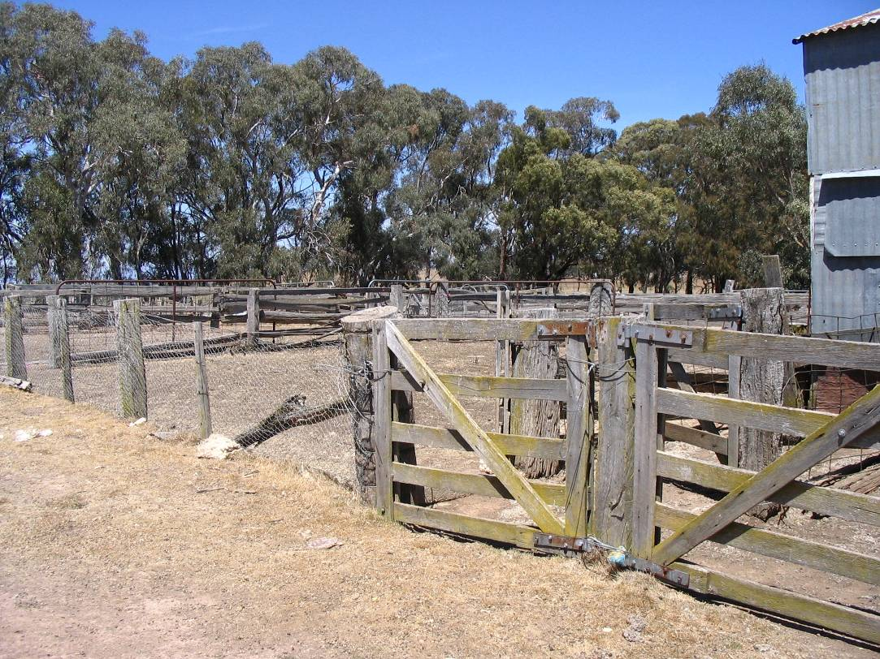

Stock yards at Elm Grove.

