Australian Capital Territory

Building and Construction Industry Training Levy (Training Plan) Approval 2008

**Notifiable instrument NI2008–517**

made under the

**Building and Construction Industry Training Levy Act 1999, s 25 (1) (Approval of Training Plans)**

**1 Name of instrument**

This instrument is the *Building and Construction Industry Training Levy (Training Plan) Approval 2008*.

**2 Commencement**

This instrument commences on the day after notification.

**3 Approval**

I approve the Building and Construction Industry 2009 Training Plan set out in the schedule.

Andrew Barr  
Minister for Education and Training

date made 29.10.08



2009 Training Plan

ACT Building and Construction Industry

Training Fund Authority

ACT Building and Construction Industry Training Fund Authority  
Suite 6, National Associations Centre  
71 Constitution Avenue   
CAMPBELL ACT 2612  
www.trainingfund.com.au  
Phone 02 6262 5630 Fax 02 6257 5058

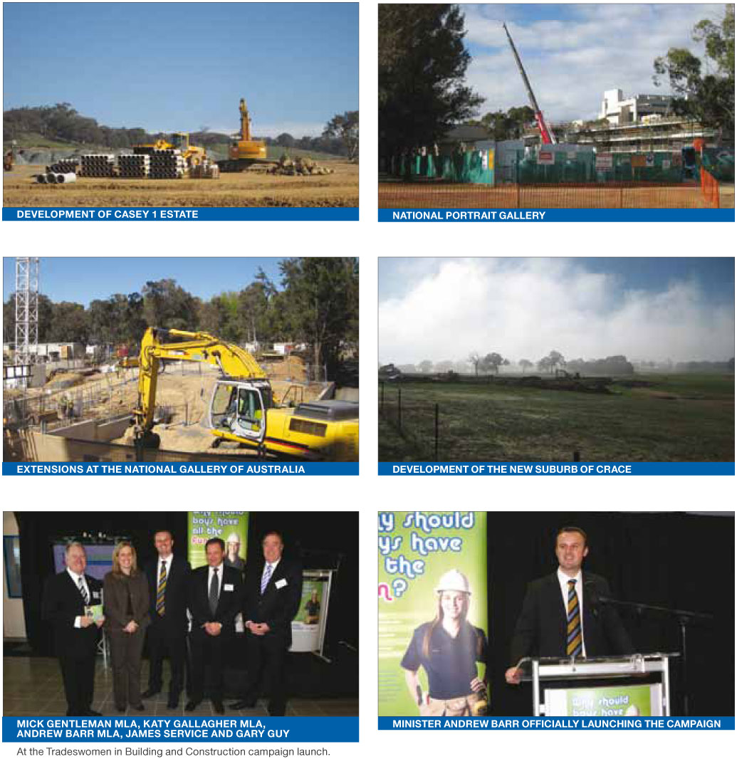

Table of Contents

TABLE OF CONTENTS 1

TFA STRUCTURE 2

MINISTER’S STATEMENT 3

CHAIRMAN’S REPORT 4

ADMINISTRATION OF THE FUND 5

DEVELOPMENT OF THE 2008 TRAINING PLAN 6

TFA COMMITMENT TO FUNDING OF OH&S TRAINING 7

ENTRY LEVEL TRAINING 8

EXISTING WORKER TRAINING AND PROFESSIONAL DEVELOPMENT 10

PROMOTION AND MARKETING 12

RESEARCH AND DEVELOPMENT 13

ACCESS AND EQUITY 14

GOVERNANCE, FINANCE AND ADMINISTRATION 15

COMPLIANCE ACTIVITY 16

INDUSTRY LIAISON ACTIVITY 17

ELIGIBLE PERSON CRITERIA 18

WORK LIABLE FOR THE TRAINING LEVY 19

COURSES FUNDED IN 2007 AND CONTACT DETAILS 20

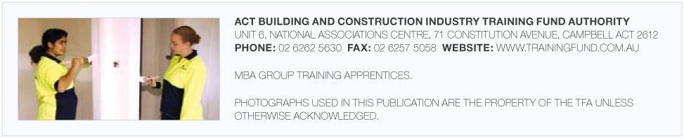

ACT Building & Construction Industry Training Fund Authority



The ACT Building & Construction Industry Training Fund Authority (TFA) is an ACT Government agency, with a Governing Board consisting of two employer representatives, two employee representatives and an independent Chairman. The Chief Executive Officer sits on the Board as a non-voting member. The Minister for Education and Training appoints the Board for a term of up to 3 years, and members may be re-appointed. The responsibilities, governance and powers of the TFA are set out in the Building and Construction Industry Training Levy Act 1999 and the Financial Management Act 1996.

The TFA was established in 1999 to administer an industry training fund and to make payments for industry training, in accordance with the annual training plan. The TFA was previously known as the ACT Building & Construction Industry Training Fund Board; the change of name and status took place on 1 December 2006.

|  |  |
| --- | --- |
| **the board comprises:** | **TFA staff:** |
| Independent Chairman  Mr. James Service  Employee Representatives  Ms. Sarah Schoonwater  Mr. Brian O’Reilly  Employer Representatives  Ms. Alison Just Mr. John Hailey | Chief Executive Officer  Mr. Gary Guy  gguy@trainingfund.com.au  Compliance Manager  Mr. Colin McJannett  colin@trainingfund.com.au  TFA Industry Liaison Officer  Mr. Ray Stowers rstowers@trainingfund.com.au |

Minister’s Statement



As ACT Minister for Education and Training, I am pleased to approve the 2009 Training Plan of the ACT Building and Construction Industry Training Authority (TFA). This approval is in accordance with Section 25 of the Building and Construction Industry Training Levy Act 1999.

I note that wide-spread industry consultation took place over a period of six months to develop the 2009 Training Plan, and I thank industry stakeholders for their comments and advice in the formulation of the 2009 Training Plan.

The Building and Construction Industry Training Fund was established in May 1999, and the   
liability to pay the Training Levy commenced in November 1999. Since that time, the TFA (and   
its predecessor the Training Fund Board) has   
been responsible for producing nine annual Training Plans. During the period 2000 to 2008,   
the TFA funded $6,829,558 million for the   
training of existing workers and $5,221,941 million for entry level training. Over the past six years,   
the TFA has made incentive payments to employers and group training organizations to assist them in the employment of apprentices in areas of skills shortages.

As in past years, the 2009 Training Plan will provide a policy framework for the funding of training for entry-level and existing workers in a wide range of occupations; it will also provide funding for other training, promotional and research related activities within the industry.

Also in 2009, the TFA will continue to fund the Tradeswomen in Building and Construction campaign that was launched in September 2008 to encourage women to seek a career in the industry. Campaign details are provided in the Access and Equity section of the Plan on page 16.

I am pleased to note that under the 2009 Training Plan, the TFA expects to provide $2.8 million in funding for training in the industry and will continue to provide funding incentives to employers and group training organisations who will employ and train Apprentices in the industry. These incentives will not only assist the industry overcome skills shortages, but will also provide employment opportunities for young people seeking a career in the building and construction industry. It is also pleasing that the TFA has re-affirmed its commitment to the funding of OH&S training for workers in the industry

I recommend the 2009 Training Plan to all stakeholders who are keen to participate in training for the ongoing development of the building and construction industry in the ACT.Construction Industry Training Fund Board; the change of name and status took place on 1 December 2006.

**ANDREW BARR MLA**Member for Molonglo  
Minister for Education and Training   
October 2008

Minister’s Statement



This is the ninth Training Plan produced by the ACT Building & Construction Industry Training Fund Authority (TFA). The Plan provides a policy framework for entry-level and existing workers to access funding for training in a wide range of occupations. The Plan will also provide funding for other training, promotional and research related activities within our industry. The TFA greatly appreciates the advice and contributions made by many industry stakeholders, including employers, employees, group training organisations, industry training advisory bodies, trades groups, registered training organisations, government agencies, industry associations and unions, in the development of the 2009 Training Plan.

In the year 2008, a record number of 10,211 eligible industry workers attended approved training programs funded by the TFA. In 2009,   
it I estimated that around 9,800 eligible industry workers will attend an approved training course funded by the TFA.

During the financial year 2007-08, the TFA provided a record amount of $3.4 million to fund activities in its five key areas of – Entry Level Training, Existing Worker Training and Professional Development, Promotion and Marketing, Research and Development, and Access and Equity. At the time of preparing the 2009 Training Plan, the TFA expected to provide $2.8 million for activities during the 2008-09 financial year.

As in past years, the TFA will provide incentive payments to employers of apprentices, who are engaged under an ACT Contract of Training, in those trades that have been identified as having   
a skills shortage, and over the past four years these financial incentives have been extremely successful. In the calendar year 2008, incentive payments were provided in the trades of Plastering – Solid, Plastering Wall & Ceiling Lining and Wall & Floor Tiling. The trades where these incentives   
will be offered in 2009 will be announced in January 2009.

The TFA will continue funding to ACT Colleges who provide Vocational Education and Training (VET) in Certificate I and II Construction   
training programs.

In 2009 funding will continue to be provided to employers and group training organisations who will employ and train an estimated 465 Apprentices who are expected to enter the industry in 2009.

As in past years, the TFA will continue to provide funding for training in the following key areas and activities in 2009:

• Entry Level Training

• Existing Worker Training & Professional Development

• Promotion and Marketing

• Research and Development

• Access and Equity

Also, the TFA re-affirms its commitment to fund OH&S training for workers in the industry so as to provide for safe workplaces.

Included in the 2009 Training Plan are examples of training courses funded in 2007 and 2008, Registered Training Organisations and contact details. If the training course you wish to undertake is not listed in the Training Plan, please contact the TFA for further information. Additional information is available on the TFA’s website at [www.trainingfund.com.au](http://www.trainingfund.com.au) where application forms, our annual report and the Training Plan can be downloaded.

I would like to record my thanks to the members of the TFA Board for their assistance and advice, and to the staff of the TFA for their commitment to the Authority and its stakeholders.

The Board commends this Training Plan to all stakeholders who have an interest in training for the future development of the building and construction industry in the ACT.

**JAMES G SERVICE**  
Chairman   
October 2008

Administration of the fund

**MISSION STATEMENT**

The ACT Building and Construction Industry Training Fund Authority (TFA) may fund up to 70% of the cost, for the training of eligible workers (see page 20) and for the development of skills identified as being in short supply within the industry in the ACT. Through the funding of such training, the TFA strives to improve the culture, level and access to training and to support the entry of new people into the Building and Construction Industry.

**OVERVIEW**

Subject to funds being available, the TFA will allocate funds for training on the following terms:

• Payments for training are intended to achieve additional training outcomes, and are **NOT** to substitute for existing workforce training.

• Allocation of funds will be needs based against predetermined priorities.

• Funding is for the delivery of training and must   
NOT be used to cover capital expenditure costs.

**TRAINING**

Funding for training is targeted at developing new skills for entry level (apprentices) and existing workers in the industry. For example:

• Apprentices under an ACT contract of training are eligible for business skills training.

• Injured & unemployed workers are eligible for training to assist their return to the industry.

• Existing workers are eligible for training in new fields and management techniques relevant to the industry.

**TRAINING PLAN**

This Training Plan applies to the calendar year 2009.

**APPLICATIONS**

Employees, apprentices, employers, Group Training Organisations, industry bodies and associations and Registered Training Organisations may lodge an Application Form seeking funding. Application forms can be downloaded from the TFA’s website

www.trainingfund.com.au

**APPLICANT’S RESPONSIBILITY**

The applicant must demonstrate to the satisfaction of   
the TFA that any individual covered by a request for funding of training, is an eligible worker (see page 20).

**HOW ARE TRAINING FUNDS ALLOCATED?**

The TFA will assess all applications against the   
following criteria:

1. NO retrospective applications will be considered.

2. Funding will be provided for skills training and activities identified in the Training Plan. Training and activities not covered by the Plan may be funded on their merits.

3. Training must be provided by a Registered Training Organisation (RTO).

4. The training course must be accredited under the Australian Quality Training Framework (AQTF), or is a course of training approved by the TFA.

5. There must be an identified training outcome for   
each participant.

6. Participants, other than unemployed workers, may be required to contribute to the cost of the training course.

7. Participants must be carrying out work that makes them eligible – either as an employee or an independent contractor (see Eligible Person Criteria at page 20).

8. Product specific training courses will not be funded. Training courses must be generic.

9. The TFA will monitor the cost of training courses and may set a maximum amount to be funded per participant. The TFA will evaluate the delivery of training courses and may audit the outcome of funded courses.

10. The TFA may withhold payment for training where an individual fails to successfully complete all components of the approved training course.

**REGISTERED TRAINING ORGANISATIONS   
AND ACCREDITED COURSES**

Registered Training Organisations (RTO’s) are registered by State and Territory Accreditation Agencies, usually within the relevant Department of Education. This registration recognises that the RTO has the ability to deliver, assess and issue qualifications that are recognised under the national quality system.

The benefit of using RTO’s and accredited courses is that competencies gained can combine to form nationally recognised qualifications. Accredited courses are assessed under the Australian Quality Training Framework (AQTF) as satisfying industry needs and having appropriate outcomes, competencies standards, structure, delivery, articulation, credit transfer and monitoring and evaluation.

Development of the 2009 Training Plan

**The development of the 2009 Training Plan involved widespread research and consultation with industry participants, and the Plan reflects the training priorities identified during this process.**

**The Training Plan identifies five key areas and activities that will continue to be funded in 2009:**

• Entry Level Training

• Existing Worker Training and Professional Development

• Promotion and Marketing

• Research and Development

• Access and Equity

**The consultation and research process to develop the 2009 Training Plan was done at three levels:**

1. The ACT Regional Building and Construction Industry Training Council Inc. (CITC) provided reports to the TFA, based on interviews with stakeholders. The information collected in this manner was collated to assist in the production of the 2009 Training Plan.

2. The ACT Utilities and Light Manufacturing Industry Training Board (ULMITB) provided information from the electrotechnology and electrical supply sectors. This information was collated and used in the production of the 2009 Training Plan.

3. The ACT Building & Construction Industry Training Fund Authority undertook surveys of other stakeholders.

**The following organisations were consulted:**

• Master Builders Association of the ACT

• Housing Industry Association –   
ACT & Southern NSW Region

• Property Council of Australia (ACT)

• Construction Forestry Mining &   
Energy Union – ACT

• Unions ACT

• Civil Contractors Federation

• Master Plumbers Association – ACT

• Master Painters Association – ACT

**Registered Training Organisations and Group Training Organisations consulted included:**

• Canberra Institute of Technology

• Construction Industry Training and Employment Association (CITEA)

• MBA Group Training

• Capital Skills Centre

• Creative Safety Initiatives

• HIA Group Training

• Electro Group Training

• Electro Skills Centre

• Regional Group Training

• National Safety Council of Australia

Other Organisations consulted included the Accreditation & Recognition Council; Department of Education, Employment & Workplace Relations; Office of Regulatory Services; Government & Private Schools & Colleges; ACT Department of Education & Training; Construction & Property Services Industry Skills Council; ACT Skills Commission; National Construction Research Centre and the ACT Long Service Leave Authority.

**Regulatory and Planning Bodies consulted included:**

• ACT Planning and Land Authority

• ACT Land Development Agency

• ACT WorkCover

• ActewAGL

Individual organisations within the Commercial, Housing and Civil sectors were also consulted. Responses received during the above described consultation process were then summarised and these are included in the five key sectors and activities that will be funded during 2009.

OH&S Training Programs

Occupational health and safety training is the most discussed and reported issue that arises during the consultation process in the development of the Training Plan. In recognition of this, the TFA introduced oh&s as a stand-alone withing the 2007 and 2008 training plans, and it is repeated here for the 2009 plan.

OH&S training issues identified by   
stakeholders include:

• Identification and Safe Handling of Asbestos

• National Construction Induction Training (OH&S Induction)

• Manager / Supervisor OH&S construction training based on Construction Safety Competency Framework –  
www.construction-innovation.info

• OH&S for Managers

• OH&S Risk Management for persons who are not employed in a supervisory capacity

• Assessing Safe Work Methods Statements (SWMS)

• Site establishment - emergency planning and amenities

• Dangerous Goods & Hazardous Substances   
(identification and management)

• Certificate IV & Diploma in OH&S

• Height Safety, Manual Handling, Confined Space, Traffic Management, Overall Site Safety, development of Technology, encourage the use of new technology

• Asbestos identification and awareness

• Electrical testing and tagging and electrical replacement of 240V sockets

• Fire Warden

• Health & Safety Representatives (HSR) course and HSR Refresher Course

• First Aid Courses

• Health and well being promotion

• Industry inductions need to aim at eradicating OH&S complacency and to place more emphasis on the fact that a safe work site is everyone’s responsibility

• Correct use of safety and personal protection equipment ranging from hard hats to breathing apparatus

• How to access aand understand Regulations and Codes of Practice.

• Licensing Induction

• Safety in Design

• ‘Subby’ Pack

The TFA will once again be pleased to be a sponsor for a specifically written Safety Handbook, compiled by the ACT WorkCover, for the Building and Construction Industry (and related sectors). This handbook has been widely provided to industry and is available from ACT WorkCover, free of charge.

During the financial years 2001-2002 to 2007-2008, the TFA provided a total of $3,648,900 for OH&S training.

The TFA will continue to work with Training providers to ensure that any OH&S training funded by the TFA for the building and construction industry (and related sectors) complies with regulatory requirements. Further information should be obtained from ACT WorkCover on 6205 0200 or email workcover@act.gov.au or use the WorkCover website www.workcover.act.gov.au

The TFA re-affirms its commitment to the funding of OH&S training programs for workers in the industry. The application of such training and programs will apply to both entry level and existing workers.

Entry Level Training

Entry Level Training funded under this program only applies to persons who are under an ACT Contract of Training in an occupation or an activity considered relevant to the building and construction industry, or are persons employed as entry level workers in general construction. See Schedule of Work on page 21 for the types of work and activities associated with the industry.

|  |  |  |
| --- | --- | --- |
| **objectives** | **strategies** | **outcomes** |
| • To increase the number of apprentices (this term includes apprentices and trainees) entering the industry under an ACT contract of training, especially in trades or occupations where a skills shortage exists. | • Provide financial incentives to group training organisations and individual employers to employ and train persons in areas of skills shortages. | • Increase the number of new entrants to the industry under an ACT contract of training, especially in trades where a skills shortage exists. |
| • To increase the retention  rate of apprentices. | • Research industry trends and provide advice to industry sectors and government, for the retention of apprentices. Continue to inform and promote the career opportunities within the industry. | • Improve the retention rate  of apprentices. |
| • To increase the number of students undertaking Certificate I and II in Construction at ACT High Schools and Colleges. | • Liaise with industry sectors, government, schools and colleges, and group training organisations, to provide information, advice, and training, to school and college students regarding employment in the industry. | • Increase the number of students  who wish to pursue a career in  the industry. |



Entry Level Training (continued)

The consultation process to develop the above-mentioned objectives, strategies and outcomes is described on page 8.

Offering financial incentives to trades with skills shortages has been quite successful over the past 6 years, with increases in the intake of Apprentices to the trades of - bricklaying, tiling, plastering and refrigeration and air-conditioning. In 2008 the TFA offered financial incentives in the trades of Plastering – Solid, Plastering – Wall & Ceiling Lining, and Wall & Floor Tiling. The trades where these incentives will be offered in 2009 will be announced in February 2009.

TFA will continue to work with industry sectors, government and group training organisations, to identify areas of skills shortages at entry level to the industry.

The TFA will, where and when appropriate,   
provide financial incentives to group training organisations and individual employers, to employ and train apprentices in occupations where skills shortages exist.

The TFA will continue to provide financial incentives to ACT Schools and Colleges that provide construction training.

Entry Level training needs / issues identified by stakeholders in the electrotechnology and electrical services supply sector included:

• An increasing number of mature age (over 21 years) persons are entering Apprenticeships in traditional trades within the Electrotechnology and Electricity supply industry and these Apprentices should have access to Recognition of Prior Learning (RPL) to make their training more effective. Professional development courses should also be accessible by Apprentices.

• Security and fire networks, electrical licence, first aid, OH&S, business skills, basic computer skills and computer accounting skills, sustainable/renewable energy, new and emerging technology, interpersonal skills,   
logic process skills (commencement and progressing a job or project), testing skills   
and the development of industry awareness and knowledge.

• Need to employ and train apprentices against  
the following qualification: Cert III in Electrotechnology Electrician, Cert III in Electrotechnology Refrigeration and Air-conditioning, Cert III in ESI – Distribution (Lineworker), Cert III in ESI – Cable Jointing, Cert III in Telecommunications (Customer Premises Cabling & Equipment and Cert III in Telecommunications.

Entry Level training needs / issues identified by stakeholders in the building & construction sector and civil construction included:

• Developing a business plan, basic computer skills and literacy and numeracy programs (funding for one to one tutoring where appropriate).

• Programming of Work, Cost & Job Planning, Measuring & Estimating, Setting Out and Plan Reading.

• Life skills for young workers, importance of OH&S, drug and alcohol awareness specific to the construction industry.

• Training needs analysis for all persons entering the industry from Prevocational Training and Schools Programs.

• Blue Card program (OH&S training for work   
experience students).

• Understanding and working with other trades on a multi skilled / multi-discipline site.

• Continued support for cadetship programs / assistance for existing workers who want to move into management roles.

• Skills shortage funding to be provided to Cert III Furniture / Cabinet Making, Bricklaying / Blocklaying and Roof Tiling.

In a skills shortage trade, persons aged 30 years and over, who enter an Apprenticeship, may be eligible for financial support from the Australian Government, and persons aged under 30 years who enter an Apprenticeship my be eligible for a wage top up. For details www.australia.gov.au/australianapprenticeships

Existing Worker Training and Professional Development

The following information sets out some of the initiatives to assist existing workers and businesses to undertake training courses and programs. Details of approved training courses that were funded by   
the TFA during 2008 are outlined on pages 22 – 23.

|  |  |  |
| --- | --- | --- |
| **objectives** | **strategies** | **outcomes** |
| • To provide financial assistance  for the training of existing  eligible workers. | • Maintain a system for monitoring the quality and effectiveness of training funded by the TFA, and audit training course results. | • Ensure that the training meets the criteria established by the TFA. |
| • Increase worker and employer awareness of the TFA and  improve access to TFA  funded training programs. | • Continue to present a high  profile to the industry through  the use of industry journals  and sponsorship.  • Maintain a register of Registered Training Organisations who  deliver approved training  programs to the industry.  • Enhance the cost effectiveness  of approved training within  the industry. | • Increase the number of existing workers who undertake training. |
| • Promote training and skills development as a means  of improving business and individual performance. | • Liaise with industry sectors on emerging technology and any new legislative requirements  in the industry, to ensure that existing workers can access contemporary and relevant training courses. | • Increase the number of  existing workers who access  ‘best practice’ training and  professional development. |

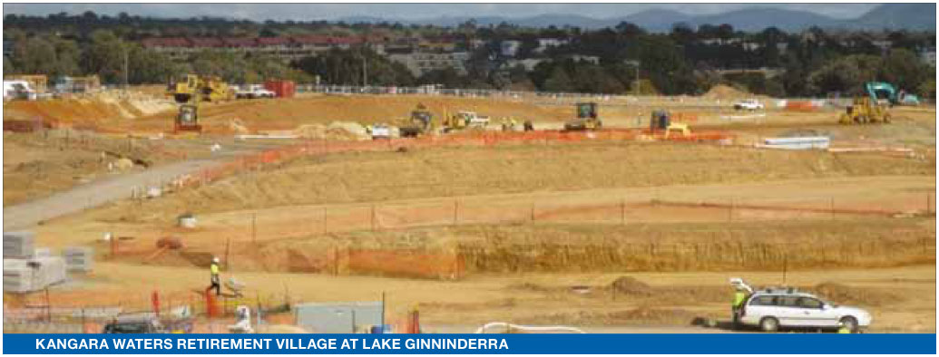

Existing Worker Training and Professional Development (continued)

The consultation process to develop the above-mentioned objectives, strategies and outcomes is described on page 8.

The TFA will consult on a regular basis with stakeholders to determine training issues arising out of new technology and legislation.

In cases where an existing worker seeks to attain a formal qualification through skills recognition, and requires additional training to attain that qualification, the TFA may fund up to 70% of the cost of that training. However, the TFA cannot under its legislation fund the skills recognition process itself. For further information and advice on skills recognition, contact the ACT Regional Building and Construction Industry Training Council Inc on 02 6241 3977.

Existing Worker training needs / issues identified by stakeholders in the electrotechnology and electrical services supply sector included:

• An urgent need to provide bridging programs to train existing workers to become Trade Teachers.

• Sustainable and renewable energy, business skills and bookkeeping, professional development on new technology, dual qualifications, risk assessment and management, diagnostics and schematics, managerial skills and leadership, data and telecommunications, information technology, professional development and updating of rules and regulation, data communication, base cabling (Austel), OH&S, fault finding skills, computer skills, industry knowledge, networking, first aid, smart wiring, electronics, systems electricians, security.

Existing Worker training needs / issues identified by stakeholders in the building & construction sector and civil construction included:

• Scaffolding and confined space training (Non-certificate) for supervisors.

• Computer training (MS Project, Excel, Word, Power Point, XP, Outlook) and Business Skills (including Report Writing and Minute Taking).

• Cost estimating.

• People Management (communication, performance management, managing underperformance, managing grievances   
in the workplace, coaching & mentoring).

• Elevated work platform and restricted   
height scaffolding.

• Cert IV, Diploma and Advanced Diploma in Building & Construction, including Building, Site Management, Estimating, Contract Administration & Sales.

• Diploma & Advanced Diploma in   
Project Management.

• Programs to meet the requirements of the Office of the Federal Safety Commissioner (OFSC).

• Programs addressing the requirements under the National Code of Practice.

• Contract Management/Administration for experienced project staff.

• Marketing and promotion skills for   
business owners.

• Achieving a clean site and a good   
managed workplace.

• Work/Life balance and Men’s   
health awareness.

• Management – Job responsibilities ‘Shared Equally.’

• Encouraging older workers to stay in the industry as mentors (mentor planning).

• BCA application, Slabs & Footings and Timber   
Framing Code.

• BASIX Course.

• Design with colour.

• Green Smart Awareness (GreenSmart Professional and Refresher).

• Wet Area Waterproofing.

• Professional development for biomechanics.

• Cert IV in Training & Workplace Assessment.

Promotion and Marketing

**The following information sets out some of the initiatives the TFA will use to promote and market the operational role of the tfa.**

|  |  |  |
| --- | --- | --- |
| **objectives** | **strategies** | **outcomes** |
| • Increase the awareness  amongst stakeholders as to  the TFA’s funded programs. | • Liaise with stakeholders to promote access to the TFA’s funded programs, with an emphasis on funding incentives to address skills shortages in specific occupations. | • Increased access to TFA  funded programs. |
| • Promote training and enhancement of skills as a means of improving business and personal performance. | • Design and distribute material  to inform industry of the benefits and availability of training. | • Increased numbers of workers participating in TFA funded training. |
| • Promote the employment and career opportunities in the building and construction industry. | • Design and distribute material to prospective entry-level workers to promote the employment and career opportunities in the industry.  • Support awards for training and ‘Best Practice’, in collaboration with group training organisations, industry and government. | • Increased numbers of entry- level workers and apprentices under an ACT contract of  training. Improved retention  rate of new apprentices. |

The consultation process to develop the above-mentioned objectives, strategies and outcomes is described on page 8.

The TFA has increased its compliance activity which provides access and information to a wider range of stakeholders.

The TFA consults widely with industry stakeholders and government contributors.

The TFA produces a bi-monthly newsletter, and uses direct mailing, industry functions, and a website, to promote the role of the TFA. The TFA website offers a comprehensive range of information, including – the annual report, the Training Plan, and application forms. The website is www.trainingfund.com.au

The TFA will continue its ongoing relationship with the Construction Industry Training Council and other training advisory bodies, registered training organizations and group training organizations, by consulting on a regular basis and undertaking joint partnership ventures that meet TFA objectives.

The TFA will continue to market and promote the building and construction industry and associated sectors to the general public, to develop a better understanding of the employment and excellent career opportunities in the industry.

The TFA will support organisations in these sectors to increase awareness and achievements of the industry through training outcomes and the promotion of ‘best practice.’ The TFA will sponsor special events and training outcomes that enhance and recognise the role of industry workers, especially those under an ACT contract of training.

During the consultation process for the   
2009 Plan, issues identified by   
stakeholders included:

• Promote the building and construction industry as an excellent career choice. Funding of OH&S training for ACT school students and support of ACT WorkCover Awards could form part of this strategy.

• Promote the role of Group Training Organisations and Registered Training Organisations.

• Market the TFA and Group Training Organisations to Job Network providers for unemployed persons seeking to get into the industry.

• Promote new programs such as the ‘Subby Pack’ and Men’s Health through the media.

Research and Development

**The following information sets out the initiatives the TFA will adopt in research and development during 2009.**

|  |  |  |
| --- | --- | --- |
| **objectives** | **strategies** | **outcomes** |
| • Liaise with stakeholders and identify changes in building technology, methods, materials and legislation that will require new training resources. | • Ensure stakeholder involvement with the development of the TFA’s Training Plan. | • The TFA responds promptly by providing funding for the development of these new  training resources. |
| • Ensure the TFA has the  funding required to develop  these new resources. | • Continual liaison with industry sectors to keep informed on training issues. | • The TFA provides relevant and innovative resources to industry and government for the training needs of the industry. |

The consultation process to develop the above-mentioned objectives, strategies and outcomes is described on page 8.

The TFA’s annual Training Plan operates for a calendar year, and must be approved by the Minister on or before 31 October in the year preceding the commencement of the plan.

The TFA believes that its Research and Development strategy will continue to involve stakeholders in the development of the Training Plan, and have continual liaison with industry sectors, especially those organisations concerned with developing and delivering new training packages and courses to the industry.

To enhance this liaison role, the TFA (or its agent) will initiate collective meetings with group training organisations, registered training providers and industry associations, to discuss matters of mutual interest regarding training for the industry. This strategy will recognise privacy and copyright issues.

The TFA will consider funding requests for research projects regarding new training needs   
in the industry.

The TFA will consider applications for funding from registered training organisations to develop training courses that will deliver relevant and innovative training outcomes not currently being provided.

During the consultation process for the 2009 Plan, training issues identified by stakeholders included:

• Training for new ACT OH&S Regulations.

• Men’s Health Program.

• Manager/Supervisor training.

• New and emerging construction practices and improving existing practices with a view to making them safer, more environmentally friendly and more cost effective.

Access and Equity

**The following information sets out some of the initiatives the TFA will adopt to promote access and equity during 2009.**

|  |  |  |
| --- | --- | --- |
| **objectives** | **strategies** | **outcomes** |
| Enhance training opportunities for:  • Women in the industry.  • Workers with special language  and literacy needs.  • Aboriginal and Torres Strait  Islander workers.  • Workers with an injury or disability.  • Young workers at risk. | • Include access and equity requirements in funding for Registered Training Organisations and Group Training Organisations.  • Provide supplementary funding for the training of identified groups.  • Market the benefits of training to workers with special training needs.  • Fund re-training programs  for injured workers returning  to the workforce.  • Fund special skills development programs for young workers at risk. | • Increased participation  of individual workers and  organisations in language,  literacy and numeracy programs.  • Increased participation in training by workers in identified groups.  • Increased satisfaction  from identified workers  in training outcomes. |

The consultation process to develop the above-mentioned objectives, strategies and outcomes is described on page 8.

In addition, funding may be available from ACT Training and Adult Education to assist apprentices in literacy and numeracy. The TFA may provide additional funding to eligible workers, depending on individual circumstances.

During the consultation process for the 2009 Plan, issues identified by stakeholders included:

• A mentoring role for women in non-traditional trades in the industry.

• Work with students at ‘Risk.’

• English for non-English speaking persons and Literacy and Numeracy (including use of signs and signals) programs.

• Relocation costs of bringing rural apprentices to Canberra.

• Anti-discrimination training for employers and employees.

• Projects to target young males with poor levels of education and from disadvantaged socio-economic groups such as indigenous, migrants and non-English speaking backgrounds.

• Work/Life and family balance.

• Funding to develop industry wide attraction and retention strategies for minority groups such as women, indigenous and older workers.

• Sourcing participants from all areas – women, school, indigenous, migrant and new retirees to act as mentors.

• Continue to fund the Tradeswomen in Building and Construction campaign that was launched in 2008 to encourage woman to seek a career in the industry in trades that are particularly suited women. These trades have been identified as carpentry and cabinet making, plumbing, painting and decorating, wall and floor tiling, electrical, hortuculture and plastering. For more information about the campaign visit www.tradeswomen.com.au

Governance, Finance and Administration

|  |  |  |
| --- | --- | --- |
| **objectives** | **strategies** | **outcomes** |
| • Ensure the Authority and  the Training Fund are administered in accordance with the Act, the Training Plan and any other relevant legislation. | • Carry out all functions of the  TFA and administer the Training Fund in accordance with the Act, the Training  Plan and any other relevant legislation. | • Obtain an unqualified audit  opinion from the Auditor-General in respect to the operation of the TFA and  the administration of the Training Fund. |
| • Ensure that applications  for funding comply with the  Training Plan, and that there is a consistent and transparent assessment of applications. | • Applications will only be considered on merit, and must comply with all criteria set down in the Training Plan. Ensure applicants are made aware of TFA processes in assessing applications. | • Continued high level of  compliance with the Training  Plan criteria from applicants. |
| • Ensure the efficiency of TFA administration, and the use  of Training Funds. | • Continual review of internal administrative procedures. | • Continued efficient operation of TFA administration and effective and targeted use of Training Funds. |
| • Establish measures to assess the effectiveness of training delivered. | • Conduct audits of TFA  funded training courses. | • Training delivery and outcomes meet the expectations of  participants and industry. |
| • Ensure compliance with the requirement to pay the Training Levy. | • Administer the approved  Compliance Policy of the TFA. | • Compliance is maintained to  the satisfaction of the TFA. |

TFA is responsible for maximising compliance with the Act and for the effective use of the Fund.

A compliance program and policy has been in place for several years and is monitored by the TFA on the basis of regular staff reports.

The effectiveness of TFA funded training programs is monitored and audits of TFA funded training are conducted to ensure the accountability of expenditure and training outcomes.

Internal procedures are regularly assessed to ensure ongoing efficiency to deliver the most effective use of TFA funds.

Compliance Activity

The TFA is established under the Building and Construction Industry Training Levy Act 1999, and the purpose of the Act is to provide a   
“levy to fund training in the building and construction industry”. The   
Act can be downloaded online at http://www.legislation.act.gov.au

Project Owners, who are defined as the owner   
of the land or the owner of the work, are required to pay a Training Levy of 0.2% on the value of the work. The type of work that is subject to the Levy   
is described in the Schedule of the Act, which is reproduced at page 21. Work that is exempt from the Levy includes work valued at less that $10,000 and work carried out by the staff of a public authority.

Collection of the Levy

The Levy on work that is subject to the issue of a building approval by the ACT Planning and Land Authority (ACTPLA) must be paid prior to the issue of the building approval. The Building Controller is authorised to collect the Levy on such work, acting as an agent for the TFA.

The payment of the Levy on non-building approval work, such as civil works, landscaping, utilities and telecommunications, is arranged between the TFA and the Project Owner. This is usually done through the mechanism of a written agreement that allows the Project Owner to self-assess the Levy liability and make a single annual retrospective Levy payment.

Where work is carried out by or for a Project Owner not covered by a written self-assessment agreement with the TFA, the work is monitored   
to determine if a Levy liability exists. The TFA   
will then contact the Project Owner to achieve compliance. The TFA has a statutory obligation   
to ensure that the requirements of the Act are observed.

Self-assessment of the Levy

The TFA has negotiated written self-assessment agreements with ACT Government Departments, Agencies and Statutory Bodies such as the Land Development Agency. The TFA also has agreements with major Private Sector Estate Developers, ActewAGL, Telstra, the Australian National University, Private Hospitals, Retail Shopping Centres and Clubs (including Golf, Bowling and Racing Clubs).

These self-assessment agreements are an important source of Levy for the TFA and account for about 28% of our income. They are also a useful arrangement for Project Owners, as they provide a simple solution to comply with the Act, by way of a single annual payment calculated on the value of capital works expenditure.

Other Levy Collection Arrangements

Since 2003, the TFA has had in place written agreements which authorises major Kitchen Manufacturers (Joinery Shops) to act as an Agent for the TFA and collect the Levy on kitchen refurbishment work in existing homes, where the work does not require a building approval from ACTPLA. The TFA will be examining ways of extending this arrangement into other sectors during 2009.

In December 2006, the Act was amended to better define a project owner.

Promotion and Education

The TFA works closely with industry stakeholders, industry bodies, businesses and Government Agencies to promote the role of the TFA and this assists in achieving a high level of compliance with the Act.

Refund of Levy

Where a building approval project does not commence and the Levy has been paid, the Project Owner or Agent may apply, in writing, to the TFA for a refund. Where a civil project is abandoned after commencement and after the Levy has been paid, the Project Owner may seek a partial refund of the Levy.

Colin McJannett  
Compliance Manager

Industry Liaison Activity

**To promote employment and funding of training   
in the five key areas of the Training Plan, the TFA   
has regular contact with stakeholders such as:**

• building and construction employers

• group training organisations

• unions and employer organisations

• schools and colleges

• registered training organisations

**The TFA also liaises with stakeholders on matters such as:**

• apprenticeships & entry level training

• group training

• school-to-work transition

• skills shortages

The TFA collects statistical data to determine priorities for the funding of training, particularly in relation to skills shortages.

This is an ongoing activity and the TFA works   
with stakeholders to initiate funding incentives to

employers who employ new apprentices in   
trades that have been identified as having a   
skills shortage.

Under our Access and Equity program, the   
TFA will also provide additional funding for the employment of apprentices who are – indigenous, women in a non-traditional vocation, workers with   
a disability and young workers at risk.

To assist the TFA communicate to a wide   
range of stakeholders, the TFA uses – its own website, bi-monthly newsletter, direct mail, meetings with industry, functions and advertising   
in industry journals.

The TFA provides advice on training choices   
for existing worker training and professional development.

The TFA has developed partnerships with public and private organisations to promote an awareness of the TFA and its programs, to support school-to-work programs, identify skills shortages, promote new apprenticeships and to encourage young people to make a career in the industry.

**Ray Stowers  
Industry Liaison Officer**



Eligible Person Criteria

**This section sets out the eligible person criteria and provides some examples of eligible and non-eligible employment.**

An ELIGIBLE PERSON is any person usually working in or in connection with the Building and Construction Industry in the Australian Capital Territory, who is substantially (at least 80%) performing work as set out in the Schedule of Work

in the Act – see page 21; or is a person deemed as an Eligible Person on application to the TFA. An eligible person can be either an employee, or an independent contractor. Examples of an Eligible or Non-Eligible Person include:

|  |  |  |
| --- | --- | --- |
| **objectives** | **strategies** | **outcomes** |
| • Any person working for a  company or organisation that is substantially (at least 80%) engaged in carrying out work described in the Schedule of  Work in the Act, within the ACT. | YES | • The company or organisation  is substantially (at least 80%) engaged in the Building and Construction Industry and  therefore ALL employees and/or contractors working for the business are eligible. |
| • A maintenance electrician / plumber / carpenter or  similar occupation who is substantially carrying out their trade or occupation (at least 80%) but working for a non-building company in the ACT. | YES | • The activity of the occupation  is work covered by the  Schedule of Work in the Act. |
| • A NSW or other interstate  worker who works in the ACT. | Conditional | • The worker must be substantially engaged (80%), in the ACT, in work covered by the Schedule of Work in the Act. |
| • An ACT industry worker  seeking training to qualify for  a NSW licence or certificate. | Conditional | • The worker must be substantially engaged (80%), in the ACT, in work covered by the Schedule of Work in the Act. |
| • An apprentice under a NSW contract of training. | NO | • The apprentice is not under  an ACT contract of training |

Work liable for the Training Levy

**Project owners are liable to pay the Levy on work set out in the schedule of the Act which is reproduced below.**

1. The construction, erection, alteration, repair,   
renovation, demolition, maintenance or removal   
of a building or structure.

2. The construction, alteration or repair of a road, street parking area, footpath, thoroughfare   
(for pedestrians or vehicles), kerbing, guttering, roundabout, median strip, or the performance of other road works.

3. The construction, alteration, repair, demolition   
or removal of a railway or part of a railway, or of any platform, signal or other structure connected with a railway.

4. The construction, alteration, repair, demolition,   
or removal of an aircraft runway or helicopter-landing pad.

5. The construction, alteration, repair, demolition, or removal of a bridge, viaduct, aqueduct, or tunnel.

6. The construction, alteration, repair, demolition, or removal of a harbour, breakwater, retaining wall, or marina.

7. The performance of excavation work.

8. The construction, alteration, repair, demolition   
or removal of a dam, reservoir, weir or other embankment or structure for the catchment, collection, storage, control or diversion of water.

9. The laying of pipes and other prefabricated material in the ground.

10. The construction, erection, installation, alteration, repair, demolition or removal of any system or plant associated with the conveyance, collection, storage, treatment or distribution of water or gas, or the disposal of sewage or effluent.

11. Electrical, electronic, communications or data networks or mechanical services work, including on-site work that is related to the construction, erection, installation, alteration, repair, servicing or dismantling of any plant, plant facility   
or equipment.

12. The on-site construction, installation, alteration, repair, renovation, demolition or removal of (a) a lift or escalator. (b) any air conditioning, ventilation, or refrigeration system or equipment.

13. The construction, repair, alteration or removal of a playing field, golf course, racecourse, stadium, swimming pool or other sporting or recreational facility.

14. Landscaping or the construction, alteration or removal of a park or garden.

15. Work to improve the drainage of land.

16. The removal of material that is asbestos for the purposes of the Building Act 1972 from a building or any machinery, plant or equipment located in or on a building.

17. Any site preparation work (including pile driving) preliminary to the performance of any construction work.

**EXEMPT WORK:**

Exempt Work is that:

1. The value of which does not exceed $10,000.

2. Work carried out by a public authority using its own staff.

Courses funded in 2008 and contact details

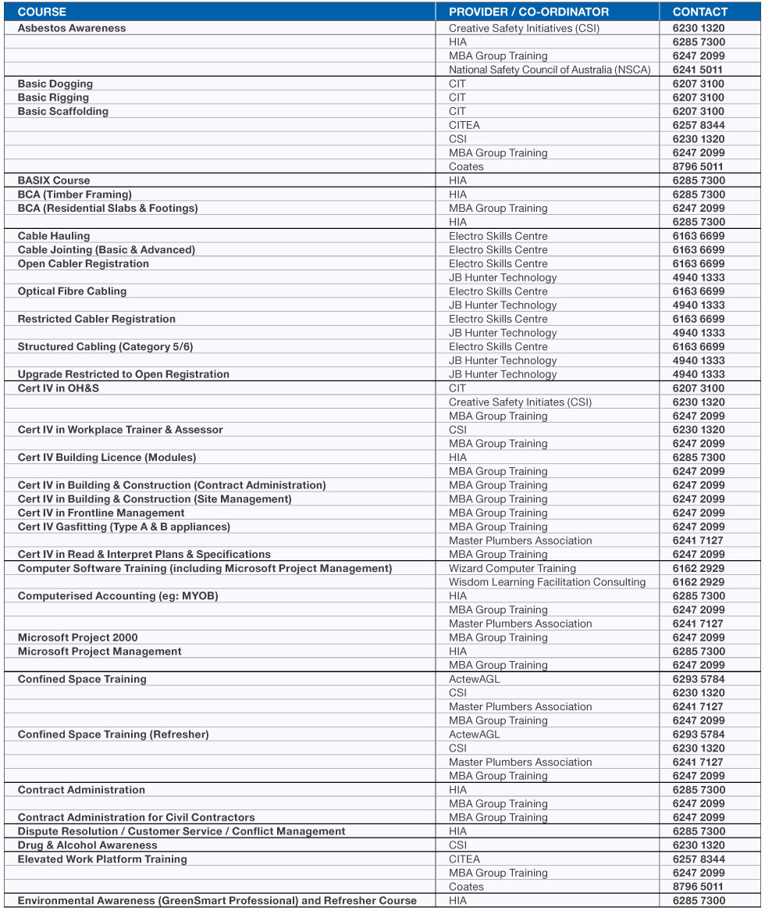

Courses funded in 2007 and contact details (continued)

